
AC 1.1
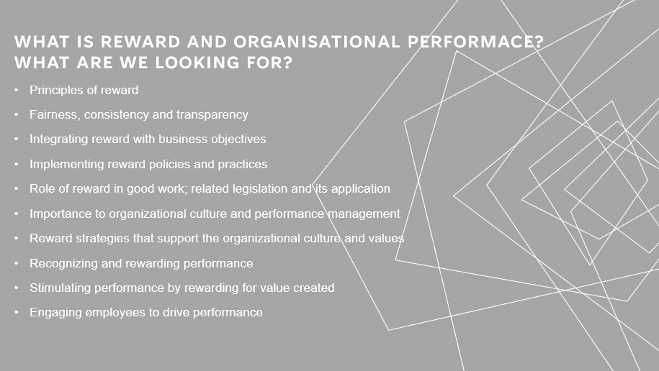
‌ CIPD (2021) The principals of reward cover the financial provisions that are made to the employees, this includes things such as cash pay, and the wider benefits on offer such as pensions or private medical care. It can also include such things as non-pay benefits; this could be flexible working opportunities.
There are also benefits of a total reward approach these can create the maximum use of relational as well as transactional rewards. This can engage individuals in their own reward package design, which provides a sting message about the organisation as a whole and its values.
Through this it is important to ensure that fairness, consistency and transparency are adhered to, and that reward is rooted in principle of fairness, as this can demonstrate to employees that it is equitable treatment, which is tow will drive retention, engagement and performance.
How to implement the reward policies and practices, can be done through highlighting the key reward issues and problems that need addressing. The most successful rewards management can be done through providing the opportunity for self-evaluation and allowing organisations to recognise good workers. It has been shown that by rewarding employees it provides motivation to work hard, work smart and more efficient and productive.
This can all be linked to best practice as it can be shown that by researching and providing experience to produce and optimise results. AC 1.1
AC 1.2
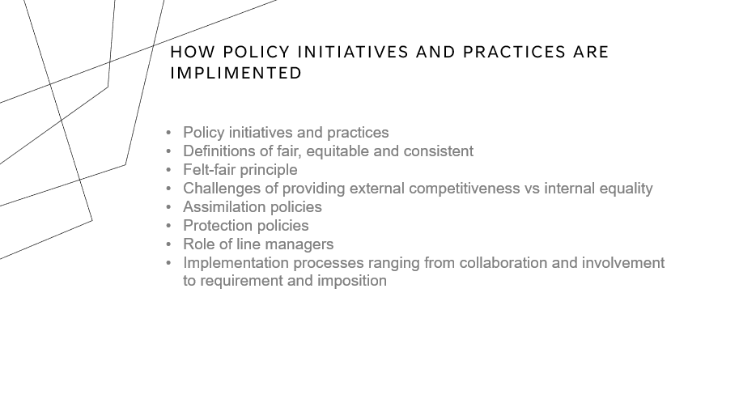
HR Policies | Factsheets | CIPD (2019) looks into how policy initiatives and practices are implemented. This covers the importance of how HR provides a supporting role when it comes to fairness, culture trust and inclusion. As they can have an impact on employee motivation, the overall organisations reputation and the ability to attract and retain talent. It is important that organisations show that they are equitable and consistent within this area as it needs to all be valid and distinct. Ceplenski, C. (2013) explains that there are three types of fairness within the workplace, this is distributive, procedural and interactional.
Within this we can also look at the felt fair principle. This looks at how things felt to the people on the receiving end, and regarding any policy initiatives and practices is all about the felt fair. hrgem (n.d.) quoted that Maya Angelou is often quoted as saying that ‘people will forget what you have said, people will forget what you did, but people will never forget how you made them feel’.
It is important as a line manager to look at your role and how you would implement, process, collaborate and be involved with reward. Line managers have a vital role in ensuring that rewards are communicated and that policy guidelines are clearly set out and followed. The consistent decisions would also need to be made across the organisation, and this can be done though line manager input to ensure transparency throughout. AC 1.2
AC 1.3
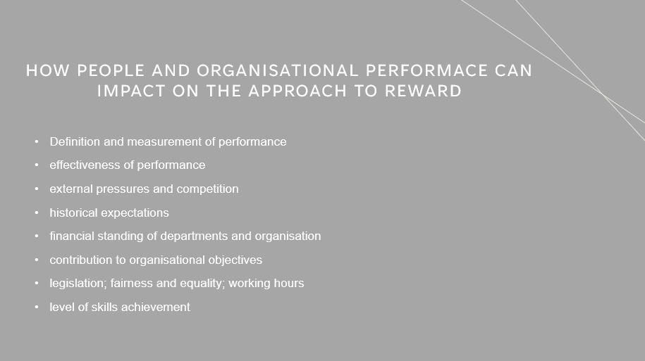
Looking at the definition of measurement and performance, this explains that there are regular measurements of outcomes and results. This allows an organisation to look at the reliable data and the effectiveness and efficiency of the programs.
CIPD (2020) explains that people are the greatest creators of value within an organisation, but it needs to be made clear what is expected of employees, and is all about monitoring, maintain and improving overall performance.
Internal pressures could also have an impact on reward as high expectations, and possibly targets may not be realistic. External pressures can also have an impact on success; however, it is very difficult to control these, and all you can do as an organisation is to be reactive as and when these come into play.
CIPD. (n.d.) suggests that to implement fairness and quality within your organisation, you could also opt for objectives on a teal-level rather than individually. In some instances, this would work as I is striking a balance between level of skill and achievements overall. AC 1.3

AC 1.4
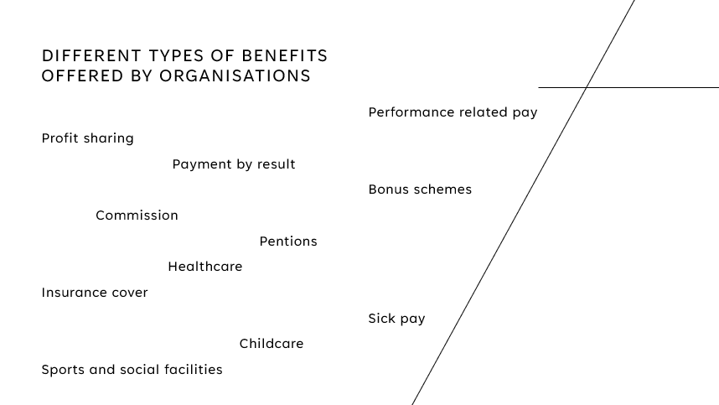
HR News. (2022) looks at why employee benefits are important, it looks at why companies need to provide a comprehensive benefits package, weather that include things such as healthcare, sick pay, bonus schemes to name a few. It allows employers to embrace unique needs and the power of choice. By investing in your employers, you are also inspiring them to build communities and motivate themselves. People work for people – not businesses. Each company normally tailors the benefits to their organisation, and what would suite their employees best.
There are also many other reasons why employees choose an organisation that offers benefits as it shows that the company believes and wants to invest in the workforce.
‌www.linkedin.com. (n.d.). shows the advantages of staff benefits, which includes job satisfaction, the staff will be motivated, low absenteeism and low turnover. It also allows you to attract the best talent, if you want to hire the best employees.
CIPD. (n.d.2) also looks at when offering different packages and schemes it is important to make clear that their choices and consequences are included in their terms of employment. It is also important to maybe keep a limited but meaningful choice of options for any benefits as this can limit complication. AC 1.4

AC 2.1
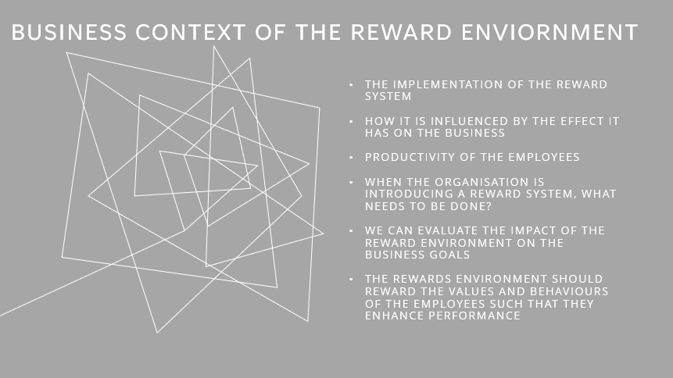
CIPD People Profession. (n.d.) Explains that designing and implementing reward strategies ensures that employees are rewarded, which then links with the organisational context and culture. This influences the effect that it has on the business as it looks at how performance is enhanced when implemented.
Strickland, K. (n.d.) looks at how the expectancy theory motivates employees. It allows employees to think their best efforts will lead to reward, ad that is something that they will value.
When introducing a reward system, it is important to look at your external and internal factors, this can be done with a PESTLE or SWOT analysis, to be able to analyse what the internal and external factors may be when it comes to reward. Stemming from this you could link this with how reward intelligence can be beneficial this can be done through surveys and robust exit interviews with staff. The overall impact of what information is provided by your employees is key and should not be swept under the carpet. This information is vital on how your organisation can grow and develop, as it can hugely impact on the business goals.
There are many useful tools to look at when it comes to assessing your reward environment, this can be through investigating such information as National statistics, ONS labour market outlook, CIPD information and OECD, which looks at and brings together a wide variety or organisations.
As stated, the rewards environment should look at the values and behaviours of the employees so that they enhance their overall performance. AC 2.1

AC 2.2
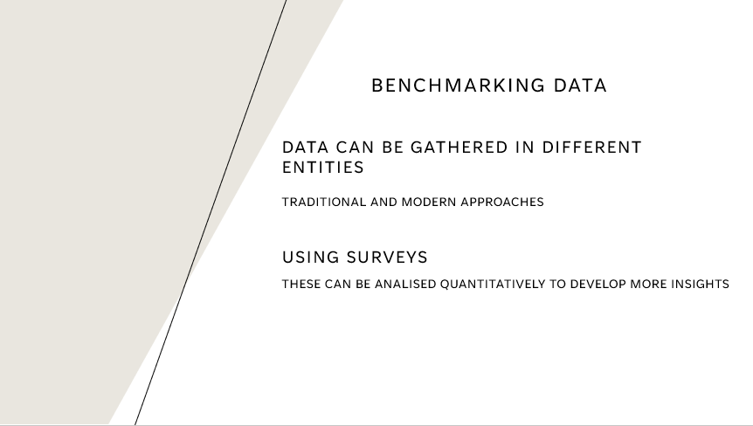
Anon, (2021) looks at the three may ways in which benchmarking can be gathered, this can be done through internal benchmarking. A method used to compare teams within an organisation, to see the best practices. It is about looking at departmental strategies and finding out what is causing their success and rolling this out across your team. Competitive benchmarking compares competitors’ products, processes and systems, this is a difficult and very traditional way of gathering the relevant data, and may be difficult to collate accurate information, as competitors normally keep items such as strategies and reports behind closed doors. They may also influence their information that they are providing, and it may be exaggerated. The third is strategic benchmarking, this involves looking outside of your own organisation an industry to explore different and potentially new ways of working, products and processes.
It is an important way of gathering information based on reward, as noticeable trends can be found when looking at a reward system. It can be useful when measuring rate of turnover, level of staff satisfaction, productivity per employee and workforce composition.
Surveys are also a good tool to analyse data quantitatively, this can be a very convenient and accessible choice, as it can be created and completed online. This must be a well-designed, and well thought about survey for it to be as accurate as possible. AC 2.2

AC 2.3
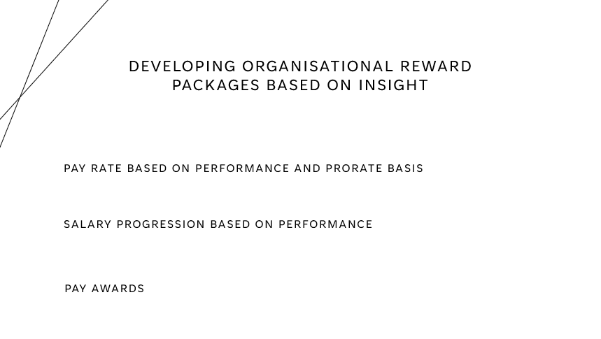
CIPD (2019b) looks at the use of benchmarking data and the use of this when looking into developing appropriate rewards. These can be used from four main sources of data, all of which can help with the points shown on the slide, this can be from looking pay rates, based on performance, salary progression, also based on performance, and pay rewards. These can be developed through looking at the four benchmarking purposes, from published data, pay clubs, special surveys and consultants’ pay databases. All this useful data can be found from providers such as:
CIPD's Labour Market Outlook - for pay predictions
Croner Salary Surveys – Sector, function and regional surveys
Incomes Data Research – pay review data
Labour Research Department (LRD) pay surveys – collective pay agreements
XpertHR Cendex - private and public sector pay reviews
MakeUK – manufacturing pay settlements

‌CIPD (2021) looks at how non-financial reward can be just as beneficial, as non-financial rewards such as flexible working, extra leave, time and resources to develop such as courses. This can all be appropriate as it meets the needs of both the organisation and its employees. AC 2.3

AC 2.4
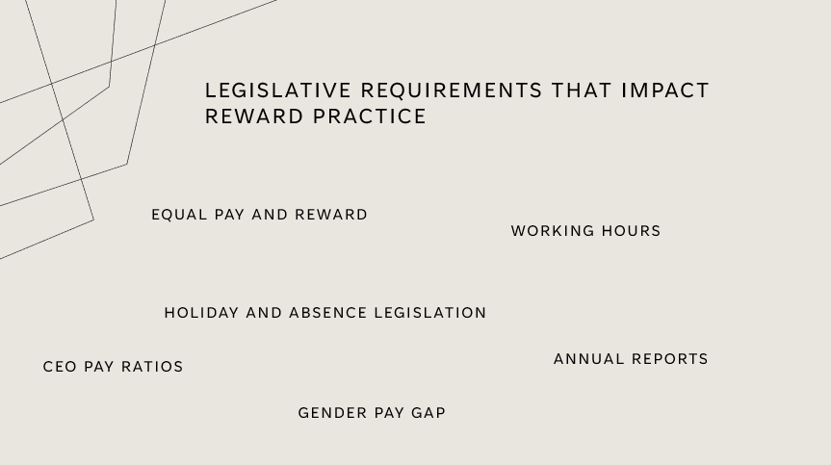
‌CIPD (2022) explains that there are legislative requirements when it come to reward practice. This can include things like equal pay, as under the Equal Pay Act 2010 this details that men and woman are to be paid the same, for the same, or equivalent work.
Pulse survey (2015) also looks at the pay gap with regards to CEO’s and if their employees are happy with this. As you can se from the table the consensus is that within most sectors the employees thought that the CEO’s pay was either around the about right, too high or far too high. Also, a large amount of employees don’t know what their CEO’s are paid.
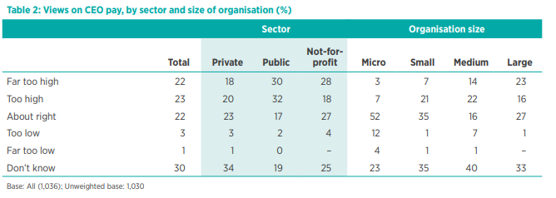
It is important that any organisation with 250 or more staff publish their employees gender pay gap. This would mean that under the Gender Pay Gap reporting (2017) it requires businesses to publish the statutory calculations that show how large the gender pay gap is. This shows if there are any discrepancies between the levels of pay that male and female employees earn. This would be a report that would need to be published every year. AC 2.4

AC 1.5
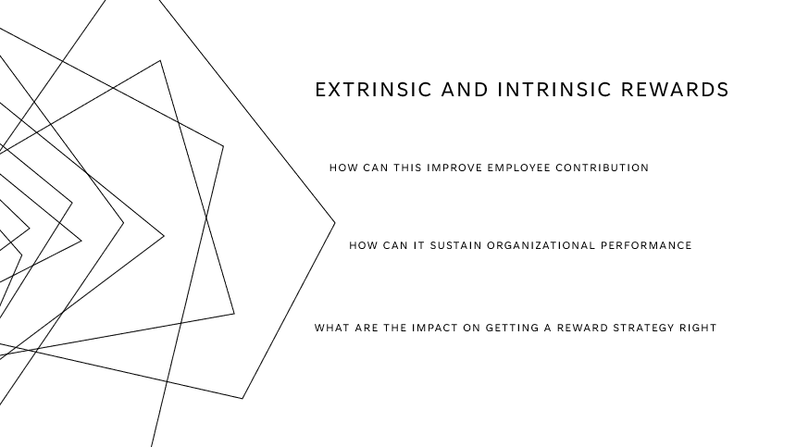
May 2017, P.H. 6 (n.d.) explains that extrinsic rewards are tangible, covering pay bonuses and benefits, whereas intrinsic rewards are phycological benefits that an employee would gain from making a meaningful contribution to their work.
The Economic Times (2019) give a good example of what extrinsic rewards are and how they can be used to the organisations advantage. They can be used to motivate and inspire employees as this type of reward is focused on the individual and are generally rewarded to the employee based on their contribution alone. However, this type of reward may only work well in the short term, as employees may use this to their advantage and for the wring reasons.
Glassdoor Blog. (n.d.) looks at intrinsic reward and how this differs from extrinsic, as this is more based on what the employee achieves psychologically and how this is based on emotional reaction to a person’s work or achievements. Because of this it will motivate the employee to complete tasks and continue to complete task successfully, based on the positive emotions.
Both ways are measurable and can have pros and cons, the pros are what have already been discussed however the impact that extrinsic rewards could have on your organisation is that you can diminish employee’s intrinsic motivation and cause employees to reply on the rewards rather than the overall intrinsic rewards that come at no extra cost, as pay rewards are not always the best motivator. AC 1.5

AC 3.1
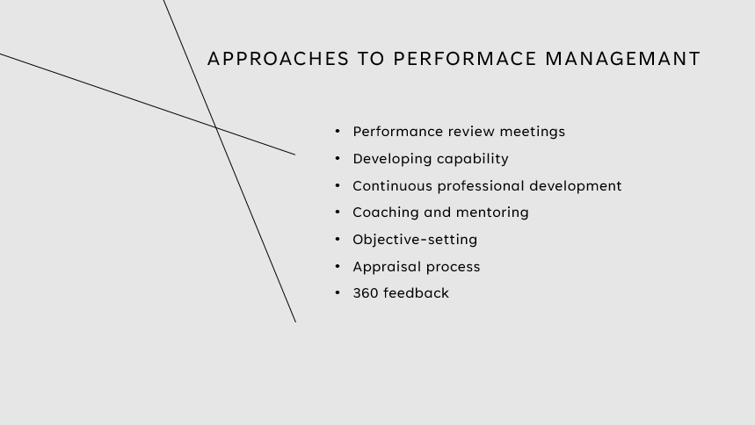

Performance management can come in may forms from setting objectives, appraisals, and 360 feedback forms to name a few. It is important for an organisation to maximise their value and creating by ensuring their employees contribute to the organisation’s objectives and goals. By the employee having continued performance management, allows the employee to consider themselves as part of the overall mission and strategy. Performance management doesn’t only benefit the organisation, it also benefits the employees and teams. It is also a good tool to use to ensure that people are held accountable of their actions, and development, along with linking this to career progression and reward.
Different regards have their different outcomes and benefits to the organisation and employees. For example, Explorance. (n.d.) explains that there are five key benefits to having and implementing 360 reviews. These are an increase in self-awareness, a balanced view, leverages strengths, uncovers blind spots and develops skills. It allows useful feedback to be obtained, along with providing organisational growth, team development, and individual development.
Whereas performance reviews look at more KPI’s and objective setting. This is more set on what the employer thinks you should be developing and is measured on what you are delivering. By speaking directly with the employee directly, you can talent spot, and encourage engagement.
There are many advantages and disadvantages of all types of reviews, however within your time within organisations you will be subject to most reviews, it will all depend on your organisation and what you are looking to achieve from your employees and the overall goal of the company. AC 3.1

AC 3.3
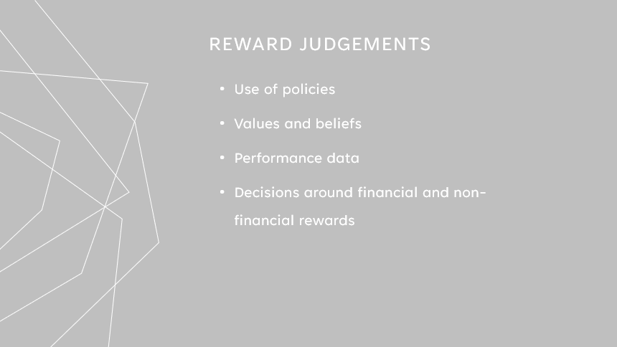
Harris, L. (2001) looked at how line managers’ vales, beliefs and perspectives are linked to reward. Her study found that middle managers often do not share the principles or objectives that they require to operate, and that rewarding an individual has been overlooked and underestimated. It is important to have HR policies linked with the organisations values and beliefs. It has long been argued that more significant contributions from line managers, can have a large impact on how HR policies are shaped and integrated into the organisation. Judgement can be made from line managers by being involved in annual or periodical appraisals, data can also be collected by the employees using different tools and resources, revolving around the appraisal or performance assessment. Good data tools would be such things as 360 reviews. They can also provide a review for every employee, which allow regular checks, and being able to identify if anyone would be experiencing challenges. From this the line manager would be able to make any appropriate judgements and be able to introduce relevant objectives for the work force to develop and thrive.
HrHelpboard. (n.d.) looks at the best policies that could be implemented, such as a reward programme. This would include the aim, purpose, structure, steps to make the development as effective as possible. Why reward should be implemented, key responsibilities, nominations, selection, the effectiveness of the policy and the review. All are important in ensuring that full transparency is provided. AC 3.3

AC 3.2
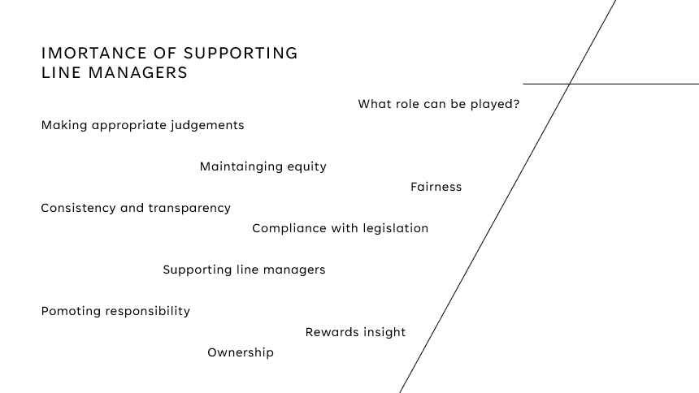
Supporting (2019) looks at how important it is for people practices supporting line managers. As even managers need supporting framework, to enable them to be confident with what they are producing and capable of within their organisation. This is where appropriate L&D is provided for those in a line manager role.
It is having the support to be able to make the right judgements, as HRM have had a large part to play in how the role has changed. As there is now a growing emphasis on how both HR and L&D teams work closely with the business strategy, which has also highlighted that there are opportunities to develop and align.
It is all about the line managers being given the right tools to be able to make the right judgements, this could be done through having a robust 360 review, which have been implemented in a fair and transparent manner. It is also important for line managers to have the correct infrastructure for communicating with employees, to be able to provide as much information regarding any changes or policies being implemented. It is all about the line managers having the right tools and guidance, from compliance with legislation, taking ownership, consistency and transparency, maintaining equity and promoting responsibility. All of which play an important role in supporting line managers with consistent and appropriate reward judgement.AC 3.2

AC 2.3 (2)
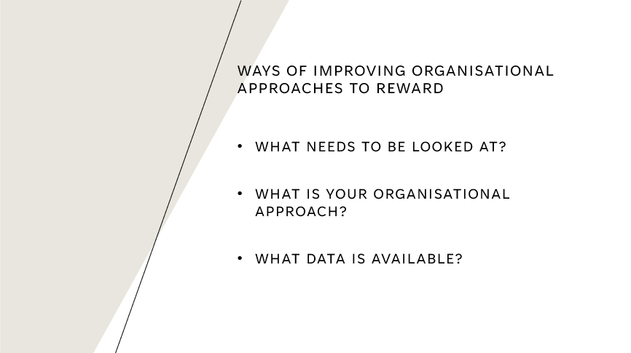
What needs to be looked at? In my organisation the benchmarking tools that we use are customer satisfaction ratings. This is done by feedback forms and emails to ensure that standards are as high as possible. It allows us as a company to look at staff training and make sure that training is effective and that are processes are robust. Our organisational approach is that we use benchmarking as a form of data collection, which allows us to put together business strategies, and include critical functions to increase efficiency and performance. The way in which my organisation could improve on this is to focus more on benchmarking than KPI’s, as currently we focus a lot on the KPI’s, but this will only get the organisation so far, as this generally looks at the company progress to a specific goal and not necessarily the bigger picture. By using benchmarking data, it will allow my organisation to improve and have insight into the best way forward.
Use of systems, analytics, website user data and databases are some of the most useful tools to use and having an action plan in place should allow you to address the gaps in performance and allow measurable and time-sensitive targets. AC 2.3 (2)



Bibliography

Anon, (2021). How To Efficiently Collect, Analyse and Interpret Benchmarking Data for Competitive Benchmarking I Symanto. [online] Available at: https://www.symanto.com/blog/benchmarking-data-collection-analysis-interpretation/?msclkid=96b4ce41d16511ec81aecef8ae2a5dad [Accessed 11 May 2022].

Ceplenski, C. (2013). Employee Rewards: The Importance of Perceived Fairness. [online] HR Daily Advisor. Available at: https://hrdailyadvisor.blr.com/2013/06/29/employee-rewards-the-importance-of-perceived-fairness/.

CIPD (2019a). Costing and Benchmarking Learning & Development | Factsheets | CIPD. [online] CIPD. Available at: https://www.cipd.co.uk/knowledge/strategy/development/benchmarking-factsheet.

CIPD (2019b). Job Evaluation & Market Pricing | Factsheets | CIPD. [online] CIPD. Available at: https://www.cipd.co.uk/knowledge/strategy/reward/market-pricing-factsheet.

CIPD (2020). Performance Management | Factsheets | CIPD. [online] CIPD. Available at: https://www.cipd.co.uk/knowledge/fundamentals/people/performance/factsheet.
‌CIPD (2021). Reward & Pay | Factsheets | CIPD. [online] CIPD. Available at: https://www.cipd.co.uk/knowledge/fundamentals/people/pay/reward-factsheet.
CIPD. (n.d.). Performance Management | Factsheets. [online] Available at: https://www.cipd.co.uk/knowledge/fundamentals/people/performance/factsheet#26123.

‌CIPD (2022). Reward & Pay | Factsheets | CIPD. [online] CIPD. Available at: https://www.cipd.co.uk/knowledge/fundamentals/people/pay/reward-factsheet.
CIPD. (n.d.2). Employee Benefits | Factsheets. [online] Available at: https://www.cipd.co.uk/knowledge/fundamentals/people/benefits/factsheet?msclkid=0e3c71ebcfd911ecbe48b89738c657ed#8297 [Accessed 9 May 2022].

‌CIPD (2021). Reward | Factsheets | CIPD. [online] CIPD. Available at: https://www.cipd.co.uk/knowledge/fundamentals/people/pay/reward-factsheet#gref.

CIPD (2021). Strategic & Total Reward | Factsheets | CIPD. [online] CIPD. Available at: https://www.cipd.co.uk/knowledge/strategy/reward/strategic-total-factsheet.

CIPD Good Work Index 2020 UK Working Lives Survey. (2020). [online] Available at: https://www.cipd.co.uk/Images/good-work-index-full-report-2020-2_tcm18-79210.pdf#:~:text=The%20%EE%80%80CIPD%EE%80%81%20is%20the%20professional%20body%20for%20%EE%80%80HR%EE%80%81 [Accessed 11 May 2022].

CIPD People Profession. (n.d.). Reward | CIPD Profession Map. [online] Available at: https://peopleprofession.cipd.org/profession-map/specialist-knowledge/reward?msclkid=8c80d8a5d09811eca1882b60383e1c70 [Accessed 10 May 2022].

Explorance. (n.d.). 5 Employee Benefits of 360 Degree Feedback. [online] Available at: https://explorance.com/blog/5-employee-benefits-of-360-degree-feedback-2/#:~:text=1%20Increases%20self-awareness%3A%20One%20of%20the%20most%20important [Accessed 14 May 2022].

Glassdoor Blog. (n.d.). Intrinsic Rewards: Why They Matter In the Workplace | Glassdoor. [online] Available at: https://www.glassdoor.com/blog/guide/intrinsic-rewards/

Harris, L. (2001). Rewarding employee performance: line managers’ values, beliefs and perspectives. The International Journal of Human Resource Management, 12(7), pp.1182–1192. doi:10.1080/09585190110068386.

hrgem (n.d.). felt fair. [online] People Stuff. Available at: https://hrgemblog.com/tag/felt-fair/ [Accessed 29 Apr. 2022].

HrHelpboard. (n.d.). Rewards and Recognition Policy, how to reward employees, types of incentives. [online] Available at: https://www.hrhelpboard.com/hr-policies/reward-and-recognition-policy.htm.

HR Policies | Factsheets | CIPD (2019). HR Policies | Factsheets | CIPD. [online] CIPD. Available at: https://www.cipd.co.uk/knowledge/fundamentals/people/hr/policies-factsheet.

HR News. (2022). Why employee benefits are beneficial to all. [online] Available at: https://hrnews.co.uk/why-employee-benefits-are-beneficial-to-all/?msclkid=f904c11acfd411ec82cfb5f7466997c2 [Accessed 9 May 2022].

Information on Reward Strategy | CIPD (2019). Information on Reward Strategy | CIPD. [online] CIPD. Available at: https://www.cipd.co.uk/knowledge/strategy/reward.
May 2017, P.H. 6 (n.d.). What’s the real value of reward? [online] www.peoplemanagement.co.uk. Available at: https://www.peoplemanagement.co.uk/article/1743866/real-value-reward.

Pulse survey (2015). The view from below: What employees really think about their CEO’s pay packet. [online] Available at: https://www.cipd.co.uk/Images/The-view-from-below_2015-what-employees-think-CEO-pay-packet__tcm18-8916.pdf.

Strickland, K. (n.d.). Expectancy Theory to Motivate Employees. [online] www.peoplegoal.com. Available at: https://www.peoplegoal.com/blog/expectancy-theory?msclkid=5a3b595fd15e11ecb68f5b751660dd88 [Accessed 11 May 2022].

Supporting (2019). Line Managers’ Role in Supporting the People Profession | Factsheets | CIPD. [online] CIPD. Available at: https://www.cipd.co.uk/knowledge/fundamentals/people/hr/line-managers-factsheet#8029.

The Economic Times (2019) What is Extrinsic Rewards? Definition of Extrinsic Rewards, Extrinsic Rewards Meaning -. What is Extrinsic Rewards? Definition of Extrinsic Rewards, Extrinsic Rewards Meaning - The Economic Times. [online] The Economic Times. Available at: https://economictimes.indiatimes.com/definition/extrinsic-rewards.
‌www.linkedin.com. (n.d.). Compensation and Benefits: Definition and Importance. [online] Available at: https://www.linkedin.com/pulse/compensation-benefits-definition-importance-ahmed-abdul-qader?msclkid=97e78629cfd611ec87a474b98f28b97a [Accessed 9 May 2022].
‌

‌

‌

