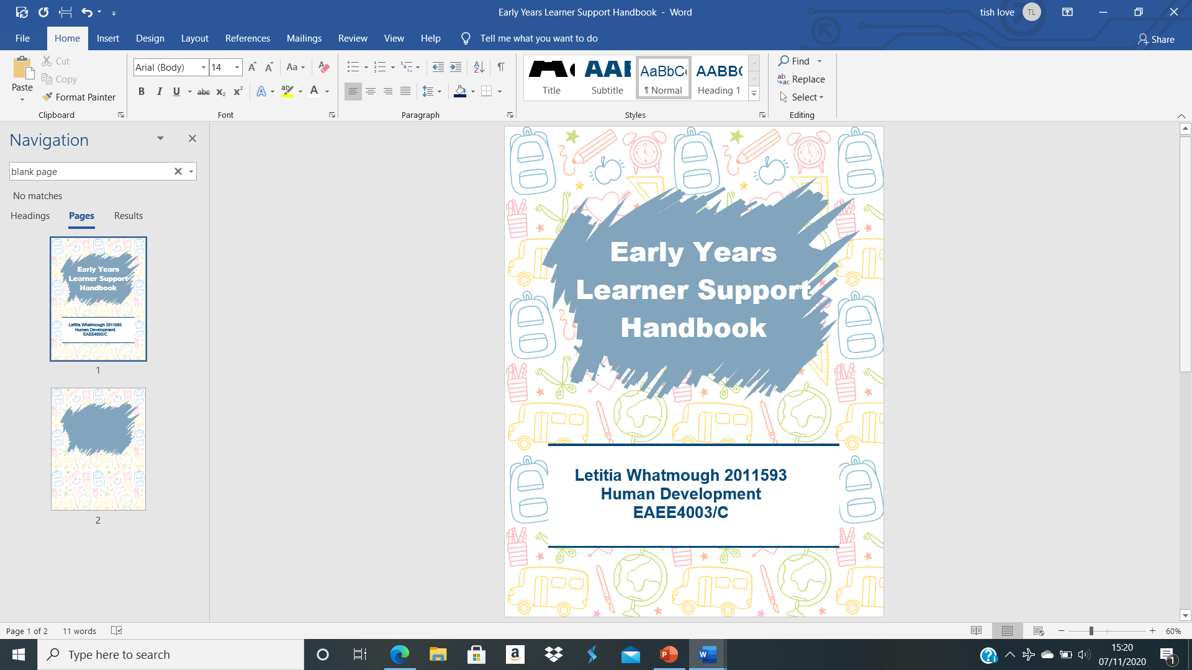

Contents
Introduction 3
How to use this guidance handbook 4
- The role of an adult 5
- The children’s needs 8
Partnerships 10
- Interventions 12
- Proposed outcomes 13
- Refences list 14


A key aim of any transition programme is that early years practitioners must allow the child to feel welcomed when going through this significant experience. Due to the fact, a child’s ability to cope with change in the short and long term is dependent on the key worker as its more than likely a child could be affected by their first experience. Therefore, it is advised that transitions should happen gradually in a new setting to enable a child to feel confident. (O’Connor, 2006)
Successful transitions are dependent on commitment and effective communication as a result of a child’s emotional, personal, physical, psychological development affected. Therefore, who ever may be involved with the child must work closely and ensure effective communications is continuous. This can be achieved through shared information systems, team meetings, home visits, open days or face to face meetings etc. Trusting and strong relationships are a fundamental part of the process to help facilitate the children alongside taking into account a child’s emotions to ensure they feel comfortable in their new setting as they leave their ‘comfort zone’.
Bronfenbrenner (1979) highlighted that children who experience smooth transitions from home into the learning setting will most certainly experience a positive outcome. As a result of this, he firmly believed that the development of the child will depend on the environment that the child would transition and undertaking tasks which were familiar to the child in their own natural environment would highlight the true nature of the child can be revealed in order for them to become proactive, successful learners. .
The importance of transitions will allow children to develop, grow and learn by providing a nurturing and supportive environment. Therefore, Bronfenbrenner urged everyone who was responsible for the child’s development to work as one in the best interests of the child; otherwise, it could negatively impact a child’s development as they receive poor transitions later impacting their future transition’s as they will be distressed. ( Aubrey and Riley, 2018, p.149-161)

Transition
The transition from infancy to early childhood, “The process of changing, or a change from one form or condition to another.” (Cambridge dictionary, 2020)

Introduction


The first aspect to note is that children will experience multiple transitions during their early years all the way to adulthood. One should not forget that a transition is the process of change which modifies an individual’s typical routine. This is particularly adjusting to key events over their life course for example, when children move from home into a Flying Start childcare. It can be argued that transitions are now viewed, not as an event as transitions focus on a ‘one-point’ event like a child’s first day at school. It follows that transitions are formed by social structures and the process of where children and their families alongside keyworkers are all involved. (Flying Start,2017)

According to researchers they have indicated two types of transitions situations: horizontal and vertical. (Vogler et al,2008:Firth et el, 2009) The first referring to a less formal change for example, playing outside with friends, to sitting on the tables and chairs for a formal activity with a keyworker. Whereas, a vertical transition are the main focus towards a child’s guidance as a vertical transition links to a major change in a child’s everyday routine for example, starting school for the first time.

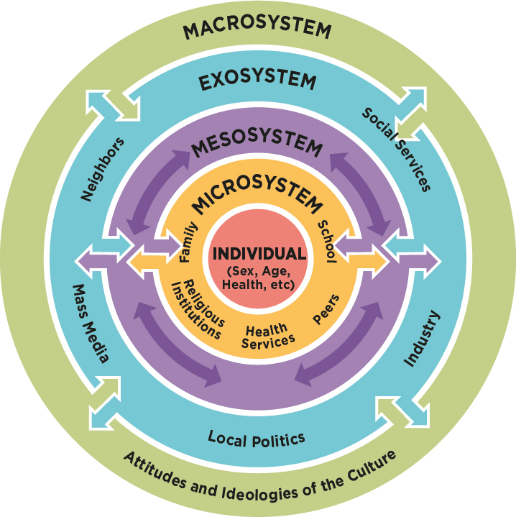
Source: Human Services Client Interaction: Ecosystem Strength Perspectives, 2019)
Bronfenbrenner also highlighted the more likely that a child will receive support and the parents get professionals partnerships, the better for the child’s development making the transition less stressful for both participants. (Longfordchildcare,2017 )
Bronfenbrenner’s Bioecological Model of the Human Development concentrates on the impact that the environment and the system of relationship impact a child’s development. ( Aubrey and Riley, 2018, p.149-161)
The Gaudium School (2020) state that both parents and teachers play an essential role in a child’s life. Resulting in this, children can be fully supported within the setting allowing them to achieve the best they possibly can. However, it was highlighted that the first mentor of a child’s development are parents followed by teachers. It is clear to see that both participations have a contribution to shaping a child’s personality for example a teacher’s responsibility is to see if they play enough, read enough, socialise enough whereas a parent’s duty to teach lessons of majority as a child should become emotionally and intellectually matured as they grow.
The first aspect to note, is that this handbook is precisely designed for keyworkers, working with children aged 2-3 years in pre-school settings. In order for young children to learn and develop during transitions it’s important that keyworkers use this handbook as a guidance as it encourages their understanding of effective communication.
The purpose of this guidance is for keyworkers to acknowledge how they can efficiently manage smooth transitions such as home into pre-school, pre-school to primary school until the child is three and can therefore move when they are ready. In addition to this, the role of adult and the need of child will also be encountered in this handbook alongside looking at safeguarding children and newcomer children as well as partnerships, interventions and proposed outcomes.
The information presented in the handbook will allow keyworkers to adapt and understand how transitions can be used effectively in regards to the early years, allowing children and their families to feel at ease. Central to this analysis is that keyworkers must be able to build good relationships with the child’s parent/guardian allowing keyworkers to gain key information in relation to the child’s needs benefiting the parent to have a trustworthy relationship. In the terms of the child’s needs, practitioners should be mindful of the child’s learning, development, transitions and their cultural and language barriers.

How to use this handbook

The relationship between the two recipients enables them both to develop a deeper understanding of the child in their care i.e. their personality, their ability, their concerns, likes and dislikes and how any scenarios at home could affect a child behaviour in nursery. It is clear to see that effective communications systems and information through notice boards, online alerts, school websites and newsletters.(Earlyyearscareers,2015)
For schools’ transitions should be one of their highest priorities meaning they must be well executed, as if they are not, children will prevent from engaging in learning activities later causing anxiety. However, if this is successfully delivered, a children’s confidence will boost as well as developing resilience so there are many hurdles to still achieve. In order for this to be achieved staff need to acknowledge their responsibility for example showing commitment which allows transitions to be achieved at a high standard. (Successful transitions in early years, 2017)

When children leave the home environment, they will experience a huge change in their lives. This can lead a child to feel anxious or nervous and can overall be an emotional time for their family. In regards to this, by allowing a child to meet their new school it is has shown to be virtually important by parents and the early years team. (Brostrom, S, 2004)
Perhaps, this could lead a child to feel excited and at ease therefore the childcare setting that the child is attending must be managed effectively, efficiently and sensitively. In addition to this, a support system is good practice when introducing a new experience that much preached in a positive way when working with young children.

The role of an adult
For a child to be fully supported throughout their transition it is vital that an early year’s practitioner must plan with a consideration of a child’s needs. Therefore, each child will have the ability to build a level of understanding, independence and confidence as well as them becoming familiar with their new surroundings and routines as this will prepare children to start school. When this transition takes part, their routine should be alike to those which will happen in school to create some familiar with the school day such as, registration or story time. Successful transitions are dependent on the practitioner’s commitment for example, helping a child move onto their next step when transitioning from preschool onto foundation phase nursery in primary school. In addition to this, a child’s family must be supported alongside this process. Families’ impression of their first point of contact with a service or project often determines their view of the entire service and their willingness to engage (Moran, 2004).

The term ‘Parents’
The home environment that parents create is the only single most important aspect in shaping their children’s accomplishments, prospects and well-being. (Department for Education and Skills, 2007,p1)

Key Person is an individual who is responsible for, co-ordinating observations, record-keeping, building relationships for the child and their family, helping a child become familiar with the provision, meeting their individuals care needs, supporting close attachments and responds sensitively to a child’s feelings. (Supporting children’s transitions across the Early Years Foundation Stage, 2012)

It is strongly advised that visits to the settings are encouraged to children, gradually introducing them to the provision to help the child, parent/guardian familiarise their surroundings and settle comfortably, with the certain day-to-day routines carried out. A high quality of inter-personal skills has been proven to be a success in regards to engagement with families. Therefore, this is about sharing information with parents, showing them respect in relation to their child’s learning. (Barrett,2003; Moran, 2004; Welsh Government 2013a)

In terms of this approach, the key person helps the child and their family alongside the practitioner in order to develop a close relationship. John Bowlby’s work in attachment has be identified that by establishing a secure attachment is most certainly a vital task of a parent, guardian or a caregiver as it will influence social relationships. Bowlby’s research evidently showed that children are born with a distinctive need to form attachment to their mother figure and what concerns arise when they become separated. This type of attachment bond offers security, nourishment, survival and comfort. Whilst other children can feel abandoned ,unwanted and feel a sense of grief. (Daly,Byers,Taylor,2004)
Before children start their transition process, the first point of call is to arrange a home visit either by the manager or keyworker to gain an insight on the child and family needs by gathering relevant information. Prior to starting the early years provision, a key person has the opportunity to engage with family members as they tell you about their child and ask suitable questions such their cultural needs, vulnerabilities, any disabilities needs, or any special health or dietary reequipments as a result of discussing these topics this will allow parents to feel reassured and will ultimately be helpful towards the key worker. As a guidance to support the transfer of information at times children are experiencing a transition, they will complete a ‘ Getting to know you’ or a ‘ all about me’ booklet. Without producing these booklets and questions the early years team will find it extremely difficult to provide a high quality service.


(Source: John Bowlby,1997)
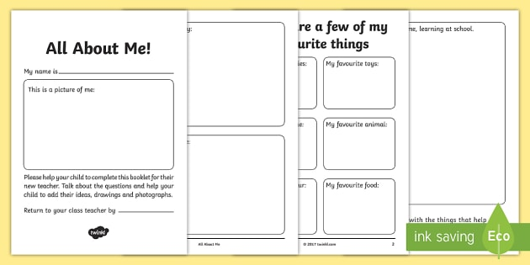
When the child has started the settling in process, keyworkers must remember to develop policies and procedures and do the following checklist below:
- Maintain effective correspondence with parents, other family members and guardians.
- Always read and check upon information on individual children.
- Continuously review the progress on each child and feedback on a daily basis with parents/guardians and maintain planning, assessments and observations
- Arrange meetings with staff to review and update the policies and procedures on transitions. Act as a good influence and always support the child and families as well as value and respect them.
- Liaise with other professionals who may be involved with particular children i.e. safeguarding children and always support them.
- Provide suitable information/assessments to the nursey teacher when a child is ready for their next transitioning process.
- Respond sensitively and reassure both the child and parent/guardian
- Make provision for parents, children with language barriers.
- Meet physical, social and emotional needs as well as providing a high quality care for the child for example, in a warm welcoming environment.
- Ensure experiences are provided that reflect children’s home life and culture, with child initiated activities.
The intention is to help children transition smoothy and successful as it will allow them to lead fulfilling lives in the long term. What follows is that early years practitioners should plan for them appropriately as it could impact them and their family.

(Source: All about me, 2017)
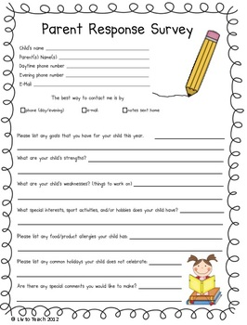

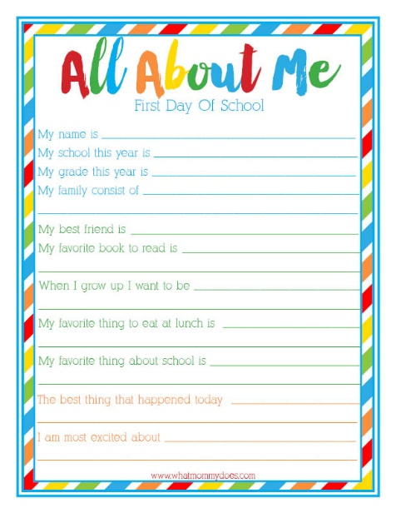

(Source: Parent Survey, 2020)

(Source: All about me, 2016)

The needs of the child
It is very clear that all children need to be included and cared for in a secure, safe and loving environment. The environment should ensure that no child should be excluded due to their culture, ethnicity or religion, family background, home language, special educational needs disability, gender or ability. By ensuring this is met, a child’s diverse learning needs enables them to develop a secure attachment with their keyworker. As a result of some children experiencing a deep insecurity and loss when leaving their mother as this is their most important figure of attachment. Experiences play a vital role in shaping a child’s development and should therefore be based on what the child already knows such as their likes and dislikes in order to provide the best transitioning. If children are not gaining an enjoyable experience this can later impact on their development as well as their well-being therefore, it is a keyworker’s responsibility to match the appropriate experience to the level of the child’s needs. (Smidt, 1998)
In relation, to smooth transitions ‘serve and return’ interactions shape brain architecture are extremely important in regards to the young child during their transition process. In this developmental game, a young child’s new neural connections from the brain serve through facial experiences, gestures, facial experiences and gestures. Whereas, adults return the serve by reciprocating in an expressive way. (Center on the Developing Child at Harvard University, 2011)

To illustrate this point further, a child’s brain may be disrupted and could lead to physical, mental and emotional health may be impaired if these interactions are inappropriate, unsuitable, unreliable or absent. (Harvard University, 2017).
A child centred approach is how children become active participants by communicating and connecting with people who also have a choice without someone interfering.
An equally important aspect is enabling a child centred approached within this setting to guarantee that the child is put first before anyone else. By using the right approach practitioners and key workers have the opportunity to observe and plan when taking into consideration a child’s interests and adapting these into learning and helping a child settle.

The hierarchy of needs triangle demonstrates the needs of the child’s and what is required for each stage. By using Abraham Maslow’s theory it enables practitioners to use this as guide in order to be encourage and promote support towards the individual’s needs.
It is a well-known fact that play is a fundamental part of the transition process, as every child has the ‘right to play’ administered by the United Nations Convention on the rights of the child article 31. Play can be both child and adult initiated, but it is best to strike a balance between adult led and child initiated play to meet the best children’s outcomes; allowing this to be demonstrated in a positive manner by the keyworker. Bruner (1974), Piaget (1951), Vygotsky (1978) have been proven to play crucial roles in shaping the educational practices of today.



The curriculum for Wales: Foundation Phase Framework (2015) states the seven learning outcomes in regards to children and their advocates in promoting positive connections between home and childcare are fostered and promoted.
The following objections represents a variety of play opportunities for them to achieve:
- Personal and Social Development
- Well-Being and Cultural Diversity
- Language, Literacy and Community Skills
- Welsh Language Development
- Mathematical Development
- Acknowledging and Understanding of the World
- Physical and creative Development

Maslow’s Hierarchy of needs (1943)
(Source: SimplyPsychology,2020)

9

Partnerships

Child
Keyworker

Family
Multiagency

The early Years Foundation Stage in England (EYFS) is highly dependent on the National Minimum Standards for Registered Childcare (NMS) in Wales as its entails a high quality when working in partnerships with parents. It is important as key worker to inform parents with regular updates so they feel reassured on their child’s transiting process from day one. In order to achieve a strong bond between both parties, daily chats and learning journals are seen as vitally important alongside sharing of resources, events and information sessions. When involving parents, a keyworker must be mindful when approaching commutation with parents as they will need to adapt to suit different parents for example other parents may have an additional barrier such as language or have specific learning needs. (Pacey, 2009-2020)
Another beneficial way of promoting support for children is introducing multiagency as they help secure a child’s life outcome. The multiagency method is very proactive as they all come together as one to enhance a child’s life. Any areas of learning developments delay can be quickly accessed and identified by the help of the foundation phase profile. Allowing parents to be aware of the verdicts and any other multiagency who needs to be involved. Due to this, as a key worker is crucial, they receive parental permission when working with any multiagency, such as the health visitor, speech and language therapists etc.

Interventions

It has been evidently shown that all children under the early years team need to provide a high quality of care in order for children to feel cherished and appreciated allowing them to have best possible outcome for the short and long term. As previously mentioned, commitment is a key factor that all professionals need to fulfil when accessing high quality care as well as developing positive relationships alongside having a shared approach in providing a holistic environment for the child.
In terms of the philosophy of nurseries, is that childhood is important and that children should be encouraged to achieve their full potential through a range of meaningful full experiences. In relation to this, it can be successful through both indoor and outdoor learning and through a mixture of spontaneous play and intentional teaching, proving children’s work to very impressive and their attentiveness to difference aspects of learning. Individuals in the community are involved due to the fact everything is recorded and documented, contributing all successful interventions. Smidt (1998) notes that nurseries are a fundamental resource as they provide many ideas for individuals that want to visit for ideas of this approach.

Proposed Outcomes
It cannot be denied that all children have different personalities, skills, abilities ,backgrounds as well as experiences when familiarising to new transitions and routines. The Welsh Government (2018) states that children and their parents/guardians experience emotional and practical support through all the stages of when their children is making the transition as smooth and effective, as it can possibly be as it will enhance their learning and well-being.
Piaget’s theory was known for his solitary learners however Vygotsky(1896-1934) believed that children were active learners.
Vygotsky firmly believed that children need social interactions, to further their knowledge and increase their confidence. Through these interactions it promotes cognitive development and speech even though it is an individual development. Through these collaborations in social activities, it determines how a child will understand and construct the world between skilled and less skilled participations. (Urquhart,200:61). Not only that, he believed that children copy the way adults conduct themselves in their environment preparing them take on parents’ role when appropriate in adults like. (REFERENCE)
High quality interactions between both parties are important especially when solving an intellectual problem together, also known as ‘sustained shared thinking’ that singled out successful teachers from others. Another aspect to consider, is that this approach is as equally important to finding out children who may experience fewer opportunities when engaging with others. The moment of interaction to the children and staff is very beneficial. (Gants Hill Partnership Teaching Alliance,2020)
Welsh Government (2018) has introduced a new curriculum across Wales, highlighting new opportunities to keyworkers within the childcare setting in order to enhance a child’s outcomes for all the identified areas mentioned. Through the transition process a key workers role will massively help when trying to obtain these proposed outcomes.

Reference List

