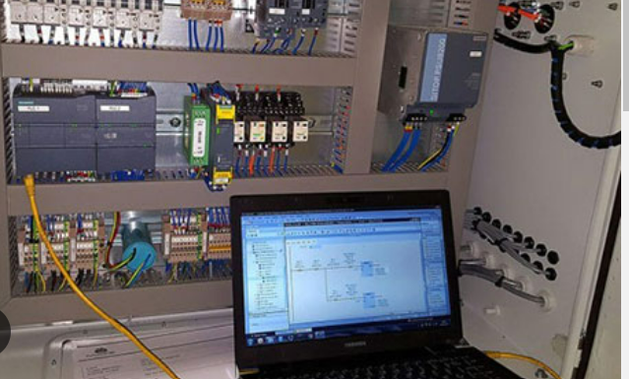  Applied Programmable Logic Controllers | Brett Williams (2215656)  December 2022  Module Code: ACDA6000

Contents

The Assignment brief 2
Task 1 – Provide a brief literature review of several PLCs currently used in industry and provide a table of Pros and Cons of each in your opinion. 2
Basic controller- (Fixed, compact or Unitary PLC) 3
Modular PLC- medium assets 3
SCADA 3
Rack mount modular PLC- Larger assets 3
Common problems with PLC’s 4
British Safety Standards 4
PLC Decision matrix 5
PLC- Pros and Cons 5
Task 2 – Utilising the components within Factory I/O, design a factory process capable of sorting a range of package sizes and weights (minimum 4 different types) 6
Task 3 – Write a ladder logic program to control your factory process 9
PLC Communication protocols 16
PLC tags and Addresses 17
Task 4 – Incorporate a HMI device into your factory and program 20
Task 5 - Provide a formal report detailing tasks: 1 to 4 23
Downloading/Simulating the program 24
Flow Diagram 26
Warnings and Alarms 26
Bibliography 28

Assignment brief
Design and control a factory system which sorts 4 different sized packages based on size and weight. The factory is to be designed in FACTORY I/O and must contain and control the following as a minimum:-
4 conveyor belts
2 pushers
1 conveyor scale
2 diffuse sensors
1 Emergency STOP
2 buttons
1 Siren
1 warning light
2 stack lights.

To limit the current draw at start up, each conveyor should be started in sequence. A manual reset of alarm signals once the alarm issue is corrected.

The system will require a HMI for operator interaction. The HMI must have the following controls and displays available on the root screen:-
- Start and /stop button
- An Emergency STOP button
- A button to reset all counters
- Counters
- A replication of the stack lights
- Fault and warning signals

Task 1 – Provide a brief literature review of several PLCs currently used in industry and provide a table of Pros and Cons of each in your opinion.

When selecting a PLC for a specific industrial application there are a many influencing factors to consider.
The size of the asset that is to be automated can vary dramatically as can the amount of inputs and outputs to safely control the automation functions. It is an increasing expectation to remotely monitor pumps and fans on site, slowing a centrifugal fan or pump down using a variable speed drive can dramatically reduce the energy consumption used during the process. This coupled with vibration monitoring, flows, pressures and temperatures are routine feedback for the control room operators. Collecting running data to further analyse an asset to predict deviations will need to be monitored continuously and made available to the analytics team. There are over eleven thousand alarms routed through to the main ifix server in Port Talbot and this value is increasing with the demand for further information to assist the control room operators to best balance the many systems, all this at the touch of a button. Removing personnel from dangerous process risks is fundamental to any business and there are many tasks that can be automated to help reduce this probability.

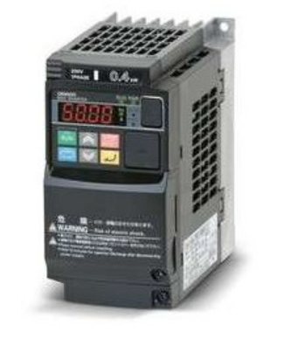
Basic controller- (Fixed, compact or Unitary PLC)
There are many smaller or mini automation systems within Tata Steel UK in Port Talbot, for example the 4 post locomotive lift situated in the diesel locomotive workshops. This uses a small Omron fixed PLC. It has a small square front display with a few function buttons and measures approx 200mm deep. It is used to control the switching of the motors to drive the loco up and down on the lift to allow for maintenance access from the pit area. It is not expandable and can only be utilised for very small automation applications.

Modular PLC- medium assets
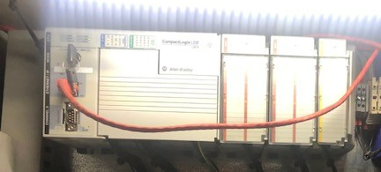
Within the Energy department of Tata steel Port Talbot there are many different types and brands of PLC. Our medium sized assets, for example, the flaring off of Blast furnace Gas, each flare has an Allen-Bradley PLC as its main controller. It is approximately shoe boxed size and adequately controls all the isolations, flows and pressures associated with flaring off the furnaces bi-product that cannot be utilised as fuels elsewhere on the plant. All this is done in a safe and controlled manner. There are two Blast Furnace gas flares and 2 bleeder systems backing each other up as redundancy to allow for maintenance periods and breakdowns. Each individual system has a local Human machine interface (Hmi) that allows operators to test and control locally. The option of remote operation can be selected , this moves control to a central control room which has a graphical mimic of the asset illustrated on a Secretarial Control and Data Acquisition SCADA interface screen which is interactive and is commonly referred to as ifix.

SCADA
Ifix is where the control operator has a visual description on the whole of the Port Talbot plant. His role is to balance bi-products and best utilise all the services in and around the plant, with electrical generation and balanced usage being one of our major costs.

Rack mount modular PLC- Larger assets
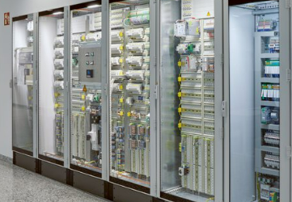
All of TATA steels major assets are built with multiple PLC processors and an abundance of local and remote I/O taking up dedicated control rooms within unmanned areas of plant. These PLC’s are vast and require control rooms that are fitted with air purifiers and filters and can also include thermally controlled air coolers to ensure a good level of cooling is continuously maintained, processors emit a vast amount of heat during their process and maintaining a low ambient temperature maximises longevity of the hardware, avoiding intermittent over-heating problems with the controllers. They can also have large uninterruptable power supplies that automatically switch in if there is a loss of an incoming power supply. This ensures that there is enough power to safely shut down a critical aspect of the process to avoid a major process upset or even a catastrophic event or major accident hazard.

Common problems with PLC’s
Some of the most common issues with PLC’s is a failure of the central processor or CPU as mentioned above, adequate cooling can help avoid this issue. Failed input or output cards this is mainly due to the amount of cycles or demand on the final element eg the valve, motor or fan.

Another common issue it interference from electrical noise. During installation the project manager must ensure that the crossing of comms cables and power cables is minimised to 90° wherever possible, they are never run in parallel over any length next to each other. This can cause PLC memory failure or corrupt the memory resulting in a mismatched program which can be extremely dangerous. Screened cables are a must and can help limit these issues by grounding the stray eddy currents that can be found within power cabels.
Following best practice and relevant standards a safety PLC system will need to have dedicated I/O and separate independent processors as well as independence or voting systems to select 1 out of 3 sensors and independent final elements to protect against a major catastrophic failure. These systems will usually be functionally tested as part of the automation system or can be tested off line on a suitable frequency that satisfies the risk assessment requirement by using its failure on demand figure as a guideline. Usually the original equipment manufacturer or OEM may be able to provide documentation to support the testing frequencies requirement to satisfy the competent authority.
[1]
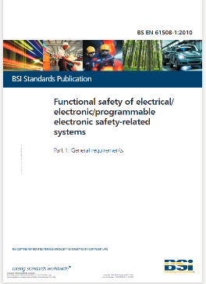
British Safety Standards
It is worth mentioning that in the past PLC systems controlling some of our largest unmanned systems have quickly become obsolete and the OEM will no longer support faults and breakdowns as the replacement hardware cards are no longer manufactured. This information should be requested during the quotation phase of a project to avoid huge unwanted costs and downtime.
Adherence to the British Safety Standard is a great place to standard BS EN 61508.

PLC Decision matrix

PLC Size | Manufacture | Expandable | Approx Cost £’s | I/O | Connectivity
Small assets | Omron | no | 200 | 16 | No
Medium sized assets | Allen-Bradley | Limited | 9k | 32+ | Ethernet
Large control systems | Eurotherm | yes | 400k+ | 200+ | Many Options

PLC- Pros and Cons

PLC | PROs | CONs
Unitary
Omron | Small  Cheap  Reliable  Modular  Simple to use  Off the shelf  Many UK distributers | Small amount of I/O  Not worth repairing  Limited Connectivity
Modular
Allen-Bradley L23E  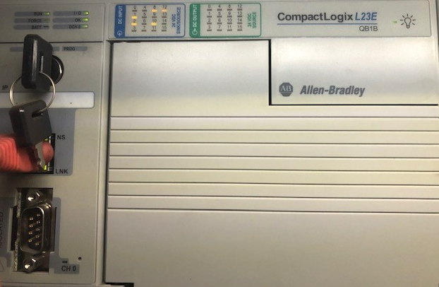 | Reliable  Expandable with limits  Connectivity (plug and play)  Simple to use  Reliable  Supported | Medium costs of £9k  Limited expandable I/O  Lead time est 10months
Rack Mount
Eurotherm T2750 | Fully expandable  Dedicated safety modules  Seamless backups  Continuous monitoring  Eliminates the use of manning (unmanned plant)  Reliable  Controlled remotely | Very Expensive  Specialist installation/programming and support required  Large size  Air conditioned room  Dedicated UPS backup  Can go obsolete/unsupported quickly  Long delivery times

Task 2 – Utilising the components within Factory I/O, design a factory process capable of sorting a range of package sizes and weights (minimum 4 different types)

Factory I/O is a PLC simulation package that allows the user to drag and drop basic items commonly found within a sorting process. It allows the user to utilise the inputs from sensors to drive outputs eg warning lights and sirens and conveyors.

Each component piece has its own function that needed to have a PLC tag assigned to it. The factory inputs were dragged and dropped onto the I/O Drivers page within ‘FactoryI/O’ in a structured way to ensure similar items were all sat together to make it easier to segregate and find later in the programming function.

Here the sensors awaiting tags were on the left hand side as inputs and the Actuators or outputs were on the right hand side.

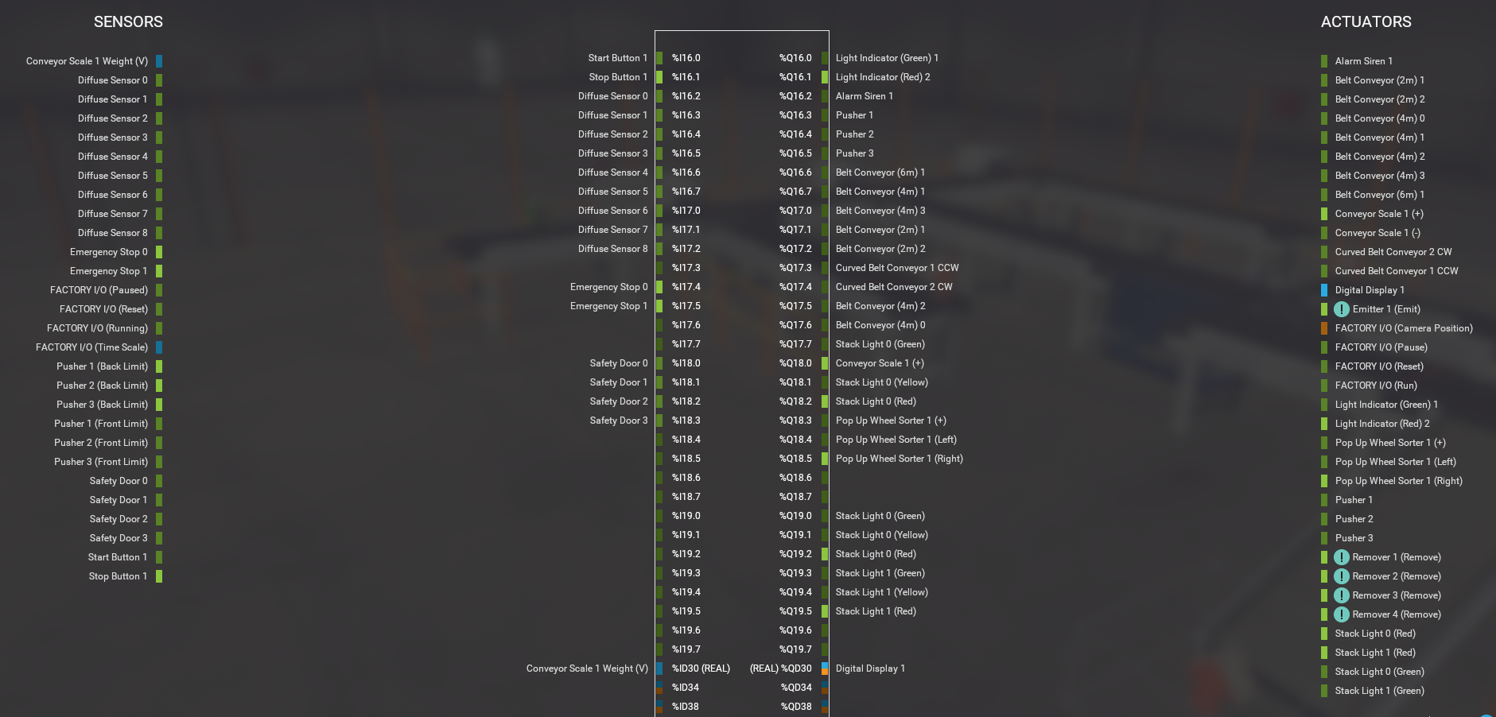

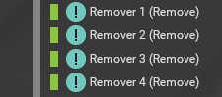
Emitter 1 along with and 4 removers were forced TRUE to ensure they were running at all times. This ensured a flow of boxes onto and off of the process, this avoids continuous build up of unwanted items In the packaging areas.

The sensors and actuators were dragged and dropped onto the center of the ‘DRIVER’ page where it was given an address.

INPUT ADDRESS OUTPUT


Overview of the final factory
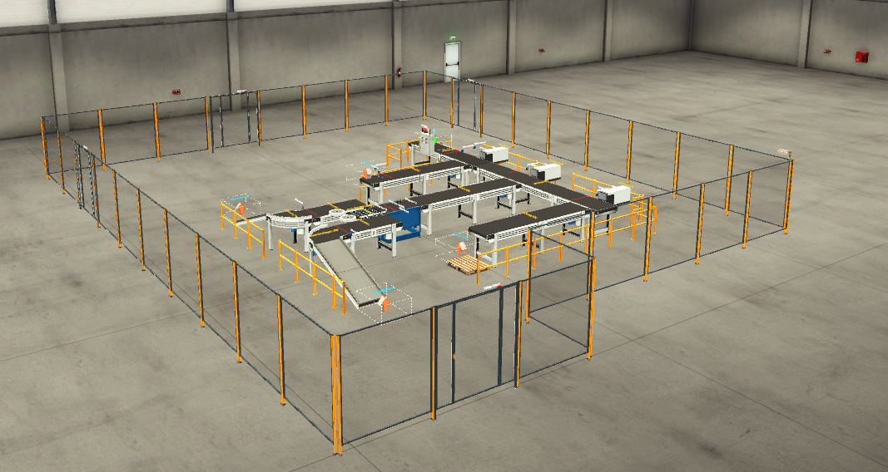
Figure 1

The following screen shot below shows the process running and sorting various sized boxes into their correct sizes.
Large boxes are sent to the first packing section as these take the most amount of energy to move them around, optimising energy within a process can add value to the product, it makes good business sense to have these large boxes packaged early in the process.
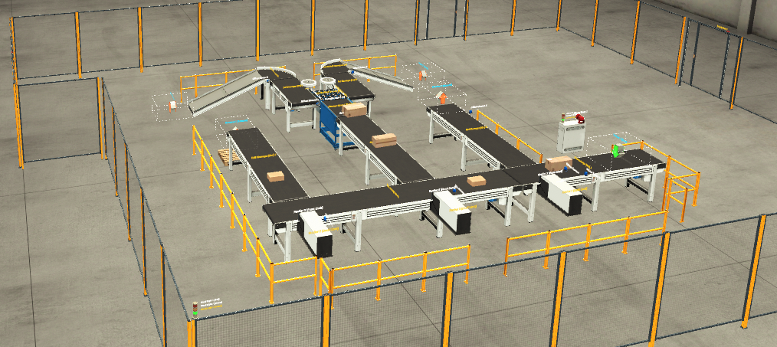
Figure 2

A different elevated angle can be seen in figure 3, this was part of a learning curve which showed that a delay was required to allow the weight sorting conveyor extra time to weigh and sort, to avoid boxes building up on the conveyor.
2 sets of stack warning lights are present , one on the main control panel and one on the left hand corner of the perimeter fence, this allows operators to see status prior to entry.

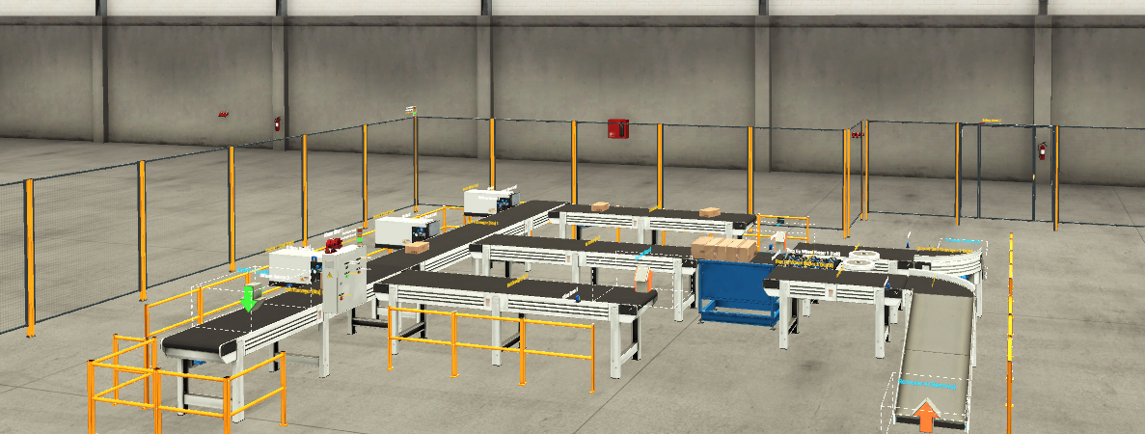
Figure 3

Task 3 – Write a ladder logic program to control your factory process

Below is the actual written logic program, complete with the as built rung comments. Some of these are explained in further detail within the report section of Task 5.

As the programmer writes the program it makes very good sense to make factual comments in the sections provided. These can help the programmer as a large program with similar functions can easily be confusing.
Detailed comments can also speed up the fault finding process, the more factful the information in the comments section the quicker a systems engineer can check the logic functions are performing correctly.

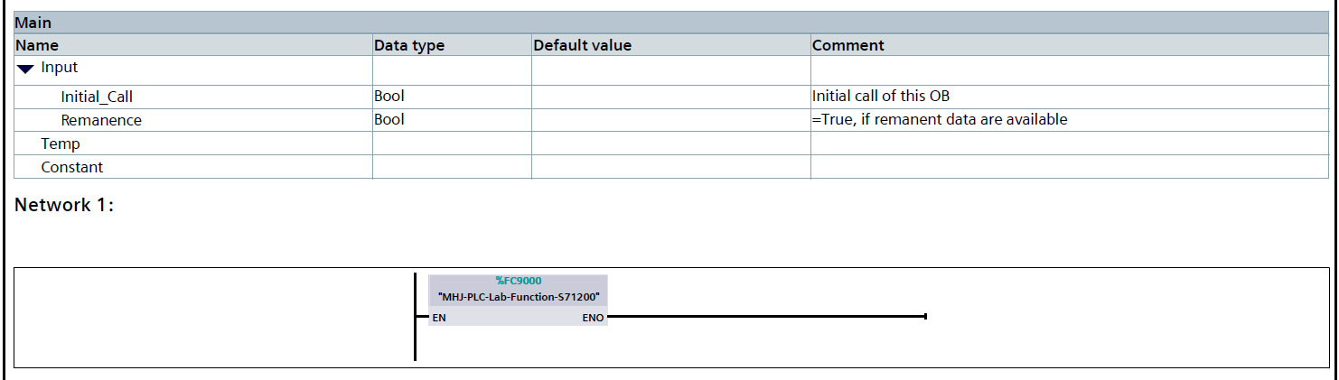

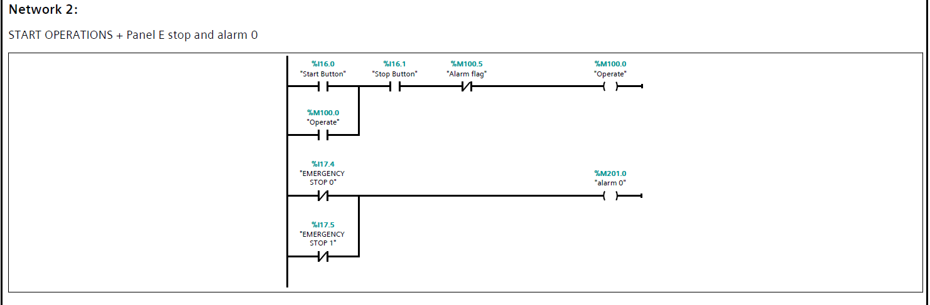

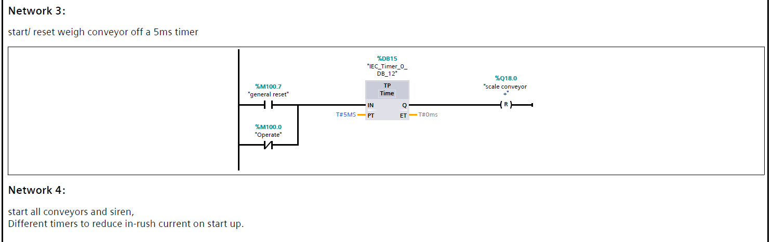

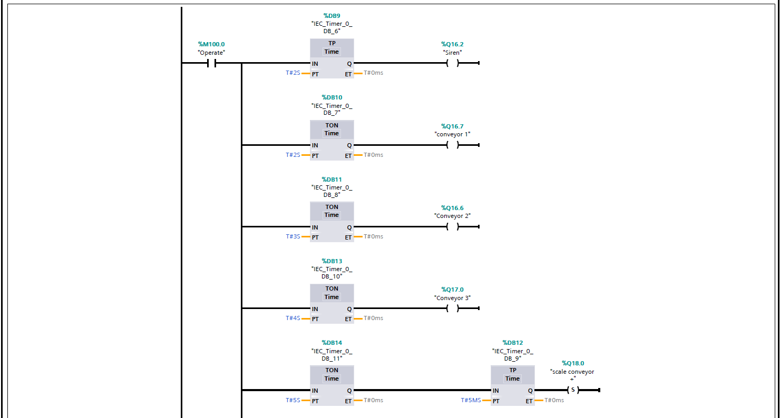
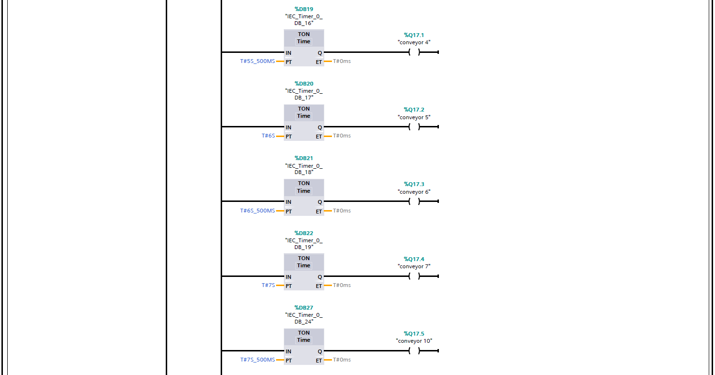
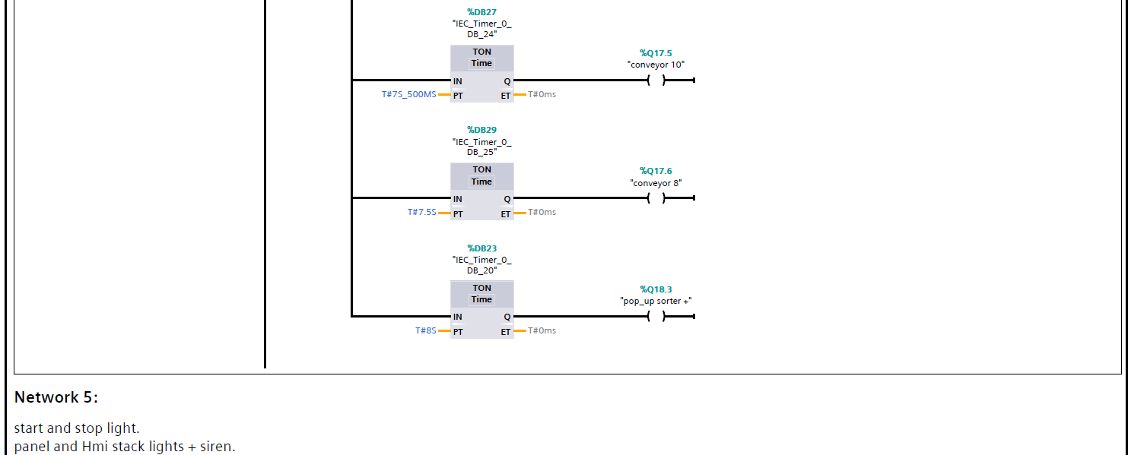
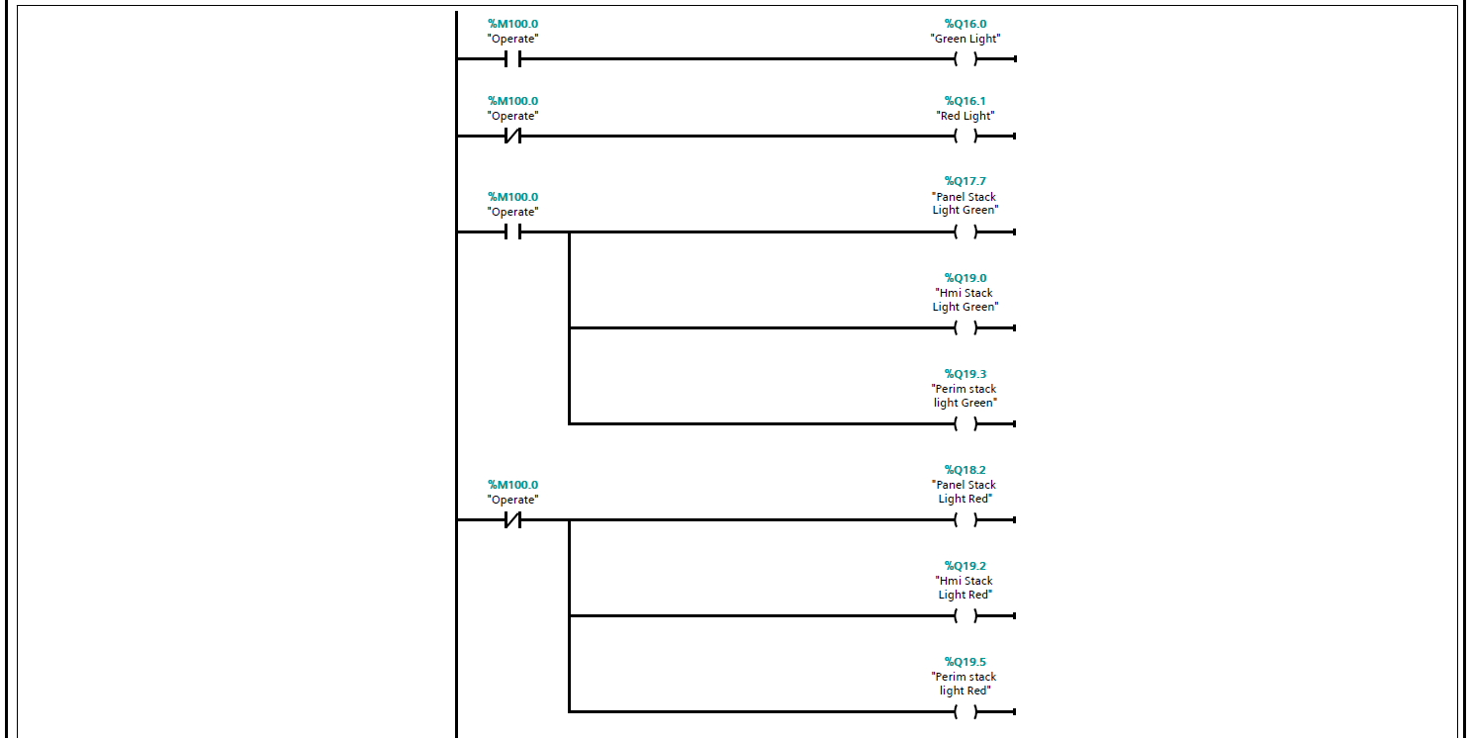

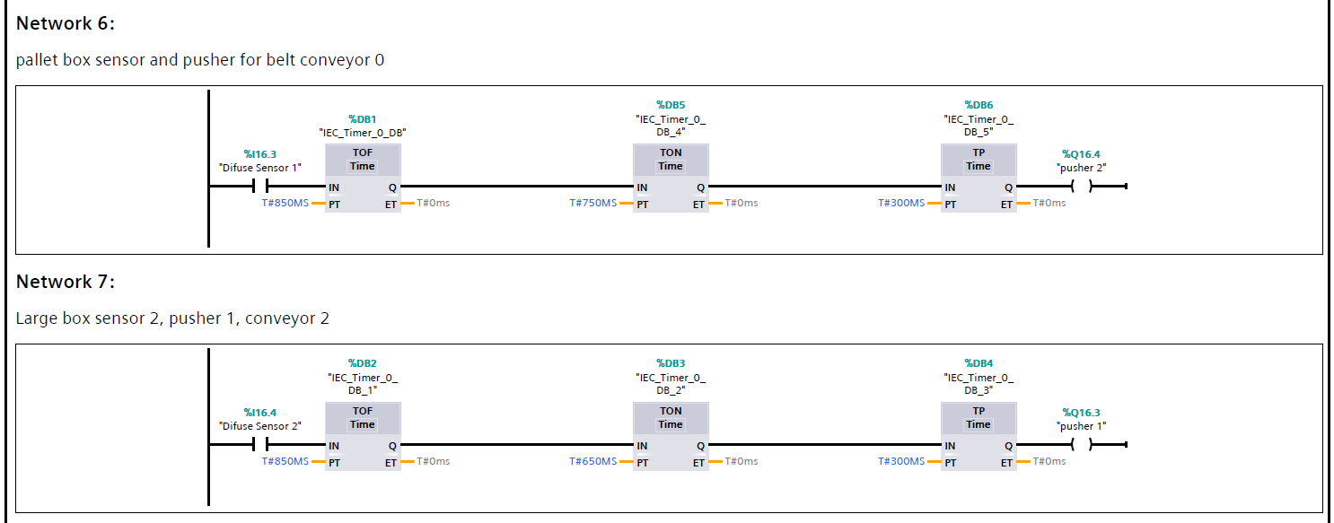
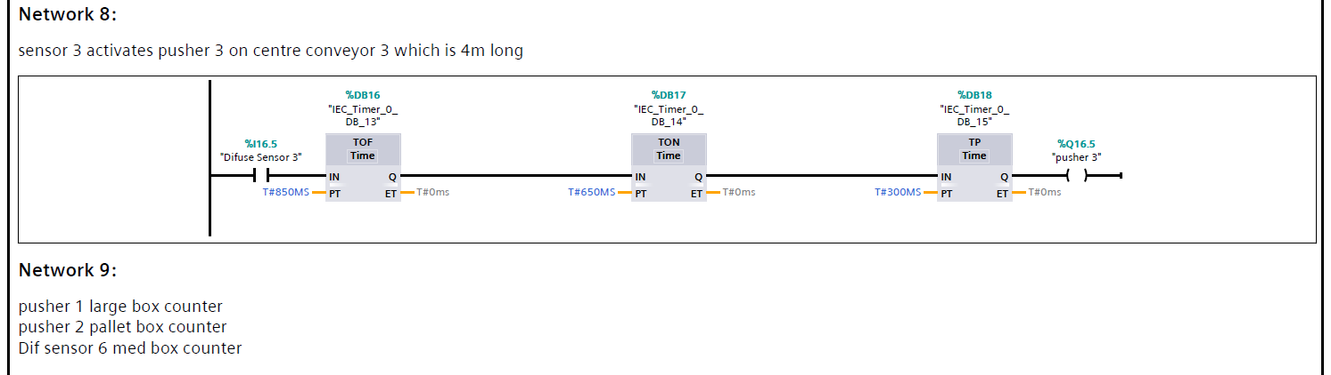
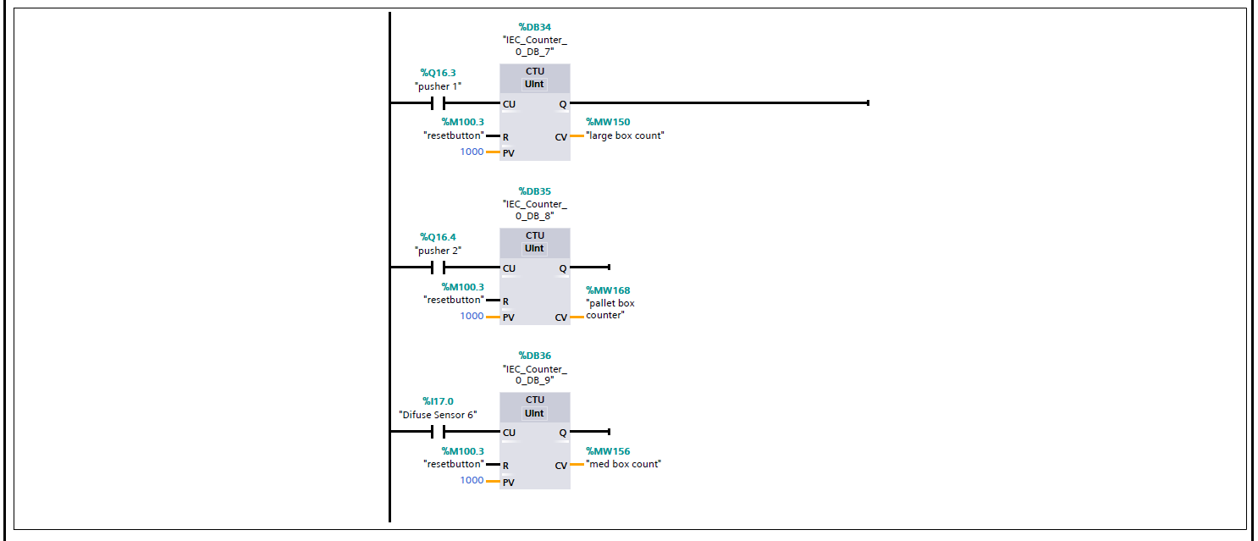
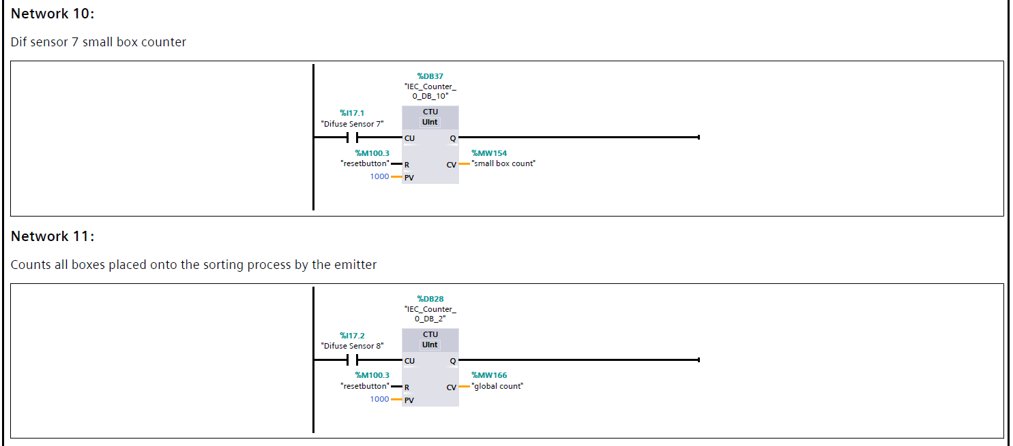

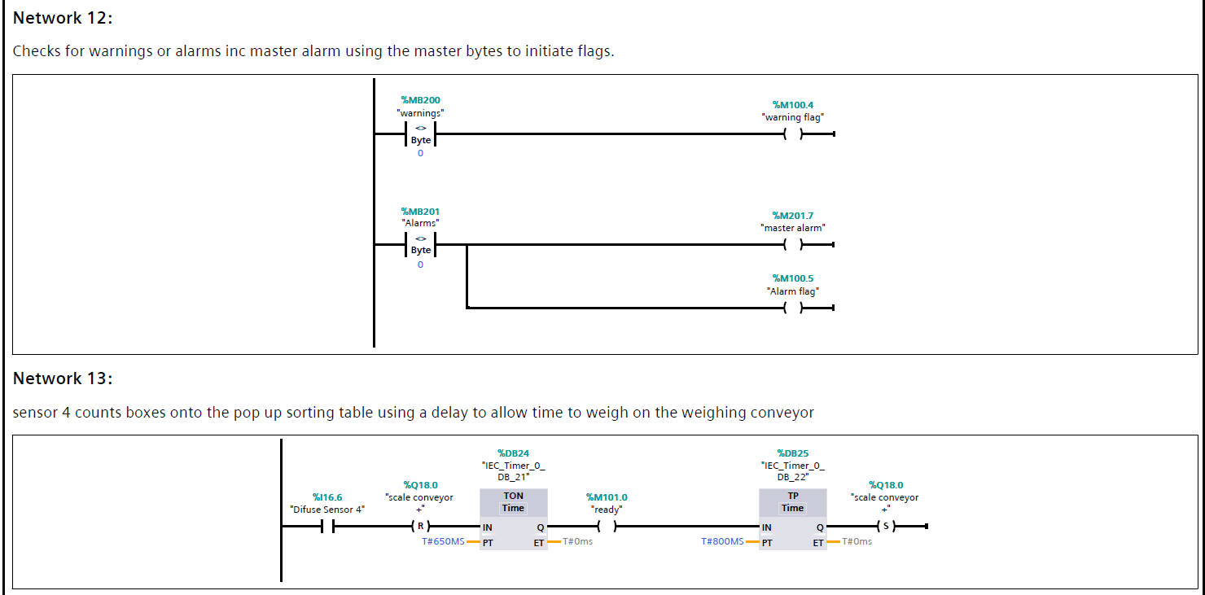
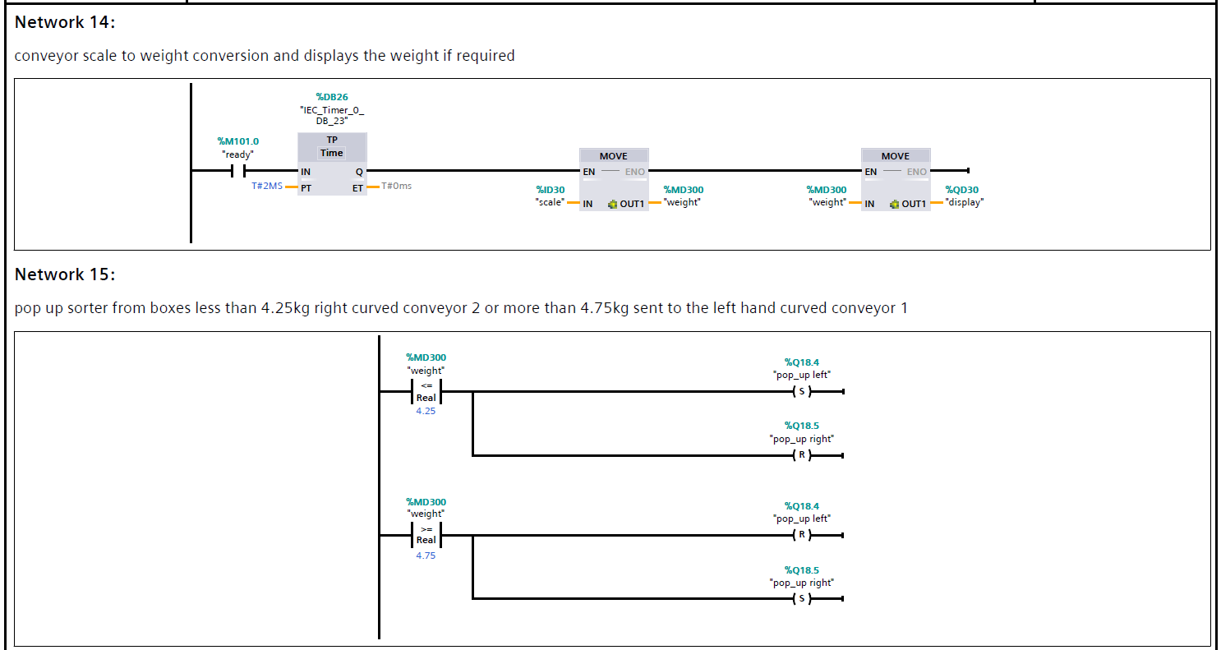

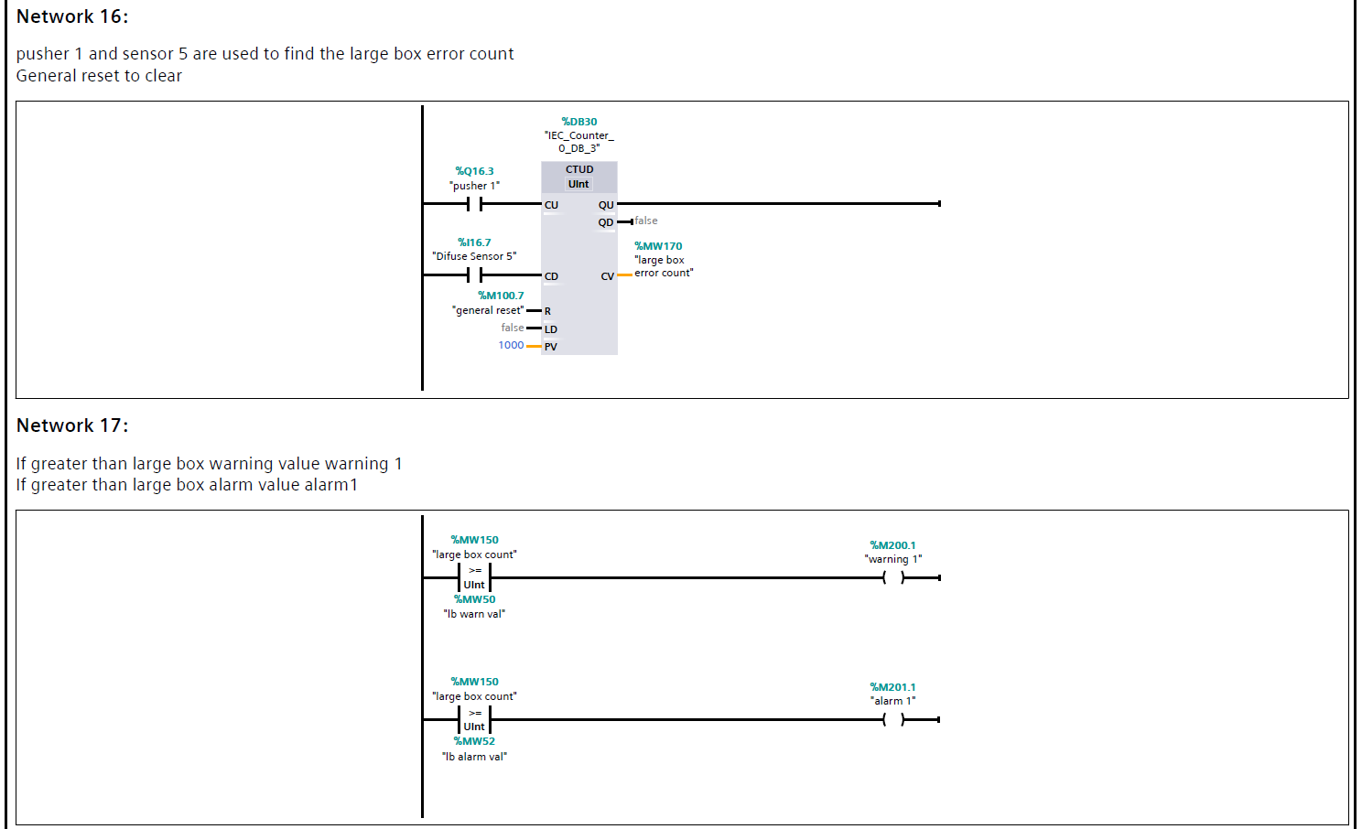

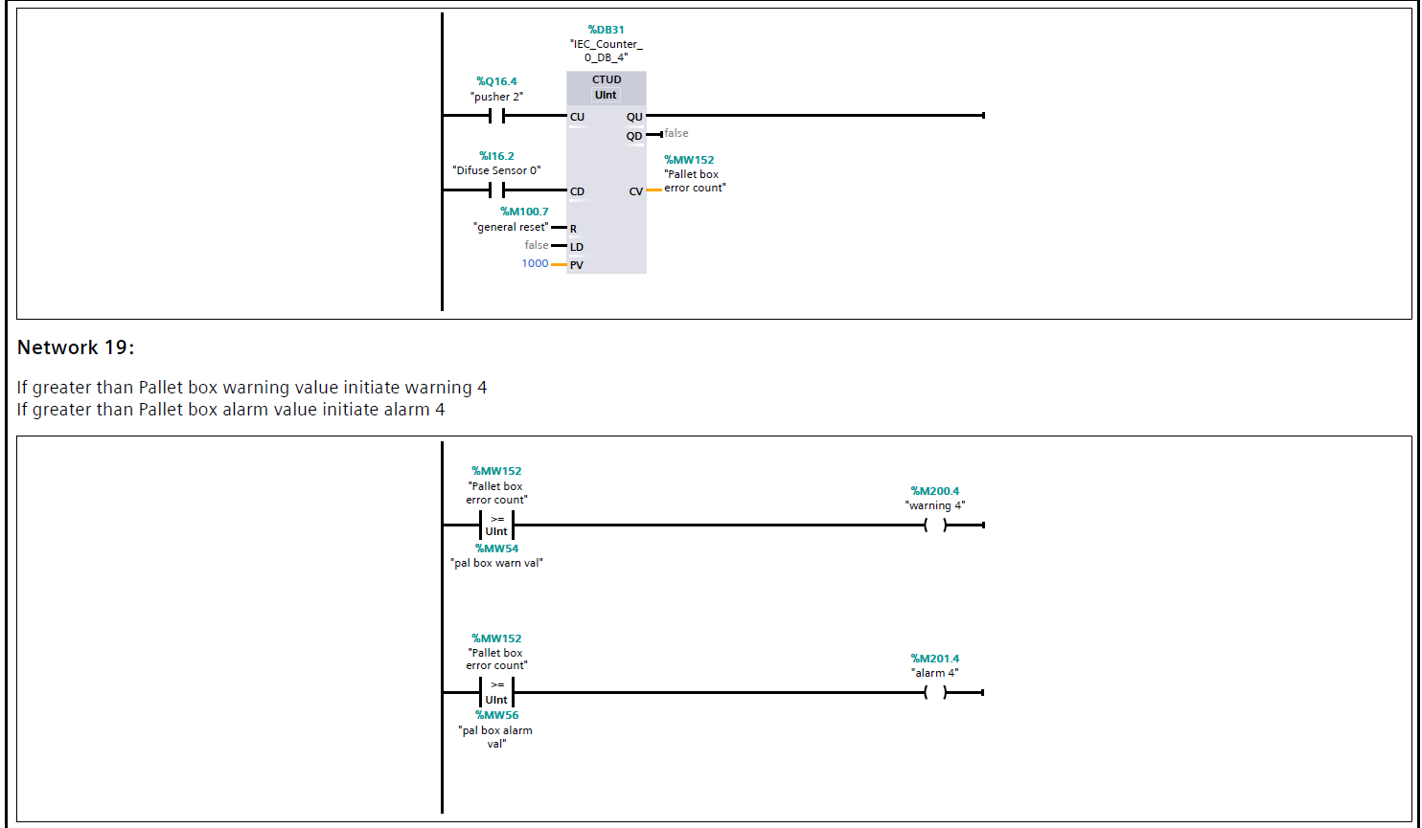

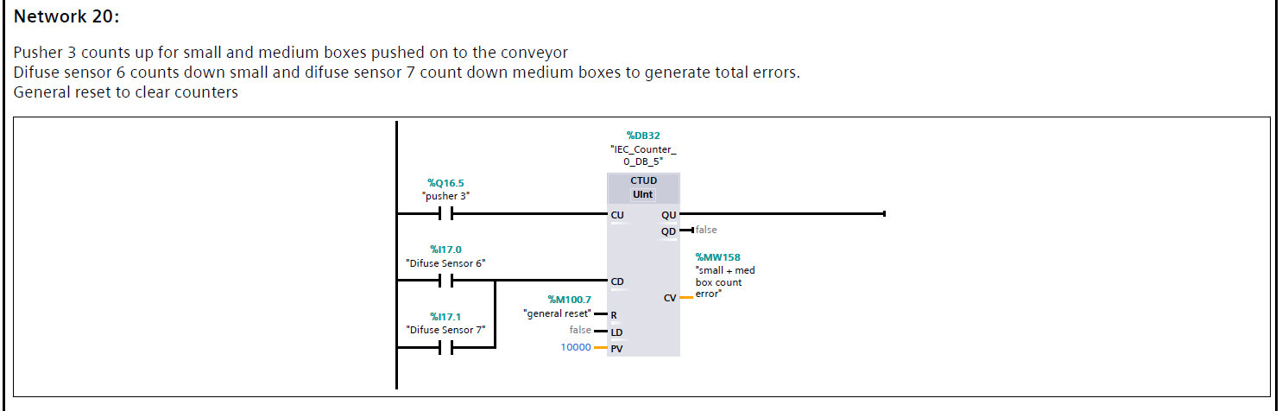
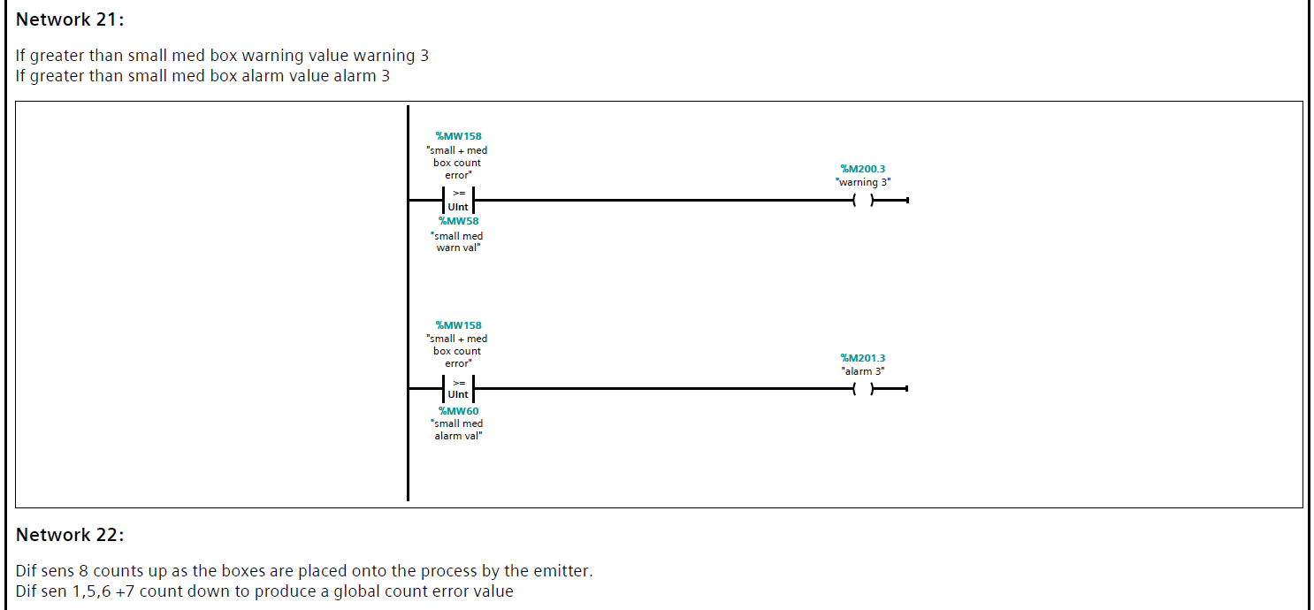

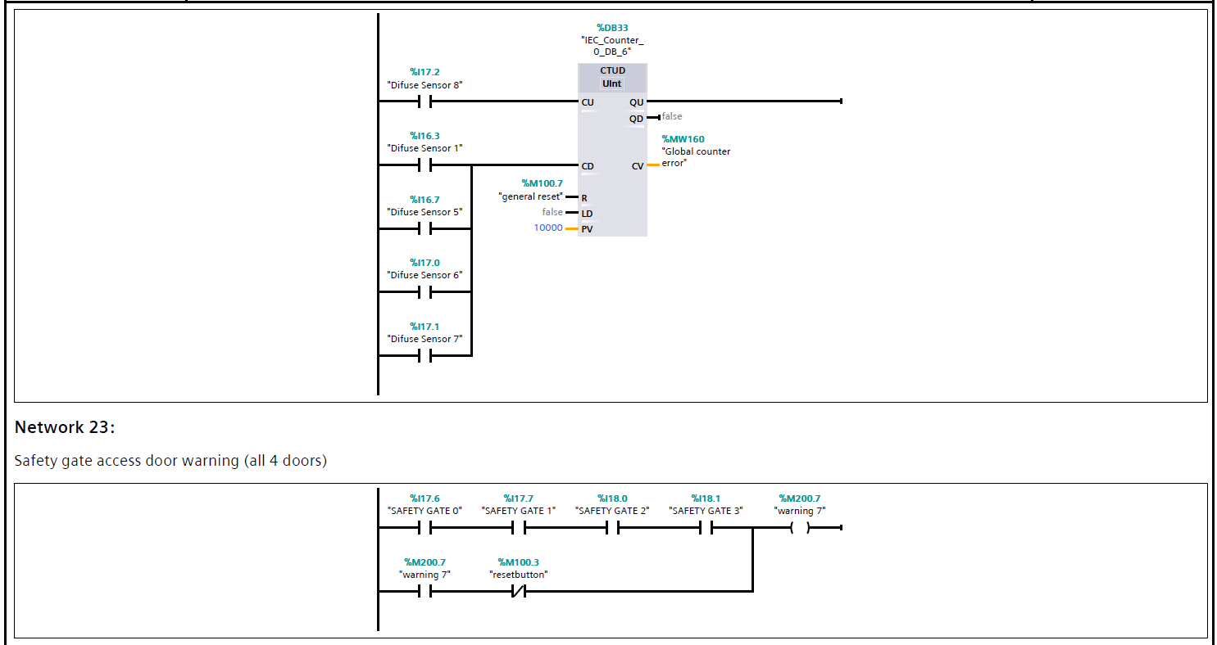

Following the final network:-
This is where the 1st scan finishes and then returns to network 1 for scan 2. This is continuous and happens in milli seconds. The Scan time can sometimes be delayed in large programs due to the amount of processing that has to be computed. This has to be factored in by the programmer otherwise the processor will quickly under count, causing issues with timings and possibly costly asset damage.
This would be evident during the live commissioning phase if not fully tested during the factory acceptant tests.

PLC Communication protocols

Some of the many industrial communication protocols can include BACnet, Controlnet, EthernetI/P and Modbus. As a PLC manufacture the more communication options the more sales to the end user, this increases profit and can help with research and further development.

Modbus is known to be one of the most common and it is a master slave type of protocol where one device is the dedicated master and all the other devices on the Modbus network are slaves.
Master devices can also write data to slave devices.
Example:-a Modbus master may be installed and setup to write data back to a variable frequency converter to control the speed of a centrifugal pump, possibly to a given level produced from a level transmitter analogue value.

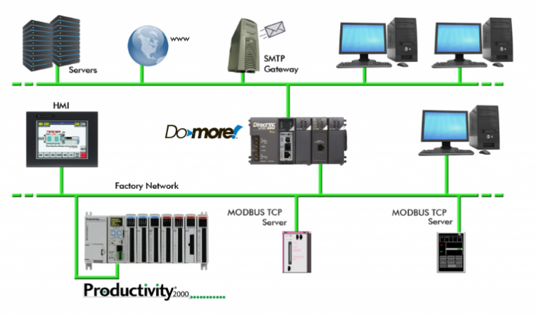
“Using Ethernet, it’s not too difficult to interconnect several devices such as PLCs, HMIs, field I/O and valve banks. Plus, the communication remains fast while talking to several dissimilar devices on the same cable, due to the very high speed of Ethernet as compared to older serial networks.
Above is an example of a typical Ethernet network connecting a wide variety of control systems and other components”

[2]

PLC tags and Addresses

Here is a table to better explain the most common S7 TCP/IP (Transmission control protocol/internet protocol) communication components that are internal to the PLC. The CPU uses the addresses and assigned tags to communicate and function during each scan of the logic.

It continuously checks the functions have been performed using the correct data type/range.

Memory Type |  | Range | Description | Read/Write | Data Type
I | I | 0.00 - 65535.7 | Input Memory | R/W | Bit
 | IB | 0 - 65536 |  |  | Byte
 | IW | 0 - 65535 |  |  | Word
 | ID | 0 - 65535 |  |  | Double Word
Q | Q | 0.00 - 65535.7 | Output Memory | R/W | Bit
 | QB | 0 - 65536 |  |  | Byte
 | QW | 0 - 65535 |  |  | Word
 | QD | 0 - 65535 |  |  | Double Word
M | M | 0.00 - 65535.7 | Internal Memory | R/W | Bit
 | MB | 0 - 65536 |  |  | Byte
 | MW | 0 - 65535 |  |  | Word
 | MD | 0 - 65535 |  |  | Double Word
DB | DBX | 1.0 - 65535.65535 | Data Block | R/W | Bit
 | DBB |  | Memory |  | Byte
 | DBW |  |  |  | Word
 | DBD |  |  |  | Double Word
Figure 5

Here is a full list of the PLC tags and I/O addresses
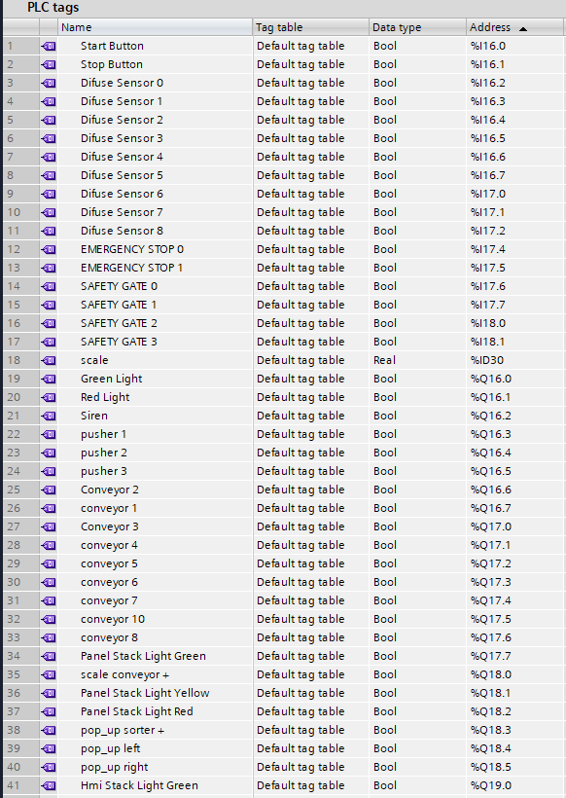
I/O Tags 1 of 3

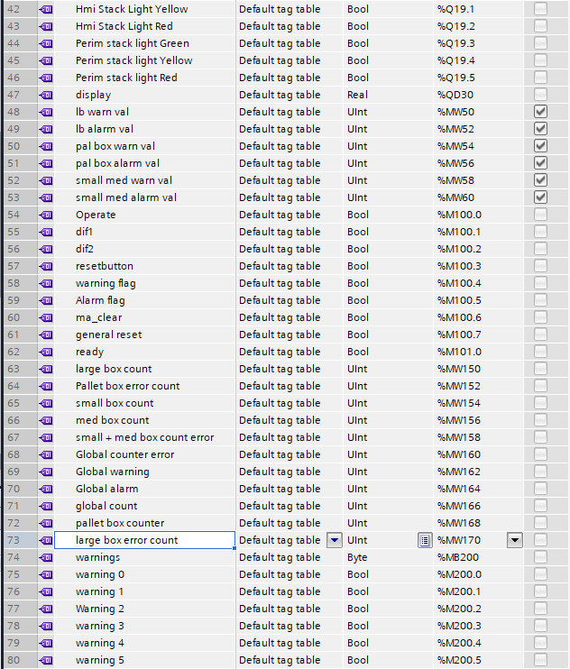
I/O Tags 2 of 3
A UNIT is a 32-bit unsigned integer which can only store positive numbers starting with 0 >
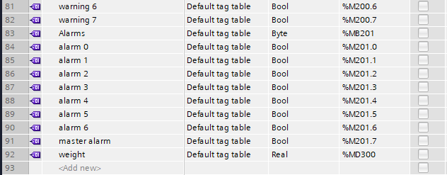
I/O Tags 3 of 3
- Package weight was available as a real double word value represented in kg’s

Task 4 – Incorporate a HMI device into your factory and program

Here is the full list of the HMi Tags.
Each tag is linked in the PLC where it can be utilised within the program.

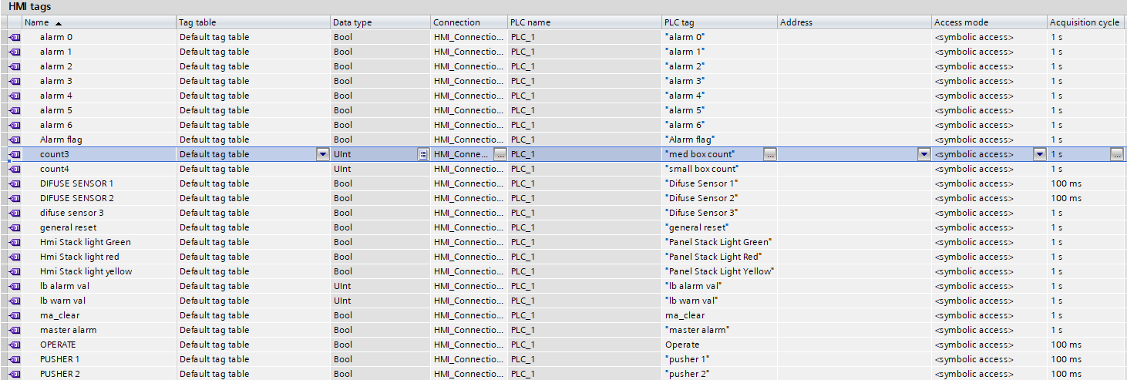
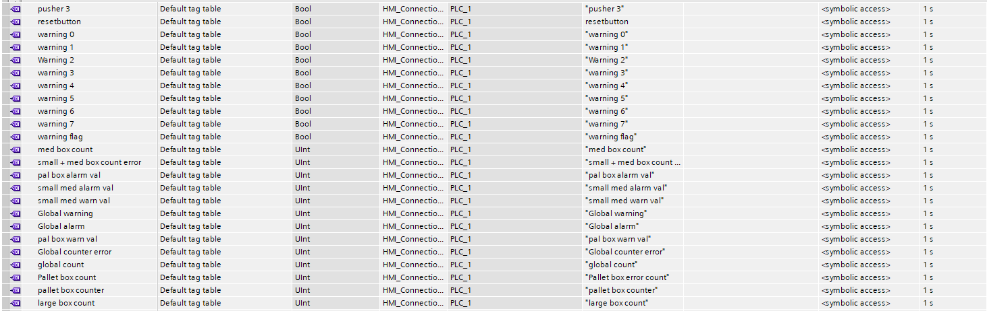

The following Hmi screens were developed by selecting a blank screen in the TIA software and dragging and dropping various buttons and counters on to populate , each selection was found within the library section on the far right hand task bar. Each button or counter had to be given a HMI tag as mentioned previously and addressed in the ‘Driver’ section of the Factory I/O page. Here you can also drag and drop the inputs and outputs into your selected I/O addresses. Following this the I/O can then be included in the logic and actioned by the PLC programmer

HMI Screen functions
Home button takes the user directly to this the root screen.

Green + Red START and STOP buttons
General Reset function
Sensor and Pusher activation lights- counters
Box counters, large, med, small and pallet
E Stop PB
Warning and alarm lights present
Access buttons for other screens eg alarm screen
Global counter to tally the total of all the boxes through the process

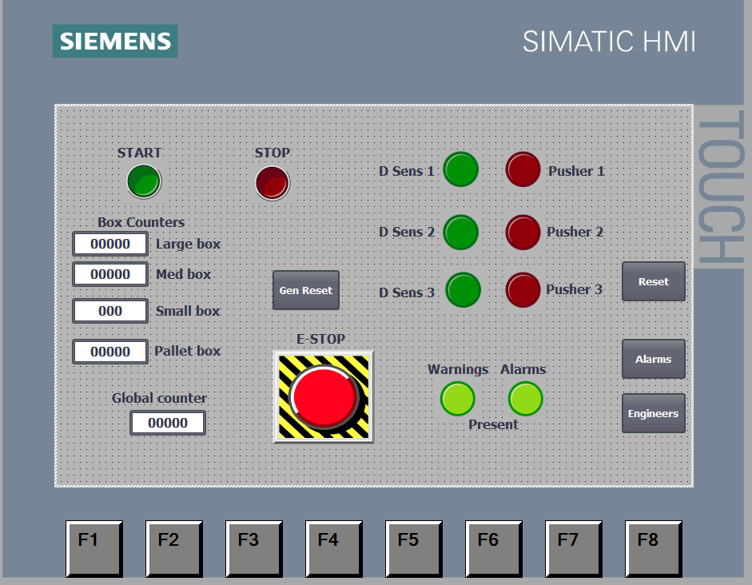
Root screen screen shot

The Engineers Hmi screen which includes a copy of the simulated stack lights as mentioned, duplicated from within the factory simulation.
Warning and Alarm counters for errors, Master reset to reset any warning present after the operator has cleared the issue.

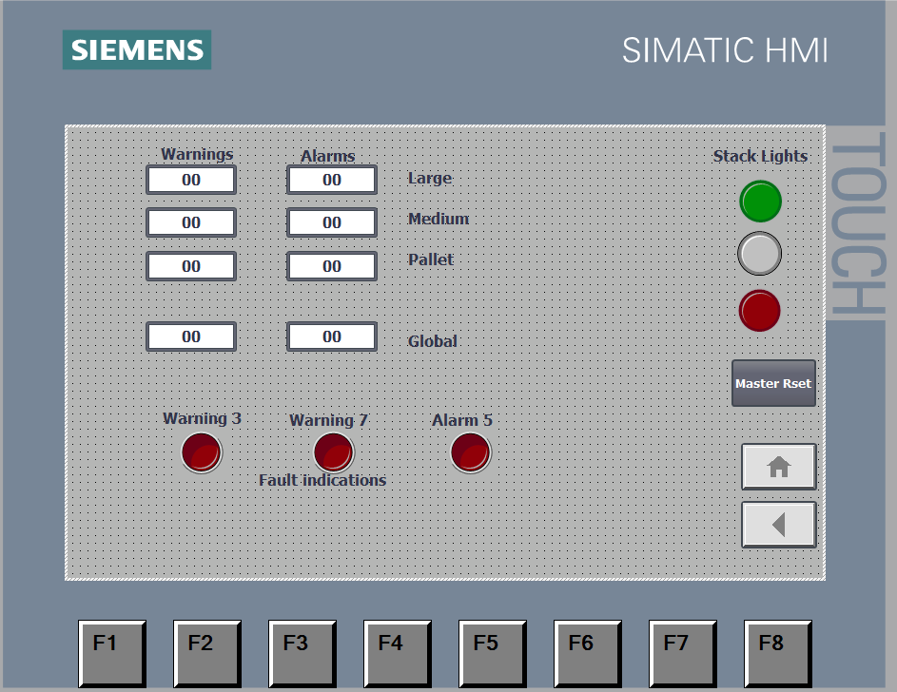
Warning and Alarm page screen shot

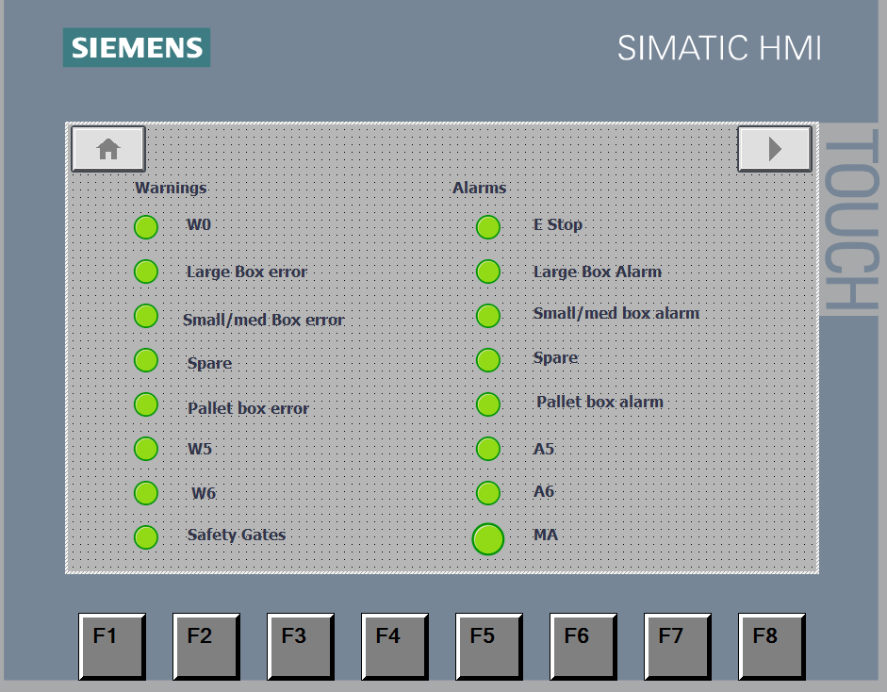
Alarm page screen shot

Task 5 - Provide a formal report detailing tasks: 1 to 4

Network 1 (screen shot below) is a function that allows the Siemens interface to link with the factory I/O program.
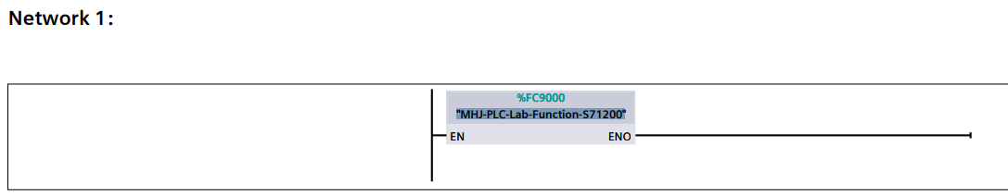

To begin the actual program, the logic software was performed by selecting a Start button which is latched by the ‘operate’ output coil and a STOP button which breaks the circuit and permits the coil from energising.

Many timers were incorporated into the program, these were mainly used to delay the start time on the many conveyors. This was to ensure the conveyor motors power circuit was not stressed, Direct online motors can demand up to eight times normal running current on start up.

Counters were included in the program to keep track of the amount of packages put into and out of the process. A deviation from the allowable setpoint would develop an error and also an Alarm. The alarm would prevent a continuous build up of packages should there be an error over the allowable alarm value both values were able to be altered on the HMi.

It was good practice as a beginner programmer to upload and simulate the changes following any alteration of the logic. This would prove less confusing as many simultaneous logic changes could result in many different program issues.

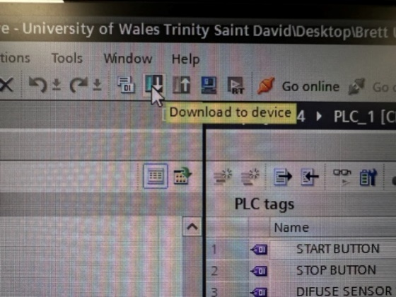
Downloading/Simulating the program

As the program was being developed it is a good idea to download it to the controller. To ensure it matches and there are no errors.

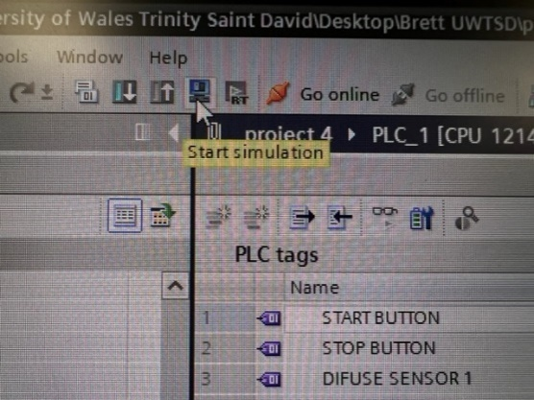

Figure 6

To test the simulation factory matches the main OB1 logic program, It has to be downloaded, any logic changes and hardware simulation additions or alterations must match and show zero errors.

Figure 7

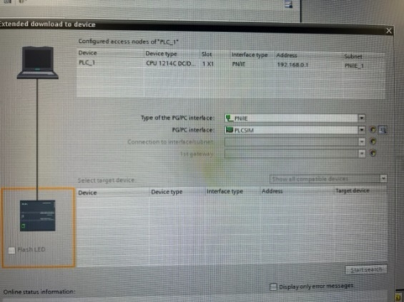
To ensure the download it send to the appropriate controller there is a sub menu with illustrations as seen here in figure 6

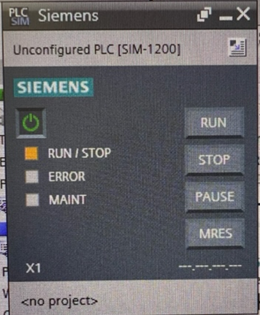
Figure 8
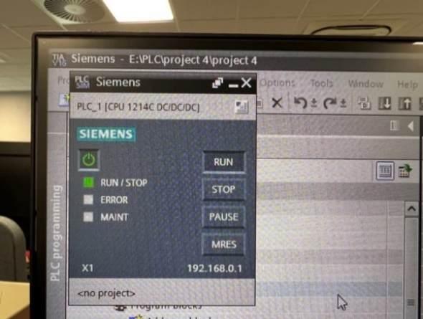
The Siemens Central Processing Unit (CPU) has some basic functions that can be accessed via the simulation graphic. The RUN led is required to ensure the Logic was sequenced/downloaded and configured correctly.

Figure 8 Figure 9

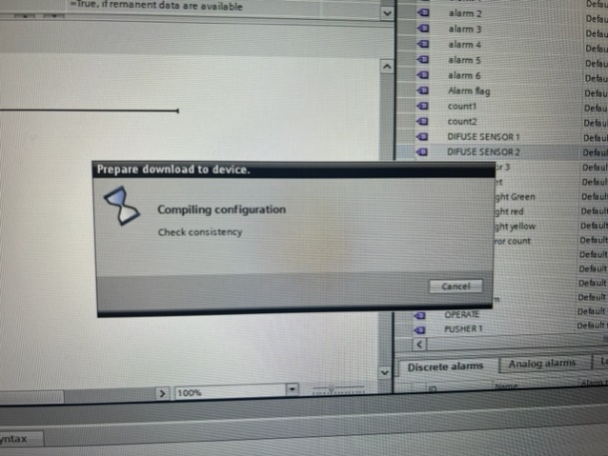

The compiling configuration screen pop up notification
One this was complete and the red motion counter in the right hand corner had stopped counting the load was complete and the program could be altered and simulated until another change required the programmer to carry out a fresh download and update the controller or simulator.

Figure 10

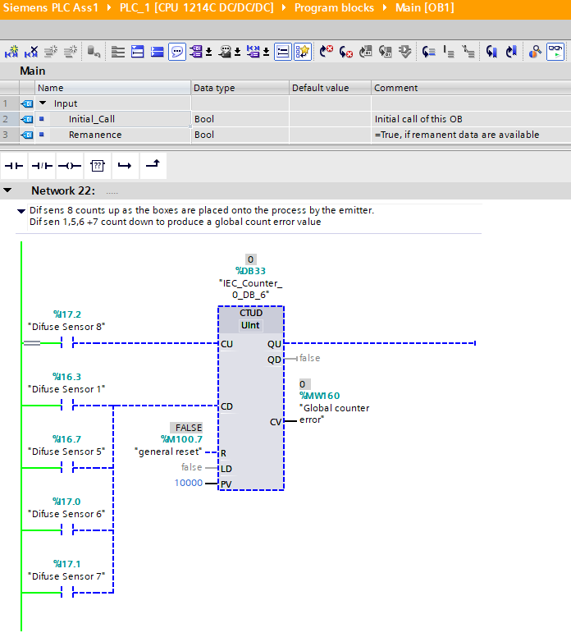
There is a monitoring option on the TIA software (represented by a pair of spectacles which allows the programmer to watch the logic in its ‘live’ status. As you can see below, the active section of the rung is bright green in colour and the yet to be energized section or the ‘dead’ section of the logic is awaiting a signal, in this case it can come from any of the 5 Diffuse sensors.

Figure 11

Flow Diagram

A flow diagram representing the order of actions carried out by the control logic.

Warnings and Alarms

There are various warnings and alarms written into the program. There are two green lights labelled warnings and alarms on the root screen of the HMI. Either of these will illuminate to signify to the operator there is a valid warning or alarm present. Once the fault has been rectified the gen reset will clear these ready for the process to be started again.

Warnings

- A warning will trigger the illumination of the yellow stack lights on the perimeter fence, control panel or the HMI root screen as well as being part of an error count.
- A separate warning for 3 or 7 errors/warnings are present on the general reset HMI page. These red lamps will illuminate as the warnings increase to the numbered values.
- Each individually assigned warning is labelled on the HMI Warning/Alarm page.
- There is also a global warning and alarm on the HMI eng’s page

Warning | Reset function | Indication | Related function
Warning flag | Remove issue + Reset | Yellow Panel stack light  Yellow HMI stack light  Yellow Perimeter stack light
Warning 1 | Remove issue + Reset | Red lamp W1 | Large B error count
Warning 3 | Remove issue + Reset | Red Lamp W3 | Small + med error count
Warning 4 | Remove issue + Reset | RED lamp W4 | Pal B error count
Warning 7 | Remove issue + Reset | Red lamp W7 | Safety gate 0,1,2,3 access

Alarms

- Either E-STOP pushbutton, One situated on the main control panel and one on the HMI root screen, will initiate the Alarm function M201.0.
- Each individual Alarm is labelled on the HMI warning/Alarm page.
- There is a separate red Alarm lamp which will illuminate when there are alarms present from any of the separate box counter alarms, these are on the root screen page of the HMI.

Alarm | Reset Function | Indication Root Screen | Indication Alarm Screen | Related function
Alarm Flag | Mast Reset | Green Lamp | Red Master Alarm
Alarm 0 | General reset | Green lamp | Red Master Alarm  Red Alarm output 0
Alarm 1 | General reset | Green lamp | Red Alarm output 1 | Large B error count
Alarm 2 | General reset | Green lamp | Red Alarm Output 2
Alarm 3 | General Reset | Green lamp | Red Alarm Output 3 | Small + med error count
Alarm 4 | General reset | Green lamp | Red Alarm A4 | Pal B error count
Alarm 7 | General reset | Green Lamp | Red MA lamp | Master Alarm

Further Learnings

- There was a slight delay required on the center pusher to ensure that the weighing conveyor had enough time to react without the boxes piling up. This was noticed and has been mentioned within the Factory I/O section on figure 3.

- As I have not programmed anything using ladder before there was also a large learning curve with regards to copying and pasting timers and counters which caused me a great deal of frustration and lost time. After this was rectified the system ran as expected.

- The safety gates were added as an extra layer of safety but instead of tripping the process I feel that a warning indication was sufficient enough to let the operator know that an access door had been opened. He could then investigate why prior to stopping the process of required. Access would be required to remove the full pallets from each of the separated and stacked sections.

- The weight of each of the small/medium boxes could have been added to the HMI to give the operator a historian of the weights. This could be used to see if there were any extremes that could require investigation.

- A watchdog timer is also commonly used in PLC automation to ensure that the handshake to the controller is continuous. This is hardwired and can trip the system off in a fail safe manner.

References

[1] | "Communication issues," 07 07 2022. [Online]. Available: https://www.plctechnician.com.
[2] | "newsletter," Automation direct, 2022. [Online]. Available: https://library.automationdirect.com.
[3] | Customer forum CM635, "www.automationdirect.com," 2019. [Online]. Available: https://www.automationdirect.com/microsites/c-more/software-help/Content/635.htm. [Accessed 12 2022].

