UNIVERSITY OF WALES
TRINITY ST DAVID

Student name: | Timotei Daniel Bodolan | Student ID number: | 2235425
Programme: | BSC Applied Computing
Module: | Usability Engineering
Module code: | ACCB6017
Lecturer: | Koushik Modak
Assignment Title: | User Requirements and Prototype
Submission deadline: | 28th November 2025

TABLE OF CONTENTS
1. Introduction 3
2. Personas and Main UX Requirements 3
3. Designing for Usability and Recommendations from Literature 6
4. Storyboards Wireframe 7
5. Process of Collecting Feedback and Summary of Positive and Negative Feedback 12
6. Conclusion 13
References 14
Appendices 16
Appendix 1: Screen Interactions 16
Appendix 2: Menu and Profile Set Up 16
Appendix 3: Gameplay Mechanics 16
Appendix 4: Suggestion 17
Appendix 5: Inspect and Notes 17
Appendix 6: Selecting and Accusing Killer 18
Appendix 7: End-game Mechanics 19
Appendix 8: MoSCoW Requirements Table 20

1. Introduction
This assignment aims at creating a low-fidelity prototype of a mobile-based computer game version of the classic board game Cluedo and placed in the context of the University of Wales Trinity Saint David (UWTSD). This is because the game is based on the following premise: The Vice-Chancellor has been murdered! Who did it?" has to be locally adjusted, in which participants have to find their way through university campuses to figure out the answer. User Experience (UX) design is becoming a major force in modern game development, and it helps to create an intuitive, accessible and even enjoyable experience between the player and the system [1].

2. Personas and Main UX Requirements
As a way to make sure that the "University Cluedo" mobile prototype will cater to the needs of the diverse population at UWTSD, four new personas were created. The data collection process was a semi-structured interview and observation of the potential users of the university population. This qualitative method stimulated profound information on behaviours, frustrations, and motivations of users, which offers insights to formulate a user-centred design [2].
Field | Details
Name and details | Liam Jenkins  19; First-year undergraduate student living in Halls  Plays in the common room with friends using a single shared smartphone ("Pass-and-Play").
Goals | Wants a fun, social "party game" experience without requiring every player to install the app.
Frustrations | Accidental cheating when passing the phone; friends seeing his cards during his turn; confusing setups.
Tech confidence | High; comfortable with gestures and quick navigation.
Use case | Friday night in the halls. Liam sets up a "Create Match" on his phone, adds 3 friends locally, and needs a way to show his cards secretly without others seeing.
MoSCoW | Must: "Private Reveal Mode" (screen blackout or tap-to-hold) to protect hidden info on shared devices.  Should: Easy "Add Player" interface for local setup.
User Persona 1: The Social Student (Shared Device User)
(Source: Self-developed)
Field | Details
Name and details | Sarah Williams  22; Final year student, commutes by bus (45 mins)  Plays on mobile during bumpy bus rides; unreliable internet connection.
Goals | Kill time during commute; practice strategy without social pressure.
Frustrations | Games that require constant internet, matches that take too long, and small buttons that are hard to hit on a moving bus.
Tech confidence | Moderate; prefers simple taps over complex swipes.
Use case | Sarah opens the app on the bus. She has no signal, so she selects "Bot" opponents in the match setup to play a quick offline game against AI.
MoSCoW | Must: Offline/Bot capability (as seen in Screen 3); large touch targets (Fitts's Law) for unstable environments.  Should: "Watch Tutorial" for quick rule refreshers.
User Persona 2: The Commuter (Solo/Bot Player)
(Source: Self-developed)
Field | Details
Name and Details | Dr. Alan Griffiths  58; Senior Lecturer  Older smartphone; has mild visual impairment (presbyopia) and struggles with low contrast.
Goals | Engage with students in a campus-themed activity; simple and readable interface.
Frustrations | Tiny text; low contrast grey-on-grey text; finding accessibility settings buried deep in menus.
Tech confidence | Low; gets frustrated by complex "gamer" jargon.
Use case | Dr Griffiths wants to play but cannot read the standard small font. He needs to configure the app immediately upon launching.
MoSCoW | Must: "Accessibility Presets" available during setup (as seen in Screen 2) rather than hidden in settings; High Contrast mode.  Should: Clear labels rather than just icons.
User Persona 3: The Staff Member (Accessibility Focus)
(Source: Self-developed)
Field | Details
Name and Details | Priya Patel  20; Computer Science student, competitive gamer  High-end mobile; customised settings preferred
Goals | Fast-paced gameplay; tracking stats; optimising the interface for speed.
Frustrations | Slow animations; unskippable tutorials; lack of game customisation (e.g., timers).
Tech confidence | Very High.
Use Case | Priya sets up a tournament. She uses the "Create Match" screen to toggle "Timed Turns" on to force fast gameplay and selects a specific "Campus Map" for variety.
MoSCoW | Must: Advanced match settings (Timer toggle, Map selection); Profile customisation (Avatar/Display Name).  Should: "Skip" button for onboarding flows.
User Personal 4: The Competitive Strategist
(Source: Self-developed)
With these personas formed, a MoSCoW (Must, Should, Could, Won’t) analysis was conducted to rank the features and ensure that the design accounted for the needs based on the important ones found above.

3. Designing for Usability and Recommendations from Literature
The design philosophy of the prototype product, the University Cluedo, is based on the classical theories of Human Computer Interaction (HCI), namely, 10 Usability Heuristics and the Web Content Accessibility Guidelines (WCAG 2.1). When these structures are employed, the design is made in such a way that the application created is not only functional but also intuitive and inclusive.
The first heuristic of Visibility of System Nielsen, "Visibility of System Status," states that the system must continuously remind the users of what is occurring by giving them relevant feedback within a befitting time [3]. The principle is implemented in the Create Match screen. Once a user clicks on a Campus Map or chooses an option of a Bot player, it also happens as visual feedback as the interface completes checkmarks and gives members an outline of the borders.
People tend to do things unintentionally, or they want to move across the flows fast. The heuristic of User Control and Freedom proposed by Nielsen [4] justifies the appeal of high-level positioning of the Skip button at the Profile Setup screen. This also enables the skilled user to skip the avatar-creating process in case he/she wants to jump into the game right away. Likewise, the presence of a Back button (top-left of the screen) is a security feature, which guarantees that the user will be able to step back out of the setup menu to the main screen without losing track of a wizard flow.
The interface makes use of terms and concepts that are known to the user. Also, the visual display of the choice of Campus Map adheres to the card-like UI elements, which is a reflection of the real cards which serve as the playing pieces of a classic board game called Cluedo. This mode of skeuomorphism is used to close the distance between the physical board game mental model and the digital variant [5].
To minimise the cognitive load, the design is as per platform conventions. The placement of the icons (Settings) and the Hamburger (Menu) in the upper right and left corners of the Welcome Screen, respectively, conforms to the conventional mobile design patterns. By arranging such features in familiar places, the user can trust their already acquired experience with the mobile app, reducing the learning curve among non-technical users.
One key theme of this design is that it is compliant with the concepts of WCAG, especially as regards to Perceivable and Operable. The system supports visually impaired users instantly since it is provided upfront with a set of presets (ex, "Large Text," "High Contrast" etc.). The design is also made in compliance with certain touch-target size suitable recommendations (minimum size 44x44 pixels), to ensure that even those users, either with motor deficiencies, or on the roads, (Persona 2) can correctly use the buttons [6]. The difference between the Bot and the Human type of players is expressed not only using colour but also icons, text labels, which meet the need not to use colour exclusively to represent information.

4. Storyboards Wireframe
The low-fidelity wireframes demonstrate the main user pathway of how to launch the application to the point of starting a match. When a match starts, the players can move within the rooms at the university campus by taking basic paths which comply with mobile touch-target specifications and help to keep it accessible and do not diminishing the Visibility of System Status.
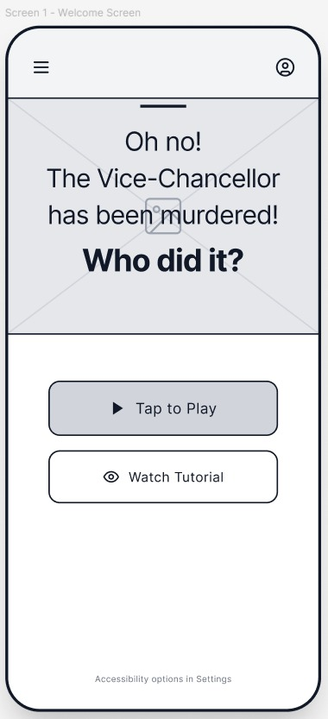
Figure 1: Welcome Screen
(Source: Self-created using Figma)
It also has a clean and non-cluttered design that is meant to reduce the cognitive load. The main Call to Action (CTA) of the page, which is Tap to Play, is located in the third section of the screen. This is a favourable position, following the mobile ergonomics of the element of the thumb zone, which holds that the lower portion of the screen is the most accessible to use with the hand [7]. There exists a secondary button, Watch Tutorial, which serves inexperienced users (Persona 2) and allows taking an immediate path to discovering the rules without resorting to clicking on the menus. The suggestion interface (Screens 6 and 6.1) enables any available suspect and item to be selected when entering a room, and the room itself is automatically entered to reduce the cognitive load and avoid errors. At the top of the navigation bar, it includes the User Profile icon and Menu icon, which allows access to the secondary features.
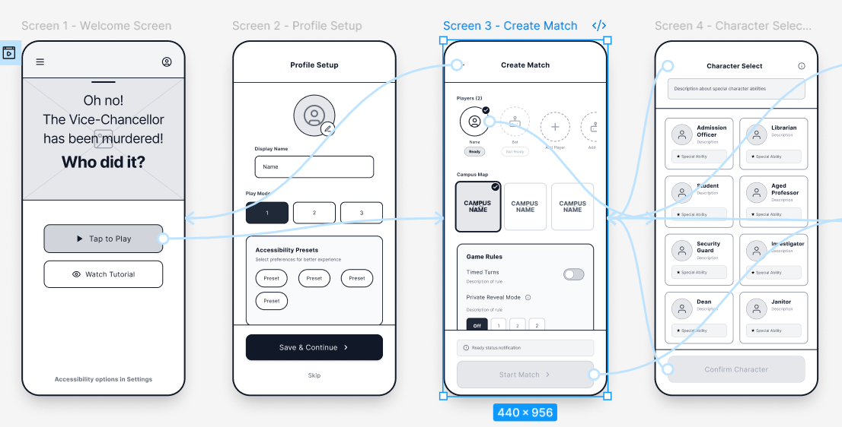
Figure 2: Profile Setup, Character Selection, and Create Match (Lobby)
(Source: Self-created using Figma)
When the user taps the Play button, he or she is automatically presented with the Profile Setup screen that focuses on the personalisation and early accessibility setup. This user interface gives users the ability to use a personalised avatar or change their display name, which is meant to make the game social. The Private Reveal (Screen 6.2) allows the confidential display of cards using a temporary blackout overlay or can speak out the text to provide fairness when using a shared device. The play mode numbers exceeding them are large and are placed at the centre of the screen in large buttons to make sure that the targets can be hit without any trouble. Accessibility presets have a section on the front page, where the customers can choose their vision or motor support; this establishes an inclusive setting right at the first encounter, which is widely used in famous games like The Last of Us Part II [8]. A navigation flow will be controlled by the Save and Continue button, and at the bottom, there will be a Skip link, which is an immediate exit for the user who does not want to see his or her settings. This feature directly makes the usability heuristic of User Control and Freedom.
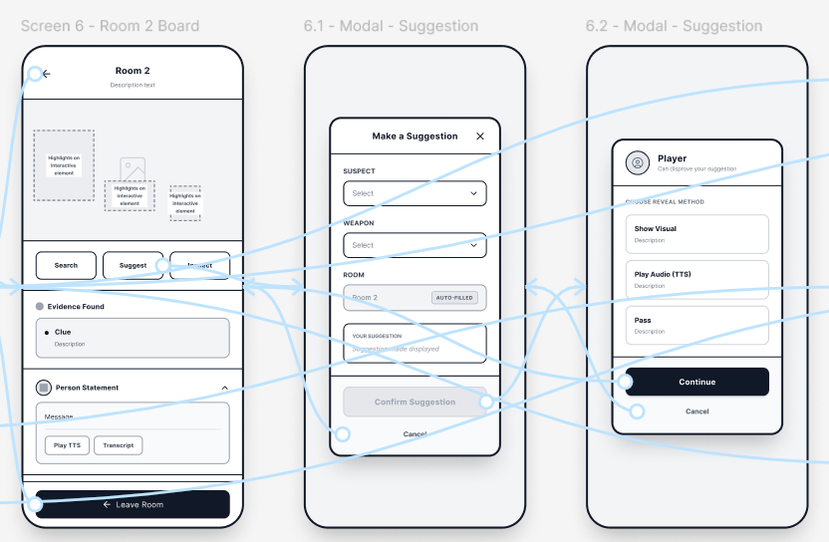
Figure 3: Suggestions Mechanics
(Source: Self-created using Figma)
The last screen in the setup sequence is the Match Lobby, which is a screen where the specifications of the game session are laid down. The upper part of the interface shows the participants; the empty slots have clear buttons with the label Add Player and occupied slots show that the player is ready. To comply with the principles of WCAG 2.1, the digital investigation notebook (Screen 7) has a systematised list of deductions to track, which is guided by a high contrast text and distinct grouping. Interestingly, the appearance of a Bot icon also means the possibility of adding the AI-controlled opponents, which is clearly meant to meet the demands of the solo play of Persona 2 (The Commuter). The central part of the game allows the participants to vote or choose a particular map in the UWTSD campuses, which puts the game in its local context. The lower section has advanced match game settings, such as the "Timed Turns" option, which is a competitive option that enables quicker games, and the " Private Reveal Mode", which regards the scenario unique to Persona 1, which hides screen contents in between players. Lastly, the Start Match button is not active until the minimum criteria (like the number of players) have been reached: it is greyed out, which is an error prevention method of the system.
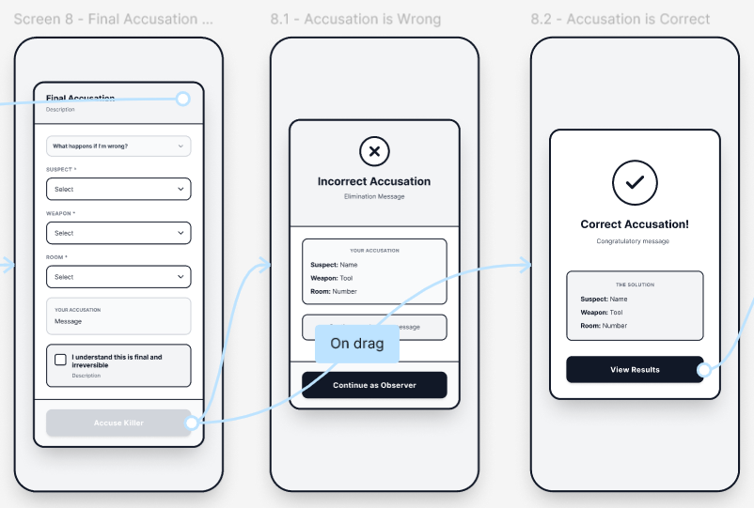
Figure 4: Accusing Killer Mechanics
(Source: Self-created using Figma)
When the user clicks on a player slot, he is brought to the Character Select screen, which substitutes generic board game pieces with university-themed archetypes, like the Dean, Library, Security Guard and Aged Professor. The grid used in this screen follows Gestalt principles of proximity and similarity; thus, the options can be scanned. The last flow of the accusation (Screens 8, 8.1 and 8.2) includes a confirmation summary, and it ends with specific win or lose feedback states, which have a powerful visual effect to enhance the emotional clarity of the very last moment of the gameplay. All the character cards have a large badge of Special Ability on them, which serves as a signifier of special gameplay. In aid of usability, the top of the screen has a description box to give contextual help, and the header has a back arrow plus an info icon, which enables the user to always be in command and be able to access any documentation he or she needs, in line with the principle that game usability covers how well the game guides the player [9]. The big button used at the bottom for confirming a character leaves a clear call-to-action button to make the final decision.

5. Process of Collecting Feedback and Summary of Positive and Negative Feedback
To test the original design hypotheses, the summative usability testing session was carried out under the instructions of the Think Aloud [10]. Being logistically constrained, the testing was conducted remotely over Microsoft Teams with four participants who were recruited to represent the project personas, including two undergraduate students, one senior staff member of an academic program, and one experienced competitive gamer. The interactive Figma prototype was available to the participants, who were asked to perform certain tasks not only in setting up a match but also moving to a room and accusing someone, but discussing their reasoning process with words.
The response to the prototype was mostly favourable as it justified some of the central design choices. The participants identified the "Bot" feature as being essential to campus life, through the mentioning of the fact that the internet always goes down in lecture classes or during transit. Moreover, using large, distinct touch targets (at least 44px high) on the Gameboard (Appendix 2) was confirmed as the users claimed that the app feels robust and it can be easily navigated even during the simulation of daily commute instability.
Nevertheless, the test session also unveiled the main areas of friction where design iteration had to be performed on the very first stage. The vagueness in the meaning of the Private Reveal mechanic first confused users as to how to display cards safely on the shared device. To this end, the mode of the Choose Reveal Method (Appendix 3) was increased with direct replies to the Show Visual and Play Audio (TTS). Text-to-Speech (TTS) feature was introduced, particularly when one of the users pointed out that holding the phone was too bulky. The text can now be read out using headphones, and it does not even require physical delivery as the card stays confidential. Lastly, in terms of feedback visibility, the competitive gamer reported the challenge in following up proposed hints.

6. Conclusion
The wireframes indicate a solid command of the principles of Usability Engineering, which makes the game reachable to the diverse people at UWTSD. The fact that the initial testing received positive feedback justifies the current direction, and the identified issues serve as a clear roadmap for the next phase of development of high-fidelity, full-colour prototypes.

References
[1] A. G. Persada, “User experience on games development trends,” Journal of Physics: Conference Series, vol. 1341, no. 4, p. 042010, Oct. 2019.
[2] A. O. Alsayed, N. A. Ismail, and L. Hasan, “Exploring user perspectives: empowering self-management strategies through semi-structured interviews in the context of mobile app-based approaches,” in Proceedings of the 2024 13th International Conference on Software and Computer Applications, 2024, pp. 38–44.
[3] M. Mirkowicz and G. Grodner, “Jakob Nielsen’s heuristics in selected elements of interface design of selected blogs,” Soc. Commun, vol. 4, no. 2, pp. 30–51, 2018.
[4] M. Rosala, “User Control and Freedom (Usability Heuristic #3),” Nielsen Norman Group, Nov. 29, 2020. [Online]. Available: https://www.nngroup.com/articles/user-control-and-freedom/. [Accessed: Nov. 28, 2025].
[5] M. Chan, “Skeuomorphism,” Nielsen Norman Group, Mar. 15, 2024. [Online]. Available: https://www.nngroup.com/articles/skeuomorphism/. [Accessed: Nov. 28, 2025].
[6] P. Kela, “Mobile Accessibility Checklist | BrowserStack,” BrowserStack, Sep. 29, 2025. [Online]. Available: https://www.browserstack.com/guide/mobile-accessibility-checklist. [Accessed: Nov. 28, 2025].
[7] J. Xiong and S. Muraki, “Effects of age, thumb length and screen size on thumb movement coverage on smartphone touchscreens,” International Journal of Industrial Ergonomics, vol. 53, pp. 140–148, 2016.
[8] “The Last of Us Part II: Accessibility Features - Controller Remapping,” PlayStation, 2024. [Online]. Available: https://www.playstation.com/en-us/games/the-last-of-us-part-ii/accessibility/. [Accessed: Nov. 28, 2025].
[9] R. Yanez-Gomez, J. L. Font, D. Cascado-Caballero, and J. L. Sevillano, “Heuristic usability evaluation on games: a modular approach,” Multimedia Tools and Applications, vol. 78, no. 4, pp. 4937–4964, 2019.
[10] K. Ishaq, F. Rosdi, N. A. M. Zin, and A. Abid, “Heuristic and think aloud method to evaluate the low fidelity prototype of game-based language learning application,” in 2021 International Conference on Innovative Computing (ICIC), IEEE, Nov. 2021, pp. 1–10.

Appendices

Appendix 1: Screen Interactions
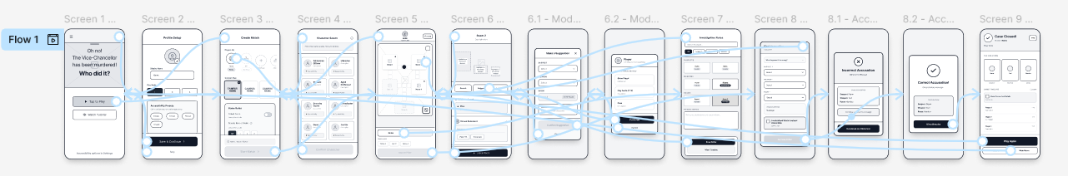

Appendix 2: Menu and Profile Set Up
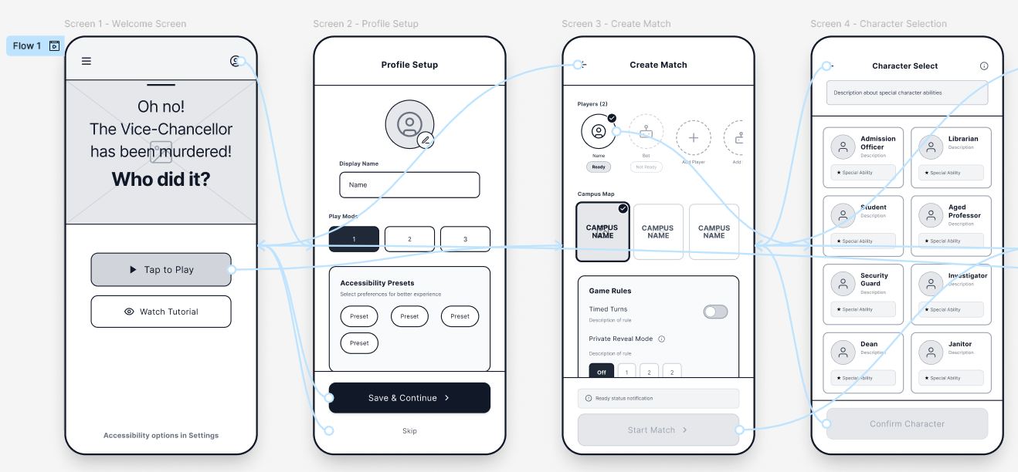

Appendix 3: Gameplay Mechanics
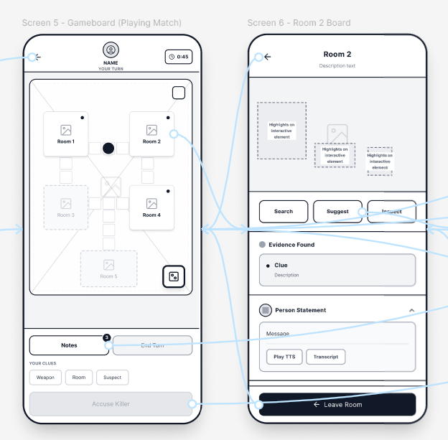

Appendix 4: Suggestion
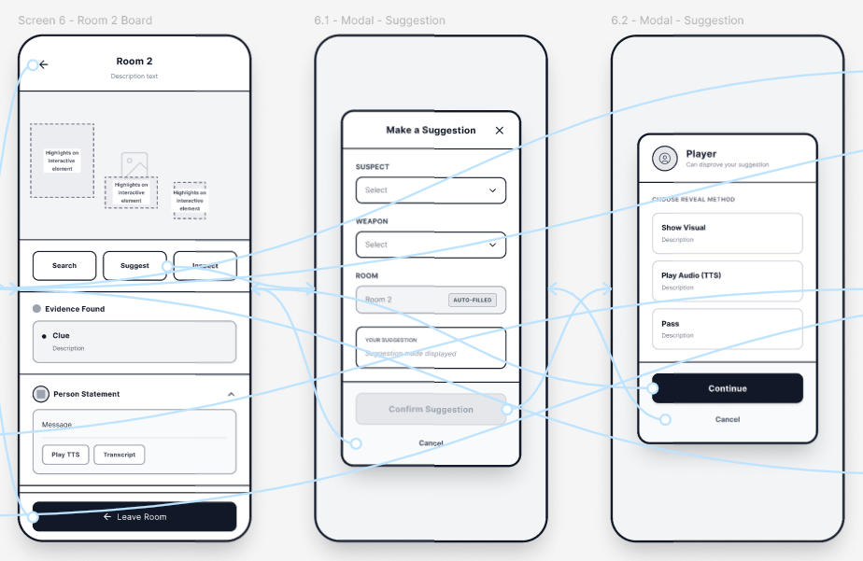

Appendix 5: Inspect and Notes
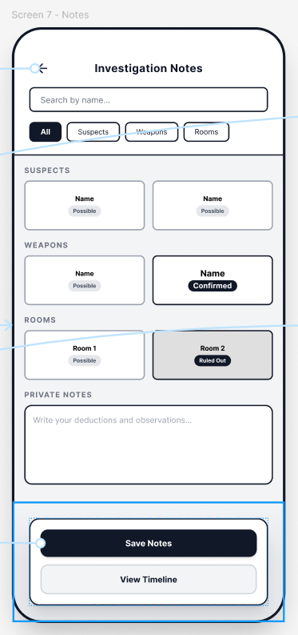

Appendix 6: Selecting and Accusing Killer
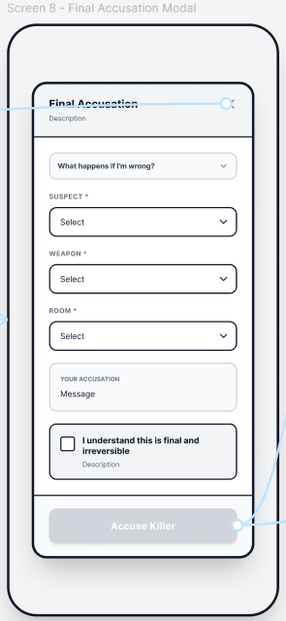

Appendix 7: End-game Mechanics
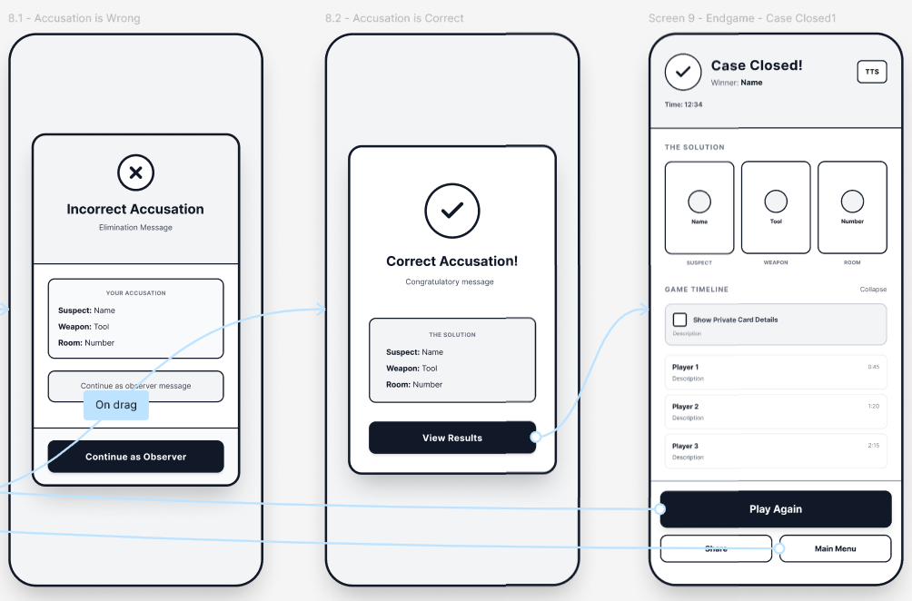

Appendix 8: MoSCoW Requirements Table
Requirement | Description | Persona Link | Priority
Accessibility Presets | High-contrast mode, large text, reduced motion support | Staff member (Persona 3) | Must
Offline/Bot Mode | Ability to play without internet connectivity | Commuter (Persona 2) | Must
Private Reveal Mode | Protects card information during shared-device play | Social student (Persona 1) | Must
Campus Map Selection | Ability to choose between different UWTSD campuses | Competitive player (Persona 4) | Must
Large Touch Targets | Minimum 44px buttons for mobile stability | Persona 2, general | Must
Timed Turns | Competitive timed mode for fast-paced gameplay | Persona 4 | Should
Advanced Match Customisation | Configure avatars, rules, and player settings | Persona 4 | Should
Tutorial Mode | Quick on-boarding explanation for new users | Persona 2 | Should
Animated Transitions | Light animations for improved engagement | General | Could
Cosmetic Customisation | Additional avatar accessories or skins | Persona 4 | Could
Augmented Reality Features | AR room exploration and clue interaction | Not tied to personas; excluded due to complexity and accessibility concerns | Will not
Cross-Device Multiplayer | Full online synchronous gameplay | Out of scope for low-fidelity prototype | Will not

