Assessment 1 Marking sheet

Module: BMPL6011 Conducting Investigations.
Assessment 1 Role Play, practical demonstration of knowledge application and demonstration of thought processes.

Student Name: | Paige Davies
Student ID: | 2204437
Module Tutor: | M Thomas
Assessment 1 | Grade 0-19 | Grade20-39 | Grade 40 - 59 | Grade 60-69 | Grade 70+
Categories | Unsatisfactory | Improvement needed | Satisfactory / Good | Very Good | Excellent
Critical application of the National Decision Model | No / minimal reference to NDM | Reference made to but no application of NDM | Reference made to and a basic application demonstrated or NDM | A Very good reference made to and very good application of NDM | Excellent reference and application of the NDM
Stage 1  Gather Info and Intel  THRIVE  W’s & H’s  Witness/Victim details |  |  | Good 5 WH  Enquiries re CCTV  Checked to see where loser was and arranged to speak with her later.
 |  |  |  | Mark | 12 /20
Stage 2  Assess TRH and develop a working strategy  Golden hour Principles  Cross Contaminations  Crime Scene Management Considerations  3 Types of Evidence (DNA/Trace/Impressions) |  |  | Golden hour discussed  Taped off room, asked students not to enter until after CSI  Described types of packaging for different exhibits  Identified forensic opportunities, knife, window, desk, files on floor, table, can – dna, hair and blood stained clothing  PPE prior to entry  CID to be informed  Aware to check outside as there may be evidence inclusive of footmarks  Didn’t mention common path
 |  |  |  | Mark | 27 /30
Stage 3  Consider Powers and Policies  Identify potential offence  Power of Arrest  IDCOPPLAN  Power of Entry  Power of Seizure  Power of Search |  |  | Power of entry – consent but did explain Sec 17 could be used to arrest someone or to save life and limb  Offence identified as burglary but not more specific  Power to arrest for burglary but no necessity given  Sec 19 of PACE mentioned re seizing exhibits.
 |  |  |  | Mark | 14 /20
Stage 4  Options and Contingencies  Officer Actions  Assistance  4 R’s |  | . | Asked for CSI and CID  Photography – but could have considered popping on own BWC too (missed).
 |  |  |  | Mark | 5 /10
Stage 5  Action and review  4 R’s |  |  | Will speak to loser and witnesses, check CCTV and will check with hospitals given blood just in case suspect has sought treatment.
 |  |  |  | Mark | 6 /10
Stage 6  Code of Ethics |  |  | Very organised, professional and business like. Could have considered safeguarding and target hardening.
 |  |  |  | Mark | 6 /10
Total Marks |  |  |  |  | /100
Overall Comments / Summary of Feedback.

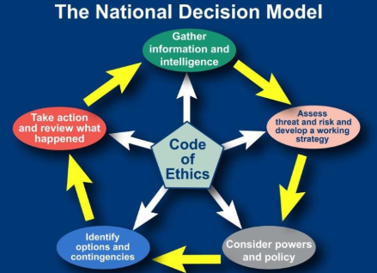

Golden hour considerations
Area | Considerations
Victims, witnesses and suspects | - Identification.  - Risk assessment.  - Safeguarding.  - Support, such as a family liaison officer or sexual offences liaison officer.  - Sensitively preserve and gather initial account and material (for example, clothing, forensic samples and digital opportunities) as appropriate. Consider use of body-worn video (BWV) for initial accounts.  - Use sensitive, non-accusatory and impartial language.  - Use communication enablers to support victims and witnesses, such as interpreters, intermediaries, and appropriate adults.  - Consider victims’ rights under the Code of Practice for Victims of Crime(opens an external website in the same tab), and conduct a victim needs assessment.  - Consider community impact and reassurance.  - Consider and record contextual background to situation, such as the demeanour of parties involved and the circumstance of the victim, suspect and any dependents (consider BWV). This may include the condition of their home environment, the overall welfare of the parties involved, previous calls for service, previous offending history and/or intelligence.  - Where the suspect is not already known, take steps to identify, trace, investigate and evaluate persons of interest.  - See APP on Working with suspects.
Scenes | - Identify, preserve (prevent contamination) and gather (where appropriate) material. Where material is exposed to the elements – such as footmarks in mud, or blood stains – take steps to preserve or protect pending recovery.  - Assess and commence crime scene log.  - Consider:  - entry and exit routes  - escape routes  - cordons  - forensics (including digital forensics)  - exhibits  - Remember that victims, witnesses and suspects are also scenes. Take steps to avoid contamination – for example, take victims and suspects to different police buildings and keep contact officers with each group separate. See also APP on Scene strategy.
Records | - Record decisions with rationale, circumstances (using professional curiosity to provide background detail, see the 'family and community' section of this table) and what is known (including 999 recordings and call taker notes).  - Witness first account given, description of suspects.  - Identify risks or threats.  - Consider use of incident management log, decision log, scene log, exhibits log and passive data, such as digital images and BWV.
Physical evidence | - Identify, preserve and gather physical and digital evidence – including use of crime scene investigators, digital media investigators, forensic evidence, use of early evidence kits, digital and passive data, CCTV and documentary evidence. See also APP on Forensics and Closed Circuit Television (CCTV) initial training level one(opens an external website in the same tab) (you will need to log in to College Learn).  - Consider proportionality and relevant powers. See APP on Investigative strategies – Scene strategy and Physical evidence.
Intelligence | - Identify and use police, community and open-source intelligence to inform risk and threat assessment, decision making and investigative lines of enquiry.
Lines of responsibility | - Identify, inform, brief and coordinate, as appropriate.  - Consider escalation to the appropriate line management or team.  - Consider relevant authorities for powers – for example, search and/or seizure, and use of the Police and Criminal Evidence Act 1984 (PACE) powers and identify authorising officers as appropriate.
Family and community | - Consider cultural and community factors, including:  - the protected characteristics of involved parties  - communities where cultural practices may exist, such as so-called honour-based abuse and female genital mutilation  - language and communication  - neurodiversity  - Consider the safety of those at the scene (for example, cordons and safeguarding actions).  - Identify a critical incident and escalate, if appropriate.  - Consider engagement with force media department.  - Consider specific duties under Children Act 2004, s 11(opens an external website in the same tab) and Equality Act 2010, s 149(opens an external website in the same tab).

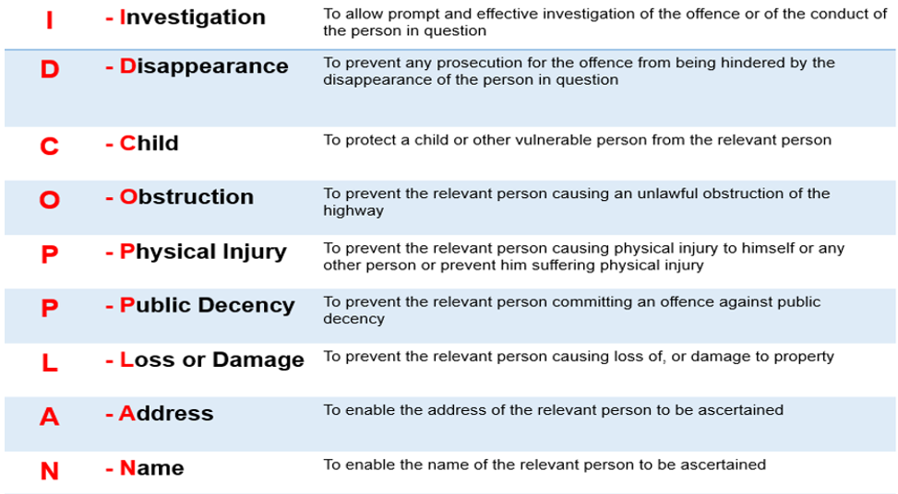
Sec 17, 18, 32 and 19 PACE 1984


