
UNIVERSITY OF WALES TRINITY SAINT DAVID
LEVEL 4 ASSESSMENT
Assignment 1: E-Portfolio
Module Name: | Software Solutions for Business
Module Code: | ACCA4026
Assignment Title: | Assignment 1: E-Portfolio
Programme / Course Title: | CertHE Computing Skill for Workplace
Student Name: | Gabriel Polleti Scalise Pessarelo
Student ID Number: | 2534474
Lecturers: | Dr Osman Elgawi / Mohd Syafiq Bin Zolkeply
Submission Deadline: | July 6, 2026, 2PM

Table of Contents
Table of Contents 2
E-Portfolio 3
Task 1. e-Commerce Website builders/software solutions 4
Task 2. Mind-map of contemporary software applications 5
Task 3. Office Applications for creating, storing, presenting, and analysing information/data 6
Task 4. Communication and Collaboration applications 9

E-Portfolio

https://sites.google.com/view/gabrielpessareloacca4026e-port/home

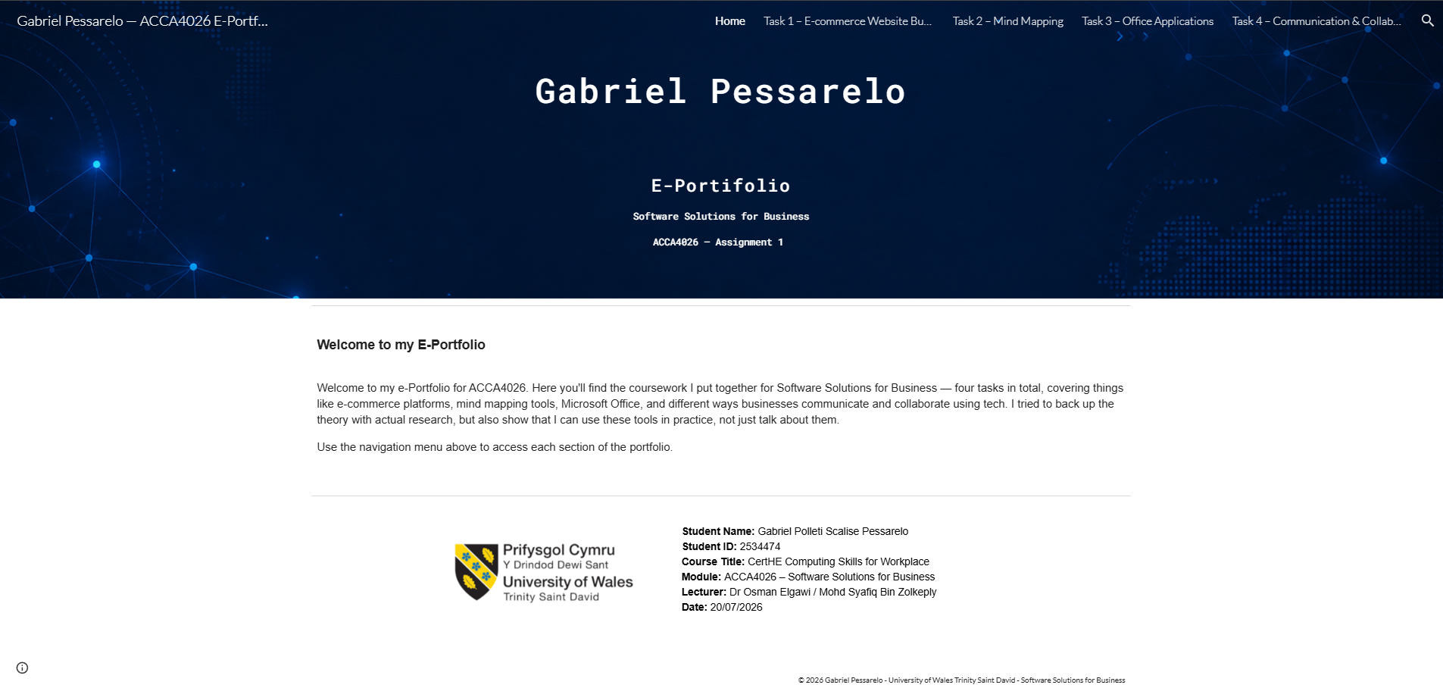

Task 1. e-Commerce Website builders/software solutions

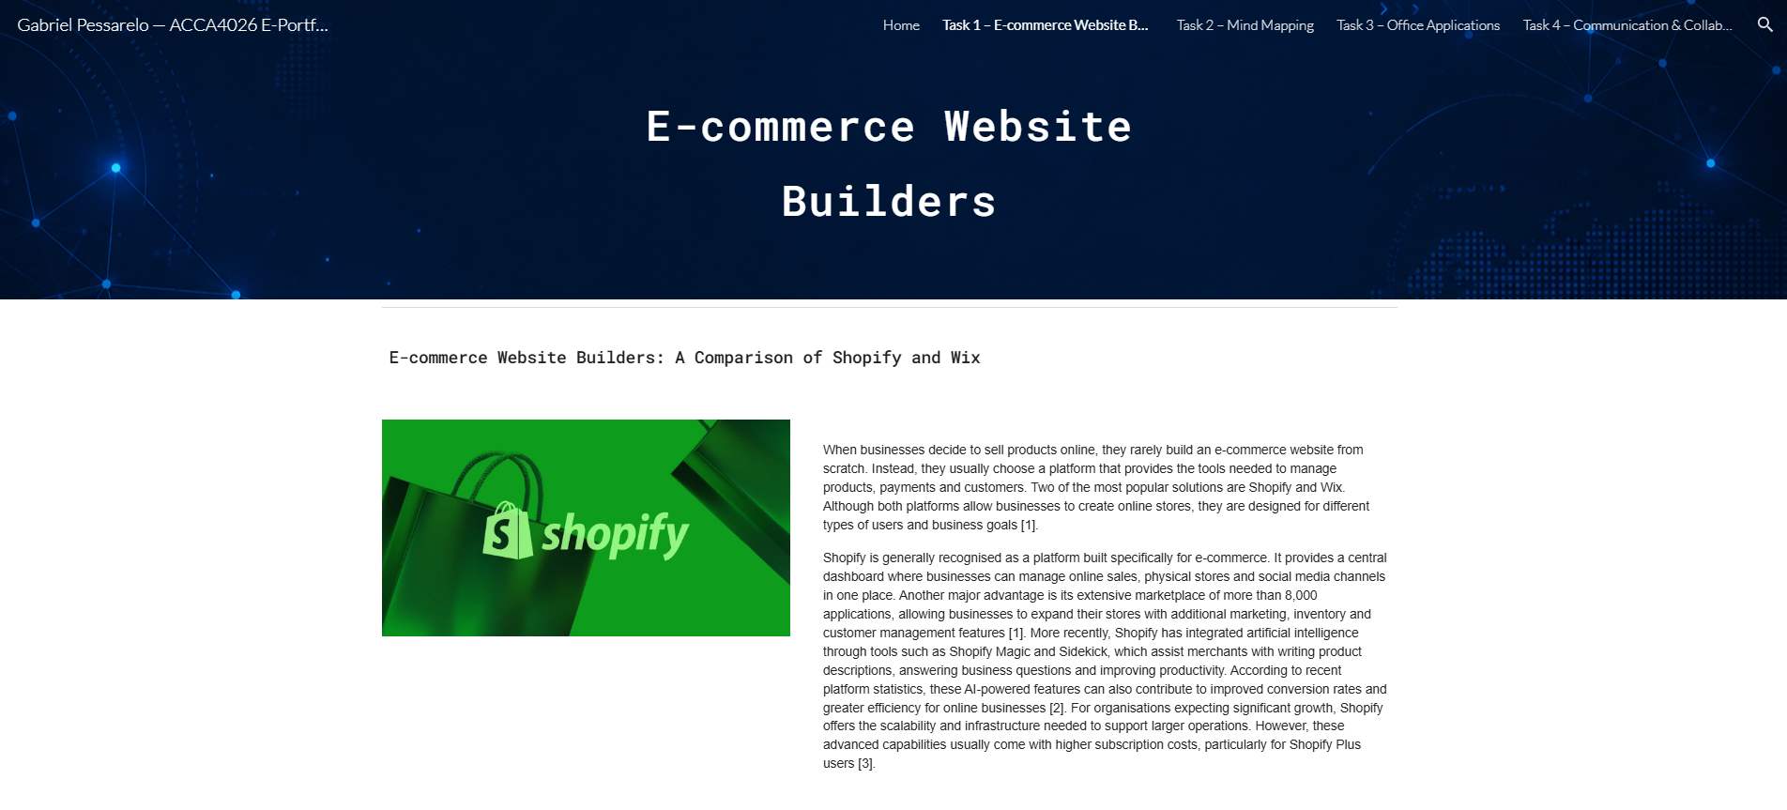


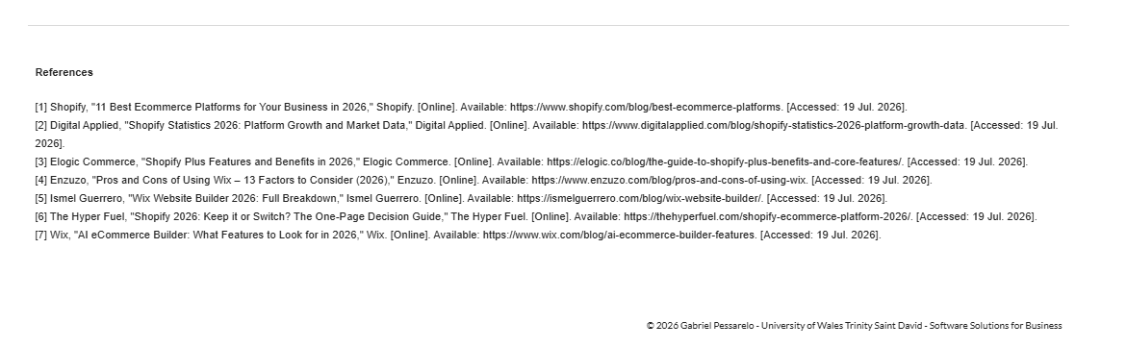

Task 2: Teamwork Mind-Map and Academic Poster

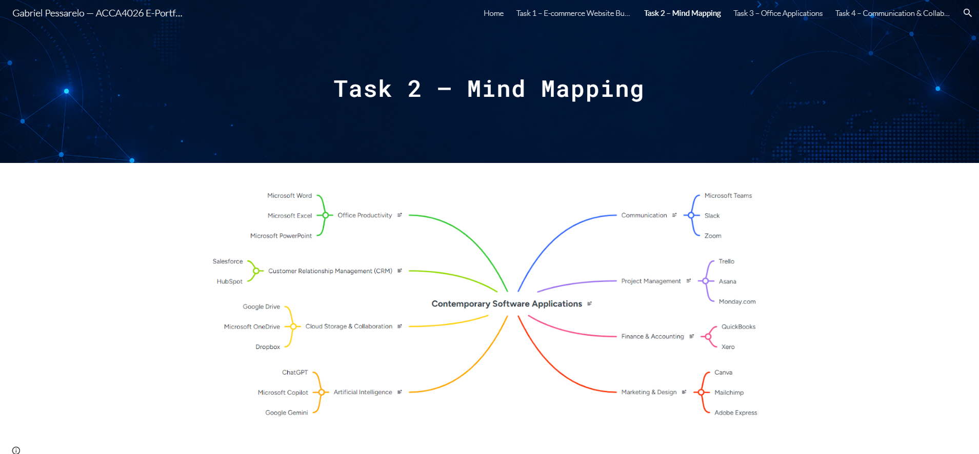
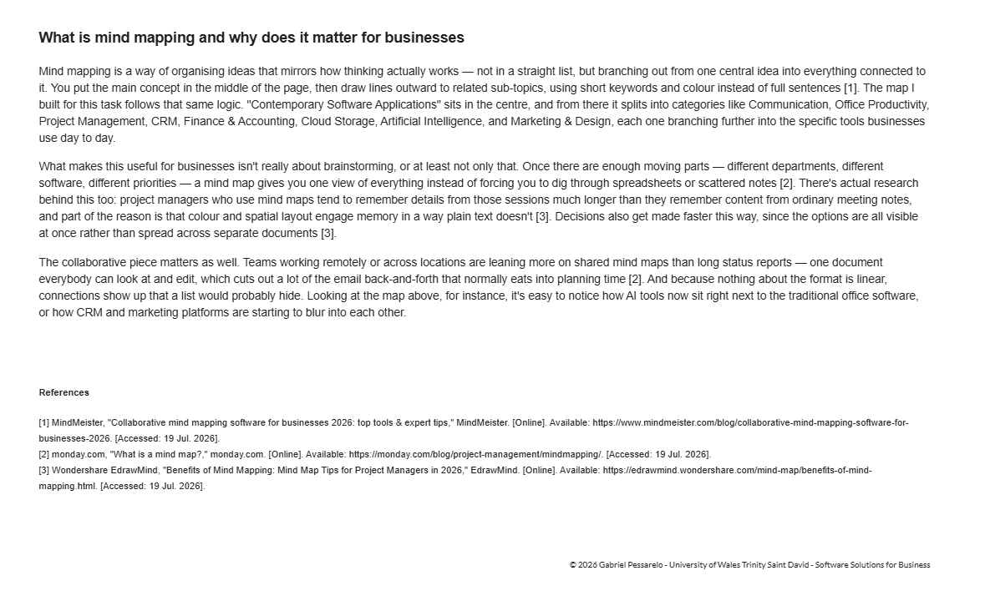

Task 3. Office Applications for creating, storing, presenting, and analysing information/data
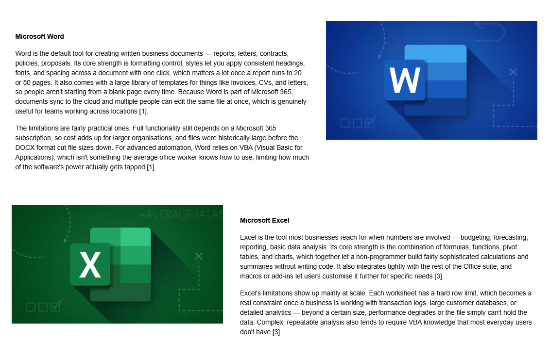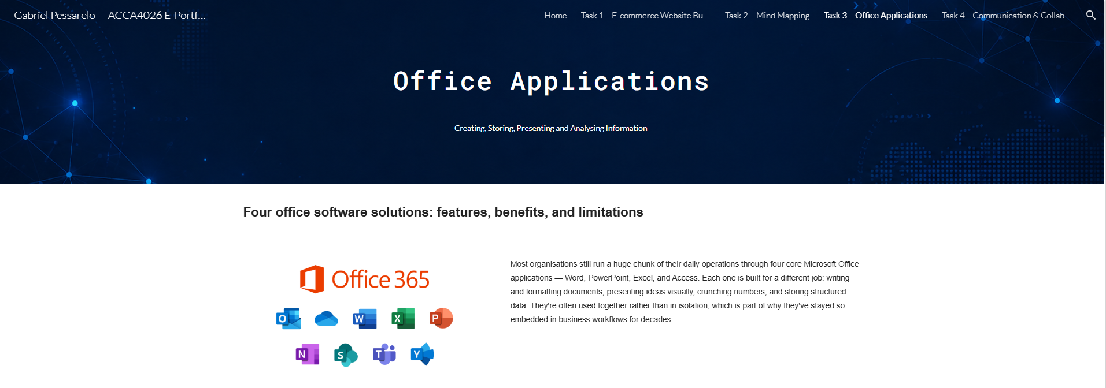
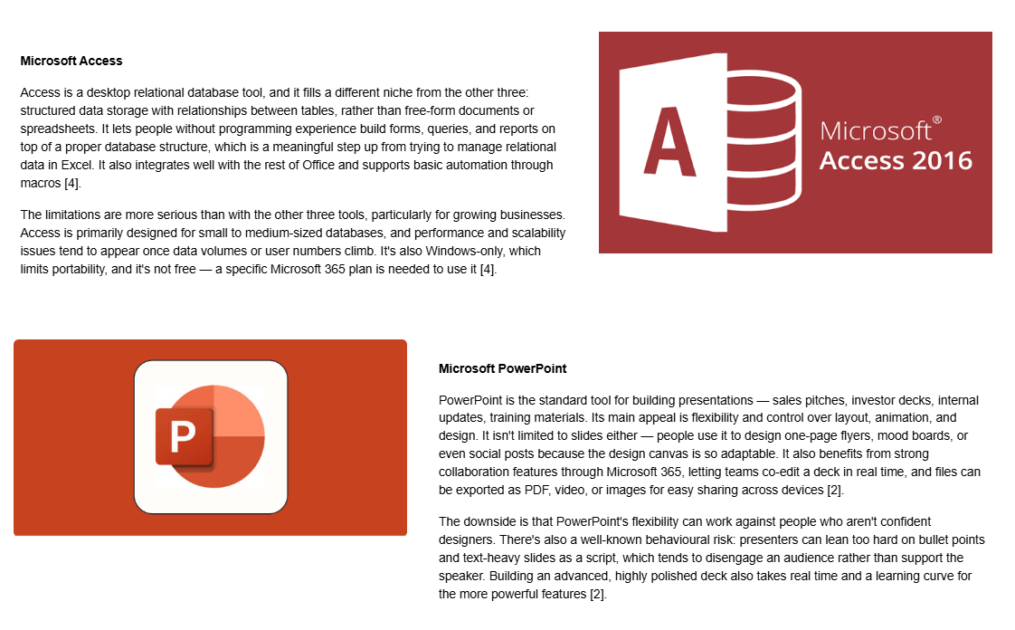
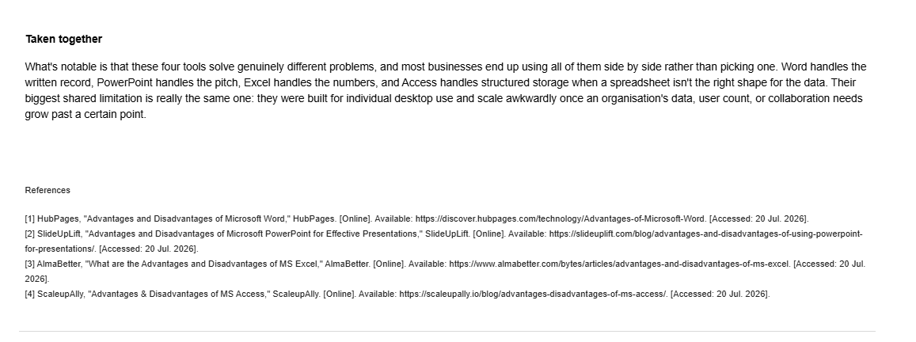
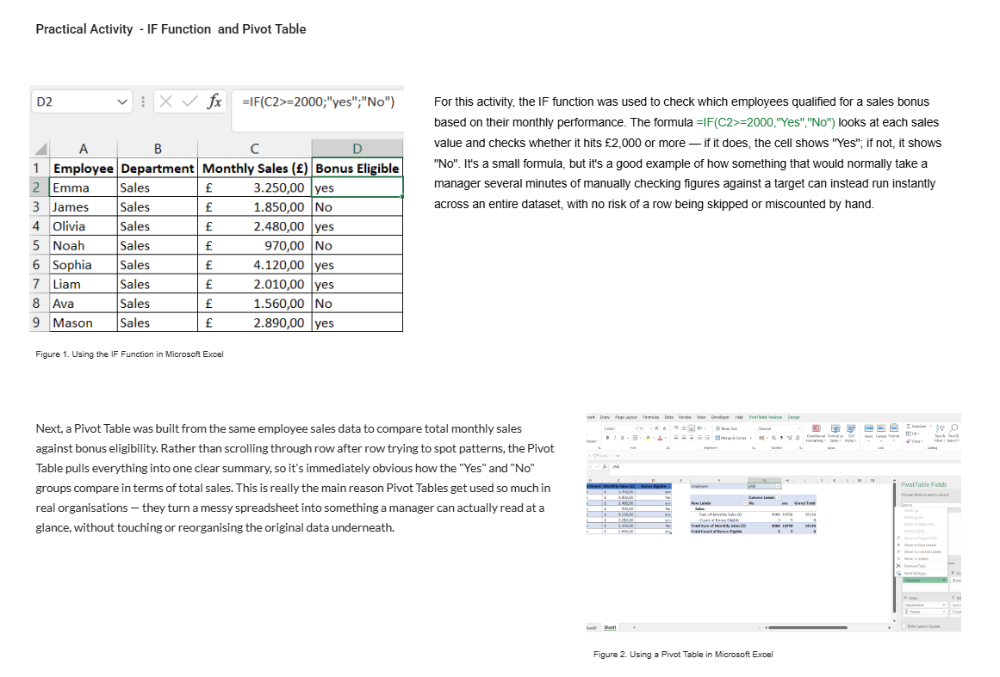

Task 4. Communication and Collaboration applications



