BA (Hons) Leadership and Management Skills for the Workplace

BMSW5105 Workplace Culture and its impact on Organizational Efficiency
Student ID:2113593
Name: Iuliana Mare

Task 1: Individual Written Report

Table of Contents

Introduction to EasyJet airline 3
Relationship between Organizational Culture and Structure of EasyJet and Its Impact on Financial and Non-Financial Performance 4
Organisational culture 4
Organisational structure 5
Evaluating the Broader Environment of EasyJet Plc Using Environmental and Organizational Analytical Techniques 7
PESTLE analysis 7
Porter’s Five Forces 9
Exploring Easy Jet Plc's Ethical Practices and their Benefits 11
Recommendations to Easy Jet Plc to Address Environmental and Ethical Challenges and Improve Performance 12
Conclusion 13

Introduction to EasyJet airline
EasyJet is a low-cost airline based in Luton, UK. In 1995, Stelios Haji-Ioannou launched the company with only two planes. Its quick expansion since then has allowed it to amass a fleet of more than 300 aircraft, which it uses to travel to more than 150 locations around Europe, North Africa, and the Middle East (EasyJet, 2023).
EasyJet's business approach is straightforward: it focuses on minimising expenses in order to provide low-priced airline tickets. To do this, the airline uses a number of cost-cutting strategies, including making use of secondary airports, charging for in-flight meals and beverages, and lowering the amount of time aircraft spend on the ground in between trips.
All of EasyJet's planes are Airbus types; specifically, A319s, A320s, and A321. These aircraft are well known for their dependability and efficiency; they are designed to fit as many passengers as possible without sacrificing comfort (SN, 2023).
EasyJet allows passengers to purchase flights through their website, mobile app, or via a variety of third-party booking channels. Standard prices, flex rates, and premium seats with additional legroom are just some of the options available to them.
EasyJet prioritises its customers and works to make flying as easy as possible for them. Online check-in, mobile boarding passes, and a devoted customer support staff are just a few of the services and facilities it provides to ensure a pleasant and stress-free flight experience for its customers.
EasyJet has been working to improve its sustainability and lessen its influence on the environment in recent years. To improve fuel efficiency, reduce emissions, and extend the lifespan of its fleet, the company has implemented a number of new policies. Moreover, a carbon offsetting scheme has been introduced to assist consumers in compensating for their flights' carbon footprints (ES, 2023).
The low fares offered by EasyJet have made air travel more feasible for tens of millions of people. As a result of its dedication to customer service and environmental responsibility, as well as its straightforward and effective business plan, it has quickly risen to the ranks of Europe's premier low-cost airlines.

Relationship between Organizational Culture and Structure of EasyJet and Its Impact on Financial and Non-Financial Performance

Organisational culture
The culture of a company is one of the most important factors in determining how well an organisation does in both the financial and non-financial realms. EasyJet is not an exception to this rule. By gaining knowledge of the organisational culture of EasyJet, one may acquire insight into the factors that have contributed to the company's success and how it has been able to sustain that success over time.
The reduction of expenses and the maximisation of useful resources play a central role in EasyJet's corporate culture. EasyJet's objective all along has been to provide passengers a service that is both economical and effective (Panduwinasari, Afandi and Wahyuni, 2020). This is accomplished by being vigilant about the control of expenses and being committed to the search for new innovations. EasyJet has been able to maintain its position as a market leader in the low-cost airline business by using this strategy to decrease costs. In addition, EasyJet has been able to stay profitable over the course of time as a direct result of its emphasis on cost reduction, despite the difficulties brought on by the COVID-19 epidemic.
EasyJet has prioritised the development of a workplace culture that is supportive of its workers and places a high value on their contributions in addition to its efforts to reduce costs. The workers of EasyJet are eligible for a wide variety of perks, including a range of flexible working arrangements, training and development programmes, and rewards for performance (Marinakou, 2022). Because of their positive and encouraging work environment, EasyJet has been able to recruit and keep talented employees, which has contributed to their company's success.
Lastly, EasyJet has placed a significant emphasis on cultivating a culture of superior customer service. EasyJet is committed to providing its clients with an experience that is both pleasurable and uncomplicated. This may be accomplished by offering excellent customer service, boarding passengers in a timely manner, and providing a broad selection of services, such as online check-in options. EasyJet has been able to maintain its competitive position in the low-cost airline business by putting a strong emphasis on providing quality customer service, which has resulted in increased customer loyalty (Rotondo, Corsi and Giovanelli, 2019).
EasyJet has been successful in attaining both financial and non-financial performance, in large part due to the company's strong organisational culture. EasyJet has been able to maintain its position as a successful and competitive airline by putting a strong emphasis on both reducing costs and fostering innovation. In addition, EasyJet has been successful in recruiting and retaining high-quality employees because of the supportive atmosphere, it has fostered in its workplace (Taylor and Perkins, 2021). Last but not least, EasyJet has been successful in fostering brand loyalty among its clientele because of the importance it places on providing excellent customer service.

Organisational structure
A well-structured organisation is essential to its success. It entails the method through which several groups and people are coordinated to achieve a common objective. British-based EasyJet is a market leader among low-cost carriers in Europe. Its success may be attributed in part to the well-oiled machine that is its internal structure.
Commercial, Operations, and Business Support are EasyJet's three primary departments (EasyJet, 2023). Marketing, pricing, revenue management, customer service, and product development are all handled by the Commercial department. Flight operations, ground operations, and maintenance, as well as safety and security, are all handled by the operations department. Everything from accounting and human resources to information technology and legal and compliance falls under the purview of the Business Support department.
EasyJet's organisational structure was developed to maximise productivity with the lowest possible overhead. There are just a few tiers of management, and everyone in the company reports directly to the top brass. As a consequence, individuals can make decisions more quickly and with less red tape, which helps us save money and provide better service to our customers (Independent, 2023). EasyJet is able to adapt quickly to market shifts because of its flexible organisational structure.
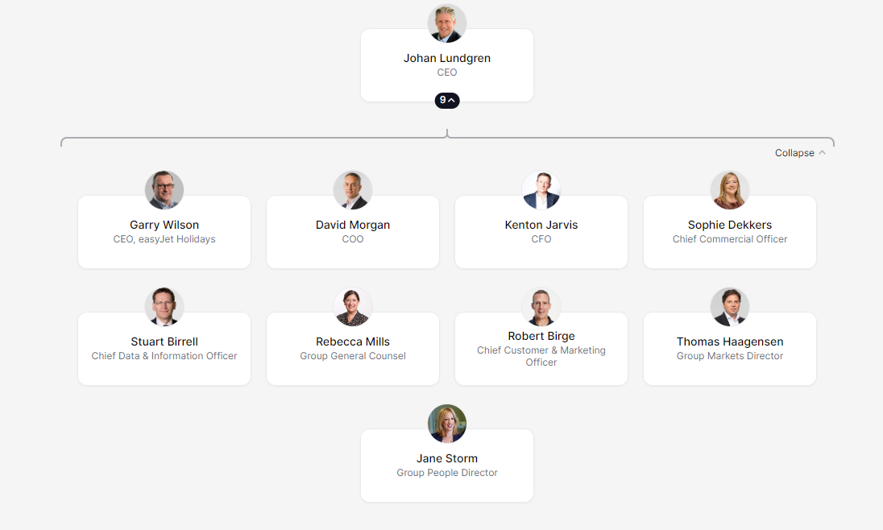
Figure: Organisation Structure of EsayJet
(Source: The Org, 2023)
EasyJet is able to succeed in both the financial and non-financial realms because of its well-designed organisational structure. The company's financial performance benefits from the flat organisational structure because of the increased speed and efficiency with which decisions can be made. The organisation is set up in such a way that it can swiftly adapt to new market conditions, which will enable the firm to keep its competitive advantage and increase its market share.
EasyJet's structure also helps them succeed in areas other than finances. Management is more accessible to workers in a flat organisation, which fosters a culture of cooperation and new ideas. Employees are better able to meet customers' demands in a timely manner, which improves customer service. Staff are well-trained and motivated thanks to the framework, which also boosts efficiency and output (BBC, 2023).
In sum, EasyJet is able to succeed in both financial and non-financial areas because to its well-designed infrastructure. Effectiveness, economy, adaptability, swiftness, teamwork, and originality are all guaranteed by the flat organisational structure. It helps with consumer satisfaction, financial savings, market share, and staff morale. The organisational framework that EasyJet uses has been crucial to its success.

Evaluating the Broader Environment of EasyJet Plc Using Environmental and Organizational Analytical Techniques
EasyJet Plc, which has its headquarters in the United Kingdom and is one of the most successful airlines in Europe, is known for its low ticket prices. EasyJet is able to provide passengers with low rates since the airline does not provide any extra services or amenities (SN, 2023). The company must contend with fierce competition and is susceptible to a number of external factors, each of which has the potential to have a substantial impact on the company's operations and financial performance. If one were to carry out a PESTEL and porter’s five forces analysis, one may get a better understanding of the environment in which EasyJet Plc works as well as the variables that are most likely to influence the choice of the firm to change the way it now does business.

PESTLE analysis
Political
The rules and regulations that have been adopted by the governments of Europe and the United Kingdom have a significant impact on the ways in which EasyJet does its business. Any additional taxes, levies, or other charges that the UK government chooses to implement on air travel may have a detrimental effect on the bottom line of EasyJet. EasyJet has been able to expand its business and remain competitive with other airlines in the region as a result of the open-skies policy that the European Union has implemented (ES, 2023). The decision of the United Kingdom to leave the European Union might have a substantial impact on the operations of EasyJet, as the airline could become subject to new regulations and levies or lose access to routes as a result of the vote.
Economic
The current status of the international economy has a direct bearing on the way EasyJet conducts its operations. Since the airline industry is so dependent on the spending of customers, the bottom line of EasyJet is susceptible to the unpredictability of the economy. In addition to this, EasyJet must contend with the ever-increasing price of fuel, which represents one of the most significant costs for the airline business. British Airline Pilots Association, EasyJet has been estimated to have contributed £4.1 billion to the UK GDP. This includes the direct contribution of £1.9 billion from passenger and freight services and a further £2.2 billion from the airline’s activities and related economic activities (Statista, 2022).
Social
If EasyJet wants to continue to be successful in the future, it must have the capacity to adjust to the ever-shifting preferences of its consumers. EasyJet is obligated to ensure that its services meet the requirements of its clientele, which include simplicity, luxury, and cost-effectiveness. In addition, the viewpoints of consumers on air travel are undergoing a transition, as seen by the growing number of people who are concerned about the future of the world as a direct consequence of their frequent trips. EasyJet has to take steps to reduce the negative impact that it has on the surrounding environment if it wants to continue to be successful at luring new consumers (Ambrose and Waguespack, 2021).
Technological
Because of the considerable impact that technology has had on EasyJet's business model, the airline has been able to broaden the range of services it provides and increase the effectiveness of its operations. EasyJet has made substantial investments in technological advancements in order to provide superior service to its clientele and reduce its overall operating costs (Silling, 2019). This includes the use of mobile technology to provide customers with real-time information, the utilisation of online booking systems, and the utilisation of automated check-in procedures.
Environmental
EasyJet is aware of the need of doing all it can to preserve the environment, and the company is making concerted efforts to achieve this goal. Among these initiatives are improvements to the plane's existing fuel efficiency as well as the adoption of brand-new designs that are friendlier to the environment. EasyJet is looking at the use of renewable energy sources in addition to its plans to reduce the amount of carbon dioxide it emits into the atmosphere (Kachi, Mooldijk and Warnecke, 2020).
Legal
EasyJet is subject to the compliance of a plethora of distinct laws and regulations, not just in the UK but also in the many other nations in which the firm does business (Ayele et al., 2022). There are regulations in place to secure a number of things, including people's safety, the protection of consumers, the maintenance of fair competition, and the preservation of the environment. It is necessary for EasyJet to be certain that it is adhering to these standards in order for the company to remain on the legal side of the fence.

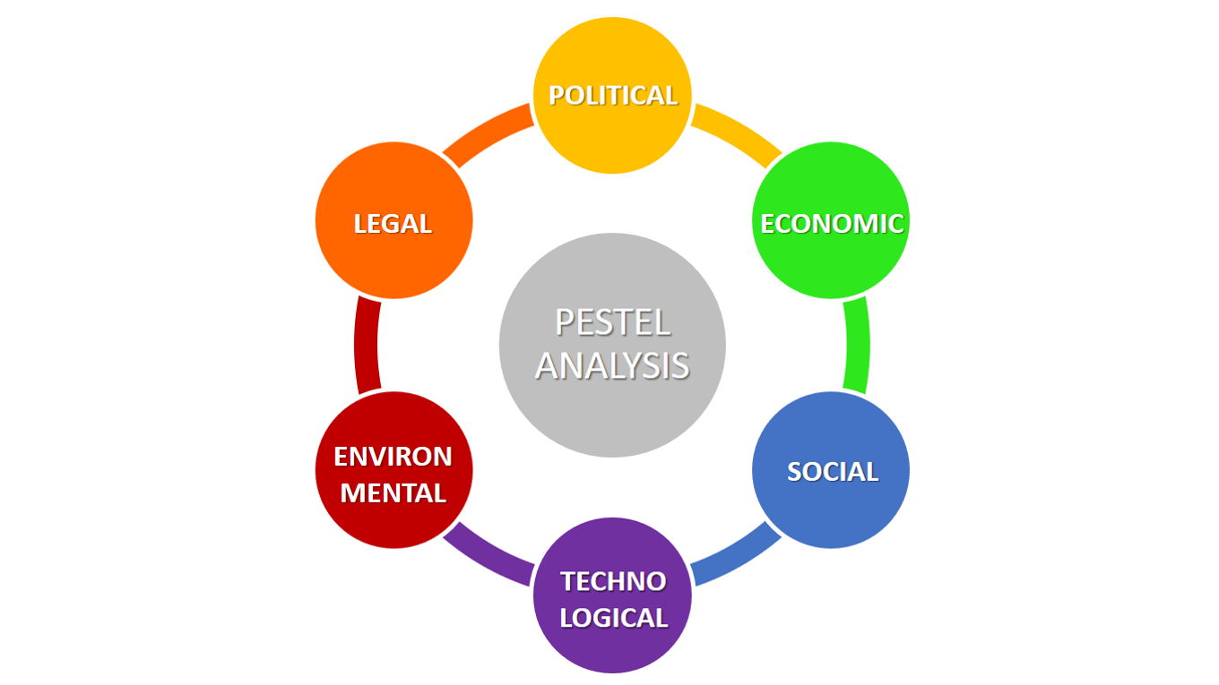
Figure: PESTEL Analysis
(Source: The Guardian, 2023)

Porter’s Five Forces
EasyJet Plc is one of Europe's most successful low-cost airlines because it has learned to adapt to a dynamic industry. They were able to do this by keeping a close eye on the actions of their rivals and adjusting their business strategy accordingly. Analysis of the external factors affecting EasyJet Plc using Porter's five forces is essential for a complete picture of the industry in which the firm operates.
The threat of new entrants: As a result of its well-known brand and extensive coverage of the European market, EasyJet Plc has gained an important competitive edge over any new competitors (MEN, 2023). As a result of the high price of aircraft and the overall complexity of the sector, there are also substantial obstacles to the entrance. The presence of several incumbents with preexisting client bases increases the challenge of breaking into the market. As a result, it's challenging for upstarts to get into the industry and create a dent in the market.
The power of suppliers: When it comes to planes, fuel, and other necessities, EasyJet Plc must rely on its suppliers. Although the company's excellent relationships with its suppliers, the market's scarcity of such businesses means that it has little leverage in negotiations. That way, the suppliers get to set the parameters of the partnership and the business has less leverage to negotiate favourable terms.
The power of buyers: Customers of EasyJet Plc may exert considerable leverage because of the abundance of alternatives. Customers are then free to look elsewhere for better deals and options (The Guardian, 2023). So, in order to attract and maintain clients, the firm should prioritise offering competitive pricing and superior service.
The threat of substitutes: Other modes of transportation, such as trains and buses, pose a threat to EasyJet Plc. If customers find that EasyJet Plc's offerings (in terms of price or quality) are not competitive, they may go elsewhere. The corporation is also susceptible to the development of new technology, like self-driving vehicles, which may reduce the need for air travel and hence harm the company's profits.
Level of rivalry among existing competitors: Competitors in the low-cost airline business are many and fierce. This fuels fierce rivalry among the industry's major players, making it tough for EasyJet Plc to set itself apart (Nanni, 2022).
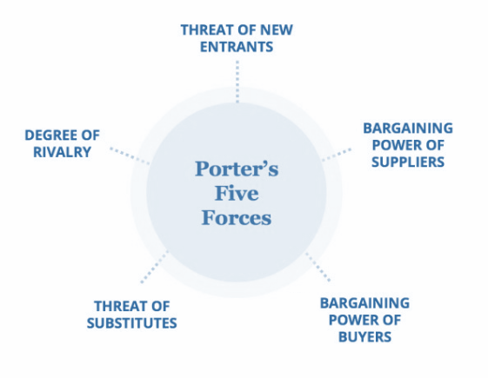
Figure: Porter’s Five Forces
(Source: The Guardian, 2023)
EasyJet Plc has recognised the necessity to adjust its operations and strategy in response to the dynamic nature of the market. The firm has taken a number of steps to ensure its continued success in this market, including cutting expenses, improving customer service, and broadening its distribution system. The firm has been able to adapt to the evolving market and maintain its competitive edge thanks to these efforts.

Exploring Easy Jet Plc's Ethical Practices and their Benefits
EasyJet Plc flies to over 130 different cities across 34 different countries. EasyJet has quickly become a favourite of both vacationers and businesspeople because of the company's dedication to offering excellent service at a reasonable price, doing business ethically, and caring about the communities in which it operates (Easyjet, 2023).
The manner EasyJet operates is illustrative of the company's commitment to ethics. The firm is dedicated to long-term prosperity and has implemented a variety of sustainable practices and programmes to that end. They include protecting the natural world, standing up for civil liberties, and encouraging moral shopping.
EasyJet has implemented several environmental policies and programmes in an effort to lessen its impact on the environment. The corporation has implemented waste reduction plans, researched and developed more fuel-efficient engines and planes, and embraced alternative energy sources (Hasan et al., 2021). In addition, EasyJet has vowed to lessen the effect of its aircraft on surrounding areas by implementing a noise abatement strategy.
EasyJet is likewise committed to upholding human rights. The United Nations Guiding Principles on Business and Human Rights have been embraced by the corporation, which also includes a Human Rights Department. There are no rules in place that allow for discrimination against workers on the basis of their race, religion, gender, sexual orientation, or handicap, and the corporation makes it a point to treat all employees with dignity and respect.
As an added bonus, EasyJet has implemented many policies that encourage responsible shopping. Suppliers must avoid exploiting workers, providing them with unhealthy working circumstances, and using child labour, among other ethical and environmental criteria, as stated in the company's ethical buying policy (Hennart, 2019). Moreover, the firm collaborates with neighbourhood groups to encourage eco-friendly vacationing by bolstering existing companies and minimising negative effects on the environment.
EasyJet has reaped several advantages as a result of committing to ethical business practises. By adhering to these guidelines, the firm has expanded its clientele and earned a name for itself as one that prioritises ethics and social responsibility. As a consequence, people have seen an increase in both client loyalty and revenue. Customers are more inclined to pick a firm that is regarded to be doing the right thing, therefore EasyJet's embrace of ethical standards has given it a competitive edge over its competitors (Kassem, Salama and Ganepola, 2023).
The company's staff has also benefited from the implementation of ethical standards. The organisation has been successful in attracting and keeping top talent because its workers believe their needs and ideals are being taken into account. Benefiting the firm and its stakeholders, the company's dedication to ethical standards has helped it develop good connections with its suppliers, partners, and local communities.

Recommendations to Easy Jet Plc to Address Environmental and Ethical Challenges and Improve Performance
British low-cost airline EasyJet Plc flies to hundreds of locations throughout Europe and beyond. The airline's environmental and ethical policies have been under increased scrutiny in recent years. EasyJet Plc has to take significant measures to address these difficulties if it is to enhance its performance.
EasyJet Plc's carbon emissions are a major concern for the environment. The airline's carbon emissions have skyrocketed over the last decade, and the business now has a responsibility to take measures to mitigate its effect on the environment. Investing in more fuel-efficient planes and engines is the first step towards this goal since they will cut down on emissions per passenger kilometre flown. Using renewable fuels like biofuels or hydrogen in EasyJet Plc's operations is another way to lessen the company's impact on the environment (Nanni, 2022). To offset its emissions, a business might finance carbon-offsetting programmes like tree-planting campaigns.
EasyJet Plc has another environmental problem with the way it handles trash. There is a great deal of trash created by the aircraft, including discarded food and packaging. EasyJet Plc has to take action to reduce the amount of trash produced and make sure it is properly discarded. It is possible to accomplish this goal by switching to more environmentally friendly packaging and instituting a recycling and composting programmes (Silling, 2019). In addition, EasyJet Plc may work with community groups to guarantee proper trash disposal.
EasyJet Plc has an ethical obligation to treat its workers with dignity and respect their rights. Fair compensation and benefits, as well as a secure and encouraging workplace, may help accomplish this goal. EasyJet Plc also has a responsibility to make sure that its vendors are acting ethically and legally. The creation of codes of conduct and the subsequent monitoring of vendors to guarantee their adherence to these standards may accomplish this goal.
The time has come for EasyJet Plc to take measures to lessen the toll it takes on the environment and local communities. Sustainable techniques, such as using less water, producing less waste, and cutting down on noise pollution, may help accomplish this goal (BBC, 2023). In addition, EasyJet Plc may make investments in regional projects, such as expanding access to local education or fostering economic growth.

Conclusion
In conclusion, EasyJet Plc's dedication to ethical standards and corporate responsibility has paid off in the form of enhanced consumer loyalty, higher earnings, stronger staff engagement, and better interactions with the company's stakeholders. Hence, EasyJet's embrace of ethical principles has been, and will likely continue to be a fruitful approach.
EasyJet Plc has to take significant and effective action to address its environmental and ethical concerns if it wants to enhance its performance. It's possible for the firm to put money into carbon offsetting projects, renewable fuels, and planes and engines that use less gas. EasyJet Plc also has a duty to treat its workers and vendors fairly and to properly dispose of its trash. At last, the business must take measures to lessen its negative effects on the environment and fund community projects. By making these changes, EasyJet Plc will be able to boost its efficiency and conduct its business in a more ethical and sustainable way.

Reference
Ambrose, S. and Waguespack, B., 2021. Fundamentals of Airline Marketing. Routledge.
Ayele, Y., Borchert, I., Gasiorek, M., Holmes, P., Jerzewska, A., Morita-Jaeger, M. and Walmsley, S., 2022. Not so frictionless after all: trade in goods and services in the EU-UK Trade and Cooperation Agreement. In Research Handbook on Legal Aspects of Brexit (pp. 148-174). Edward Elgar Publishing.
BBC, 2023, “Easyjet”, Available at https://www.bbc.com/news/topics/c302m85q52jt/easyjet [Accessed on 20th March 2023]
EasyJet, 2023, “About us”, Available at https://corporate.easyjet.com/about/what-we-do [Accessed on 20th March 2023]
ES, 2023, “Easyjet”, Available at https://www.standard.co.uk/topic/easyjet [Accessed on 20th March 2023]
Hasan, M.A., Mamun, A.A., Rahman, S.M., Malik, K., Al Amran, M.I.U., Khondaker, A.N., Reshi, O., Tiwari, S.P. and Alismail, F.S., 2021. Climate change mitigation pathways for the aviation sector. Sustainability, 13(7), p.3656.
Hennart, J.F., 2019. Digitalized service multinationals and international business theory. Journal of International Business Studies, 50, pp.1388-1400.
Independent, 2023, “Easyjet”, Available at https://www.independent.co.uk/topic/easyjet [Accessed on 20th March 2023]
Kachi, A., Mooldijk, S. and Warnecke, C., 2020. Climate neutrality claims. How to distinguish between climate leadership and greenwashing. New Climate Institut.
Kassem, R., Salama, A. and Ganepola, C.N., 2023. CSR, credibility, employees' rights and legitimacy during a crisis: a critical analysis of British Airways, WizAir and EasyJet cases. Employee Relations: The International Journal, 45(1), pp.1-20.
Marinakou, E., 2022. Post-pandemic Factors Influencing Job Satisfaction Among Airline Crew: A Comparative Study of Two Airlines. JOURNAL OF TOURISM. RESEARCH, p.5.
MEN, 2023, “EASYJET”, Available at https://www.manchestereveningnews.co.uk/all-about/easyjet [Accessed on 20th March 2023]
Nanni, A., 2022. Sustainability transition challenges for low-cost airline from E-aviation technologies and solutions.
Panduwinasari, E., Afandi, A. and Wahyuni, H., 2020, April. Low Cost Carrier in Airlines: In Terms of Cost Perspective. In 1st Annual Management, Business and Economic Conference (AMBEC 2019) (pp. 84-89). Atlantis Press.
Rotondo, F., Corsi, K. and Giovanelli, L., 2019. The social side of sustainable business models: An explorative analysis of the low-cost airline industry. Journal of Cleaner Production, 225, pp.806-819.
Silling, U., 2019. Aviation of the future: What needs to change to get aviation fit for the twenty-first century. In Aviation and Its Management-Global Challenges and Opportunities. IntechOpen.
SN, 2023, “Easyjet”, Available at https://news.sky.com/topic/easyjet-6784 [Accessed on 20th March 2023]
Statista, 2022, “Annual revenue of easyJet plc from 2009 to 2021(in million GBP)”, Available at https://www.statista.com/statistics/1007546/revenue-easyjet-plc/ [Accessed on 20th March 2023]
Taylor, S. and Perkins, G., 2021. Work and Employment in a changing business environment. Kogan Page Publishers.
The Guardian, 2023, “EASYJET”, Available at https://www.theguardian.com/business/easyjet [Accessed on 20th March 2023]

