Name: Nicoleta Briceag
Student number: 1914033
Module: LCBB4005 The Global Business Environment
Assignment 1: Car Manufacturing Industry
Lecturer: Syed Jaffery

Table of Contents
Introduction 3
Major Forces Shaping the Business Environment: An Analysis 3
Changes within the Industry in the Past Few Years and Identified Forces Shaping Business of Car Manufacturing Industry 3
Models and Frameworks for Evaluating the Business Environment of the Automobile Manufacturing Industry 6
Opportunities and Challenges Imposed by these Forces 11
Conclusion 14
Reference List 15

Introduction
The technological advancements in every sector have been motivating the organisations to develop the kind of products that would enable them to compete with the rising competition that prevails across the global market. As a result of the same, the automobile manufacturing industry has been focusing on the development or production of electric vehicles (EVs) as these offer a more reliable and green solution to the modern issue of air pollution and global warming, which basically have become a major issue for the traditional fossil fuel operated automobiles. As a result of this, there is a rising demand for the EVs, and these have been substituting the traditional vehicles in several markets such as Asia, Europe and the US. This rising demand is further amplified by the sustainability offered by these vehicles and thereby have contributed towards the rise in the market share (Mahmoudi, Flah, and Sbita, 2014) of these vehicles in the industry or the market of operation. In the following discussion, the different business environmental factors that have been influencing the automobile manufacturing industry have been explored. The example of Tesla has been considered for a better understanding of the industrial aspects.

Major Forces Shaping the Business Environment: An Analysis

Changes within the Industry in the Past Few Years and Identified Forces Shaping Business of Car Manufacturing Industry
Concepts regarding electric vehicles (EVs) have been about 100 years old, although, only in recent times has it been gaining more recognition. This is majorly due to the advancement of the technology that is facilitated by better stability of the economy, along with the necessity for an eco-friendly substitute in terms of automobiles. The introduction of the luxury sports cars by Tesla led to the hype for EVs in modern times, as the car offered 200 miles coverage in just one charge (DE, 2014). By the year 2010, Tesla had eventually begun the manufacturing of more EVs upon receiving a loan amount of $465 million from the Loan Programs Office offered by Department of Energy (DE, 2014).
Gradually, towards the end of the year 2010, many other automobile manufacturers have also initiated the manufacturing of the EVs, and the notable ones include Chevy Volt and Nissan LEAF by Chevrolet and Nissan respectively (DE, 2014). Eventually, the automobile manufacturers shifted towards the development of the hybrid cars, by making variations in the models of EVs. These hybrid cars offer the advantage of a gasoline engine that would supplement the electric drive under the circumstances of the exhaustion of the battery, thereby offering the clients with the provision of driving to the nearby charging station to renew the battery (DE, 2014).
The fresh and innovative technologies were developed for the batteries, and these were introduced in the market, which assisted with the reduction of the EV prices. Currently, in the market, clienteles have gained more options with respect to the EVs and hybrid car models, with there being 23 plug-in models and 36 models of EVs and hybrid cars, respectively (DE, 2014). The declining price of the EVs has further amplified with the increase in the gasoline price (DE, 2014). The variation in the sales of the automobiles through the years, across the global market, can be presented as follows.
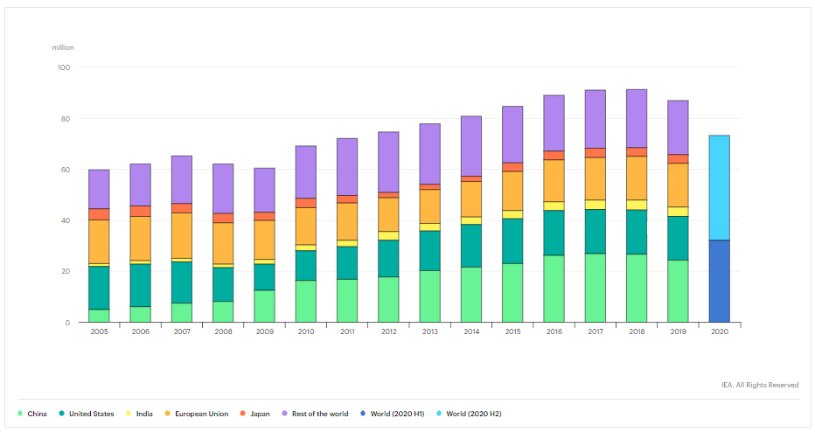
Figure 1: Global car sales by key markets, 2005-2020
(Source: IEA, 2020a)
The variation in the sales of the EVs through the period of 2010-2020 can be depicted as follows.
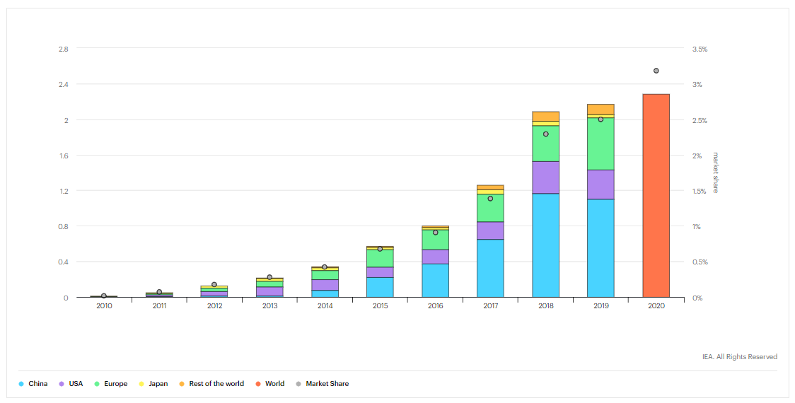
Figure 2: Global electric car sales by key markets, 2010-2020
(Source: IAE, 2020b)
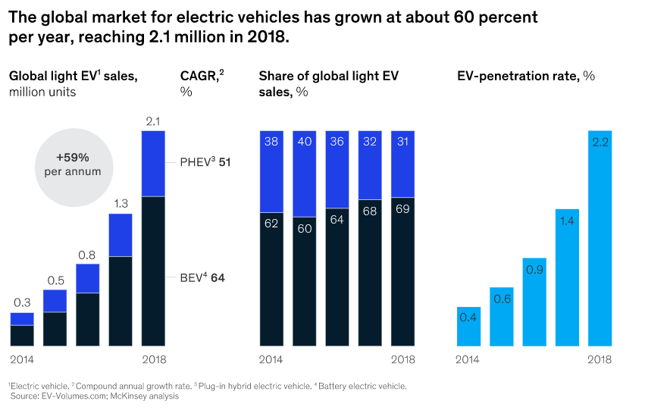
Figure 3: Global Market for Electric Vehicles in 2018
(Source: Hertzke, et al., 2019)
Based on the data that has been presented above, it can be deciphered that there has been a rise in the sales of EVs with the growth percentage being 60% every year, between the years 2014 and 2018, thereby reaching the total sales of 2.1 million by the year 2018. The projected growth of the global automotive industry has been estimated to be about $9 trillion by the year 2030, and this can be depicted as follows.
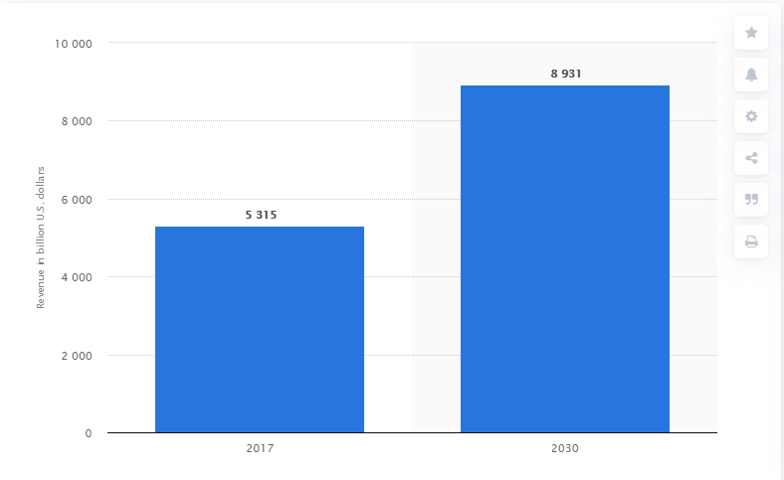
Figure 4: Global automotive industry revenue between 2017 and 2030
(Source: Statista, 2020a)

Models and Frameworks for Evaluating the Business Environment of the Automobile Manufacturing Industry
PESTLE analysis framework is one of the frameworks that can be used for evaluating the manner in which the macro environmental factors have been influencing the business of an organisation. Political factor could include the European Green Vehicle Initiative (EGVI) that have been supporting the financial backup, development and further expansion of the EVs in Europe (Musonera, and Cagle, 2019). This is further supported by the initiative in Europe, Horizon 2020, which is dedicated to delivering green vehicles and is a contractual partnership between public and private agencies that is focused towards solutions green mobility system. Economic factors could comprise of the sales that have been achieved in the leading global market during the period of 2016-2019. This can be detailed as follows.
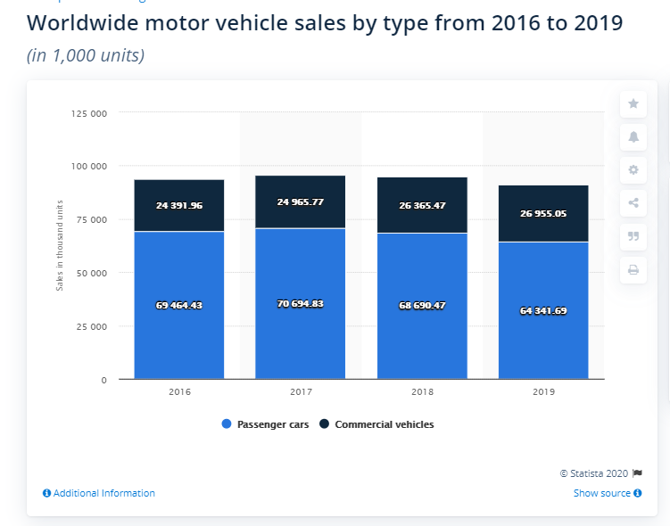
Figure 5: Worldwide motor vehicle sales by type from 2016 to 2019
(Source: Statista, 2020b)
As per the data that has been presented in the figure, it is evident that the sales of the commercial vehicles increased by 1.4 million units globally in the year 2018, whereas the sales of the passenger vehicles decreased to 68.7 million for the year (Statista, 2020b).
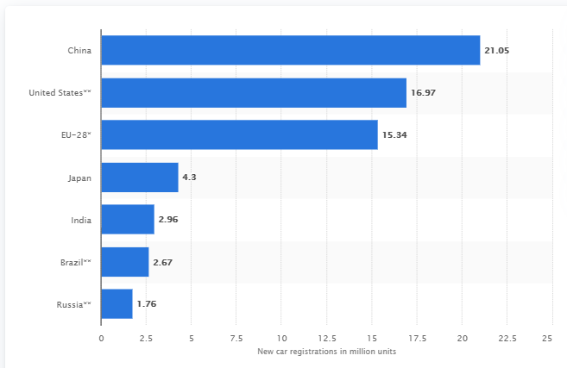
Figure 6: Largest automobile markets worldwide in 2019, based on new car registrations
(Source: Statista, 2020c)
It has also been estimated that the sales of the EV by the year 2020 would be between the range of 10 - 12 % of the overall sales of the cars (Musonera and Cagle, 2019), although, the purchase price is considered to be the major challenge hindering the further penetration of EVs in the automobile market. The rise in the GDP of a market also facilitates the increase in the sales of cars (Mounce and Nelson, 2019).
Social factors would focus on the EU customers who have a lack of knowledge for the EVs, and do not possess much expertise regarding the usage of these vehicles. However, as witnessed during the three months trial that occurred between the period 2009-2012, it can be said that the outlook of the clients can be altered as about 340 EVs were tested by the EU consumers and several of them claimed EVs would provide them with the satisfaction level similar to that of traditional vehicles when daily charging of the batteries is also included (Musonera and Cagle, 2019). The following data elucidates the trend of registrations of new cars in the EU market.
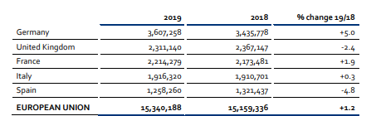
Figure 7: Top 5 – New passenger car registrations in the EU
(Source: ACEA, 2020)
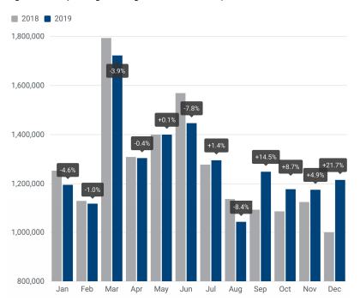
Figure 8: New passenger car registrations in the EU | 12‐month trend
(Source: ACEA, 2020)
Technological factor details the attributes that one battery of EVs is capable of covering about 100 - 120 km while a traditional vehicle covers 600 km and this negative aspect is amalgamated with the challenge of charging station establishment for convenience of the consumers for being able to charge the battery (Musonera and Cagle, 2019). Therefore, for the businesses to be able to enhance their performances, they are needed to further innovate their work so that the challenges can be overcome.
Legal factors are supported by the 2011 White Paper Roadmap that mentions that there would be a decline in the usage of traditional vehicles by 50% and thereby shall facilitate the reduction of the greenhouse gas emission prevention to about 60%, by the year 2050 (Musonera and Cagle, 2019). Environmental factors would include the usage of the fossil fuels by traditional vehicles that cause environmental pollution and global warming, while on the other hand, EVs have the potential of reducing these pollutants such as emissions levels of CO₂ NO₂ and SO₂ (Musonera and Cagle, 2019).
Porter’s five force analysis would reveal the extent of competition that prevails within the car manufacturing industry, with special reference to the EVs manufacturing. Threat of substitution is high as traditional vehicles are preferred more over EVs, by the consumers and thereby poses a threat on EVs market. Threat of new entrants is low because of the high barrier related to enter the industry. Moreover, special technologies and expertise are needed for the development of EVs, which are also expensive and require high financial expenditure (Mahmoudi, Flah, and Sbita, 2014). Therefore, companies like Tesla experience low threat with respect to new entrants.
Bargaining power of suppliers is low due to the prevalence of several suppliers capable of providing the required components for the vehicles. Moreover, organisations like Tesla, innovate and develop their own components, thereby decreasing the dependency on suppliers. Purchasing power of consumers is high, and this is intensified by the assorted array of traditional vehicles that are available in the market, in comparison to EVs, and also the switching cost is low between the EVs models, which makes it easy for the consumers to select any other vehicle of their choice, thereby placing the bargaining power in their favour (Un-Noor et al., 2017). Industrial competitive rivalry is high as EV manufacturers are fighting hard to gain the customers of the traditional vehicles. Also, there are limited companies producing EVs, thereby further intensifying the competition.
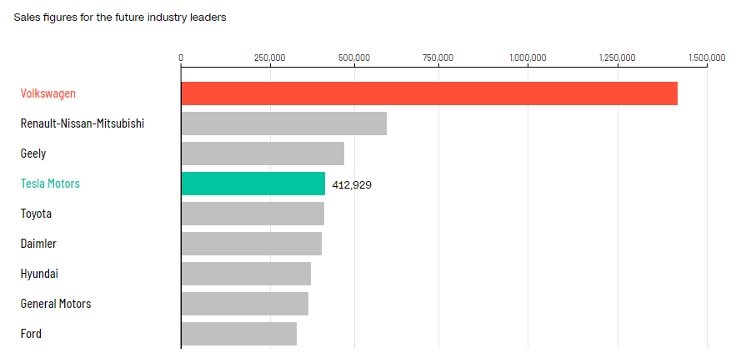
Figure 9: Top electric car manufacturers in 2025
(Source: Riley, 2019)
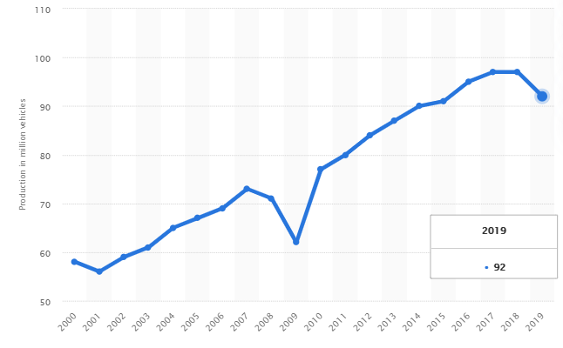
Figure 10: Estimated worldwide automobile production from 2000 to 2019
(Source: Statista, 2020d)

Opportunities and Challenges Imposed by these Forces
It has been estimated that by the year 2020, the prevalence of EVs would be one in 20 vehicles, with about 0.01% of the vehicles being fortified with fuel cells, which is nearly 16,000 units annually (Sharma et al., 2016). The trend that is associated with the global electrified powertrain estimated for the period between 2011 and 2020 can be depicted as follows.
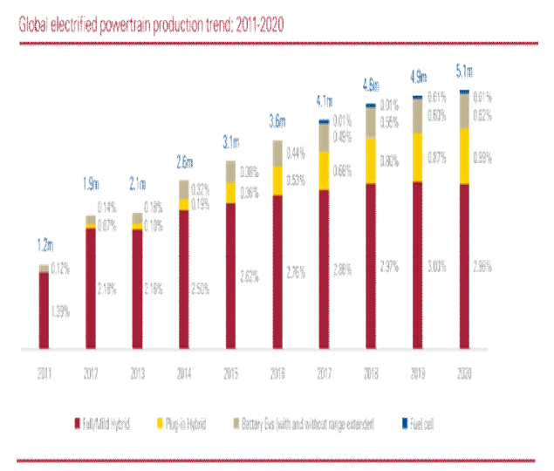
Figure 11: Trend of Global Electrified Powertrain: 2011-2020
(Source: Sharma, et al., 2016)
The global EV forecast that has been conducted by J P Morgan (2018) can be presented as follows.
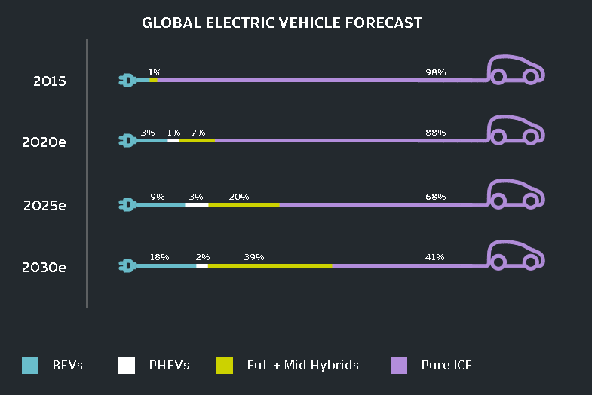
Figure 12: Global Electric Vehicle Forecast
(Source: JP Morgan, 2018)
It has been estimated that the EVs would overtake the traditional vehicles in terms of sales, by the year 2040. This can be better illustrated with the help of the following figure.
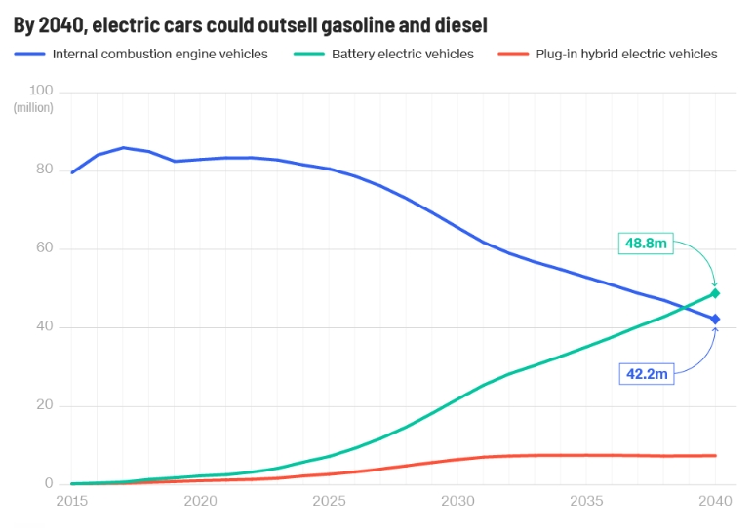
Figure 13: Sales Comparison between Traditional and Electric Vehicles
(Source: Riley, 2019)
With the growing concern related to the global climate change, amalgamated with the rising price of fossil fuels, there has been an increase in the drive towards the manufacture of the electric cars and these are becoming more desirable in contrast to the ICE (internal combustion engine) vehicles. The presence of electric motors of the EVs react rapidly, thereby presenting high responsiveness and good torque. Moreover, these are digitally connected, in contrast to traditional vehicles and certain EV charging stations offer the option of controlling the battery charging through their smartphone apps (OEERE, 2020).
The major challenges that have been identified include diverging markets, shifting landscape of the industry, digital demands and complexity and cost pressure, The market shares of emerging markets with respect to the global sales are expected to rise to 60% by 2020, against 50% in 2012, with the rise in the share of global profits being estimated to be 10% points (McKinsey & Company, 2013). However, the major challenge that is identified to be currently affecting the automobile industry is the Covid-19 pandemic and the associated economic losses that have resulted from the lockdown of the markets.
The Covid-19 pandemic has had a severe effect on the global economy and has affected the key EVs market as well. Within the first quarter of 2020, there has been an unprecedented decrease in the global car sales, with the same being estimated to be one third in comparison to the sales achieved in this period for the year 2019; around 9 million fewer cars being sold in this period (Gül, Gorner, and Paoli, 2020). The monthly decline in sales has been more severe, with the largest car market, China, experiencing a decline of nearly 80% in comparison to 2019. Irrespective of the decline in sales across global car market, the EVs have been experiencing high demands, and it is expected that the sales of EVs could achieve a record share this year for the global car market (Gül, Gorner, and Paoli, 2020).
Based on the challenges and opportunities that have been identified, it can be mentioned that automobile manufacturing organisations such as Tesla are needed to position themselves in such manner that they are able to attract the attention of the consumers and able to gain the sales that is being anticipated with respect to the automobile market, particularly with respect to the EVs.

Conclusion
To conclude, it can be stated that the global automobile manufacturing industry has been gaining high growth and popularity, which has been intensified due to the production of electric vehicles. However, there has also been a rise in the competition within the industry with respect to the production and sales of the most preferred vehicles. Irrespective of the growth that has been experienced, the Covid-19 pandemic had severely affected the industry as the global economy has also been influenced by the pandemic and its associated lockdown. However, there prevails the anticipation that the electric vehicles would eventually rise in the sales irrespective of the damage done to the industry due to Covid-19 pandemic.

Reference List
ACEA, 2020. Economic and Market Report | EU Automotive Industry: Full‐year 2019. [pdf] Available at: <https://www.acea.be/uploads/statistic_documents/Economic_and_Market_Report_full-year_2019.pdf> [Accessed 24 July 2020].
DE, 2014. The History of the Electric Car. [online] Available at: <https://www.energy.gov/articles/history-electric-car> [Accessed 24 July 2020].
Gül, T., Gorner, M. and Paoli, L., 2020. As the Covid-19 crisis hammers the auto industry, electric cars remain a bright spot. [online] Available at: <https://www.iea.org/commentaries/as-the-covid-19-crisis-hammers-the-auto-industry-electric-cars-remain-a-bright-spot> [Accessed 24 July 2020].
Hertzke, P., Müller, N., Schaufuss, P., Schenk, S., and Wu, T., 2019. Expanding electric-vehicle adoption despite early growing pains. [online] Available at: <https://www.mckinsey.com/industries/automotive-and-assembly/our-insights/expanding-electric-vehicle-adoption-despite-early-growing-pains> [Accessed 24 July 2020].
IEA, 2020a. Global car sales by key markets, 2005-2020. [online] Available at: <https://www.iea.org/data-and-statistics/charts/global-car-sales-by-key-markets-2005-2020> [Accessed 24 July 2020].
IEA, 2020b. Global electric car sales by key markets, 2010-2020. [online] Available at: <https://www.iea.org/data-and-statistics/charts/global-electric-car-sales-by-key-markets-2010-2020> [Accessed 24 July 2020].
J.P.Morgan, 2018. Driving into 2025: The Future of Electric Vehicles. [online] Available at: <https://www.jpmorgan.com/global/research/electric-vehicles> [Accessed 24 July 2020].
Mahmoudi, C., Flah, A. and Sbita, L., 2014, November. An overview of electric vehicle concept and power management strategies. In 2014 International Conference on Electrical Sciences and Technologies in Maghreb (CISTEM) (pp. 1-8). IEEE.
McKinsey & Company, 2013. The road to 2020 and beyond: What’s driving the global automotive industry? [pdf] Available at: <https://www.mckinsey.com/~/media/mckinsey/dotcom/client_service/Automotive%20and%20Assembly/PDFs/McK_The_road_to_2020_and_beyond.ashx> [Accessed 24 July 2020].
Mounce, R. and Nelson, J.D., 2019. On the potential for one-way electric vehicle car-sharing in future mobility systems. Transportation Research Part A: Policy and Practice, 120, pp.17-30.
Musonera, E. and Cagle, C., 2019. Electric Car Brand Positioning in the Automotive Industry: Recommendations for Sustainable and Innovative Marketing Strategies. Journal of Strategic Innovation and Sustainability, 14(1), pp.120-133.
OEERE, 2020. Electric Vehicle Benefits. [online] Available at: <https://www.energy.gov/eere/electricvehicles/electric-vehicle-benefits> [Accessed 24 July 2020].
Riley, C., 2019. The great electric car race is just beginning. [online] Available at: <https://edition.cnn.com/interactive/2019/08/business/electric-cars-audi-volkswagen-tesla/> [Accessed 24 July 2020].
Sharma, K.V.M., Kulkarni, M.R., Veerendra, G.P. and Karthik, N., 2016. Trends and challenges in electric vehicles. International Journal of Innovative Research in Science, Engineering and Technology, 5(5), pp.8589-8596.
Statista, 2020a. Global automotive industry revenue between 2017 and 2030. [online] Available at: <https://www.statista.com/statistics/574151/global-automotive-industry-revenue/ > [Accessed 24 July 2020].
Statista, 2020b. Worldwide motor vehicle sales by type from 2016 to 2019. [online] Available at: <https://www.statista.com/statistics/1097326/worldwide-motor-vehicle-sales-by-type/> [Accessed 24 July 2020].
Statista, 2020c. Largest automobile markets worldwide in 2019, based on new car registrations. [online] Available at: <https://www.statista.com/statistics/269872/largest-automobile-markets-worldwide-based-on-new-car-registrations/> [Accessed 24 July 2020].
Statista, 2020d. Estimated worldwide automobile production from 2000 to 2019. [online] Available at: <https://www.statista.com/statistics/262747/worldwide-automobile-production-since-2000/> [Accessed 24 July 2020].
Un-Noor, F., Padmanaban, S., Mihet-Popa, L., Mollah, MN and Hossain, E., 2017. A comprehensive study of key electric vehicle (EV) components, technologies, challenges, impacts, and future direction of development. Energies, 10(8), p.1217.

