Leo Pietrapertosa (2219977)

Evidence of Learning E-Portfolio
BMPS4010

Blog 1
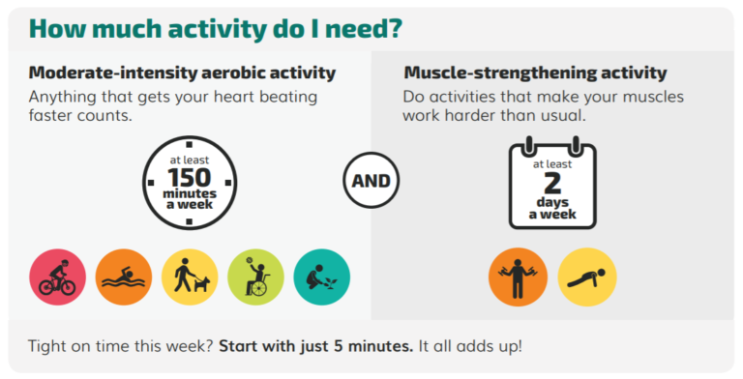
(CORA Development team, 2020)

After doing research it is evident to see that one of the biggest threats to humankind is the lack of physical activity. World health organisation (WHO) (2022) describes physical activity as any form of movement produced from muscles that require energy. Being physically active is vital for reducing risk of cardiovascular health, where in the United States heart disease and strokes are the two most common causes for death (Centers for Disease Control and Prevention, 2021). In addition to this 1 in 4 adults globally do not meet the recommended amount of physical activity (WHO, 2022). This is a concerning statistic as 1 in 4 adults will have more vulnerability to health conditions caused by inactivity.
People who sit for hours at a time increase their risk to developing chronic diseases such as diabetes, heart disease, dementia and certain types of cancer and people living a sedentary lifestyle are more prone to having an early death (Diaz, 2023). This is concerning as since the covid 19 pandemic in 2019 sitting down and working from home has become much more popular and normal. It is shown that in February 2022, 42% of workers planned to use a hybrid pattern of working from home mostly and sometimes going to the usual workplace which is a rise from 30% in April 2021 (Office for National Statistics, 2022). Although office jobs do not tend to have much activity the actions of walking to the car in the morning and walking to get lunch for example adds to the level of physical activity.
The NHS (2021) states that a healthy adult should participate in 150 minutes of moderate intensity exercise or 75 minutes of vigorous intensity exercise every week spread across 4 to 5 days. This physical activity could be activities such as going to the gym, joining a sports team, or going for a walk. Adults should also train major muscle groups at a moderate intensity 2 days a week (WHO, 2022).
In 2018, the world health assembly agreed that 15% reduction of physical inactivity is the target to hit by 2030 (WHO, 2022). This can be seen as a realistic target but because of the covid 19 pandemic many people became more inactive. A few ways to make this more achievable is to get local councils to introduce more ways to get active, such as outdoor gyms, parks, and more walkways.
It is important to implement activity at an early age and quite easy to do so. This is vital as only 17.5% of children and young people are reported to have taken part in physical activity for 60 minutes a day meeting UK CMO guideline (Public Health England, 2020). These guidelines being all children should participate in 60 minutes of physical activity every day across the week whether that being a PE lesson or extracurricular activities, engage in several types and intensities of physical activity and to minimise the amount of time sitting still and to break up long times spent sedentary with light activity (Public Health England, 2020). These guidelines are a huge step forward in fighting against one of the biggest threats to humankind.

Centers for Disease Control and Prevention (2021). Benefits of physical activity. [online] CDC.gov. Available at: https://www.cdc.gov/physicalactivity/basics/pa-health/index.htm.
CORA Development team (2020). How Much Physical Activity Do You Need? Remove Barriers, Move Your Way. [online] CORA Physical Therapy. Available at: https://www.coraphysicaltherapy.com/how-much-physical-activity-do-you-need-remove-barriers-move-your-way/ [Accessed 9 Mar. 2023].
Diaz, K. (2023). Sitting all day is terrible for your health – now, a new study finds a relatively easy way to counteract it. [online] The Conversation. Available at: https://theconversation.com/sitting-all-day-is-terrible-for-your-health-now-a-new-study-finds-a-relatively-easy-way-to-counteract-it-197507 [Accessed 18 Feb. 2023].
NHS (2021). Physical Activity Guidelines for Adults Aged 19 to 64. [online] nhs.uk. Available at: https://www.nhs.uk/live-well/exercise/exercise-guidelines/physical-activity-guidelines-for-adults-aged-19-to-64/.
Office for National Statistics (2022). Is Hybrid Working Here to stay? - Office for National Statistics. [online] Office for National Statistics. Available at: https://www.ons.gov.uk/employmentandlabourmarket/peopleinwork/employmentandemployeetypes/articles/ishybridworkingheretostay/2022-05-23.
Public Health England (2020). What works in schools and colleges to increase physical activity? [online] Available at: https://assets.publishing.service.gov.uk/government/uploads/system/uploads/attachment_data/file/876242/Guidance_to_increase_physical_activity_among_children_and_young_people_in_schools_and_colleges.pdf.
World Health Organisation (2022). Physical activity. [online] Physical activity. Available at: https://www.who.int/news-room/fact-sheets/detail/physical-activity.

Blog 2

(Clinton Matthews, 2019)
When researching vital skills needed to join the police or the National Crime Agency (NCA) as an investigator, one of the greatest skills that is required is critical and analytical thinking. Beyer (1995), defines critical thinking as, “making clear, reasoned judgments.” (University of Essex, 2016). According to the NCA (2023), as an investigator you would be making arrests, searches and building case files. Therefore, critical thinking is vital when doing research into the suspects when building the case files, when interviewing suspects and when making judgments on strategies to pursue suspects. One important thing to consider when thinking critically and analytically is whether the information is true or whether it is disinformation or misinformation.
Disinformation is defined as information that is deliberately spread with a malicious intent (Oxford learners dictionaries, 2023). This can be viewed as hoaxes and propaganda. When policing and investigating certain crimes disinformation can be put in place to interrupt investigation into the crimes committed. Regarding policing, if officers start to try and police fake news and disinformation could cause individuals civil unrest, disorder, and outright panic (Mills, 2019). This meaning more use of police resources that otherwise would not have to be used.
Misinformation is defined as information that is falsely spread without the intent to mislead (dictionary.com, 2018). This can be rumours that are spread. Similarly, to disinformation this can cause interruption to suspect leads within policing and investigation which will further strain the abilities of the policing service.
Another important thing that police officers need to consider when thinking critically is avoiding implicit bias. Implicit bias is unconscious associations, beliefs, or attitudes toward social groups, because of implicit bias, people often ascribe certain qualities and traits to all members of a particular group. This is a phenomenon known as stereotyping (Cherry, 2020). This is important to be avoided by police officers and investigators when pursuing suspects as some people may pursue suspects due to prejudice on race, gender, and socioeconomic backgrounds.
More important skills as a police officer or investigator are conflict management and negotiation skills. College of Policing (2020) says that officers and staff find ways of managing conflict without using any sort of force. Communication is needed when training in specialist roles such as public order, crisis negotiation and firearms (College of Policing, 2020). Officers will regularly put themselves in situations of high conflict with dangerous offenders so being able to talk and manage the conflict without any force is vital to ensuring the safety of both the officer and the offender.
Negotiation is where you come to an agreement over an issue between people. To do this the individual should compromise and argue until the people in disagreement can come to an agreement (Skillsyouneed, 2011). Negotiation is especially important when conducting interviews to get information on a case. Also, it can be important when there is disagreement among staff on how to pursue suspects and it is vital that the staff come to a swift decision. Therefore, negotiation is especially important in policing roles.
Cherry, K. (2020). Is It Possible to Overcome Implicit Bias? [online] Verywell Mind. Available at: https://www.verywellmind.com/implicit-bias-overview-4178401.
Clinton Matthews (2019). Vincy cops trained in hostage negotiation – iWitness News. [online] www.iwnsvg.com. Available at: https://www.iwnsvg.com/2019/06/24/vincy-cops-trained-in-hostage-negotiation/ [Accessed 9 Mar. 2023].
dictionary.com (2018). the definition of misinformation. [online] www.dictionary.com. Available at: https://www.dictionary.com/browse/misinformation.
Mills, G. (2019). Why LE needs to prepare for the disinformation era. [online] Police1. Available at: https://www.police1.com/chiefs-sheriffs/articles/why-le-needs-to-prepare-for-the-disinformation-era-8AgmShfpEXwW1RrK/ [Accessed 23 Feb. 2023].
NCA (n.d.). NCA Investigator. [online] nationalcrimeagency.gov.uk. Available at: https://nationalcrimeagency.gov.uk/careers/ncaroles/nca-investigator [Accessed 23 Feb. 2023].
Oxfordlearnersdictionaries.com. (2023). disinformation noun - Definition, pictures, pronunciation and usage notes | Oxford Advanced Learner’s Dictionary at OxfordLearnersDictionaries.com. [online] Available at: https://www.oxfordlearnersdictionaries.com/definition/english/disinformation [Accessed 23 Feb. 2023].
Skillsyouneed (2011). What is Negotiation? - Introduction to Negotiation | SkillsYouNeed. [online] Skillsyouneed.com. Available at: https://www.skillsyouneed.com/ips/negotiation.html.
University of Essex Online. (2016). The importance of critical thinking | University of Essex Online. [online] Available at: https://online.essex.ac.uk/blog/the-importance-of-critical-thinking/.

Blog 3

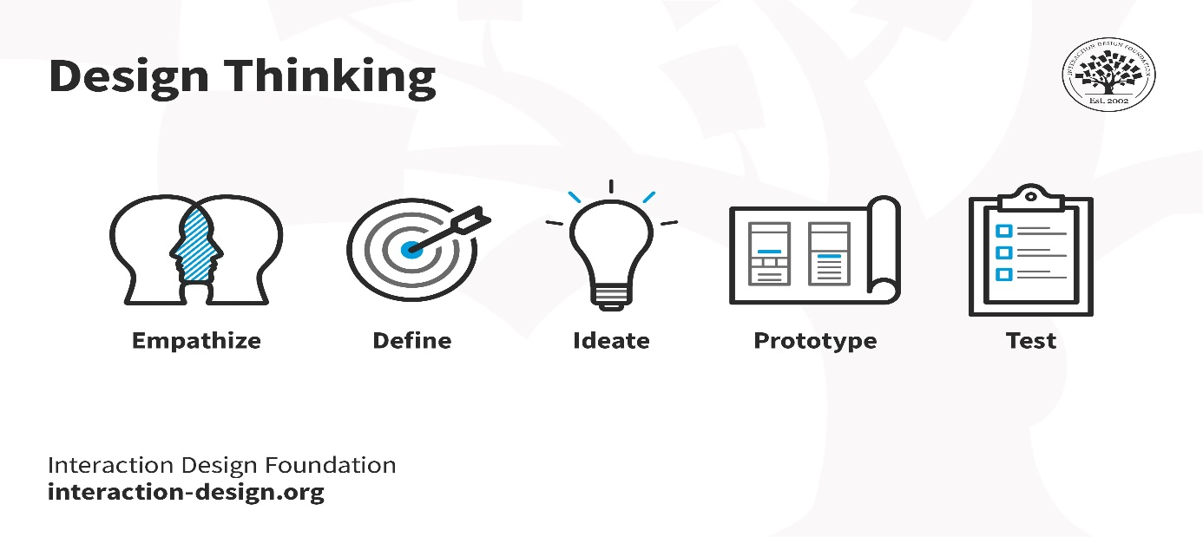(Yu Siang, 2009)

Design thinking is a non-linear, iterative process teams use to understand users, challenge assumptions, redefine problems, and create innovative solutions for prototyping and testing. It has five phases: Empathize, Define, Idea, Prototype, and Test, and is most useful for tackling poorly defined or unknown problems. (Yu Siang, 2009). Within policing design thinking can be incredibly important in defining and solving complicated and complex cases.
A key value of design thinking is to provide a defined innovation process. Trial and error are effective ways to test and experiment with what works and what does not, but it is often time consuming, expensive, and ineffective. On the other hand, following the concrete steps of design thinking is an efficient way to develop new and innovative solutions (Han, 2022).
The first stage of design thinking is empathize. during this stage, design teams set aside their own biases and work to gain a deeper understanding of real users and their needs—often through direct observation and engagement. (Gupta, 2020).
The second step is to define the problem. In this phase, the designer analyses the data collected in the previous phase to identify and define the problem in a clear and concise problem statement. (Murtell, 2021).
ideating is an important part of design thinking, the stage where designers are ready to generate ideas when they reach the third stage. Teams with rich backgrounds need to plan and develop "out of the box" ideas to find new practical solutions to problems (DesignerPeople, 2019).
Prototyping phase is when the team produces key ideas and solutions to the problem, they are phasing (Dam, 2019). For example, this stage in policing can be thinking of how to tackle certain problems within the area they serve.
The testing phase is when you test out the solutions that was put together in the prototyping phase producing the best possible solution to fix the problem that was occurring (Dam, 2019). In policing this helps build case reports that will help other cases in the future.
Gordon (2019) describes a way design thinking was used in policing. The scenario was an incident involving a mentally ill man who ended up getting shot and killed by the officers. A team was put together to design think a situation that does not involve killing the mentally ill man. They went through the five steps of empathize, define, ideate, prototype and test. In the test ended up with the officers detaining the man with no shots fired and no force required (Gordon, 2019).
To add to this, the design thinking process forced design teams to look at different perspectives and produce solutions from different angles. The process also included a more three-dimensional approach to designing solutions. This can be much more beneficial to the relationship between the agency and the community, especially in the event of future serious incidents. Also, learning from all perspectives was an invaluable achievement. Law enforcement team members fled with mixed views, as did our community members (Gordon, 2019).
College of Policing (2020). Conflict management skills. [online] College of Policing. Available at: https://www.college.police.uk/guidance/conflict-management/conflict-management-skills.
Dam, R. (2019). 5 Stages in the Design Thinking Process. [online] The Interaction Design Foundation. Available at: https://www.interaction-design.org/literature/article/5-stages-in-the-design-thinking-process.
DesignerPeople (2019). 5 Steps of Design Thinking Process. [online] designerpeople. Available at: https://www.designerpeople.com/blog/design/5-steps-of-design-thinking-process/#3_Ideate-_Challenge_assumptions_and_create_ideas [Accessed 9 Mar. 2023].
Gordon, J. (2019). How to use design thinking to address critical issues in policing. [online] Police1. Available at: https://www.police1.com/chiefs-sheriffs/articles/how-to-use-design-thinking-to-address-critical-issues-in-policing-1bN1tbscpZtFlnD9/ [Accessed 9 Mar. 2023].
Gupta, S. (2020). What Are the 5 Stages of Design Thinking? [online] Springboard Blog. Available at: https://www.springboard.com/blog/design/design-thinking-process/.
Han, E. (2022). What Is Design Thinking & Why Is It Important? | HBS Online. [online] Business Insights Blog. Available at: https://online.hbs.edu/blog/post/what-is-design-thinking.
Murtell, J. (2021). The 5 Phases of Design Thinking. [online] American Marketing Association. Available at: https://www.ama.org/marketing-news/the-5-phases-of-design-thinking/.
Yu Siang, T. (2009). What is Design Thinking? [online] The Interaction Design Foundation. Available at: https://www.interaction-design.org/literature/topics/design-thinking.

