

Task 1 – Reading Task Template
Upload your photo of your A3 in-class notes here:
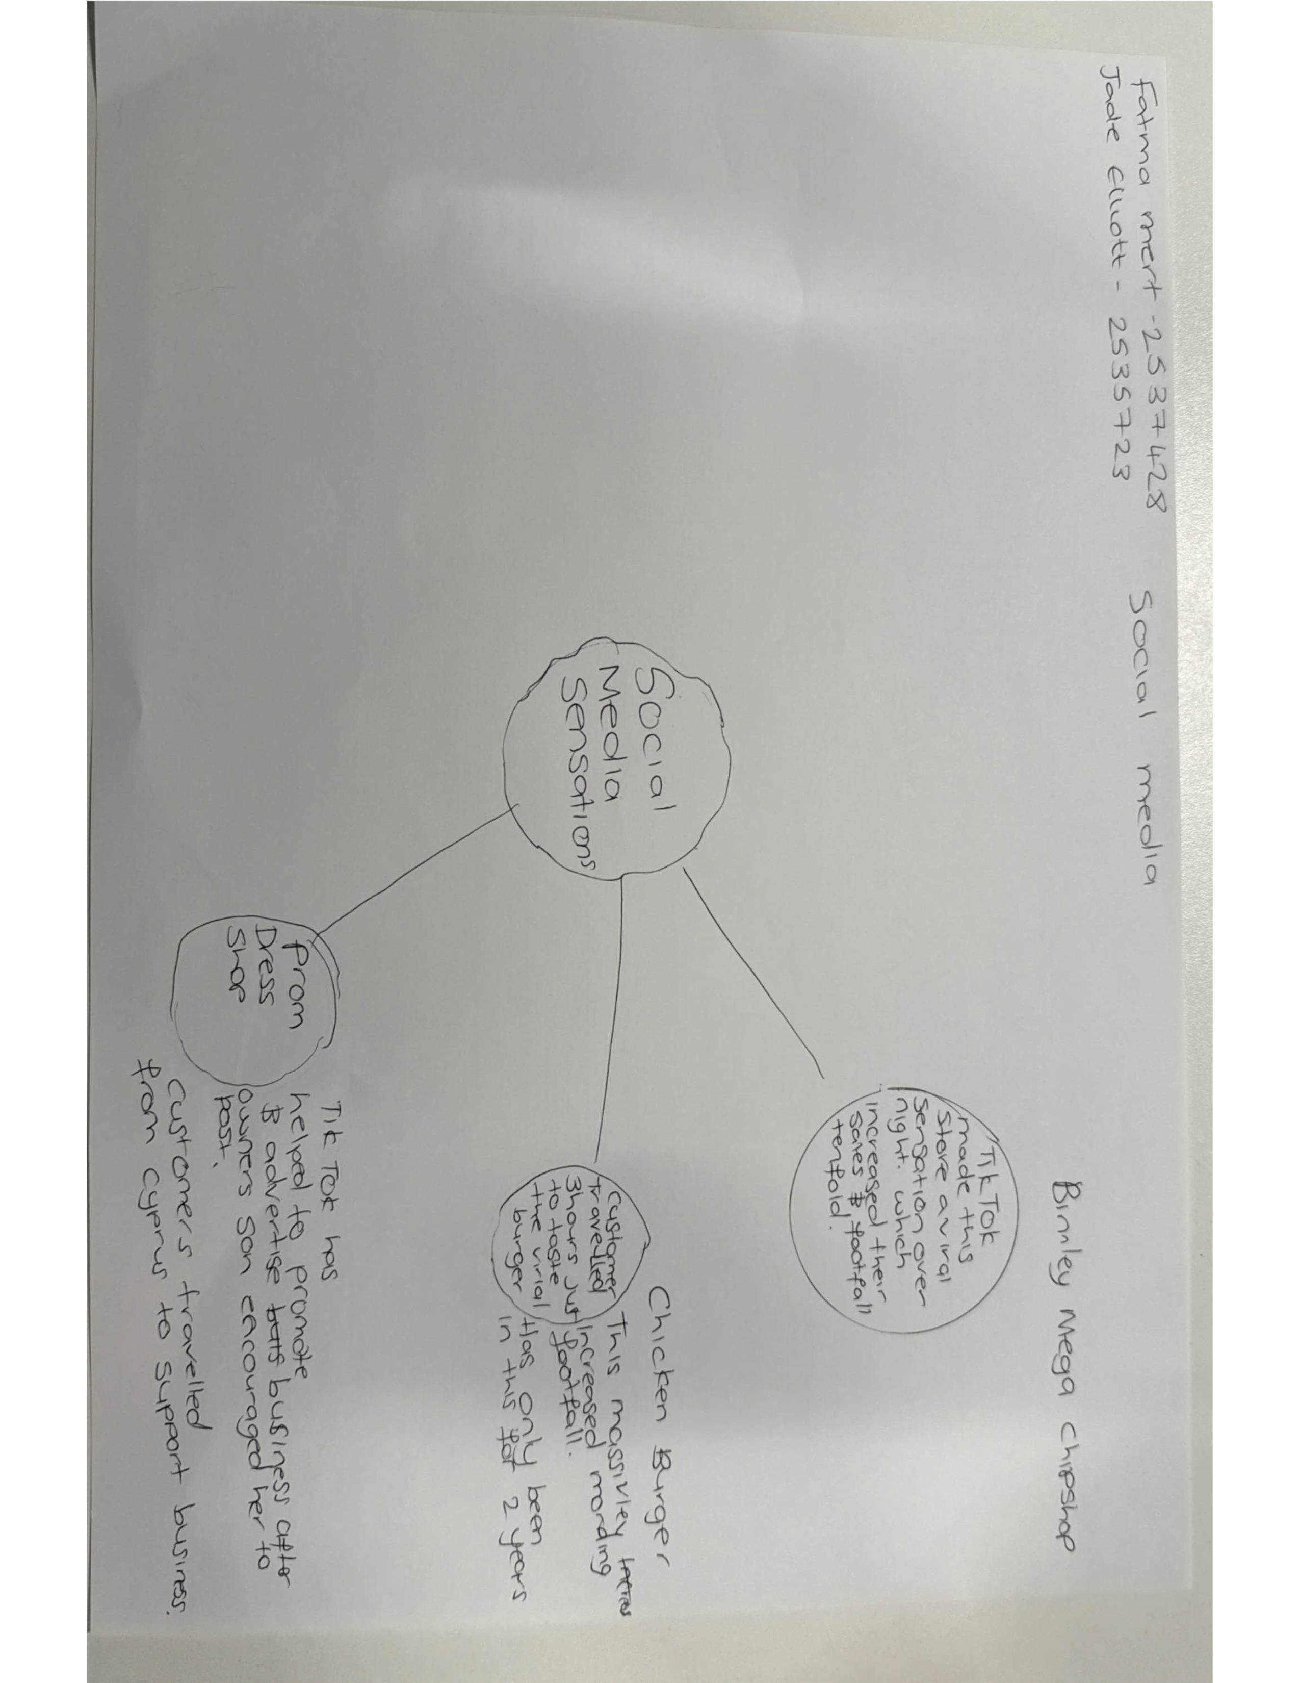

1. Answer these questions using the sentence starters below
a. What is the main idea of the text?
The main idea is that social media platforms such as TikTok and Instagram can help businesses become more popular and attract more customers to increase their sales and success.
b. What are two key points?
One key point is that businesses can gain thousands or even millions or of view on social media, which helps attract more customers.
Another key point is that customer made videos often help businesses become viral which help increase sales and profits.
c. What part of the text did you find most important? Why?
The most important part is when customers travelled hours to vist businesses they had seen on social media because it shows how powerful social media can be influencing people.
d. Was anything unclear or difficult to understand?
I was not sure about how some businesses became so viral so quickly as the article does not exactly how the videos spread online.
e. How did your group help you understand the text better?
My group helped me by discussing the examples and sharing ideas about how social media effects businesses.
3. One sentence reflection
Question: What did you find challenging about this task?
The hardest part was finding the main idea and choosing. The most relevant information from the long article.

