Millie Cayford
2305218

Targets | What I’ve done in this assignment.
Engage in an even wider range of literature which includes more credible and reliable sources. | Used google books and scholars to find relevant journals and research.
Further strengthen your critical writing by making references to literature throughout your writing. | Find positives and negatives of cross-curricular and using them to argue against each other.
Think carefully about your use of paragraphs. Avoid very long paragraphs that appear in your work. | I split my main body into two sections based on the frameworks and my resource.

Demonstrate how cross-curricular teaching and learning can influence in-depth skills and understanding, underpin this with reference to relevant research, a detailed lesson plan and an enhanced provision material.

A cross-curricular method of teaching and learning has been implemented in the Curriculum for Wales, with literacy, numeracy, and digital competency being mandatory cross-curricular skills (Welsh Government, 2022). The Curriculum for Wales has six Areas of Learning and Experiences, which include languages, literacy, and communication; maths and numeracy, science, and technology; health and well-being; humanities; and expressive arts (Welsh Government, 2019). The implementation of cross-curricular learning is considered beneficial, for it is an effective way to deliver multiple areas of learning and experiences in one topic or lesson which provides the children with transferable knowledge that can be applied to the real world and within their work (Weinstein, A. 2018). A cross-curricular method exhibits holistic characteristics whereby a child is put at the centre of their education and can explore their natural curiosities by having a say in their education (Rousseau, 1762 cited in PhD Essay, 2020). The benefits of cross-curricular learning are plentiful, such as being motivational catalysts for children, in the sense that children carry their excitement from a particular topic or subject onto another, which allows them to succeed across the curriculum (Watson, M. 2020). Children who are taught following a cross-curricular method are more likely to be creative and innovative by integrating diverse subjects. This outcome supports a child’s ability to become an enterprising and creative contributor, which is one of the four purposes. This includes using their skills and creativity to generate ideas and problem solve (Welsh Government, 2020). The initial idea of implementing a cross-curricular method was put forth by Donaldson in his report of the curriculum, ‘Successful Futures’. Donaldson (2015) suggested the six AoLEs are to be used interconnectedly to organise a child’s learning and should be completed in a creative way as decided by individual schools (Donaldson, 2015 cited in Dauncey, M. 2015). Notably, the delivery of such a curriculum does not come without its challenges, which has been recognised by Donaldson. Potential barriers to delivering a cross-curricular method of teaching can include a lack of resources, which is often a result of insufficient funding. A lack of resources can lead to increased uninterest from students, and fewer children being engaged in the lesson, which results in decreased motivation, participation, and insufficient learning (Tambayan, D. 2023). During my enrichment days, I have discovered that many schools are underfunded and must budget according to their priorities, which can often lead to funding for resources being in short supply. Another barrier to successfully delivering a cross-curriculum is the size of the classroom, whether too big or too small. For example, a classroom too large could result in poor quality feedback from the teacher and reduced individual support (Blatchford, P. 2020). An important factor of any classroom, especially larger ones, is the classroom support because group work is often completed alongside a teaching assistant. However, there can be a lack of classroom support because of lack of funding. A result of cross-curricular learning leads to an increased workload from additional planning. The issue of increased workload for teachers was investigated by the EWC in their 2021 National Workforce Survey and found that teachers worked an average of 56 hours a week, with 70% of teachers concerned with the workload because they are unable to keep up (Senedd, 2023). An increased workload led to a further increase of staff shortages with teachers choosing to leave their profession. The NASUWTs 2023 Big Question Survey revealed that almost three quarters of teachers in Wales had contemplated leaving the profession (Senedd, 2023). Without improvements to work conditions, this statistic will continue to increase.
Within the curriculum for Wales, the essential cross-curricular skills are literacy, numeracy, and digital competency to ensure children are taught essential skills from a young age. These skills integrate with the four purposes which are the basis for children’s education. They include ambitious, capable learners; enterprising, creative contributors; ethical, informed citizens; and healthy, confident individuals (Welsh Government, 2020). The skills that are developed with the integration of the four purposes include “creativity and innovation, critical thinking and problem solving, personal effectiveness, planning and organising” (Welsh Government, 2020). The essential cross-curricular skills within the curriculum for Wales have frameworks that break down the strands, elements, and progression steps, which outlines the development of children and what skills they should acquire at a certain stage in their education. These frameworks provide guidance to ensure mandatory skills are taught effectively and correctly (Welsh Government, 2020). Cross-curricular teaching allows children to combine the different aspects of their learning and provides them with transferable skills that can be used across their education (Barnes, J. 2015). Such skills derived from their cross-curricular education include the enhanced ability to think critically and logically when faced with a problem (Byrne, J. 2017). Byrne, inspired by Jonathan Barnes’ Cross-Curricular Learning 3-14, wrote that children’s problem-solving abilities improve when taught cross-curricular methods because it can strengthen “left brain-right brain”. Additionally, cross-curricular learning is beneficial for children when considering the process of learning new information and retaining it, as well as when recalling in different situations. When teaching subjects separately, children can struggle to find connections that would benefit them, for example, using existing knowledge they have in science with something new they are learning in geography (Historical Association, unknown). This method of teaching subjects together was suggested for the Welsh curriculum by Donaldson in 2015 when he reviewed the current curriculum and why it wasn’t proving successful. Donaldson (2015) suggested 6 Areas of Learning and Experiences that altogether meet the intentions of the four purposes and incorporate a more creative way to learn. However, integrating, and practising a cross-curricular method of learning can be strenuous since educational settings must create their own curriculum. Arguably, this can be problematic based on teacher knowledge because all teachers are expected to have rich knowledge on every AoLE to teach it correctly and confidently. Teachers must be equipped with subject knowledge across the curriculum and be able to teach and explain to children (Khwaja, C. 2006). Khwaja (2006) writes about the importance of teachers not only having a well-rounded understanding of what they’re teaching, but also have enough knowledge expertise to teach it in several ways to accommodate children who struggle to understand, and to also keep lessons relevant but also stimulating, inspiring and intriguing. The Department for Education (2018) stated it is difficult for primary teachers who don’t specialise in certain subjects to find appropriate resources to use in the classroom, which is an additional concern for teachers who aren’t confident in what they’re teaching. A challenge influenced by cross-curricular learning is the time-consuming element of planning to ensure sufficient inclusivity of subjects are integrated with one another, all while considering relevant and useful connections (Byrne, R. 2017). Integrating cross-curricular lessons also require additional resources that may not be available to the school due to lack of funding, which is particularly applicable for subscription-based resources (DfE, 2018). I have witnessed the effects of lack of funding for subscription-based resources during my enrichment experience whereby an online programme that supported spelling, reading, phonics, and maths could no longer be afforded and the negative responses from parents were plentiful because their children did not work well with other online programmes and believed their progress would be hindered. As stated by the Department for Education (2018), time is a crucial element when considering which resources are used because you must “find, review, and tailor resources” which, on top of planning and other responsibilities, is a tedious task.
The fundamental cross-curricular links in my lesson include numeracy, literacy, and digital competency, as seen in appendix 5. As stated within the curriculum for Wales, these three cross-curricular skills are the most crucial for children to develop because they provide a foundation for the remainder of their curriculum (Welsh Government, 2021). Additionally, I have incorporated other Areas of Learning and Experiences such as science and technology and expressive arts. My lesson supports the pedagogical principle of “regularly reinforces the cross-curricular skills of literacy, numeracy and digital competence, and provides opportunities to practice them” (Welsh Government, 2023). This provides children with the necessary skills required to get the most from their curriculum. The topic for my lesson is minibeasts, which I have chosen because it allows cross-curricular activities whilst being intriguing for the children. My lesson intention is for the children to name different minibeasts and at least one fact for each by the end of the lesson. This is specific, measurable, attainable, realistic and includes a timeframe. It also provides opportunities for children to challenge themselves by memorising more than one fact for each minibeast. For my lesson, I have created a presentation to introduce the topics of minibeasts and to demonstrate which activities we will be completing, as seen in appendix 1. As a hook, I will ask the question “what is a minibeast?” and show them a video by BBC Bitesize (2020) that explains what a minibeast is so they have a general understanding of what they will be learning. Listening and taking in information is a skill children must learn; it will test their retention too because I will ask questions based on the video. After this, I have created a list of minibeasts with the name and its Welsh translation which I will be teaching and practicing the pronunciation of, see appendix 1. This will develop the children’s Welsh skills and my professional standard of professional learning and innovation by offering my expertise to practice Welsh language skills. The main task of this lesson incorporates the outdoor facilities the school has by going up the forest with iPads to search for information through QR codes I have created about minibeasts, in appendix 2. Not only does this allow children to practice digital competency, but it supports their health and well-being because they are exercising and getting fresh air. Learning in the outdoors also provides children with authentic learning opportunities and experiential learning with hands on learning (Kiviranta, L et al. 2023). Whilst in the forest, the children can take photos of any minibeasts they find, and I will then show them how to create a QR code from these images. By doing this, the children are practicing digital skills by application and creation, not simply using resources given to them. Additional activities I have created to incorporate maths and literacy skills include spider and ladybird templates, in appendix 3, which will be placed into a tuff tray with maths sums written within and they’d answer with spider legs, which are wooden pegs, or ladybird spots. It can be easily adapted for children of different abilities by choosing appropriate questions for them to answer. Additionally, handling small objects such as wooden pegs would develop fine motor skills that would support handwriting abilities (Ralphs, A. 2023). To conclude the lesson, the children will draw a picture of their favourite minibeast and write the fact underneath it. This is how I will determine if the lesson was successful and if they learned something. I believe this lesson will engage children since it is hands on and involves the outdoors, which in my experience is popular amongst the children. However, the activities I have planned would realistically take place over a few lessons because I will not be teaching for the whole duration of the day and the children could take a while to settle, so it would be unrealistic to expect every task to be completed in one lesson.
I have learned that the literacy, numeracy, and digital competency skills are the foundation of a child’s curriculum and it’s essential to incorporate these alongside the other AoLEs to ensure children gain a well-rounded education. By considering cross-curricular when planning my activities I will be practicing the professional standard of innovation by developing new techniques, also professional learning by completing wider reading and research to discover effective methods of teaching and exciting topics for the children. I intend to create engaging lessons that will be memorable for children, which allows them to look forward to learning. Cross-curricular methods have proven effective through research. Additionally, I have witnessed positive results from enrichment because children carry their knowledge through subjects and use it to support themselves and problem solve. By continuing the use of cross-curricular methods, children are more likely to enjoy education, thus gain more from it.

  - Appendix:

Appendix 1:

Slide 1:
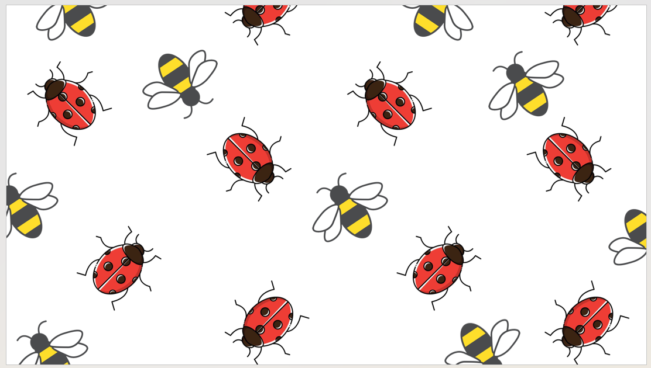
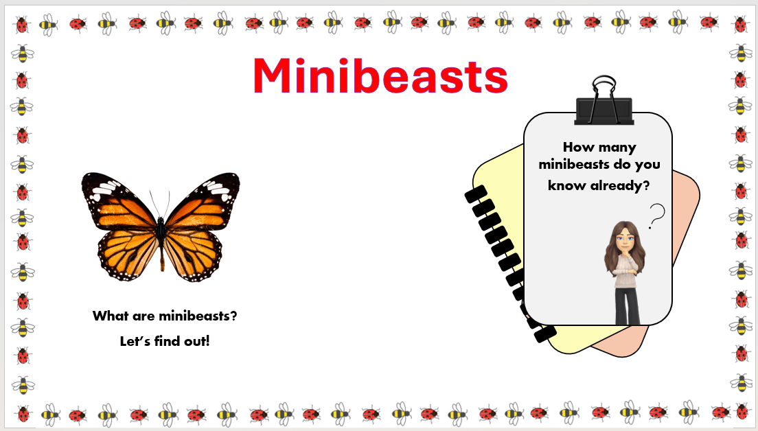
Slide 2:
Hyperlink to video below.

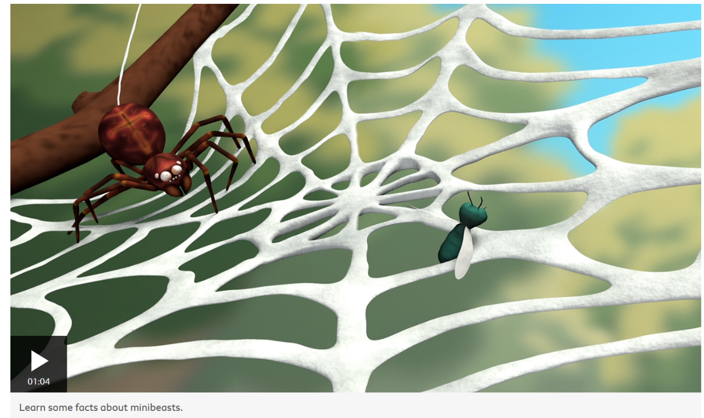
What are minibeasts? - BBC Bitesize

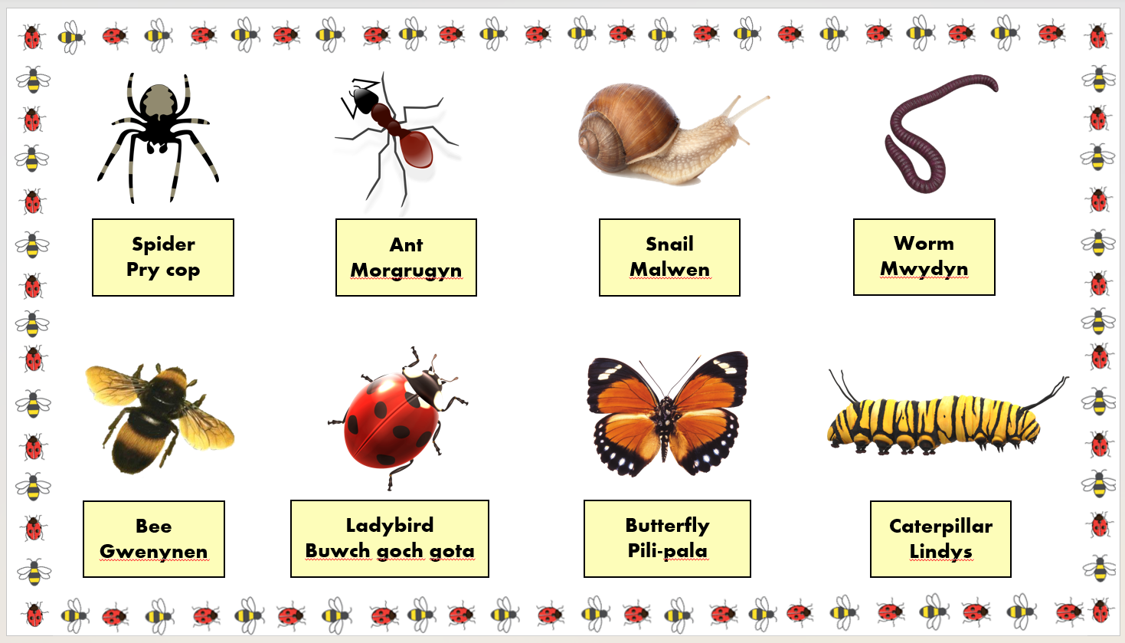
Slide 3:

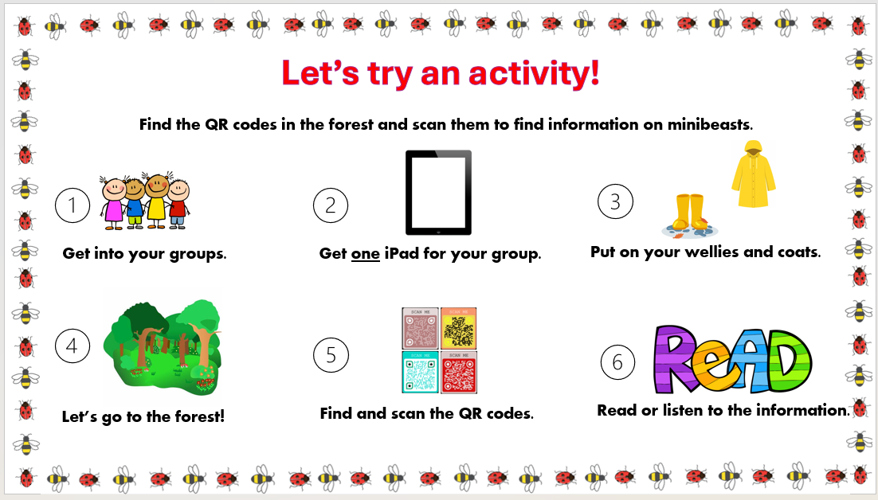
Slide 4
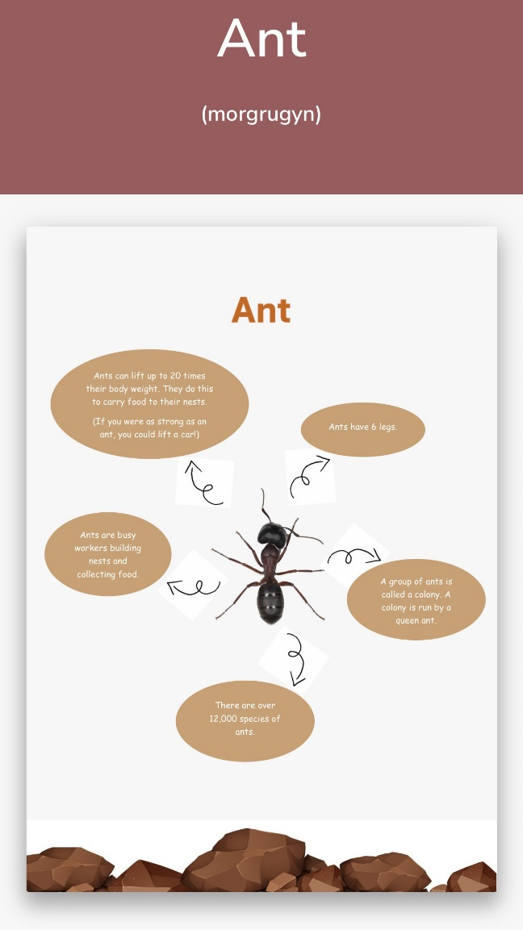
Appendix 2:

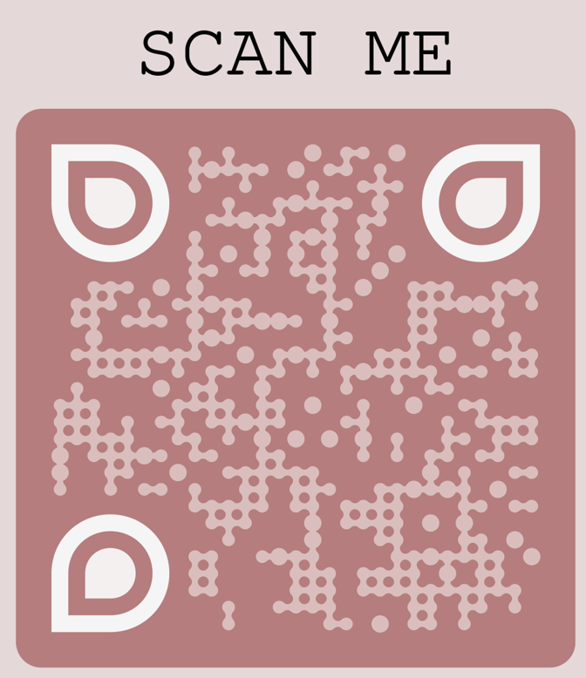

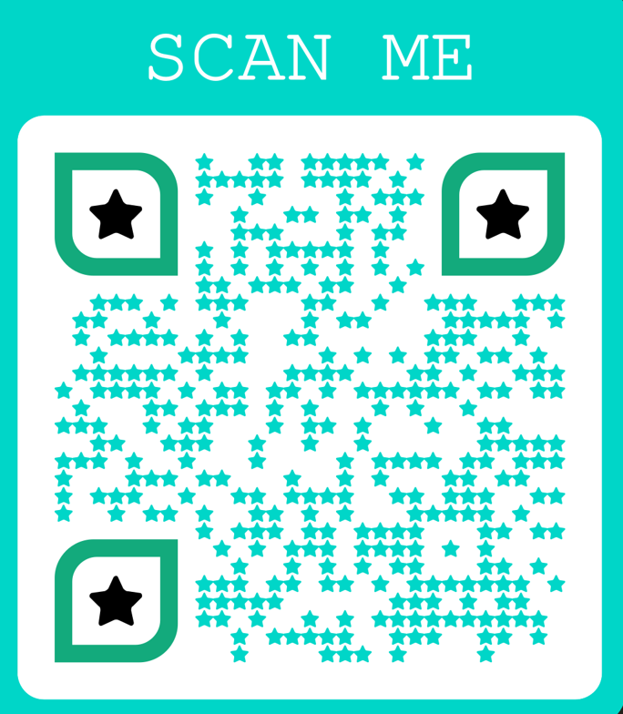
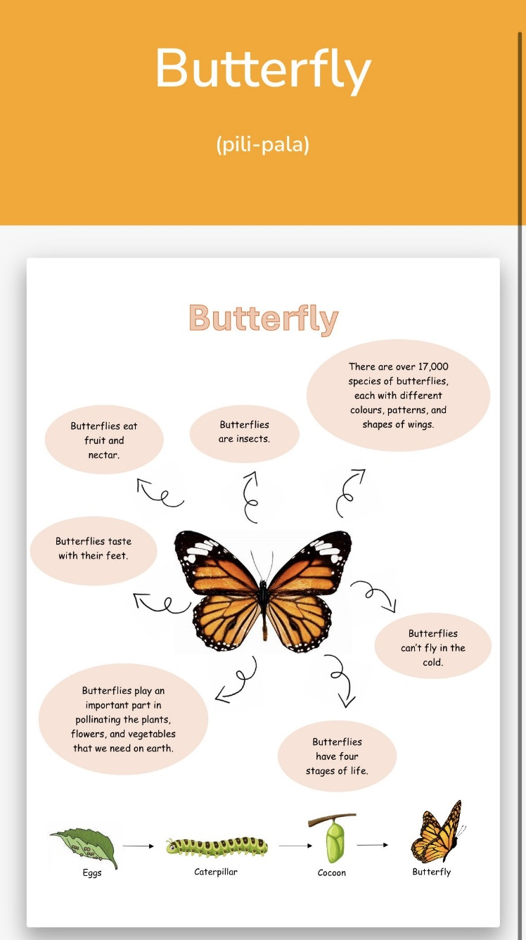
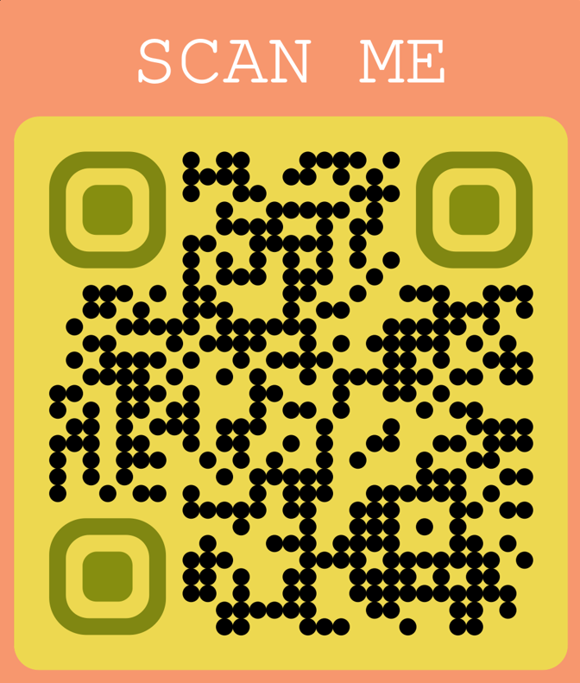

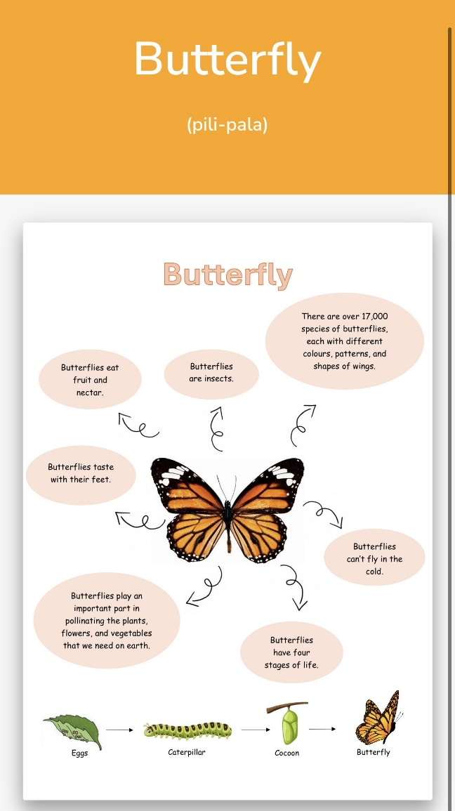

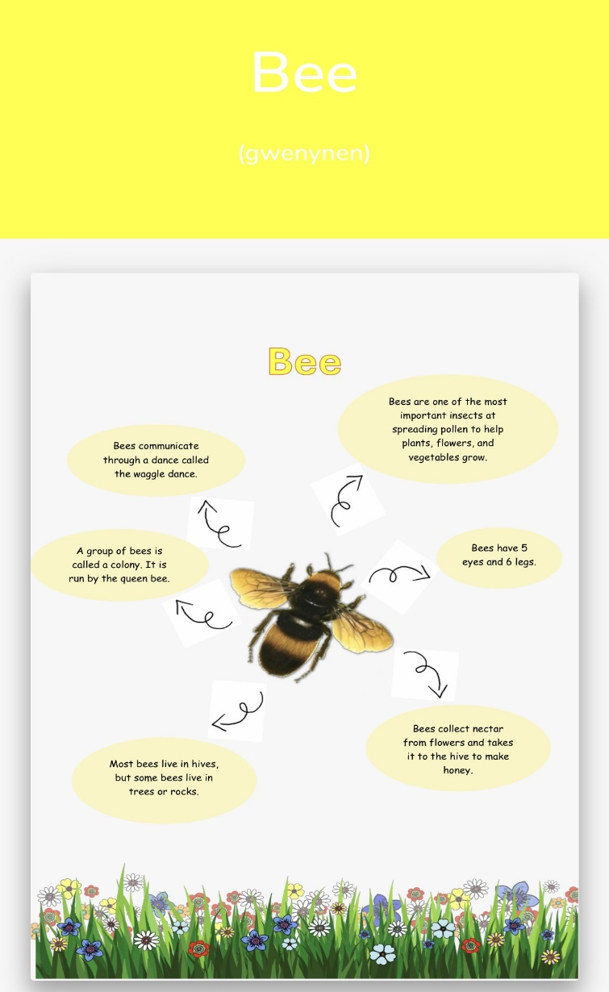
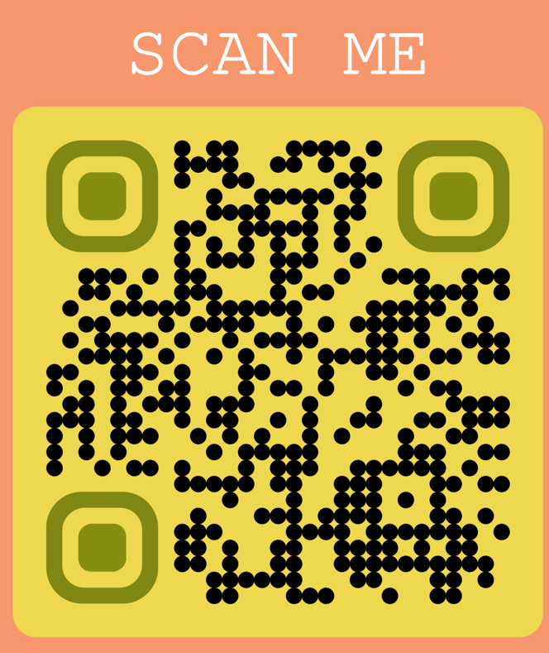

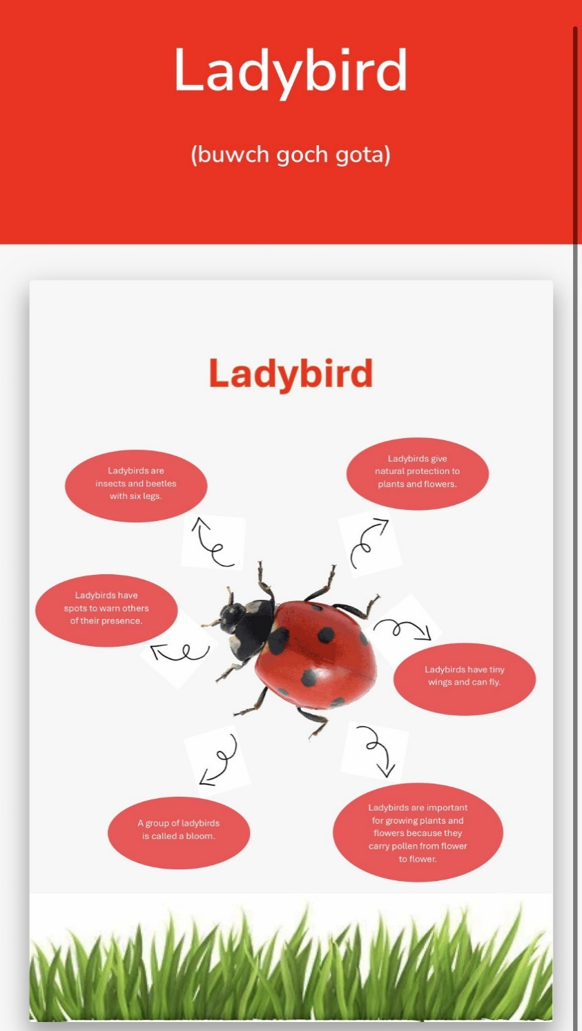

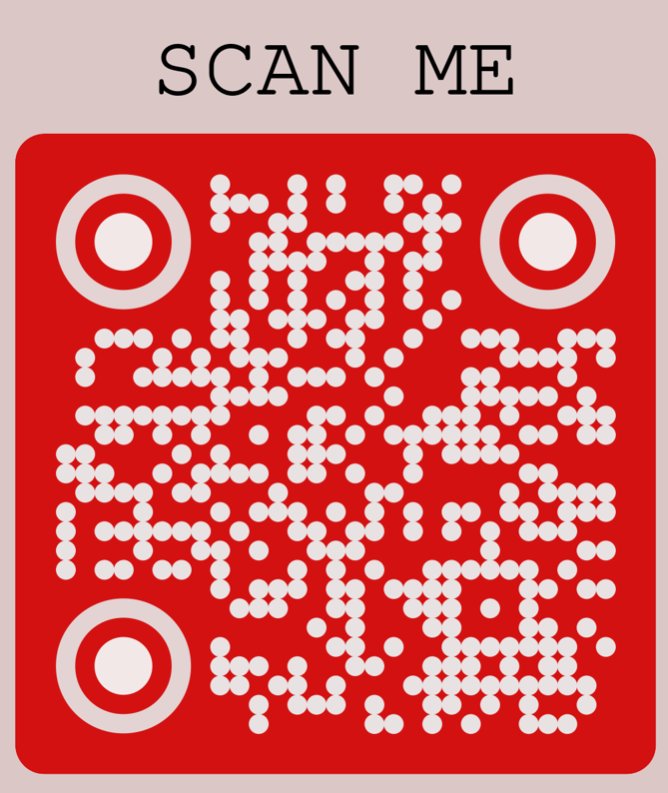

Appendix 3:
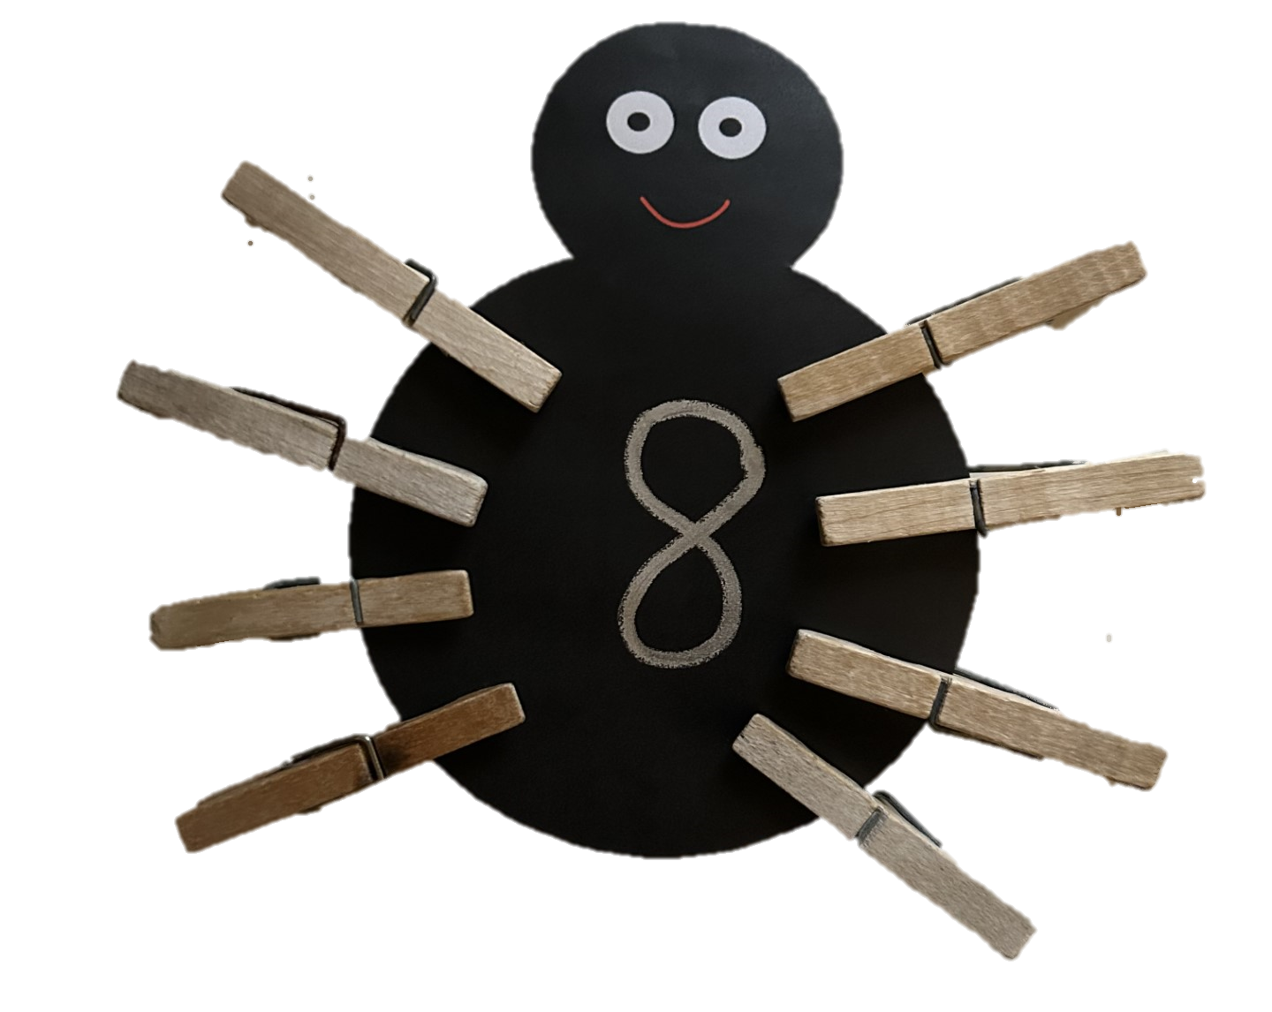
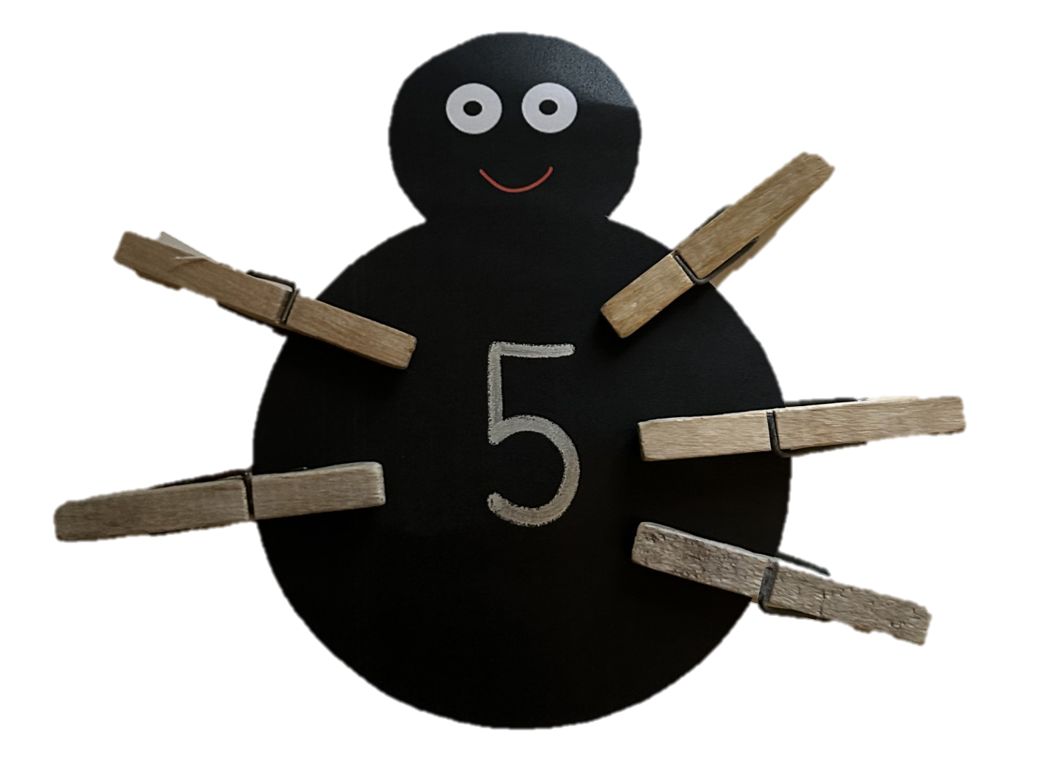

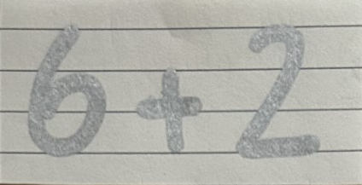

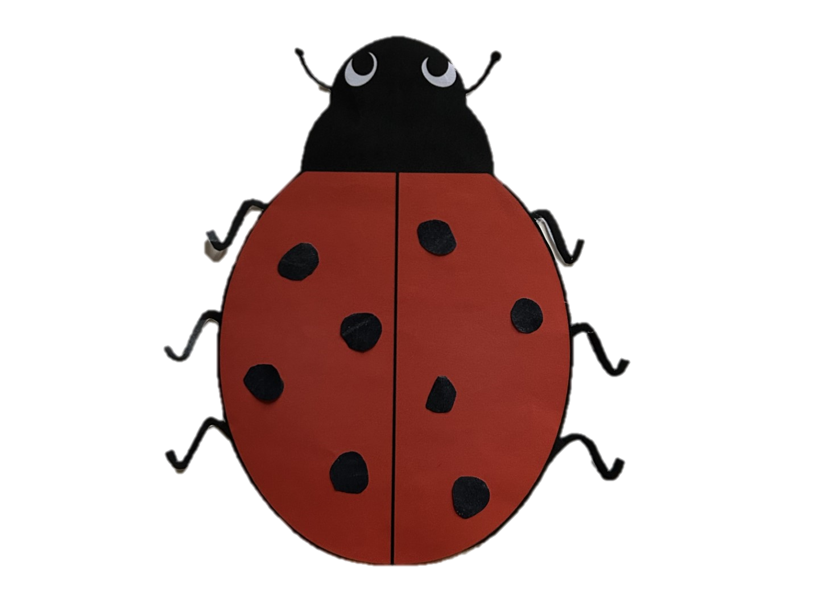

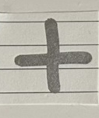
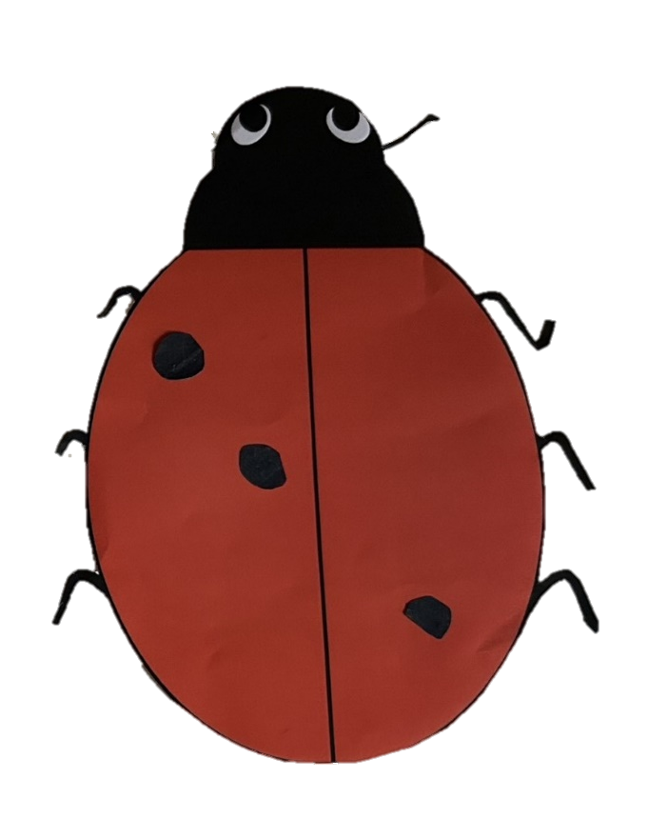
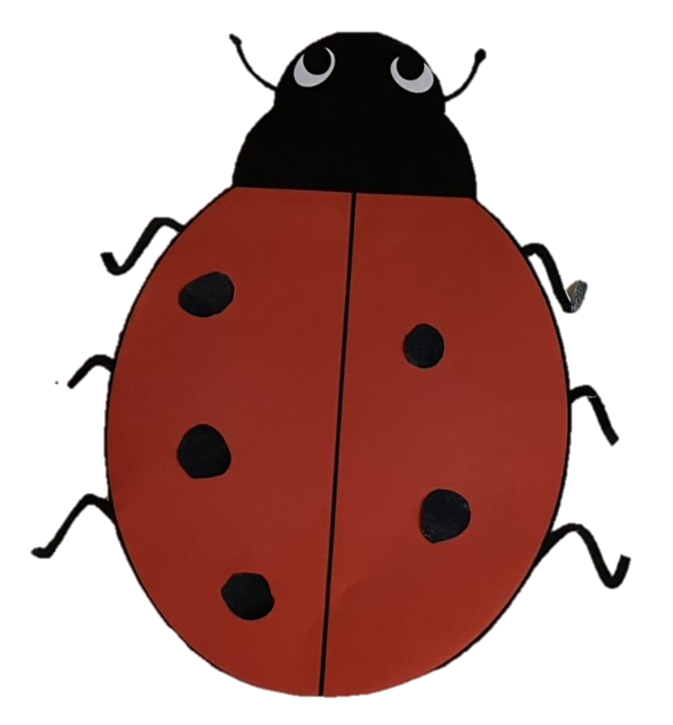



Appendix 4:
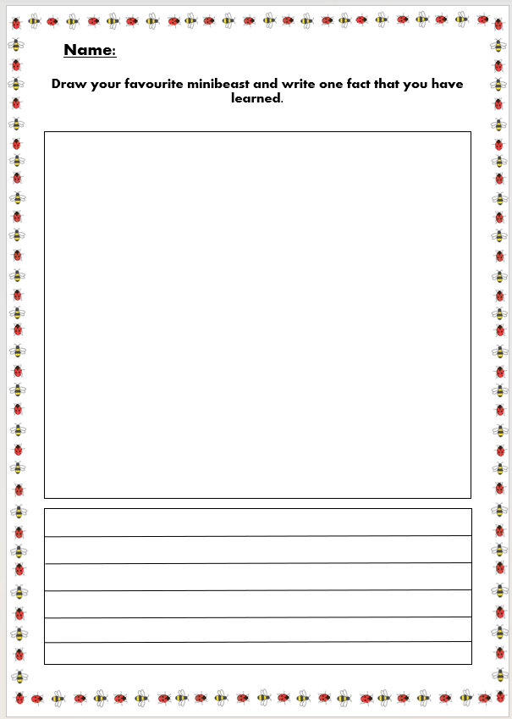
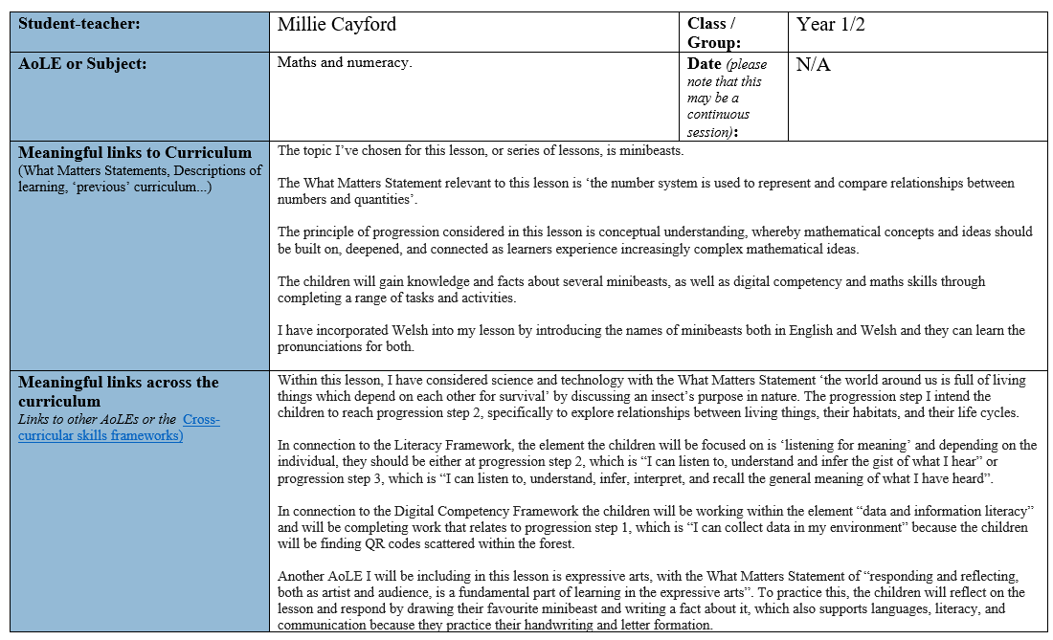
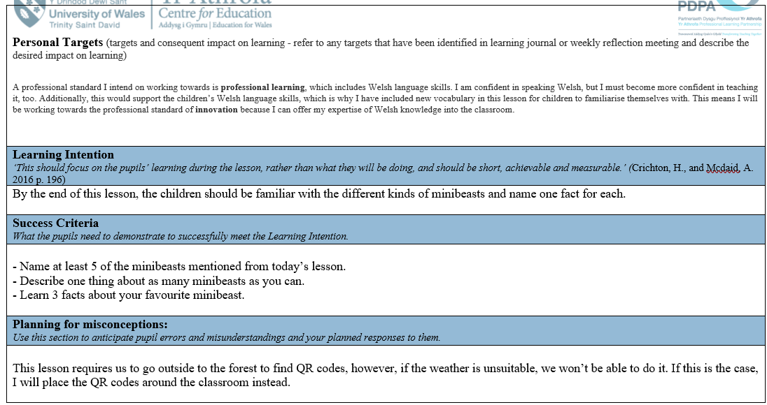
Appendix 5:

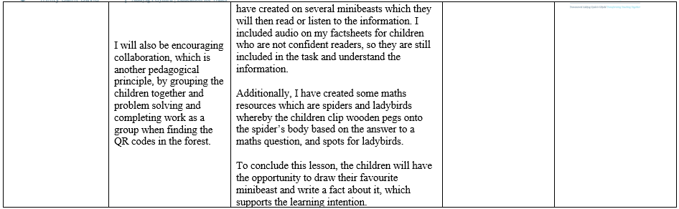
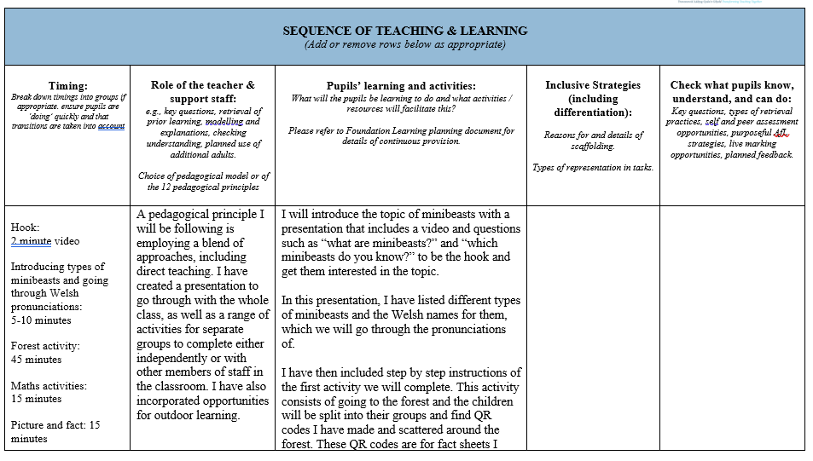

  - Reference list:

BBC Bitesize (2020) What are Minibeasts? Available at: What are minibeasts? - BBC Bitesize. (Accessed 12/04/2024).
Blatchford, P (2020) Rethinking Class Size: The Complex Story of Impact on Teaching and Learning. Available at: Rethinking class size: The complex story of impact on teaching and learning | BERA. (Accessed 09/04/2024).
Byrne, R (2017) The Benefits of Cross-Curricular Learning. Available at: The Benefits of Cross-Curricular Learning - Kids Discover. (Accessed 10/04/2024).
Dauncey, M (2015) Donaldson Review: The ‘Purposes’ and Content of a Curriculum for Wales. Available at: Donaldson Review: The ‘purposes’ and content of a Curriculum for Wales (senedd.wales). (Accessed 10/04/2024).
Department for Education (2018) Use and Perceptions of Curriculum Support Resources in Schools. Available at: Use and perceptions of curriculum support resources in schools (publishing.service.gov.uk). (Accessed 12/04/2024).
Free Essays (2018) Rousseau’s Theory of Education. Available at: Rousseau's Theory of Education - PHDessay.com. (Accessed 09/04/2024).
Historical Association (unknown) Cross-curricular Learning. Available at: Cross-curricular learning / Leading Primary History / Historical Association. (Accessed 11/04/2024).
Khwaja, C (2006) The Role of Subject Knowledge in the Effective Teaching of Primary Science. Available at: (PDF) The Role of Subject Knowledge in the Effective Teaching of Primary Science (researchgate.net). (Accessed 11/04/2024).
Kiviranta, L et al. (2023) Outdoor Learning in Early Childhood Education: Exploring Benefits and Challenges. Available at: Full article: Outdoor learning in early childhood education: exploring benefits and challenges (tandfonline.com). (Accessed 12/04/2024).
Ralphs, A (2023) Fine Motor Skills for Handwriting. Available at: Easy Fine Motor Skills for Handwriting (onehundredtoys.com). (Accessed: 13/04/2024).
Tambayan, D (2023) The Hidden Costs of Inadequate Resources: Exploring the Impact on Student Learning. Available at: The Hidden Costs of Inadequate Resources: Exploring the Impact on Student Learning • DepEd Tambayan. (Accessed: 10/04/2024).
Watson, M (2023) Cross-curricular Learning. Available at: Exploring Space KS1 Cross-curricular Topic by PlanBee. (Accessed 10/04/2024).
Weinstein, A (2018) Benefits of Cross-curricular Education. Available at: Benefits of cross-curricular education - Letters to a Pre-Scientist (prescientist.org). (Accessed 09/04/2024).
Welsh Government (2019) Cross-curricular Skills Framework. Available at: Cross-curricular skills frameworks - Hwb (gov.wales). (Accessed 09/04/2024).
Welsh Government (2019) Curriculum for Wales. Available at: Curriculum for Wales - Hwb (gov.wales). (Accessed 09/04/2024).
Welsh Government (2020) Developing a Vision for Curriculum Design. Available at: Developing a vision for curriculum design - Hwb (gov.wales). (Accessed 09/04/2024).
Welsh Government (2020) The Four Purposes of the Curriculum for Wales. Available at: the-four-purposes-of-the-curriculum-for-wales.pdf (gov.wales). (Accessed: 11/04/2024).
Welsh Government (2023) Pedagogy. Available at: Pedagogy - Hwb (gov.wales). (Accessed 12/04/2024).
Senedd (2023) Teaching Matters. Available at: Teaching matters (senedd.wales). (Accessed 12/04/2024).

