

LOCATION: Swansea | LLEOLIAD: abertawe
LEVEL 5 | LEFEL 5
EXAMINATION PERIOD | CYFNOD ARHOLIADAU
MAY 2019 | MAi 2019

MODULE CODE: ACCb5002
ROUTING AND SWITCHING CONCEPTS
TIME: 2 HOURS
answer ALL quESTIONs IN SECTION A

answer TWO quESTIONs out of THREE in SECTION B

Equipment or materials required – None
Adnoddau neu ddefnyddiau sydd eu hangen - Dim

SECTION A: ANSWER ALL QUESTIONS

- Which type of static route is configured with a greater administrative distance to provide a backup route to a route learned from a dynamic routing protocol?
- Standard static route
- Floating static route
- Default static route
- Summary static route

- What network prefix and prefix-length combination is used to create a default static route that will match any IPv6 destination?
- ::/128
- ::/0
- ::1/64
- FFFF::/128

- A router has used the OSPF protocol to learn a route to the 172.16.32.0/19 network. Which command will implement a backup floating static route to this network?
  - ip route 172.16.32.0 255.255.224.0 S0/0/0 200
  - ip route 172.16.0.0 255.255.240.0 S0/0/0 200
  - ip route 172.16.0.0 255.255.224.0 S0/0/0 100
  - p route 172.16.32.0 255.255.0.0 S0/0/0 100

- Employees of a company connect their wireless laptop computers to the enterprise LAN via wireless access points that are cabled to the Ethernet ports of switches. At which layer of the three-layer hierarchical network design model do these switches operate
  - Distribution
  - Data link
  - Physical
  - Access
  - Core

- What is a characteristic of the distribution layer in the three layer hierarchical model?
  - acts as the backbone for the network, aggregating and distributing network traffic throughout the campus
  - provides access to the rest of the network through switching, routing, and network access policies
  - distributes access to end users
  - represents the network edge

- Which statement is correct about Ethernet switch frame forwarding decisions?
  - frame forwarding decisions are based on MAC address and port mappings in the CAM table.
  - Cut-through frame forwarding ensures that invalid frames are always dropped.
  - Only frames with a broadcast destination address are forwarded out all active switch ports.
  - Unicast frames are always forwarded regardless of the destination MAC address.

- Which information does a switch use to populate the MAC address table?
  - the destination MAC address and the incoming port
  - the destination MAC address and the outgoing port
  - the source and destination MAC addresses and the incoming port
  - the source and destination MAC addresses and the outgoing port
  - the source MAC address and the incoming port
  - the source MAC address and the outgoing port

- In what situation would a Layer 2 switch have an IP address configured?
  - when the Layer 2 switch needs to forward user traffic to another device
  - when the Layer 2 switch is the default gateway of user traffic
  - when the Layer 2 switch needs to be remotely managed
  - when the Layer 2 switch is using a routed port

- A network technician has been asked to secure all switches in the campus network. The security requirements are for each switch to automatically learn and add MAC addresses to both the address table and the running configuration. Which port security configuration will meet these requirements?
  - auto secure MAC addresses
  - dynamic secure MAC addresses
  - static secure MAC addresses
  - sticky secure MAC addresses

- A network administrator is configuring port security on a Cisco switch. When a violation occurs, which violation mode that is configured on an interface will cause packets with an unknown source address to be dropped with no notification sent?
  - Off
  - Restrict
  - Protect
  - Shutdown

- Refer to the exhibit. What protocol should be configured on SW-A Port 0/1 if it is to send traffic from multiple VLANs to switch SW-B?
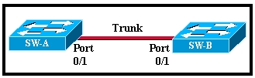

  - Spanning Tree
  - RIP v2
  - IEEE 802.1Q
  - ARP
  - Rapid Spanning Tree

- A Cisco Catalyst switch has been added to support the use of multiple VLANs as part of an enterprise network. The network technician finds it necessary to clear all VLAN information from the switch in order to incorporate a new network design. What should the technician do to accomplish this task?
  - Delete the startup configuration and the vlan.dat file in the flash memory of the switch and reboot the switch.
  - Erase the startup configuration and reboot the switch.
  - Erase the running configuration and reboot the switch.
  - Delete the IP address that is assigned to the management VLAN and reboot the switch.

- What VLANs are allowed across a trunk when the range of allowed VLANs is set to the default value?
a. All VLANs will be allowed across the trunk.
b. Only VLAN 1 will be allowed across the trunk.
c. Only the native VLAN will be allowed across the trunk.
d. The switches will negotiate via VTP which VLANs to allow across the trunk.

- Refer to the exhibit. A network administrator is configuring inter-VLAN routing on a network. For now, only one VLAN is being used, but more will be added soon. What is the missing parameter that is shown as the highlighted question mark in the graphic?
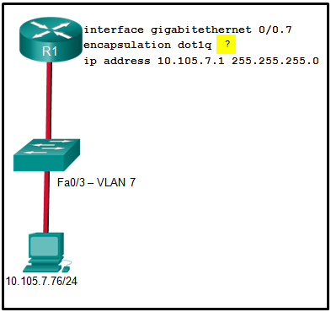

  - It identifies the subinterface.
  - It identifies the VLAN number.
  - It identifies the native VLAN number.
  - It identifies the type of encapsulation that is used.
  - It identifies the number of hosts that are allowed on the interface.

- A network administrator is designing an ACL. The networks 192.168.1.0/25, 192.168.0.0/25, 192.168.0.128/25, 192.168.1.128/26, and 192.168.1.192/26 are affected by the ACL. Which wildcard mask, if any, is the most efficient to use when specifying all of these networks in a single ACL permit entry?
  - 0.0.0.127
  - 0.0.0.255
  - 0.0.1.255
  - 0.0.255.255
  - A single ACL command and wildcard mask should not be used to specify these particular networks or other traffic will be permitted or denied and present a security risk.

- What is the reason why the DHCPREQUEST message is sent as a broadcast during the DHCPv4 process?
  - to notify other DHCP servers on the subnet that the IP address was leased
  - to notify other hosts not to request the same IP address
  - for hosts on other subnets to receive the information
  - for routers to fill their routing tables with this new information

- Which command, when issued in the interface configuration mode of a router, enables the interface to acquire an IPv4 address automatically from an ISP, when that link to the ISP is enabled?
  - ip dhcp pool
  - service dhcp
  - ip helper-address
  - ip address dhcp

- A network engineer is interested in obtaining specific information relevant to the operation of both distribution and access layer Cisco devices. Which command provides common information relevant to both types of devices?
  - show ip protocols
  - show ip interface
  - show cdp neighbors
  - show port-security
  - show mac-address-table

- Refer to the exhibit. An administrator is examining the message in a syslog server. What can be determined from the message?

  - This is a notification message for a normal but significant condition.
  - This is an alert message for which immediate action is needed.
  - This is an error message for which warning conditions exist.
  - This is an error message that indicates the system is unusable.

- When a customer purchases a Cisco IOS 15.0 software package, what serves as the receipt for that customer and is used to obtain the license as well?
  - Software Claim Certificate
  - End User License Agreement
  - Unique Device Identifier
  - Product Activation Key

- Refer to the exhibit. Which route was configured as a static route to a specific network using the next-hop address?

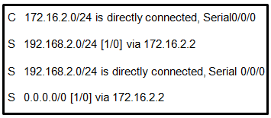

  - C 172.16.2.0/24 is directly connected, Serial0/0/0
  - S 192.168.2.0/24 is directly connected, Serial 0/0/0
  - S 0.0.0.0/0 [1/0] via 172.16.2.2
  - S 192.168.2.0/24 [1/0] via 172.16.2.2

- Refer to the exhibit. Currently router R1 uses an EIGRP route learned from Branch2 to reach the 10.10.0.0/16 network. Which floating static route would create a backup route to the 10.10.0.0/16 network in the event that the link between R1 and Branch2 goes down?
  - ip route 10.10.0.0 255.255.0.0 Serial 0/0/0 100
  - ip route 10.10.0.0 255.255.0.0 209.165.200.226 100
  - ip route 10.10.0.0 255.255.0.0 209.165.200.225 100
  - ip route 10.10.0.0 255.255.0.0 209.165.200.225 50

- Refer to the exhibit. A network engineer is examining a configuration implemented by a new intern who attached an IP phone to a switch port and configured the switch. Identify the issue, if any, with the configuration.
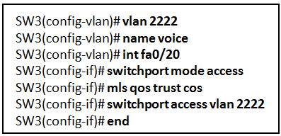

  - The voice VLAN has not been specified on the interface
  - The configuration is correct.
  - There must be a data VLAN added.
  - The spanning-tree BPDU guard feature is missing.
  - The switch port is not configured as a trunk.

- Refer to the exhibit. A network administrator has configured R2 for PAT. Why is the configuration incorrect?

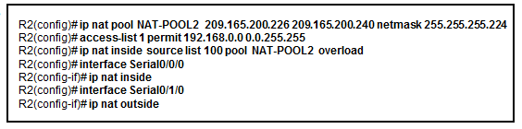
  - The static NAT entry is missing.
  - NAT-POOL2 is bound to the wrong ACL.
  - The ACL does not define the list of addresses to be translated.
  - The overload keyword should not have been applied.

- A college marketing department has a networked storage device that uses the IP address 10.18.7.5, TCP port 443 for encryption, and UDP port 4365 for video streaming. The college already uses PAT on the router that connects to the Internet. The router interface has the public IP address of 209.165.200.225/30. The IP NAT pool currently uses the IP addresses ranging from 209.165.200.228-236. Which configuration would the network administrator add to allow this device to be accessed by the marketing personnel from home?
  - ip nat pool mktv 10.18.7.5 10.18.7.5
  - ip nat outside source static 10.18.7.5 209.165.200.225
  - ip nat inside source static tcp 10.18.7.5 443 209.165.200.225 443
ip nat inside source static udp 10.18.7.5 4365 209.165.200.225 4365
  - ip nat inside source static tcp 209.165.200.225 443 10.18.7.5 443
ip nat inside source static udp 209.165.200.225 4365 10.18.7.5 4365
  - No additional configuration is necessary.

SECTIONB : ANSWER TWO QUESTIONS OUT OF THREE

  - With aid of a network diagram explain the Hierarchical network model and given some examples of switch models used at each layer. (16 Marks)

  - Explain the operation and functionality of Cut-through and store-and-forward switch packet forwarding methods. (5 marks)

  - List VLAN types. (4 marks)

  - With aid of a diagram explain legacy and Router-on-Stick Inter-VLAN Routing. (12 marks)

  - DHCPv4 uses three different address allocation methods, explain them all. (9 marks)

  - Briefly explain VLAN Trunks. (4 marks)

  - Explain OSPF packet types. (10 marks)

  - In reference to OSPF, explain the databases used. (15 marks)

Diwedd/End

