Global Sustainability

With in sustainability especially in terms of littering it goes deeper than people just being too lazy to throw there trash in the garbage it's a reflection of the community mental health for example in places where there is lots of crime or where a depression is happening you can see this wherever you go like cities where crime and homelessness are common, although there is evidence that does not support this, according to SUSSEXBYLINES by Ginny Smith even though there was a decrease of smokers throughout the years even so the amount of littering has increased even so this study was taken place in the 1960s where things were far more strict.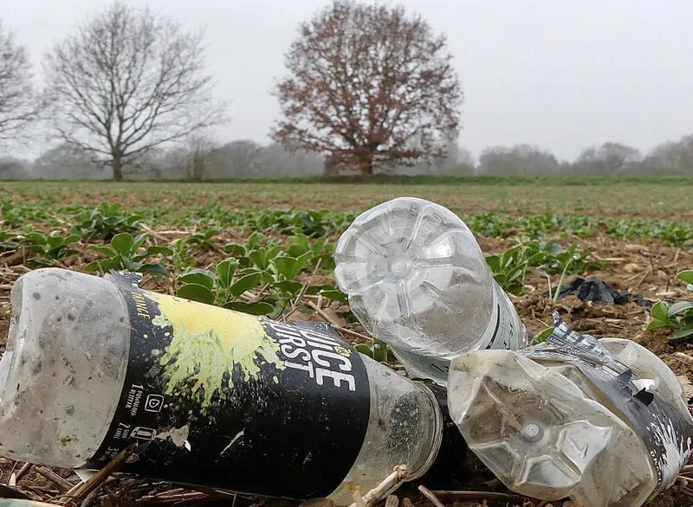

To make the beaches cleaner in the long run they should have things in place to help the communities mental health like events, although this will cause littering in the short term this will be a schedule event so what the government should do is every 2 month have a party at the beachfront which will raise morality and for the day after the party have cleaners pick up all the litter by doing this it will not just affects the littering but also the economy of the area because at these parties there will be shops you can buy stuff perhaps alcohol creating opportunities for businesses and helping the economy in case of a recession.

Within the UK throw away your own trash is always such a burden no one wants to throw away their own trash so they're always looking for someone else to do it or something else but for the majority of people people don't want to waste their taxes on cleaners that the money could be used for something else such as putting the money towards the cost of living crisis or homelessness so we end up running into a big problem some people do not litter so they should not have their taxes used fix it and the fact that no one wants to clean anyone else's mess. But it is important to have people pick up litter because it is not just rappers and cigarette but also Syringes and other things that might put the community in Risk for example according to healthline by Gigen Mammoser because of the opioid rise there was a increase in hazardous things like drugs and dirty needle in which can seriously impact a public place for the simple reason that a person can step on a needle so my opinion is that beaches should have a sign telling people to put on foot where just in case of hazards.

While in the beach there was small bits of trash people just left on the sand and i could tell that is was there for awhile

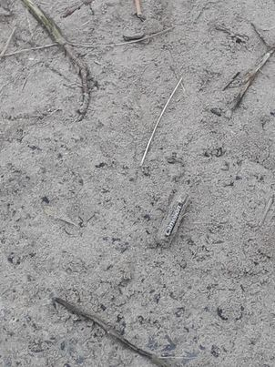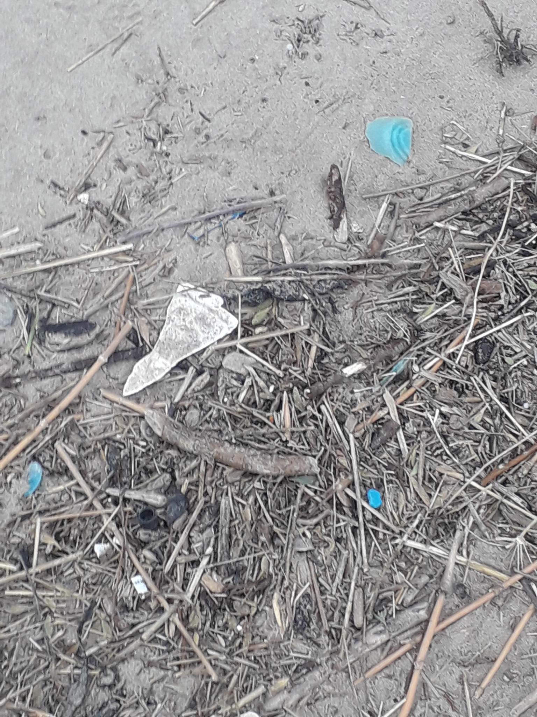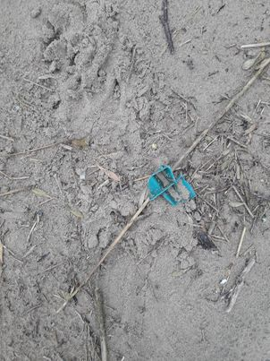
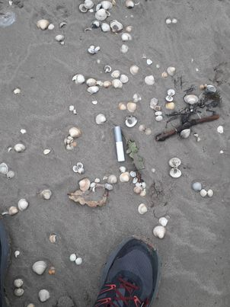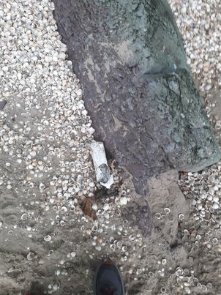
These images are the photos i have taken to clean up the beach and i have learned that the mess has been spread out so it is difficult to clean a massive area and in these distant areas where there was lots of litter their was not garbage can so if anyone who had trash they would need to walk a far distance to get rid of so it makes sense there is trash there trash at those far distances so the best thing for this is to have more garbage cans around the beach give people more of a ability to throw there trash away without needlessly walking a far distance to throw away something small.

Ginny Smith
17/05/2022
https://sussexbylines.co.uk/is-the-uk-the-litter-lout-of-europe/

Gigen Mammoser
08/07/2017
https://www.healthline.com/health-news/used-needles-littering-streets-parks-beaches#Sign-of-a-larger-problem

