James Hunt (2215832)
2215832@student.uwtsd.ac.uk
Learning in the Digital Era (Computing & Electronics)
ACCA4025

Contents
Link to e-Portfolio 2
Link to Microsoft Sway 2
Task One 3
Written Summary 3
Task Two 4
Academic Poster 4
Task Three 5
Automatic Referencing Tool 5
Task Four 6
e-PortFolio Review 6

Link to e-Portfolio

Link to Microsoft Sway

https://sway.office.com/WQABeFx2FYQU5Dgl?ref=Link

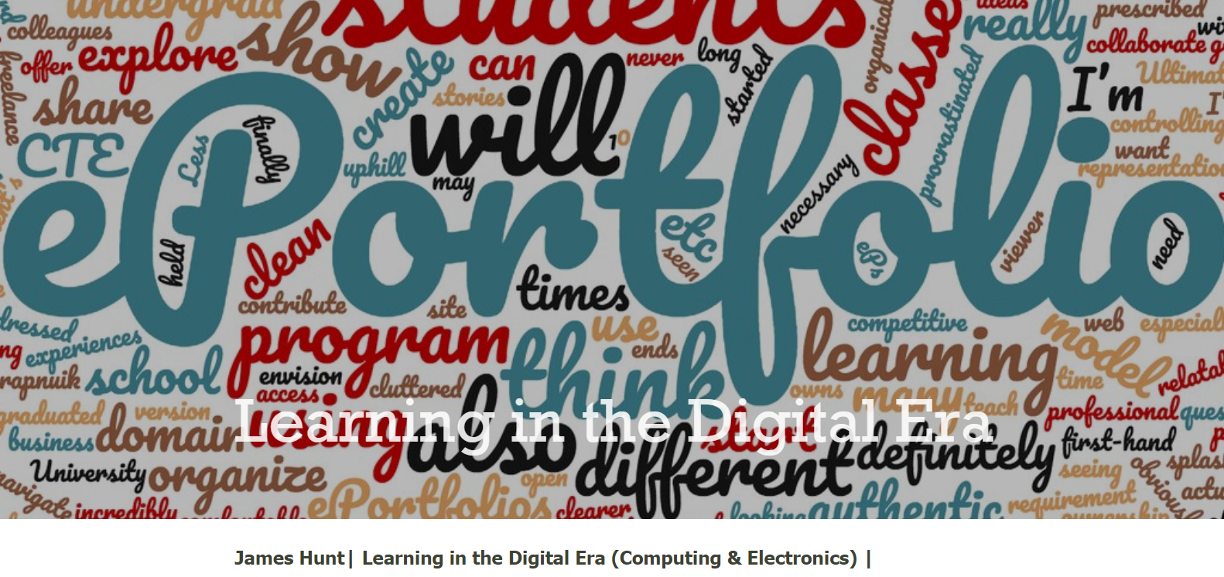

Task One

Written Summary

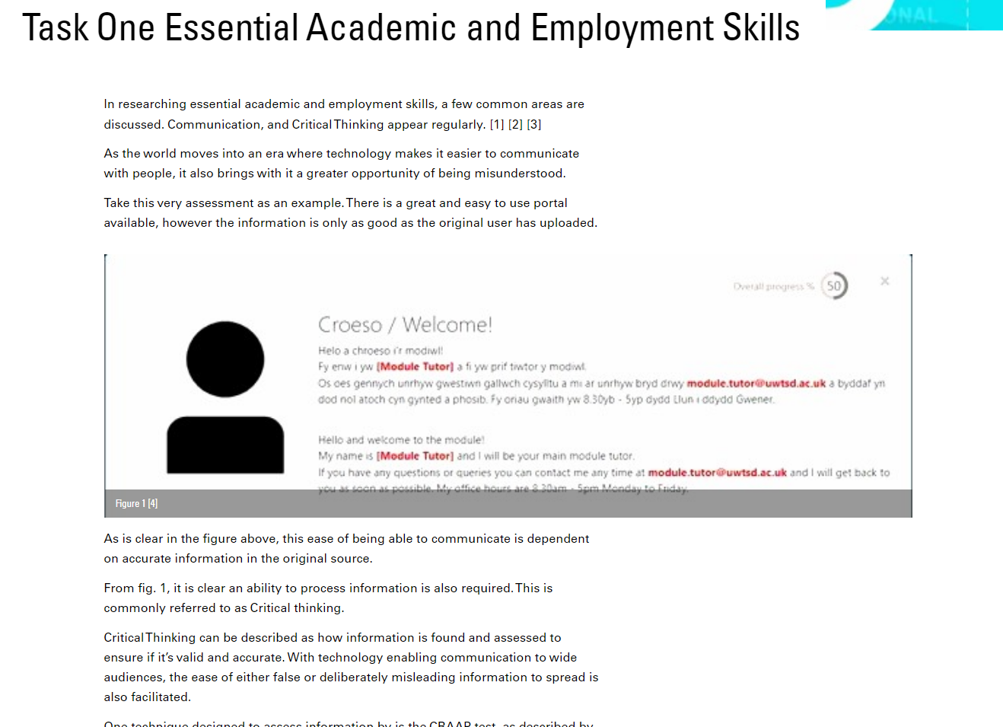

Task Two

Academic Poster

Life is a Team Sport.pptx

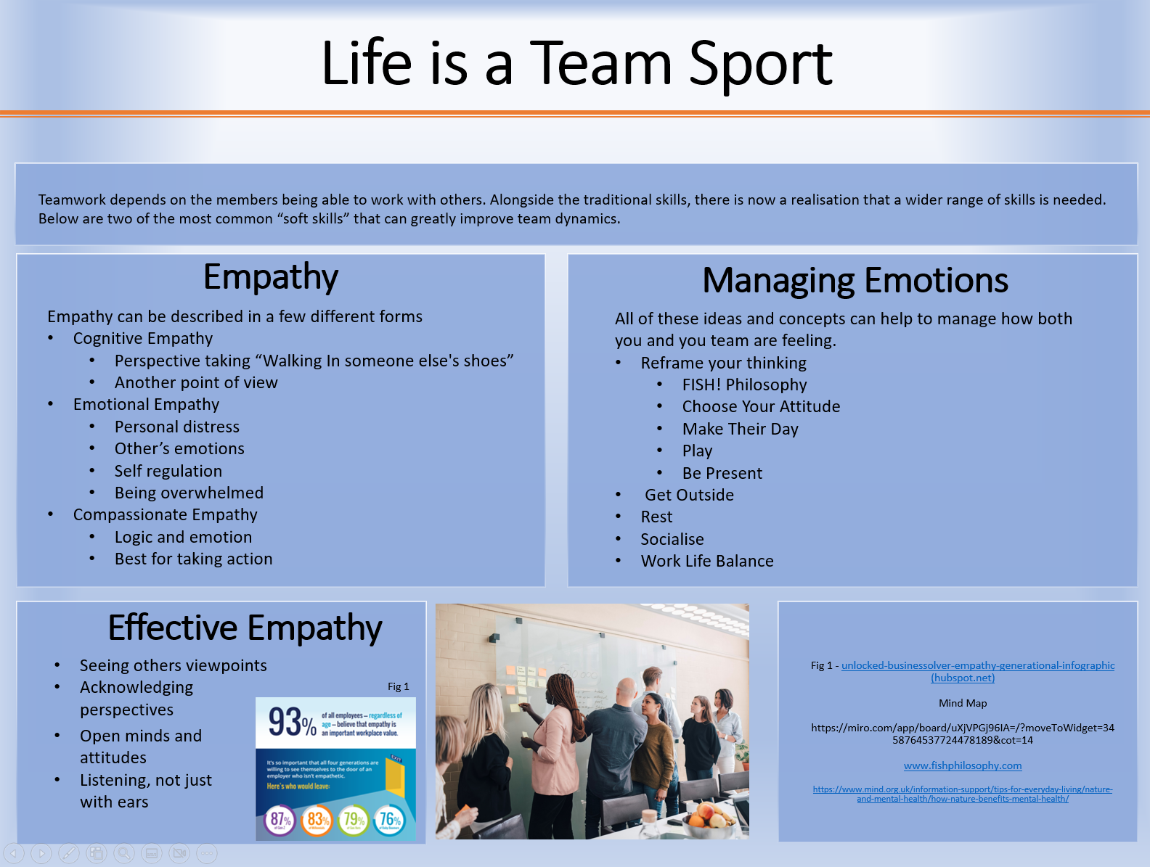

Task Three

Automatic Referencing Tool

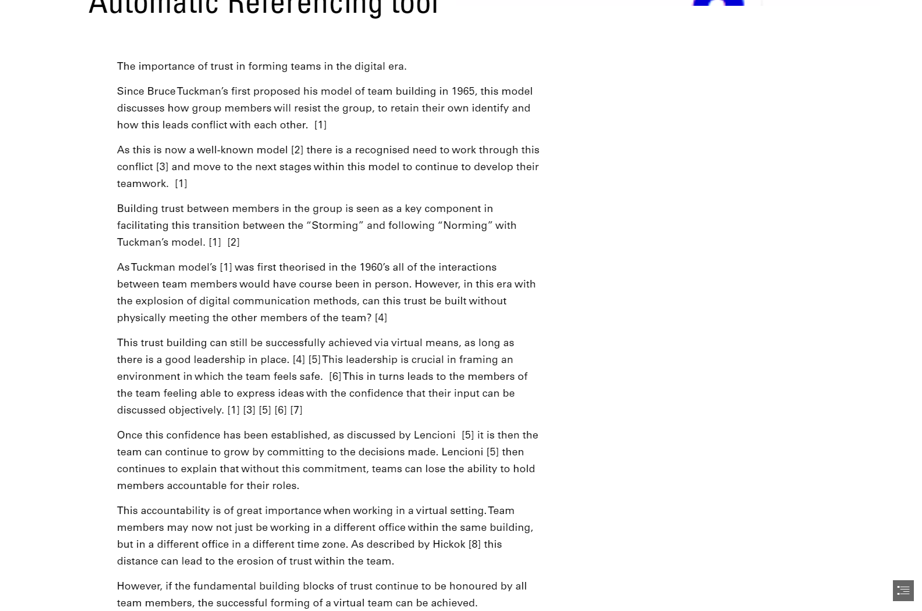

Task Four

e-PortFolio Review



