Certificate of Higher Education in Employability Skills
LEVEL 4

Problem Solving and Innovation (BMSW4014)

Assignment Title: An analysis of the factors impacting Starbucks in the UK

Student Name: Irina Gorbe
Student ID: 2330421

Table of Contents
1. Introduction 3
1.1 Introduction to Starbucks 3
1.2 Background and Current Situation of the Company 3
1.3 Report Structure 3
2. Findings 3
2.1 Factors Impacting Starbucks in the UK: PESTLE Analysis 3
2.2 Theoretical Explanation: Environmental Scanning Theory 6
3. Conclusion 7
4. Recommendations 8
4.1 Recommendation 1: Enhance Sustainability Practices through Innovation 8
4.2 Recommendation 2: Leverage Digital Innovation to Enhance Customer Experience 9
5. Reference list 10

1. Introduction

1.1 Introduction to Starbucks
Starbucks is a multinational company that specialises in providing premium coffee and beverages which focus on customer experience and innovation. It was founded back in 1971 by the great man, John Pierce in Seattle and developed its way to manage thousands of stores around the globe (Starbucks, 2024).

1.2 Background and Current Situation of the Company
Starbucks has become one of the market leaders in the world within the coffee industry. This particular company is now directing focus towards its digital and sustainability aspects catering to the needs of a consumer and environmental issues also.

1.3 Report Structure
Starbucks' market environment analysis, challenges, opportunities and strategic recommendations for further expansion will be discussed.

2. Findings

2.1 Factors impacting Starbucks in the UK: PESTLE Analysis
PESTLE analysis helps to determine the external environment of a company and specifically political, economic, social, technological, legal and environmental factors. In this scenario, it is a helpful analytical tool to determine the factors which directly impact Starbucks.
Political factors | Political stability and government policies in different countries, specifically the United Kingdom, directly affect Starbucks. Starbucks, being an international company, has to deal with various political conditions of the countries in which it operates and address changes in local as well as international trade policies. For instance, Starbucks has to deal with certain supply availability such as coffee beans and other raw materials it imports, which would depend on trade agreements and tariffs (Chang, 2020). Political events such as Brexit have created uncertainty in Europe and affected the operations and cost structure of Starbucks. Additionally, government regulations on labour practices, such as minimum wage laws, can impact the company’s employee costs, particularly in the UK, where Starbucks is a major employer. Moreover, the company’s initiatives related to corporate social responsibility (CSR) and sustainability can be influenced by political pressures for more ethical business practices.
Economic factors | At a time when the UK economy is flourishing and disposable income is up, customers are willing to pay for premium products offered by Starbucks. This has been seen in the performance of the company after the COVID-19 pandemic. For fiscal year 2022, Starbucks reported total net revenues of $32.25 billion, up 11% from $29.1 billion in fiscal year 2021 (Zhang and He, 2024). The company benefited from increasing consumer confidence and spending as consumers resumed social activities and more eagerly went for premium products such as speciality coffee drinks and beverages.
Social factors | Consumer trends and lifestyle changes in the UK have a direct impact on Starbucks. Social attitudes toward health, wellness, and sustainability have influenced the company to change its menu items and introduce low-calorie, vegan, and plant-based products to meet the increased demand for healthier products (Tsai et al., 2020). In addition, the demand for ethically sourced products has been increasing, and the company has responded by focusing on fair-trade and ethically sourced coffee beans.
Technological factors | Technological advancements also opened up avenues to improve the experience of the customer and facilitate the operation of Starbucks in the UK. It has utilised digital means such as mobile apps and loyalty programs where customers can order and pay and accumulate rewards for their increased convenience and loyalty. Moreover, the adoption of AI and machine learning by Starbucks in demand forecasting, supply chain optimisation, and marketing will give Starbucks a technological advantage (Zhou, 2024). Through technological developments in brewing and roasting, Starbucks improves the quality and consistency of coffee. The firm invested in automating store operations and digital equipment to reduce labour costs while maximizing efficiency. On the environmental front, technology also allowed Starbucks to minimise waste by providing sustainable packaging and designing energy-efficient store formats.
Legal factors | Starbucks operates in an environment where the UK has a regulation set that is very huge. Therefore, the corporation faces a large number of legal requirements, including labour laws, food safety regulations, health and safety standards, and intellectual property laws (Lee, Jung and Moon, 2022). The company also runs the risk of legal challenges involving employee relations and unionisation issues, especially in the United Kingdom and Canada.
Environmental factors | For Starbucks, environmental sustainability is an essential focus in both its operation practices and public relations. Starbucks is an agricultural products company, with coffee beans as its main product, hence facing challenges associated with climate change, deforestation, and water use. Poor weather conditions, like droughts and floods, will influence the supply of coffee and, therefore, both the availability and cost of the beans (Areiza-Padilla, Cervera-Taulet and Manzi Puertas, 2020). Starbucks has ensured that it would decrease its impact on the environment through numerous initiatives. Among them is reaching carbon-neutral operations and less waste. Starbucks has become successful in utilizing recyclable or compostable packaging. The company also minimizes single-use plastic. Through programs such as Coffee and Farmer Equity, known as C.A.F.E. Starbucks focuses on ethically sourcing coffee beans from farmers.
Table 1: PESTLE Analysis of Starbucks

2.2 Theoretical Explanation: Environmental Scanning Theory
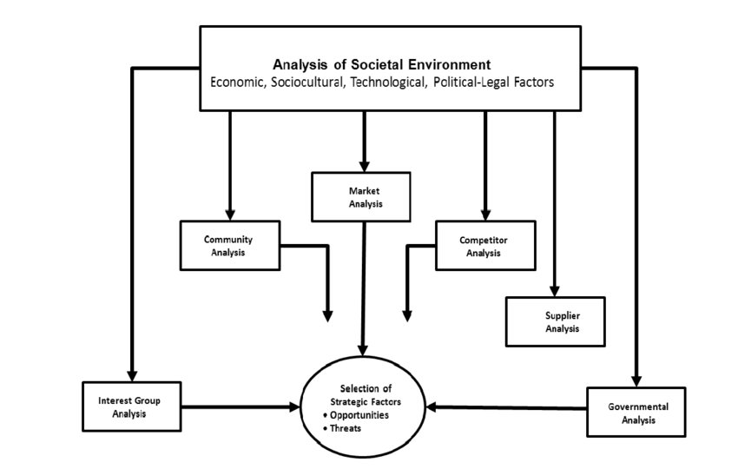
Figure 1: Environmental Scanning Theory
Source: (Albadry, 2021)
The PESTLE framework of Starbucks is based on the environmental scanning theory. It puts on the spotlight the influence of external factors affecting the performance of Starbucks. This theory calls for Starbucks to continually scan their environment for opportunities and threats that might be developed by political, economic, social, technological, legal, and environmental factors (Ayesh, Abu-Ghazaleh and Al-Zyoud, 2021). This is an immensely widely used model of strategic management and business planning that provides an overarching view of all types of external forces, shaping companies' strategies. This theory basically underlines strategic fit-internal fit that reflects matching Starbucks' internal capabilities to the environment that a business needs to adapt its organization strategy to fit the strategic vision. Using PESTLE makes Starbucks understand whether the company's resources and activities line up well with the opportunities or challenges of the outside world. This alignment keeps Starbucks aware of the changes in market situations. Besides, PESTLE is linked with the environmental scanning theory which suggests that Starbucks must adapt according to the environment they are surrounded by (Moon et al., 2023). Applying PESTLE, Starbucks can upgrade its knowledge about the market dynamics and change its business policies to make proper decisions regarding performance and sustainability in this dynamic global scenario.

3. Conclusion
This assignment is helpful in knowing why it is necessary to know the external factors affecting Starbucks using a PESTLE analysis. Political, economic, social, technological, legal, and environmental factors would be assessed in order to give Starbucks an insight into the opportunities and threats in the marketplace. The theoretical foundation of PESTLE emphasizes strategic alignment with the external environment. Some of the recommendations for Starbucks are to enhance sustainability practices by innovation and further leveraging the transformation digitally to improve customer experience. These strategies align with evolving market trends and can help Starbucks maintain its competitive advantage, strengthen its brand, and ensure long-term growth.

4. Recommendations

4.1 Recommendation 1: Enhance Sustainability Practices through Innovation
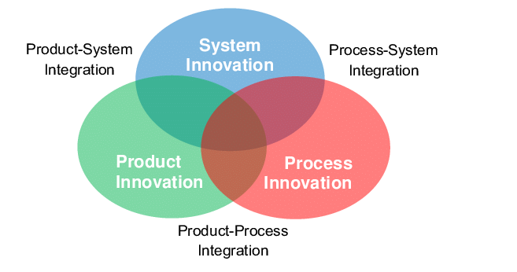
Figure 2: Sustainability Practices Through Innovation
Source: (Jawahir, Badurdeen and Rouch, 2023)
Given the increasing need for sustainable practices and increasing demand in consumer markets, Starbucks is well placed to strengthen sustainability efforts as an increasing environmental requirement. For example, it should focus on the practice of innovation towards environmental needs (Akcam, 2023). Some of these can involve more use of renewable resources for energy generation, maximize the recycling of materials within stores, and reduce water usage and energy use within retail locations. Starbucks could invest more in sustainable packaging and entirely use recyclable or compostable cups and lids, eliminating the problems of plastic waste, a common problem for environment-sensitive consumers. In addition, Starbucks may team up with other technological companies to innovate its environmentally friendly products and solutions. For instance, using plant-based material in packaging or initiating a traceability program for coffee beans with blockchain technology would relate to consumers' increasing concerns about transparency and ethical sourcing (Xu, 2020). Positioning itself as the leader in sustainability, Starbucks could increase its brand value, develop customer loyalty, and attract an emerging base of green-conscious consumers.

4.2 Recommendation 2: Leverage Digital Innovation to Enhance Customer Experience
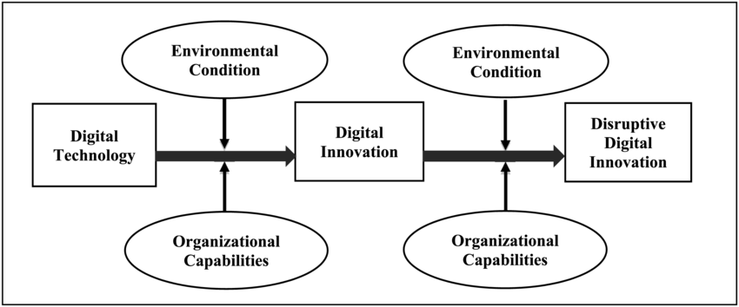
Figure 3: Digital Innovation
Source: (Chan et al., 2019)
With rapid technological advancements and the importance of digital platforms on the rise, Starbucks needs to invest more in its digital transformation to enhance customer experience and increase brand engagement. The company has already made some steps forward in this area with its mobile app and loyalty program, but there is room for expansion in these initiatives. Starbucks could leverage highly advanced technologies like Artificial Intelligence (AI) and machine learning to make more personalised engagements with the customers and develop recommendations according to the customers' preferences and purchases (Artuğer, Sayın and Kilinç Şahi̇n, 2024). Thirdly, collaboration with the most prestigious tech companies might also help achieve a better and more streamlined delivery and ordering system across Starbucks stores and websites, resulting in the establishment of an omnichannel experience. Its features include contactless payment methods, voice-activated orders, and AI-driven chatbots, improving customer convenience, streamlining service, and responding to the growing demands of consumers for efficiency and ease of use. Another avenue that Starbucks can pursue is entering emerging markets where digital-first consumers are more likely to interact with digital offerings as part of this digital innovation strategy (Li, 2022). Localised digital marketing and promotional programs will help Starbucks connect better with new customers, thereby increasing market share and retaining these customers at the same time.

5. Reference list
Akcam, B.K. (2023) ‘The impact of technology on the Starbucks experience’, Journal of Information Technology Teaching Cases, 13(1), pp.104-110. https://doi.org/10.1177/20438869221099305
Albadry, O.M. (2021) ‘Strategic Management and its impact on university’s Service Quality: The role of Organisational Commitment’. https://pearl.plymouth.ac.uk/cgi/viewcontent.cgi?article=1022&context=pbs-theses
Areiza-Padilla, J.A., Cervera-Taulet, A. and Manzi Puertas, M.A. (2020) ‘Ethnocentrism at the coffee shop industry: A study of starbucks in developing countries’, Journal of Open Innovation: Technology, Market, and Complexity, 6(4), p.164. http://dx.doi.org/10.3390/joitmc6040164
Artuğer, S., Sayın, K. and Kilinç Şahi̇n, S. (2024) ‘The effect of social servicescape on price fairness and customer trust: a study in coffee shops’, British Food Journal. https://doi.org/10.1108/BFJ-01-2024-0059
Ayesh, L., Abu-Ghazaleh, T. and Al-Zyoud, M.F. (2021) ‘The Influence of brand equity on customer loyalty in Starbucks chain in Jordan’, International Journal of Business and Social Science, 12(2), pp.59-69. https://doi.org/10.30845/ijbss.v12n2p5
Chan, C.M., Teoh, S.Y., Yeow, A. and Pan, G., 2019. Agility in responding to disruptive digital innovation: Case study of an SME. Information Systems Journal, 29(2), pp.436-455. https://doi.org/10.1111/isj.12215
Chang, W.J. (2020) ‘Experiential marketing, brand image and brand loyalty: a case study of Starbucks’, British Food Journal, 123(1), pp.209-223. https://doi.org/10.1108/BFJ-01-2020-0014
Jawahir, I.S., Badurdeen, F. and Rouch, K.E. (2023) ‘Innovation in sustainable manufacturing education’, 10.14279/depositonce-3753. https://api-depositonce.tu-berlin.de/server/api/core/bitstreams/5965aae5-e54e-489d-9877-965f2949ebac/content
Lee, W.S., Jung, J. and Moon, J. (2022) ‘Exploring the antecedents and consequences of the coffee quality of Starbucks: a case study’, British Food Journal, 124(4), pp.1066-1080. https://doi.org/10.1108/BFJ-04-2021-0442
Li, X. (2022) ‘The discursive construction of corporate identity in the corporate social responsibility reports: A case study of Starbucks’, Frontiers in Psychology, 13, p.940541. https://doi.org/10.3389/fpsyg.2022.940541
Moon, J., Song, M., Lee, W.S. and Shim, J.M. (2023) ‘Structural relationship between food quality, usefulness, ease of use, convenience, brand trust and willingness to pay: the case of Starbucks’, British Food Journal, 125(1), pp.65-81. https://doi.org/10.1108/BFJ-07-2021-0772
Starbucks (2024). Our Company. [online] Starbucks Coffee Company. Available at: https://www.starbucks.com/about-us/ [Accessed on 02.12.2024].
Tsai, P.H., Lin, G.Y., Zheng, Y.L., Chen, Y.C., Chen, P.Z. and Su, Z.C. (2020) ‘Exploring the effect of Starbucks' green marketing on consumers' purchase decisions from consumers’ perspective’, Journal of Retailing and Consumer Services, 56, p.102162. https://doi.org/10.1016/j.jretconser.2020.102162
Xu, D. (2020) ‘Cross-cultural Human Resource Management Research by the Case of Starbucks (China)’, Academic Journal of Humanities & Social Sciences, 3(9), pp.132-141. https://doi.org/10.25236/AJHSS.2020.030915
Zhang, J. and He, Y. (2024, May) ‘The Effectiveness of Starbucks’ Loyalty Program Across Different Culture (UK: Edinburgh; China: Kunming)’, In 9th International Conference on Financial Innovation and Economic Development (ICFIED 2024) (pp. 601-611). Atlantis Press. https://doi.org/10.2991/978-94-6463-408-2_67
Zhou, Q. (2024) ‘The Impact and Investigation of Starbucks’ Profit Generation Strategies’, In SHS Web of Conferences (Vol. 185, p. 03020). EDP Sciences. https://doi.org/10.1051/shsconf/202418503020

