A critical evaluation and the identification of next teaching and learning steps focusing on a case study of an individual learner or a group of learners, based on an observed critical incident.
A number of observations were completed (see appendices 1-5) and one focal critical incident was considered that led to reflection post observation. This essay will discuss an observed critical incident through a case study approach of a group of learners, which will include a critical evaluation and identification of next teaching and learning steps. The essay will begin by describing the school and class context, progressing onto the methodology used. Arthur, Waring, Coe et al. (2012) suggest that case study research describes a situation in detail, which will allow for in depth discussions. Hardford and MacRuaric (2008) propose that engaging in reflective practice and being willing to learn from these reflections is vital in becoming an effective classroom teacher. There is a range of benefits of reflective practice including broadening the teacher’s perspectives on incidents and how to solve within their classroom (McGarr and McCormack, 2016). The essay will describe the critical incident and how it links to one of Donaldson’s four core purposes (Donaldson, 2015). Critical incidents have been widely used to document or evaluate behaviour, which was initially developed as a technique by Flanagan (1954), using analysis and reflection, a variety of considerations arise. Critical incidents are cultivated by the way the observer looks at a situation, it is an interpretation of the significance of a specific event and how they can be used to improve teaching and learning (Tripp, 1993). However, the main issues with observed critical incidents are that they are subjective, leading to issues with validity and bias (Arthur, Waring, Coe et al., 2012). Two observers may see completely different incidents within the same classroom but there is not currently a more successful approach available. The essay will discuss and analyse three key areas for potential research, linked to the critical incident. Using this, a reflection and evaluation of the critical incident through observation, teaching and learning steps will be suggested. The essay will conclude with an assessment of the observation and a summary of the approach.

The essay will outline the school and class context in which the observation was undertaken. “The confidential and anonymous treatment of participants’ data is considered the norm for the conduct of research. Researchers should recognise the entitlement of both institutions and individual participants to privacy, and should accord them their rights to confidentiality and anonymity”, so the associated school shall be referred to as school X in this essay (BERA, 2018, p.21). School X is a yellow categorised school, suggesting it is doing well and knows the key areas that it needs to improve, including access to ten days of support, as seen in Fig. 1 (Welsh Government, 2019).
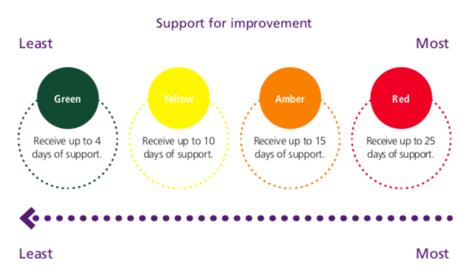
Figure 1. School colour categories used within Estyn (Welsh Government, 2019).
Conversely, there may be issues with the categorisation of schools, such as the stigmatisation that are in need of more support. Estyn (2014) advises school X to be a ‘good’ school implying it has many strengths but no specific areas that require significant improvement. School X is located rurally in South Wales and supports villages close by but also buses in pupils outside of these villages with <1% claiming free school meals (FSM) (My Local School, 2014). The class that the critical incident occurred in was year 5, aged between nine and ten years old. There was an even split between males and females with only one student needing a one-to-one learning support assistant (LSA) due to additional learning needs (ALN). The teacher was unavailable to be spoken to for further information on the class so understanding of the class dynamics was limited. Having more information on the class dynamics may have been vital for this observation, as something that was unknown may have led to the critical incident.

The essay will now discuss how the data was collected; observation, and the research methodology; case study. It will then progress on to analysing the strengths and weaknesses of observations and case study. Research design is an umbrella term that encompasses methods of data collection and methodology. A research design is a specific plan or protocol for conducting the study, allowing the researcher to translate the conceptual hypothesis; what the plan means into an operational hypothesis; something that can be measured (Abutabenjeh and Jaradet, 2018).
Observation research is a technique to collect data in social research but is rarely used in isolation (Arthur et al., 2012). Observational research is one of the most common techniques used in an education setting (Arthur et al., 2012) but it tends to be reactive in nature, as it is almost impossible for an observer to observe without anyone noticing. The observation used was non-participant observation that is a technique where the observer watches the participants without taking an active part (Scott and Marshall, 2009). However, a weakness of non-participant observation could be that the participants may behave differently, invalidating the results; this is known as the Hawthorne effect (Scott and Marshall, 2009). Two important considerations when completing observations are confirmed consent and anonymity to ensure the participants are fully at ease and true behaviours can be observed (Arthur et al., 2012). Direct observation is considered the gold standard technique, where learners are observed in their usual environment as is tries to ensure true behaviour is being observed (Murphy and Dingwall, 2007). Observing people in their environment removes self-reported issues but reveals insights not possible in other data collection methods (Furlong, 2010). Weaknesses of this approach that need to be considered are reliability and validity, but Arthur et al. (2012) suggest ways to combat these, such as, working with multiple observers so any inconsistencies can be identified. Observer bias is the most well documented weakness associated with observations due to the subjectivity nature of this research type. This is the tendency to for the observer seeing what they want to see within the research but this can be reduced by ensuring observers are well trained, clear rules / procedures are set and a specific time frame is set (Hammer et al., 2009). However, this was not possible for this observation so bias needs to be considered within the analysis.
Case study research is a type of research methodology that is suggested to be “thorough, holistic and in depth” within the area that is looking into (Kumar, 2014). Yin (2009) argues that case studies can answer why and how research questions leading to explanations as to why the situation unfolded. Using critical incidents allows for discussion with enhanced understanding and how classroom dynamics led to the incident arising (Rademacher, Simpson and Marcdante, 2010). Within this observation, a critical incident approach was adopted due to its bounded nature (Hyett et al., 2014). Creswell (2007) describes having a bounded nature as the observer making clear statements to the focus of their research. Strengths of the case study approach are that it provides an in depth investigation, allowing for more detail to be documented within the area (Morgan et al., 2017). It can be easier to understand a case study as it shows participants in real life situations. However, the results from a case study need to be looked into with caution, as there are multiple weaknesses associated. The most influential weakness is the inability to generalise the findings so what is found in one study cannot be used on a different population but shows in depth information in one cohort (Kumar, 2014), but is beneficial when completing in school research.
This essay will describe the critical incident and relate it to one of Donaldson’s four core purposes. The critical incident emerged during a games lesson (see appendices 4). The incident was when the teacher punished the class for the behaviour of three boys by removing dodgeball from them for “the next few weeks, but we shall see”, implying there was no end to this punishment. It led from numerous occurrences within the games lesson that began with two games of bench ball. There were no objectives set at the beginning of the lesson, which led the learners to focus on outcome goals like winning. Sadler (1998) suggests that sharing criteria with learners including learning objectives / success criteria, improves their understanding of what will make their work good and where they need to go next. This ensures that appropriate feedback can be given in relation to the objectives and criteria provided (Black and Wiliam, 1998). During the lesson the teacher pointed out aspects that the learners needed to work on but did not help them, which include passing, catching, communication, getting into space and sportsmanship behaviour. One team lost both bench ball games and when they started to lose dodgeball, frustration and anger started to arise from the three boys. They removed themselves from the game, which led to the teacher punishing them and then the whole class. This incident links to one of the four core purposes suggested by Donaldson (2015, p.30); “healthy, confident individuals who are ready to lead fulfilling lives as valued members of society” because if the learners are having negative experiences within physical education (P.E.) this may impact lifetime use of physical activity (PA). This is defined as physical literacy and was first presented by Whitehead (1993) where it was suggested that it incorporates knowledge, skills and motivation necessary to lead a physically active lifestyle. Learners being physically literate is important to enable them to apply knowledge about the impact of exercise on physical and mental health in their daily lives, take part PA and have the confidence to participate in the performance ensuring PA as a lifelong habit (Capel and Whitehead, 2013). There are many issues within the critical incident as PE has an important role in learners becoming physically literate (Lynch and Soukup, 2016) and as the learners having a negative experience could contribute to issues with confidence and habitual PA. Efforts to enhance physical literacy should commence as early as possible and be supported within school settings focusing on developing or reinforcing fundamental movement skills in a encouraging environment (Krader and Whitehead, 2018). Considering this, learners were not adequately supported in the critical incident or given a supportive environment to allow for progression and increased confidence within PA. Lessons that have progressions and tasks that practice skills whilst integrating systematic assessments that aid learning are suggested to be fundamental to successful PE lessons creating physically literate children (Foley et al., 2018). This information can be considered when evaluating the critical incident and how this incident may not support the purpose of creating healthy, confident individuals.
The essay will discuss, synthesis and critically analyse key aspects of the critical incident relating to three research areas; assessment for learning (AFL), physical literacy and theories of learning.
Assessment is considered important within education and most commonly used are summative assessments (OECD, 2008). Summative assessments are used to measure the knowledge the learners have accumulated at the end of a topic or unit to document levels attained (Mahshanian et al., 2019). Assessment can also serve in a formative (assessment for learning; AFL) way referring to frequent, interactive assessments of learner progress and to gain teacher understanding of any specific learning needs (Mahshanian et al., 2019). Mahshanian et al. (2019) suggest that using a combination of both summative and formative can lead to higher achievements within learners. However, Black and Wiliam (1998) suggest that formative techniques meet the diverse needs of learners, slowly raising achievements, whilst raising overall levels of learner achievements. One element of AFL is sharing criteria with learners so they know what makes good work; they know where they are in their learning and any next steps according to criteria (Jones, 2005). Sadler (1998) suggested teachers need to ‘let learners into the secret’ so they understand the assessment process, which can be achieved through success criteria. Numerous researches Leirhaug and Annerstedt (2016); Borghouts et al. (2017) suggest that success criteria can equip learners with how to be successful to develop peer and self- assessment. Allowing the ‘learners into the secret’, ensures they are aware of what is expected of them, increasing their motivation within lesson and allows them to be in charge of their own learning, linking to theories of learning outlined further on in the essay. Chroilin and Cosgrave (2013) completed a review into the use of formative assessment in primary P.E. and found success criteria and learning objectives are key for learning. The use of AFL within P.E. lessons provided structure and focus to planning, teaching and learning processes, which positively impacted both teacher and student learning. The use of AFL focuses the learners, allowing for appropriate feedback and informing future lessons. However, in the review completed by Chroilin and Cosgrave (2013), there were only 5 primary teachers included. This is a really small sample size that could be difficult to gain strong results from, especially as they stated the cohort had a “high level of knowledge and motivation towards the subject, which may not reflect the general population” so may not be reflective of a typical teacher population. It could be suggested that implementing AFL may have contributed to a structured, positive learning environment that ensured learning tasks were the focus rather than the outcome of the games during the critical incident. Improving the learning environment within a P.E. lesson could improve a learner’s disposition towards P.E. and their motivation to be active. With this in mind, the essay will move onto analyse the importance of physical literacy and consider what may be the most important aspect of P.E. in learner’s learning journey.
Physical literacy can be described as a disposition acquired by individuals incorporating motivation, confidence, physical competence, knowledge and understanding that establishes physical activity (PA) as a lifetime habit (Whitehead, 2010). When an individual is suggested to be physically literate they can be described with six different components:
- Physical literacy can be described by the motivation and confidence to utilise the potential behind PA to enhance their quality of life and a commitment to maintaining PA through their lifetime
- They will move with poise, economy and confidence in a wide variety of challenging situations
- They will be able to read all aspects of the physical environment, anticipating movement needs or possibilities and responding appropriately, with intelligence and imagination
- Individuals will have well-established sense of self in the world. This will enhance positive self esteem and self confidence
- Sensitivity to and awareness of embodied capability will lead to fluent self expression through non-verbal communication and to have an empathetic interaction with others
- They will have the ability to self assess their own movement performance, and have an understanding of healthy lifestyle considerations such as exercise, sleep and nutrition (Capel and Whitehead, 2013).
This element is such an important area as in the new curriculum Health and Wellbeing is suggested to be of equal weighting to other areas of learning such as science and technology. Health and Wellbeing includes a ‘what matters statement’ that says; “developing physical health and well-being has lifelong benefits” (Welsh Government, 2019b, p.6), and is supported by Olive et al. (2015). They suggest that a child that is physically literate, experiences a better psychological well-being contributing to other areas in their learning journey. Olive et al. (2015) looked at 478 girls and boys placing confidence into these results and they had a range of qualitative and quantitative assessments that gives the reader an in depth understanding of how the children perform and feel. They suggest that enhancing psychological well-being, such as self esteem can contribute positively to other aspects within school, like speaking in front of the class and volunteering. It puts a lot of emphasis on the learner being physically literate and the critical incident identified does not support all learners to develop the six components described by Capel and Whitehead (2013). Health and wellbeing that has been described as physical literacy, is strongly linked with the development of the child within other areas in their learning journey (Lundvall, 2015). Therefore, ensuring the learner has a good level of physical literacy develops the wider areas of the learner, such as cognition and social interaction (Whitehead, 2013). Being physically literate is important within schools as it supports the cognitive process, so if this critical incident is continual over the learners time in school it may impact negatively on a child’s development (Tandon et al., 2016; McGuire, 2011). A child’s experiences shape their trajectory within PA and cognitive processes so continual negative experiences within P.E. could lead to barriers towards learning (Carson et al., 2015b; Kranz et al., 2008; Reedy and Krebs-Smith, 2010). The essay will analyse theories of learning and how negative emotional experiences may impact on learning.

The final aspects to consider are the theories of learning and negative emotional experiences from a lesson that may lead to barriers towards learning. The lesson observed (see appendices 4) could be suggested that it mainly consisted of a constructivist school of learning approach because the learners constructed their own learning making sense of it for themselves. By creating their own meaning it leads to their own understanding (Vygotsky, 1978; Bruner, 1990). This is fundamental to learning as when new learning has connections to existing learning that is formulated by the learner it cements understanding, explained in Fig 2. (Huitt, 2009; Petty, 2012).
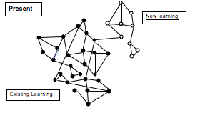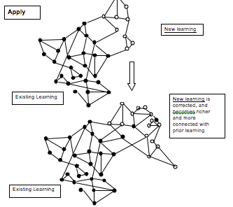
Figure 2. Explains how new learning needs to be based on existing learning to ensure full understanding (Petty, 2012).
However, there were integral aspects to the constructivist theory that was not included in the lesson that led to the critical incident and associated motivational / behavioural issues. An important concept to include within a constructivist lesson is to set activities that require the children to check their own and others’ learning errors and omissions through guided discovery (Gangwar and Savita, 2017). This links to aspects within AFL; introducing learning objectives and success criteria analysed at the beginning of the literature review, suggesting that sharing the learning objectives to the learners is important within the constructivist theory of learning (Jones, 2005). Therefore, the absence of learning objectives runs contrary to details of constructivism, which may have led to the critical incident detailed in appendices 4. In addition to this, the humanistic school of learning suggests that learning should meet the emotional needs of learners or it may lead to a fear of failure or fear of rejection (Holt, 1964) and these emotional needs are not met within this critical incident as numerous children sit out upset by the end of the lesson. This usually leads to two things; the learner could sit back and disengage or they could distract the teacher through bad behaviour (Kazamias, 2018). The bad behaviour and disengagement is seen in this lesson suggesting that the humanistic theory was not met in this lesson increasing the learners’ fear of failure. This is an important consideration when looking at physical literacy as when the emotional needs of the learners are not met this could lead to unmotivated behaviour and negative experiences within P.E., which may impact the lifetime habits of PA of children.

The essay will reflect on the critical incident and progress to suggest next steps. Reflective practice is strongly associated with learning in a variety of professional contexts, especially within the teaching profession (The Open University, 2016). Reflection can be associated with self-regulated learning, as Kistner et al. (2010) suggested that including reflection within the classroom led to an improvement of student performance in tests. This is an important point of consideration as it suggests that reflection is a strong cause to improving performance. Critical analysis and reflection is a key tool to allow practitioners to develop and learn from complex situations and any conflicts encountered (The Open University, 2016). Dewey (1910, p. 6) believes that reflective practice is the “active, persistent and careful consideration of any belief or supposed form of knowledge in the light of the grounds that support it”. However, Schon (1983) suggests reflection has two areas; reflection during and reflection post the incident. Reflection post incident was completed (see appendices 9) and allows for the observer to consider the situation again, which stimulates deeper thinking about different areas. Being a reflective practitioner is vital within the new Teaching and Leadership Standards for Wales as in the professional learning section a teacher need to extend knowledge, skills and understanding that can be done through reflection and an openness to challenge, developing pedagogy (Welsh Government, 2018). This suggests that to be an effective teacher developing reflective practice skills to ensure pedagogy is the best it can be for the learners.
An Assisted Reflective Conclusions (ARC) model was completed following the critical incident (see appendices 9) that include my feelings on the incident, going through the understanding of the incident, through to evaluate and the analysis of the incident, finally discussing my conclusions and any actions going forward. In this section, it will follow Gibb’s reflective model that is adapted from Dye (2011) that includes experience, feelings, evaluation, analysis, conclusion and adaption plan see Fig. 3. 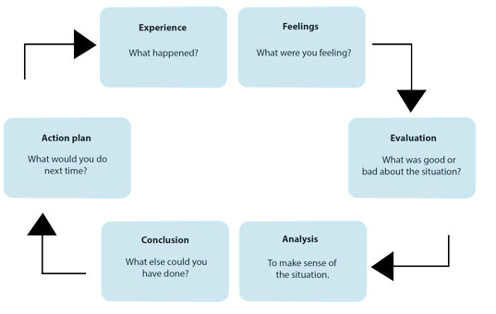Figure 3. Gibb’s reflective cycle (Adapted Dye, 2011).
As explained in appendices 4, the incident focused on a few children who lost multiple games so ended up losing motivation and sat out of the game, the teacher then punished them and then the whole class. I felt slightly confused about this experience, as initially it was great to see the children so engaged within P.E. This shows that the teacher has really great potential to positively engage them within P.E, creating physically active learners as a lifetime habit.
When evaluating the situation the good points was that the games undertaken were chosen by the learners allowing them to take ownership of their learning experience, which is part of constructivism learning theory detailed earlier in the essay. Another positive point of the game was the inclusion of every learner due to the type of team games chosen, they ensured that every player was important giving the learners a real purpose within the team. However, the negative aspects of the situation that I could see were in relation to the limited structure. I think that this limited structure meant that the learners did not focus on developing their game skills such as passing, catching and getting into space, all vital to team sports. Another issue with the lack of structure meant that there was a huge focus with winning leading to motivational knocks when a team continually lost. The final issue that was seen in the experience was the punishment for the children who chose to sit out of the lesson. The teacher began by punishing the three children by making them tidy up the equipment and then when they came back in and the whole class was punished for their actions so dodgeball was taken out of the option for their P.E. lessons.
When analysing the situation, I think the main issue was the lack of direction of the lesson allowing for the learners to focus on the outcome goals rather than process goals and when the outcomes are not successful this can lead to a lack of motivation, which was seen with the three children who sat out when they consistently lost.
This leads to the actions that I would include in any future lessons. My initial steps would be to include a learning objective, like: ‘To learn the different skills needed in a game of bench ball and dodgeball’. This will then lead to the children deciding what the success criteria might look like when trying to aim to this learning objective. For example; ‘I can pass accurately’, ‘I can catch the ball most of the time’. This could initially be incorporated into the game through small zones focusing on one area and then bringing this together into a big game, whilst using reflective points for the learners to ensure they understand why something may not be going to plan. Another thing to consider may be to shuffle teams around multiple times so that one team of children do not consistently lose. In addition, incorporating sportsmanship behaviour into these lessons so that all learners understand what it means to be sportsman like and installing these positive attributes in at all levels. These considerations will hopefully lead to a different focus within the lesson, engaging the learners positively so that they all have a positive experience enhancing their motivation within P.E.

Finally, the essay will conclude with an explanation of the assessment and summary of the approach taken. This will be linked to the role of the reflective practitioner in Wales and the new Professional Standards for Teaching and Leadership. The role of Professional Learning allows for effective pedagogy to be taken deeper, being reflective in practice and open to challenge, supports and informs learning whilst developing pedagogy (Belvis et al., 2013). This essay has detailed the use of an observation approach with case study, specifically a critical incident as the research method. It has allowed for the research to be in depth and reflective. As stated previously, being reflective is paramount to being an effective practitioner, especially within education. The new Teaching and Leadership Standards link perfectly with this reflective, detailed approach (critical incident) as has allowed for a deepening understanding of the pedagogy used, it moves pedagogy forward through innovative approaches, whilst also ensuring practitioners are deepening their professional learning (Welsh Government, 2018). This ensures that observers consistently extend knowledge, skills and understanding allowing consistent challenge of why they do what they do within lessons. Therefore, if practice is effective it can be continued, if its not effective finding out why it is not and how best to change it for the learners. A critical incident is an effective way to ensure constant reflective practice within the profession, continually striving for the best for the learners within schools.

Reference List

Abutabenjeh, S., and Jaradat, R. (2018). “Clarification of research design, research methods, and research methodology: A guide for public administration researchers and practitioners”, Teaching Public Administration, 36(3), pp. 237-258. DOI: 10.1177/0144739418775787

Arthur, J., Waring, M., Coe, R., and Hedges, L, V. (2012). Research methods and methodologies in education. California: SAGE publications.

Belvis, E., Pineda, P., Armengol, C., and Moreno, V. (2013). Evaluation of reflective practice in teach education. European Journal of Teacher Education, 36(3), pp. 279-293
BERA. (2018). “Ethical guidelines for educational research”.(4th edn). London: British educational research association. Principles, Policy and Practice, CARFAX, Oxfordshire, Vol. 5, No. 1, pp. 7-74.
Black P. and D. Wiliam (1998), “Assessment and Classroom Learning”, London: GL Assessment.
Borghouts, L, B., Slingerland, M., and Haerens, L. (2017). Assessment quality and practices in secondary PE in the Netherlands. Physical Education & Sport Pedagogy, 22(5), pp. 473-490.
Bruner, J. (1990). Acts of meaning. Cambridge, MA: Harvard University Press
Carson, V., Kuzik, N., Hunter, S., Wiebe, S, A., Spence, J, C., Friedman, A., Tremblay, M, S., Slater, L, G., and Hinkley, T. (2015). Systematic review of sedentary behavior and cognitive development in early childhood. Preventive Medicine, 78, pp. 115-122.
Capel, S, A., and Whitehead, M. (2013). Debates in Physical Education. Milton Park, Abingdon, Oxon: Routledge.
Chroinin, D, N., and Cosgrave, C. 2013. Implementing formative assessment in primary physical education: teacher persepctives and experiences. Physical education and sport pedagogy, 18: 219-233

Creswell, J. W. (2007) Qualitative Enquiry and Research Design: Choosing Among Five Approaches, Thousand Oaks, CA: Sage Publications.

Dewey, J. (1910) How we think, Boston, D.C.Heath

Donaldson, G. (2015). “Successful futures: Independent review of curriculum and assessment arrangements in Wales.” ISBN 978 1 4734 3043 3.

Dye, V. (2011) ‘Reflection, Reflection, Reflection. I’m thinking all the time, why do I need a theory or model of reflection?’, in McGregor, D. and Cartwright, L. Developing Reflective Practice: A guide for beginning teachers, Open University Press

Estyn (2014) Estyn A Report on Pendoylan C.I.W. Primary School [report] (Accessed: 11 October 2019). https://www.estyn.gov.wales/sites/www.estyn.gov.wales/files/documents/Inspection%20report%20Pendoylan%20C.I.W.%20Primary%20School%202014%20%28English%20only%29_0.pdf.pdf.pdf.pdf.pdf.pdf.pdf.pdf.pdf.pdf.pdf.pdf.pdf.pdf
Estyn (2015). Estyn Effective practice on improving attendance in primary schools [report] (Accessed: 11 October 2019) https://www.estyn.gov.wales/sites/www.estyn.gov.wales/files/documents/Effective_practice_in_improving_attendance_in_primary_schools_-_June_2015.pdf
Flanagan JC. 1954. The critical incident technique. Psychol Bull 51(4):327–358.
Furlong, M. (2010). Clear at a distance, jumbled up close: Observation, immersion and reflection in the process that is creative research. In Liamputtong, P. (Ed.), Research methods in health: Foundations for evidence-based practice (pp. 153–169). South Melbourne, Australia: Victoria Oxford University Press.
Foley, J, T., MacDonald, L, C., and Breiman, D, J. 2018. “Shake up PE’s Status Quo: When done right, physical education can contribute to overall well-being, fitness and improved academic behaviors.” National addociation of elementary school principals, 98:24-27.
Gangwar, B., and Savita, B. (2017). Constructivist Approach in Teaching Learning. Deliberative Research, 34(1), pp. 71-74.
Hammer, G., P. du Prel, J. B., and Blettner, M. (2009). Avoiding bias in observational studies, Dtsch Arztebl, 106(41), pp. 664-668. Doi: 10.3238/arztebl.2009.0664.
Harford, J., and G. MacRuairc. 2008. “Engaging Student Teachers in Meaningful Reflective Practice.” Teaching and Teacher Education 24: 1884–1892. doi:10.1016/j.tate.2008. 02.010.
Holt, J. (1964). “How children fail” (2nd edn). London: Penguin.
Huitt, W. (2009). Constructivism. Educational Psychology Interactive. Valdosta, GA: Valdosta State University

Hyett, N., Kenny, A., and Dickson-Swift, V. (2014). “Methodology or method? A critical review of qualitative case study reports”. International Journal of Qualitative Studies on Health and Well-being, 9(1), pp 1-12. doi: 10.3402/qhw.v9.23606

Jones, C. (2005). Assessment for learning. Learning and Skills development Agency: London.

Kazamias, A. (2018). The Owl of Athena: History, Philosophy, and Humanism in Comparative Education. European Education, 50(2), pp. 84-100.
Krader, C, ,G., and Whitehead, M. 2018. “Physical literacy: new paradigm for fighting physical inactivity/commentary.” Contemporary paediatrics 18: 20-21.
Kranz, S., Findeis, J. L., and Shrestha, S, S.. (2008). Use of the revised children's diet quality index to assess preschooler's diet quality, its sociodemographic predictors, and its association with body weight status Jornal de Pediatria, 84 (1), pp. 26-34.
Kumar, R. (2014). Research methodology: a step-by-step guide for beginners. (4th edn) Los Angeles: SAGE.
Leirhaug, P, E., and Annerstedt, C. (2016) Assessing with new eyes? Assessment for learning in Norweigian physical education. Physical Education & Sport Pedagogy, 21(6), pp. 616-632.
Lundvall, S. (2015). Physical literacy in the field of physical education – A challenge and a possibility. Journal of Sport and Healthy Science, 4 (2), pp. 113-118. https://doi.org/10.1016/j.jshs.2015.02.001

Lynch, T., and Soukup, G. (2016). ““Physical education”, “health and and physical education”, “physical literacy” and “health literacy”: Global nomenclature confusion. Cogent Education, 3 (1), pp. 1-22, DOI:10.1080/2331186X.2016.1217820

Mahshanian, A., Shogi, R., and Bahrami, M. (2019). Investigating the differential effects of formative and summative assessment on EFL learners’ end-of-term achievement. Journal of Language Teaching & Research, 10 (5), pp. 1055-1066.
McGarr, O., and O. McCormack. 2016. “Counterfactual mutation of critical classroom incidents: implications for reflective practice in initial teacher education” European Journal of Teacher Education, 39: 36-52. http://dx.doi.org/10.1080/02619768.2015.1066329
McGuire, S. (2011). Institute of Medicine (IOM) Early Childhood Obesity Prevention Policies. Advances in Nutrition, 3(1), .pp. 56-57
Morgan, S. J., Pullon, S, R, H., Macdonald, L, M., McKinlay, E, M., and Gray, B, V. 2017. Case study observational research: a framework for conducting case study research where observation data are the focus. Qualitive health research, 27: 1060-1069.
Murphy, E., Dingwall, R. (2007). Informed consent, anticipatory regulation and ethnographic practice. Social Science & Medicine, 65, 2223–2234. doi:10.1016/j.socscimed.2007.08.008
My Local School (2014). Pendoylan C/W Primary School. Available at: http://mylocalschool.gov.wales/School/6733363?lang=en (Accessed: 11 October 2019).
Olive, L., Telford, R., Telford, R., and Byrne, D. 2015. Physical literacy development in Australian youth: A current concern Pschological consequences of physical literacy in primary school children. Journal of Science & Medicine in Sport, 19: 62.
Petty, G. (2012). Constructivist teaching. Available on http://geoffpetty.com/for-team-leaders/downloads/ (Accessed on: 12 October 2019).
Rademacher, R., Simpson, D., and K. Marcdante. 2010. “Critical incidents as a technique for teaching professionalism.” Medical teacher, 32: 244-249.
Reedy, J., and Krebs-Smith, S, M. (2010). Dietary sources of energy, solid fats, and added sugars among children and adolescents in the United States. Journal of the American Dietetic Association, 110 (10), pp. 1477-1484.

Sadler., T. 1998. Letting students into the secret. Further steps in making criteria and standards work to improve learning. Paper presented at the annual conference for state review panels and district review panel charts, July 1998.

Schon, D. (1983) The reflective practitioner: How professionals think in action, London, TempleSmith

Scott, J., and Marshall, G. (2009). “A dictionary of sociology”. (3rd edn). Oxford University Press.

Tandon, P, S., Tovar, A., Jayasuriya, A, T., Welker, E., Schober, D, J., Copeland, K., Dev, D, A., Murriel, A, L., Amso, D., and Ward, D, S. (2016). The relationship between physical activity and diet and young children’s cognitive development: A systematic review. Preventive Medicine Reports, 3, pp. 379-390.

The Open University (2016). Learning to teach: becoming a reflective practitioner. Available at: https://www.open.edu/openlearn/ocw/mod/oucontent/view.php?printable=1&id=14520 (Accessed: 12 October 2019).

Tripp, D. 1993. “Critical incidents in teaching. Developing professional judgement.” Pp 28.
Vygotsky, L. (1978). Mind in society. Cambridge, MA: Harvard University Press.
Welsh Governement (2018). An introduction to professional standards for teaching and leadership. Available at https://s3-eu-west-1.amazonaws.com/hwb-live-storage/9b/9a/d3/8a/f1354794bb954aa3cbb0f5e3/an-introduction-to-the-professional-standards-for-teaching-and-leadership.pdf (Accessed: 12 October, 2019).

Welsh Government (2019). National School Categorisation System. Available at: https://gov.wales/sites/default/files/publications/2019-01/national-school-categorisation-system-guidance-for-parents-and-carers.pdf (Accessed: 11 October 2019).

Welsh Government (2019b). Draft Statutory Guidance Area of Learning and Experience. Health and Well-being. Available at: https://s3-eu-west-1.amazonaws.com/hwb-live-storage/b3/3c/8c/5f/267e48f8bf37c66bd3d8bb5b/draft-statutory-guidance-health-and-well-being.pdf (Accessed: 13 October 2019).

Whitehead, M. (1993) Cited on IPLA (2019). International Physical Literacy Association. Available at: https://www.physical-literacy.org.uk/about/ (Accessed: 11 October 2019).

Whitehead, M. (2010). Physical literacy throughout the lifecourse. (1st edn). New York: Routledge.

Whitehead, M. (2013). Debates in Physcial Education. Milton Park, Abingdon, Oxon: Routledge.

Yin, R., K. 2009. “Case study research: Design and methods (4th edn). Thousand Daks, CA: Sage Publications.

Appendix

Appendices 1

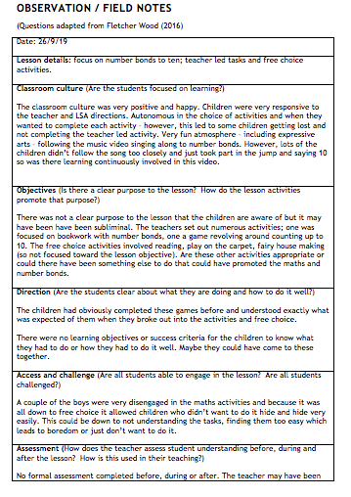
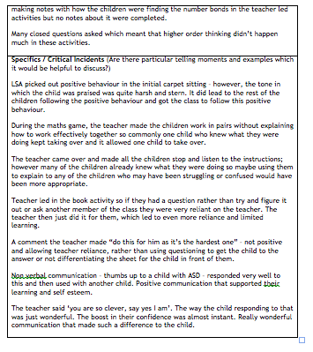

Appendices 2

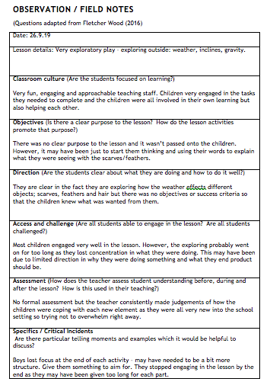

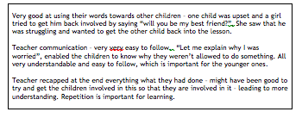

Appendices 3

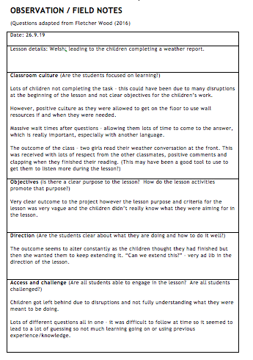

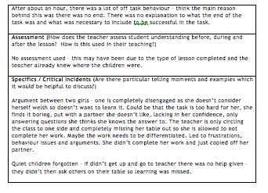

Appendices 4

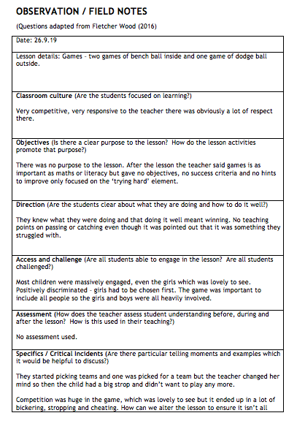

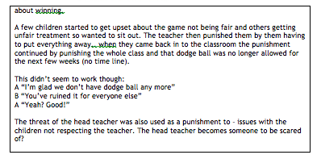

Appendices 5

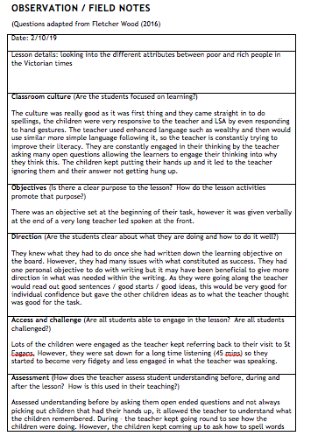

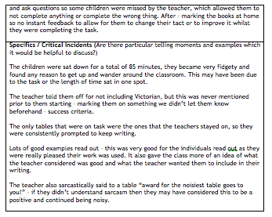

Appendices 6

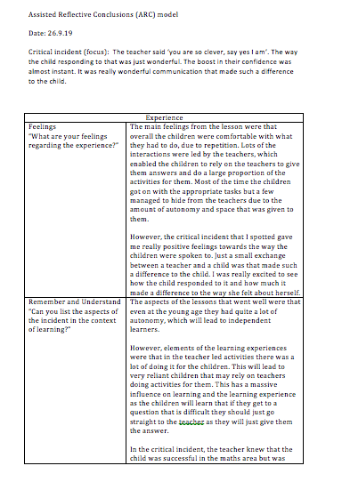

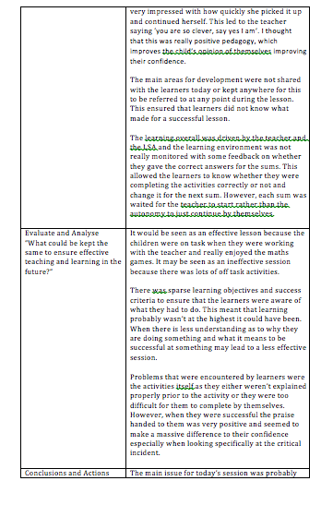

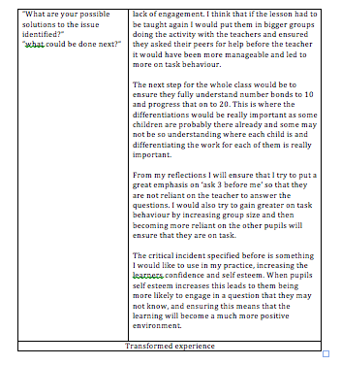

Appendices 7

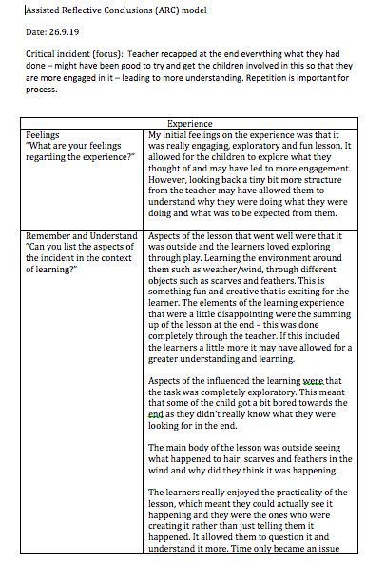
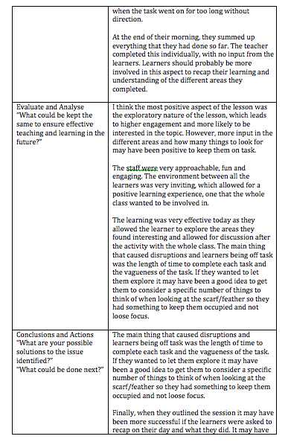

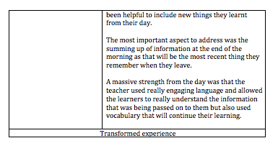

Appendices 8

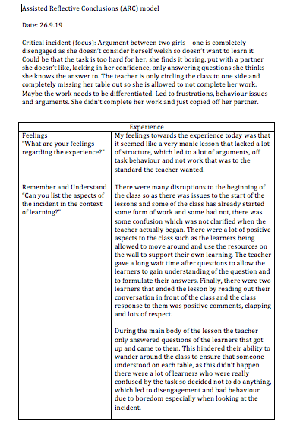

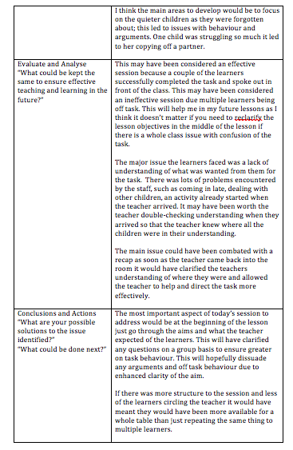

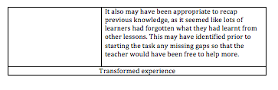

Appendices 9

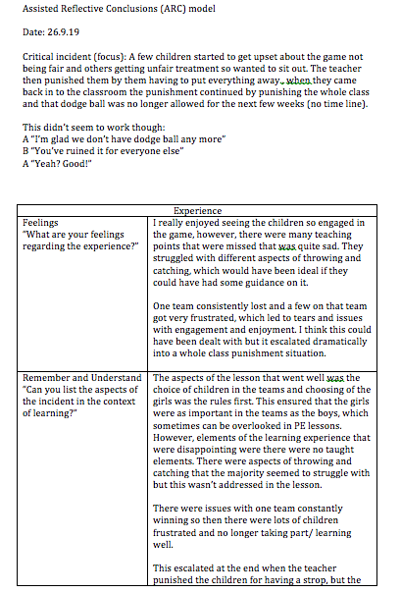

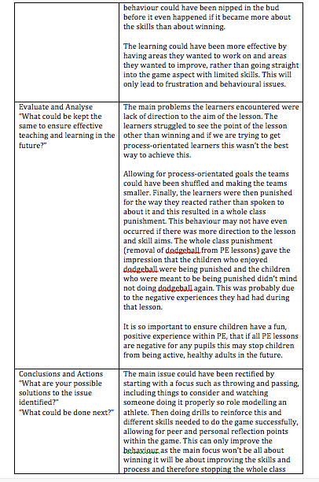

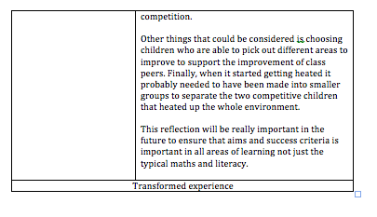

Appendices 10



