

Assignment Title: How Management and Leadership Style Affects Associate Engagement and Retention at Amazon CWL1 Fulfilment Centre (FC) Swansea
Module name: Developing a Research Proposal BMSW5014
Student name: Marian Mihai Luca (1712434)
Lecturer Name: Jaliya De-Silva
Submission date: Friday 26th of June 2026

Word count: 2,135
Contents
1. Title and introduction 3
2. Literature review 5
3. Research Methodology 7
4. References 12

Title and introduction

How Management and Leadership Style Affects Associate Engagement and Retention at Amazon CWL1 Fulfilment Centre (FC) Swansea
This research proposal explores how management and leadership style affects associate engagement and retention at Amazon CWL1, located in Swansea, Wales. I chose this topic because I currently work at CWL1 as an Interim Area Manager, and during my time there I have seen how much of a difference a manager's daily behaviour can make to how associates feel about their work and whether they decide to stay.
CWL1 is a large-scale fulfilment centre that operates around the clock, with hundreds of associates across Pick, Pack and Ship departments. Like many similar operations, it faces persistent challenges with associate engagement and turnover. The CIPD (2023) estimates that replacing one frontline employee costs between £3,000 and £5,000 when recruitment, training and lost productivity are included. Gallup (2023) reports that only 23% of employees globally feel genuinely engaged at work.
In my own experience at the site, I have observed that engagement and retention are shaped less by formal HR policies and more by the day-to-day actions of direct managers and how they communicate, whether they recognise effort, and how they respond when associates raise concerns.
The aim of this research is to examine how frontline management and leadership style impacts associate engagement and retention at CWL1. The five objectives are to: critically review relevant literature; explore which leadership behaviours associates connect with feeling valued; investigate how management communication affects intention to stay.
The central research question is: To what extent does frontline management and leadership style influence associate engagement and retention at Amazon CWL1?

Objectives:
- To critically review the existing academic literature on leadership styles and their relationship with employee engagement and retention
- To explore which specific leadership behaviours associates most associate with feeling valued and motivated at work
- To investigate how management communication practices affect associate’s intention to remain with the organisation
- To understand how organisational culture shapes the way leadership is experienced by associates at the frontline level
- To propose evidence-based recommendations for frontline management development that could improve engagement and reduce voluntary turnover
Questions:
- What does the existing academic literature tell us about the relationship between leadership style and employee engagement and retention?
- Which specific leadership behaviours do associates identify as making them feel valued, recognised and motivated?
- How does the quality and frequency of management communication influence associate’s intention to stay with the organisation?
- In what ways does the organisational culture of an Amazon fulfilment centre shape how associates experience leadership at the front-line level?
- What practical changes to frontline management development could most effectively improve associate engagement and reduce voluntary turnover?

Literature review

Leadership Style and Engagement
The relationship between leadership style and employee engagement has been widely studied. Bass and Riggio (2006) distinguish between transformational and transactional leadership. Transformational leaders inspire, develop and emotionally connect with their teams, while transactional leaders manage primarily through targets, rewards and consequences. In high-volume operational environments like CWL1, transactional approaches tend to dominate because performance metrics are central to daily operations (Daft, 2018). However, Bass and Riggio argue that transactional leadership alone does not build loyalty or emotional commitment and it keeps people compliant, but not engaged. This is a significant limitation of this work, as the original studies focused mainly on military and education settings, not logistics or warehousing environments.
Northouse (2021) supports this view, arguing that transformational leadership consistently produces higher levels of employee engagement. However, much of Northouse's research is based on professional and managerial workers, which makes it less directly applicable to hourly associates like those at CWL1.
Taken together, Bass and Riggio (2006) and Northouse (2021) suggest a pattern that is directly observable at CWL1 — where transactional approaches dominate daily operations yet consistently fail to build the emotional commitment that prevents voluntary turnover among associates.
Employee Engagement
Macey and Schneider (2008) define engagement as having three components, cognitive, emotional, and behavioural investment in work. Their model is useful for understanding the different ways associates can be engaged or disengaged, though it is largely theoretical and does not specifically explore how leadership style drives each component.
Saks (2006) found that the quality of the manager relationship is the strongest single predictor of employee engagement, stronger even than job content or pay. This is particularly relevant for CWL1, where most associates have limited control over their job design, meaning the manager relationship becomes even more important. A limitation of Saks's work is that it is nearly twenty years old and the workforce context has changed considerably since then.
Nevertheless, Saks's (2006) core finding reinforces the argument made by Bass and Riggio (2006), that the quality of the manager relationship remains the most controllable lever available to frontline leaders at CWL1 for driving meaningful engagement outcomes.
Bakker and Demerouti (2008) developed the Job Demands-Resources (JD-R) model, which proposes that engagement is high when job demands are balanced by sufficient resources, including managerial support. In a fulfilment centre environment, where demands are consistently high, particularly during peak periods and the role of the manager in providing support and resources becomes critical. The limitation here is that the JD-R model does not specifically examine how different leadership styles moderate the relationship between demands and resources.
Retention
Harter, Schmidt and Hayes (2002) found that engaged employees are 51% less likely to leave their organisation. This directly connects leadership behaviour, which drives engagement to retention outcomes. A limitation of this research, however, is that it draws heavily on Gallup's commercial survey database, which may introduce bias toward positive findings.
Hausknecht and Trevor (2011) found that fairness, communication quality and management behaviour are among the strongest non-financial drivers of retention. Purcell et al. (2003) add that the frontline manager is the critical link between what an organisation formally promises and what employees actually experience. This is especially true at CWL1, where formal HR policies exist but the daily experience of associates is shaped entirely by their direct Team Lead or Area Manager.
The cumulative evidence from Harter et al. (2002), Hausknecht and Trevor (2011) and Purcell et al. (2003) therefore establishes a direct chain: leadership behaviour drives engagement, engagement drives retention, and the frontline manager at CWL1 is the critical link in that chain.

Organisational Culture
Schein (2017) argues that organisational culture shapes how leadership is practised in ways that are often invisible. Yukl (2013) observes that in performance-driven cultures, managers often feel pressure to prioritise metrics over people, which gradually erodes trust and engagement. At CWL1, the culture is heavily performance-focused, rate targets, quality scores and attendance are tracked daily. This creates real tension for managers who want to lead in a more people-centred way.
This cultural pressure, combined with the resource constraints described by Bakker and Demerouti's (2008) JD-R model, suggests that the organisational environment at CWL1 may itself actively undermine the transformational leadership behaviours that the literature identifies as most effective for improving engagement and reducing voluntary turnover.
Research Gap
Despite the volume of research on leadership and engagement, very little of it focuses specifically on hourly associates in large-scale e-commerce fulfilment environments. Most studies draw on professional workers, office settings, or healthcare. CWL1 represents exactly the kind of environment that is missing from the literature, fast-paced, physically demanding, high-turnover, and heavily metrics-driven. This study directly addresses that gap.

Research Methodology

Research Philosophy
This study adopts an interpretivist philosophy. Interpretivism holds that reality is subjective and that people construct meaning through their personal experiences (Creswell and Creswell, 2023). This is appropriate because the research is concerned with how associates at CWL1 personally experience their managers and what those interactions mean to them, and how they shape their decision to stay or leave. A positivist approach, which seeks objective, measurable facts, would not capture this kind of lived experience.
This study follows Saunders, Lewis and Thornhill’s (2023) Research Onion to structure and justify each methodological layer in sequence. Ontologically, the study adopts a social constructionist position, recognising that associate experiences of leadership are shaped by personal, cultural and contextual factors. Epistemologically, knowledge is treated as subjective and co-constructed through interpretation of participant accounts (Creswell and Creswell, 2023).
Research Approach
The approach is inductive. Rather than starting with a hypothesis and trying to prove or disprove it, inductive research allows themes and understanding to emerge from the data itself (Bryman and Bell, 2023). This is appropriate here because associate experiences at CWL1 are likely to be varied and context-specific. Beginning with a fixed hypothesis would risk imposing assumptions onto findings that do not fit them.
Research Design
The design is a qualitative case study, with CWL1 as the single research site. Yin (2018) argues that the case study design is most appropriate when the aim is to understand a real-world situation in depth and in its full context. A quantitative survey design was considered, but rejected, while a survey would produce more responses, it would not reveal the reasons behind people's feelings or experiences. A mixed methods design was also considered but was judged to be beyond the scope and resources of this study.
Data Collection
Data will be collected through semi-structured interviews. Each interview will last approximately 30 to 45 minutes and will take place either face-to-face at CWL1 or via Microsoft Teams. All interviews will be audio recorded with the participant's consent and transcribed verbatim. Semi-structured interviews are chosen because they allow flexibility and the researcher can follow up on interesting points, while still maintaining a consistent focus across all interviews (Flick, 2023).
Interview topics will include daily management experience, whether associates feel recognised and valued, how management communication affects their motivation and whether leadership behaviour has influenced their intention to stay at CWL1.

Sampling
Purposive sampling will be used, following Patton (2015). This means participants are deliberately selected because they have direct, relevant experience of the research topic and they are not chosen at random. A random sample might include people with no meaningful experience of the leadership dynamics being investigated.
The target sample is 12 to 15 associates from across Pick, Pack and Ship departments, representing a range of tenure lengths, plus 4 to 6 managers including Team Leads and Area Managers. This gives a total of approximately 16 to 21 participants. Guest, Bunce and Johnson (2006) found that thematic saturation, the point at which new interviews stop producing new insights and is typically reached within 12 interviews in a focused qualitative study. This sample size is therefore considered sufficient.
Recruitment will be fully voluntary, through notice boards and briefings, and completely independent of any management reporting line, to avoid pressure on associates to participate.
Data Analysis
Data will be analysed using Thematic Analysis, following the six-phase process described by Braun and Clarke (2006): familiarising with the data; generating initial codes; searching for themes; reviewing themes; defining and naming themes; and writing up findings. NVivo software will be used to organise and manage the coding process.
To ensure the honesty of findings, this study applies Lincoln and Guba’s (1985) four criteria: credibility, dependability, confirmability and transferability. Credibility is supported through careful follow-up questioning during interviews. Dependability is maintained through a consistent interview guide across all participants. Confirmability is achieved via a reflexive research journal to document and challenge the researcher’s assumptions. Transferability is supported through rich, contextually detailed descriptions of the research setting.

Ethics
Ethical approval will be obtained from the UWTSD Ethics Committee before any data collection begins. Every participant will sign a written informed consent form and will be clearly told that they can withdraw from the study at any time without any consequences. All names and identifying details will be replaced with coded identifiers throughout all outputs. Data will be stored on a password-protected device and deleted after five years, in line with GDPR (2018) and BERA (2018) guidelines.
The most significant ethical consideration in this study is the power imbalance. As a manager at CWL1, the researcher works within the same operational hierarchy as the participants. To manage this, recruitment will be conducted independently of any management chain, and the consent process will explicitly state that participation has no connection to employment.
Limitations
The single-site case study design means findings cannot be statistically generalised beyond CWL1. There is a risk of social desirability bias, where associates give more positive answers than they truly feel. Researcher bias is a further risk, given the researcher's managerial position at the site. These limitations are acknowledged and managed but not fully eliminated.

Project Plan and Timeline
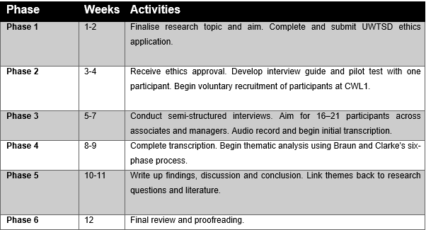
  - Appendix - Research Project Gantt Chart
  - 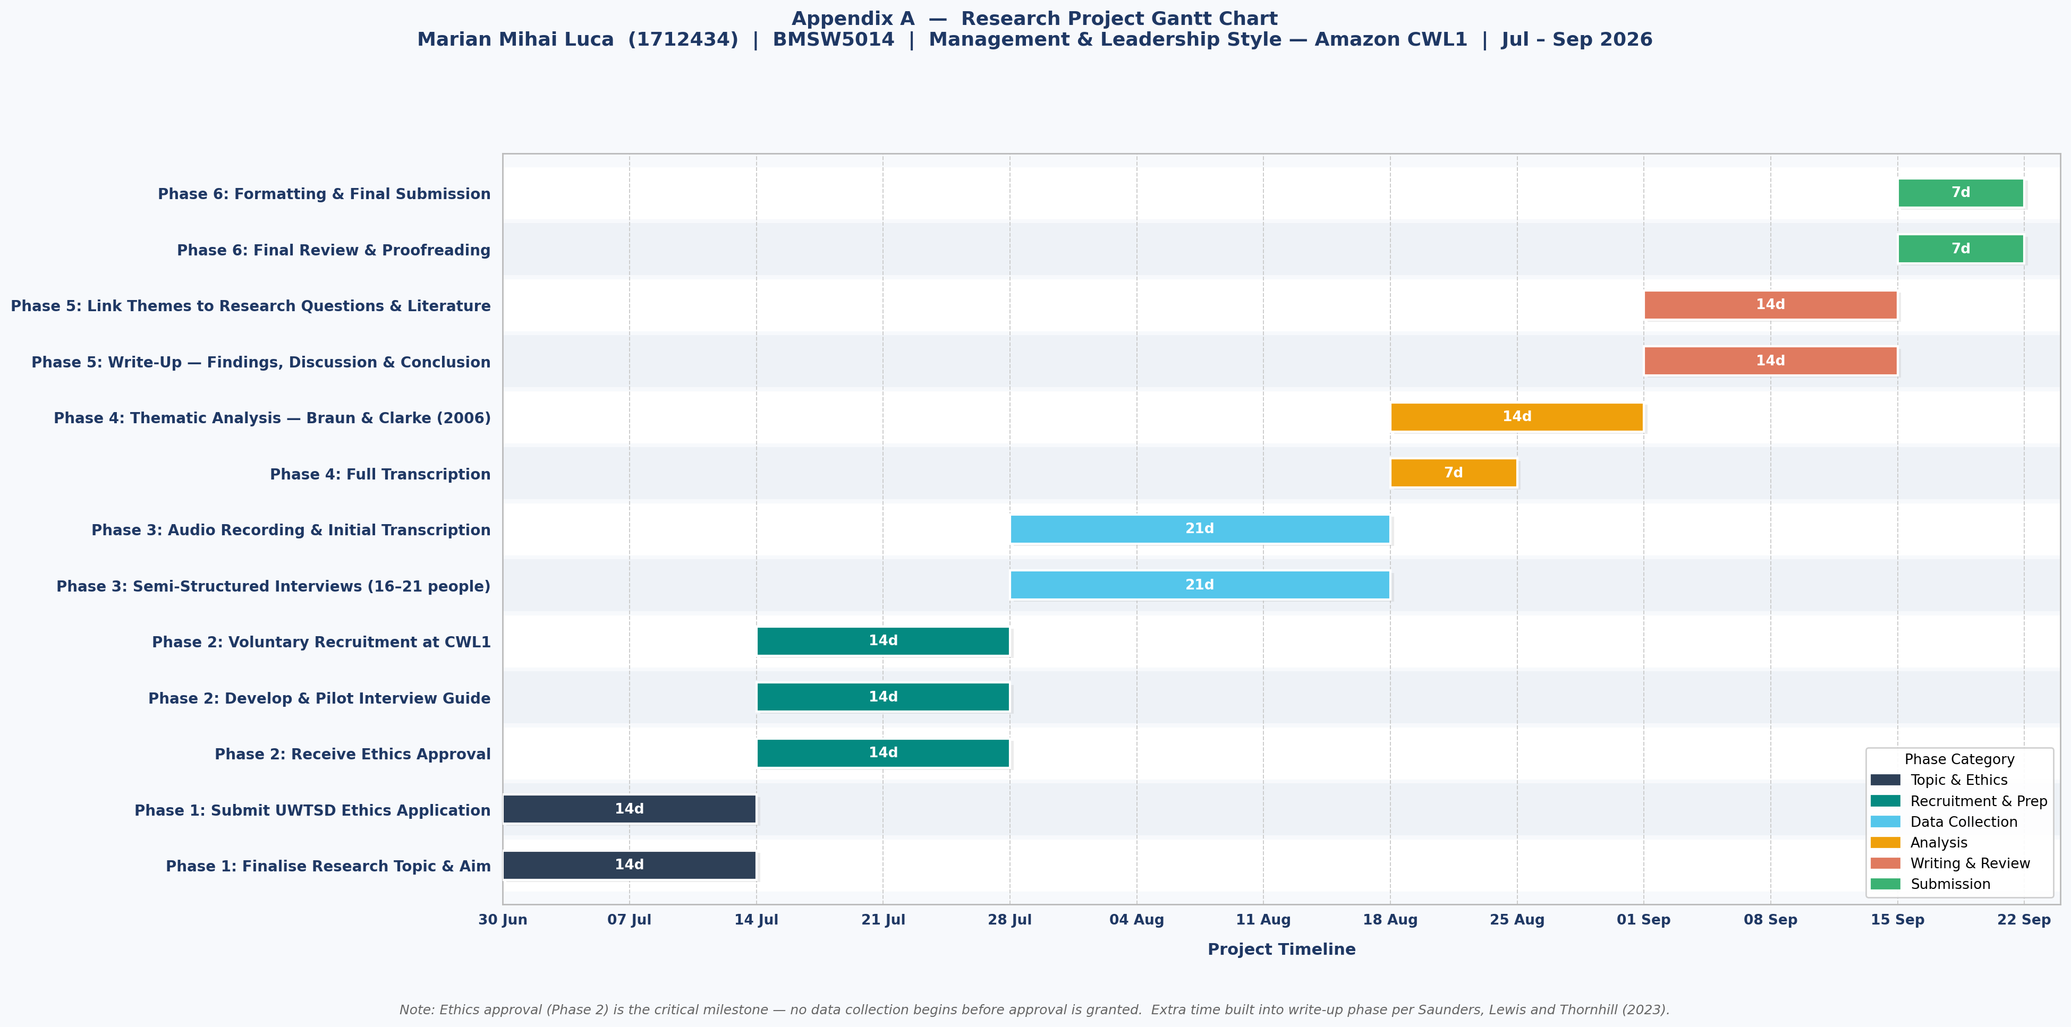

This timeline has been designed to be realistic for a single researcher working alongside academic and professional commitments. Extra time has been built into the writing-up phase in line with guidance from Saunders, Lewis and Thornhill (2023).

References

- Bakker, A.B. and Demerouti, E. (2008) 'Towards a model of work engagement', Career Development International, 13(3), pp. 209–223.
- Bass, B.M. and Riggio, R.E. (2006) Transformational Leadership. 2nd ed. Mahwah: Lawrence Erlbaum Associates.
- BERA (2018) Ethical Guidelines for Educational Research. 4th ed. London: British Educational Research Association.
- Braun, V. and Clarke, V. (2006) 'Using thematic analysis in psychology', Qualitative Research in Psychology, 3(2), pp. 77–101.
- Bryman, A. and Bell, E. (2023) Business Research Methods. 5th ed. Oxford: Oxford University Press.
- CIPD (2023) Resourcing and Talent Planning Survey. London: Chartered Institute of Personnel and Development.
- Creswell, J.W. and Creswell, J.D. (2023) Research Design: Qualitative, Quantitative, and Mixed Methods Approaches. 6th ed. London: SAGE Publications.
- Daft, R.L. (2018) The Leadership Experience. 7th ed. Mason: Cengage Learning.
- Flick, U. (2023) An Introduction to Qualitative Research. 6th ed. London: SAGE Publications.
- Gallup (2023) State of the Global Workplace Report. Washington DC: Gallup.
- Guest, G., Bunce, A. and Johnson, L. (2006) 'How many interviews are enough? An experiment with data saturation and variability', Field Methods, 18(1), pp. 59–82.
- Harter, J.K., Schmidt, F.L. and Hayes, T.L. (2002) 'Business-unit-level relationship between employee satisfaction, employee engagement, and business outcomes', Journal of Applied Psychology, 87(2), pp. 268–279.
- Hausknecht, J.P. and Trevor, C.O. (2011) 'Collective turnover at the group, unit, and organisational levels: evidence, issues, and implications', Journal of Management, 37(1), pp. 352–388.
- Lincoln, Y.S. and Guba, E.G. (1985) Naturalistic Inquiry. Beverly Hills: SAGE Publications.
- Macey, W.H. and Schneider, B. (2008) 'The meaning of employee engagement', Industrial and Organizational Psychology, 1(1), pp. 3–30.
- Northouse, P.G. (2021) Leadership: Theory and Practice. 9th ed. London: SAGE Publications.
- Patton, M.Q. (2015) Qualitative Research and Evaluation Methods. 4th ed. London: SAGE Publications.
- Purcell, J., Kinnie, N., Hutchinson, S., Rayton, B. and Swart, J. (2003) Understanding the People and Performance Link: Unlocking the Black Box. London: CIPD.
- Saks, A.M. (2006) 'Antecedents and consequences of employee engagement', Journal of Managerial Psychology, 21(7), pp. 600–619.
- Saunders, M., Lewis, P. and Thornhill, A. (2023) Research Methods for Business Students. 9th ed. Harlow: Pearson.
- Schein, E.H. (2017) Organizational Culture and Leadership. 5th ed. Hoboken: Wiley.
- Yin, R.K. (2018) Case Study Research and Design: Design and Methods. 6th ed. London: SAGE Publications.
- Yukl, G. (2013) Leadership in Organizations. 8th ed. Harlow: Pearson.

