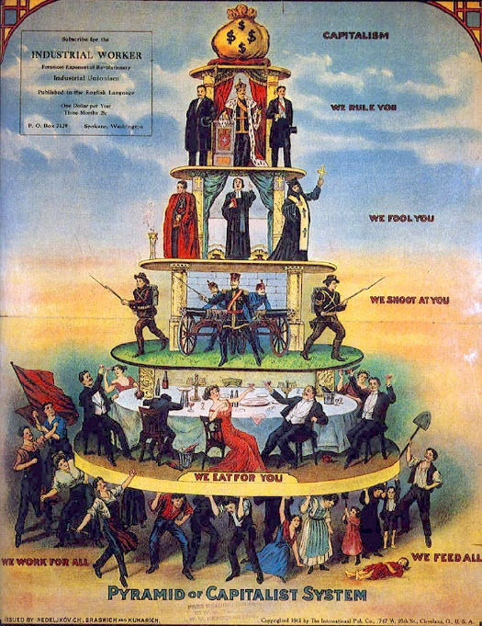
Marxism’s not dead!
By Michael Jones

Fundamentally, society is divided into two great classes; The Bourgeoisie and The Proletariat. The Bourgeoisie control the means of production; the factories, land, industry and housing. The means through which economic wealth is created. This is called private ownership of the means of production, private property. The Bourgeoisie consists of the wealthy, the elite, the 1%. They are few in number but hold great power economically and politically. He who has the gold makes the rules.
Artist not credited. Published by International Pub. Co., Cleveland, Ohio. - Uni Hamburg
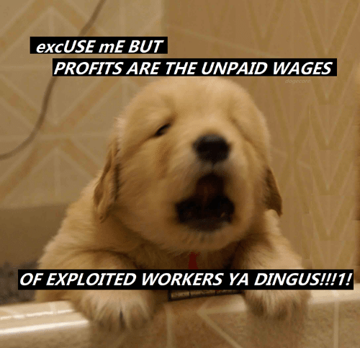
The Proletariat are deprived of the means of production, having only their labour with which to sell to attain the means to live, to feed and house themselves. Therefore, The Proletariat must trade their labour and time with the Bourgeoisie, working to produce ‘commodities’ for the Bourgeoisie. In exchange the Bourgeoisie pay the Proletariat a wage.
The Bourgeoisie sell these commodities to consumers on the ‘free market’. However, they are able to sell these commodities for far more than they were worth as raw materials prior to the labour of the proletariats, the workers. The workers ‘mixed’ their labour with the raw material and thus increased its value, transforming it from a less valuable material into a commodity, something that can be sold as a product on the market. The Bourgeoisie are able to sell these products for a profit, paying the workers only a tiny fraction of the market value of the commodities. In Marxist terms, this is known as The Base.
https://www.facebook.com/296630693807656/posts/1189724357831614

Workers are alienated from the product of their labour, because they do not reap the full benefits, the full product of our labour. The nature of Capitalist production also alienates workers from each other and from their own humanity, forcing them to labour in oppressive and dangerous conditions.
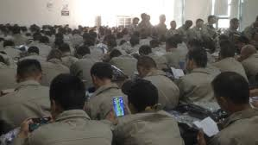
https://www.news.com.au/finance/work/at-work/workers-at-chinese-factory-linked-to-apple-face-10hour-shifts-toxic-gas-for-95-a-week-ngo-claims/news-story/58897e420fea21baa9814e0ecb9212d9
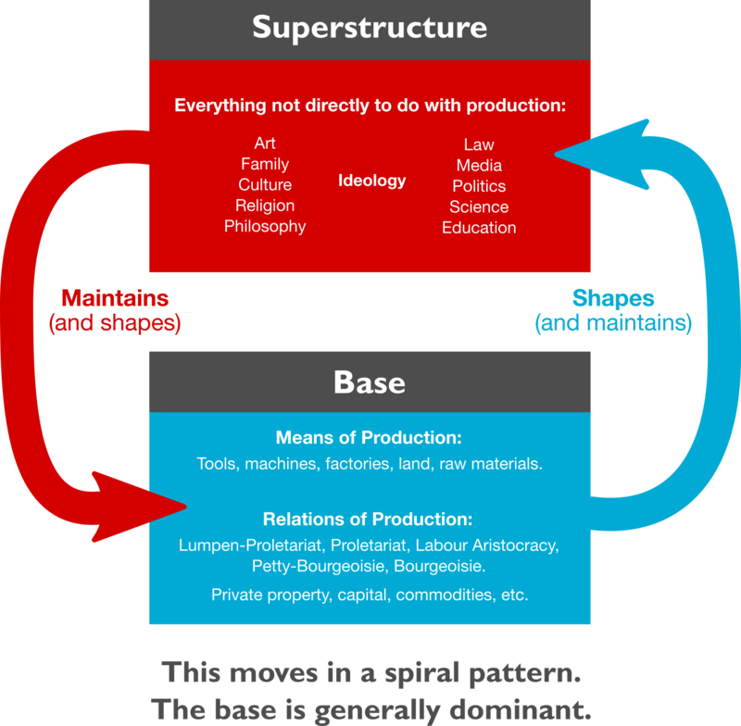
This arrangement is legitimised through the Superstructure; Through Religion, The State, The system of state education, The Laws of society, Family and Culture. The ideology of Capitalism.
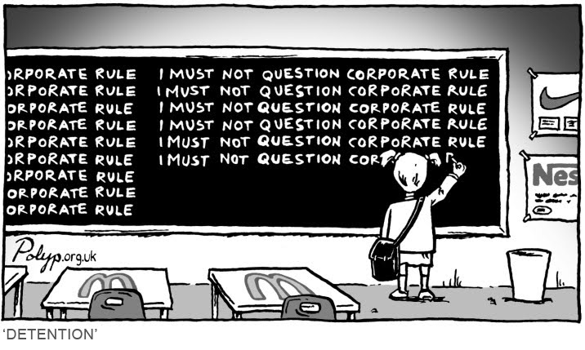
The Proletariat is blinded by the superstructure, they have a ‘false consciousness’, unaware of they're of exploitation. Only through education and the development of class consciousness will they be able to organise in their own interests against Capital/Bourgeoisie. Revolution is the means through which the Proletariat will become emancipated from the exploitation of Capitalism and the oppressive control of the Bourgeoisie.
https://philosophersforchange.org/2016/02/09/capitalism-and-the-efficacy-of-education-reform/
Alyxr - Own work, CC BY-SA 4.0, https://commons.wikimedia.org/w/index.php?curid=34613773

References
Marx, Engels, and Engels, Friedrich. Capital; a Critique of Political Economy. Moscow: Progress, 1956. Print.
Marx, Karl and Friedrich. Engels. Communist Manifesto. Washington: Regnery, 2009. Print. Skeptical Reader Ser.

