
data analysis and design
ACCA4023

April 25, 2023
Kelly casey
2106451

Table of Contents
Introduction 2
Initial findings. 3
Types of users 3
Types of departments 3
View and query information. 4
View, record and generate invoices. 4
Entity relationship diagram (ERD) 5
ERD diagram 6
Normalization 7
Implementation 7
Tables 7
Relationships 7
Forms 7
Queries 7
Reports 7
Macros 7
Menu 8
Summary 8

Introduction
Northern Lights Pvt Ltd is a growing company which organizes events such as, workshops, music festivals, conferences, and seminars. Northern lights, pvt ltd is located in Swansea however they have recently expanded into Neath and Carmarthen. All the branches are managed by a branch manager who will then in turn supervise a team of staff who are responsible for jobs such as setting up audio and visual equipment, selling tickets, cleaning, and maintaining events. The branch managers act as the main contact point for event patrons.
Because of the company's ever growing size, Northern Lights would like to replace its current administration process which is a manual system to a computerised system using a database management system (DBMS). Northern Lights Pvt Ltd would like to also create an online to increase its customer count which will also show upcoming events and customer enquiries . This report outlines the development of a suitable DBMS solution for Northern Lights, including the design and implementation of the database.

Initial findings.

Types of users
Using the information provided in the assignment brief the different types of users that would have access to the Database management system are:
- Staff members – they will use the database management system to carry out tasks associated with the event.
- Suppliers – will use the database management system to manage orders, deliveries, and supplies.
- Branch managers – they will be the main users of the database management system to manage the events and to link with the patrons. They will be in charge of managing the event requirements, as well as the different department heads, making sure the events run smoothly.
- Patrons – will use the system to give and receive the event related data. They will also use it to provide information about their company as well as other information that will make the event successful.
- Accountants – they will use the system to manage the events accounts, like making invoices and monitoring income.

Types of departments
using the information provided in the assignment brief the different types of departments each branch may require are:
- Accounting department – used for overseeing the company’s financial data. Fundamental for accurate financial and accounting reporting for the company.
- Event management department – used for managing the event, they will talk to patrons to gain the information required for the event to run smoothly.
- Human resource department – they are responsible for managing all employees, such as hiring, firing, training and payroll.
- Audio-visual department – responsible for setting up and managing audio and visual equipment for events.
- Cleaning and maintenance departments – they manage the maintenance of the event, making sure it’s a clean and safe, before, during and after.
- Sales and marketing department – in charge of selling tickets as well as promoting the events.
- IT department – responsible for managing computer and database systems.
- Procurement department – in charge of suppliers and ordering of supplies for events.

View and query information.
For both clients and staff to be able to view and query information associated to booked events the database management system should provide:
- Communication – it should provide a communication element for staff and clients to contact each other.
- Event details – it should provide detailed data about the events.
- Access control – the system should have a role-based access control function allowing different parts of access to clients and staff.
- Dashboard – the management system should provide a dashboard with important information about events.
- Reporting – the system should provide a reporting element to be able to report any bugs or problems.
- Search function – the database should provide a search function making It easier for both clients and staff to search up information easily.
- Event details – like the dashboard it should show information about events however in a lot more detail.
- task management – having a task management element allows staff to be able to manage tasks.

View, record and generate invoices.
Northern Lights pvt Ltd need to implement a purchase management system into their data management system. It should allow departments to document all purchases and add details into the system such as suppliers name, price, description, quantity, price, payment details and date or purchase.
After the system records everything it then should be able to produce an invoice to send to the supplier to confirm all details of the purchase.

Entity relationship diagram (ERD)
An ERD is a basis for a database design, it shows the entities, relationships, and attributes of the system. After the initial findings, the entities that were found are:
- users
- invoices
- clients
- departments
- resources
- suppliers
- events
- staff.

The entities are connected via relationships. Attributes are then assigned to the entities to be able to store the correct information.

ERD diagram
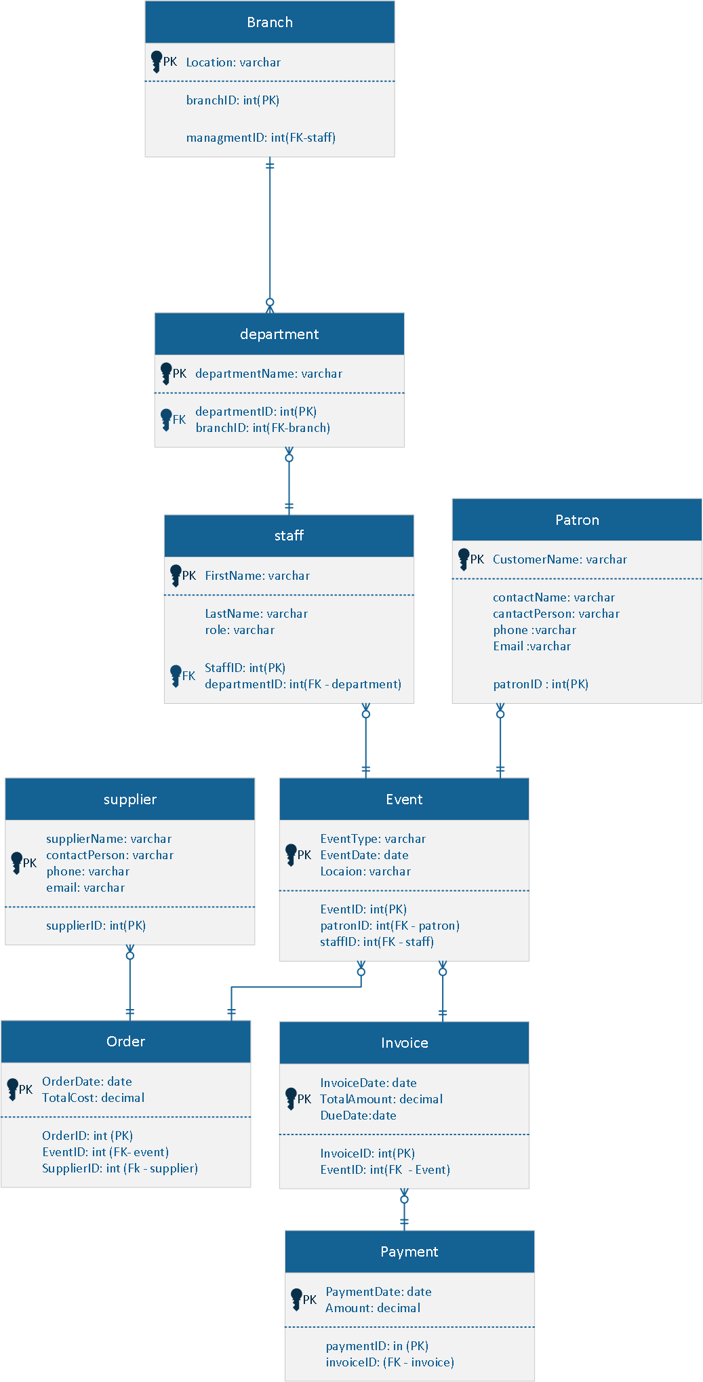

Normalization
The database is made to meet the third normal form (3FN), making sure to abolish redundancy whilst keeping consistency. The tables have been produced with the correct fields, keys, and relationships.

Implementation

Tables
Tables are made to mimic the ERD, with the correct information and data types.

Relationships
Relationships are made between tables whilst keeping the correct keys

Forms
Personalized information forms were made for all tables, which allows user input and edit as well as delete.

Queries
These are made to receive specific information from the database, such as staff/ event/ invoice details.

Reports
Reports show data in a orderly manner which makes the users able to clear decisions.

Macros
Macros allow the database automata tasks, like opening forms.

Menu
Here I have a few pictures of the menu with some sample data
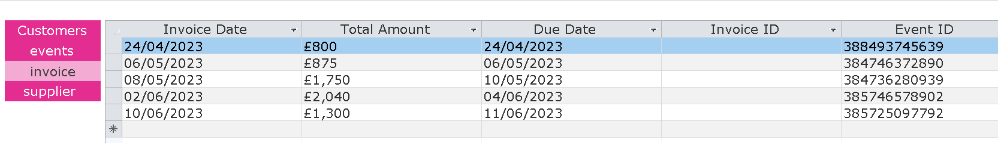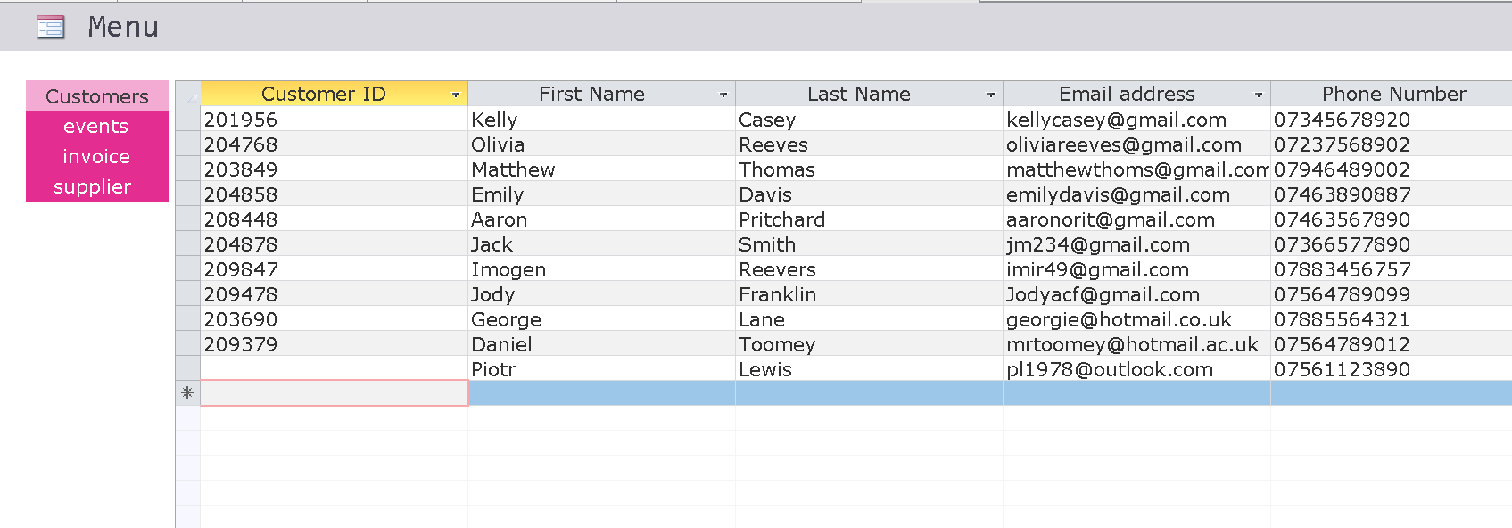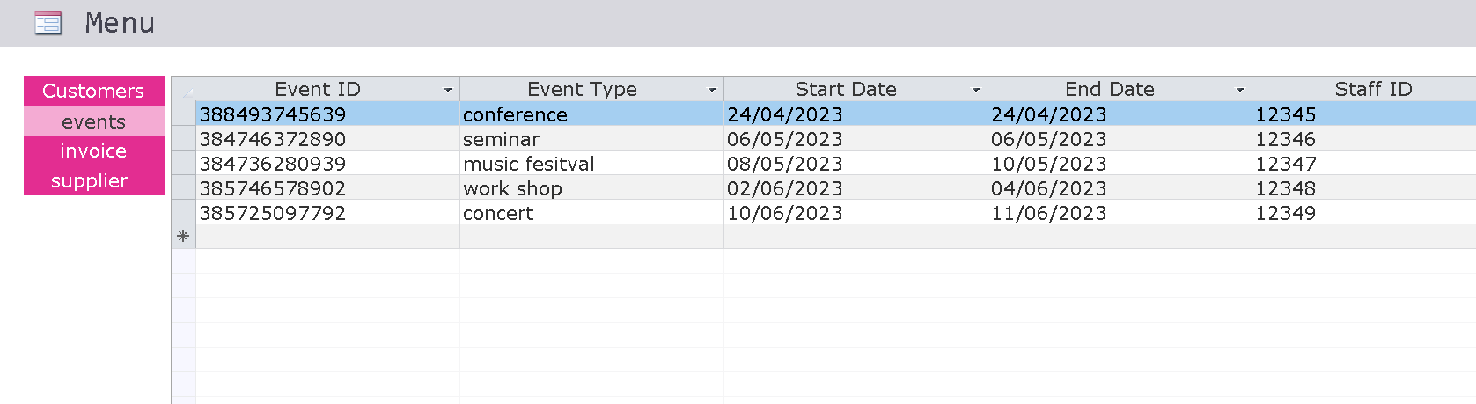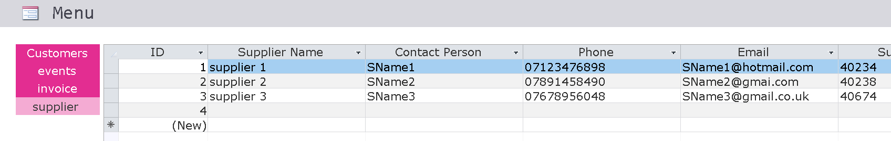

Summary
In summary the use of Microsoft access and Visio will let Northern Lights Pvt Ltd to document all customer, suppliers, staff information as well as allowing user input to keep up to data details.

