Michael Cunniffe (P148021)

Powertrain Technology
Turbochargers


Powertrain Design and Efficiency: Cylinder Heads

Student name: Michael Cunniffe (P148021)

Programme: HND/BSc Motorsport

Module: Powertrain Technology

Lecturer: Pedro Monteiro-Ferreira

Internal verifier: Andrew Gibson

Content Page

- Introduction = page 4

- Factors which affect volumetric efficiency in NA engines = page 5 - 6

3. Turbochargers and forced induction = page 7

4. Turbochargers class work = page 9

5. Turbocharger and intercooler results = page 9 - 13

6. References = page 13

1) Introduction
In the field of motorsport and the automotive industries the process of burning fuel with a mixture of air in an engine as a means of propulsion has become more technical once manufacturers began to select correct size turbos and intercoolers required for their engines. Across a variety of motorsports the use of turbochargers is more and more common as nearly every road car in Europe nowadays is fitted with a turbo. With the introduction of forced induction systems, developments into compressor sizing in similar turbo casing is becoming more common such as the use of ‘’Hybrid turbos’’ (an oem turbo casing with larger internals).
This means that there is a growing need for highly skilled engineers to be able to choose the correct turbo for an engine on various choices of turbo outputs which is relevant as nearly every modern car has a turbo. This following report is to produce and select the correct size turbo from the compressor maps supplied by the faculty. The assignment requires research into the factors in which influence volumetric efficiency in a naturally aspirated engine.
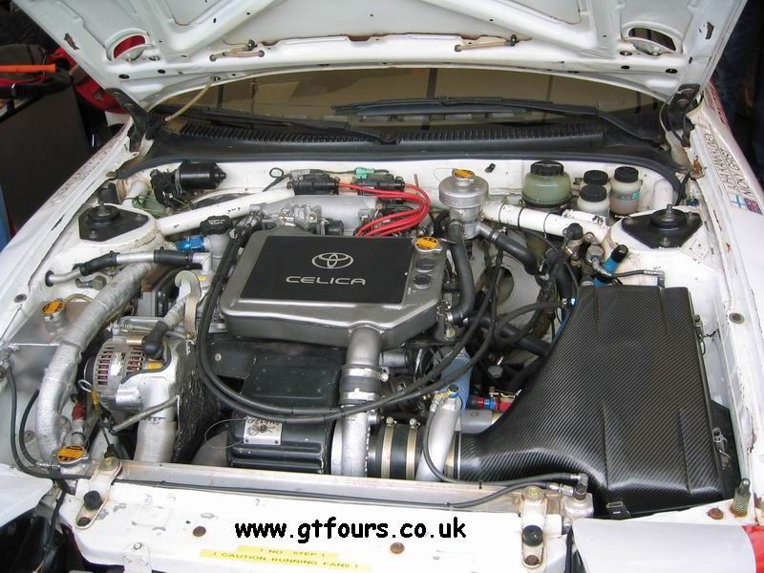

2) Factors which affect volumetric efficiency in NA engines
Basically to produce more power from an engine the engine must be able to burn more fuel this means filling the engines cylinders with fuel that is burnt more efficiently. Many factors come into play when increasing an engines VE means having less unburnt fuel exiting your engine, injecting the correct amount at the right time, better atomisation of fuel molecules and all of this takes place in the engines cylinder head where the air/fuel mixture enters the engine. As the intake valves open on the induction stroke air is drawn into the engine and fuel is injected, at this point the mass and density of the air/fuel mixture is brought at (regular athmospheric pressure) therefore the engines ability to fill its cylinder relies on the mechanical downdraft created in the induction stroke. This is known as volumetric efficiency VE (Liversey.2011).
In the motor racing and rallying fraternity have many racing series that only allow naturally aspirated engines and therefore increasing the engines volumetric efficiency within the regulations is what all competitors strive to do. In rallying there is the R2 homologated class which is 1600cc NA and each manufacturers car has to have the same size throttle body of 36mm, if the all 1600cc engine have the same size throttle body then it is down to the manufacturers to design there engine best to fit the throttle body as this is the first restriction of air and you can only raise compression if you can get in and burn more air and fuel. From the R2 classes regs it meant some manufacturers are able to get between 170bhp and others are getting close to 190bhp from their engines.
Naturally aspirated engines such as R2 rally cars are limited in there capacity so there bore and stroke can be changed very little as manufacturers try to create a lively revving engines whilst retaining a wide torque curve across the rev range. It makes it difficult to make little gains for example having even higher lift cams will draw more air in but then higher compression pistons are needed with deeper pockets on the crown (Burgess and Gollan .1997) which has some drawbacks as following. There has been big disgussion into 11.5:1 compression pistons and 12.5:1 compression pistons in building rally engines. Yes you can create more horsepower at higher rpm in your rev range with 12.5:1 but then how long does the engine create peak horsepower? (Burgess and Gollan .1997). Many engine builders Such as KGP engineering in Co.Donegal and Stafford performance in Co.Wexford recommend using 11.5:1 over 12.5:1 compression pistons for building their rally engines the reason being that in stage rallying also in motorbike road racing there are many corners and a lot of tight hairpins that the car needs to accelerate out of quickly to the next, So the engine needs to create more horsepower earlier in the rev range then reaching max horsepower from say 7000rpm to 8000rpm so it holds onto peak horsepower for an entire thousand rpm. With using higher compression piston the engine revs higher with a greater output of power and torque but the torque curve drops off earlier and the engine only creates peak power for say 500rpm.
It all really depends on the desired application of the engine but many factors affect a naturally aspirated engines volumetric efficiency such as:

The cylinder Head: the ability of air to flow through the cylinder head into the cylinder plays a major factor to VE. Port sizes, shape, number of valves etc this is why nowadays you see 2 or 3 intake valves on engines. The size of ports have been empirically studied by Connaught competition engines as they developed a big bore 16-valve head to bolt onto a pinto engine as an alternative to the old 8-valve design. (Connaught competition engines).
Piston crown: clearance between the pistons crown at T.D.C, this has a major impact on VE for the following reason. ‘’Larger clearance means lesser the air discharged per stroke and the lesser the volumetric efficiency’’ (Baechtel .2015). This is why you see pocketed pistons on modern honda vtec engines and race engines so that they can get more lift and a greater volume into the cylinder without making contact.
Temperature of air: the cooler the air entering your engine means that you can create cooler combustion temperatures therefore the engine is less susceptible to be harmed by knock or pinking (Baechtel .2015). It has less chance of detonating if air is cooler entering the engine because cooler air is more dense than warmer air and if the air entering is warmer then air fuel ratios are now altered.
Engine ware: over the course of a season of motor racing you are expected to lose horsepower due to internals being worn such as leaky pistons from piston rings worm by friction, sluggish operation of valves from consistently running high rpm so valve springs get tired and maybe an old air filter capable of starving the engine.

3) Turbochargers and forced induction
Installing a type of forced induction system such as a turbocharger or a supercharger is a positive way to improve your engines power output and efficiency as nearly all petrol and diesel engines on the market today are fitted with a type of forced induction system. Forced induction has proven to be the way forward as with the large emphysis on downsizing the capacity of engines so manufacturers can meet emissions legislation with the simple logic of the more fuel you burn the greater the amount of emissions and particles are released. The exhausts manifold designs in turbocharged engines are totally different to naturally aspirated manifolds as the primary tube length is not a big concern as back pressure wont occur. (Jay K, Miller. 2008). The most important factor is the exhaust diameter because the velocity of the exhaust gasses is important and if the exhaust manifold port and the primary tube port match equally then the exhaust gases will not slow down the gases velocity. With a turbo charged engine it is recommended the primary tube diameter the same up to the turbine so it will improve blending.(Jay K, Miller. 2008).
The use of a turbo charger or more has been the key to every car manufacturer surviving in Europe. Not only in road cars but in rallycars such as in the World Rally Championship. The turbo 4X4 setup has been the leading powertrain since 1984 when Audi pioneered its new Quattro design and even to this day not only in the world rally championship. In the past turbo lag was a major issue were engines were dead below 5000rpm then get a big surge of power which was due to large turbos with compressor to big for the engine, as times moved on smaller turbos are used with anti-lag systems with the help of EGR were developed by retarding the ignition that made an explosion of unburnt exhaust gasses to keep the turbo spinning.
Also in the 2019 regulation R2 Class. Downsizing has been creeping into motorsport in recent years for example with the new ford fiesta R2T is a 1000cc 3cylinder turbo eco-boost engine that produces 200hp ahead of its 1600cc 4cylinder 190bhp naturally aspirated competitors. This is done by high pressure fuel rails that spray the fuel in such an atomised mist due to its high pressure and fast spinning turbos that increase the volume of air that able to enter the small engine along with and ‘’intercooler that keeps the compressed hot air cool so that the air entering is more dense’’. (Baechtel .2015)
Also in formula 1 the 3.0 V10 naturally aspirated engines of the 2000’s were able to achieve 125% VE, due to highly optimised inlet manifolds and through different charge flow techniques combined with direct to head fuel atomisation was the reason for the high VE values. (F1 technical, article .2009). As said above as a result of increased efficiency means the engine can run at ‘’higher compression ratios’’ therefore giving ‘’higher rpm’’ (Increase the amount of times the cylinder will combust in a minute) (Burgess and Gollan .1997)

Although not all has been good to the environment from forced induction as it has been shown in examples by most manufacturers went with was placing a turbo charger on their engines like BMW’s twin power turbo technology and Toyotas twin entry turbo technology create a leaner burn which studies are now finding are rise in particulates in the athmosphere due to these higher combustion temperatures and leaner burn. (R.Sindhu, G.Amba Prasad Rao, K.Madhu Murthy. 2018).
Forced induction is the cheapest way also to improve power over building your naturally aspirated engines internals up. For example building a naturally aspirated Honda K25 race engine VS Supercharged Honda K20.
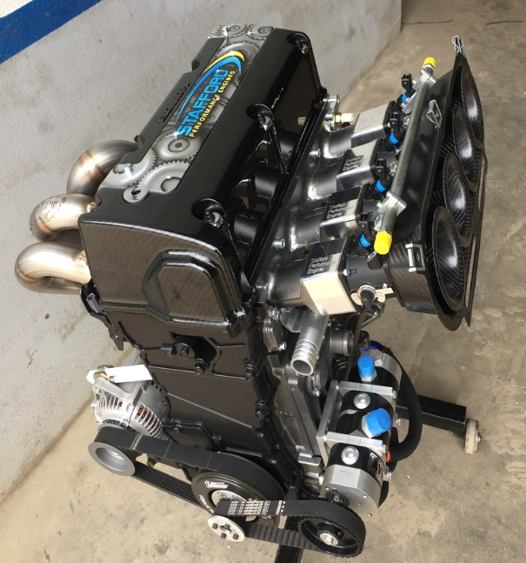
Honda K25 (stafford performance)
​K24 Bottom end with K20 Type R head
Darton Wet liners bringing the engine to 2.5
​Variable cam control on the intake cam and Vtec control
Slipper Pistons
Long Rods
Custom Rally Cams
Jenvey Throttle Bodies
Simpson Exhaust
Dry sump Kit
DTA S60 ecu
​Electric water pump
Steel flywheel
Race Alternator/Starter
354bhp @ 8600rpm
​Price €19500 ex vat

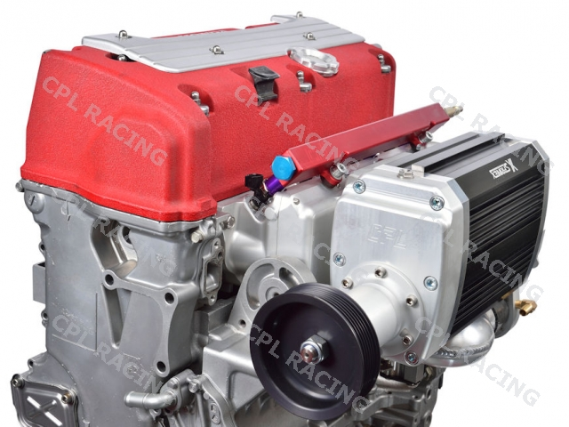
Supercharged Honda K20
Crate engine: Stock 2.0litre 16 valve internals with HKS supercharger and fuel rail, 400bhp
Price €5200 ex vat

4) Turbochargers class work
The report required a scheduled class in the universities engine workshop in which the students took part in stripping apart and assembling a turbocharger back together. For everyone to get hands on experience we were put into groups of 2 and 3 to take part the turbo. Each group was given adequate tools such a ratchets, sockets spanners, allen keys, pliers and screwdrivers as they were required.
The way our group did it was one person took the turbo apart and the other assembled it. To begin we had to separate the exhaust manifold so that we could access the compressors turbine and shafts. We could now remove the oil feed line to the turbo were on the car there would be an oil non return valve. The next step we had to take off the v band clamp the holds the compressors turbine with a deep socket. At this point the compressor housing could be separated and then the turbos bearings could be removed along with the O-ring. The turbine wheel side was turned anti-clockwise to separate and the compressor wheel side was opposite thread so that was turned clockwise the undo. Another student was to put the turbocharger back together.

5) Turbocharger and intercooler results
As part of the report as a group we were assigned to correctly fit the right turbo theoretically for an engine supplied to us in the assignment. A lot of calculations had to be done that we were briefed on in lectures prior to the reports completion. The assignment brief stated that we ‘’are required to perform the basic design of a turbocharger installation for a V8 spark ignition four stroke engine that has a bore of 95mm and a stroke of 80mm. the engine has a rev limit of 9500rpm. In naturally aspirated form it has a volumetric efficiency of 85%. It is desired to run the turbocharged engine with 12psi of boost pressure’’.
- Rev limit = 9500rpm
- Bore and stroke = 95mm x 80mm
- Engine = V8 spark ignition four stroke
- volumetric efficiency NA = 85%
- 12psi of boost pressure

Single turbo calculations
These calculations below are representing a single big turbocharger for all 8 cylinders.
Cylinder volume: Volume = A x L
A = πd² / 4 = {π x (95 x 10­³)²} / 4 = 7.09 x 10­³ m²
V = A x L = 7.09 x 10­³ x 80 x 10­³ = 5.672 x 10­⁴ m³
Total volume for all 8 cylinders: Vc = 5.672 x 10­⁴ x 8 = 0.0045376 m³
Naturally aspirated engine flow rate:
Va = (Vc x ny x N) / (2 x 60) = 0.0045376 m³
Va = 0.31 m³/s and Va = 0.15 m³/s @ 4750rpm
Turbocharged flow rate:
PR = (14.7 + Boost) / 14.7 = (14.7 + 12) / 14.7 = 1.82
Vt = PR x Va = 1.82 x 0.31 = 0.56 m³/s or 83.06 lb/min or 1186.64 CFM
Vt = 0.28 m³/s or 41.53 lb/min or 593.32 CFM @ 4750rpm

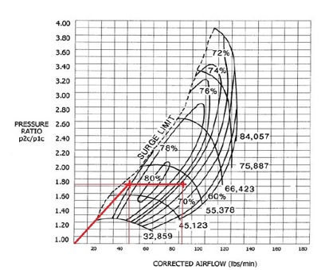
Compressor map 1.
The diagram above is the compressor map 1 where the turbo was flowed to give the following values. As you can see on the left of the graph the surge limit shows the minimum flow rate which the compressor operates. The compressor presented above shows that it has the highest capabilities to deliver greater airflow than the other compressors. This can be seen by looking at the pressure ratio in the Y axis at a PR of 1.82 and by following the red line represents the compressor efficiency and its peak efficiciency is between 70% and 76% between mid to max rpm with the airflow rate 50 lbs/min to 85 lbs/min. This compressor would be suitable to fit a single turbocharger because at low engine speeds it shows the compressor is efficient giving bottom end torque.
Twin turbo calculations:
The following calculations below are representing a twin turbo set up therefore both turbos will cater for both 4 cylinders.
Total volume for both 4 cylinders of the 8 cylinder engine:
Vc = 5.672 x 10­4 x 4 = 0.002688 m³
Naturally aspirated engine flow rate:
Va = (Vc x ny x N) / (2 x 60) = (0.002688 m³ x 0.85 x 9500) / (2 x 60)
Va = 0.18 m³/s @ 4750rpm
Va = 0.09 m³/s @ 4750rpm
Turbocharged flow rate:
PR = (14.7 + Boost) / 14.7 = (14.7 + 12) / 14.7 = 1.82
Vt = PR x Va = 1.82 x 0.18 = 0.33 m³/s or 48.95 lb/min or 699.27 CFM
Vt = 0.16 m³/s or 23.73lb/min = 339.04 CFM @ 4750 rpm
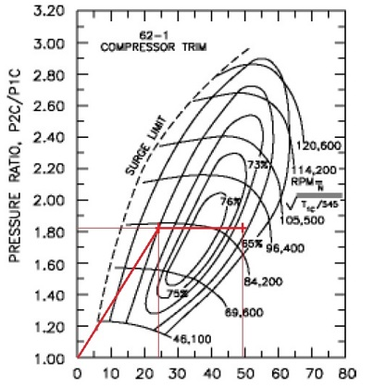
Compressor Map 2
The v8 engine could have a twin-turbo setup with one turbo serving 4 cylinders and the other serving the 4 others with this compressor Map 2 because this compressor is in an efficient of 70% working range at low engine speed This can be seen by looking at the pressure ratio in the Y axis at a PR of 1.82 and by following the red line represents the compressor efficiency and its peak efficiency and at full speed the compressor works a 71% so it dosnt just drop off immediately at high speed.

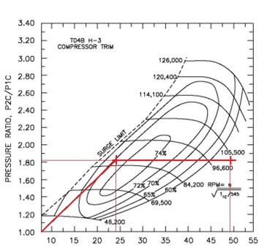
Compressor Map 3

Compressor map 3 only works well at 72% in low engine speeds but at maximum rpm the efficiency drops to 60%. Compressor 3 is beyond of the range of airflow rate for this turbo.

Turbocharge temperature calculations:
Ambient temperature = 27ºC therefore 300K also we were given the compressor efficiency of 0.76 therefore 76%
To find actual temperature rise we use the following equation:
Actual temperature rise: Tco = {(PR^0.28 x Ta) – Ta} / Nc
Tco= {(1.82^0.28 x 300) – 300} / 0.76 = 72Kelvin
Tco = 300 + 72.1 = 372K OR 99 ºC
Intercooler calcultaions:
With the ambient temperature the same value of 27ºC therefore 300K the following calculations are representing how much the temperature of the turbo would decrease with the installation of an intercooler that was 0.60 efficient therefore 60%. Our lecture supplied us with the following formula.
Ni = (Tco – Tio) / (Tco – Ta) and Tio = Tco – {Ni(Tco – Ta)}
Tio = 372 – {0.60(372 – 300 )} = 372 – 43.2 = 329K or 56%

Intercooler density ratio: DR = (Tco / Tio) – 1
DR = (372 / 329) -1 = 0.14 or 14% rise in efficiency
14% rise in efficiency because the engine is fitted with an intercooler and is the rise in the compressor efficiency.

6) References
- (Advanced motorsport engineering, Pub 2011, by Andrew Liversey)
- Steve De Groote: 18th/July/2009, https://www.f1technical.net/articles/4
- (How to Build, Modify & Power Tune Cylinder Heads, 3rd Ed 1997, Pub Motorbooks International, 1999 By Peter Burgess and David Gollan.)
- Practical Engine Airflow: Performance Theory and Applications, 2015, Pub Pro Series, by John Baechtel
- R.Sindhu, G.Amba Prasad Rao, K.Madhu Murthy (Effective reduction of NOx emissions from diesel engine using split injections, September 2018, by Department of Mechanical Engineering, NIT Warangal, Telangana, India).
- Turbo: Real world high performance turbocharger systems, USA, CarTech Inc, 2008. by Jay K, Miller.

