BMHP5015_BIRM Changemakers: Building your Personal Brand for Sustainable Employment
Component 1 - Portfolio

Student Name: Shagufta Bi
Student Number: 2324572

Task 1: Personal Brand
I view my personal brand as a reflection of who I am and how I contribute to the health and social care sector. Personal branding is about articulating my professional identity and the distinct value I contribute to my field (Gorbatov, Khapova, & Lysova, 2018).
I believe my brand shows compassion, dependability and effective communication. I am dedicated to helping people, upholding ethics and providing great treatment in a team setting. These characteristics are required for leadership in healthcare administration, where empathy and accountability are critical. However, I realise that to advance in my career, I must improve my leadership confidence and strategic decision-making abilities. To achieve these goals, I intend to participate in management training programs, shadow experienced executives, and increase my professional visibility through LinkedIn and networking events. Creating a consistent and credible personal brand allows me to showcase my leadership potential and stand out in a competitive industry (Shepard, 2005).
By continuing to study, reflect and lead with authenticity, I hope to establish myself as a compassionate and capable healthcare manager who inspires and drives positive change.
Task 2: Network Map and Rationale
When mapping my professional network, I recognised four critical dimensions: career, social, support and community. My network is diverse, encompassing both close personal relationships and professional contacts. I have good connections with family and colleagues that provide emotional support and encouragement. These ties foster a sense of belonging and stability, both of which are essential in the health and social care setting. However, I understand that my bridging and linking social capital - connections with professionals outside my immediate group and those in positions of authority - is limited.
To expand my network, I intend to participate more actively in professional associations, attend healthcare management events and use LinkedIn to connect with industry experts. Building these connections can increase mentorship and professional development possibilities, as well as improve employability and career progression. Creating an open, diversified network is critical for knowledge sharing and innovation in healthcare administration (Ibarra and Hunter, 2007). Effective networking not only helps with professional advancement, but it also increases resilience and adaptation in changing work situations (Seibert, Kraimer and Liden, 2001).
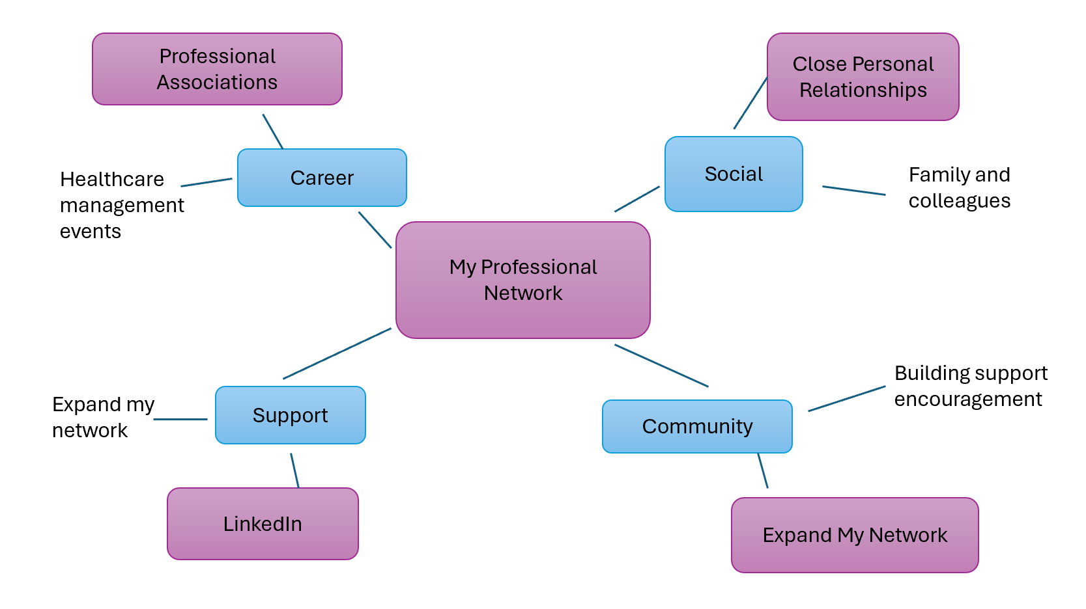
Task 3 – Blog
Caring for the Carers: Tackling Mental Health Challenges in Health and Social Care
Compassion is important in everything we do in health and social care, but carers frequently struggle silently. The emotional pressures of caring for vulnerable individuals, along with long hours and staff shortages, have resulted in a mental health crisis that cannot be ignored.
According to recent research, stress, burnout and compassion fatigue are rapidly increasing among health and social care professionals (Kinman and Teoh, 2018). Many have entered this field to make a difference, yet it's difficult to assist people when they are exhausted. Job demands, such as handling challenging caseloads or witnessing emotional anguish on a regular basis, can have an impact on one's well-being and job satisfaction.
Healthcare executives have a responsibility to establish cultures in which patient wellbeing is as important as patient outcomes. Simple improvements, such as protected breaks, wellbeing advocates and regular supervision, can make a significant difference. Building resilience through peer support and reflective practice also assists employees in processing emotional issues in a healthy manner.
The culture in health and social care must transition from "keep going" to "it's okay to need help." As an upcoming healthcare manager, I feel that investing in employee well-being is not only ethical, but also necessary for providing safe, compassionate and sustainable care (West et.al., 2020). When employees feel respected and supported, everyone benefits, particularly the people we care for.
Task 4 - NHS Equality and Diversity Quiz
What is the primary goal of the NHS Equality, Diversity and Inclusion Improvement Plan?
The goal is to establish a fair, comprehensive and compassionate NHS where all employees feel respected, supported and capable of thriving (NHS England, 2023).
How does the NHS EDI Improvement Plan propose to tackle the gender pay gap?
To eradicate pay discrepancies, the plan aims to promote pay transparency, monitor pay gaps and increase women's representation in senior leadership roles (NHS Employers, 2023).
What is meant by the term ‘intersectionality’ as used in the NHS EDI Improvement Plan?
Intersectionality refers to how many components of identity, such as gender, race, and disability, interact to influence discriminatory experiences (Crenshaw, 1991).
Why is it important for the NHS to create a psychologically safe work environment?
Psychological safety allows employees to discuss problems and ideas without fear of negative consequences, which promotes learning, well-being and better patient care (NHS Employers, 2024).
How does the NHS EDI Improvement Plan suggest improving the experience of internationally recruited staff?
The approach encourages comprehensive introduction, mentoring and ongoing welfare support to ensure international employees feel included and valued in the workplace (NHS Employers, 2025).
What role does leadership play in advancing EDI objectives according to the NHS Improvement Plan?
Leaders are responsible for showing inclusive conduct, instilling EDI ideals into everyday practice and ensuring responsibility for verifiable progress that promotes fairness and compassion throughout the NHS (NHS England, 2023).
Identify one way the NHS EDI Improvement Plan aims to reduce health inequalities within the workforce.
Supervisors and line managers ought to engage in frequent, efficient wellness talks with their staff, utilising reserves such as the national NHS health and wellbeing framework (NHS Employers, 2023).
Why does the NHS EDI Improvement Plan emphasise the importance of collecting and analysing data on protected characteristics?
Collecting reliable EDI data helps uncover inequality patterns and informs focused development measures (NHS England, 2023).
Explain how flexible working policies can contribute to equality and inclusion in the NHS workforce.
Flexible working options support work-life balance and allow staff with various requirements or caring obligations to stay, develop, and progress in their NHS careers, contributing to a broader and more equitable workplace (NHS England, 2023).
What is one strategy mentioned in the NHS EDI Improvement Plan to combat bullying and harassment in the workplace?
The plan imposes a no-tolerance stance against bullying and harassment, followed by clear reporting processes and leadership responsibility (NHS England, 2023).
Task 5 - A Letter to Yourself
Dear Younger Me,
I recall how confused and overwhelmed you felt at the time - carrying too much on your shoulders, trying to be strong for everyone else and never giving yourself a break. You felt asking for help indicated weakness, but now I realise that you needed guts rather than strength. I want you to know that it is alright to take a break, breathe and care for yourself as much as you do for others.
If you had known emotional intelligence back then, you may have acknowledged the feelings underlying your stress rather than suppressing them. Feeling sad, frustrated or afraid is not a sign of weakness; it is human. Learning to identify and manage your emotions allows you to respond with empathy, not only to others but also to yourself.
Resilience, too, has taught me that difficulty does not imply failure. Even when you couldn't see it, each setback helped to shape your strength. You didn't have to be flawless; you just needed to keep going, one small step at a time.
I've also discovered that self-awareness is the foundation for growth. Taking the time to ponder, rather than rushing through issues, allows you to understand your values, set boundaries and make decisions that promote your well-being. If you had trusted yourself more, you would have recognised that vulnerability and strength can coexist.
Today, I carry those lessons forward. You showed tenacity when things were tough and that courage built the foundation for all I am now. Be proud of the person you were - because she helped me become who I am.
With love and gratitude,
Your Future Self.
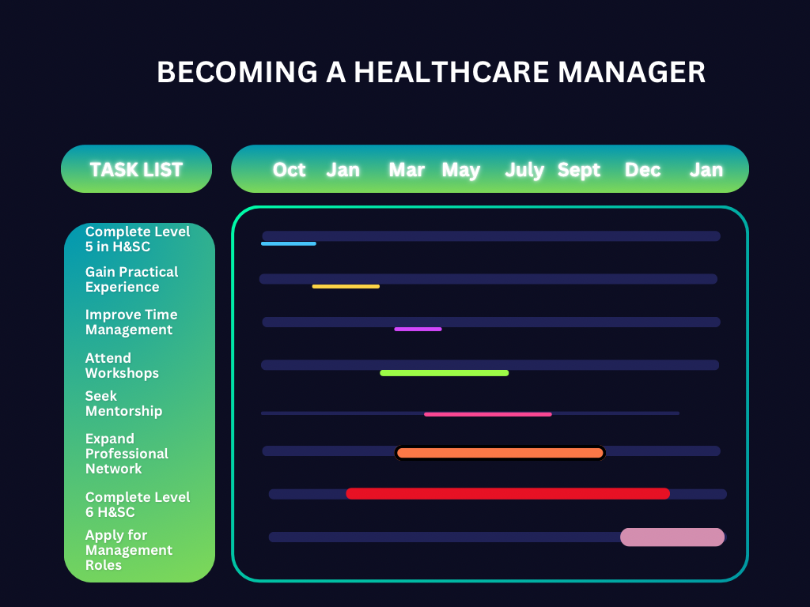
Task 6 – GANNT Chart
Figure 1: (GANNT chart, from Canva).

My GANNT chart shows a professional growth plan which begins in October, when I complete the final five weeks of my Level 5 Health and Social Care qualification. This period is dedicated to completing my assignments, reflecting on my learning and planning for progression to Level 6. In addition, I plan to obtain more practical experience in healthcare settings to help me better understand leadership and team dynamics.
In January, I will begin my Level 6 studies, focusing on improving my academic and professional skills in preparation for managing responsibility. During this stage, I intend to attend leadership and healthcare management training, seek mentorship from experienced professionals and continue to strengthen my communication and decision-making skills.
Throughout the year, I plan to develop my professional network through LinkedIn and sector events. By the end of the 18-month plan, I hope to have updated my professional portfolio, applied for entry-level healthcare management positions, and demonstrated the resilience, adaptability and leadership skills required to succeed in the field.

Task 8 – Making Changes – Report
Implementing Digital Care Planning in a Care Home
Introduction
As a care home manager, I intend to replace paper-based work with a digital care planning system. This improvement is intended to improve communication, accuracy and the delivery of person-centred care by making information more accessible and secure (Bujnowska-Fedak and Pirogowicz, 2014).
Planning the Change
Using Kotter's 8-Step Change Model (1996), the first stage will be to raise awareness of the limits of paper-based methods, which are sometimes time-consuming and prone to errors. Staff will be encouraged to consider how digital systems can improve workflow and resident outcomes. The following steps will be to construct a steering coalition, create a shared vision and provide digital training to all employees. Progress will be tracked by regular reviews, feedback sessions and supervision. Integrating digital care planning into daily routines ensures sustainability and ongoing improvement.
Skills Required
To properly make this shift, I will need strong leadership, communication, problem-solving and computer literacy abilities to engage employees and effectively manage the transition.
Barriers and Solutions
Staff reluctance, a lack of digital confidence and inadequate resources are all potential barriers. These can be addressed by encouraging open communication, providing specialised training and guaranteeing management involvement throughout the process (Ross et al., 2016).
Conclusion
Introducing digital care planning will streamline operations, improve care quality and help staff provide safe, efficient and person-centred care.
Task 9 – Self-Reflection
Using Gibbs' Reflective Cycle (1988), I reflected on how this module helped shape my professional identity and confidence as a future healthcare leader.
Description:
In Week 8, we looked at change management in health and social care, specifically Lewin's Field Theory (1951) and Kotter's Eight-Step Model (1995). We looked at why change is necessary, the challenges that arise and how leaders may deal with resistance from staff.
Feelings:
Initially, I was concerned about managing organisational change, particularly employee resistance and communication issues. As the session progressed, I gained confidence after learning Kotter's structured method, which provided practical measures for achieving change.
Evaluation:
Groupwork helped me connect theory to real-world care settings. I understood that excellent communication and teamwork are key for gaining trust in the workforce. However, I realised that I am sometimes hesitant to challenge people, which may limit my potential to drive change.
Analysis:
According to Burnes (2004), Lewin's model of unfreezing, changing and refreezing involves emotional and practical preparation before committing to new behaviours. Fear, not opposition, is frequently the source of resistance. Kotter's model emphasises developing urgency and celebrating short-term victories to build momentum (Kotter, 2012).
Conclusion:
I discovered that to lead change empathy, planning and effective communication is needed. To effectively manage change, I need to continue to build my leadership confidence and emotional intelligence.
Action Plan:
I plan to use Kotter's model in future workplaces, practise clear communication and seek supervisor input to improve my capacity to help others through change.

References
Bujnowska-Fedak, M.M and Pirogowicz, I (2014). ‘Support for e-Health Services Among Elderly Primary Care Patients’, Telemedicine and e-Health, 20 (8), pp. 696-704. Available at: https://doi.org/10.1089/tmj.2013.0318 (Accessed: 10 October 2025).
Burnes, B (2004). ‘Kurt Lewin and the Planned Approach to Change: A Re-appraisal’, Journal of Management Studies, 41(6), pp.977-1002. Available at: https://doi.org/10.1111/j.1467-6486.2004.00463.x (Accessed: 04 November 2025).
Crenshaw, K (1991) Mapping the Margins: Intersectionality, Identity Politics, and Violence Against Women of Color. Stanford Law Review, 43 (6), 1241-1299. Available at: https://doi.org/10.2307/1229039 (Accessed: 04 October 2025).
Gorbatov, S., Khapova, S.N., & Lysova, E.I (2018). Personal Branding: Interdisciplinary Systematic Review and Research Agenda. Frontiers in Psychology, (9). Available at: https://doi.org/10.3389/fpsyg.2018.02238 (Accessed: 02 October 2025).
Ibarra, H and Hunter, M (2007). How Leaders Create and Use Networks. Harvard Business Review, 85 (1), 40-47. Available at: https://hbr.org/2007/01/how-leaders-create-and-use-networks (Accessed: 04 October 2025).
Kinman, G and Teoh, K (2018). What Could Make a Difference to the Mental Health of UK Doctors? A Review of the Research Evidence. Society of Occupational Medicine. Available at: https://www.som.org.uk/sites/som.org.uk/files/What_could_make_a_difference_to_the_mental_health_of_UK_doctors_LTF_SOM.pdf (Accessed: 04 October 2025).
Kotter, J.P (1995). Leading Change: Why Transformation Efforts Fail. Harvard Business Review. Available at: https://hbr.org/1995/05/leading-change-why-transformation-efforts-fail-2 (Accessed: 04 November 2025).
NHS England (2023) Equality, Diversity and Inclusion Improvement Plan. Available at: https://www.england.nhs.uk/long-read/nhs-equality-diversity-and-inclusion-improvement-plan/#:~:text=for%20our%20patients.-,Introduction,and%20responsible%20for%20their%20delivery (Accessed: 04 October 2025).
Ross, J., Stevenson, F., Lau, R and Murray, E (2016). ‘Factors That Influence the Implementation of e-Health: A Systematic review of Systematic Reviews’, Implementation Science, 11 (146). Available at: https://implementationscience.biomedcentral.com/articles/10.1186/s13012-016-0510-7 (Accessed: 10 October 2025).
Seibert, S.E., Kraimer, M.L and Liden, R.C (2001). A Social Capital Theory of Career Success. Academy of Management Journal, 44 (2), 219-237. Available at: https://www.jstor.org/stable/3069452 (Accessed: 02 October 2025).
Shepherd, I.D (2005). From cattle and coke to Charlie: Meeting the Challenge of Self Marketing and Personal Branding. Journal of Marketing Management, 21(5-6), 589-606. Available at: https://doi.org/10.1362/0267257054307381 (Accessed: 15 October 2025).
University of Cumbria (N.D). Gibb’s Reflective Cycle. Available at: https://my.cumbria.ac.uk/media/MyCumbria/Documents/ReflectiveCycleGibbs.pdf (Accessed: 04 November 2025).
West, M.A., Bailey, S and Williams, E (2020). The Courage of Compassion: Supporting Nurses and Midwives to Deliver High-quality Care. The King’s Fund. Available at: https://www.kingsfund.org.uk/insight-and-analysis/reports/courage-compassion-supporting-nurses-midwives (Accessed: 15 October 2025).
NHS Employers (2023). Pay Gaps. Available at: https://www.nhsemployers.org/articles/pay-gaps (Accessed: 02 November 2025).
NHS Employers (2024). Top Tips for Supporting The Psychological Safety of Staff. Available at: https://www.nhsemployers.org/articles/top-tips-supporting-psychological-safety-staff (Accessed: (02 November 2025).
NHS Employers (2025). International Retention Toolkit. Available at: https://www.nhsemployers.org/publications/international-retention-toolkit (Accessed: 02 November 2025).
NHS Employers (2023). NHS Equality, Diversity and Inclusion (EDI) Improvement Plan. Available at: https://www.nhsemployers.org/articles/nhs-equality-diversity-and-inclusion-edi-improvement-plan (Accessed: 02 November 2025).

