GLOBAL BUSINESS ENVIRONMENT
Uwaoma Ochonogor

Apres Food Company

Asen Metodiev Asenov
2028526
Table of Contents
1.0 Introduction 2
1.1 Aim 2
1.2 Background 2
1.3 Scope 3
2.0 Main body 3
2.1 Five critical global factors of the macro-environment 3
2.2 Comparative advantage of choosing China for expansion 7
3.0 Conclusion 9
Reference 11

1.0 Introduction

1.1 Aim
The aim of the report is to identify the important forces of structuring the global business environment. The report discusses the importance of understanding the changing global market environment. The global environment mainly includes the foreign connection of a company where it has no control. Additionally, in international business with such a huge amount of competitiveness, a UK firm like Apres Food should be concerned about the global environment. The paper aims to identify the five critical global elements of the macro environment.

1.2 Background
In current days, there are certain major changes in the international business as well as economy. For expanding a company’s business in a foreign market, it is important to understand the changes in the environment. Furthermore, Apres Food company needs to analyze China’s environmental elements to make decisions whether to engage in foreign trade or not. Apres Food Company is an active private company which is located in the UK, incorporated on 12 January 2016 (Apres Food co, 2021). The organization’s office is found at Delft Way, Norwich. Before engaging in international trade, it is essential for the company to study China’s business environment.

1.3 Scope
The scope of the report is to focus on the global market environment for an SME company. The paper focuses on China’s business environment to gain knowledge about the future impact of the global elements on Apres Food Company. The study finds out the comparative advantage of selecting a nation like China for business expansion. The paper provided some strategic recommendations for the company in order to engage with international trade.

2.0 Main body

2.1 Five critical global factors of the macro-environment
The macro-environment relates to the external business environment of any firm in which it exists. This type of environment can be unpredictable as well as enormous and therefore uncontrollable by the company. For this reason, the success of any company usually relies on their potentiality in order to adjust to the macro environment changes. According to Ghauri et al. (2021), an organization’s macro environment includes factors that influence the company but are commonly beyond their direct control. Referring to this, these factors are characteristics of the world that all businesses should contend with, regardless of the industry they are engaged with.
In contrast, Cherunilam (2021) has stated that the macro environment is more common which means the environment influences how every business group practices, operates as well as makes decisions. It can be considered as dynamic and needs organizations to track their changes continuously. Such an external environment engages many elements which any firm might not control by themselves. Moreover, before becoming involved in the international business it is important to track the environment in which an Apres Food Co is going to operate their business as well as planning to introduce their new project. Pestle analysis can be used as a tool for tracking the organization’s business environment in China. This tool is helpful for a company to analyze the political, economic, social, technology, legal, and environmental factors (Paurova and Gregova, 2020).
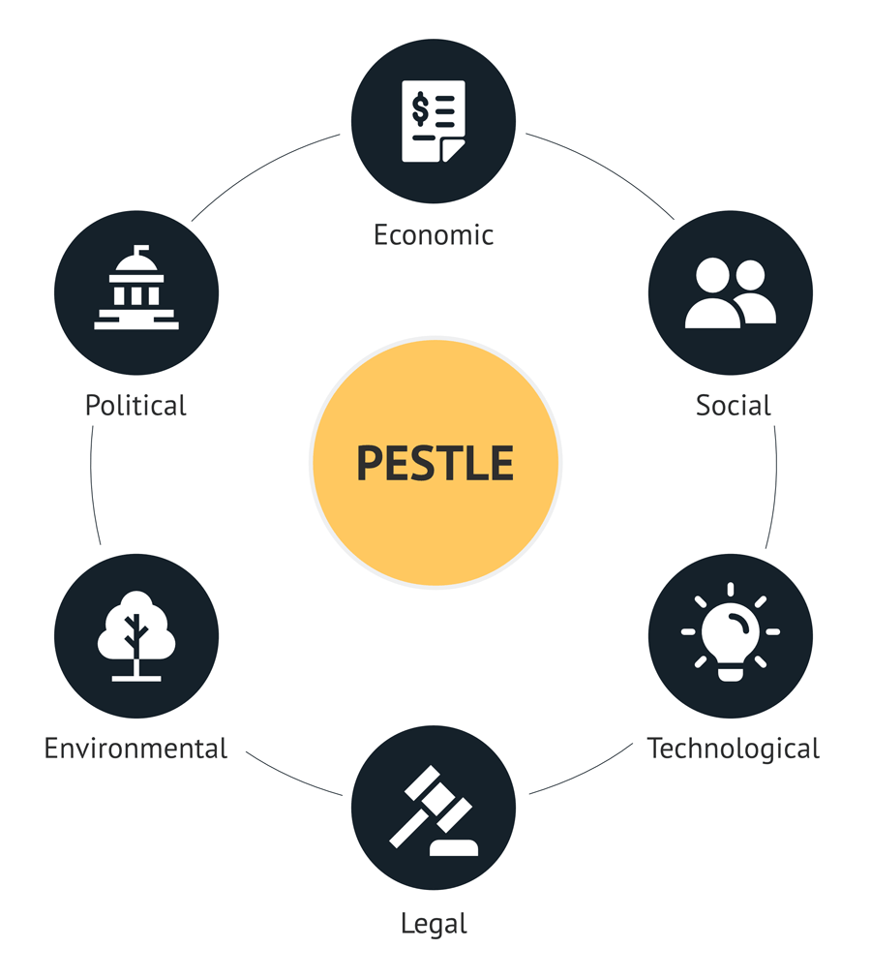
Figure 1: Pestle analysis
(Source: Paurova and Gregova, 2020)
Pestle analysis of Apres Food Company:
- Political factor: this environment determines the limit to which the China government can impact the economy of the Apres Food Company. As per Peng et al. (2021), the People's Republic of China refers to a socialist state under the citizens of China's democratic dictatorship led by the performing class and rooted in the worker’s alliance. With regard to this, the Chinese government includes multi-party corporate systems and political consultation under the communist party of China's leadership. Cooperative relationships among the communist party of china and political parties are associated with the principles of long-term mutual supervision and coexistence sharing weal or woe and treating each other with full sincerity (Peng et al., 2021).
Apart from this, China is especially hazardous in terms of political risk. The company needs to identify the certain political risk before making decisions on expanding its business. These risks might include expropriations, contract repudiation, confiscations, and currency incontrovertible. There can be risks to Apres Food company employees of kidnapping or personal harm, as well as risk to the organization of extortion attempts. Besides, the standard of international business practices in China has fallen off in many places, consisting of foreign investment and tourism. Meanwhile, the development of China and reform has improved the lifestyle of thousands of millions of citizens of China, enhanced social mobility, and expanded personal freedom (Liu and Lo, 2021). It gives a meaning of substantial freedom of employment opportunity, cultural pursuits, and travel and educational factors.
- Economic factor: in current days, China has remained the main recipient of the globe’s destination of foreign direct investment. FDI accounts for twenty-seven percent of the value-added production, fifty-eight percent of international trade, and 4. 1 percent of national tax revenue (Bruton et al., 2021). The Chinese national development & reform commission has made a plan to manage foreign direct investment in the economy. The plan identifies the bonding among the national security investment as well as international investment. The NDRC believes in increasing investment as well as setting the production (Bruton et al., 2021). The plan might be to expand the freedom of innovation for business. This might help the Food company to establish their business strongly in China.
However, the global economic era in current days has formed a world-identified economic power that plays an important role in foreign affairs. It seems that Apres Food Company has many opportunities for new business. According to Ccencho et al. (2021), China’s public as well as external debt is found high, their vast foreign exchange reserves must cover these debts. It can be said that the Chinese government and authority have the balance to undertake significant reform whilst preserving social as well as political stability. China’s population is huge as compared to other nations. It means that people in the lower, middle, and upper classes have much to invest in food. As an outcome, the total revenue of the Apres Food Co. is increasing, as people of china cook is less and eat out more commonly.
- Social factor: in current days, the relationship between food and individuals is greater than ever before. There is an apparent bonding between the food, people of China consume and personal health. It is important for the company to offer the best quality and healthy food to people. Along with it, Chinese people are friendly towards their preferred sectors, which could increase the chances for the company to attract them towards their food product. There is another impact that might be taken into account is the trend of employment based on unemployment level. The Chinese government has raised wages by 13 percent (Tahajuddin et al., 2021). However, southern China Provinces generate about the thirteenth percent of the economic output of China, one of the nation’s thirty-two provinces. This increase in the minimum wage may lead to a challenge for Apres Food Company as they have to pay higher labor prices which might bring a fall in business profit.
- Technological factor: the organization seeing many types of automation more in the food sector. According to Ren (2021), China is the topmost developing emerging business for environmental technologies. This nation is putting their efforts to bring improvement in the environmental quality as well as expand environment governance in current days. The China government is focusing on companies in many industries to explore their technologies with enterprises of china as a situation of operating in the nation (Ren, 2021). It is fueling tensions among foreign authorities as well as an organization along it increases the critical problem of whether the Chinese companies of socialism might coexist with western capitalism.
Moreover, the china government demanded that every technology utilized in products sold to the authority be developed in China, which might have emphasized an organization for locating many business locates in a nation in which intellectual assets are unsafe (Wang, et al., 2021). The food company needs to tackle the problems of how it might minimize security as well as competitive risk to their technologies.
- Legal factor: legal environment plays a vital role in the spending environment and is an important element of attracting foreign investors. Referring to this, it has become a significant indicator to improve the investment environment in a country like China. There are many reforms as well as opening up China emerging, a series of international investment laws were introduced during the 1980s to make legal systems of international investments (Hg.org, 2021). Additionally, the Law of the People's Republic of China on foreign-owned enterprises as well as the law of foreign-owned business implementation regulations is part of it. Besides, China's foreign investment law (FIL) aims to offer more transparency and clarity for an international business operating in China (Dadush and Pauline, 2021). Thus, the Apres Food Company can easily operate its business in China. It can be said that the FIL ensures equal participation offered to invested organizations in government procurement.
- Environment factor: in china, outdoor air pollution is considered the biggest environmental challenge. China’s rapid economic growth has influenced on their natural environment. Air pollution, climate changes, water pollution, biodiversity, and industrial waste are some examples of issues facing China’s people and enterprises. The china government for improving the environment has to establish environment control systems and leading into full role environment administration and supervision (Rahman, 2021). Moreover, there is a number of laws that regulate business as well as employee remuneration, labor standards, and labor disputes. The catalog of sectors for directing Foreign direct regulates Foreign Direct Investment in China. Along with it, this Catelouge divides FDI into four parts such as encouraged, prohibited, restricted, and permitted. Apres Food company comes under this category (Rahman, 2021). Thus, a company must follow environmental laws to sustain its organization in a global business context.

2.2 Comparative advantage of choosing China for expansion
Over the past 20 years, China has been involving itself in the globalization of the economy by leveraging its comparative advantage as well as developed a strong relation with developed nations such as European nations (Wang, and Zhang, 2021). Relating to their respective comparative advantages, the EU and China have led about trade development, job increase, investments returns, economic prosperity, and technology. According to Pelagidis and Mitsopoulos (2021), China is attracting more attention for the best cause. This reason is not only that China is great or that its economy is the only one that has the potential to sustain instant development in the last few years. Due to this, it can be said that China is profoundly influencing the competitive abilities of corporations.
In contrast, Wang, and Zhang (2021) stated that when China opened its economy to international investment in the year 1979, the laws tightly limited the places, firms, and types of participation open to international business. As such laws gradually relaxed in the ensuing years, the luck of the foreign organization improved drastically. It has been found that China has started to apply their world trade organization accessibility obligations, as well as the nation, which has focused on developing significance across the world (Liu et al., 2021) The opportunities, challenges, and necessity of studying how to in China, Apres need to know the corporate competitive strategy to be successful in the global market.

3.0 Conclusion
The global environment of a business is so important in order to understand international business practice. All of the information represents that before engaging in the international trade market, a company needs to look over the country’s different types of environment that can influence its market's activities. It has been found that China has vast business opportunities for Apres Food Co in order to expand the business. In addition, before becoming involved in an international or foreign business it is essential to track the environment. It can be said that the Chinese government, as well as authority, has the balance to undertake changes and reform whilst preserving social or political stability.
Apart from it, the report has found many opportunities for the UK Company to lead their business successfully. Thus, the Apres Food Company can easily operate its business in China. It is recommended that the company needs to identify the current trends in China's Business activities. They need to focus on the customer’s demands and taste to be the topmost priority of the Chinese customers. Moreover, the company must focus on the quality and quantity of its food items to meet its market goals.

Reference
Ai, Y.H., Peng, D.Y. and Xiong, H.H., 2021. Impact of Environmental Regulation Intensity on Green Technology Innovation: From the Perspective of Political and Business Connections. Sustainability, 13(9), p.4862.
Apcho-Ccencho, L.V., Cuya-Velásquez, B.B., Rodríguez, D.A., de las Mercedes Anderson-Seminario, M., Alvarez-Risco, A., Estrada-Merino, A. and Mlodzianowska, S., 2021. The Impact of International Price on the Technological Industry in the United States and China during Times of Crisis: Commercial War and COVID-19. In Advances in Business and Management Forecasting. Emerald Publishing Limited.
Apres Food co,2021. https://www.aparesfood.com
Bruton, G.D., Ahlstrom, D. and Chen, J., 2021. China has emerged as an aspirant economy. Asia Pacific Journal of Management, 38(1), pp.1-15.
Cherunilam, F., 2021. Business environment. Himalaya Publishing House Pvt. Ltd.
Ghauri, P., Strange, R. and Cooke, F.L., 2021. Research on international business: The new realities. International Business Review, 30(2), p.101794.
Hg.org,2021. China’s evolving environmental protection laws.https://www.hg.org
Li, K., Feng, C., Liang, Y., Qi, J., Li, Y., Li, H., Liang, S. and Yang, Z., 2021. Critical transmission sectors for provincial food-water nexus in China. Journal of Cleaner Production, 279, p.123886.
Liu, M. and Lo, K., 2021. Pathways to international cooperation on climate governance in China: a comparative analysis. Journal of Chinese Governance, 6(3), pp.417-434.
Liu, M., Tan, R. and Zhang, B., 2021. The costs of “blue sky”: environmental regulation, technology upgrading, and labor demand in China. Journal of Development Economics, 150, p.102610.
M Rahman, 2021. Global business issues. https://wwwhowandwhat.net
Mikhailitchenko, A., 2021. Antecedents and Outcomes of Network Involvement in the Internationalization Process: A Case of SMEs from the USA, China, and Russia. Organizations and Markets in Emerging Economies, 12(1), pp.6-26.
Paurova, V. and Gregova, E., 2020, December. Importance and Process of Marketing Environment Analysis as Strategic Analysis Tool of Business. In Fifth International Conference on Economic and Business Management (FEBM 2020) (pp. 720-723). Atlantis Press.
Pelagidis, T. and Mitsopoulos, M., 2021. Greece’s Comparative Advantage as China’s Backdoor to Europe. In Who’s to Blame for Greece? (pp. 369-373). Palgrave Macmillan, Cham.
Ren, W., 2021. How to realize the sustainable development of mariculture industry——Re-examine from the perspective of biased technological progress in China. Marine Policy, 134, p.104791.
Tahajuddin, S., Xin, Z., Kassim, A.W.M. and Noordin, R., 2021. Social Stakeholders' Pressure on Environmental Accounting Reporting in Small and Medium Enterprises–Evidence from China. International Journal of Research in Engineering, Science and Management, 4(1), pp.82-87.
Uri Dadush and Pauline Weil, 2021.How difficult is China’s business environment for European and American Companies.https://www.brugel.org
Vlados, C., 2019. Porter’s diamond approaches and the competitiveness web. International Journal of Business Administration, 10(5), pp.33-52.
Wang, H. and Zhang, Z., 2021. The Influence of Corporate Networks on the Competitive Advantage of High Technology Enterprises in China: The Mediating Effects of Dynamic Capacities and Ambidextrous Combination. International Journal of Financial Studies, 9(3), p.42.
Wang, K.H., Umar, M., Akram, R. and Caglar, E., 2021. Is technological innovation making world" Greener"? An evidence from changing growth story of China. Technological Forecasting and Social Change, 165, p.120516.
Wang, Z. and Sun, Z., 2021. From globalization to regionalization: The United States, China, and the post-Covid-19 world economic order. Journal of Chinese Political Science, 26(1), pp.69-87.

