

Leading and Managing Projects (MBA)


PROJECT INITIATION DOCUMENT (PID)

INSTRUCTIONS:
- Give as much justification as possible for every question asked. This means, you must not limit yourself to just stating WHAT you believe is an appropriate response, but WHY.
- ALWAYS provide an outline of the financial and cost imperatives associated with your project aim and objectives. Remember, you must be able to SELL your project idea.
- Put effort into your PID and you will benefit when it comes to undertaking your project and writing your final report.

PID submission date detailed on module schedule

- Your name: | Nicole Williams
- Name of (client) organisation | Results or Excuses (Nathan Blackler)
- Aim of project:
In no more than twenty words, state the overall aim of the project.

The overall aim of the project is to attract new clients to the gym.

- Objectives of project:
Lists up to four objectives that are each directly from the project aim. The objectives should be S.M.A.R.T (specific, measurable, achievable, realistic, time bound).

Objectives:

- To develop a marketing plan suggesting steps to be taken in order to attract new clients to the gym.

- To report marketing plan and provide recommendations to Nathan Blackler in a professional manner by Friday 18th January 2020.

- What is the business case for considering undertaking the project? Justify how achieving the project aim will advantage and benefit the business and its stakeholders.
By successfully attracting new clients to the gym this would:
- Increase income; through the uptake of memberships as well as one-on-one training, creation of diet plans and the sale of supplements and gym-branded apparel.
- Increase exposure for the gym as well as the business owner, being a Personal Trainer. More exposure could attract even more new clients and enhance the business as a competitor within the business environment. Should the business become more successful, new developments could be made into enhancing the business in aspects of offering new services.
- Allow potential to enter new markets e.g. the supply of fitness-enhancing supplements, therefore enhancing the customer journey. Another market could be the supply of own-branded gym kits.

- Identify the risks associated with the project and how these could be overcome.
A potential risk for this project includes personal bias from me as I have a personal relationship with the business owner. This could be overcome by remaining in a professional capacity when the project is concerned to eliminate such bias.
Another risk for this project could be my lack of knowledge and experience within the business sector. This could be overcome through setting myself targets to familiarise myself with the health and fitness business environment.
Furthermore, not using effective metrics to measure the outcome of the project could be risky. This could be avoided through a discussion with a marketing professional in order to provide guidance on the most effective metrics to use for the project.
Lastly, poor time management by the project manager could result in a less-than-desirable marketing plan. The project manager has other deadlines to adhere to with other assignments. This could be overcome through the use of a GANTT chart in order to allocate time accordingly.

- List the resources you will need to make your project a success. These may include, people, time, cash, technology, data. Say why you need them and identify any constraints that you may encounter and explain how you would overcome these.
The main resources which will need to be utilised for this project will be time to gather information, the business owner in order to supply said information and to attend regular meetings, and a laptop in order to design the marketing plan, GANTT charts, and the final report.
The project manager will need time to gather information from the business owner to identify the desired outcome and time to construct a cohesive marketing plan. This could be achieved through an initial meeting whereby expectations are clearly outlined, followed by regular meetings thereafter.
The business owner will need to be available for regular touchpoints along the design process of the marketing plan to ensure scope. A constraint for this would be the availability of the business owner at amicable times. The project manager will overcome this by agreeing times and dates well in advance to avoid disruption.
Technology will be at the centre of all design processes such as the marketing plan, GANTT chart and the final report. The business owner has offered use of their iPad, however the project manager has deemed their own laptop more appropriate for the task.
Advice and guidance from a marketing professional will be needed in order to establish appropriate metrics to measure the success of the project.
- If primary research is involved, state what method you intend to use to collect your primary data. Outline why a particular research method was chosen over alternatives.
There will be no need for primary research in this project.
- State from whom you plan to collect primary data and detail any challenges you anticipate.
N/A
- Operationalisation

Give a brief outline how you will operationalise this project, including a rationale for a project management approach if appropriate, and as a minimum an appropriate time and task plan.
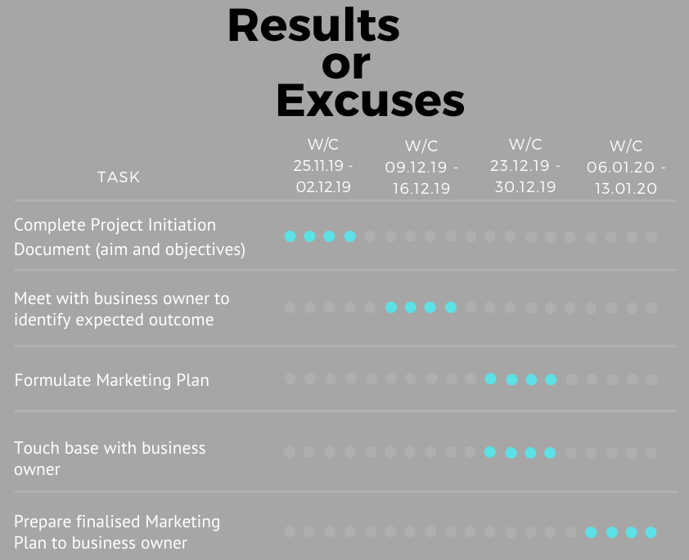
In order to put this project into use, a meeting will be held with the business owner to discuss the completed marketing plan and illustrate how the plan could benefit the business if utilised appropriately.
An agile Project Management approach will be demonstrated for this project, in order to remain focused on the end product, to scope the work and to ensure inclusion throughout the project.

Overall, this project has the potential to make valuable suggestions to Results or Excuses, including increased income, heightened exposure, new clientele, and the possibility of entering new markets. Using an agile management approach to the marketing plan, keeping a controlled scope, as well as seeking professional guidance, the business owner will be delivered a cohesive marketing plan which has the potential to benefit both the business and the business owner.

The form has 334 words in instructions, these are not to be included in your word count of 1000 words +/- 10%

