Cat 5e and 6 Ethernet Cable Standards
By Daniel Bennett

Contents
Introduction 3
Cat 5e 3
Cat 6 3
TIA/EIA-568 3
Reflection 5
Bibliography 6

Introduction
Ethernet cables are constructed with strict standards to ensure they operate at the specifications of their category. While there exist many types of ethernet cable, this report will be focusing on Category 5e and Category 6 ethernet cables.

Cat 5e
Cat 5e (Category 5 Enhanced) cables are “very popular and still being used widely in most offices, homes and warehouses” [1]. This is due to their low price, wide availability and performance.
Cat 5e cables are an improved version of their predecessor the Category 5 cable. Cat 5e cables use 4 UTP (Unshielded Twisted Pair) to reduce crosstalk and increase their performance which allows for up to 1 GB/s with this configuration, which is perfect for most consumers. Cat 5e cables are rated at 100 MHz and are speed are guaranteed for up to 100 metres. [2][3]

Cat 6
Cat 6 (Category 6) cables were developed as the need to transfer more data at a faster rate was realised. These wires were thinner, occupied less space and had improved insulation. [3]
Cat 6 cables still consisted of 4 UTP copper wires however, they now operated 250 MHz instead. Cat 6 cables therefore, had more stringent requirements with cross-talk and system noise. This in turn allowed for speeds up to 10 GB/s [1][3][4].

TIA/EIA-568
The TIA/EIA-568 is a standard created by the Electronic Industries Alliance as a means to create a standard for the use of cabling in telecommunications. [5]
In relation to cat 5e and cat 6 cables, the RJ45 connector is the main link. Both those categories of cable use the RJ45 connector to interface with hardware. The TIA/EIA-568 applies to the way the 4 UTP cables are fitted into that connector. [5]
TIA/EIA-568 has two ways in which you can configure the RJ45 connector. TIA/EIA-568-A and TIA/EIA-568-B. These are two different configurations on the placement of the 8 wires in both the category 5e and 6 cables. [5][6]
If you are to use the same configuration on each end of a cat 5e or 6 cable, for example TIA/EIA-568-A. You will have created what is called a patch cable. This is used when you are connecting two devices to each other via a switch, for example two PC’s together. [5][6]
If you have a TIA/EIA-568-A on one end and TIA/EIA-568-B on the other, you have a cross-over cable. This cable can be used to directly connect two PC’s together without the need for a switch in-between.[5][6]
Below is the cable configuration for the TIA/EIA-568-A and TIA/EIA-568-B: 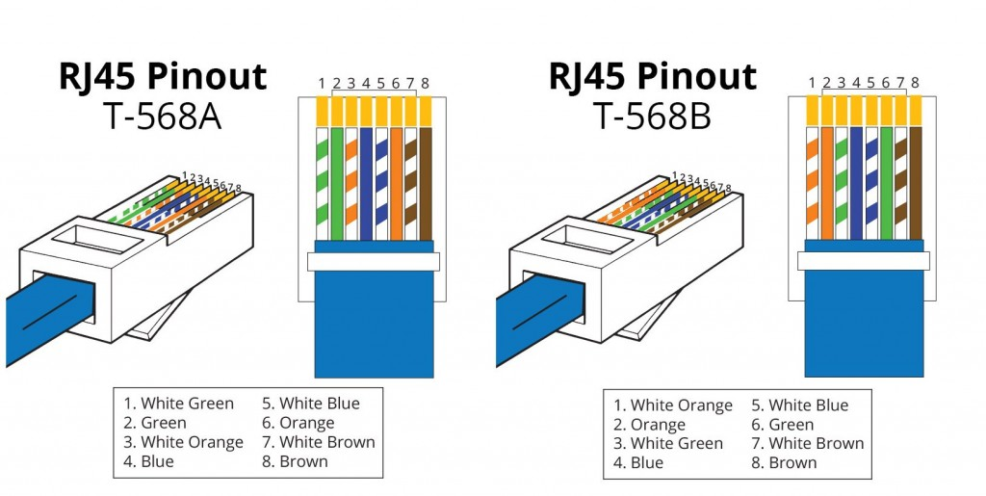[6]

Reflection
After completing the lab, it is clear that there are harder aspects to creating cables correctly in order for them to work. By far, the most difficult aspect during the process was lining up the internal wires in the correct order, inside of the RJ45 connector. Often, the wires would either knock each other out of position or not be long enough to be long enough to contact the gold pins.
From the lab, I now understand that although it is cheaper and easier to buy pre-built in certain circumstances, it would be easier to construct the cable yourself. For example, if you are running large amounts of cable through a building it is easier to fit the cable through a hole in the wall without an RJ45 connector on the end of it. In addition to this, the cables make be needed to be wired up to sockets instead of an RJ45 connector. So larger scale projects seem to be easier if you construct the cable yourself.

Bibliography
[1]"Cat5, Cat5e, Cat6, Cat6a Cat7 Cabling types - Cablify", Cablify, 2019. [Online]. Available: https://www.cablify.ca/cat5-cat5e-cat6-cat6a-cabling-types/. [Accessed: 01- Dec- 2019].

[2]V. Beal, "What is Cat-5e? Webopedia Definition", Webopedia.com. [Online]. Available: https://www.webopedia.com/TERM/C/Cat_5e.html. [Accessed: 01- Dec- 2019].

[3]G. Bidasaria, "cat5 vs cat5e vs cat6 vs cat6a vs cat7 - Which Ethernet Cable to Use? | TechWiser", TechWiser, 2018. [Online]. Available: https://techwiser.com/cat5-vs-cat5e-vs-cat6-vs-cat6a-vs-cat7/. [Accessed: 01- Dec- 2019].

[4]V. Beal, "What is Cat-6 (Category 6) Network Cabling? Webopedia Definition", Webopedia.com. [Online]. Available: https://www.webopedia.com/TERM/C/cat_6.html. [Accessed: 01- Dec- 2019].

[5]"What is the difference between TIA/EIA standards 568-A and 568-B?", Cat-5-cable-company.com. [Online]. Available: http://www.cat-5-cable-company.com/faq-568A-VS-568B.html. [Accessed: 01- Dec- 2019].

[6]"Patch Cable vs. Crossover Cable: What Is the Difference?", https://community.fs.com, 2016. [Online]. Available: https://community.fs.com/blog/patch-cable-vs-crossover-cable.html. [Accessed: 01- Dec- 2019].

Engagement with a wide range of literature, including sources retrieved independently.
Selection of relevant sources. Consistently accurate application of referencing. – 75%

Exceptional levels of application and deployment skills in particular practical contexts. – 100%

