My learning journey
in professional career
development

Written by umut yamac

Date: 11/06/2019

In this assignment I will be including:

: introduction
: SMART GOAL
: SWOT analysis
: my SWOT analysis framework
: GO MAD framework
: the KOLB’S learning cycle
: VARK learning styles
: THE JOHARI WINDOW
: My personal development plan
: conclusion
: references

Introduction:

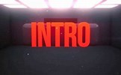

Since my early age and due to immigration, I was an entrepreneur and during my childhood I was involved in a family run business. Also, having to run my own business for over five years in the UK even without knowing I was using methods like SWOT analysis and conversion strategies such as converting weaknesses to strengths threats to opportunities and having a specific target that I plan to reach in my head such as having a SMART GOAL. However, this course helps me gain the skills and the knowledge to apply all this information in the right order and understanding and better the outcome of my decisions.

What is SMART?

SMART is a word formed from the initials letters of specific, measurable, achievable relevant(realistic), time bond. SMART GOAL can use to guide your goal settings.
Its criteria are commonly attributed to Peter Drucker's Management by Objectives concept. The first known use of the term occurs in the November 1981 issue of Management Review by George T. Doran. Since then, Professor Robert S. Rubin (Saint Louis University) wrote about SMART in an article for The Society for Industrial and Organizational Psychology. He stated that SMART has come to mean different things to different people(mindtools.com).
And objective to be SMART it should be;
Specific (simple, sensible, significant)
Measurable (meaningful, motivating)
Achievable (agreed, attainable)
Realistic (reasonable, relevant)
Time framed (time limited)

"Attitude Is Everything: If You Want to Succeed Above and Beyond (j.meyer2003) said j.meyer when he describe SMART GOAL in his 2003 book. I will expand on his definition and give example of my own SMART GOAL
Specific: my goal is clear that I want to be a subtitler at the end of my study period
Measurable: to rich my goal I need to have enough skills and knowledge there for I need to complete skill for the work place course first and then see where and what companies or institutions offers training courses.
Achievable: I need to see if the training will get me closer my goal or do I need to use different methods and reassess myself to see how closer I am to achieving my goal.
Realistic: I should ask myself questions like; do I really want this job? is this what I want for a career? Am I the right person for this job? Am I taking every necessary steps in order to reach my target.
Time bond: a SMART GOAL should have a time frame there for I need to see what I can do in six months from now on, is my training enough or do I need further training to become a subtitler.
Applying SMART to my life can help me create clear and meaningful plan as well as improving my motivation to reach my goal.

SWOT analysis:
SWOT analysis is an acronym for strengths, weakness, opportunities and threads and it used by an organization or a person to identify their internal strengths and weaknesses as well as external opportunities and threats.
Strengths and weaknesses are inward- looking, and particularly concerned with the resources of the organisation. Opportunities and threats are outward- looking and involves the analysis of environmental factors. The organisation should ensure that its strength are appropriate ones the exploit opportunities or the counter threats. (business environment John Kew,John Stredwick)
My SWOT analysis helps me identify my weakness and threads and how to convert them in to strengths and opportunities as well as improving my skills and abilities My main thread is owning a takeaway because I often find myself short of staff and I have to work 7 days a week until midnight and study at the same time. To solve this issue and make more time to study I take my laptop to work most of the days and plan ahead my time after work and I also make sure I spare at least an hour every day to work on my assignments so I wont have to rush before the dead line.

My SWOT analysis framework:

Opportunities
-studying in university
-improve knowledge
-new jobs opportunities
-improve academic writing skills
Weakness
-Emotional
-Easily distracted

Strengths
-Organized
-Honest
-Multilingual
-Good at time keeping
truste

-working and studying at the same time
-competitive market
-finding to right training program

Threads
-working and studying at the same time
-competitive market
-finding the right training programs

GO M.A.D FRAMEWORK and my personal reflective on make a difference:

The Go M.A.D. Results Framework and solution focused thinking methodology enables people to accelerate results and improve productivity. (GOMADTHINKING.COM)

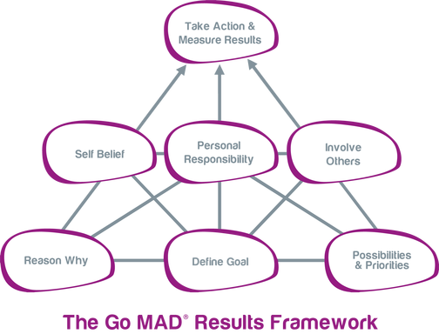

GO MAD is a very useful framework for me to improve, think and achieve my defined goal successfully.

Define goal: my goal is to become a subtitler in movie and cinema sector in turkey.
Reason why: as I can speak and understand both Turkish and English, it will be so much fun, and I will very much enjoy working for movie companies.
Possibilities and priorities: having a university degree from the UK is very prestigious in turkey therefor studying and completing the university will make me an ideal candidate for the job.
Involving others: I will look for the right training course to achieve my goal and I already know people who works as a subtitler in turkey who would assist me and lead me to right direction towards accomplishing my goal.
Personal responsibilities: studying hard and completing university is my main priority. I will have to make sure I can gain enough skills and knowledge to apply them in real life.
Take action and measure results: through out my study and training period I will reassess and see how far I came towards achieving my goal. What I can do more and if I am on the right training course.
Self-belief: if I don’t try, I will never know if I can become a successful subtitler. listening negative inner voice would not get an individual to achieve the goal so I will flip my weaknesses to strengths by avoiding distractions, make more time to study, plan ahead and be more organized.

KOLB’S LEARNING CYCLE
AND
HONEY AND MUMFORD learning styles:
KOLB’s learning style suggests that people learn from their experience in a cyclical way. people observe what is going on around them and reflect their observation. KOLB’s learning cycle help people to gain theoretical knowledge of skills they already possess.

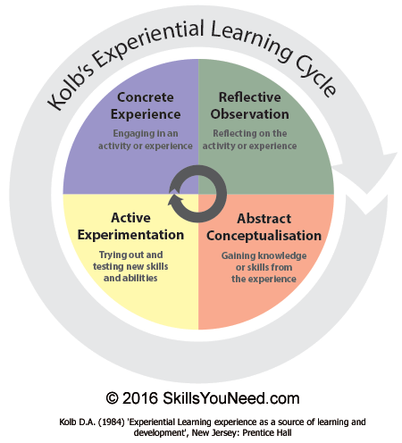
KOLB proposes this as a cycle, and we all go through that when we learn something but there is no doubt that people are not uniform, so we all prefer to start from different places and spend more time some parts than others. Peter Honey and Alan Mumford realized this and expand on KOLB’s work, so they came up with a four different learning styles.
Individuals can evaluate their current learning styles by undertaking one of the many Honey and Mumford learning styles inventories, which are widely available. (Maund.A, Schriek.M,Tinkler.P).
Honey and Mumford learning styles are;
--activist: they are learning by doing.
--pragmatist: they care about what really works in real world.
--reflector: they want to understand things before they try them.
--theorist: they don’t like things that don’t match what they already know and would want to get more information before they get comfortable with it.
Honey and Mumford questionnaire help me pinpoint my leaning style as a pragmatist I very much care about what really works in real world, I often find myself being activist and pragmatist at the same time I am more like a logical learner and focused on getting the job done even though it could sometimes end with an unwanted result but I take lessons from my mistakes.

VARK LEARNING STYLE:
VARK stands for visual, auditory, reading and writing, and kinesthetics learners. The VARK model acknowledges that students process information differently, referred to as “preferred learning modes”. This has a significant impact on the student’s ability to collect and disseminate information and should be matched with appropriate learning strategies.( essaysamurai.co.uk/definition-of-vark-learning-style/)
I am a kinesthetics learner. Kinaesthetic learning is one of the three different learning styles popularized by Neil D. Fleming in his VAK model of learning. In essence, kinaesthetic learners process information best when they are physically engaged during the learning process.( https://www.thoughtco.com/)
As it stated above I like to learn by physically as an example if I wanted to learn how to take picture with a camera I just bought, I would go through the settings and try see how I can adjust the exposure what types of filters camera have , which filters suit for me, how I can zoom in and zoom out and I would try and take as many pictures as I can and compare them to see which one is better until I feel satisfied by my skills of photograph taking.

The Johari window:
Sometimes we do not like about ourselves and sometimes people do not tell us what we are really like it could be because they do not want to offend us. This idea led joseph Luft and Harry Ingham to develop what is known as Johari Window. (Luft and Ingham 1955). (morgan. P).

Johari Window is psychological tool that helps people better understand their relationships with themselves and others. (selfawareness.org.uk)

Known to self | Blind spot (known to others)
facade | Unknown (unknown to others)

Known to self: this area is the about the person’s attitude, knowledge, skills and emotions known by the person and the others.
Blind spot: this pane of the Johari Window known by the others but unknown by the person himself for example we may think we are such a funny person, but the other people may think the completely opposite.
Facade: this area known by the person but kept hiding from the others. We do not always share our thoughts or emotions with the others. We may have different sides that we would not want others the know.
Unknown: this area unknown by the person and the others and contains hiding information. God knows how many hiding talents we may have.

My personal development plan

Skills and behaviour | Action needed | Resources needed | Date for action | Date for review | Aspirational goal
Speaking both English and Turkish fluently and writing skills on both languages | I need the complete the university in order to gain skills and the knowledge to become a subtitler | Involving friends that work for movie industry -looking for training programs and online sources | Going to university every Monday and Thursday and revise at home after three times a week | Reassess my whole year of study in march 2020 see what skill and knowledge I gained and what could of gone better | I want to be a subtitler and work for the movie sector

Conclusion:
I began writing this assignment with a bit of my personal background and importance of setting a SMART goal to achieve my target. What makes a goal a SMART goal, learning to learn and discovering my own learning preferences by looking into learning styles, models and questionnaires. People may have different learning preferences what are those learning styles and what benefits we may gain from those learning styles. I also mentioned about psychologic tool that can help people better understand their relationship with themselves and others such as given example of JOHARI WINDOW.

References:

https://www.mindtools.com/pages/article/smart-goals.htm
https://www.gomadthinking.com/
https://www.skillsyouneed.com/learn/learning-styles. htmlessaysamurai.co.uk/definition-of-vark-learning-style/
https://www.thoughtco.com/the-kinesthetic-learning-style-3212046 http://www.selfawareness.org.uk/
morgan.P(the business students guide to study and employability).sage publishing.
Maund.A,Schriek.M,Tinkler.P(Certification in higher education: skill for the workplace student year book)page337.sagepublishing.
www.businessballs.com.
Kew,J.Stredwick,J(2008)business environment managing in a strategic context.2.edition.

