Student name: Greti Anita Popescu
Student Id: 2114613

Programme: | BA Business Management
Module: | International Business Communications
Module code: | LCBB6001 | Contribution to | 50%
Module code: | LCBB6001 | Overall Module | 50%
Module code: | LCBB6001 | Assessment (%): | 50%
Lecturer/Module Leader: | Dr Husam Helmi | Internal Verifier: | Dr Anupam Mazumdar
Assignment Title: | Component 1 Coursework: Essay | Word count (or | 2500 words (+/- 10%)
Assignment Title: | Component 1 Coursework: Essay | equivalent): | 2500 words (+/- 10%)

Introduction
British corporate communications have evolved significantly over the years, being characterised by a blend of tradition and openness to new ideas. Because of its long tradition of trade and the English language, the United Kingdom is often regarded as a global leader in efficient and impactful business communication. British people tend to be formal and courteous in their interactions with one another, placing a premium on civility and the ability to express oneself clearly in the workplace. The ability to blend established norms with cutting-edge strategies is a hallmark of British corporate discourse. Addressing coworkers using their titles and surnames reflects the continued importance placed on hierarchy and deference to authority in the business world (Cornelissen, 2020). Email, video conferencing, and other digital collaboration tools have replaced more formal and slow methods of communication as a result of globalisation and technological advancement.
In addition, diversity and inclusion have been given more attention in the British corporate world. In light of the multicultural nature of modern society and the increasingly global nature of business, companies are becoming more open to a variety of communication methods and points of view. The focus on diversity and inclusion is not just a moral obligation but also a strategic commercial benefit in stimulating innovation and extending market reach (Bailey et al., 2021).
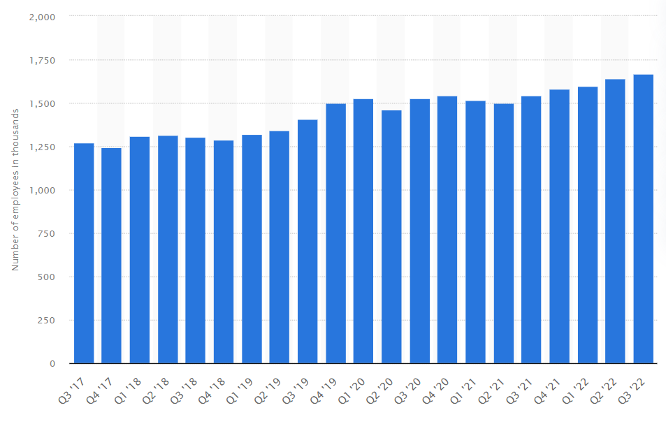
Figure 1: “Employment in the Information & Communication industry in the United Kingdom (UK) from 2017 to 2022, by quarter” (Source: Statista, 2023)
As global trade and communication patterns evolve, British corporate communications combine tradition with adaptability, formality and informality, and variety and inclusiveness (Kalam and Kalam, 2020). The rapid development of British corporate communication is reflected in Vodafone, a leading telecoms firm. British communication approaches, like Vodafone's worldwide expansion, combine contemporary technology with more traditional methods. “Nearly 1.7 million Britons found gainful employment in the technology and communication sector in the most recent quarter, up from 1.5 million in the third quarter of 2021” (Statista, 2023). Both emphasise precision, competence, and openness to many points of view in an increasingly complex and interdependent world.

Discussion
Brief Introduction to Vodafone
Vodafone Group Plc, with headquarters in the United Kingdom, is a worldwide telecommunications company that has quickly risen to the top of a highly competitive market. Originally established in 1984 under the name Racal Telecom Limited, in 1991 the corporation underwent a name change to Vodafone. Since its foundation, Vodafone has become one of the major mobile and internet carriers in the world by means of mergers and acquisitions.
The rise to prominence of Vodafone may be traced back to the deliberate purchases and investments made by the company (Neamat, 2022). Vodafone's 1999 and 2000 acquisitions with AirTouch Communications and Mannesmann AG respectively allowed the company to strengthen its position in Europe and developing countries. Its worldwide success may be directly attributed to its aggressive growth plans and constant innovation.
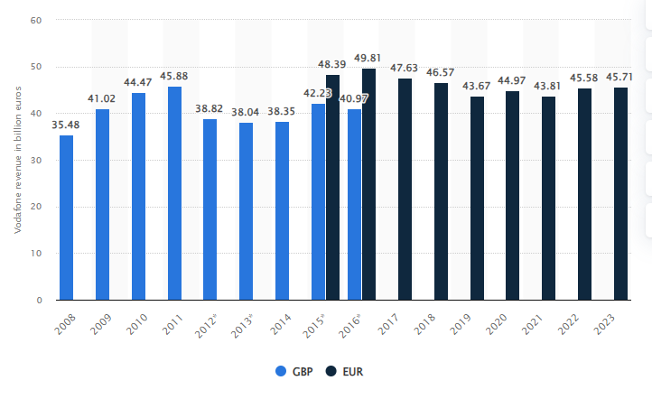
Figure 2: “Revenue of the Vodafone Group from 2010 to 2023 (in billion British pounds/euros)” (Source: Statista, 2023)
System of Intercommunication:
When it comes to speed, accuracy, and adaptability, the Vodafone communication system is unparalleled. The company employs a variety of channels of interaction with customers to guarantee a smooth experience for everyone involved. Employees at Vodafone are encouraged to be open and collaborative via the company's internal communication strategy (Graaf et al., 2022). Sales have gone up and client trust has grown thanks to the company's ability to break down complex technical knowledge.
Segmentation of Customers:
Vodafone has a wide variety of clients, from multinational corporations to single individuals. It provides a variety of services, including mobile and fixed-line phone plans, high-speed Internet access, and digital TV. Vodafone has achieved significant market penetration by catering to a broad variety of client subsets (Meena and Geng, 2022.). The company's dedication to its customers is seen in its customised service options, affordable rates, and consistently accessible network.
Critical Evaluation:
Vodafone's performance is remarkable, but not without hurdles. Although it operates on a worldwide scale, the corporation confronts stiff competition from regional entrants. Constantly adapting and localizing its services is necessary due to cultural and legal variations across markets (Van Herwerden et al., 2022). In addition, keeping up with the ever-changing nature of the digital ecosystem is a constant source of worry for those responsible for network quality and security.
Even though Vodafone has a reliable communication system, it has to be constantly improved to meet the ever-changing demands of the company's customers. In order to provide even better service to customers, the corporation has to put money into cutting-edge technology like AI and chatbots (Neamat, 2022). Furthermore, Vodafone must be watchful in protecting client data and maintaining adherence to data protection legislation across various nations in light of increased privacy concerns in the modern day (Abdulhadi, 2023).
According to Mihailović (2019), Vodafone's rise to the top of the telecoms industry throughout the world is a result of the company's foresight and flexibility. However, Eswaran and Honnavalli (2023) stated that, in order to maintain its place in the global telecommunications business, the corporation must stay proactive in solving growing difficulties, encouraging development in its networking systems, and assuring the happiness of its diversified client base.
Evaluation of Two EU Countries
Given the cultural diversity inside the European Union (EU), effective cross-cultural business communication is essential in today's globalised economy. This article compares Vodafone's operations in Spain and Germany and discusses the impact of cultural differences and other variables on effective cross-border business communication.
According to Statista (2023), as of 2019, Vodafone's revenue in Spain is projected to be about €4.2 billion, down from a record of almost €5 billion in 2018.
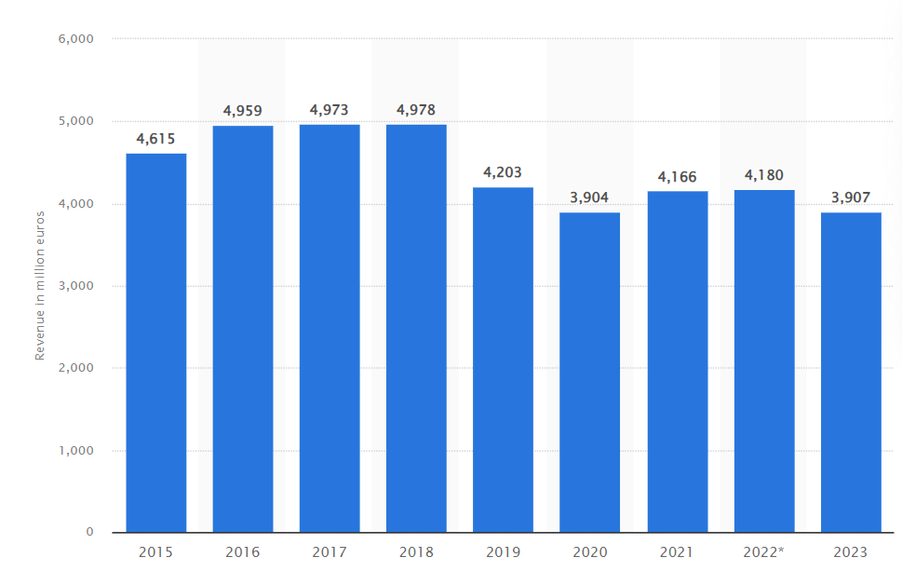
Figure 3: “Vodafone revenue in Spain 2014-2023” (Source: Statista, 2023)
Geographical Data:
Spain and Germany, as two of the major economies in the European Union, provide Vodafone with different possibilities and challenges (Satsangi and Das, 2022). Although both nations are EU members, there are important cultural and economic differences that must be taken into account when doing business.
Situations in Society:
Knowing the social norms of both Spain and Germany is crucial for successful interaction. Spain has a more laid-back and sociable culture due to its long history. There might be considerable effects on business operations as a result of the focus on relationships and interpersonal ties. The German work culture, on the other hand, is legendary for its rigour and timeliness. Formality is more common in German business relationships, with competence and dependability being the cornerstones of trust (Kargas et al., 2023). Taking into account these distinctions is essential when developing market-specific communication plans.
Language:
The importance of language in cross-cultural business interactions cannot be overstated. Although Spanish is the country's official language, many Spaniards also speak Catalan and Basque. Learning the language of a country may help to connect with its people and gain their trust. Vodafone could provide its staff with language training and think about employing native speakers from the area.
Potential Dangers:
There is always a degree of uncertainty when doing business on a global scale. The dangers in Spain and Germany are different. The Spanish economy is volatile, and the country's legal system is complicated (Kumar, 2022). It is also possible that economic growth may vary greatly from place to place. On the other side, Germany has a very strictly regulated corporate environment, with severe consequences for noncompliance. Vodafone should implement thorough risk management measures adapted to the difficulties faced in each individual country.
Employment Prospects:
Another important aspect of intercultural business communication is the diversity of the workforce itself. Workers in Spain come from a wide variety of cultural and geographical origins. Recognising the importance of work-life balance to Spanish workers may improve engagement and morale. The German workforce is exceptionally well-educated and proficient. The job market in Germany is expected to change, and those who want to succeed there may need to invest heavily in their technological skills and education.
Cultural Factors According to Hofstede:
If people want to know how Spain differs culturally from Germany, consider that the Spanish tend to have a larger power distance, which means that hierarchies are respected and the power to make decisions is concentrated at the top. In contrast, Germany's power distance is smaller, leading to more horizontal structures and distributed authority. There is a tremendous emphasis on community and family in Spanish culture. Germany places a greater value on independence and personal success (Ramiro et al., 2022). This affects team relationships and communication techniques inside the workplace. Spain has a more macho culture that places a premium on self-confidence and success. While Germany is likewise more masculine, the country places a premium on having a healthy work-life balance. Due to the country's high level of uncertainty avoidance, Spaniards may place a premium on straightforward and organized discourse. However, German workers are more open to change and risk because of the country's lower uncertainty avoidance. Both the Spanish and the Germans have a penchant for the long view, placing premiums on continuity and history. Because of this same cultural ground, communication and cooperation are facilitated.
Evaluation of the two different EU countries, and the communication barriers the British business could experience
Communication Barriers in British Business Expansion: Germany and Spain:
There are advantages and disadvantages to expanding a British company into other EU nations like Germany and Spain. Even though the European Union encourages economic cooperation, British companies that want to expand internationally sometimes face formidable challenges due to language and cultural limitations (Abdulhadi, 2023). In this essay, the researcher has delved into the language and cultural differences that British companies may face while doing business in Spain and Germany.
Germany:
Formality and Language: There is a strong emphasis on politeness and formality in German business interactions, and the language itself plays a vital role. While English is widely spoken in Germany, fluency in German is advantageous in the corporate world (Langinier and Ehrhart, 2020). The results of negotiations and regular encounters might be negatively affected by misunderstandings caused by linguistic complexity.
Hierarchy and the Decision-Making Process: The Germans place a premium on formal organisational structures, and they like to have many people sign off on major decisions (Loconto et al., 2021). Companies in Britain that are used to operating with less bureaucracy may find this structure restrictive. Establishing effective ways to communicate with individuals at different levels becomes crucial.
Professionalism and Punctuality: Timeliness and regularity are hallmarks of German culture. Meeting attendees may see tardiness or lack of preparation as rude and unprofessional. If British firms want to gain customers' confidence and credibility, they need to include German timekeeping techniques in their communication strategies.
Spain:
Informality and Language: Many Spaniards, especially in larger cities, are fluent in English, yet the language of formal business remains Spanish (Gómez, 2019). Spanish business conversations are known for their casual tone and casual terminology. Businesses in Britain may need to adopt this more relaxed style, with its focus on human ties and kinship.
Hierarchy and Flexibility: Despite the rigid German hierarchical structure, Spanish companies are known for their more fluid approach to making decisions. Personal relationships and networks may be influential in the corporate world. British companies must find their way through this unofficial system of authority by cultivating personal connections while maintaining strict professional boundaries (Kristoffersen, 2019).
Cultural awareness and flexibility: Spain places a high priority on its history, customs, and regional diversity. British companies can't expect customers to trust them unless they learn to recognize and accommodate these cultural differences. Adapting marketing techniques and communication methods to suit distinct areas within Spain may boost acceptability and engagement.
In order to communicate well with someone from Germany or Spain, you must master the language and learn about their culture. Companies from the United Kingdom who want to do business in Germany and Spain should invest in language training for their staff members. In addition, it is crucial to learn and adhere to the local business customs, communication norms, and cultural norms of any place you do business in.
In addition, establishing relationships with regional businesses and recruiting native speakers may increase knowledge of the local market and the efficiency of internal and external communications. British enterprises may ensure long-term development and expansion inside the EU by overcoming these communication hurdles via cultural competency and flexibility, especially in the German and Spanish markets.
Challenges and Recommendations for British Businesses to Expand
Choosing the correct nation to expand into is a major choice for a British company. Think about the company's aims, its industry, and its chances of success to make a well-informed decision. In light of what has been said so far about Spain and Germany, it would be a good idea for the British company to set up shop in Germany (Bourreau and Lemstra, 2022). Germany is a great option for international growth because of its numerous benefits. Its robust and stable economy offers a wealth of prospects for expansion and financial gain. There are a few different approaches the company may use to improve communication when it expands into Germany.
Invest in the staff's language skills and make sure they can communicate fluently in German. While many Germans do understand English, making an effort to demonstrate competency in the native tongue may go a long way toward building rapport and trust (Lorenzo et al., 2022). Help the staff better comprehend the working environment and interpersonal norms of Germany by providing them with cultural sensitivity training. Being prompt, formal, and knowledgeable in one's field are all essential components of this. Recruit experts from Germany who are familiar with the market's nuances. Employing people from the area may assist in getting useful insights into the local business climate and establishing rapport with local partners and consumers. Adapt company processes to match the local market. To gain credibility and trust, they must understand and adhere to German legislation and norms (Kargas et al., 2023). Put money into getting to know people and making connections. Building trust and credibility in the German market requires attendance at industry events, membership in local business chambers, and the cultivation of relationships with German enterprises. Give them instruction in other cultures to help them understand and collaborate with their German counterparts. Communication and cooperation might benefit from a deeper understanding of the subtleties and expectations of both cultures. Set up channels and mechanisms for open and honest internal communication. Open and honest communication may help prevent misunderstandings and missteps.
If people are looking to build a company, Germany is a great place to do it (Lorenzo et al., 2022). The British company may foster a productive setting conducive to the success of everybody by adopting these tactics and adjusting to local customs and business norms. Gaining traction in Germany might pave the way for growth in other European and Asian markets.

Conclusion
Successful foreign commercial endeavours may be hindered by issues like these, making it all the more important to recognise and overcome them. German language and culture, especially its focus on politeness and formality, may play an important role in commercial dealings. If British businesses want to flourish in this market, they need to make an effort to familiarize themselves with the local business culture and provide their workers with language training. The hierarchical and bureaucratic decision-making process also demands change, and British enterprises must discover effective methods to navigate through it. The business climate in Spain is more easy-going and friendly, with an emphasis on personal connections. The ability to communicate fluently in Spanish and the desire to adopt a more casual tone are essential for success in British business.
The importance of personal networks and the flexibility with which decisions may be made call for a careful balancing act between formality and informality. Both nations place a premium on cultural sensitivity and adaptability; each is justifiably proud of its own history, traditions, and regional variety. The marketing and communication strategies of British businesses need to change to reflect these disparities. Recruiting native speakers and cultivating partnerships with local firms helps increase fluency in the local market and improve communication. To flourish in both Germany and Spain, British firms must engage in language training, understand and adhere to local business practices, and exhibit cultural competence and adaptability. By learning about and adapting to other cultures, British businesses can better communicate and expand across the European Union over time. If people want to capitalise on the various possibilities presented by the European market, they will need to be able to communicate effectively across linguistic and cultural boundaries.

References
Abdulhadi, O. (2023). The human connection to information security: A qualitative study on policy development, communication and compliance in government agencies.
Bailey, D., Almusharraf, N. and Hatcher, R. (2021). Finding satisfaction: Intrinsic motivation for synchronous and asynchronous communication in the online language learning context. Education and Information Technologies, 26, pp.2563-2583, DOI: 10.1007/s10639-020-10369-z.
Bourreau, M. and Lemstra, W. (2022). Open interfaces and innovation in telecommunications.
Cornelissen, J.P. (2020). Corporate communication: A guide to theory and practice. Corporate Communication, pp.1-336.
Eswaran, S. and Honnavalli, P. (2023). Private 5G networks: a survey on enabling technologies, deployment models, use cases and research directions. Telecommunication Systems, 82(1), pp.3-26, DOI: 10.1007/s11235-022-00978-z.
Gómez, M.A. (2019). Spanish on the language map of the Lesser Antilles. The economic and commercial influence of Spanish-based languages, pp.62-74.
Graaf, J., Kraus, K. and Strömsten, T. (2022). The problematics of financialization–On the important (but neglected) horizontal axis of organizational action. Critical Perspectives on Accounting, 89, p.102339, DOI: 10.1016/j.cpa.2021.102339.
Kalam, K.K. and Kalam, K.K. (2020). Market segmentation, targeting and positioning strategy adaptation for the global business of Vodafone Telecommunication Company. International Journal of Research and Innovation in Social Science, 4(6), pp.427-430, ISSN 2454-6186.
Kargas, A., Argyroulis, V. and Varoutas, D. (2023). Mergers and acquisitions in telecommunications market: a simultaneous equations approach to study Structure, Conduct and Performance.
Kristoffersen, M. (2019). Problematizing boundaries of care responsibility in caring relationships. SAGE Open Nursing, 5, p.2377960818808692, DOI: 10.1177/2377960818808692.
Kumar, N. (2022). Merger and Acquisition deal between Vodafone and Idea.
Langinier, H. and Ehrhart, S. (2020). When local meets global: How introducing English destabilizes translanguaging practices in a cross-border organization. Management international, 24(2), pp.79-92, DOI: 10.7202/1072643ar.
Loconto, A.M., Arnold, N., Silva-Castaneda, L. and Jimenez, A. (2021). Responsibilising the Fairtrade Premium: Imagining better decision-making. Journal of Rural Studies, 86, pp.711-723, DOI: 10.1016/j.jrurstud.2021.07.011.
Lorenzo, C., Erika, C., Di Torrice, M., Alessandra, R., Santoro, M.T., Tuoto, T., Luca, V., Di Sorte, D., Zaramella, M.R.A., Dario, B. and Glauco, M. (20220. Exploring mobile network data for tourism statistics: the collaboration between Istat and Vodafone Business Italia. RIVISTA DI STATISTICA UFFICIALE, 3, pp.43-76, ISSN 1972-4829.
Meena, M.E. and Geng, J. (2022). Dynamic competition in telecommunications: A systematic literature review. SAGE Open, 12(2), p.21582440221094609, DOI: 10.1177/21582440221094609.
Mihailović, J. (2019). The future of mobile operators-new business models. Management: Journal of Sustainable Business and Management Solutions in Emerging Economies, 24(2), pp.73-84.
Neamat, S. (2022). A Strategy for the Growth and Internationalization of Companies: International Mergers and Acquisitions. Journal of Applied Science and Technology Trends, 3(01), pp.20-26, DOI: 10.38094/jastt302133.
Ramiro, R., Arahuetes, A. and Robinson, R.A. (2022). A tale of two international strategies: how telecom operators of the European Union and the USA dealt with the political-institutional environment after the global financial crisis. European Journal of International Management, 18(2-3), pp.351-378, DOI: 10.1504/EJIM.2022.124911.
Satsangi, S. and Das Saini, P. (2022). A Study of Merger and Acquisition and Its Impact on Profitability Performance of Selected Merger (With Reference to Vodafone Idea Merger). In Flexibility, Innovation, and Sustainable Business (pp. 169-181). Singapore: Springer Nature Singapore, DOI: 10.1007/978-981-19-1697-7_12.
Statista. (2023). Vodafone revenue in Spain 2014-2020. [online] Statista. Available at: https://www.statista.com/statistics/687632/vodafone-revenue-in-spain/.
Statista. (2023). UK: Information & communication employment 2021. [online] Statista. Available at: https://www.statista.com/statistics/1066588/it-employment-overall/ [Accessed 7 Nov. 2023].
Statista. (2023). Vodafone Group Revenue 2008-2020. [online] Statista. Available at: https://www.statista.com/statistics/241610/revenue-of-vodafone-since-2008/ [Accessed 7 Nov. 2023].
Van Herwerden, L.A., Reidlinger, D.P. and Palermo, C. (2022). The role of communication, building relationships, and adaptability in non-profit organisational capacity for health promotion. Health Promotion International, 37(3), p.daac074, DOI: 10.1093/heapro/daac074.

