

Dissertation

Student name: Elena Carmen Anghel
Student ID: 1905217
Proposed research title: “Impact of Globalisation on Small Business”
Supervisor name : Husam Alharahsheh

2022
Table of Contents
“Chapter 1: Introduction” 3
“Significance of research” 3
“Research Rationale” 3
Aims 4
Objectives 4
“Research question” 4
“Chapter 2: Literature Review” 5
“Chapter 3: Research Methods and Methodology” 8
“Research Philosophy” 8
“Research Paradigm” 9
“Research approach” 9
“Research methods” 10
“Research strategy” 10
“Sampling” 11
“Data collection tools” 11
“Data analysis technique” 12
Timeline 12
“Ethical consideration” 13
Findings 14
Survey questionnaires 14
Discussion 23
“Chapter 4: Conclusion and recommendations” 27
References 29

“Chapter 1: Introduction”
The topic that will be discussed in the research is “the impact of globalisation on small business”.

“Significance of research”
The research that will be conducted in the “impact of globalisation on small business” will be evaluating several characteristics of globalisation. The key aspects of globalisation will be identified in the research. The research will also evaluate the challenges that small businesses can face due to globalisation. Moreover, the research will be identifying the benefits imposed by globalisation and the opportunities that globalisation has introduced. The completion of this research will be very beneficial for the small business owners as they will be able to understand different aspects of globalisation. This knowledge will allow them to bring changes in their operation which will support their growth and development. In the correspondence of this research it will also consider determining key important areas where improvement can be seen for the aspect of globalisation. Along with this the research will also target apprehending the complex changes that globalisation can bring within operations of Small business entities. In the aspect of globalisation, it relatively changed the overall course of operation of business entities irrespective of their size and nature. Such a significant change in the aspect of small business will be effectively apprehended and determined in the research.

“Research Rationale”
The study will be evaluating the concept of globalisation and the impact generated by it on the performance of small businesses. The research will cover a wide range of concepts within globalisation and the use of the concept will be done to analyse the impact. Several advantages and disadvantages will be identified. The study is lacking the strategies that can be used to overcome the challenges faced by the small business. In the consideration of challenges the utilisation of different methods and strategies for dealing with the issue of globalisation is widely regarded as one of the significant measures. The identification of strategy is very important as it will allow the small business owners to develop approaches to mitigate issues. Moreover, the research can lack in collecting authentic and quality information as access to some of the authentic websites are blocked which will impact the quality of the study. Contextualisation with the study and assessment of the overall factors of the globalisation can be effectively enumerated that several gaps in the aspect of this study are remaining and this relatively hinders the overall understanding of the current project. This research will identify such gaps present in the study and assess the relative form of measures to select an effective strategy for the business.

Aims
The core aim behind conducting this research is to evaluate the influence generated by globalisation on small businesses.

Objectives
- To examine the characteristics of globalisation.
- To identify the benefits of globalisation on small businesses.
- To identify the disadvantages of globalisation on small businesses.

“Research question”
- What are the key characteristics of globalisation?
- What is the influence of globalisation on the business performance of small businesses?
- What are the advantages imposed by globalisation on small businesses?
- What are the disadvantages of globalisation on small businesses?

“Chapter 2: Literature Review”
The concept of globalisation and its impact
According to Zajda and Majhanovich (2021), the spreading of information, products, technologies, techniques and jobs internationally is called globalisation. Globalisation has been supported by a concept called free trade which allows the business of different nations to trade with foreign countries without any prime restrictions. Globalisation has some primary characteristics that support the growth of the business. Some of the characteristics are liberalisation, free trade, connectivity and development. Globalisation has supported the development of several businesses and people as businesses are now able to connect with foreign cultures to enable trade that has offered them several opportunities to explore.
As started by Liñán et al. (2020), globalisation has offered several benefits and growth opportunities for small business owners. The free trade enabled by globalisation has allowed the small business owners to trade with foreign nations at reduced costs. It can be said that globalisation has allowed the small business owners to access foreign clientele. This has made it easier for them to support the growth of their business. Globalisation has allowed the business to connect with people in foreign nations through the internet and to import or export goods from foreign nations through cargo ships and flights. This has allowed the small business to import the latest technologies available in foreign market that can help them to improve their business performance. Moreover, the small business owners have been able to learn new techniques and approaches of operating business that has allowed them to gain competitive advantage in the market.
As per Coulibaly et al. (2018), globalisation has allowed every business to trade with foreign nations. There are many large businesses in different countries which makes it difficult for the small business owners to survive in the market. Globalisation has allowed large businesses to acquire innovative technologies that can help them to reduce the costs of production. Thus the first challenge imposed by globalisation on small businesses is price wars. Small businesses are like small fish in a big sea thus competing with the large business is very hard for them. Large businesses have greater access to capital that allows them to acquire several innovative technologies and this allows them to provide their products at a lower price (Lund and Tyson, 2018). Thus small businesses have to face intense price wars that restrict them from increasing their profitability. The other challenge is that competition has increased due to globalisation. Globalisation has allowed multinational corporations to expand in foreign lands which has significantly increased the competition for small business.
Understanding the characteristics of globalisation
In the larger aspect globalisation is considered as an effective expansion of the geographic distribution system of a business entity and scattering its services to various regions much more effectively. The aspect of globalisation is directly related to the growth and development of individual business entities in terms of its profitability and marketability of products and services. The globalisation helps in expanding the reach of the business and helps in enhancement of the differential growth of the company much more effectively. Hourvouliades, (2022), suggests that for contemporary business units globalisation is a mandatory aspect as it helps in enhancing the overall survivability of the business. According to the author, globalisation is the essence for the modern day business units, and it relatively helps in growing the individual operations of a company or the business entity. Considering the approach of globalisation there are several factors that relatively helps in boosting up the individual operations of the business and ensure higher effective operations of the company. Gorynia (2019), in his article reflects that globalisation within the different sectors of the economy cumulatively helps in building a nation and enhances the growth aspect of the business much more effectively. Contextualising with the aspect of globalisation, it can be enumerated that globalisation of the differential aspect of the business can be done much more effectively as the practice of free trade is the primary aspect of globalisation.
According to Hall (2019), the free trading practice aspect of globalisation relatively helps companies and business entities to effectively manage the overall practice of the business and ensure all the relative aspects of the business are managed much more effectively. Globalisation helps in reducing the barriers for conducting business and helps in flourishing the different aspects of trade much more effectively. According to Farnsworth and O’Brien, (2022), globalisation into the aspect of business helps in liberalising the activities of trading and further provides freedom of trade practices within the greater extent of the business much more effectively. Freedom of trade practices helps various companies and organisations to reach a greater extent of the world and effectively sell its products. French (2018), contradicts the aspect of liberalisation, the author reflects that liberalisation and globalisation are completely different aspects and the former originated from the latter. In the context of the author it is not necessary that with globalisation, the aspect of liberalisation will also come into existence, however where there is liberalisation there must be globalisation of industries and business entities. In accordance with the overall aspect of globalisation it relatively helps in promoting the overall context of business entities and provides a significant base for conducting effective business operations.
Contextualisation with the overall working and functionality of globalisation it can be effectively enumerated that connectivity and economic globalisation is a mandatory aspect. According to Sobratee and Bodhanya (2018), better connectivity among the different individuals across the world relatively helps in freely sharing the ideas and help in the overall growth of the business much more effectively. With the comprehensive assessment connectivity, it also helps in educating the general public of the differential aspect of the business and assess the qualitative aspect of the business much more effectively. The author also states that comprehensive assessment of differential aspects of the business and growth of the business relatively helps in enhancing economic independence and help foster the growth of globalisation worldwide. According to Grose and Imam, ( 2022), the cumulative enhancement of technology, the growth in the aspect of business and the reach of different cultures among the world is much more effective in nature. The author suggests that economic independence relatively helps in enhancement of the overall proposition of the business and ensures the cumulative operations of the company are managed in a much more effective manner.
Impact of globalisation in small business entities
In the aspect of small business entities, it lacks a cheap labour force and lower marketability of products of the business. With the corresponding assessment of the operations of the business it can be effectively enumerated that globalisation helps in boosting the overall reach of the market much more effectively and ensures higher propagated growth and development of the business. With the comprehensive assessment of the differential aspect of growth and development it can be enumerated that globalisation helps in bringing up better sources of funding to the business and helps in reducing the cost of operations with the help of economies of scale. In the context of globalisation and aspect of development it can be effectively enumerated that globalisation helps in providing a significant boost to the tourism aspect of the business and ensure higher propagated development of the business. Van Binh, (2022), considering the aspect of general business management it can also be effectively enumerated that utilisation of complex business operations directly enhances the overall aspect of the business and provides a cumulative advantage to the operations of the business. The author in the relative aspect also provides effective understanding of the operations of business along with its financial requirements. Considering the financial growth of the business and assessment of the individual requirements of the business it can also be effectively enumerated that there are several effective factors that help in boosting up the overall market presence of the business much more effectively. With the rise in the complexities of the business and assessment of the individual factors of the business it can also be effectively enumerated that several of the individual aspects are to be highly affected and enumerated in a substantial nature. With the comprehensive assessment of different ideologies of operation and utilisation of different aspects of operations of the business is required to be done much more effectively.
According to Calabrò et al. (2022), globalisation presents its own set of challenges to the individual business entities operating within a particular sector. In the aspect of enhancing different possibilities and opening several doors for conducting business, it is not limited to one business or industry and therefore companies from all around the world relatively utilise such resources and help further enhance the growth of the business much more effectively and efficiently. With the progressive assessment of the overall operations of the business it can also be enumerated that utilisation of different marketing channels enhances the competition within the market space and relatively enhances the challenges present within the operations of the business much more effectively. The aspect of globalisation is not effectively managed or introduced to different countries much more effectively. According to Qin et al., (2022), the introduction of globalisation may relatively raise the GDP proportion however, due to this rise in the immigration can also be seen and this may negatively impact the overall growth prospect of the economy.

“Chapter 3: Research Methods and Methodology”

“Research Philosophy”
Research philosophy is the section of methodology that reflects the thigh of the researcher. This section deals with the development of knowledge that allows the researcher to have insight on the study. In this research, the researcher utilised positivist research philosophy (Žukauskas et al., 2018). The choice of the philosophy is based on the fact that it allows the researcher to develop several hypotheses of the study that have been very helpful to fulfil different aspects of the study. With the comprehensive utilisation of such a philosophical approach the overall research can be conducted much more evidently and efficiently (Cr, 2020). The positivist (positivism) research philosophy particularly utilises factual data and knowledge in order to drive suitable conclusions much more effectively. In accordance with the research it directly aims at understanding the impact of globalisation on small business, however the positivism approach significantly helps in verifying the research utilising different hypotheses and articles. In the context of positivism philosophy it has very minor disadvantage to the aspect of a particular study and therefore it is considered best for conducting the research.

“Research Paradigm”
The set of beliefs and agreements that developed by the researcher regarding the approach to solve the issues of the study is called the research paradigm. In this research interpretivism hasbeen used by the researcher to study the owners of small businesses to understand the impact of globalisation. In the context of the paradigm of a research it must be inclined or associated with the topic of the research and must consider effectively enumerating the overall aspect of research much more evidently (Hughes and Barlo, 2021). The interpretivism approach is considered best in this context as the research is particularly inclined towards obtaining significant information and establishing subjective relevance to the aspect of the research and the study in particular manner.

“Research approach”
The section of the methodology that demonstrates the assumption and beliefs of the researcher during the collection of the data is called research approach (Roy and Uekusa, 2020). The research approach briefly describes the methods of data collection and the selection of the approach is used in the nature of the study. In this research, an abductive research approach has been used to evaluate interesting facts and surprising elements of the study. The utilisation of the abductive method of data collection significantly helps the researcher to apprehend the significant facts and knowledge associated with the research and find cumulative explanation as to facts and riddles associated with the research. Along with this, the abductive approach relatively takes established theories and researches into consideration for contemplating significant forms of results much more effectively and ensures higher proportionate assessment of the research (Daniel, 2018). In the relative consideration of the abductive approach, the researcher will attain the privilege of differentiating among various factual data and information present within the study and assess the individual aspect of the research.

“Research methods”
There are mainly two types of research methods namely primary and secondary research methods. The primary method requires the physical involvement of researchers while the secondary method is used to collect data from sources like journals, books and articles. In this research, the researcher has utilised a mixed method that includes primary methods of collecting data (Oliva, 2019). This method is used as the study demands the need of real time data as well as the perspectives of authors. In the aspect of conducting research it can be effectively enumerated that there are several effective operations that relatively help in contemplating the overall approach of the research much more effectively. Data collection strategies particularly help a researcher to effectively reflect upon the differential aspect and ensure all its significant data are collected much more effectively. With the aspect of understanding the individual aspect of operations of the business helps in gaining significant information about the participants and delivers the results much more effectively (Willmott, 2020). For conducting the research the researcher has utilised the primary data analysis method and conducted a survey on the basis of that. Along with this the contemplation of the survey has been done with the help of a cumulative questionnaire covering the individual aspect of the questions much more effectively. The data collection will be undertaken by the researcher itself and utilise cloud based informative resources to store the data and analyse the significant aspect of the business much more effectively.

“Research strategy”
The plan that is developed by the researcher that demonstrates the way the research will be conducted is called research strategy. There are mainly four types of research strategy. In this research, the researcher has utilised a quantitative survey as a research strategy. This is used because the study demands the views of many of the small business owners that help the researcher to develop quality findings of the study. In the aspect of quantitative survey it is considered in this research proposition due to its simple nature of understanding and wider reach and responses (Pyakurel, 2022). The cumulative utilisation of such research strategy helps in gaining much more responses towards the questions of the research and ensure higher effective understanding of the approach of the research project. In the correlation of such indemnities of the research the quantitative survey proposition is less expensive to conduct and the period of time taken for its relative completion is very less.

“Sampling”
The process of selecting a group of participants from a large population is called sampling. There are mainly two types of sampling techniques. In this research the researcher has utilised“simple random sampling technique” under “probability sampling". The choice of this technique will allow the researcher to gather different types of samples for the study that will be helpful in evaluating several facts about the topic. The targeted population of the study has been small business owners of the United Kingdom and the size of sample is 30 small business owners. Strategising the technique of sampling relatively helps in dividing the group of individual respondents much more effectively and ensures its relative enumeration of growth and development (Hourvouliades, 2022). In the consideration of this project the researcher has utilised a simple random sampling method to identify and determine the number of individual business owners that are required to be reviewed in order to obtain suitable research data and information. Due to the smaller number of business entities and 30 individuals present for the allocation and identification of the data statistics the simple random sampling method is considered best fit for this particular approach.

“Data collection tools”
The tools that help in extracting data from a source are called data collection tools. In this research the quantitative data for the study will be extracted with the help of a questionnaire. A minimum of ten questions has been asked in the questionnaire session that will allow the researcher to identify different facts about the study (Yayeh, 2021). The use of questionnaires allows collecting data from large samples in a short time and also helps in reducing the costs of collecting data. The questionnaire is considered as one of the best suitable tools as it relatively helps in collecting data from a bunch of individuals much more effectively with minimum effort. The understanding of the data presented in the form of a questionnaire is much easier to understand and conclude suitable and effective information relating to the aspect of the research. In the consideration questionnaire it is much easier to transfer and obtain information about the corresponding respondent and it helps in managing the overall aspect of the business much more effectively (Akpan et al., 2022). The contemplation of data present in the form of questionnaires is very much effective in nature and can be obtained utilising different means such as online and offline or both and it does not take much time for its completion.

“Data analysis technique”
The data that will be collected from the questionnaire will be analysed using the quantitative data analysis technique. This technique allows the researcher to represent the collected quantitative data in the form of graphs and charts.

Timeline
Tasks | Start date | End date | Duration
Planning the research | 15-Jun | 20-Jun | 6
Developing aims and objectives | 21-Jun | 28-Jun | 8
Collecting primary data | 29-Jun | 10 -Jul | 13
Collecting secondary data | 11-Jul | 21-Jul | 11
Analysing the data | 22-Jul | 30-Jul | 9
Developing findings | 31-Jul | 7-Aug | 8
Conclusion | 8-Aug | 13-Aug | 6
Table 1: Work Breakdown Structure
(Source: Created by the learner)
Gantt chart

Figure 1: Gantt chart
(Source: Created by the learner)

“Ethical consideration”
Many of the ethical issues can be raised during the research, for the mitigation of some of the ethics has been considered by the researcher. The information of the participants will be protected considering the “Data Protection Act of the United Kingdom”. The data will be collected by gaining the fullest consent of the respondents (Arifin, 2018). The respondents can withdraw at any stage of the data collection process. In the context of ethical consideration it is considered a very important aspect that is required to be followed by individual researchers while taking information from individual respondents. Along with this there are several individual aspects of the business. It is considered a different aspect that relatively helps in managing the individual aspect of the research much more effectively (Kavitha and Gopinath, 2022). In the consideration of a research it is considered a very important aspect that a researcher must consider destroying the personal information of the respondents in a timely manner. Along with this, with the consideration of data protection act the researcher will not reveal the data and responses of respondents to any other individuals involved in the research, securing their privacy aspect.

Findings

Survey questionnaires
1. How familiar is your company with globalisation?
Responses | No of responses | Total number of responses | Percentage
Highly familiar | 28 | 30 | 93%
Not familiar | 02 | 30 | 07%
Table No 1: How familiar is your company with globalisation?
(Source: Created by the learner)
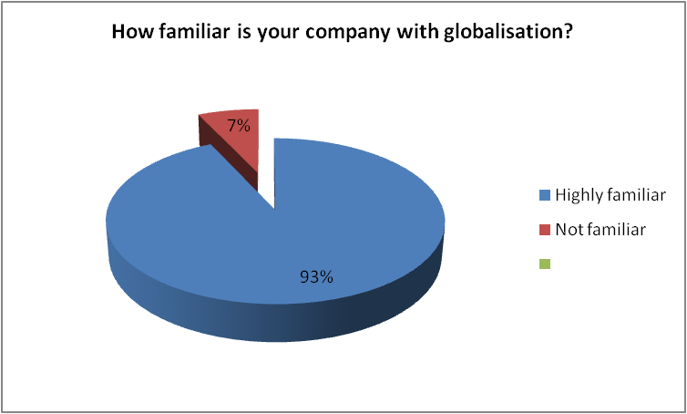
Figure No 1: How familiar is your company with globalisation?
(Source: Created by the learner)
2. Do you think globalisation has an impact on small businesses?
Responses | No of responses | Total number of responses | Percentage
Positively | 20 | 30 | 66%
Negatively | 07 | 30 | 24%
Not sure | 03 | 30 | 10%
Table No 2: Do you think globalisation has an impact on modern businesses?
(Source: Created by the learner)
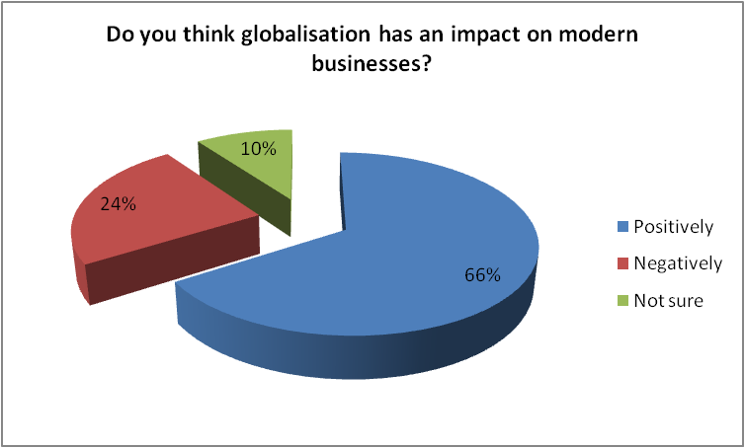
Figure No 2: Do you think globalisation has an impact on modern businesses?
(Source: Created by the learner)
3. Which are the areas of your business that have been impacted due to globalisation?
Responses | No of responses | Total number of responses | Percentage
Overall business | 15 | 30 | 50%
Investments in projects | 08 | 30 | 26%
Technology development | 07 | 30 | 24%
Table No 3: Which are the areas of your business that have been impacted due to globalisation?
(Source: Created by the learner)
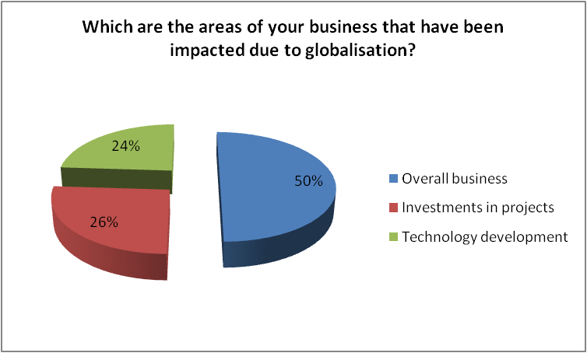
Figure No 3: Which are the areas of your business that have been impacted due to globalisation?
(Source: Created by the learner)
4. Which characteristic of globalisation has the maximum impact on the business of your company?
Responses | No of responses | Total number of responses | Percentage
Free trade | 11 | 30 | 36%
Liberalisation | 10 | 30 | 33%
Connectivity | 09 | 30 | 31%
Table No 4: Which characteristic of globalisation has the maximum impact on the business of your company?
(Source: Created by the learner)
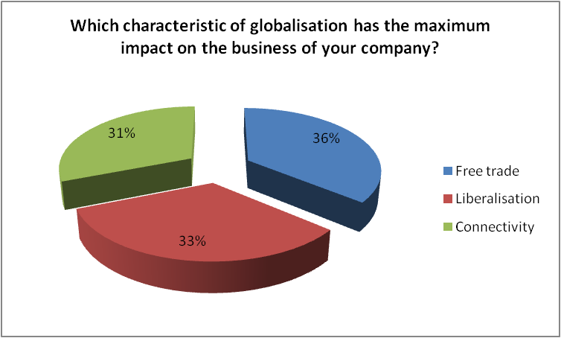
Figure No 4: Which characteristic of globalisation has the maximum impact on the business of your company?
(Source: Created by the learner)
5. Do you think small businesses would be better off if there was no globalisation?
Responses | No of responses | Total number of responses | Percentage
Yes | 03 | 30 | 10%
No | 25 | 30 | 83%
Not sure | 02 | 30 | 7%
Table No 5: Do you think small businesses would be better off if there was no globalisation?
(Source: Created by the learner)
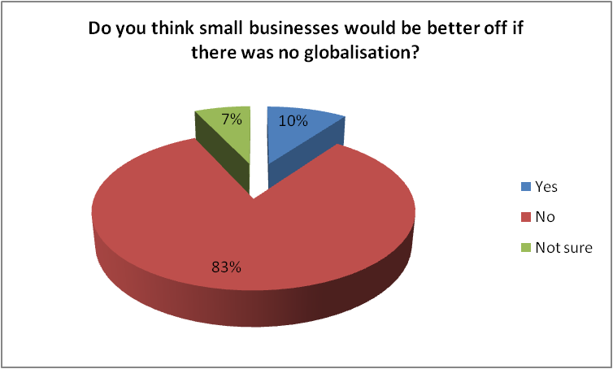
Figure No 5: Do you think small businesses would be better off if there was no globalisation?
(Source: Created by the learner)
6. Do you think that your company often has to face some disadvantages brought upon by globalisation?
Responses | No of responses | Total number of responses | Percentage
Yes | 13 | 30 | 43%
No | 10 | 30 | 33%
Not sure | 07 | 30 | 24%
Table No 6: Do you think that your company often has to face some disadvantages brought upon by globalisation?
(Source: Created by the learner)
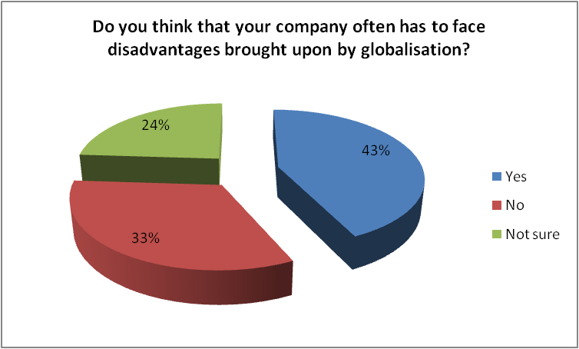
Figure No 6: Do you think that your company often has to face some disadvantages brought upon by globalisation?
(Source: Created by the learner)
7. Which is the major disadvantage that your business faces due to globalisation?
Responses | No of responses | Total number of responses | Percentage
Increased competition | 17 | 30 | 56%
Disproportionate growth | 07 | 30 | 23%
Environmental concerns | 06 | 30 | 21%
Table No 7:Which is the major disadvantage that your business faces due to globalisation?
(Source: Created by the learner)

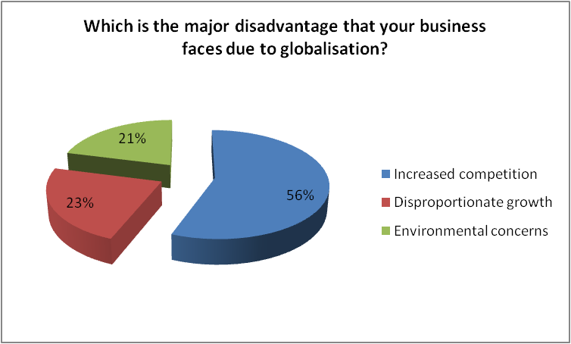
Figure No 7:Which is the major disadvantage that your business faces due to globalisation?
(Source: Created by the learner)
8. Which phase do you prefer more for doing business?
Responses | No of responses | Total number of responses | Percentage
Pre-globalisation | 07 | 30 | 23%
Post-globalisation | 20 | 30 | 67%
No sure | 03 | 30 | 10%
Table No: Which phase do you prefer more for doing business?
(Source: Created by the learner)

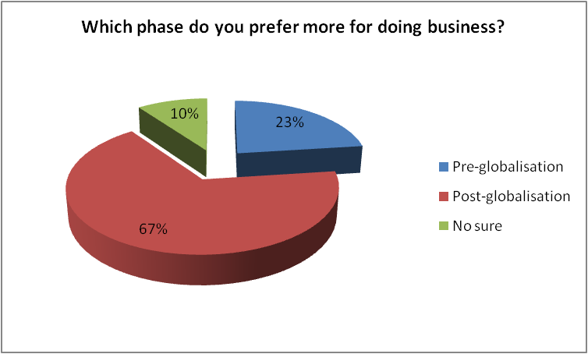
Figure No 8: Which phase do you prefer more for doing business?
(Source: Created by the learner)
9. What will you consider globalisation for the operations that your organisation will be undertaking in the future?
Responses | No of responses | Total number of responses | Percentage
Opportunity | 18 | 30 | 60%
Threat | 07 | 30 | 24%
Not sure | 05 | 30 | 16%
Table No 9: What will you consider globalisation for the operations that your organisation will be undertaking in the future?
(Source: Created by the learner)
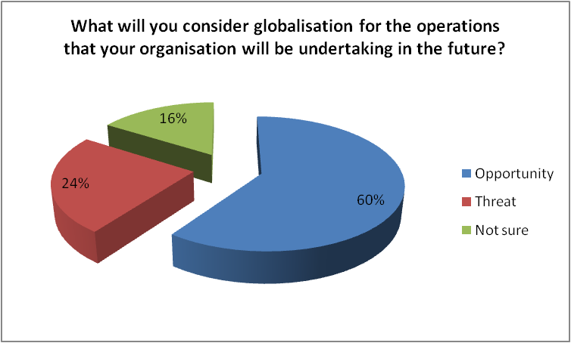
Figure No 9: What will you consider globalisation for the operations that your organisation will be undertaking in the future?
(Source: Created by the learner)
10. In the context of globalisation do you concur it provides more benefits than disadvantages to small business entities?
Responses | No of responses | Total number of responses | Percentage
Yes | 18 | 30 | 60%
No | 07 | 30 | 24%
Not sure | 05 | 30 | 16%
Table No 10: In the context of globalisation do you concur it provides more benefits than disadvantages to small business entities?
(Source: Created by the learner)
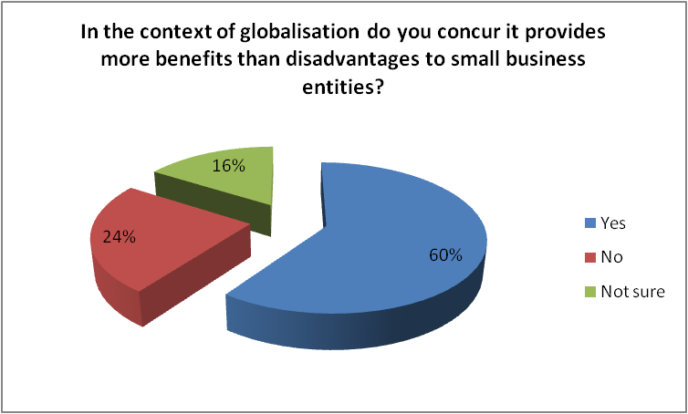
Figure No 10: In the context of globalisation do you concur it provides more benefits than disadvantages to small business entities?
(Source: Created by the learner)

Discussion
The first question of the survey intended to find out the familiarity of the research participants with globalisation. It was intended to find out that the participants are familiar with it so that findings of the survey are effective. It has been found that 93% of the research participants are familiar with it and its impact in their business. While the remaining 7% of the participants were not familiar with it. Hence, it was found that the majority of participants had proper understanding of globalisation and its impact over an organisation. The second question of the research mainly intended to find out how globalisation impacts the modern small businesses. It was found that 66% of the research participants said that it has impacted the small businesses positively. 24% among the research participants said that globalisation has impacted the small businesses in a negative manner. 10% of the participants were not sure whether the impact had been impacted positively or negatively. Hence, based on the majority of responses it is clear that globalisation has a positive impact on small businesses. As found in the literature review, small businesses have been successful in gaining a bigger customer base which allows a business to make higher profitability. Moreover, improved connectivity and free trades across the international borders due to globalisation have impacted small businesses in a positive manner.
Third question of the research was to find out the areas of small businesses which face major impacts which are brought upon by globalisation. 50% of the research participants said that the globalisation has an impact on the overall business of small businesses. 26% of the participants said that investment that businesses do in different projects have been impacted. While 24% of remaining participants said that technology development is the major area of small business which has been impacted by globalisation. Hence, based on the majority of the responses, the overall business of small businesses have been impacted due to the impact that is brought upon by globalisation. It refers to the choice of marketing, trading, sales and all other aspects of business that are impacted due to the impact of globalisation.
The fourth question which was upon the research participants was to find out the characteristic of globalisation which has maximum impact on small businesses. 36% of the participants said that free trade across international borders is one of the factors which has maximum impact. 33% of the participants said that liberalisation is the factor of globalisation that has the maximum impact. While the remaining 31% said that connectivity that has been brought around the world due to globalisation has maximum impact on globalisation. Based on the majority of responses, it is clear that all three factors have a major impact on the business. However, maximum impact has been brought upon by free trade policy.
The fifth question that was placed upon the research participants was to find out if small businesses would be better off if there would have been no globalisation. 83% of the research participants said that small would not have been better if there would have been no globalisation. Only 10% of the participants said that small business would have been if there would have been no globalisation. While the rest, 7% of the participants were not sure whether it has a positive or negative impact. It has also been found through literature review that globalisation has both positive as well as negative impact. The positive impact mainly includes free trades across the border, better connectivity across the world and so on. It also has negative impacts like increased competition due to globalisation. However, the survey found out that there are more positive impacts as the majority of participants said that the small business would not be better off without globalisation.
The sixth question that is related to the survey mainly focused on finding out if small businesses faced some of the disadvantages of globalisation. In response to this question, 43% of the participants said that there are some disadvantages of globalisation which the company has to face. While 33% of research participants said that their organisation does not face any type of disadvantages in business due to globalisation. While 24% of the research participants said that they are not sure whether their business has faced disadvantages which are brought upon by globalisation. The majority of the responses clearly suggested that there are some disadvantages of globalisation which small businesses need to face.
The next question in the research was mainly focused on finding out the most noticeable disadvantages that a business faces due to globalisation. 56% of the participants taking part in the research said that increased competition that small businesses face due to globalisation is the major disadvantage. 23% of the research participants said that disproportionate growth that a business faces is another major disadvantage of globalisation on small businesses. While increased environmental concerns is another major disadvantage that is brought upon small businesses by globalisation. The majority of responses indicated increased competition due to globalisation putting small businesses in the major disadvantage. It is clear that small businesses are benefited by globalisation by providing a bigger market. However, when the size of the market increases then the competition with it also increases.
The eighth question of the survey focused on finding out whether the research participants preferred to work in the pre-globalisation and post-globalisation phase. 23% of the participants who are the small business owners said that they prefer to work more in the pre-globalisation phase. While 67% of the participants taking part in the research said that they would prefer more to work in the current phase that is the post-globalisation phase. While just 10% of the research participants said that they do not have proper understanding regarding which phase they prefer more. Hence, maximum participants said that they would prefer to work in the post-globalisation phase which clearly shows that it has more advantages as compared to disadvantages.
The ninth question of this question of the research mainly intended to find out whether globalisation is a threat or opportunity for businesses in the future. To answer this 60% of the research participants said that they see globalisation as an opportunity. While only 24% of the research participants said that they see globalisation as a threat to the operations that business will be conducting in the future. The last 16% of the research participants said that they are not sure whether it is a threat or an opportunity. Hence, based on the number of responses, it is quite clear that most of the small businesses see globalisation as an opportunity for their business.
The final question of the research mainly intended to find out whether or not globalisation provides higher benefits as compared to disadvantages. In response to the question, it was found that 60% of the research participants said that they believe that globalisation has higher benefits as compared to the disadvantages. 24% research participants said that disadvantage of globalisation is higher as compared to its benefits. Last 16% of research participants said that they are not sure whether globalisation has higher benefits or disadvantages in the case of small business entities. Hence, depending upon the majority of the responses provided by the research participants, it is clear that globalisation offers small businesses with higher benefits as compared to disadvantages.

“Chapter 4: Conclusion and recommendations”
The research has been based on the topic “impact of globalisation on small businesses”. Firstly, a brief brief background of the topic has been provided and rationale has been determined. The proper aims and objectives of the research have been set and the focus of the research has been based on fulfilling the objectives. A comprehensive literature review has been provided on the selected topic for the research. Further, focus has been based on selecting appropriate methodology which has allowed the researcher to achieve desired results. Primary methods of data collection have been selected for collecting data for this research. The tools used for data collection have been questionnaires. The size of the sample for the research has been 30 owners of small businesses. The ethical consideration that the researcher will be making while conducting the research have been determined. It has clearly been stated that the data for the research has been collected and analysed while strictly following Data Protection Act 2018. Further, the research strategy, approach and all other factors have been determined in the methodology discussion section.
Further, a proper survey with 10 questions has been conducted. It has been found that small businesses have been impacted in both positive and negative manner. However, based on the findings of this research, it is clear that small businesses have been impacted in a positive manner due to globalisation.
With the comprehensive assessment of the aspect of small business entities it can be effectively enumerated that globalisation relatively helps in developing the overall aspect of the business much more effectively. However, for a business to effectively develop its base of consumers it must consider understanding its approach to globalisation and what are the aspects it can consider effectively following. In the aspect of small business entities the companies and business entities of the similar nature must consider effectively utilising the labour forces and utilising effective funding opportunities to attract more opportunities of business. Along with this the business must also consider underpinning the differential activities and implement equilateral strategies to recommend the overall growth and development of the business much more effectively. In the manner of growth and controlled business activities the small business must consider marketing their products and services much more effectively and ensure higher operational advantage within the present space of the market much more effectively. With the comprehensive assessment of the overall aspect of globalisation it can be effectively apprehended that significant utilisation of cumulative measures helps in contemplating the aspect of growth much more effectively and ensure a higher proportionate objective of growth much more evidently.

References
Akpan, I.J., Udoh, E.A.P. and Adebisi, B., 2022. Small business awareness and adoption of state-of-the-art technologies in emerging and developing markets, and lessons from the COVID-19 pandemic. Journal of Small Business & Entrepreneurship, 34(2), pp.123-140.
Arifin, S.R.M., 2018. Ethical considerations in qualitative study. International Journal of Care Scholars, 1(2), pp.30-33.
Bauweraerts, J., Arzubiaga, U. and Diaz-Moriana, V., 2022. Unveiling the global focus-performance relationship in family firms: the role of the board of directors. International Business Review, p.101977.
Calabrò, A., Chrisman, J.J. and Kano, L., 2022. Family-owned multinational enterprises in the post-pandemic global economy. Journal of International Business Studies, pp.1-16.
Coulibaly, S.K., Erbao, C. and Mekongcho, T.M., 2018. Economic globalization, entrepreneurship, and development. Technological Forecasting and Social Change, 127, pp.271-280.
Cr, K., 2020. Research methodology methods and techniques.
Daniel, B.K., 2018. Empirical verification of the “TACT” framework for teaching rigour in qualitative research methodology. Qualitative Research Journal.
Farnsworth, K. and O’Brien, R., 2022. Business, labour and global social policy. In Understanding Global Social Policy (pp. 67-88). Policy Press.
French, S., 2018. Between globalisation and Brexit: Migration, pay and the road to modern slavery in the UK hospitality industry. Research in Hospitality Management, 8(1), pp.23-31.
Gorynia, M., 2019. Competition and globalisation in economic sciences. Selected aspects. Economics and Business Review, 5(3).
Grose, R. and Imam, T., 2022. The tale of a failed small business. Regional Businesses in a Changing Global Economy: The Australian Experience, pp.164-177.
Hall, C.M., 2019. Biological invasion, biosecurity, tourism, and globalisation. In Handbook of globalisation and tourism. Edward Elgar Publishing.
Hourvouliades, N.L., 2022. Financing Small Businesses: The Agony of Securing Funding. In Small Business Management and Control of the Uncertain External Environment. Emerald Publishing Limited.
Hughes, M. and Barlo, S., 2021. Yarning with country: An indigenist research methodology. Qualitative Inquiry, 27(3-4), pp.353-363.
Kavitha, H. and Gopinath, R., 2022. Role of Commercial Banks Financing and Explaining towards the Small-Scale Firms in Tamil Nadu: An Empirical Investigation of Entrepreneur’s Perspectives.
Liñán, F., Paul, J. and Fayolle, A., 2020. SMEs and entrepreneurship in the era of globalization: advances and theoretical approaches. Small Business Economics, 55(3), pp.695-703.
Lund, S. and Tyson, L., 2018. Globalization is not in Retreat: Digital Technology and the Future of Trade. Foreign Affairs, 97(3), pp.130-140.
Oliva, R., 2019. Intervention as a research strategy. Journal of Operations Management, 65(7), pp.710-724.
Pyakurel, P., 2022. Rethinking an Approach for Sustainable Globalization. In Globalization and Sustainability: Recent Advances, New Perspectives and Emerging Issues. InTechOpen.
Qin, Y., Wang, X., Xu, Z. and Skare, M., 2022. The effects of globalization on family firms' business model in Europe. International Journal of Entrepreneurial Behavior & Research.
Roy, R. and Uekusa, S., 2020. Collaborative autoethnography:“Self-reflection” as a timely alternative research approach during the global pandemic. Qualitative Research Journal.
Sobratee, N. and Bodhanya, S., 2018. Leading in a global context: The balancing act between leadership and management. Journal of Business and Retail Management Research, 12(4).
Sultana, N., Rahman, M.M. and Khanam, R., 2022. The effect of the informal sector on sustainable development: Evidence from developing countries. Business Strategy & Development.
Teague, M.V., 2022. Barriers to entry: an empirical account of business creation difficulties in the United States 2011. Journal of Entrepreneurship and Public Policy, (ahead-of-print).
Van Binh, T., 2022. THE IMPACT OF INFORMATION TECHNOLOGY IN ENHANCING COMPETITIVE CAPABILITY OF YOUNG ENTREPRENEURS. Academy of Entrepreneurship Journal, 28, pp.1-6.
Willmott, H., 2020. On research methodology. The Journal of Organization and Discourse, 1(1), pp.1-4.
Yayeh, F.A., 2021. Focus Group Discussion as a data collection tool in Economics. Daagu International Journal of Basic & Applied Research-DIJBAR. Volume3, Issue-1, pp (52-61).
Zajda, J.I. and Majhanovich, S. eds., 2021. Globalisation, cultural identity and nation-building: The changing paradigms. Dordrecht: Springer.
Žukauskas, P., Vveinhardt, J. and Andriukaitienė, R., 2018. Philosophy and paradigm of scientific research. Management culture and corporate social responsibility, 121.

