

Development across the lifespan

Does ASD have and impact on social development


1 - children in a circle (Mums in the Wood, 2015)
“Autistic children find even the immediate social environment unpredictable and incomprehensible” (Baron-Cohen et al., 1985, p. 38)
What is ASD?
Autism spectrum disorder is a neurodevelopmental disorder that does not depend on gender, age or ethnicity. ASD is often characterised by differences in social communication and interaction as well as repetitive or restricted patterns of behaviour. Every person with ASD has different strengths and challenges.
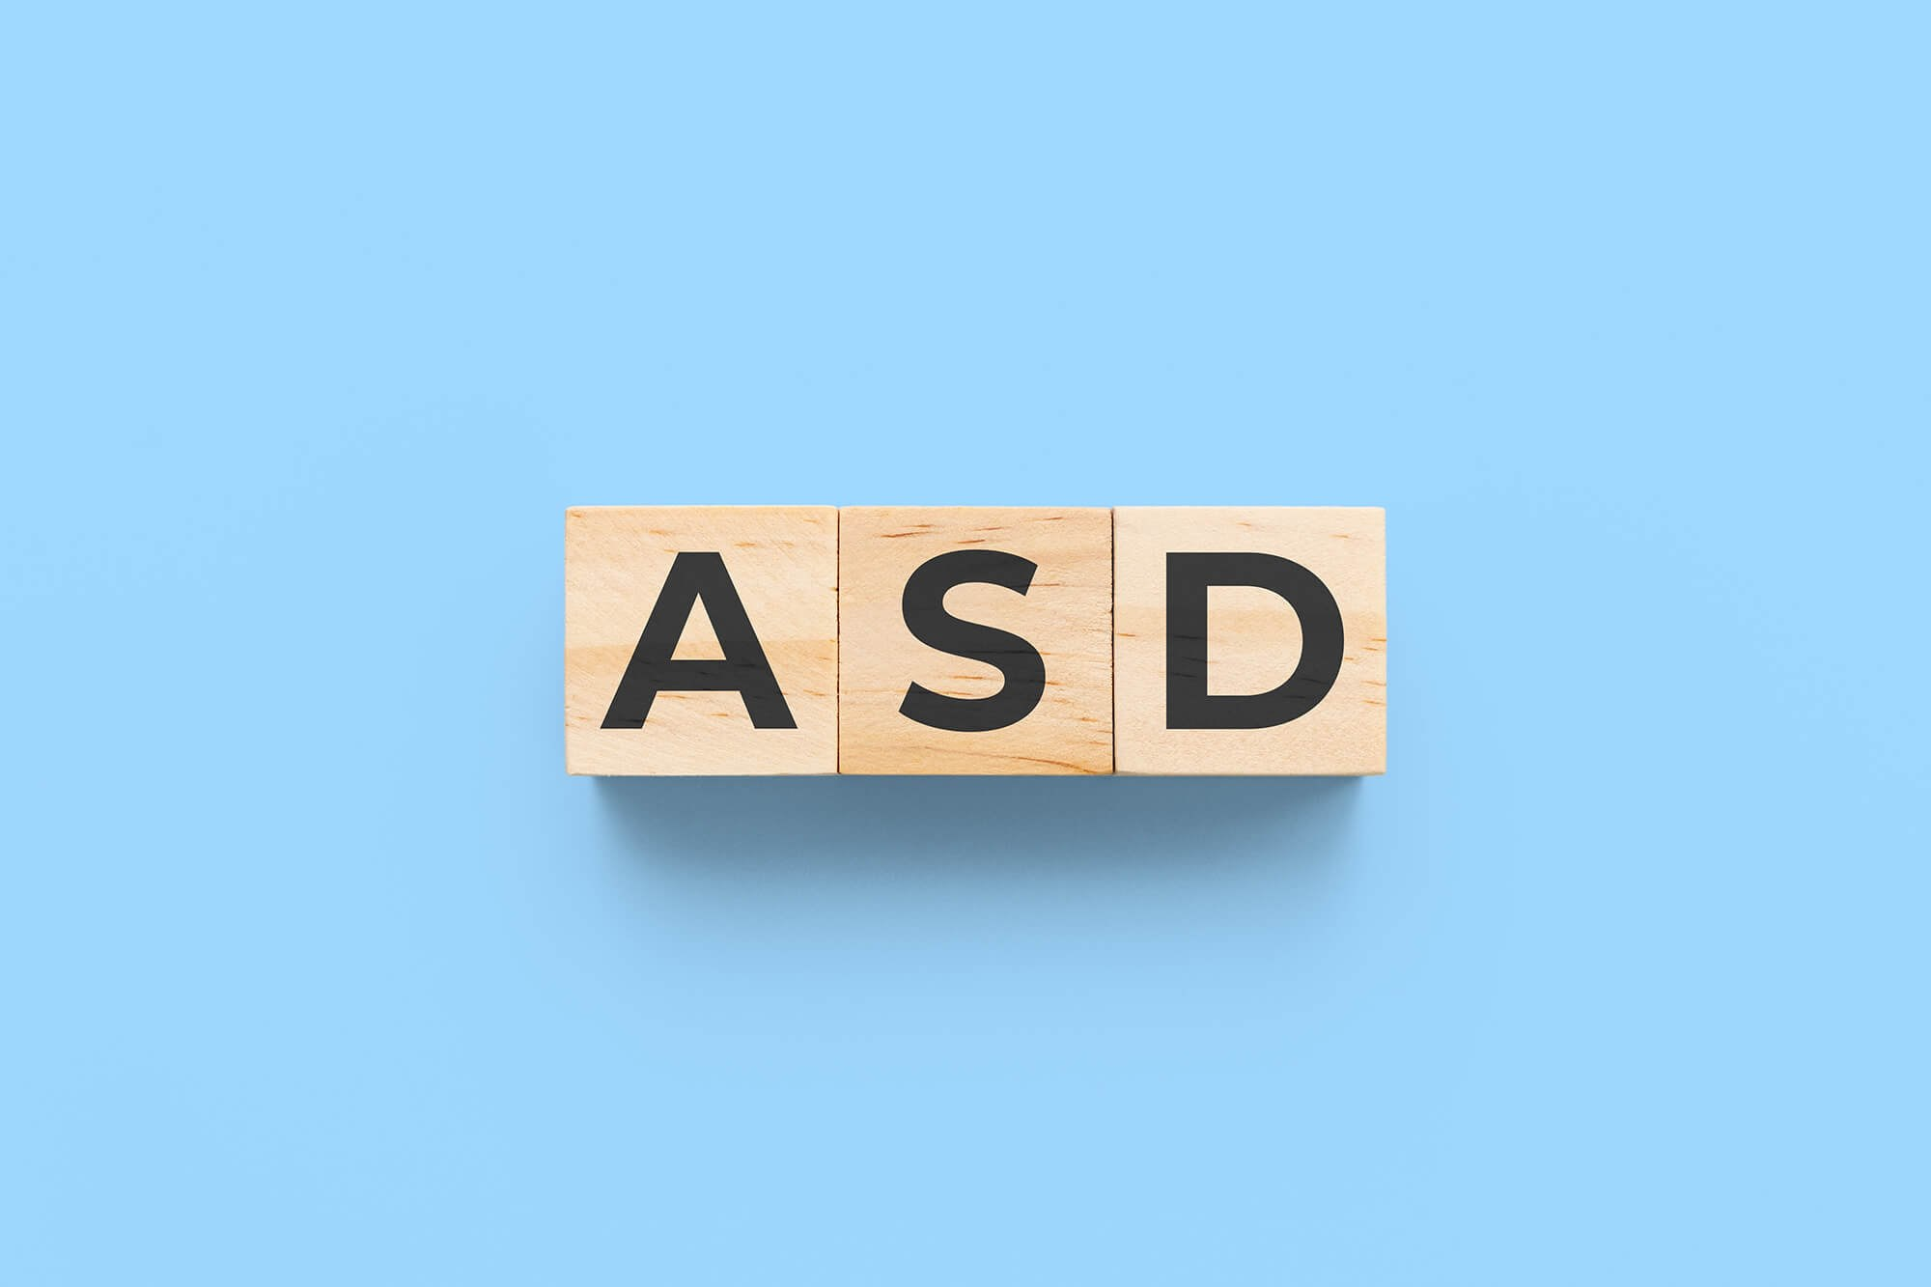
From my own experience of volunteering in primary school classrooms, I have noticed that children who are diagnosed with autism spectrum disorder (ASD) often engage in social situations differently from others. During a period of practical placement in a Reception class, I noticed that one child diagnosed with ASD frequently avoided social interactions and preferred solitary play. The child rarely participated in group activities and appeared more comfortable engaging independently rather than collaboratively with classmates. The child did however demonstrate a strong interest in animals and would engage with books about animals or animal figurines. The child showed interest in singing songs that incorporated animals such as Hickory, Dickory Dock, and other nursery rhymes.
What is social development?
Social development is the ability to:
- Engage in two-way conversations and interactions
- Develop and express empathy
- Form friendships with peers
- Regulate behaviour in social contexts
- Comprehend both verbal and non-verbal forms of communication
These abilities emerge rapidly during the early years and are influenced by neurological growth as well as environmental input.

2 - Application of learning theories in the workplace graphic (Echo360, 2022).
Theory of Mind
The Theory of Mind (ToM), developed by Simon Baron-Cohen, Uta Frith, and Alan Leslie, is the ability to:
- Recognise that others have their own thoughts and feelings
- Understand that other people have different beliefs
- Understand that people may sometimes act on what they believe not necessarily on what is true
- Interpret emotions, intentions and perspectives
Simply, it means having the ability to understand what others are thinking or feeling.

When does theory of mind usually develop?
- Around age 2–3: children begin understanding simple emotions.
- Around age 4–5: most children pass false-belief tasks.
- They begin predicting behaviour based on what someone thinks, not what is actually true.
A way of checking if a child would pass a false-belief task, a Sally- Anne task, which consisted of a child watching a scenario between two dolls was carried out. The idea behind this task was to see whether a child could put themselves into an another person’s perspective. During this experiment many ASD children struggled with understanding the task and other people’s point of view.
This video explains how the Sally-Anne test works: https://www.youtube.com/watch?v=jbL34F81Rz0

How does the theory link to ASD?
This theory mentions how people with ASD may experience a delay or differences in:
- Perspective taking
- Understanding facial expressions and body language
- Understanding jokes and sarcasm
- Recognising hidden intentions

Social interactions for people with ASD may feel unpredictable, confusing and mentally draining.
Why is this theory important for social development?
Social development relies significantly on a child’s ability to engage in reciprocal interaction, demonstrate empathy, interpret social cues, and adapt their behaviour according to the social situation. These skills help children to manage relationships and participate effectively in shared activities.
When Theory of Mind develops differently or is delayed, it can affect peer relationships, collaborative play, classroom participation, and the ability to manage interpersonal conflicts. Theory of Mind is a key cognitive framework for explaining and helping understand aspects of the Autism Spectrum Disorder.
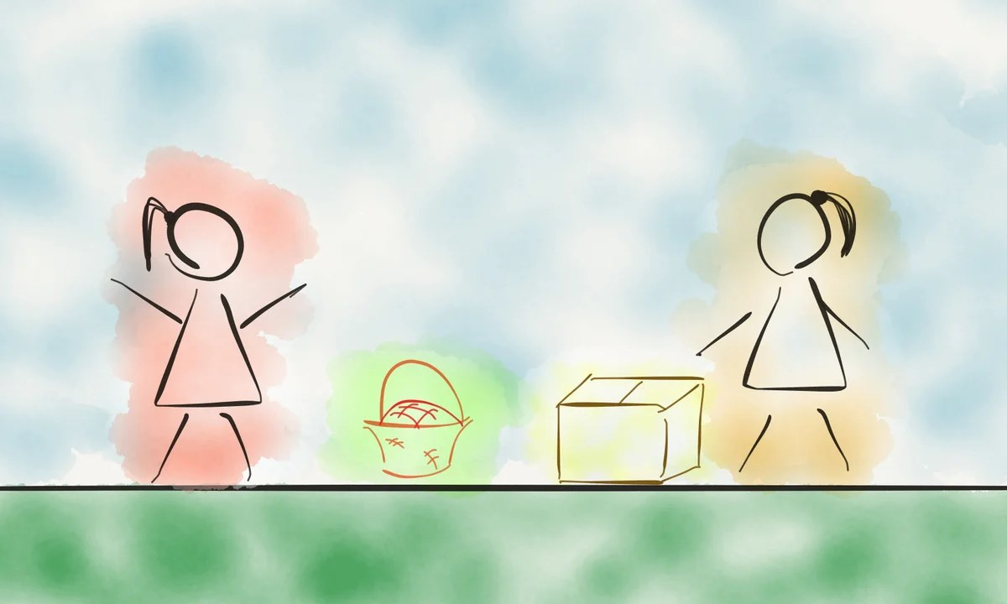
3 - The Sally‑Anne test scenario (Etchells, 2017).
Central Coherence
Uta Frith was a psychologist who shared a theory (1989) that people with ASD may have a weak central coherence. Central coherence is the ability to process separate pieces of information into a whole picture. Having a strong coherence means having the ability to put information into whole, instead of focusing on every detail separately. People with a weaker coherence focus on minor details that people with a stronger coherence might miss. This may cause difficulties in noticing or communicating important information and in understanding certain types of humour. It could also cause busy areas to seem overwhelming and overstimulating for people with a weaker coherence. A reason why people with ASD often take language literally is because they take every word individually, instead of joining it as a whole to understand the overall context of the conversation. This theory helps briefly understand why people with autism may have a greater skill or strength. A weaker coherence makes them look at the small details instead of getting distracted by the whole picture which provides an opportunity to investigate the little details in depth.
Comparison
Theory of Mind and Central Coherence are related, and Uta Frith researched both. A common observation is that children with ASD often struggle to understand jokes, humour, and sarcasm. According to Central Coherence Theory, this is due to their weak coherence.
How can practitioners provide support?
ASD appear differently in each individual, so it can be challenging for practitioners to support a child with ASD. However, there are strategies they can try and adjust as needed.
Communication with a child who is more detailed than context orientated needs to be clear and without hidden meanings, broken into smaller chunks to ensure its clarity.
There are strategies that can help the child, but practitioners must follow regulations such as Additional Learning Needs and Education Tribunal Act 2018 and the UNCRC. The ALN act mentions how autism is recognised as an ALN and requires tailored support such as an Individual Learning Plan (IDP) which helps identify what support is needed and how to provide it. Child-centred learning ensures that children receive the support they need to develop social skills, such as communication and understanding social cues.
In the UNCRC Article 23 mentions how children with a disability have the right to an education, individually tailored support and social inclusion.
Mental health and well being
Anxiety is also significantly more prevalent among autistic children (White et al., 2009, p.227), which can further restrict social participation. ‘Being bullied because of disability, race, sex, gender identity, or sexual orientation could also constitute discrimination under the Equality Act 2010’ (Anti-Bullying Alliance, 2023, p.5).

4 - Understanding brain health and mental well‑being (Canadian Mental Health Association, n.d.).
Conclusion
Researching the impacts of ASD on social development, provided me with insights into how someone with ASD thinks. Learning about Theory of Mind and Central Coherence helped me understand the wide range of characteristics. This highlights the importance of tailored support to help children with ASD thrive socially.

How Adverse Childhood Experiences (ACEs) affect emotional development?

5 - Emotions in Childhood: EmoChi project (University of Oxford, n.d.).
Emotional development during childhood is very important as it forms the foundation for future interpersonal relationships, educational performance and generally mental health. However, adverse childhood experiences ACEs) can significantly affect this process. ACEs refer to stressful or traumatic experiences that occur before the age of 18, such as abuse, neglect, or houshold dysfunction.
Feletti et al. (1998) recognised ACEs as major public health concern because fo their long term psychological and physiological consequences.
This blog explores how ACEs impact emotional development, drawing on attachment theory, neurobiological reasearch and trauma- informed approach. It suggests that while adverse childhood experiences increase the risk of negative developmental outcomes, protective relationships and early interventions play a crucial moderating role.
Defining ACEs
Feletti et al. In their 1998 study identified several categories of adversity, such as:
- physical, emotional and sexual abuse
- physical and emotional neglect
- domestic violence
- substance misuse in the household
- parental separation
- mental illness
- Imprisoment
The study shows how the ACEs can increase the risk of future mental health disorders, cardiovascular disease or substance misuse. What is important this study moved from adversity being treated as isolated incidents to cumulative developmental risk. Hughes et al. (2017) confirm that those with 4 0r more ACEs are more likely to experience depression, anxiety or behavioural difficulties. Therefore emotional development is not only influenced by trauma, but by accumulation of stress exposure.
A family member of mine was abandoned by their father during childhood. He left suddenly, leaving the mother and two children with significant debt. This happened without any explanation, apart for a brief indication that he might need to leave in the near future, and the following day he was gone. Soon after his disappearance, some individuals began visiting the family home asking for repayment of the money they were owed. This created the atmosphere of fear and instability. The child became anxious about these visits and to protect their mother, learnt how to lie that she was not at home. The family was eventually supported by grandparents who provided financial support and stability for the children by welcoming them to their home to live with them. However, it has already emotionally impacted the child. The child experienced feelings of shame related to their father’s absence and found it difficult to talk about their father. They were often distressed and avoided the topic altogether. This experience affected their emotional sensitivity and anxiety. It took many years before they were able to speak about it, even with people close to them, that they fully trusted.
6 - Application of learning theories in the workplace graphic (Echo360, 2022).
Attachment Theory and Emotional Regulation
Bowlby’s attachment theory explained in Psychology Exposed online video shows how adverse childhood experiences affect emotional development. In this video it was mentioned that Bowlby thought that safe attachment relationships help children to develop models of safety, trust and self-esteem. When caregiving is inconsistent, frightening or neglectful, children may develop insecure or disorganised attachment styles. Children who were exposed to abuse or domestic instability often show malfunctioning attachment behaviours. These children may display impaired development of emotional regulation skills due to the fear towards their caregivers.
Secure attachment supports:
- emotional co-regulation
- development of empathy
- stress recovery
- positive self-concept
When such experiences are not present during childhood, children may display emotional withdrawal or difficulty identifying their feelings. This is why ACEs can hinder emotional development by weakening the relationships that should provide stability, safety and guidance.
Neurological Impact of Chronic Stress
Apart from Attachment Theory, neuroscience gives us further insight. Shonkoff et al. (2012) describe ‘toxic stress’ as extended activation of response to stress without sufficient support from trusted adults. This chronic stress activation raises cortisol levels, which can affect brain areas responsible for emotional processing, such as:
- amygdala - detects stress
- hippocampus - manages memory and emotions
- prefrontal cortex - controls impulses and regulates emotions
Over the time it can lead to emotional dysregulation or problems with managing frustration. What is important, the changes are not irreversible. Shonkoff et al. (2012) points out theat brain neuroplasticity allows restoration when children have nurturing and supportive relationships.

7 - Emotional regulation graphic (Accelerated Resolution Therapy, 2026).
Emotional Regulation and Behavioural Expression
Children who were exposed to adverse childhood experiences may show:
- aggression
- emotional outbursts
- withdrawal
- anxiety
- low tolerance
Such reactions might be interpreted as defiance instead of dysregulated responses to stress. According to Cook et al. (2005) children exposed to trauma often display difficulties with emotion management and self regulation. Recognising behaviours as communication is crucial to understanding a child's emotional needs and responding effectively.
Resilience and Protective Factors
Even though adverse childhood experiences increase the risk of negative outcomes, they do not define a child's future. Masten (2014) defines resilience as ‘ordinary magic’ that grows from stable supportive relationships and consistent environments.
Protective factors consist of:
- a trusted adult relationship
- predictable routines
- school belonging
- emotional literacy teaching
- access to mental health support
These protective factors can reduce the influence of adversity and help with healthier emotional development. Supporting children through stable relationships and predictable environments is not only protective but also a recognition of their rights under the UNCRC (1989), which includes the right to grow up in safety and with access to appropriate care.
Implications for Early Years and Primary Practice
It is important for the practitioners working with children to identify trauma and provide support to these children. Examples of responsive approaches include:
- Emotion coaching
- Safe and predictable environments
- Co-regulation strategies
- Strength-based language
- Constructive behavioural interventions
Additional Learning Needs and Education Tribunal (Wales) Act 2018 highlights importance of child-centered planning . Importantly, trauma-informed practice must avoid labelling children as ‘damaged’, it should instead, promote emotional recovery through trusted relationships.
Critical Reflection
The ACE framework has been widely used but yet not without being criticised. Many studies rely on adults recalling childhood experiences, which may lead to inaccurate reports (Hughes et al., 2017).
Evidence from attachment theory, neuroscience and long term studies proves that early adversity has a significant impact on shaping emotional development. This is why the key strategic consideration is not only understanding ACEs but mostly implementing relational and restorative approaches in practice.
Conclusion
Adverse Childhood Experiences strongly shape emotional development by disrupting attachment, causing chronic stress and impairing emotion regulation. However the outcomes are not inevitable. Supportive relationships with trusted adult and trauma-aware educational environments can reduse long-term harm. For practitioners, the focus should move from managing behaviour to understanding emotions. Emotional regulation develops through trusted relationships, this is why early intervention is not only supportive but can prevent future difficulties.

How Poverty Affects Cognitive Development in early Childhood
Poverty Facts (figures from 2023-2024)
- About 14.2 million people in the UK, roughly 21 % of the population were living in poverty (after housing costs).
- 4.5 million, about 31 % of all children in UK were in poverty
- Poverty is especially high for example in families with three or more children families at about 44 %.

8 - Cognitive development icon (Flaticon, 2026).
What is cognitive development?
It refers to growth of thinking, memory, reasoning, problem solving skills or attention. These abilities develop quickly during childhood and are sensitive to environmental conditions. Socioeconomic disadvantage is linked to differences in thinking and learning, but poverty does not directly control how the brain develops. It affects instead the environments that either help or limit cognitive growth.
This blog investigates how poverty influences cognitive development through environmental stimulation, access to education or stress exposure. It discusses how socioeconomic disadvantage can increase developmental risks, while supportive relationships and access to education can help protect and improve outcomes.
Understanding Cognitive Development
Piaget (1952) described cognitive development as progressing through stages, where symbolic thinking and problem-solving rapidly grow during early childhood. Later, in 1978 Vygotsky highlighted the role of social interaction and supporting in learning and thinking development. Scientifically cognitive growth is both biologically prepared and environmentally shaped.
Socioeconomic Status and Cognitive Outcomes
Long-term studies demonstrate consistent link between socioeconomic status (SES) and cognitive performance. Noble, McCandliss and Farah (2007) found that children from lower-income families scored lower on language, memory and executive functioning tests, with the differences growing steadily as the household income decreased.
Similarly, Hair et al. (2015) showed that childhood poverty was associated with lower academic achievement and changes in brain areas which are involved in executive function and self-regulation. These findings suggest that early socioeconomic conditions can influence neurocognitive development.
But these outcomes are not predetermined, supportive environments can make a difference in outcomes.
Executive Functioning and Self-regulation
Executive functions are crucial in readiness for school and academic success. Blair and Raver (2012) suggest that children exposed to poverty often experience higher stress level that affects their development and executive functioning. Prolonged stress provoked body to activate stres-response systems. Chronic cortisol exposure can affect the prefrontal cortex, the area of brain that is responsible for higher cognitive control (Shonkoff et al. 2012). it can result in children demonstrating difficulties with attention, diligence and impulse control. In school setting this might be taken as lack of effort rather than how nervous system adapts to stress.
Environmental Stimulation and Cognitive Enrichment
Cognitive development is shaped by influence of environment. Access to educational experiences, structured play, adult-child dialogue or books can impact neural connectivity and conceptual understanding.
Bradley and Corwyn (2002) identified that children from lower income households have access to fewer learning materials and resources which reduced their exposure to cognitively stimulating activities. However, this is not a reflection of parental deficit; rather, structural limitations such as long working hours, financial insecurity, and limited childcare limit opportunities.
Vygotsky’s theory of the Zone of Proximal Development suggests that cognitive skills develop with structured support. When adults are restricted by socioeconomic pressures, opportunities for guidance may decrease but are not missing.
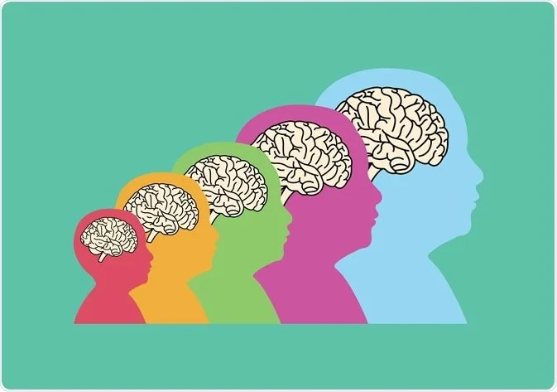
9 - Brain development overview graphic (Neurodevelopment, 2026).
Neuroplasticity and early Brain Development
Early childhood is the time when brain is adaptable. Neural pathways responsible for reasoning, attention and memory grow stronger through repeated activation. Hair et al. (2015) found that poverty related stress and deprivation were associated with differences in brain regions involved in executive control.
However, Shonkoff et al. (2012) emphasise that supportive relationships can reduce the effects of adversity. The resilience research suggests that one stable, caring and responsive adult can strongly protect developmental outcomes.
Poverty may influence the risk of cognitive difficulties, but it does not determine a child’s outcome.
Educational Implications
Cognitive differences linked to poverty may appear as:
- reduced working memory capacity
- shorter attention span
- slower processing speed
- difficulty with problem solving tasks
Without support these differences may increase achievement gaps throughout primary education. High quality early years provision can help reduce the effects of socioeconomic disadvantage. Melhuish at al. (2015) in Effective Pre-school, Primary and Secondary Education study found that sustained early education significantly improved cognitive outcomes for children from disadvantaged backgrounds.
Education policy reflects this evidence. The Curriculum for Wales highlights the development of thinking and problem solving skills across all Areas of Learning and Experiences, proving that cognitive development is a core aim.
Critical Reflection
Research shows strong links between poverty and cognitive development, but focusing on families alone oversimplifies the deeper systemic issues. Socioeconomic status (SES) includes income, parental education, housing stability and also neighbourhood safety. All of these factors contribute to shaping developmental ecology (Bronfenbrenner, 1979).
What is more, cognitive assessments are often culturally biased, often valuing certain types of knowledge over others. Practitioners must reflect on whose abilities are being measured and valued. The evidence shows that poverty can affect cognitive development through:
- Chronic exposure to stress
- Fewer stimulating learning opportunities
- Limited access to learning interventions
However, the brain’s ability to adapt and strong, supportive relationships can act as powerful, protective mechanisms.
Conclusion
Poverty considerably influences cognitive development in early childhood, especially problem solving skills, attention and executive functioning. These effects are shaped by stress, access to stimulating environments, and social inequalities, rather than by inherent ability.
Significantly, cognitive development remains adaptable. Excellent early years provision, trusted adult relationship and stimulating learning environment can considerably reduce socioeconomic inequalities. Practitioners should focus not only on improvement but on creating safe, stimulating environments that reduce the impact of structural disadvantage.

Reference list
Accelerated Resolution Therapy (2026) Improving emotional regulation graphic [Image]. Available at: https://acceleratedresolutiontherapy.com/how-can-you-improve-your-emotional-regulation/ (Accessed: 29 February 2026).
Anti-Bullying Alliance (2023)Autism and bullying guide . Available at:https://anti-bullyingalliance.org.uk/sites/default/files/uploads/attachments/Autism%20and%20bullying%20guide%202023_FINAL.pdf (Accessed: 28 February 2026).
Baron-Cohen S, et.al.(1985)‘Does the autistic child have a “theory of mind”?’, Cognition, 21(1), pp. 37–46. Available at: https://s3.eu-west-1.amazonaws.com/docs.autismresearchcentre.com/papers/1985_BC_etal_ASChildTheoryOfMind.pdf (Accessed: 28 February 2026).
Bavertockpsychology(2016) Sally-Anne Test Explained for Children with Autism [YouTube video]. Available at: https://www.youtube.com/watch?v=jbL34F81Rz0 (Accessed: 27 February 2026).
Blair, C. and Raver, C.C. (2012) ‘Child development in the context of adversity: Experiential canalization of brain and behavior’, American Psychologist, 67(4), pp. 309–318. Available at: Child Development in the Context of Adversity
Bowlby, J. (1969) in Bowlby’s Attachment Theory Explained
Bradley, R.H. and Corwyn, R.F. (2002) ‘Socioeconomic status and child development’, Annual Review of Psychology, 53, pp. 371–399. Available at: (PDF) Socioeconomic Status and Child Development
British Psychological Society (2008) Theories of the autistic mind. Available at: https://www.bps.org.uk/psychologist/theories-autistic-mind (Accessed: 28 February 2026).
Canadian Mental Health Association (2023) Understanding brain health and its connection to mental well‑being graphic [Image]. Available at: https://cmha.ca/news/understanding-brain-health-and-its-connection-to-mental-well-being/ (Accessed: 29 February 2026).
Cook, A. et al. (2005) ‘Complex trauma in children and adolescents’, Psychiatric Annals, 35(5), pp. 390–398.(PDF) Complex Trauma in Children and Adolescents
Diverse Diagnostics (n.d.) Understanding autism spectrum disorder (ASD) in adult women. Available at: https://www.diversediagnostics.co.uk/understanding-autism-spectrum-disorder-asd-in-adult-women/ (Accessed: 28 February 2026).
Echo360 (2022) Application of learning theories in the workplace graphic [Image]. Available at: https://echo360.com/application-of-learning-theories-in-the-workplace/ (Accessed: 29 February 2026).
Etchells, P. (2017) The Sally Anne test uses scenarios involving two dolls, a marble, a basket and a box to assess false‑belief understanding, The Guardian [Image]. Available at: https://www.theguardian.com/science/head-quarters/2017/jan/23/sally-anne-task-psychological-experiment-post-truth-false-beliefs (Accessed: 29 February 2026)
Felitti, V.J. et al. (1998) ‘Relationship of childhood abuse and household dysfunction to many of the leading causes of death in adults’, American Journal of Preventive Medicine, 14(4), pp. 245–258. 10.1016/S0749-3797(98)00017-8 (Date accessed: 28 February 2026).
Flaticon (2026) Cognitive development icon [Image]. Available at: https://www.flaticon.com/free-icon/cognitive-development_18320969 (Accessed: 29 February 2026).
Francis-Devine B (2025) Autism spectrum disorder: prevalence, services and policy, House of Commons Library Research Briefing SN07096. Available at: https://researchbriefings.files.parliament.uk/documents/SN07096/SN07096.pdf (Accessed: 28 February 2026).
Freepik (2026) Light green background vector [Image]. Available at: https://www.freepik.com/free-photos-vectors/light-green-background (Accessed: 29 February 2026).
Gardening Express (2026) How plants grow graphic [Image]. Available at: https://help.gardeningexpress.co.uk/knowledge-base/module-10-how-plants-grow/ (Accessed: 29 February 2026).
Hair, N.L., Hanson, J.L., Wolfe, B.L. and Pollak, S.D. (2015) 'Association of child poverty, brain development, and academic achievement’, JAMA Pediatrics, 169(9), pp. 822–829. Available at: https://doi.org/10.1001/jamapediatrics.2015.1475
Hughes, K. et al. (2017).
‘The effect of multiple adverse childhood experiences on health: a systematic review and meta-analysis’, The Lancet Public Health, 2(8), pp. e356–e366.The effect of multiple adverse childhood experiences on health: a systematic review and meta-analysis (Date accessed: 28 February 2026).
Lancaster University (2019) Mind-blindness theory. Available at:https://www.lancaster.ac.uk/fas/psych/glossary/mind-blindness_theory/ (Accessed: 28 February 2026).
Masten, A.S. (2014) in Resilience Processes in Development - Impact of Early Life Deprivation on Cognition Ann Masten
Melhuish, E. et al. (2015) Effective Pre-School, Primary and Secondary Education (EPPSE) Study Findings. Available at: Effective pre-school, primary and secondary education project (EPPSE 3-16+) (Date accessed: 28 February 2026)
Mums in the Wood (2015) Understanding Autism Spectrum Disorder: ASD in Adult Women [Image]. Available at: https://www.diversediagnostics.co.uk/understanding-autism-spectrum-disorder-asd-in-adult-women/ (Accessed: 29 February 2026).
Neurodevelopment (2026) Overview of brain development graphic [Image]. Available at: https://www.news-medical.net/health/An-Overview-of-Brain-Development.aspx (Accessed: 29 February 2026).
NHS (2025) What is autism? Available at:https://www.nhs.uk/conditions/autism/what-is-autism/ (Accessed: 28 February 2026).
Noble, K.G., McCandliss, B.D. and Farah, M.J. (2007) ‘Socioeconomic gradients predict individual differences in neurocognitive abilities’, Developmental Science, 10(4), pp. 464–480. Available at: (PDF) Noble KG, McCandliss BD, Farah MJ. Socioeconomic gradients predict individual differences in neurocognitive abilities. Dev Sci 10: 464-480 (Date accessed: 28 February 2026)
Nottinghamshire Healthcare NHS Foundation Trust (2026) Central coherence in autism. Available at: https://www.nottinghamshirehealthcare.nhs.uk/ness-central-coherence/ (Accessed: 27 February 2026).
Office of the High Commissioner for Human Rights (1989) Convention on the Rights of the Child. Available at: https://www.ohchr.org/en/instruments-mechanisms/instruments/convention-rights-child (Accessed: 28 February 2026).
Piaget, J. (1952) The Origins of Intelligence in Children. New York: International Universities Press. Available at: 2015.458564.The-Origin-Of-Intelligence-In-The-Child.pdf (Date accessed: 28 February 2026)
Shonkoff, J.P. et al. (2012) ‘The lifelong effects of early childhood adversity and toxic stress’, Pediatrics, 129(1), e232–e246.
Available at: https://doi.org/10.1542/peds.2011-2663 (Date accessed: 28 February 2026).
Sprouts (2021) Bronfenbrenner’s Ecological Systems: 5 forces impacting our lives [YouTube video]. Available at: https://www.youtube.com/watch?v=g6pUQ4EDHeQ (Accessed: 29 February 2026).
United Nations (1989) Convention on the Rights of the Child. Geneva: United Nations. Available at: https://www.ohchr.org/en/instruments-mechanisms/instruments/convention-rights-child (Date accessed: 28 February 2026).
University of Oxford (n.d.) Emotions in Childhood: EmoChi project [Image]. Available at: https://www.psy.ox.ac.uk/research/social-foundations/EmoChiProject (Accessed: 29 February 2026).
Vygotsky, L.S. (1978) Mind in Society: The Development of Higher Psychological Processes. Cambridge, MA: Harvard University Press. Available at: Vygotsky-Mind-in-society.pdf (Date accessed: 28 February 2026)
Welsh Government (2018) Additional Learning Needs and Education Tribunal (Wales) Act 2018. Available at: https://law.gov.wales/additional-learning-needs-and-education-tribunal-wales-act-2018 (Accessed: 28 February 2026).
White S, et.al (2009) ‘Anxiety in children and adolescents with autism spectrum disorders’, Clinical Psychology Review, 29(3), pp. 216–229. Available at: https://pdf.sciencedirectassets.com/271858/1-s2.0-S0272735809X00036/1-s2.0-S027273580900004X/main.pdf (Accessed: 28 February 2026).
WJEC (2019) Social development. Available at: https://resource.download.wjec.co.uk/vtc/2018-19/hsc18-19_5-22/_multi-lang/unit01/05-social-development.html (Accessed: 28 February 2026).

https://sway.cloud.microsoft/h79l3D231jo7eZEZ?ref=Link

