Test Bench to help with code: https://www.doulos.com/knowhow/perl/vhdl-testbench-creation-using-perl/
Digilent atrix-7 board: https://digilent.com/shop/arty-a7-100t-artix-7-fpga-development-board/
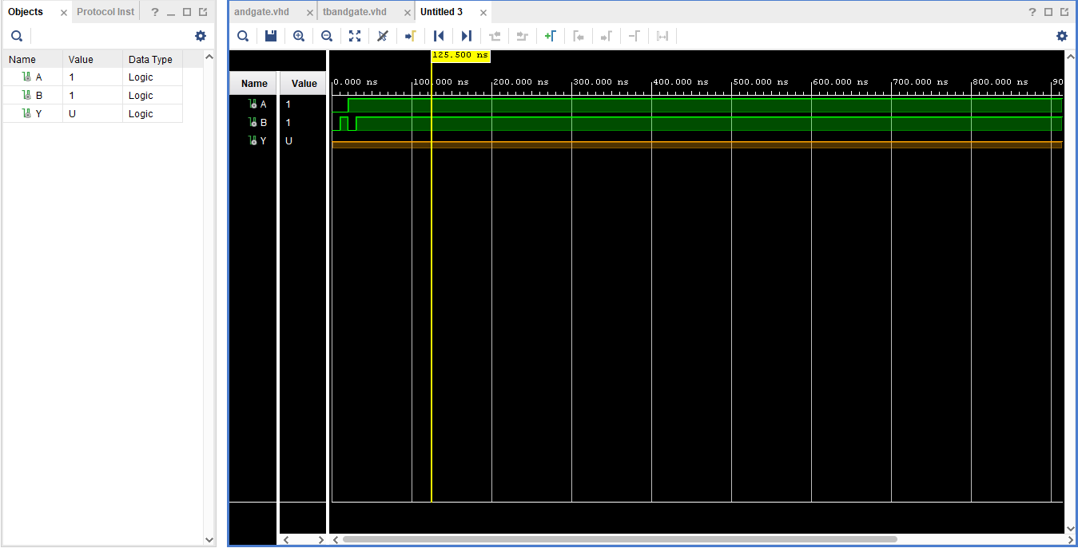
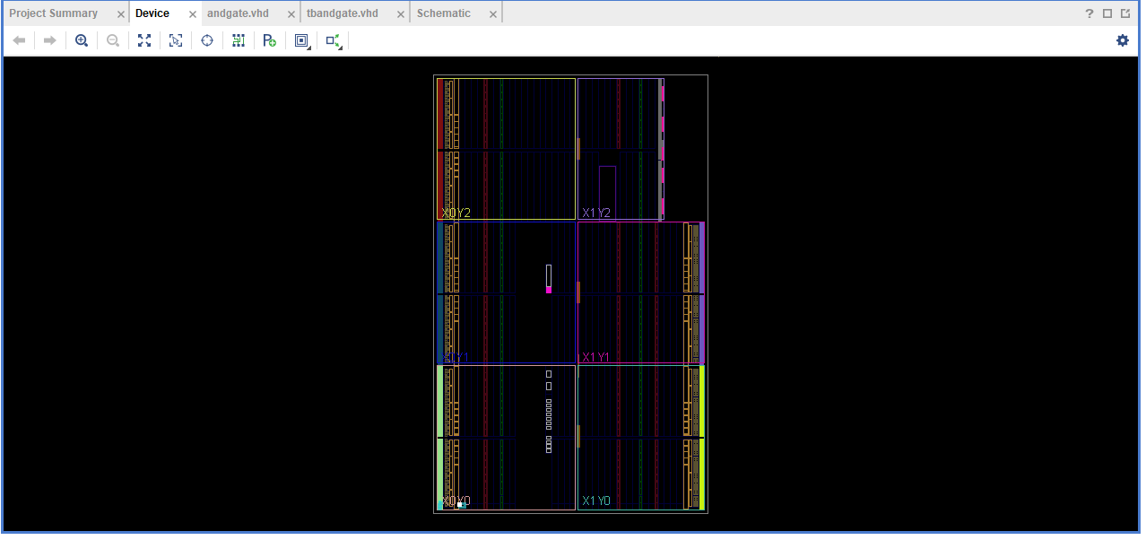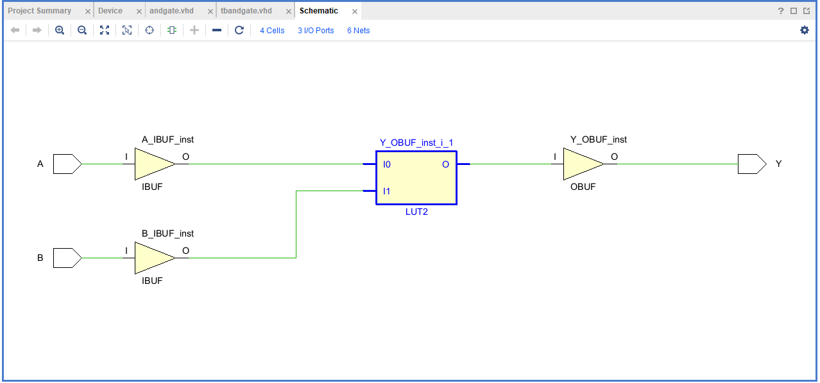
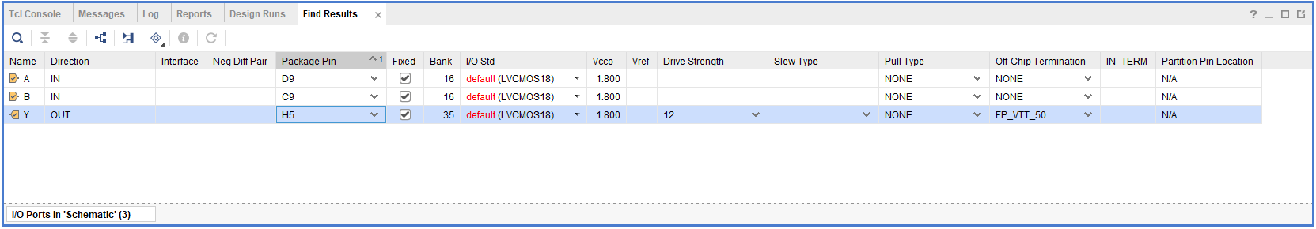
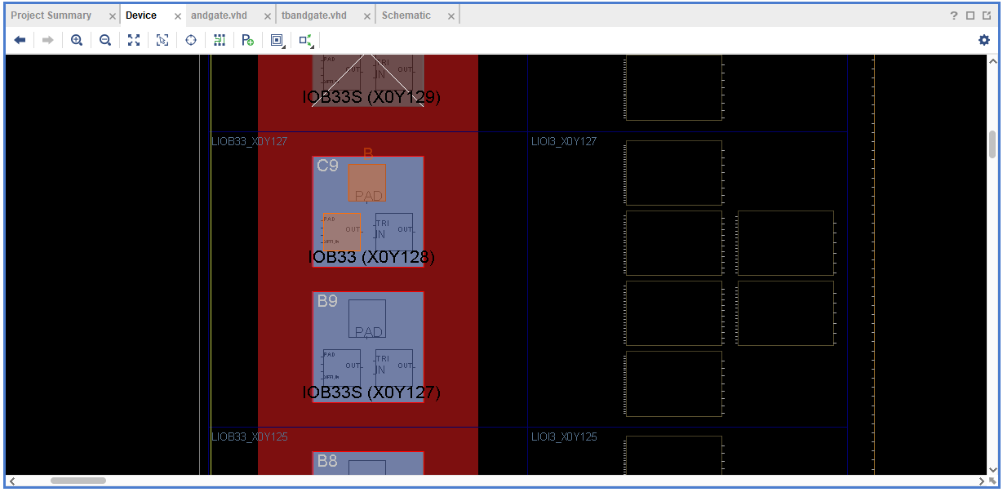
Figure 1input a
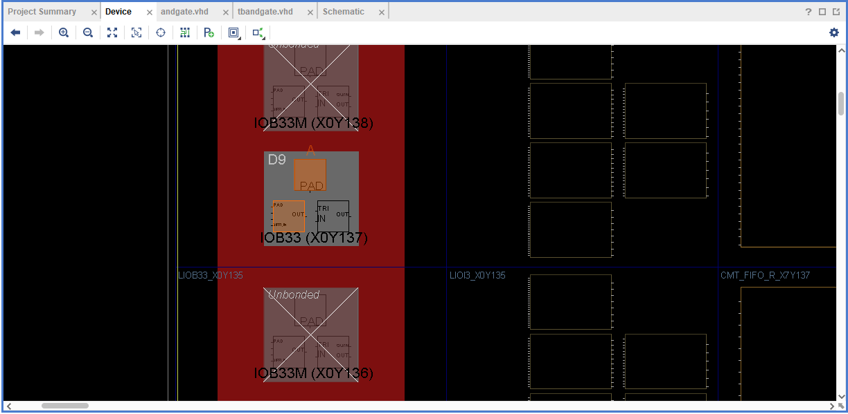
Figure 2input b
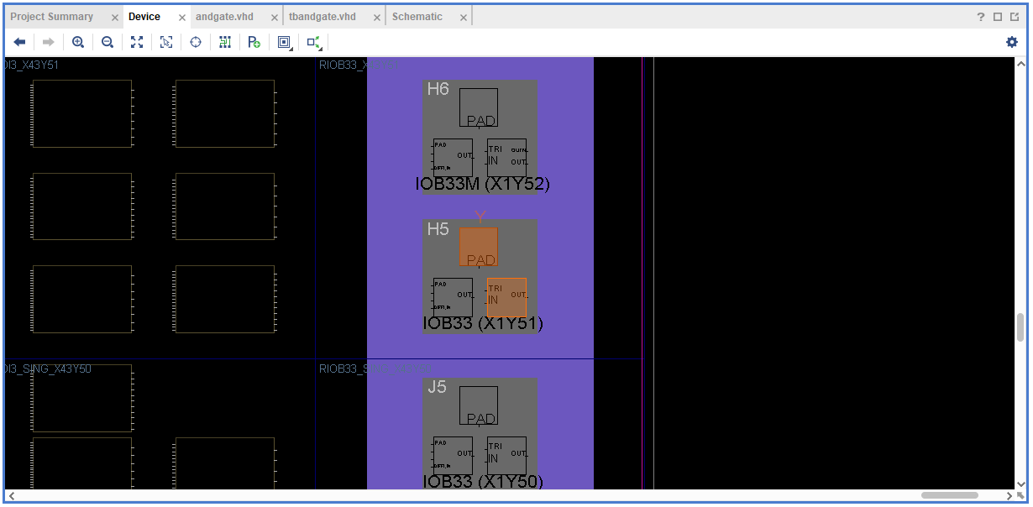
Figure 3output y
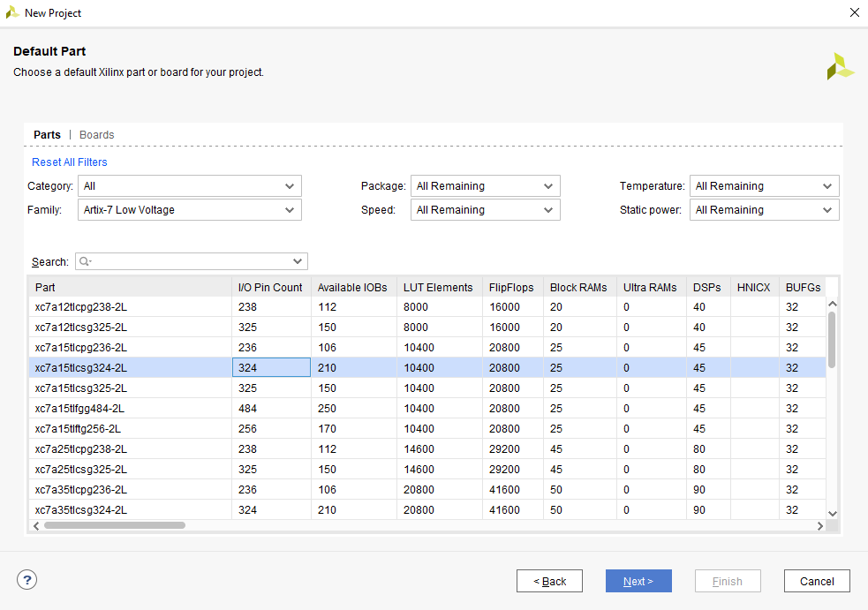

----------------------------------------------------------------------------------
-- Company:
-- Engineer:
--
-- Create Date: 14.03.2023 11:50:43
-- Design Name:
-- Module Name: tbandgate - Behavioral
-- Project Name:
-- Target Devices:
-- Tool Versions:
-- Description:
--
-- Dependencies:
--
-- Revision:
-- Revision 0.01 - File Created
-- Additional Comments:
--
----------------------------------------------------------------------------------

library IEEE;
use IEEE.STD_LOGIC_1164.ALL;

-- Uncomment the following library declaration if using
-- arithmetic functions with Signed or Unsigned values
--use IEEE.NUMERIC_STD.ALL;

-- Uncomment the following library declaration if instantiating
-- any Xilinx leaf cells in this code.
--library UNISIM;
--use UNISIM.VComponents.all;

entity andgate_tb is
end;

architecture bench of andgate_tb is

component andgate
Port (A: in std_logic;
B: in std_logic;
Y: out std_logic);
end component;

signal A: std_logic;
signal B: std_logic;
signal Y: std_logic;

begin

uut: andgate port map ( A => A,
B => B,
Y => Y );

stimulus: process
begin

wait;
end process;

end;

----------------------------------------------------------------------------------
-- Company:
-- Engineer:
--
-- Create Date: 14.03.2023 11:40:36
-- Design Name:
-- Module Name: andgate - Behavioral
-- Project Name:
-- Target Devices:
-- Tool Versions:
-- Description:
--
-- Dependencies:
--
-- Revision:
-- Revision 0.01 - File Created
-- Additional Comments:
--
----------------------------------------------------------------------------------

library IEEE;
use IEEE.STD_LOGIC_1164.ALL;

-- Uncomment the following library declaration if using
-- arithmetic functions with Signed or Unsigned values
--use IEEE.NUMERIC_STD.ALL;

-- Uncomment the following library declaration if instantiating
-- any Xilinx leaf cells in this code.
--library UNISIM;
--use UNISIM.VComponents.all;

entity andgate is

Port ( A:in std_logic;
B:in std_logic;
Y:out std_logic);
end andgate;

architecture Behavioral of andgate is

begin

Y<= A AND B;
end Behavioral;

