
Module Code: BMSW4011
Module Title: Managing Enterprise

Module Lead: Mel Squire

Student Name: Sonia Jaman
Student ID: 2506072

Table of Contents
Part 1: Business Plan 1
1. Business Proposition Description and Name 1
2. The Story Behind My Idea 1
3. Legal Structure: Sole Trader 2
4. Mission, Aim, SMART Objectives and USP 2
5. Physical Location 2
6. Human Resource Strategy 3
7. Marketing Strategy 3
8. Market Research 4
8.1 Primary Research 4
8.2 Secondary Research 4
9. Financial Resources 4
9.1 12-Month Cash-Flow Forecast 4
9.2 Financial Overview Summary 5
10. Critical analysis 5
10.1 Competitor analysis 5
10.2 SWOT analysis 5
10.3 PESTLE analysis 6
10.4 Critical feasibility analysis 6
Part 2: Individual Reflection 7
References 9
Appendix 11
Appendix A: Logo Preparation Using Canva 11
Appendix B: Primary Research Questionnaire and Response Summary. 12
Appendix C: Sample Facebook Launch Post and Flyer 17
Appendix D: Competitor screenshots and pricing examples. 18

Part 1: Business Plan

1. Business Proposition Description and Name
Sonia's Baking is a homemade cake business based in Cardiff, providing bespoke celebration cakes, cupcakes and pastries for birthdays and weddings, baby showers and small events. The service combines premium ingredients, creative decoration, online ordering, local delivery and friendly personalised communication to provide fresh, memorable desserts for customers seeking affordable bespoke cakes.
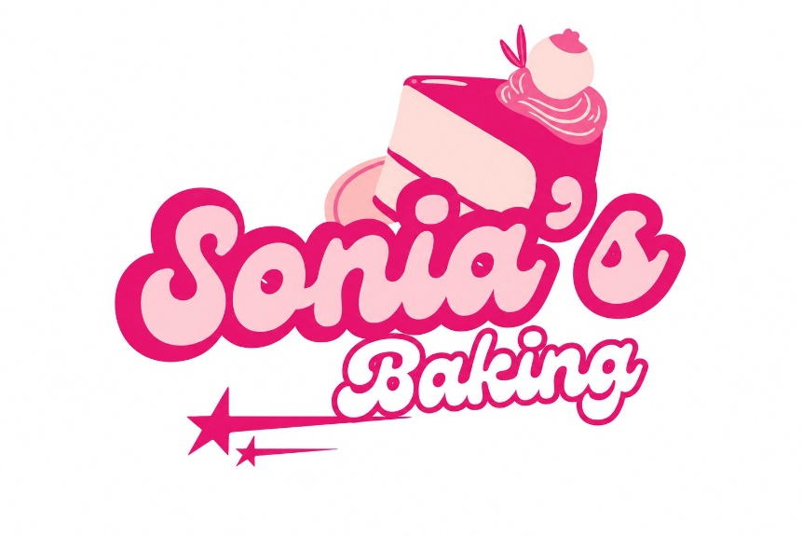
Figure 01: Logo of Sonia’s Baking (Author Generated)

2. The Story Behind My Idea
The concept was inspired by my own love for creating cakes for family events and their emotional ties with celebratory meals. I got to be passionate because cakes aren't just products; they make memories. Sonia's Baking gives me a chance to use my creative instincts, care and delight in making customers happy as a viable business.

3. Legal Structure: Sole Trader
Sonia's Baking will be a sole trader as this is a simple, low-cost and appropriate business form for a small start-up. It provides the owner 100% control, has rapid decision-making and all profits, which helps early entrepreneurs to be flexible (Barringer, 2022). The big drawbacks, however, are the lack of personal liability protection and financing options, as well as the strain on the owner's time and abilities. Nevertheless, it is suitable for a low-cost home-based bakery (Tammy, 2024).

4. Mission, Aim, SMART Objectives and USP
Mission: To bring sweet, new, creative and personalised cakes to Cardiff celebrations.
Aim: To be a well-respected local cake brand in Riverside and beyond Cardiff.
SMART objectives:
- Achieve 30 orders per month by month 12.
- Complete 5000 social media followers at month 12.
- Maintain 90% Customer satisfaction rate.
- Secure 10 repeat customers per month.
USP: Unique Selling Propositions include premium ingredients, flexible designs, and local delivery for bespoke cakes at affordable prices.

5. Physical Location
30 Craddock Street, Riverside, Cardiff CF11 6EU
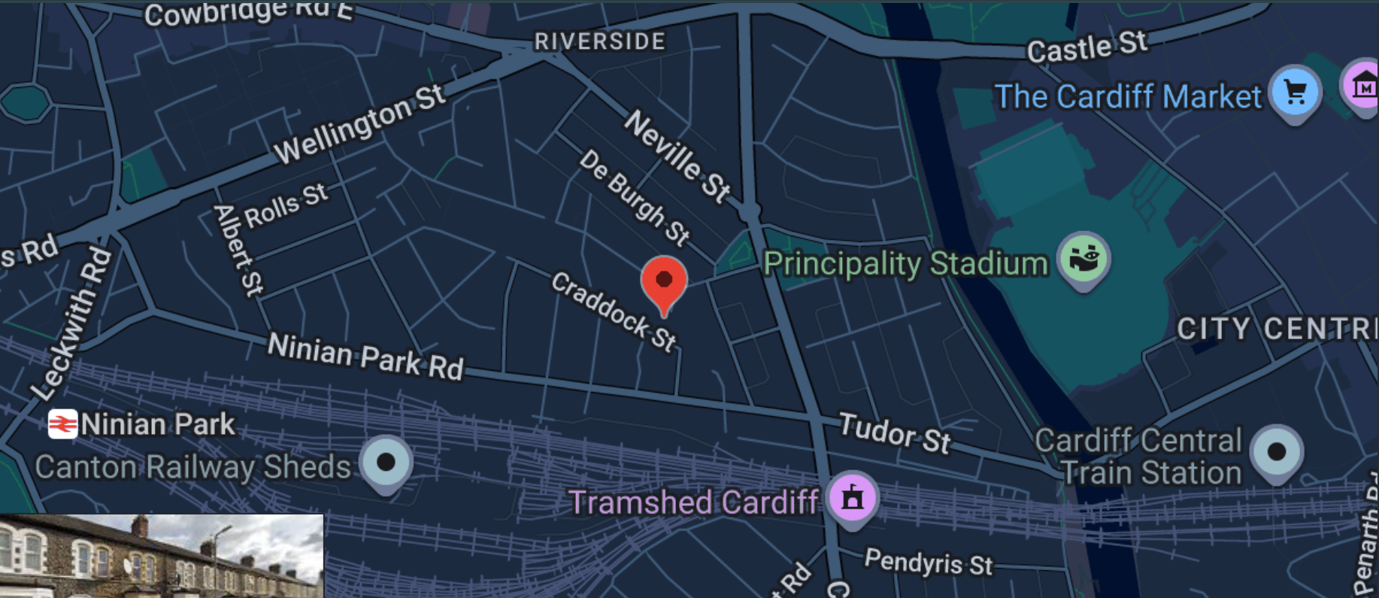
Figure 02: Physical Location of Business

6. Human Resource Strategy
The business will be established with three positions: Owner/Head Baker, Part-Time Assistant Baker, and Part-Time Delivery Support. Managing recipes, orders, finance and customer communication will be the responsibility of the owner. The assistant will assist in the preparation of the baking, decorating and hygiene. During peak times, local drop-off will be done through delivery support. Staff can be recruited from the local community, student job boards and student referrals. This training will be targeted on food hygiene, decoration standard and customer service (Finch, 2025).
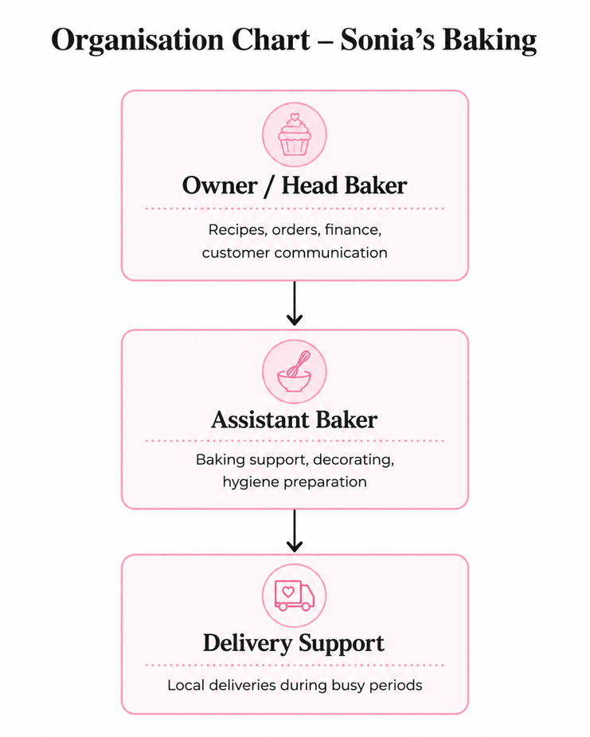
Figure 03: Organisation Chart (Author Generated)

7. Marketing Strategy
Marketing will be geared towards low-cost digital marketing and developing local relationships. Sonia's Baking will be posting reviews, suggestions and cake videos from Instagram, Facebook and TikTok of customers and seasonal designs (Kotler and Armstrong, 2023). There will be a Facebook launch post that will inform people that “10% off first custom cake orders in Cardiff.” Printed flyers and business cards will be distributed in Riverside, student community areas and community events (Kraujalienė and Kromalcas, 2022). Soft pastel coloured branding, simple logo and cake boxes branded with the brand. Some examples of PR activities are a free cupcake tasting post, Mother's Day cake promotion and referral offer: “Recommend a friend and get £5 off your next order” (Kotler and Armstrong, 2021).

8. Market Research

8.1 Primary Research
The primary research was carried out using a brief questionnaire of local Cardiff customers (15). Survey questions included cake purchasing habits, preferred prices, cake design and delivery requirements. The results indicated a high level of interest in birthday cakes, and a low cost of customisation and online ordering. The majority of respondents favoured the option of £25 – £60, depending on the size and design. These insights informed Sonia's Baking business, which features custom-made celebration cakes, social media marketing through visuals and local deliveries.

8.2 Secondary Research
Secondary research indicates that the UK bakery industry is continuing to hold its own as people continue to purchase bakery goods as budget-friendly treats. UK cakes and sweet baked goods are projected to increase, but this growth will be affected by pricing and health-conscious consumers (Statista, 2017). Local competitors such as LetThemSeeCake and Cutter & Squidge show demand for celebration cakes, delivery and premium presentation (LetThemSeeCake, 2026; Cutter & Squidge, 2026).

9. Financial Resources

9.1 12-Month Cash-Flow Forecast
Item | Months 1–3 | Months 4–6 | Months 7–9 | Months 10–12
Sales income | £2,400 | £3,600 | £4,800 | £6,000
Ingredients | £900 | £1,200 | £1,500 | £1,800
Packaging | £240 | £360 | £480 | £600
Marketing | £300 | £250 | £250 | £300
Delivery/utilities | £360 | £480 | £600 | £720
Net cash flow | £600 | £1,310 | £1,970 | £2,580

9.2 Financial Overview Summary
Initial costs will cover baking equipment, ingredients, packaging, branding, food hygiene registration, packaging and delivery costs. The primary source of funding will be from the personal savings of the individual, with the remainder coming from reinvested profit (Williams, 2021). The business is expected to be quite a feasible and sensible scale, as it begins modestly and does not pay high rents. It takes a few months to make the brand name known to them, and after the third month, their cash flow improves when people reorder (Barrow et al., 2018).

10. Critical analysis

10.1 Competitor analysis
Competitor | Business model | Pricing | Learning for Sonia’s Baking
LetThemSeeCake | Local Cardiff cake shop offering bespoke cakes | Premium local pricing | Custom designs and strong visuals matter (LetThemSeeCake, 2026)
Luxury bespoke cake makers | High-quality event and celebration cakes | Higher prices | Quality and personalisation attract customers (Butter and Sugar Cakes, 2025).
Cutter & Squidge | National cake delivery brand | From around £28.99 | Delivery, social proof and photography are key (Cutter & Squidge, 2026).

10.2 SWOT analysis
Strengths: | Weaknesses:
Personalised designs, low overheads, local delivery and creative branding. | Limited capacity and reliance on the owner's skill.
Threats: | Opportunities:
Social media marketing, events, birthdays and student customers. | Established bakeries, ingredient inflation and food hygiene risks (Food Standards Agency, 2023; UK Finance 2025).

10.3 PESTLE analysis
Local Food Business registration/hygiene compliance is a political/legal factor (Food Standards Agency, 2023). Financial constraints can have an impact on the discretionary spending of cake. Celebration culture is the main reason for supporting the demand socially. Technological factors are Instagram, online ordering and digital payments (UK Finance 2025). Environmental issues include packaging waste. Legal compliance requires registration, allergen labelling and safe food preparation (Shared Regulatory Services, 2026).

10.4 Critical feasibility analysis
Sonia's Baking is viable because the start-up costs are low, there is demand for celebration cakes and after one year cash flow is positive. The local interest in bespoke cakes at an affordable price is backed up by primary research, and secondary research indicates that bakery products are still popular as a treat. The concept works if the business has control over the prices of its ingredients, ensures its hygiene and cultivates repeat customers.

Part 2: Individual Reflection
During this module and assessment, I have practised and enhanced several entrepreneurial skills. An important skill is being able to spot opportunities. When writing this business plan, I knew little about baking, apart from it being a creative pursuit (Mullins, 2017). I was able to take the lessons I learned in the lectures and put them to use, and develop a structured business idea that meets a customer's need. Sonia's Baking is more than just cakes – it's about providing customisable celebration products for those looking for budget-friendly, beautiful and dependable cakes in Cardiff.
I also gained the skill of research. I had to plan my business and gather primary and secondary evidence to create the business plan. The key research work has enabled me to know what customers want, like customisation, fair pricing, taste, visual design and delivery. The secondary research allowed me to gain insight into the overall bakery industry, the competition, as well as external factors like inflation and health and diet trends. Improved my decision-making skills, based on evidence instead of just passion.
One thing I learned is how to plan financially. I started to think more about the product and marketing aspects at first, and then the cash-flow forecast demonstrated to me that a business has to be financially viable. I learnt how to estimate income, ingredient price, costs, packaging, marketing and delivery costs. This helped me to realise that profit is not only generated from sales, but there is also a need to control costs and ensure the proper pricing of products. I also learned that it is important to start small to have a lower risk since Sonia's Baking doesn't require a lot of expensive space at first.
I also had the opportunity to develop my marketing and branding skills. Making some examples like a Facebook launch post, flyers, business cards and referral offers helped me to get an idea of how a small business can market itself on a limited budget. A cake business can't do without social media, particularly due to the fact that customers are purchasing with their eyes. Thus, it is essential that photography and customer reviews play a crucial role in the success of your business and that consistent branding is necessary.
I would personally think about investing in her baking product as it gets me, but slowly and gradually. I would not go out on a limb to make a big investment at the beginning, as the business relies on the owner's skill at baking, time, and how many repeat customers she can get. But I would invest a little as the costs to start up are low, the local demand is there to expand and will be available by social media and word of mouth. If sales growth is steady and costs are kept under control, the business can be profitable, as indicated by the cash-flow forecast.

References
- Barringer, B.R. (2022). Entrepreneurship: Successfully launching new ventures. Pearson Education India.
- Barrow, C., Barrow, P. and Brown, R. (2018). The Business Plan Workbook: A Step-By-Step Guide to Creating and Developing a Successful Business. Kogan Page Publishers.
- Butter and Sugar Cakes (2025). Butter and Sugar Cakes. [online] Butter and Sugar Cakes. Available at: https://www.butterandsugarcakes.co.uk/.
- Cutter & Squidge (2026). Cutter & Squidge. [online] Cutter & Squidge. Available at: https://cutterandsquidge.com/.
- Finch, B. (2025). How to write a business plan: Win backing and support for your ideas and ventures. Kogan Page Publishers.
- Food Standards Agency (2023). Getting Ready to Start Your Food Business. [online] Food Standards Agency. Available at: https://www.food.gov.uk/business-guidance/getting-ready-to-start-your-food-business.
- Kotler, P. and Armstrong, G. (2021). Principles of Marketing (18e Global Edition)[E-book].
- Kotler, P., and Armstrong, G. (2023). Principles of Marketing (Global ed., 19th ed.). Pearson.
- Kraujalienė, L. and Kromalcas, S. (2022). Brand positioning strategy in the competitive aspect. Business: Theory and Practice, 23(2), pp.467-475.
- LetThemSeeCake (2026). LetThemSeeCake. [online] LetThemSeeCake. Available at: https://www.letthemseecake.com/.
- Mullins, J. (2017). The new business road test: What entrepreneurs and investors should do before launching a lean start-up. Pearson UK.
- Shared Regulatory Services (2026). Register a Food Business. Srs. Wales. Available at: https://www.srs.wales/en/Environmental-Health/Food-Hygiene-Standards/Register-a-Food-Business.aspx
- Statista (2017). Bread and bakery products market size worldwide 2017-2025 Statista. Statista. Available at: https://www.statista.com/statistics/947363/bread-and-bakery-products-market-size-global/?srsltid=AfmBOoohK_6E9Kr0j4WKlhzCX8jMHSlbmlVW8DazYoE7NvS6XjyJvFMt
- Tammy, R. (2024). Business Structure. In Business Fundamentals for the Rehabilitation Professional (pp. 23-44). Routledge.
- UK Finance (2025). UK Payment Markets 2025. Available at: https://www.ukfinance.org.uk/system/files/2025-10/Payment%20Markets%20Report%20Summary.pdf
- Williams, S. (2021). FT Guide to Business Start Up 2021-2023. Pearson UK.

Appendix

Appendix A: Logo Preparation Using Canva
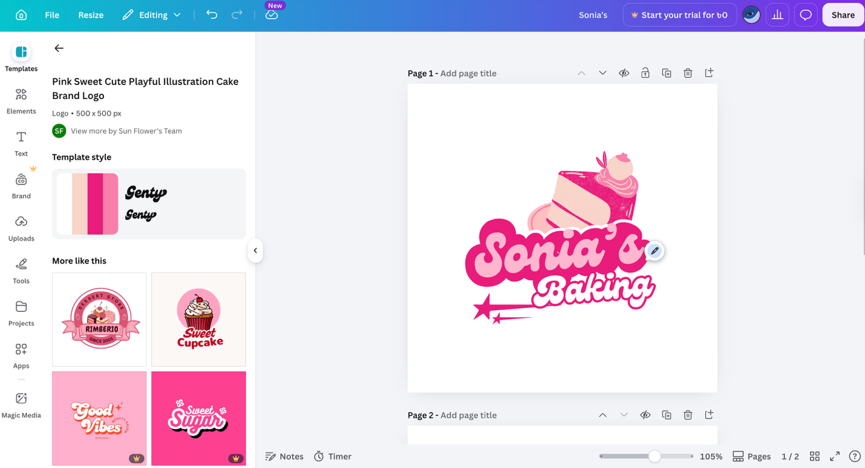

Appendix B: Primary Research Questionnaire and Response Summary.
Link: https://forms.office.com/r/WTRvcvNXh9
Survey Questions
Q1. Do you buy cakes for birthdays, parties or special occasions?
- Yes
- No
- Sometimes
Q2. How often do you buy cakes or cupcakes?
- Weekly
- Monthly
- Only for special occasions
- Rarely
Q3. What type of cake products do you usually prefer?
- Birthday cake
- Cupcakes
- Pastries
- Wedding or event cake
- Other
Q4. Would you be interested in buying customised homemade cakes in Cardiff?
- Yes
- No
- Maybe
Q5. What is the most important factor when buying a cake?
- Taste
- Price
- Design
- Freshness
- Delivery
- Customer service
Q6. How much would you usually pay for a customised celebration cake?
- £15–£25
- £26–£40
- £41–£60
- More than £60
Q7. Would you prefer to order cakes online through Facebook, Instagram or WhatsApp?
- Yes
- No
- Maybe
Q8. Would local delivery make you more likely to buy from Sonia’s Baking?
- Yes
- No
- Maybe
Q9. Which cake design would you prefer?
- Simple design
- Luxury design
- Birthday theme
- Kids’ theme
- Personalised message
Q10. Would you recommend a good homemade cake business to friends or family?
- Yes
- No
- Maybe

Response Summary (15 Participants)
Respondent | Q1 | Q2 | Q3 | Q4 | Q5 | Q6 | Q7 | Q8 | Q9 | Q10
R1 | Yes | Only for special occasions | Birthday cake | Yes | Taste | £26–£40 | Yes | Yes | Birthday theme | Yes
R2 | Sometimes | Monthly | Cupcakes | Yes | Design | £26–£40 | Yes | Yes | Personalised message | Yes
R3 | Yes | Only for special occasions | Birthday cake | Yes | Freshness | £41–£60 | Yes | Yes | Luxury design | Yes
R4 | Yes | Monthly | Pastries | Maybe | Price | £15–£25 | Maybe | Yes | Simple design | Maybe
R5 | Sometimes | Rarely | Birthday cake | Maybe | Price | £26–£40 | Yes | Maybe | Birthday theme | Yes
R6 | Yes | Only for special occasions | Wedding or event cake | Yes | Design | More than £60 | Yes | Yes | Luxury design | Yes
R7 | No | Rarely | Cupcakes | Maybe | Price | £15–£25 | No | Maybe | Simple design | Maybe
R8 | Yes | Monthly | Cupcakes | Yes | Taste | £26–£40 | Yes | Yes | Kids’ theme | Yes
R9 | Sometimes | Only for special occasions | Birthday cake | Yes | Customer service | £41–£60 | Yes | Yes | Personalised message | Yes
R10 | Yes | Weekly | Pastries | Yes | Freshness | £15–£25 | Yes | No | Simple design | Yes
R11 | Yes | Monthly | Birthday cake | Yes | Design | £41–£60 | Yes | Yes | Personalised message | Yes
R12 | Sometimes | Only for special occasions | Wedding or event cake | Maybe | Taste | More than £60 | Maybe | Yes | Luxury design | Yes
R13 | Yes | Monthly | Cupcakes | Yes | Delivery | £26–£40 | Yes | Yes | Kids’ theme | Yes
R14 | Yes | Only for special occasions | Birthday cake | Yes | Taste | £41–£60 | Yes | Yes | Birthday theme | Yes
R15 | Sometimes | Rarely | Pastries | Maybe | Price | £15–£25 | Maybe | Maybe | Simple design | Maybe

Appendix C: Sample Facebook Launch Post and Flyer
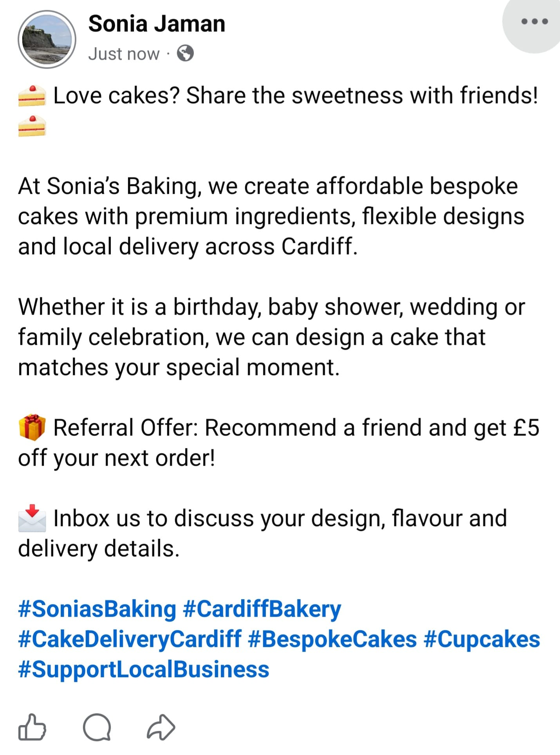

Appendix D: Competitor screenshots and pricing examples.
1. Cutter & Squidge
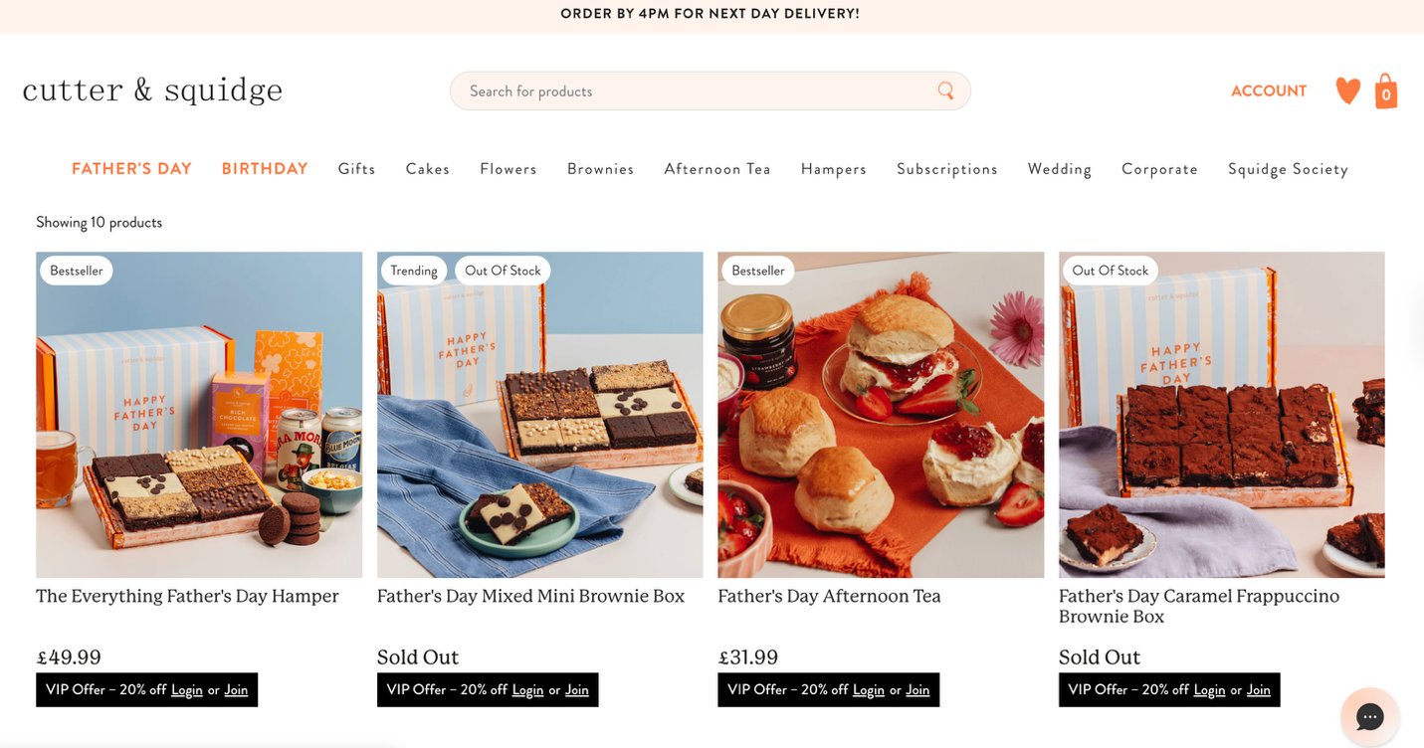
2. Let Them See Cake

