Module Title: Management and Organizational Behaviour
Module Code: BMIH5004
Assignment Type: Report

Student Name: Alin Chiteala
Student ID: 2128522

Executive Summary
The foremost aim of the study was to conduct a business audit. For the Case study organisation, Hyatt Hotel Group was selected. Organisation goals, culture, structure and strategic directions of the firm have been critically reviewed. Analysis of the current business performance of Hyatt helps to understand its current market position. Recent change initiatives of Hyatt such as reducing water wastage, minimising emissions, sustainability, increased online booking and tech-driven initiatives have been critically analysed based on their impacts and the process of management of these change initiatives.

Table of Contents
Introduction 4
Organisational Structure 4
Organisational Culture 6
Organisational Goals 7
Recent Change Initiatives and Their Impacts 7
Strategic Direction of the Company 9
Current Business Performance of Hyatt 11
Conclusion 12
References 13

Introduction
This report will aim to understand a firm's strategic direction and current performance using Audit results. The Hyatt Hotel group's organisational goal, structure and culture have been critically outlined. The strategic aim of the study is to critically evaluate the recent change initiatives of the company and their direct impact on the operation of the Hotel Group. Furthermore, the current business performance and strategic direction of the firm have been critically discussed in the following section. A five-force analysis has been selected for internal auditing, which helps to identify the current competitive advantages of the firm and future challenges.

Organisational Structure
Hyatt Hotels is a well-known global hospitality company, which was founded in 1957 with its headquarters in Chicago. With a diverse portfolio, the company is operating in more than 60 countries. Hyatt Group is known for its luxury and high-quality services, which promote international growth. Currently, Hyatt operates more than 1350 hotels and has properties across 69 different countries (Hyatt, 2024). More than 189,000 employees are engaged with the global business and recently the company dedicated to shifting itself to a sustainable and responsible business (Luu, 2023). The growing trend of sustainability and globalisation influence Hyatt to take initiatives to become sustainable. After the recent COVID-19 pandemic, customer awareness has been increased (Wang, 2023). The development of several eco-friendly programs and increasing community engagement influenced Hyatt to rethink the safety and well-being of its guests.
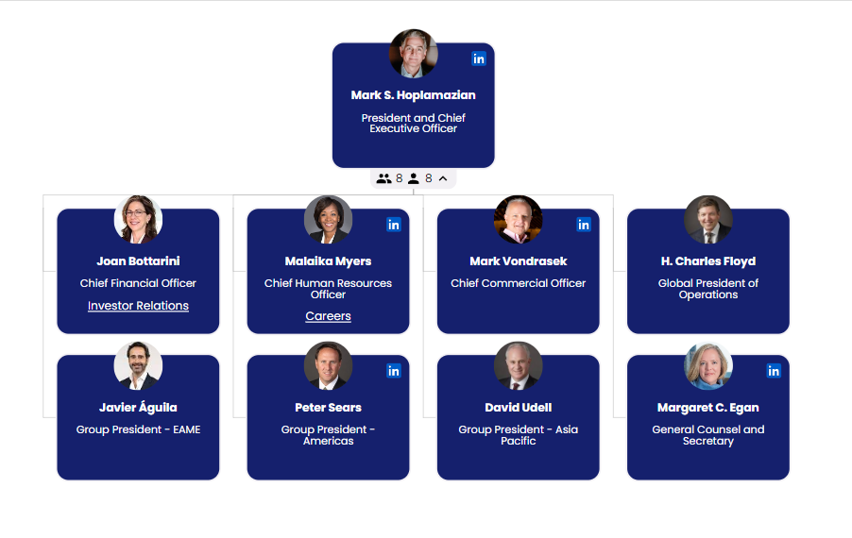
Figure 1: Organisational Chart of Hyatt Hotels
(Source: Hyatt, 2024)
Hyatt Hotels follows a Hybrid organisational structure, which combines both divisional and functional structures (Hoang et. al., 2023). It allows the company to efficiently manage the diverse range of services and product portfolio offered by Hyatt. At the corporate level, Hyatt implements a functional organisational structure, which focuses on different functions such as marketing human resources, finance and legal operation of the company (Hyatt, 2024). Each of the division is responsible for its specific task, functions and areas of expertise. According to the organisational chart of Hyatt, the CEO remains at the top of all divisional managers. For each functional department, managers have been assigned. The current CEO of Hyatt is Mark Hoplomazian (Xiong, 2023). The organisational chart of Hyatt Reveals that the Global president for each area has been selected, which helps to ensure the success of global business operations (Melián-González and Bulchand-Gidumal, 2020).

Organisational Culture
Organisational culture can be defined as a set of values, beliefs and culture, which influence the organisational behaviour of individuals. Hyatt is known for offering the best care to its people. Employees of Hyatt are treated equally without any discrimination. Hyatt Groups believe in embedding Diversity and Equity, which is part of the business (Saeidi et.al., 2021). Managers and leaders of Hyatt are committed to ensuring equality, inclusion and diversity, which reflects across the actions, behaviour, workplace environment and policies of the organisation. The organisational culture of Hyatt is designed based on empathy and focused on care (Baquero, 2023). Ethical Leadership at Hyatt helps to create a sense of belonging and respect for each employee and community. Leaders at Hyatt promote the career development of each employee (Spicer, 2020). Hyatt does not just offer job opportunities to people but also focuses on building better career opportunities for people. The organizational culture of the hospitality group is developed focusing on the agenda of “World of Care.”
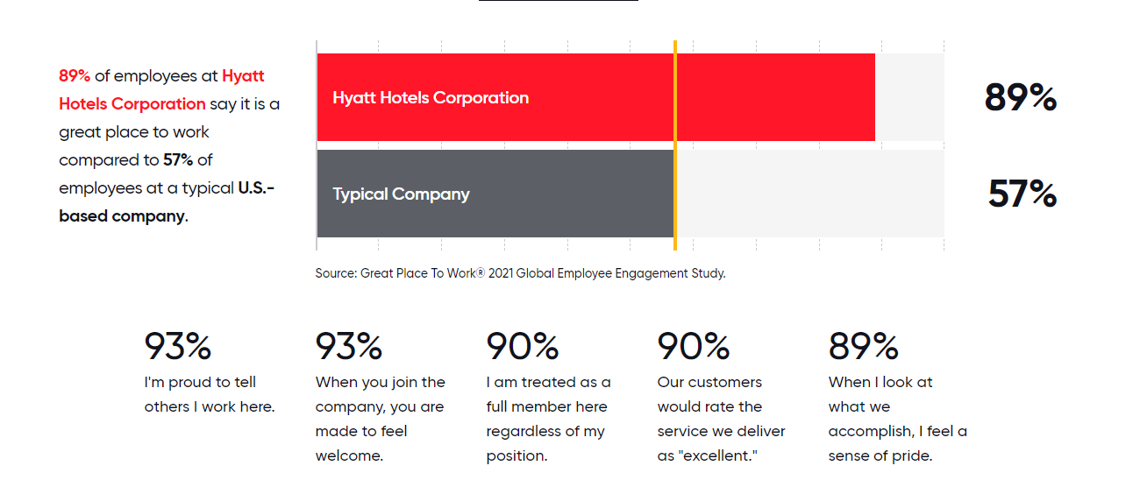
Figure 2: Organisational culture of Hyatt
(Source: Hyatt, 2024)
According to the Internet survey of Hyatt Hotels, 89% of the employees at Hyatt say it is a great workplace. On the other hand, 57% believe it is a typical U.S.-based company. According to 93% of the employees, they feel proud to become a part of Hyatt and 93% believe the workplace environment is very welcoming. According to a recent report, Hyatt is a large organisation with basic culture (Hyatt, 2024). The large size of the company and the huge number of employees globally influence Hyatt to develop sub-cultures for each division. As per the beliefs of the leaders, the sub-cultures of Hyatt help to minimise the conflicts in the basic company culture (Lee and Yu, 2023). Diversity and inclusion help to engage talents from all over the world with different knowledge, beliefs, expertise and skills (Romero and Tejada, 2020).
.

Organisational Goals
The Mission of Hyatt is to offer authentic hospitality services to make the lives of the people different. The core vision of this company is to become the most preferred hospitality organisation in the world. To become the global leader in the hospitality industry, Hyatt aims to reduce its negative impact on the environment and tries to become sustainable (Hyatt, 2024). The core purpose of the hospitality group is to offer care for the people and help them improve their lives.

Recent Change Initiatives and Their Impacts
Considering the negative impact of hospitality sectors and their operation on the environment and society, Hyatt takes the initiative to implement climate actions and water resource protection regulations. The change initiatives taken by Hyatt and their impact on the company's operation have been listed in the below section.
Reducing Carbon Emission and Energy Usage
Hyatt is committed to climate actions and targets to reduce its CO2 and greenhouse gas emissions. Corporate officers of Hyatt are taking various actions and approaches to manage the usage of water, energy and emissions. They started to implement water and light sensors, which will help to minimise water and energy wastage (Tan, 2023). Upgrading the cooling and heating machines along with laundry and kitchen equipment to minimise emissions. Using alternative water sources and water recycling helps to save water and renewable electricity will help to minimise the use of natural resources (Paais and Pattiruhu, 2020). On the other hand, building automation and energy optimisation systems are efficacious in improving the sustainability of Hyatt. However, implementing new technologies costs higher and impact directly on the profitability of the company. Lack of technological training among employees can lead to organisational inefficiency.
Improve Sustainability
The biggest environmental challenges cannot be solved without collaborating with experts and organisations. In 2022, Hyatt joined American Hotels and Lodging to reduce environmental footprints and improve sustainability (Park and Min, 2020). Members from the Sustainable Hospitality Alliance help Hyatt to tackle the global challenges associated with increased environmental issues and footprints across the tourism industry. Hyatt has launched the “Global Sustainability Initiatives,” which introduce large bathroom amenities to replace the small plastic bottles of shampoo, conditioner and shower gels (Hyatt, 2024). These global initiatives support Hotels to increase the number of water stations in public places for guest who wants to refill their bottles, which reduces the use of single-use plastic bottles (Lu and Gursoy, 2023). The management of Hyatt Hotels focuses on reducing the use of “Single-used plastics” and increasing the percentage of reuse and recycling. This global initiative helps to grab the attention of socially-concerned customers.
Increase Website Booking
According to the marketing report of Hyatt, more than 75% of the bookings were confirmed through their official websites in 2019. Considering the global trend of online booking, Hyatt has taken initiatives to increase online ticket booking. Direct booking through the websites helps avoid third-party charges (Anguera-Torrell et.al., 2021). During the ongoing financial crisis, online offers and loyalty programs help customers to enjoy affordable pricing. Affordable and luxury services offered by Hyatt help this hospitality group to enjoy advantages over competitors.
Tech-driven Initiatives (Digital Room Services)
Hyatt is the pioneer in digital room services, which offered the first digital key services to its customers. The research and engineering department of Hyatt always remains focused on offering top-notch services with the help of innovative technologies and software. The tech-driven initiatives of Hyatt aim to offer top-notch services to customers considering their health and safety (Park and Min, 2020). Keyless operations and robot services help to avoid the spread of the virus and are beneficial for maintaining social distancing protocols (Hospitality Net, 2024). Hyatt Collaborates with leading smartphone brand, which offers digital key services. Furthermore, the use of customer analytics helps to source real-time data directly from the loyal customer to make faster and more effective decisions (Berthot, 2023). The use of customer analytical tools helps to improve the quality of services and products along with enhancing customer satisfaction.

Strategic Direction of the Company
Strategic direction refers to the set of activities and decisions firms make to achieve their goals and objectives. To understand the strategic direction of the company a competitive analysis of the firm has been conducted using Porter’s five forces.
Bargaining power of Customers: The power of bargaining for customers is relatively high at Hyatt as the majority of the customers make their traveling decisions based on the price point. However, the comfort and luxury level of Hyatt helps the firm to charge competitively high pierce compared to its rivals (Paais and Pattiruhu, 2020). Customer with high-edge income generally price incentives and make their decisions based on luxury, location and comfort.
Bargaining power of Suppliers: The power of suppliers is relatively high as there are very few suppliers who offer luxury products at affordable prices. Therefore, Hyatt needs to focus more on local suppliers to reduce the power of suppliers that will support offering affordable and sustainable services to the customers.
The threat of substitutes: There are many hotel services with different price points at prime locations, which can lead to a high threat of substitutes. There is no switching cost and service differences influence customers to choose low-price services. During the COVID-19 pandemic, budget hotels suffer less than luxury hotels like Hyatt.
Threat of New Entry: Hyatt is one of the renowned luxury hotels with one of the longest hotel chains in the world. To enter into the hotel industry, a huge investment and capital will be required. This creates a huge entry barrier for new hotels, which indicates lower threats of new entry.
Threat of Rivals: The hospitality industry is intensively competitive and several market players offer almost similar services to Hyatt at different price points. The main competitors of Hyatt include Marriott, Hilton, IHG, Accor and Premier In.
The strategic objective of Hyatt is to become a global leader in the hospitality industry, which needs the development of a strategic plan (Spicer, 2020). To achieve its aims, Hyatt needs to differentiate its products and services. This will help to achieve competitive advantages over the rivals. The “Culture of Care” is the heart of its business strategy and helps to engage the best global talents. Hyatt enables their colleagues to do their best and achieve the business objectives.

Current Business Performance of Hyatt
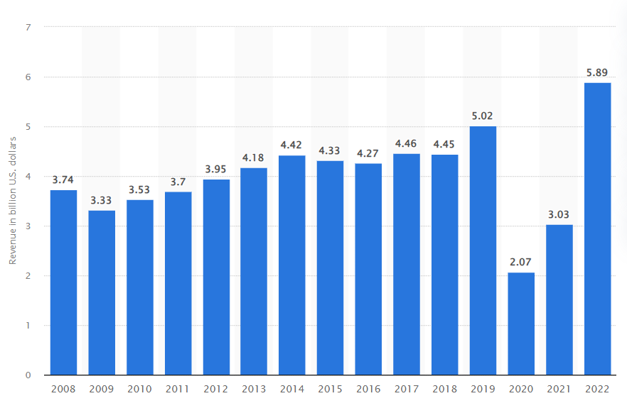
Figure 3: Revenue of Hyatt
(Source: Statista, 2024)
According to the annual report of Hyatt, currently this firm is operating with more than 13,000 employees from 79 different countries. According to recent statistics, the revenue of Hyatt in 2019 was $5.02 billion, which dropped to $2.7 billion in 2020 (Statista, 2024). The COVID-19 pandemic and travelling restrictions have a strong adverse impact on the performance of the tourism industry. However, Hyatt managed to increase its revenue to $5.08 billion by 2022. Hyatt managed to successfully gain pre-pandemic revenue and continuous growth in the revenue indicates the efficacious business performance of the hospitality industry.
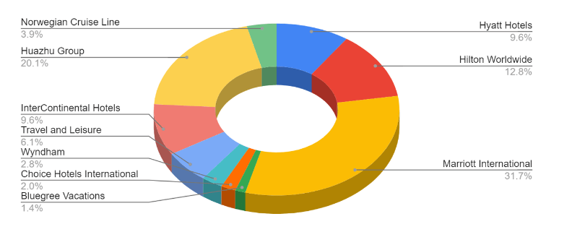
Figure 4: Market Share of Hyatt
(Source: Paais and Pattiruhu, 2020)
According to the market audit, the market share of Hyatt Hotels is 9.6%. The market of competitors such as Marriott International with 31.7%, IHG with 9.6% and Hilton with 12.8% share are leading the hotel industry market (Paais and Pattiruhu, 2020). Considering the results, Marriott is the global leader and the key competitor of Hyatt while achieving the strategic business aim.

Conclusion
It can be summarised from the above audit that Hyatt is trying to improve its business operations to become the future global leader in the competitive hospitality market. Considering the changing business landscape, Hyatt is driving toward a sustainable approach. Hyatt started to take sustainable initiatives to minimise emissions and footprints, which can help Hyatt to become a sustainable global leader in the current competitive tourism and hospitality industry.

References
Anguera-Torrell, O., Aznar-Alarcón, J.P. and Vives-Perez, J., (2021). COVID-19: Hotel industry response to the pandemic evolution and to the public sector economic measures. Tourism Recreation Research, 46(2), pp.148-157.
Baquero, A., (2023). Authentic Leadership, Employee Work Engagement, Trust in the Leader, and Workplace Well-Being: A Moderated Mediation Model. Psychology Research and Behavior Management, pp.1403-1424.
Berthot, B.D., (2023). Hero Plumbers: The Transitional Challenges of a Family-Owned Business. Muma Case Review, 8, pp.001-014.
Hoang, G., Luu, T.T., Du, T. and Nguyen, T.T., (2023). Can both entrepreneurial and ethical leadership shape employees’ service innovative behavior?. Journal of Services Marketing, 37(4), pp.446-463.
Hospitality Net, (2024). Hyatt Digital Initiatives [online] Available at: https://www.hospitalitynet.org/news/4111647.html [Accessed on 25th January 2024]
Hyatt, (2024). Organisational culture of Hyatt [online] Available at: https://about.hyatt.com/en/world-of-care/caring-for-people/culture.html#:~:text=We%20strive%20to%20create%20a,Empathy%2C%20and%20Fun%20every%20day.&text=Hyatt%20is%20not%20only%20a,place%20where%20careers%20are%20built [Accessed on 25th January 2024]
Hyatt, (2024). Sustainability report of Hyatt [online] Available at: https://www.hyatt.com/en-US/hotel/netherlands/hyatt-regency-amsterdam/amsra/home/sustainability [Accessed on 25th January 2024]
Lee, L. and Yu, H., (2023). Socioeconomic diversity in the hospitality industry: the relationship between social class background, family expectations and career outcomes. International Journal of Contemporary Hospitality Management.
Lu, A.C.C. and Gursoy, D., (2023). Cultural Value Orientation and Hospitality Employee Voice Behavior: The Moderating Role of Leader–Member Exchange (LMX). Journal of Hospitality & Tourism Research, p.10963480221148175.
Luu, T.T., (2023). Reducing unethical pro-organizational behavior in the hospitality sector through socially responsible human resource practices and responsible leadership. Journal of Sustainable Tourism, 31(3), pp.706-734.
Melián-González, S. and Bulchand-Gidumal, J., (2020). Employment in tourism: The jaws of the snake in the hotel industry. Tourism Management, 80, p.104123.
Paais, M. and Pattiruhu, J.R., (2020). Effect of motivation, leadership, and organizational culture on satisfaction and employee performance. The Journal of Asian Finance, Economics and Business, 7(8), pp.577-588.
Park, J. and Min, H.K., (2020). Turnover intention in the hospitality industry: A meta-analysis. International Journal of Hospitality Management, 90, p.102599.
Romero, I. and Tejada, P., (2020). Tourism intermediaries and innovation in the hotel industry. Current Issues in Tourism, 23(5), pp.641-653.
Saeidi, P., Robles, L.A.A., Saeidi, S.P. and Zamora, M.I.V., (2021). How does organizational leadership contribute to the firm performance through social responsibility strategies?. Heliyon, 7(7).
Spicer, A., (2020). Organizational culture and COVID-19. Journal of Management Studies, 57(8), pp.1737-1740.
Statista, (2024). Revenue of Hyatt [online] Available at: https://www.statista.com/statistics/257362/revenue-of-the-hyatt-hotels-corporation/ [Accessed on 25th January 2024]
Tan, K.L., (2023). Responsible Leadership-A Brief Review of Literature. Journal of Responsible Tourism Management, 3, pp.44-55.
Wang, Y., (2023). Research on Hyatt Regency Beijing Wangjing. World Scientific Research Journal, 9(8), pp.8-15.
Xiong, L., (2023). It takes a village: examining how and when brand-specific transformational leadership affects employees in internal brand management. Journal of Brand Management, 30(4), pp.333-346.

