Effective Team Working and Communication
BMSW4002
Student: Liudmyla Truksans
Tutor: Timothy Hopkins

01.05.2020

Table of Contents
Introduction 3
Main body 3
Section 1 3
1.1 How communication is made efficient within a business corporation 3
1.2 How the entire procedure of communication functions between working employees including management system? 4
Section 2 5
2.1 Theory of Shannon and Weaver 5
2.2 Theory of Schramm and Berlo 6
Section 3 7
Conclusion 8
References 9

Introduction
Proper interaction and team work areexecuted and operated within organizations through communication procedure. This is because communication is the only mean to convey data and information from one person to another person (De Giacomoet al., 2016). In order to ensure accurate information to be delivered, it is very essential to possesseffective communication skill within individuals without any issues and errors as well. Currently, at present there are two varying types of communication procedurewith help of which interaction is being proceeded among employees and management team as well (De Giacomoet al., 2016). One of the major reason behind establishment of proper and ethical communication is not only to manage effective professional relationship, but also to achieve organizational objectives and tasks accurately and that too within stipulated amount of time period. In fact effective communication not only assist the employees to interact with their consumers but also helps them to solve their issues and errors in most effective manner (De Giacomoet al., 2016). As a result of this fact, it has become very much important for every organizational sector, to manage and produce efficient communication within organizational culture. Throughout this entire assignment, various ways of communication opted within enterprise’s would be analysed with help of several communication theories. Apart from this, effectiveness of communication within business procedures would also be evaluated over here in order to make it easier for readers to understand (Gowet al., 2017).

Main body

Section 1

1.1 How communication is made efficient within a business corporation
For understanding business prospective, employees need to be make communication effective among each other and also with managers including hierarchy members as well. There are various ways, with help of which communication is made effective within business corporations (Gowet al., 2017). Some of the most frequently used means are as follows:
Conducting meeting
Meeting within enterprises occurs for two varying reason. One is to discuss about jobs and responsibilities and other type is to discuss about issues and errors that are faced by the employees. In both cases, communication play major role (Gowet al., 2017). As a result of this facts, seasonal meetings are conducted so that employees could be able to feel free and speak their heart out with full passion and compassion. On other hand, hierarchy members also listen to their issue as well being of workers are equally important as achieving aims (Gowet al., 2017).
Communication building through training period
After recruitment of candidates, they are trained on various professional tasks and activities as well. One of those tasks is improvement in communication skills as well. Each and every employees need to be pro in communication procedure so as to achieve their objectives without any hurdles (Keerativutisestet al., 2017).
Sending emails
It is not always possible to have verbal communication within professional work culture (Zhang et al., 2018). In fact it is also essential to keep authenticated details and written documents as well. Therefore, in order to proceed this fact, emails have been used so as to deliver essential details and information from one employee to another (Keerativutisestet al., 2017). Emails is basically a kind of text message where official communication is conducted

1.2 How the entire procedure of communication functions between working employees including management system?
Communication possess various means as already mentioned above. However, it works in some basic manner among employees and management teams as well. Some effective procedure are as follows:
Effective listening skills
In order to ensure that data including the information has been delivered accurately, it is very important to have proper listening skills. This quality need to be present not only within working employees but also withinemployees working in management team as well (Hofertet al., 2019). Efficient listening skills not only helps the workers to understand organizational facts but also assist them to analyse each of the orgnaizational prospects without any errors. Therefore proper listening skills is very much important and thus entire communication procedure is conducted in this manner (Hofertet al., 2019).
Choice of language
In every organization, choice of language especially in case of multinational corporations (MNC’s) is kept English. This is because, it is the only language which is being used all over the world. As a result of this fact, it is important to convey the entire communication procedure in such a language which is understood by vast people across entire world (Hofertet al., 2019). Thus, every employees within enterprises tend to deliver their details with help of English.
Proxemics and Kinesics
This is a particular type of communication procedure where non-verbal communication mode play the major role (Okoroet al., 2017). For example, clothing, artefacts, dressing sense of the individuals play major role in determining their way of communicating in most authenticated way. Apart from this, the gesture, body language, along with the facial expression also play a major role in executing communication procedure authentically (Okoroet al., 2017).

Section 2

2.1 Theory of Shannon and Weaver
In communication theory in other words is also known as Shannon – weaver model of communication. This is the only communication theory which has been regarded as the mother of all models(Kelly et al., 2019). As per the research scientists, it has been recognized as an effective including integrated model where various factors of receiving, delivering, transmitting, and encoding including decoding are being executed in most appropriate manner (Okoroet al., 2017). With the help of this theory, not only the data and information would be transmitted accurately but also assures the fact that each of those data would be received to the receiver appropriately without any issues (Kelly et al., 2019). Here in this model, both the encoder including the decider ensures their fact that each of their delivered messages are clarified authentically without any errors.

Fig. 1: Shannon and Weaver Model of Communication (Source: Communication Theory, 2020)

2.2 Theory of Schramm and Berlo
Taking the Berlo’s model into consideration, in other words this is also known as Aristotle model where the person who communicates is recognized as to be present in the central position and that person’s responsibility is to deliver the message authentically without any issues (Kelly et al., 2019). Basically this particular model functions with help SMCR model where S depicts source. M stands for message, C stands for selected communication channel and R stands for the receiver (Kelly et al., 2019).
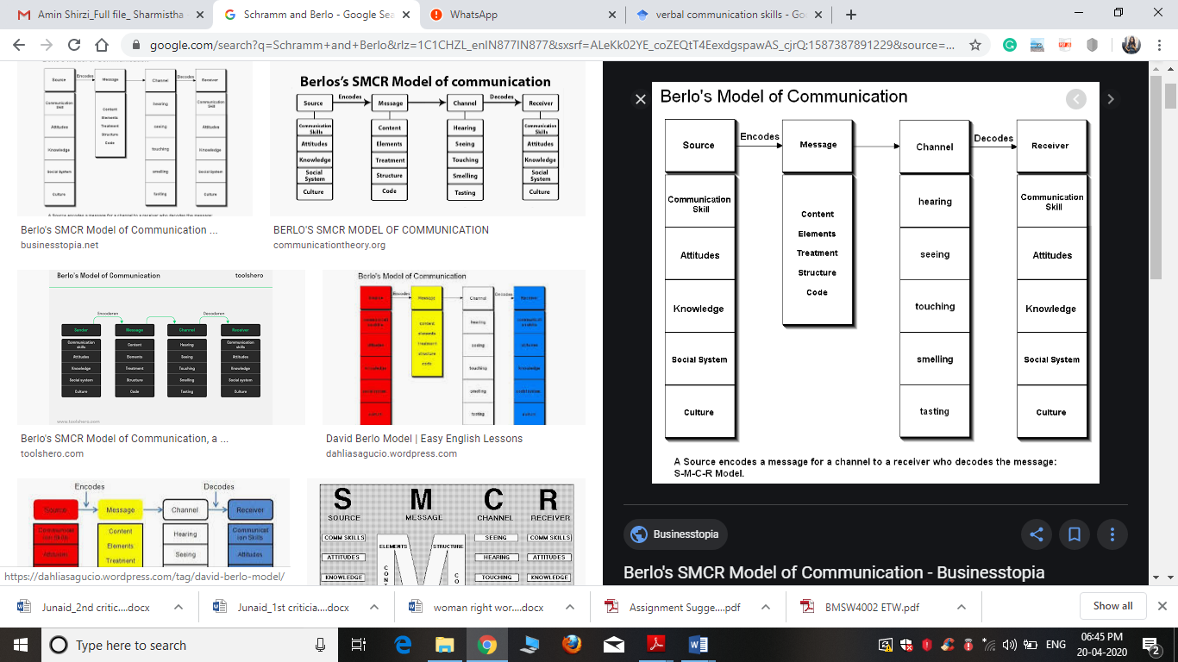
Fig. 2: Berlo’s SMCR Model of Communication (Source: Businesstopia. 2020)
On the other hand, taking Schramm model into consideration, it states the fact that a data or transferred information is of no use until and unless it is being understood by the selected receiver in most appropriate manner (Penrodet al., 2019). As a result of this fact, the entire factors of encoding play a very important role as the sender need to send the information through communication procedure in such as way so that receiver would be able to decide the message without any issues and errors as well (Raufet al., 2017). Each and every send message is of no use if in case the delivered message is not at all understood by the receiver. This particular model consist of two major meaning that is denotative meaning and Connotative meaning (Raufet al., 2017). The former one ensures the fact that none of the listener would get hurt from any kind of information that is being send and thus on the other hand, it would also ensure that every information would be accurately send to receivers and there should not be any facts of misinterpreting the send data (Stoyanovaet al., 2018). Whereas the latter one depicts the fact that it impacts and hurts the emotional factors of receivers as it mostly involves the factors of non verbal communication. For example, gestures, body languages, movements, facial expressions and many more. Therefore, it can be said that if the sender sends important data and information to receivers, they should be able to decode those data and deliver the feedback as well (Stevens et al., 2018). The reason behind this fact is if none of the receivers are able to send feedbacks then as per this model, the entire communication procedure is not completed yet.

Section 3
As far as my experience in work culture, I work as warehouse in Amazon where the work culture and environment is very much effective. As a result of this fact, my experience while working in Amazon is very much positive and productive as well. Within the organization, Amazon where I work as a warehouse, there the communication skills and communication procedure were very much effective and initiative as well. I have seen every employees to effectively communicate with their fellow members and also with management teams as well. When I went to work over there in the organization for the very first day, I was sent to the training room where training sessions would be conducted for three weeks. As explained in section 1 that training is also conducted based on enhancement in communication skills. Thereafter, I have been trained on how to develop both my verbal and non-verbal communication skills. As a result of this fact, 1 week has entirely been dedicatedfor improving our communication skills in most appropriate way. One of the major procedure that has been adopted in training period is some of the theories that has been mentioned in section 2 has been incorporated in order to enhance communication skills appropriately. In the second phase of my working period, I has witnessed, body languages, gestures, facial expressions of every employees were very effective in nature. Moreover, for achieving every organizational activities communication in the form or verbal and nonverbal were very positive as their listening skills were also equally efficient in nature. Therefore, from my point of view, I can say that my experience while working in Amazon has been very much appropriate as I have learnt to improvise my body language including communication skills via determining a lot of issues and errors as well.

Conclusion
From this entire assignment, it has been understood the fact that communication indeed play a very major role in developing a stable career while working within an orgnaizational environment in most authenticated manner (Zhang et al., 2018). This is because of the fact, without communication, it is not at all possible for enterprises to survive in this competitive business market (Zhang et al., 2018). What exactly have been analysed from this entire report that there are certain factors because of which multiple communication theories along with several approaches are implemented within organizational environment. One major reason behind this is to enhance communication qualities among employees so that in future they would be able to achieve target objectives in most appropriate manner (Vogel et al., 2017). Therefore, as per the case study and job culture, working in Amazon has been effective due to its positive communication factors.

References
Businesstopia. 2020. Berlo's SMCR Model Of Communication - Businesstopia. [online] Available at: <https://www.businesstopia.net/communication/berlo-model-communication> [Accessed 23 April 2020].
Communication Theory. 2020. Shannon And Weaver Model Of Communication. [online] Available at: <https://www.communicationtheory.org/shannon-and-weaver-model-of-communication/> [Accessed 23 April 2020].
De Giacomo, A., Craig, F., Terenzio, V., Coppola, A., Campa, M.G. and Passeri, G., 2016. Aggressive behaviors and verbal communication skills in autism spectrum disorders. Global pediatric health, 3, p.2333794X16644360.
Gow, L., Juarez, M., Cameron, A. and Lee, H., 2017. Communication Skills in Relationships among Gender Stereotypes, Beliefs Supporting Aggression, and Sexual Harassment: Mediation Analysis.
Hofert, S., Burke, M., Balighian, E. and Serwint, J., 2019. Improving Provider-Patient Communication: A Verbal and Non-Verbal Communication Skills Curriculum.
Keerativutisest, V. and Hanson, B.J., 2017. Developing high performance teams (HPT) through employee motivation, interpersonal communication skills, and entrepreneurial mindset using organization development interventions (ODI): A study of selected engineering service companies in Thailand. ABACODI Journal Vision. Action. Outcome, 4(1).
Kelly, M., Nixon, L., Broadfoot, K., Hofmeister, M. and Dornan, T., 2019. Drama to promote non‐verbal communication skills. The clinical teacher, 16(2), pp.108-113.
Okoro, E., Washington, M.C. and Thomas, O., 2017. The impact of interpersonal communication skills on organizational effectiveness and social self-efficacy: A synthesis. International Journal of Language and Linguistics, 4(3), pp.28-32.
Penrod, C.B., Tucker, M. and Hartman, K.B., 2017. Models for Delivering Written Business Communication Skills: Improving the Process. Journal of Instructional Pedagogies, 19.
Rauf, R.A., Maqbool, J. and Shoukat, S., 2019. COMMUNICATION SKILLS IN THE LIGHT OF THE HOLY QURAN. INTERNATIONAL JOURNAL OF ISLAMIC STUDIES & CULTURE, 1(2), pp.1-6.
Stevens, B.J. and Kedrowicz, A.A., 2018. Evaluation of fourth-year veterinary students' client communication skills: recommendations for scaffolded instruction and practice. Journal of veterinary medical education, 45(1), pp.85-90.
Stoyanova, K.H., Hartmann, E.R., Ivanov, E.G., Vodenitcharova, A.T., Georgiev, N.R. and Dudeva, B.D., 2019. A Model for Enhancing the Verbal Communication Skills for Physician-Patient Communication of Medical Students at the Medical University-Sofia Based on a Needs Analysis. Education Journal, 8(2), pp.75-88.
Vogel, D., Meyer, M. and Harendza, S., 2018. Verbal and non-verbal communication skills including empathy during history taking of undergraduate medical students. BMC medical education, 18(1), p.157.
Zhang, B., Ni, L., Wang, F., Li, W., Zhang, X., Gu, X., Nedelska, Z., Chen, F., Wang, K., Zhu, B. and Liu, R., 2017. Effective doctor-patient communication skills training optimizes functional organization of intrinsic brain architecture: a resting-state functional MRI study. Journal of Biomedical Research, 31(6), p.486.

Class works.
- Email to customer.
Dear customer
Hope you are well.
We are writing to you to inform that our Amazon prime membership service are changing. Unfortunately, due to situation with coronavirus, we can't offer you one day free delivery. We appreciate your patient and hope you will stay with us. This service will be available again as soon as delivery services will back to normal work. But for now we can still promise you free standard delivery. Also we happy to send you £20 voucher to spend in Amazon store and you will get 1 month free Amazon membership which you can use for unlimited online books, games, videos.
With all respect to you, we apologise for inconvenience.
If you need more information, feel free to contact our customer service.
Kind regards.
Your Amazon team.

- Email to Mary December
Dear Mary.
First of all I want to tell you thank you for your great work, we are appreciate your professionalism.
But unfortunately we got some bad feedback from your workers about your non-verbal communication skills.
We just want you to go on training course in non-verbal communication. I think it will help you to communicate better with your workers and better understand each other.
Company will fully cover all expenses. More information about time and place of training we will discuss on Monday in my office.
Have a good weekend.
Kind regards. Director of communications

