01.07.2022
Diana Ionela Beceriu 1920077
UNIVERSITY OF WALES TRINITY SAINT DAVID
Managing Projects in Organisations
[Subtitlu document]
Table of Contents

1. Introduction 2
2. Awareness Raising Workshop of Children’s Rights and Services Available 2
2.1 Project Life Cycle 2
2.2 Project Life Cycle Initiation Stage 2
2.3. Project Life Cycle Planning Stage 3
2.4. Project Life Cycle Execution Stage 5
2.5 Project Life Cycle Completion Stage 7
3. Conclusions 8
4. Reference List 9

- Introduction
A project can be defined as a set of temporary activities that are meant to achieve a desired outcome within a limited time frame and with a limited number of resources (Ballard, 2006). Thus, because there are a large number of activities that must be completed within a limited amount of time, there is a need for coordination and management. Given this, the project management is the most used concept when referring to projects, as this refers to the planning and implementation of tools adequately to the project in order to ensure that the desired goal is achieved (Soderlund, 2015). Aston (2018) argued that project management enables leadership, and it can motivate the team members to give their best to the project, but it can be a costly process and not every project can afford it.
This written assessment will look at the team performance while completing the Awareness Raising Workshop of Children’s Rights and Services Available. There are a number of concepts that have been applied by the team in order to achieve the project’s aim, such as Project life cycle, Belbin roles, Quad chart, Stakeholders analysis, WBS, Gantt chart, risk analysis and Project Evaluation, and their success will be evaluated within this report.
- Awareness Raising Workshop of Children’s Rights and Services Available
  - Project Life Cycle
The Project Life Cycle is represented by the standard stages that a project passes by from its foundation to its end, and while these stages might differ from project to project, there are four stages that are considered to be the standard for each project (Bhunu, 2007).
The Awareness Raising Workshop of Children’s Rights and Services Available is a project because it has all the elements necessary to be viewed as one. To begin with, the workshop has a main goal and a time frame, two of the projects characteristics. Moreover, for the completion of the project there have been appointed certain resources, such as human resources. In addition, it also went through all the stages of the Project life cycle in order to be completed.
  - Project Life Cycle Initiation Stage
The Initiation stage of the Project Life Cycle is the beginning of the project, where the requirement for the project is being set, and initial practices are starting to happen, such as choosing the best set of people that can bring the project to an end and achieve the project’s objective (Rojas-Meluk, 2006). Kennet (2014) considers that the biggest problem of this stage is the fact that usually the teams are not chosen for their abilities, but they are chosen for their availability at times in need, which can cause problems in the process of planning or executing the project. In addition, Kennet (2014) also considers a problem the fact that many project managers do not pay attention to the details needed to be established in the initiation stage, which represents an often reason for project failure.
Because the quality of the team is very important in the development of the project, for the Awareness Raising Workshop, the team wanted to ensure that they are compatible enough to complete this project without major challenges. Given this, the team has applied the Belbin’s theory which states that for the team to be effective, an in-depth understanding of the strengths and weaknesses of each member must be available, to ensure that the team is compatible enough to perform well under the pressure of a project, and the risk of them not being able to work together to be reduced (Belbin, 2004). The team completed the Belbin’s questionnaire to determine what roles are present and what are the strengths and the weaknesses of the team. Based on each member’s role, out of nine Belbin team roles, each of them are present except for the Plant and Coordinator. While the team has very other role within the team, the chance of the team to be performing as a highly performing team are high. Unfortunately, the lack of the Coordinator can create issues within the team as no leadership is clearly established. Moreover, because there is no Plant within the team, the creative side might be lacking, but this did not represent a point of concern as the Workshop has informative goals and the Specialists presents in the team are the solution for the lack of creativity.
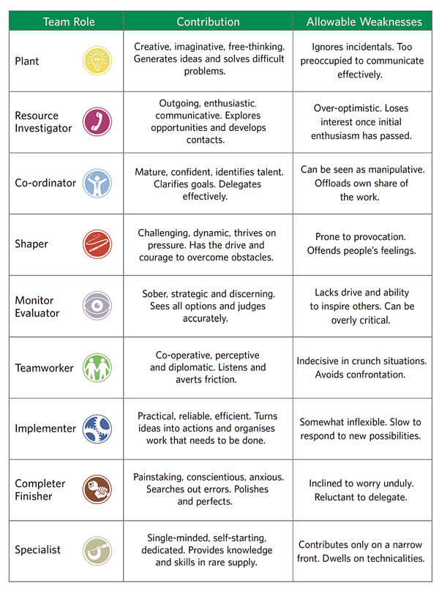

2.3. Project Life Cycle Planning Stage
The Planning Stage of the Project Life Cycle is being characterised by all the activities needed to plan the details of the project before starting the execution of the project (Thomas et al., 2008). In order to have an increased chance of a successful project, the planning is the best solution for it, as it allows the team members to gain a better understanding of what is required of them in order to achieve the main goal of the project (Thomas et al., 2008). It is essential that all the details are established within this stage and that the planning is done thoroughly to ensure that no needed activity has been overlooked or missed (Thomas et al., 2008).
For this stage, the team brainstormed a Quad Chart and then went in depth to evaluate the second quadrant, the Stakeholders, using the Stakeholders Analysis.
The Quad Chart is a project management tool that combines four important aspects of the project in one chart, which is utilised to have a clear indication of what those aspects (Stamey, Honeycutt, 2005). The Quad Chart can be customised based on the project and its needs (Stamey, Honeycutt, 2005), and for the Workshop, the Quad Chart was formed by Objectives, Stakeholders, Desired Outcomes and Measures of Success. Having the Quad Chart completed represented a needed guidance of the objectives of the workshop and its desired results and helped the team to further organise the workshop with that valuable information in mind. However, at the beginning, the team struggled to create a list of the desired outcomes, because the workshop was only meant to provide information, and this was a limitation of the team.
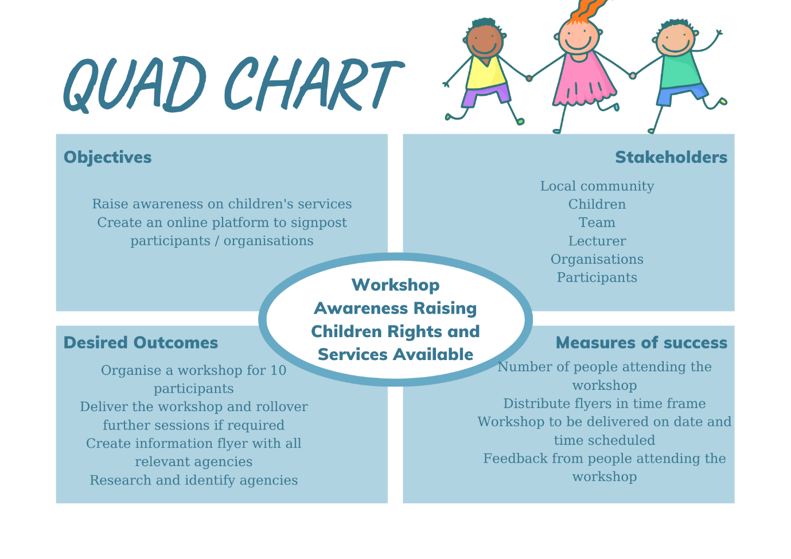
After the Quad Chart has been completed, the team began to in-depth analyse each quadrant, starting with the Quadrant 2, the stakeholders, as the first Quadrant represented the Workshop’s objective. While looking at the second quadrant, the Stakeholders Analysis has been applied to this in order to better understand each stakeholder, its level of importance and its specific role within the workshop and to have a detailed understanding of the stakeholder’s perspective to be able to produce an action plan (Riahi, 2014) to ensure that their workshop will not only meet, but also exceed their expectations. Given this, the Stakeholder Analysis for the workshop has proven to be very useful in determining a set of activities that the team must conduct in order to ensure that each stakeholder is satisfied by the workshop and its progress. However, the team faced the same challenge as when compiling the Quad Chart, the lack of imagination in determining the Stakeholder’s Perspective, as the workshop is purely informative, but with the lecturer guidance, the team has been able to gain this understanding and was able to correctly create the actions needed to make each stakeholder happy.
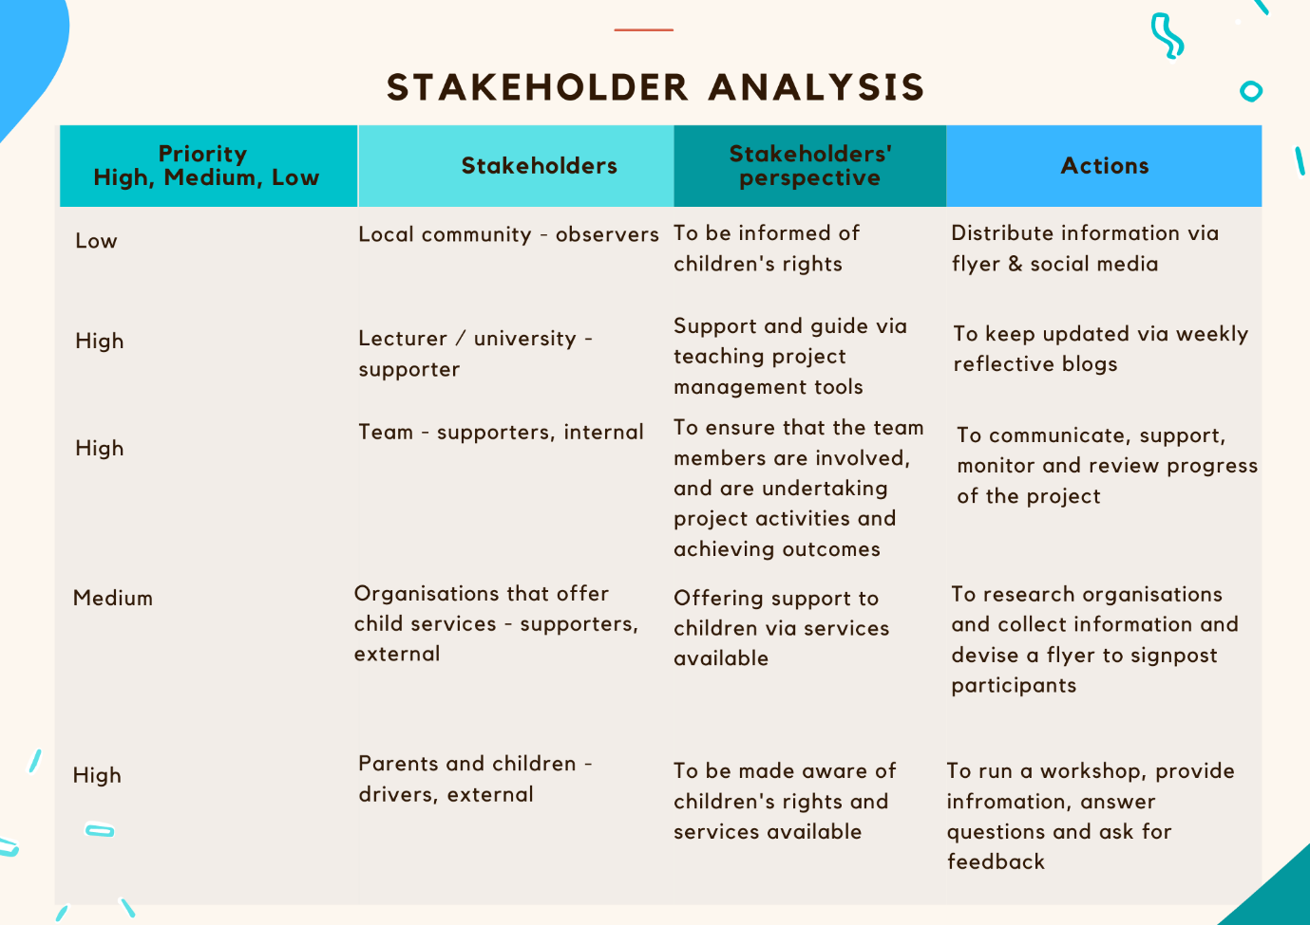

2.4. Project Life Cycle Execution Stage
The Execution Stage of the Project Life Cycle is the stage where the actual implementation of the project is happening (Marion, Richardson, Earnhardt, 2016). However, what many Project Managers are overlooking within this stage is the constant monitoring of the events, in order to be able to correct any error that will definitely happen (Marion, Richardson, Earnhardt, 2016).
Within this stage, the team has applied two project management tools to better delegate the execution of the project and to ensure that the deadlines are all achieved. The first tools applied was the WBS, which is the Work Breakdown Structure, and which helps to break each main objective into smaller tasks that are easier to achieved, but also easier to control and to keep track of the progress that is being made with the project (Globerson, 1994). The WBS helps to acknowledge the smaller activities or tasks that might be overlooked sometimes (Globerson, 1994). However, it does not provide the timely information about when the task must be completed (Globerson, 1994). This was the part where the team started to exceed and work without any limitation or challenges and was able to create a set of tasks for each part of the project.
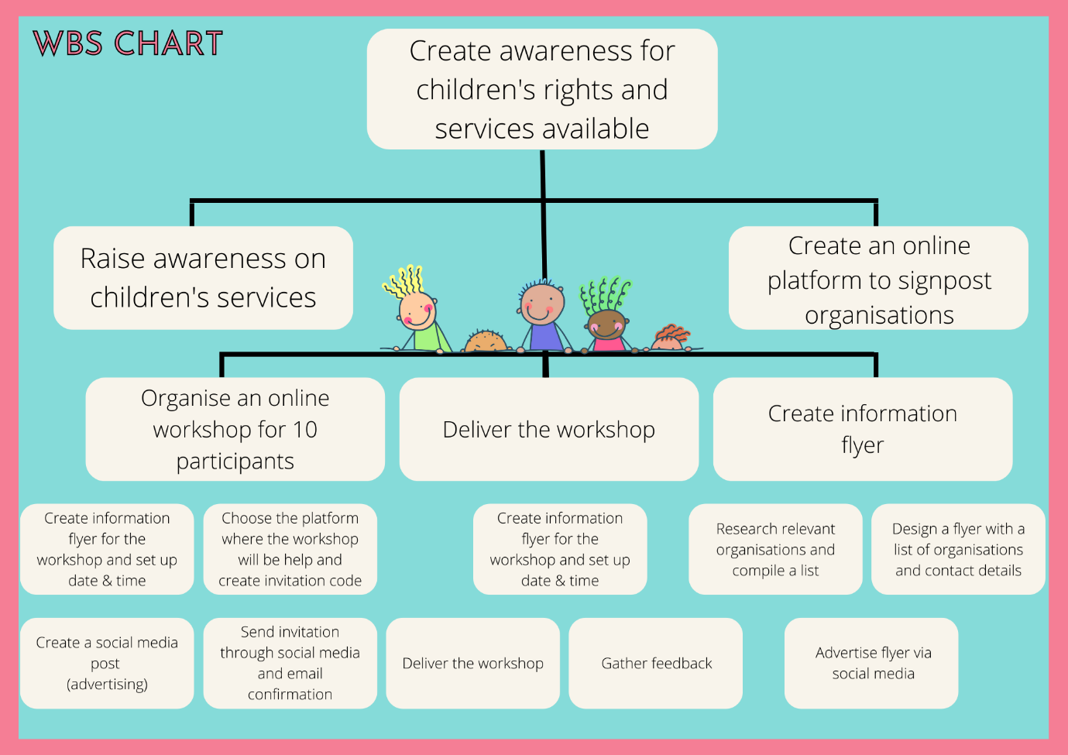
To be able to give each activity a time frame and to delegate it to a member of the team, the team applied the Gantt chart, which is a project management tool used exactly for scheduling the activities that must be done (Wilson, 2003). The Gantt Chart help to keep track of the activities, and because it also helps with the delegation of the tasks, it makes it easier for Project Managers to follow up on the person responsible to a certain task, and it improves the overall coordination of the project (Wilson, 2003). As the lack of Coordination was a reason for concern in the Initiation stage, the WBS and Gantt Chart together helped the team to better coordinate and keep up with all the actions needed to execute the workshop.
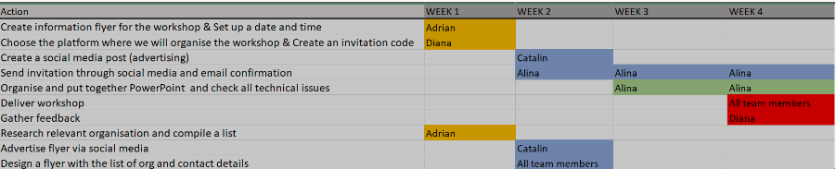

2.5 Project Life Cycle Completion Stage
This is the stage where all the activities necessary for the project have been completed and they must be analysed to check if the project achieved its objective or not (HBR Editors, 2016). The challenge of this stage is to recognise if and where things went wrong and to be objective in the evaluation (HBR Editors, 2016).
Within this stage, the team applied two project management tools. The first tool applied has been the Risk Assessment, which is a tool that offers not only an opportunity to recognise the risks and their likelihood and impact, but also offers the opportunity to prepare to combat these risks by creating a list of mitigating actions needed to avoid the risks (Aven, 2016). Again, the team succeeded at applying this tool because they were able to gain a better understanding of the project in the Initiation and Planning stage, and there have been no limitations or challenges while creating the Risk Assessment.
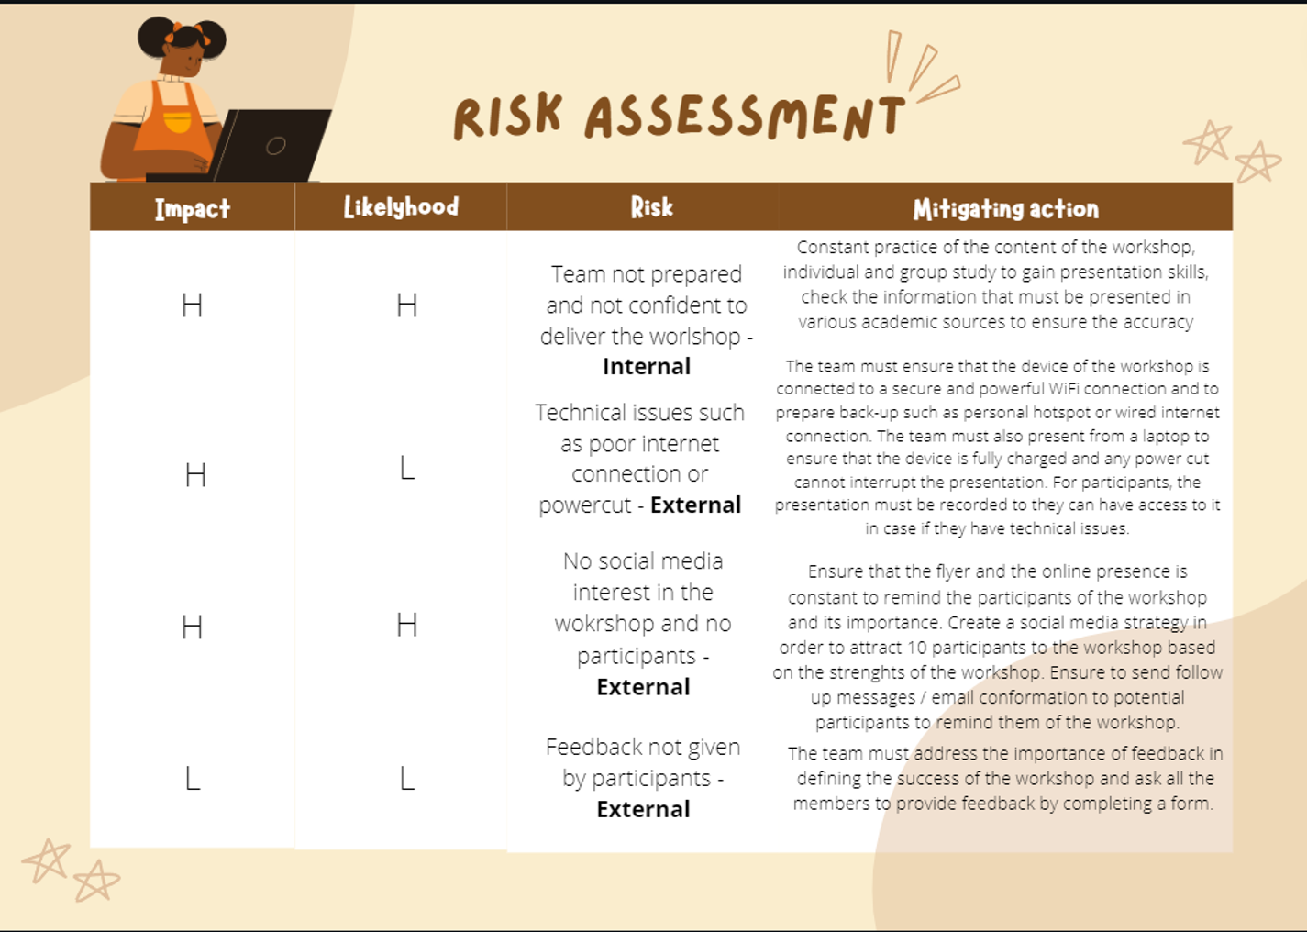
After the workshop has been delivered, to establish if it was successfully completed, the team performed a Project Evaluation. This is a tool that enable the team to be objective in discovering if the soft and the hard outcomes have been achieved (Zidane et al, 2015). The soft outcomes refers to the intangible outcomes, which cannot be measured, but the best way to establish if they were successfully achieved is by asking for feedback (Zidane et al, 2015). On the other hand, the hard outcomes are easier to recognise and assess, as they refer to outcomes that can be measured (Zidane et al, 2015).
The Project Evaluation applied for the workshop has determined that the team has been successful in achieving all the desirable outcomes proposed in the Quad Chart. While there were internal limitations provided by the lack of an Coordinator and Plant, the team used its other strengths very well and was able to highly perform and receive positive feedback from the workshop participants.
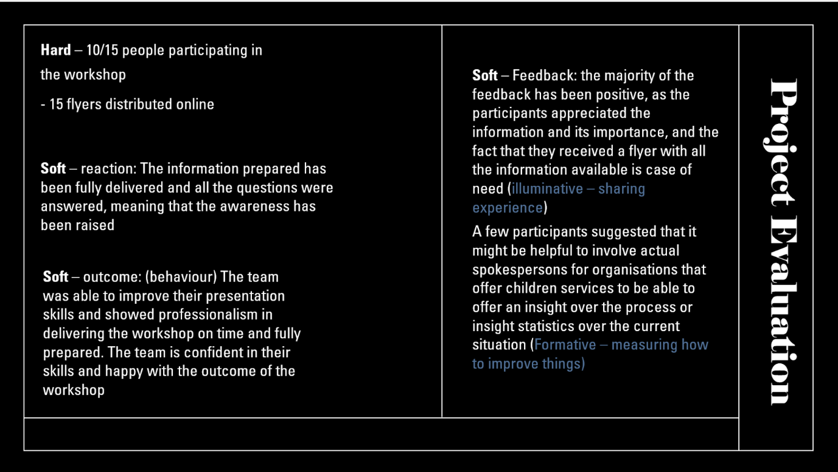
Moreover, the fact that the Project Evaluation established that the Awareness Raising Workshop of Children’s Rights and Services Available was a success, this means that each Project Manager has been successful in ensuring that the team is well performing. Moreover, each member of the team acted with responsibility and did not miss any deadline, and the overall communication and the atmosphere within the team has been impressive.
- Conclusions
The team chose the workshop in accordance with their personal experience, and it was a very motivating project. From this perspective, the team conducted each activity with respect and responsibility.
While the first two stages of the Project Life Cycle, Initiation and Planning, came with limitations in creativity and perspective, the other two stages, Execution and Planning, were successfully completed, because the team has improved and was considering every feedback received from the lecturer.
In conclusion, it is enough proof that the team acted as a highly performing team and each project management tool has been used accurately to ensure that the project will be finalised with success.
- Reference List
Aston, B. (2018) Why Is Project Management So Important To An Organization? [online] Available at: https://thedigitalprojectmanager.com/why-is-project-management-important/ [Accessed: 30th of June 2022].
Aven, T. (2016) Risk assessment and risk management: Review of recent advances on their foundation. European Journal of Operational Research, Vol. 253, Issue 1, pp. 1-13.
Ballard, G. (2006) Rethinking Project Definition in terms of target costing. [online] Available at: https://www.researchgate.net/profile/Glenn-Ballard-2/publication/252609919_RETHINKING_PROJECT_DEFINITION_IN_TERMS_OF_TARGET_COSTING/links/5665b00c08ae192bbf925b6d/RETHINKING-PROJECT-DEFINITION-IN-TERMS-OF-TARGET-COSTING.pdf [Accessed: 30th of June 2022].
Belbin, R.M. (2004) Management Teams: Why They Succeed or Fail. [online] Available at: https://www.sheffield.ac.uk/polopoly_fs/1.18832!/file/8-Horn-Team-roles-handout.pdf [Accessed: 30th of June 2022].
Bhunu, S. (2017) A closer look at project life cycles. [online] Available at: https://www.ee.co.za/wp-content/uploads/legacy/PositionITSept-Oct%2007-37-44.pdf [Accessed: 30th of June 2022].
Globerson, S. (1994) Impact of various work-breakdown structures on project conceptualization. International Journal of Project Management, Vol. 12, Issue 3, pp. 165-171.
HBR Editors (2016) The Four Phases of Project Management. [online] Available at: https://hbr.org/2016/11/the-four-phases-of-project-management [Accessed: 30th of June 2022].
Kennett, B. (2014) Planning and Managing Scientific Research: A guide for the beginning researcher. Chicago: ANU Press, pp. 19-37.
Marion, J.W., Richardson, T., Earnhardt, M. (2016) Project Execution: A Research Agenda to Explore the Phenomenon. [online] Available at: https://core.ac.uk/download/pdf/286703276.pdf [Accessed: 30th of June 2022].
Riahi, Y. (2017) Project Stakeholders: Analysis and Management Processes. SSRG International Journal of Economics and Management Studies, Vol. 4, Issue 3, pp. 37-40.
Rojas-Meluk, J. F. (2006). Project initiation and measurement: laying the foundation for better projects. Paper presented at PMI® Global Congress 2006—Latin America, Santiago, Chile. Newtown Square, PA: Project Management Institute.
Sonderlund, J. (2005) What project management really is about: Alternative perspectives on the role and practice of project management. [online] Available at: https://www.researchgate.net/publication/247832395_What_project_management_really_is_about_Alternative_perspectives_on_the_role_and_practice_of_project_management [Accessed: 30th of June 2022].
Stamey, J., Honeycutt, T. (2005) Quad charts in software project management. Journal of Computing Sciences in Colleges, Vol. 21, Issue 2, pp. 322-327.
Thomas, M., Jacques, P. H., Adams, J.R., Kihneman-Wooten, J. (2008) Developing an Effective Project: Planning and Team Building Combined. [online] Available at: https://journals.sagepub.com/doi/10.1002/pmj.20079 [Accessed: 30th of June 2022].
Wilson, J.M. (2003) Gantt charts: A centenary appreciation. European Journal of Operational Research, Vol. 149, pp. 430-437.
Zindane, Y.T.J, Johansen, A., Ekambaram, A. (2015) Project Evaluation Holistic Framework – Application on Megaproject Case. Procedia Computer Science, Vol. 64, pp. 409-419.

