University of Wales Trinity Saint David

Instrumentation & Control



Control System Design
Instrumentation & Control (ACDB5011)

Katie Byrne

2114211

19th July 2023

Lecturer: Stalin Jacob

Contents
1. Introduction
2. Simulations
- Simulation 1
- Simulation 2
3. Results
- Simulation 1
- Simulation 2
4. Discussion
5. Conclusion
6. References

1.Introduction
The behaviour of other systems or devices can be managed, ordered, directed, or regulated by a control system. A control system is a system that monitors and modifies the performance of a device or process using sensors or other feedback mechanisms. In other words, the definition of a control system can be paraphrased as a system, which controls other systems. To obtain the intended result, this may entail controlling temperature, pressure, speed, or other factors. Applications for control systems are numerous and include industry, transportation, energy production, and many more. They can be programmed to react to particular circumstances or events and can be created to work independently or under the control of an operator. [1]
A control system that uses an open loop does not feed the output of the system back to the input. Instead, a predetermined set point or reference value controls the input. After that, without receiving any feedback or adjustments, the system produces an output based purely on that input. Although simple and straightforward to use, open-loop control systems are less precise and less dependable than closed-loop control systems. They are frequently employed in situations when accuracy is not essential, like managing a fan's speed or a valve's position.
A closed-loop control system allows the system to adapt its performance in response to changes in the environment or other external factors because the system's output is sent back to the input. Through the use of a feedback loop, the system can identify mistakes or departures from a desired set point and make adjustments to bring the system back into harmony. Although closed-loop control systems are more difficult and expensive to implement than open-loop control systems, they are also more accurate and reliable. They are frequently employed in situations requiring accuracy and stability, such as managing the temperature of a manufacturing process or the position of a robotic arm. [2]

2. Simulations
Data analysis, algorithm development, and numerical computing are all done using the programming language and environment known as MATLAB. Simulink is a MATLAB add-on tool that enables the modelling, simulating, and analysis of dynamic systems. Simulink is what was used throughout the making of this simulation. To create a step input signal for a Simulink model, use the Step tool in Simulink. It is frequently used to model how a system will act in response to an abrupt change in input. A step function that can be utilised as an input signal to a system is produced by the Step block. Step time was set to 1, initial value to 0, final value to 1 and sample time changed to 10e-6 to display in micro-seconds. To add or subtract input signals, use Simulink's Add tool. It can be applied to your Simulink model to implement mathematical operations. Originally the add tool is set with two positive signs but this was changed to a positive and a negative sign for input signal. Simulink has a form of controller called a PID (Proportional-Integral-Derivative) Controller that regulates a system's output to a desired setpoint. It determines the discrepancy between the setpoint and the output of the system and modifies the input to the system in accordance with that discrepancy. Figured from this will be used in a later paragraph. The input-output relationship of a system is mathematically represented by the Transfer Function in Simulink. It is used to replicate a system's behaviour over time and to model dynamic systems. Again, figures of the transfer function will be focused and explained later. During simulation, the output of a signal is shown using Simulink's Scope function. It enables real-time observation of system behaviour. 4 input ports were added to this scope to attach at different parts of the simulation. [3]

- Simulation 1

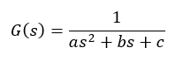
Figure 1
Using the Figure 1 equation, a, b, and c, were changed to 2, 1, and 1 as per the assignment brief tells to use the last three digits of one’s student number.

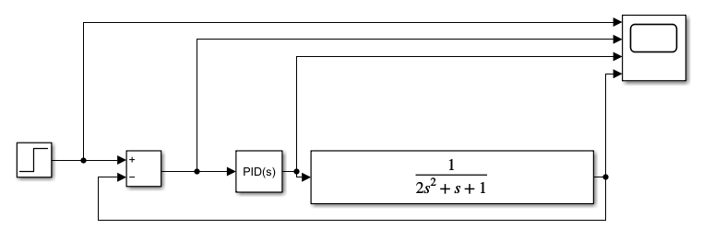
Figure 2
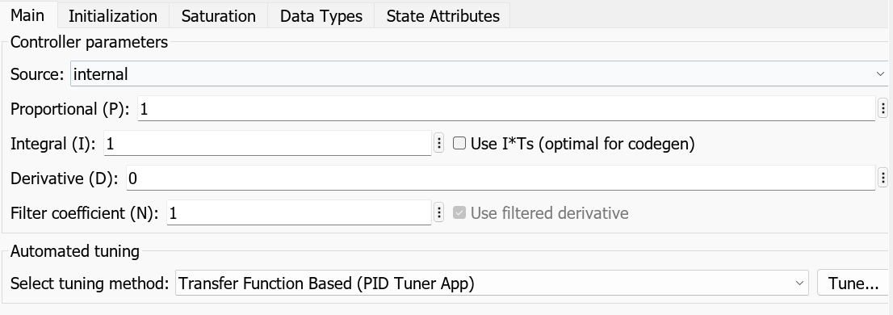
Figure 3
Figure 2 shows the closed loop system created on Simulink. The PID(s) figures in Figure 3 show the Proportional set to 1, the integral set to 1, the derivative set to 0 and the filter coefficient set to 1. The behaviour of the controller can be altered by modifying the controller parameters in Simulink's PID block. The proportional gain modifies the controller's reaction to the current error, the integral gain modifies the controller's reaction to the cumulative error over time, and the derivative gain modifies the controller's reaction to the error's rate of change. You can modify the controller to get the desired performance and stability of the system by changing these parameters. The numerator was set to [1] and the denominator set to [2 1 1] to follow the assignment task of using the last three digits to each individual student. The mathematical relationship between a system's input and output can be changed by changing the transfer function in Simulink. The system's behaviour is mathematically represented by the transfer function, which explains how the system reacts to an input signal. You can alter the system's behaviour and simulate various scenarios by modifying the transfer function. For instance, by altering the transfer function, you can model the behaviour of a completely different physical system or the impact of adding a filter to an existing one. [4]
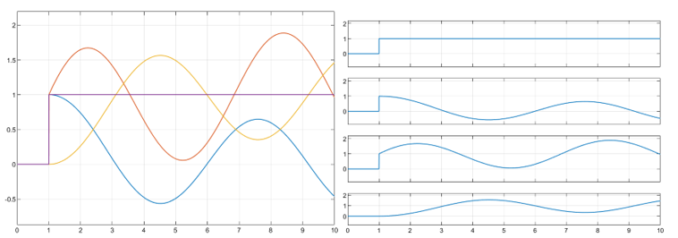
Figure 4
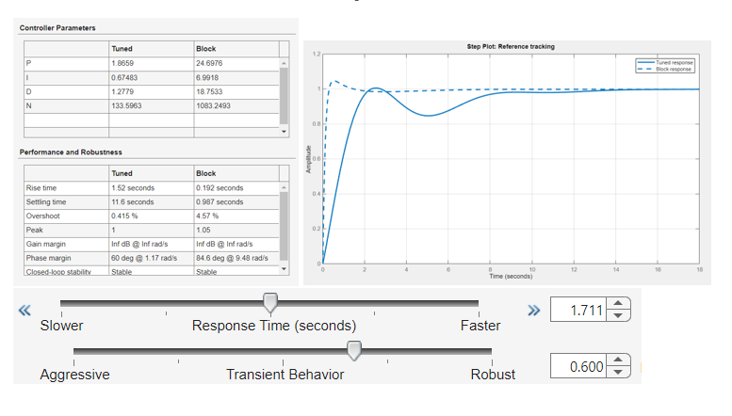
Figure 5
In Figure 4 it shows the scope calculated from the closed loop circuit before any tuning takes place. Figure 5 shows the original rise time, setting time and overshoot percentage. These are the figures that are of interest. The aim of the tuning, which will happen next, is to achieve a setting time less than 2 seconds and an overshoot less than 5 percent. To achieve this response time and transient behaviour must be adjusted accordingly. The response time (seconds) in Simulink's PID tuner option can be slowed down or speeded up to alter how quickly the controller reacts to changes in the system. Although the controller will take longer to attain the desired output with a slower response time, it will be less likely to oscillate or overshoot. A quicker response time means that the controller will react to changes in the system more quickly, but it will also increase the likelihood that it may oscillate or overshoot. You can fine-tune the controller to get the required performance and stability of the system by changing the reaction time. The controller will react to changes in the system more quickly if the transient behaviour is made more aggressive in Simulink's PID tuner setting. This can shorten settling time but may also lengthen overshoot and oscillation. The controller will be less sensitive to changes in the system as a result of making the transient behaviour more resilient. This can lead to a shorter settling period but may also lessen overshoot and oscillation. You may tune the controller to get the required performance and stability of the system by changing the transient behaviour.
- Simulation 2
To create the second simulation calculations were solved to enable the PID parameters in the PID Controller to be changed.
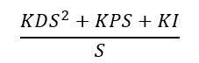
Figure 6
The formula above in Figure 6 is used to get these calculations.

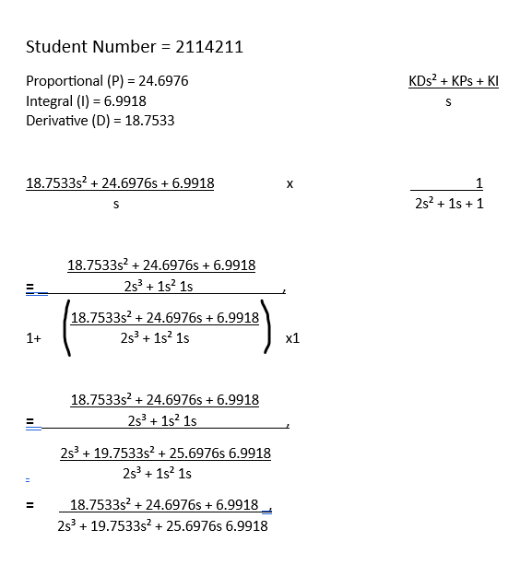
Figure 7
Using the results of the control parameters in simulation 1 a calculation (shown above in Figure 7) was able to take place to calculate the next values for the transfer function.
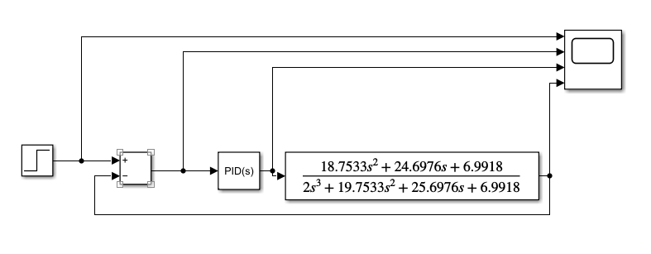
Figure 8
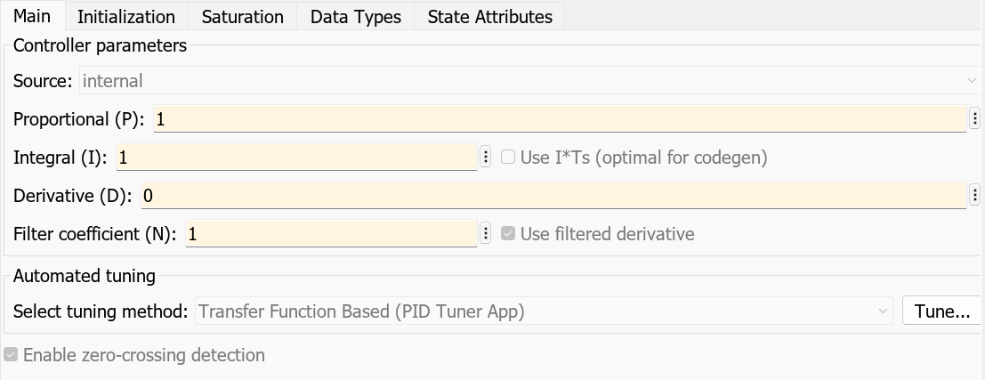
Figure 9
Once the new transfer function was inserted, the PID controller was changed back to the original 1, 1, 0, 1 figure.

3. Results

- Simulation 1
PID Tuning
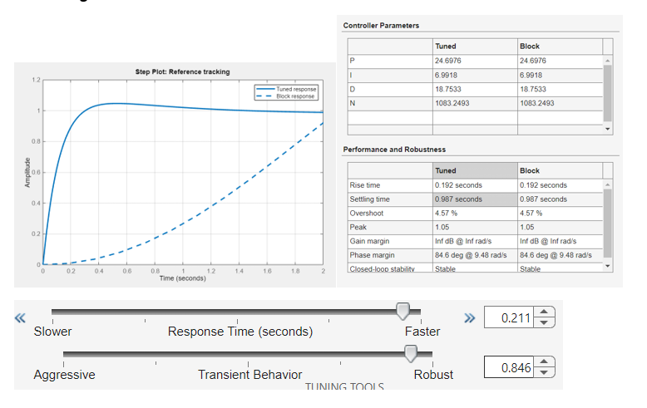
Figure 10
In Figure 10 it shows the results of the PID Tuning. With a Response time of 0.211 seconds and a Robust Transient Behaviour of 0.846 the performance managed to get to a 0.987 second Setting time and a 4.57% overshoot.

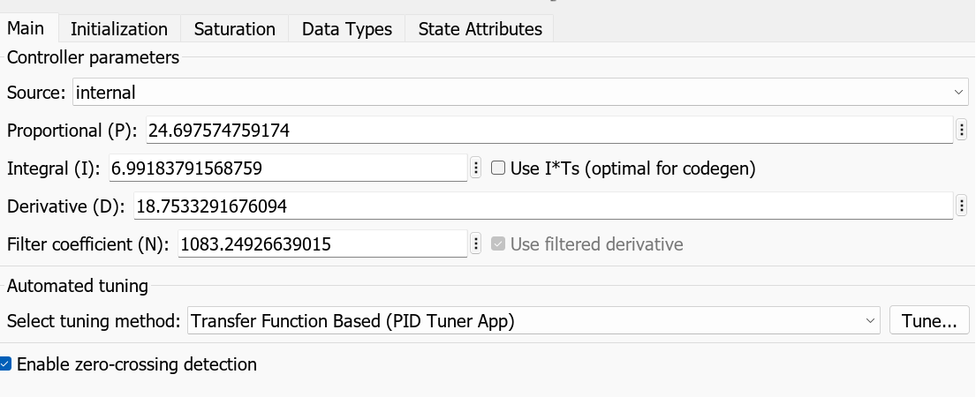
Figure 11
Figure 11 shows the new controller parameter results. Proportional at 24.6976, Integral at 6.9918 and Derivative at 18.7533. These will go on to use as figures for the simulation 2.
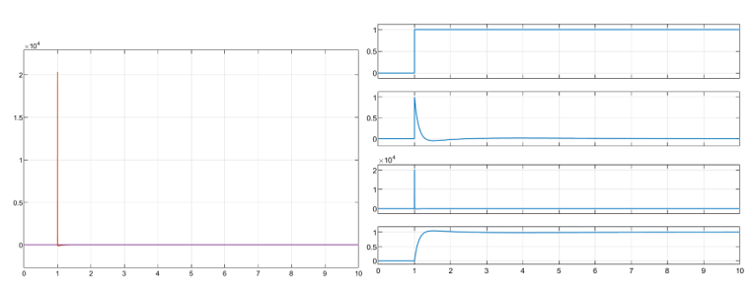
Figure 12
Figure 12 shows the scope of the tuned closed loop control system. On the right-side results of each individual input port are shown along with the left side showing the overall results together.

- Simulation 2
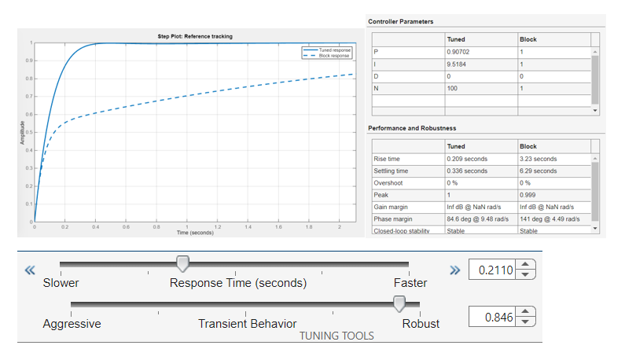
Figure 13
Shown in Figure 13 the response time was set to 0.211 seconds as it was when originally tuned with the [2 1 1] denominator using student numbers. This hit the aim of under the 2 desired seconds. The transient behaviour was also set to the tuned results of simulation 1 to 0.846. With these values the closed loop control system ended up having a setting time of 0.336 seconds and an overshoot of 0%. Overshoot is under the 5% allowance.

4. Discussion
As mentioned previously, the setting time had an aim to be under 2 seconds long. A PID tuner with a settling time of less than 2 seconds is required to ensure that the system output reaches the desired set point quickly and efficiently. Settling time is the time required for system performance to reach a specified range of a desired set point and remain within that range (usually within 5% of the set point). By limiting the settling time to less than 2 seconds, you can ensure that system performance reaches the desired set point quickly and smoothly without overshooting or excessive fluctuations. This is important for systems that require fast and precise control, such as manufacturing, robotics, and aerospace.
The overshoot had an aim to be less than 5% in this simulation. The PID tuner overshoot should be less than 5% to prevent the system output from exceeding 5% of the desired setpoint. Overshoot is the amount by which the system's performance exceeds the desired setting before levelling off. Excessive overshoot can cause system instability and oscillations. Limiting the overshoot to less than 5% allows system performance to stabilize quickly and smoothly without jitter or excessive overshoot. This is important for systems that require precise control and stability.
A PID tuner is tuned to tune the PID controller parameters to achieve the desired performance and stability of the control system. PID controllers are feedback control mechanisms that are widely used to control a wide variety of systems, from simple consumer electronics to complex industrial processes. A PID controller uses feedback from the system output to adjust the control input to maintain the desired setpoint. The tuning process involves adjusting the proportional, integral, and derivative gains of the controller to achieve the desired response characteristics, such as: Fast response time, minimal overshoot, and robustness to disturbances.
By tuning PID controllers, you can ensure system stability, responsiveness, and efficiency under different operating conditions. Using the PID Tuner to tune your PID controller provides the following benefits:
- Improved system response: By tuning the controller parameters, you can achieve faster response times, minimal overshoot, and smoother settling times, which can result in faster and more accurate system control.
- Enhanced stability: By tuning the controller to be more tolerant of disturbances, the system can remain stable and not oscillate or become unstable under different operating conditions.
- Increased efficiency: By optimizing the controller parameters, the system can operate more efficiently, using less energy and resources to achieve the desired performance.
- Improving product quality: Ensuring that a system is operating within desired performance limits can improve the quality and consistency of the product or process it controls.
[5]

5. Conclusion
In conclusion, both simulations met the under 5% overshoot and under 2 second aim. The closed loop control system simulation all works together with both simulation 1 and 2 making sense when applied together. The results achieved is somewhat what was expected as the aim was achieved in both simulations. The maths equations worked well in explaining what we were doing and why. Simulink itself shows many features that can be seen as useful in future. Overall better understanding of the wider scope of closed loop systems and how they come to work.

6. References
What is a Control System? (Open Loop & Closed Loop Control Systems Explained) | Electrical4U
https://planeus-solutions.com/blog/en/closed-loop-vs-open-loop-production-control-system/
Simulink Tools - MATLAB & Simulink - MathWorks United Kingdom
https://uk.mathworks.com/discovery/transfer-function.html
5 exciting benefits of using PID tuning software – picontrolsolutions (wordpress.com)

