THE IMPACT OF VLE (VIRTUAL LEARNING ENVIRONMENT) ON EDUCATION INSTITUTIONS
IN THE UK

PREPARED BY

THERESA OKONKWO ONUORAH
STUDENT ID: 1917499

SUPERVISED BY
SUNETH FERNANDO

MODULE CODE: BMSW4003
DEPARTMENT OF HEALTH AND SOCIAL CARE
UNIVERSITY OF WALES TRINITY SAINT DAVID
LONDON

JUNE, 2020
TABLE OF CONTENTS
Introduction -------------------------------------------------------------------------------1
Background of study---------------------------------------------------------------------1
Aims and objectives of the study-----------------------------------------------------2
Methodology------------------------------------------------------------------------------3
Results--------------------------------------------------------------------------------------5
Discussion---------------------------------------------------------------------------------8
Conclusion-------------------------------------------------------------------------------10
References-------------------------------------------------------------------------------11

INTRODUCTION
Virtual learning environments (VLE) have recently emerged as an important topic in education theory and practice (Weller, 2007). It includes the use of software or the internet in delivering instructions to students either in a particular area or in distant locations across the world. A well-maintained virtual learning environment (VLE) should enable students of all learning styles to receive the best possible education in a way that they may not receive it in an exclusive lecture-based environment which tends to be focused on auditory learners only (i.e. those who learn best by listening (Williams and Fardon, 2005; Vigentini, 2009). If the resources on a VLE do not cater for the needs of the students - both in terms of their format (text files, audio files, videos etc.) and their content - the VLE is rendered useless as it does not add to the students’ learning experience. Ideally (for students studying together rather than distance learners) it should contain just enough information to allow students to strengthen their lecture tasks and gain a broader and deeper understanding of the subject (Ofsted, 2009), preferably through a range of presentational styles (such as video or audio clips). Virtual learning environment is capable of providing a central focus for both students and staff irrespective of their location thereby aiding continuity in the teaching and learning processes. Virtual learning does not include the constant use of mails for communications between students and teachers about schoolwork; as helpful as this might sound, it does not change how students are taught nor how the comprehend (KANIMOZHI, 2018). Virtual learning environments are consolidated within education institutions. Therefore, it does not seem relevant to question their acceptance. However, it is a challenge to turn them into an important contribution to students’ performance.

Background on the study
The value of a good education is seen in how these virtual materials are presented as virtual learning has become integral to online learning (e-learning) in higher institutions around the world and it involves the use of a computer software in teaching, learning or carrying out online research. It reduces the need for a teacher to share the classroom with students. The search for a more and better education has been one of the concerns of almost every country in the world. The Recent Malaysian Government initiative introduced Frog Virtual Learning Environment (Frog VLE) to establish a simpler life for teachers and students while enhancing the teaching and learning process. The Frog VLE is a web-based learning system that replicates real life learning by incorporating virtual equivalents of traditional concepts of education. This online learning management system was therefore launched in order to enlarge the learning experiences beyond the classroom. In addition, the Frog VLE also caters searchable lecture materials, forums, streamed video and assessment as a learning and teaching resource. It is also necessary to note that this so-called frog VLE is the same as the VLE we are considering in this study.

Aims and objectives of the study
This paper aims to assess the studying and learning experience and influence of VLEs on students’ performance, a questionnaire was distributed to the undergraduate students of an Italian public university.
The aims and objectives of the study consist of:
- Identifying the students’ frequency of access to their institution’s VLE
- Assessing the positive and negative experiences students might have with VLEs
- Identifying study needs in order to know areas that need improvements
- Understanding the contributions of VLE to students’ learning processes
- Relating the frequency of access to VLEs to students’ performance
After gathering the data, the results will then be analyzed and used to make recommendations on areas of improvements on the part of the institution and the areas where a cut down is required if any and that is the main objective.

METHODOLOGY
The main data collection tool used in this study was a questionnaire. The data was obtained from students, lecturers and Admins at the university with respect to the institution’s virtual learning environment and student registration system. The access and obtainment of the data is in line with the institution’s privacy policy regarding authorization, confidentiality and data access. The validity and reliability of the data is guaranteed as it was gotten directly from people who in one way or the other are linked to the institution either as workers or as students.
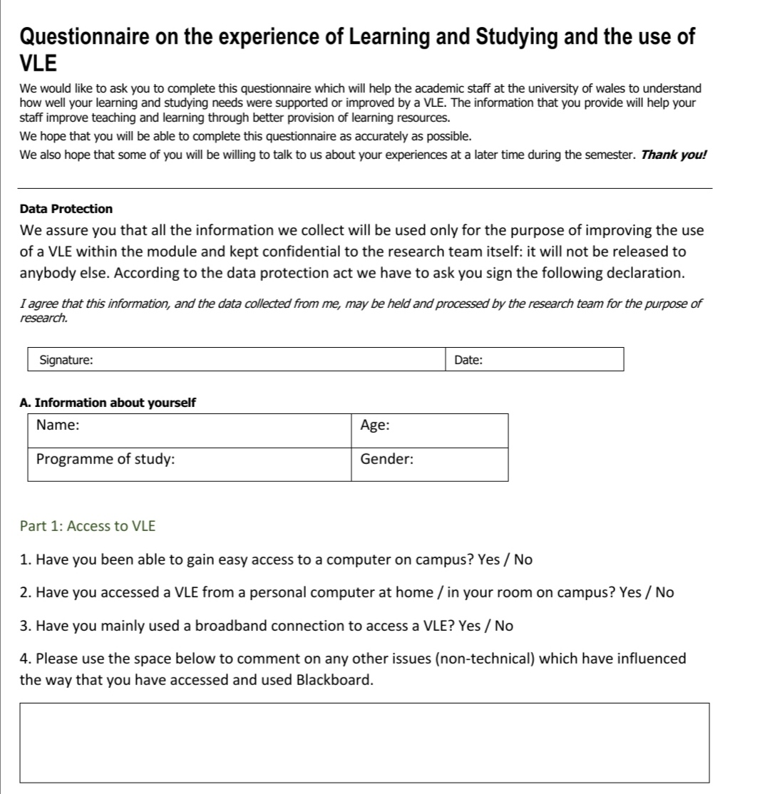
The data was compiled from 12 people using secondary research approach in order to obtain quantitative and qualitative data. The questionnaire consisted of 3 parts; part 1 was used to draw data on the access to VLE and it comprised of 3 Yes or No questions with an open end question, part 2 was used to draw data on the Experiences in using a VLE and it comprised of 8 questions stating Agreements or Disagreements and part 3 saw the contribution of VLE to the learning or understanding of the individual and it comprised of 3 open end questions as shown below.

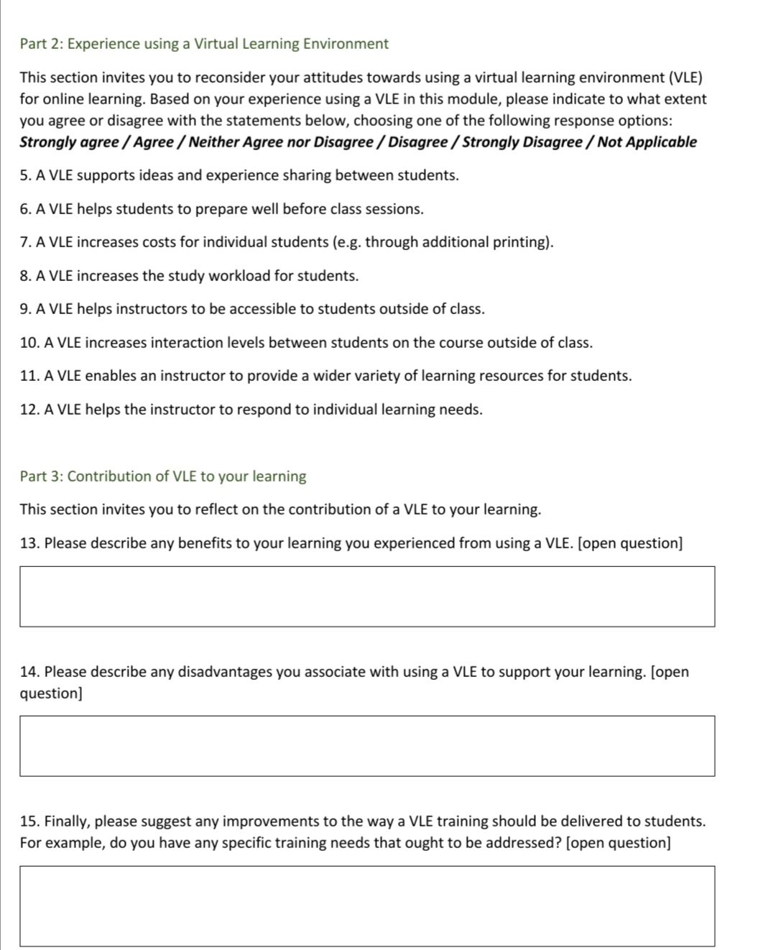

RESULTS
In this part, the answers to the questionnaire in association with the assessment of the influence of VLEs on the performance of higher education students and feedbacks from lecturers and Admins as regards the use of VLE. The results obtained shows that everyone has different a different approach to learning and this is shown by their responses to the questionnaire. In a VLE, everyone can take notes, save to a computer or print for offline use. It is not possible to draw conclusions on a student’s involvement based on the number of times that student participates or clicks whenever they access the VLE as stated by Wolff et al.

Table 1.1: Responses for part one (Questions 1-3)
Questions | Responses (Yes) | Responses (No)
Q1 | 10 | 2
Q2 | 8 | 4
Q3 | 12 | 0

The results obtained above shows that Q3 recorded no negative responses and simply means that access to a VLE is mainly via a broadband connection, while the minimum response for Q1 shows that just a few students do not have access to a computer on campus either because the university did not make it available to them in their institution or they could not afford a personal computer. The difference between the positive and negative responses for Q2 shows that more students are able to access a VLE directly from a personal computer at home and this number is slightly higher than those who cannot access a VLE directly from home.

Table 1.2: Responses for part two (Questions 5-12)
Questions | Strongly Agree | Agree | Neither | Disagree | Strongly Disagree | Not Applicable
Q5 | 4 | 5 | 0 | 2 | 1 | 0
Q6 | 3 | 3 | 1 | 5 | 0 | 0
Q7 | 2 | 5 | 0 | 5 | 0 | 0
Q8 | 2 | 5 | 1 | 4 | 0 | 0
Q9 | 2 | 4 | 0 | 4 | 2 | 0
Q10 | 1 | 4 | 0 | 6 | 1 | 0
Q11 | 4 | 6 | 0 | 2 | 0 | 0
Q12 | 3 | 4 | 1 | 3 | 1 | 0

The above chart shows a strong positive response for Q11 and this means that the students are happy about the fact that a VLE helps the lecturer provide a wider variety of learning resources for students but on the other hand, a high negative response is recorded in Q10 and this means that students are not able to interact with each other on the course outside of class, this interaction can be seen after class in a face to face session where students are congregated and after class, the students are able to interact and proffer solutions to questions that had been posed in class. Also, in Q9, it is seen and an Agree and Disagree were recorded, also an equal amount of Strongly agree and Strongly disagree were also recorded on the question, this tie means that the students are not happy about the fact that lecturers are not accessible to students outside of class as a result of VLE.

Table 1.3: Maximum and minimum responses for Q5, Q7 and Q11
Questions | Max responses | Min responses
Q5 | 5 | 1
Q7 | 5 | 5
Q11 | 6 | 2

The max and min responses were collected from questions that had the most positive feedbacks and as suspected, Q11 was the highest because a VLE has been understood as a medium through which lots of materials can reach the students and they would also find these materials easier to access. Students provided a balanced feedback in Q7 which means that generally, they are not happy about the cost increases the have to face as a result of the provision of many online learning materials.
As regards the open-ended questions, a constant feedback was obtained for question 14 where all respondents laid emphasis on the fact that the major disadvantage they could think of in a VLE was the internet. Further clarifications will be given in the next chapter.

DISCUSSION
The research on VLE was carried out by the use of a questionnaire which was attached in the methodology, as recorded in the results page, the feedback from responders displayed a lot as regards individual preferences and opinions when it comes to using a VLE. The results recorded were gotten from 12 respondents and as regards the open-end question in the first part, 4 respondents stressed that they had not experienced any problems in using a VLE while one person complained about poor service, another had nothing to say about the experience, another respondent simply explained that sometimes she found difficulties in using the system, I personally think it may be because the process is too complicated sometimes or it is generally due to the service, 5 students complained that a VLE sometimes crashes, freezes or goes off during lessons and I think this might sometimes be due to the system being overloaded or simply due to bugs in the system, either way, with the collected responses from the respondents in part one, we can say that a VLE definitely need s to be worked on in order to avoid crashing or freezing especially during lessons as this can disrupt the flow of information to the students, waste people’s time and eventually cause them to lose concentration and willingness to participate during lessons.
In part two, the highest agreement is noted in Q11 as we got 4 people strongly agreeing and 6 simply agreeing with the fact that a VLE enables the instructor to provide a wider variety of learning resources for students, this high number means that this fact is true because in a VLE, the lecturer is able to support lessons with online materials either through Google or other search engines and in turn able to share these materials in real time with the class. On the other hand, a high number of disagreements was also recorded in Q10 with 6 simply disagreeing and 1 strongly disagreeing with the fact that a VLE enables interaction between students outside of class, this data is true because usually after an online session, the VLE is shut down as soon as the lecturer who is in most cases always the host is ready to go off, and this does not give students the opportunity to interact after the lesson and they are forced to work with just the clarifications they were able to get during the class. It is also safe to point out that there was a tie in the responses on Q9 with 6 respondents on the agreement side and 6 on the disagreement side, this tie is quite tricky because on the agreement side, we can say that most people are happy about the fact that they can reach their lecturers via emails anytime they want and get clarifications but the other people are not happy about the fact that they cannot see their lecturers face to face in order to get proper explanations because there is only so much a person can explain via email and often times, it is not enough especially when it comes to courses that have to deal with mathematical equations and formulas.
In part three of the questionnaire, when respondents were asked about any benefits they had gotten from using a VLE, two people said that a VLE is the best alternative for classroom teaching, about four people said that a VLE had improved their IT skills and one added that it saved her money on commuting to school every day, another person added that a VLE increased his attitude to time, three people added that there was an improvement in their research skills, another said she is happy as she gets to access materials from the comfort of her home and the last said the variety of learning which is attributable to Q11. When asked about the disadvantages, almost everyone was of the opinion that the major disadvantage associated with using a VLE was the Internet because where Internet is absent of where the broadband connection is poor, a VLE would have to worst recommendation, one person said that a major disadvantage was lack of human contact and less opportunities to ask more questions which brings us back to Q10 and another simply said there were no disadvantages. And finally when asked about improvements to be made, two people said that the operations needed to be controlled by the local branch, I guess if this is made possible, the issue of disagreements with Q10 would be resolved because then, even if the lecturer goes off, the students would have more time to discuss after class or even organize reunions, two people said that a VLE had improved their research skills, another person was of the opinion that a VLE needs to be more regular in order to help students, another said that a VLE should be introduced to students from a very young age as this would help in understanding the technicalities involved and some people argued that there should simply be a constant improvement on the part of the institution which should in turn provide special internet access solely dedicated for VLE use in order to tackle the problem of connectivity, one person simply stated that more attention should be paid to the students’ participation as sometimes, a person can connect but is absent especially in cases where the VLE does not include an obligatory video connection.
In my personal opinion, a VLE is a very good way to learn and I have noticed an improvement especially in my IT skills as there is always something new to learn on a daily basis. Just like everything else, it has its advantages and disadvantages, a major advantage being that apart from the fact that I can learn what was intended by the lecturer, I also end up learning something new which I did not know about before in the digital world and these are things that I would need in the job market , on the other hand, a VLE has got a major issue and that is with the connection and lack of proper interaction with colleagues, I really hope that these issues could be resolved with the aforementioned recommendations herein.
Furthermore, I would like to add that this research has really opened my mind to a lot of new things and experiences, I was able to access more materials, read and understand, prepare a questionnaire which at first when the lecturer said it in class, I felt I might never be able to do it and above all, I was able to create charts and represent my ideas on excel which has been a major thing I am most happy about.

CONCLUSION
In conclusion, this research was carried out with a majority of respondents being students and a few workers who also used a VLE in one way or another, the results documented here shows everyone’s opinion and feelings as regards a VLE, it is safe to note that everyone will be generally happy about the VLE if the major problem of connectivity is resolved on the part of the institution. However, by applying appropriate analysis, we realize that the field of study also affected some persons responses just as those who complained about access to lecturers. Finally, this research was carried out by taking just 12 people into consideration and therefore cannot be generalized but then, the results also show feedbacks regarding students’ access to a VLE and these feedbacks should not be ignored.

REFERENCES

Maroco, J. (2010). Análise estatística: Com utilização do SPSS (3. ª Ed.). Lisboa: Edições Sílabo.

ECAR Working Group. The Predictive Learning Analytics Revolution Leveraging Learning Data for Student Success. Available online:http://net.educause.edu/ir/library/pdf/ewg1510.pdf.

Dahlstrom, E., Brooks, C., & Bichsel, J. The Current Ecosystem of Learning Management Systems in Higher Education: Student, Faculty, and IT Perspectives. Research report. Louisville, CO: ECAR, September 2014. Available online: http://www.educause.edu/ecar.

Norton, P., Porter, S. From Bricks to Clicks: the potential of data and analytics in Higher Education, The Higher Education Commission, Available online:http://www.policyconnect.org.uk/hec/research/report-bricks-clicks-potential-data-and-analytics-higher-education. 2016.

Morais, C. Complexidade e comunicação mediada por computador na aprendizagem de conceitos matemáticos: Um estudo no 3.º ciclo do ensino básico. Tese de Doutoramento em Educação - Área do Conhecimento de Metodologia do Ensino da Matemática. Braga. Universidade do Minho. 2000.

