Database Design (The Book Store)
Information Engineering
ACCB4012
James Beard
1901671

Table of Contents
Abstract
Section One – Tables
Section Two – Forms
Section Three – Reports
Section Four – Menu System
Conclusion

Abstract
This report aims to discuss the steps that the author took in designing a database for a bookstore in Swansea. The first section discusses the author's initial idea of how he wanted to build the database, the tables he wanted and the relationships that would connect the tables. The next section discusses the forms that the author created to allow customers and staff members to search information, create new records within the database and how the author wanted to display the information and forms to the user with his design ideas. The next section discusses the reports that the author created, how he completed them, why he created them, the design of the reports and why he chose to display the reports this way. After this we come to the menu section in this the author will discuss how he designed the visual aspects of his menu. The other aspect covered in this section is the navigation design to ensure that the user could navigate around and find the desired information or product. In the final section, the author will evaluate his database with what he felt went well and what he would like to improve on in future assignments.

Section One - Tables
Initial idea
Initially, the author wrote down the initial tables that he felt the database would need to perform the required tasks for a bookstore as recommended to do so at step two of CAT [1], these include a table for book data which is, of course, self-explanatory without this table how will the company keep tabs on the books in its collection. Other tables include authors, publisher, staff, wages, and timetable to name a few. After thinking up the ideas he began to list the possible fields that would be in the tables, This was the third step recommended in the CAT design process [1]. Such field found in the book table would include the book title, price, edition, release date as well as linking in the author and publisher which the author will discuss in the relationship sub-section. The author aimed to ensure that other than foreign keys that there were few duplicate fields used in multiple tables as advised by Exeter university's PDF on creating databases [2] All this information gives the user and database a range of information that can be used later to group data and search to find exactly what the user wants.

Relationships
The importance of gaining an initial idea on how different tables would be linked together through foreign keys was important as it would because vital in ensuring that his multi-table queries were successfully made with the desired information in them, the queries need to be correct so that information could be searched for and viewed correctly in the forms and reports. So, this initial couple of minutes of setting out a plan on the relationship of his database would be vital in creating a successful database for both staff and customers. As briefly touched on Above the book table would need an author field and a publisher field, both the author and the publisher would be credited and responsible for many books, so for this reason, both the publisher and author entities have one too many relationships with the book entity, ERD can be found in appendix two. Other relationships include the staff table/entity to the wages table/entity and timetable entity/ table, the staff ID to timetable ID relationship should be a one to one relationship in this database because a staff member can only have one timetable at a time and with staff having different schedules to each other the timetable id is specific to the staff member this can also be seen in the ERD found in appendix two.

SQL
The majority of the tables used in this database were made using SQL and some examples of the SQL used to build the table can be seen below. The reason for predominantly using SQL is the speed in which the author was able to add the field needed for the table to function correctly with all the formatting to the field, other creating a table then adding the field name, then having to find the desired field type, then searching the formatting wanted for the field. The author also used SQL to insert some records into his table such as adding a customer into the customer table, although it worked correctly it took far longer in the author's opinion to insert the data this way instead of adding the data for the record in the specific fields on the desired table. This was because the author had to remember what Id’s he had used, writing out the SQL field names then adding the input information afterwards took up more time than adding the data straight to the field, for these reasons the majority of information in this database was added straight into the tables. The author consulted and compared several references to ensure that he was able to successfully write the commands to build the table as desired, these references include Microsoft Documentation [3], Baskent [4] and Structured Query Language from Moodle [5].
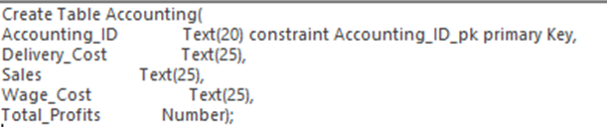
Example screenshots below, more can be found in the database.

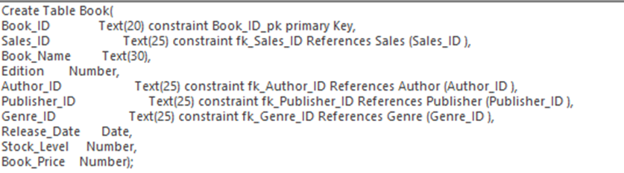

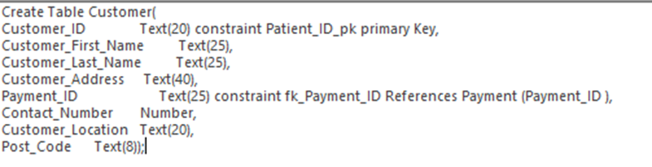

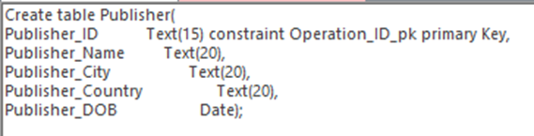

Section Two - Forms
Navigation and control design
The forms displaced in this database includes several different buttons for completing different tasks depending on what is required for the user to be able to navigate and uses successfully. Some of the forms only include a button to exit/close the form this style was used for forms where the users have searched for something with only one result or record such as if searching for a specific customer record using the customer id only one page will be shown as every customer id is unique and specific to one person. However, if the staff opened the customer record form instead of the search form then the more button will be in effect to help navigate to different records, these buttons include a left arrow to view the previous record, a right arrow to view next record, a line and left arrow to go to the first record, a line and right arrow to view the last record, a magnifying glass to search a keyword in the form, add record button so staff can add records to the record forms and again the exit button to close the form. Adding records is a specialist button in the sense that it is only included on the staff record forms that can’t be found in the customer menu. Any search form that comes back with more than one result or record will have all of the same buttons as the record reports other than the add record button, preventing unauthorised persons from making changes to the database.
Visual Display
The visual design of the forms was kept relatively simple with a light blue background, the reason for this is that after researching the best possible colours to use for his website blue was chosen. The reason it was chosen was that blue is associated with understanding and softness according to Rikard and according to six-degree blue peace, calm, trust, and business. Theses are feeling the author hope the forms give when being used, as it is a database with a customer cliental so it must leave the customer with a good impression, Blue is also a much more visually stimulating colour than just black text on a white background that is quite a boring combination for the customers to view. The blue was a lighter shade as this give a strong contrast with the black text for customers to read the text. All the control buttons are white with a black text again for a strong contrast between background and text, the white button on blue was used to hopefully give the impression of cloud on nice blue sky, again to give a calming impression.
Example screenshots below, more can be found in the database.
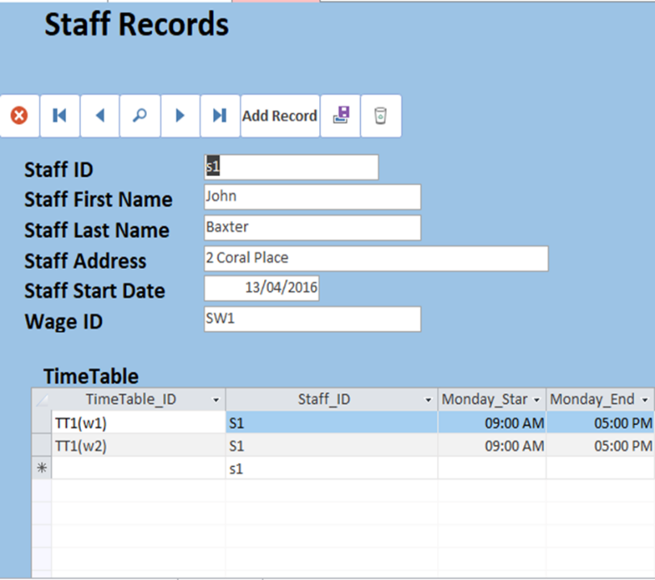
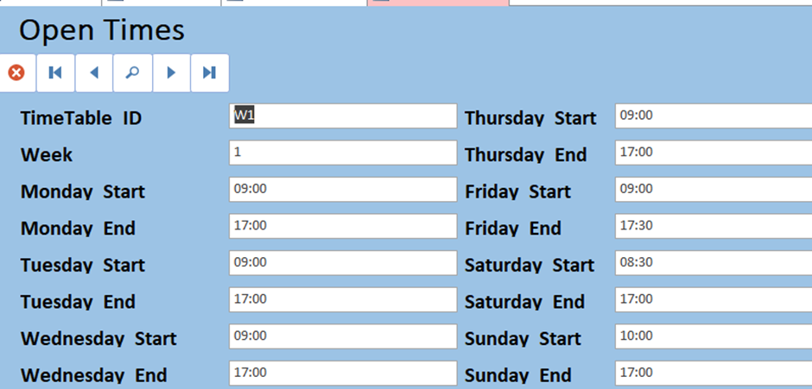
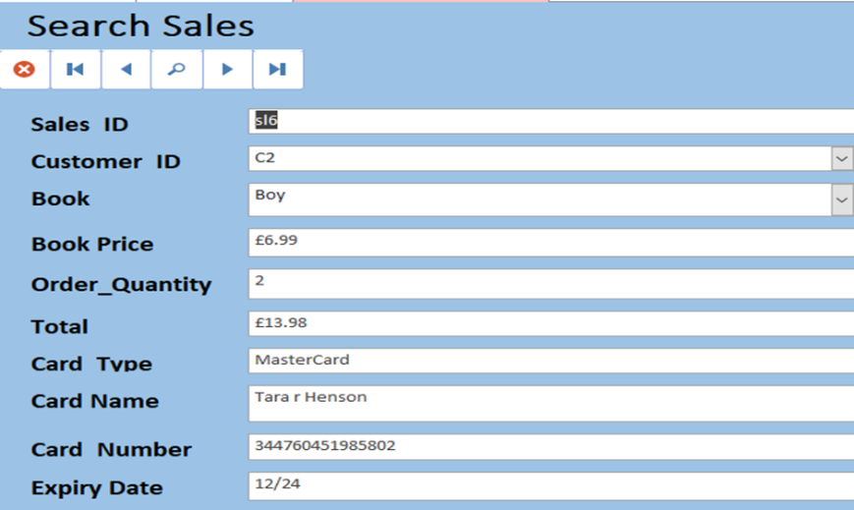
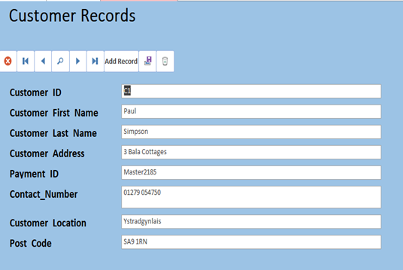
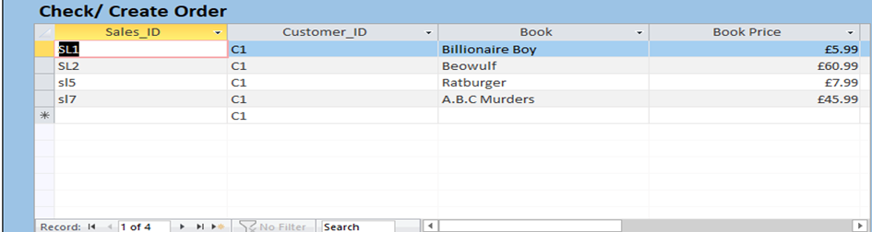

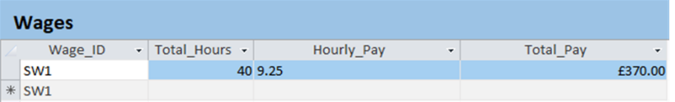

Section Three -Reports
Controls and Navigation design
The control and navigation of the forms are relatively simple and basic the only control that can be performed in the reports is exiting the report or printing out the report if desired. The reason for the lack of buttons is simplicity, the author did not want to add excessive navigation buttons to view another report or corresponding forms when a simple close button will get them back to the customer menu and search from there.

Visual Display
The form's visual design has changed much from the standard report design of report wizard, the reason for this is that the author feels that important documents such as invoices and wage slips should be kept white as reports are supposed to be professional documents and white background and the black front is the colour most used for important documents. This thinking was used when design the newsletter or first editions reports as these are not critical document in the author’s opinion, these are closer to an advertisement to draw in customers and raise sales in the author's opinion. With this thinking, the author decided to use a blue background with the talking book picture to give it a more relaxed, inviting feeling compared to the more critical confidential reports such a invoices and accounting reports. As mentioned above the colour blue, especially lighter shade gives the reader a tranquil feeling, as well as a level softness and understanding [6] [7]. A light blue contrast with black very well so it should be easy to read and notice for most readers. The more official reports were left with a white background and black font as black is the colour most associated with formality according to six-degree [6], and financial reports and documents are expected to hold a level of formality. The white background gives the strongest possible contract with black so that why white was chosen.
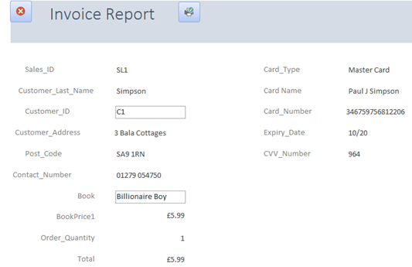
Example screenshots below, more can be found in the database.
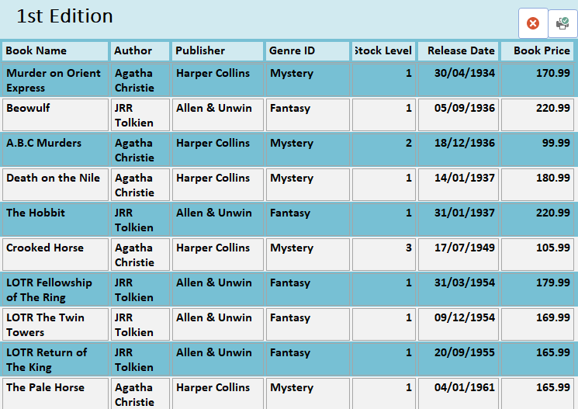
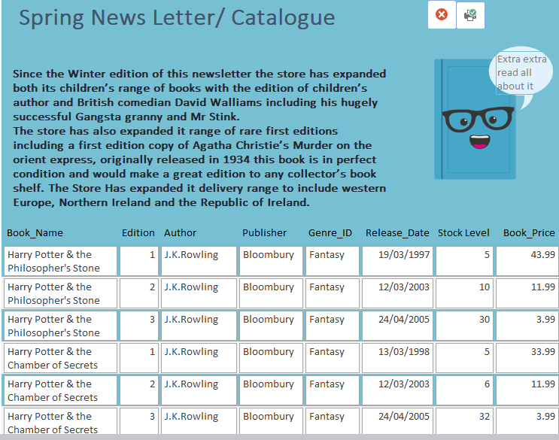
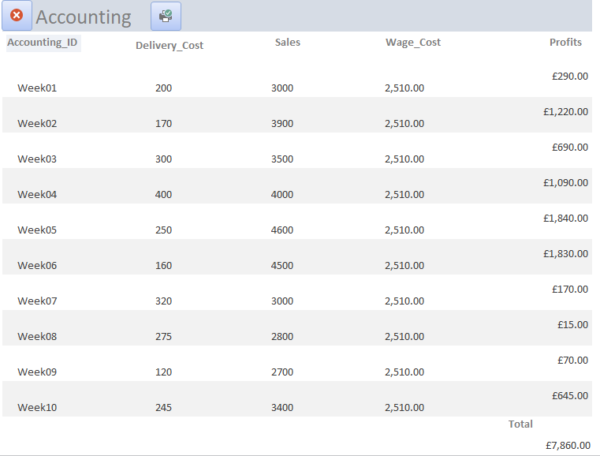

Section Four - Menu
Navigation Design
The navigation system for the menu is relatively simple in the author's opinions once gaining an understanding. The navigation is split into three sections the main menu, a customer menu, and a staff menu. The main menu has one purpose to get the user to correct sub-menu, the customer menu is the middle ground they don't have access and the ability to navigate to personal information of others and to add records other than adding orders. The staff menu has the bulk of the navigation as they will need to search records, view all records, make changes to records and access to private financial reports. The only button in the menu system that does not open a form/report or print a report is the close button that simply exits the user from the menu they are in.

Visual Design
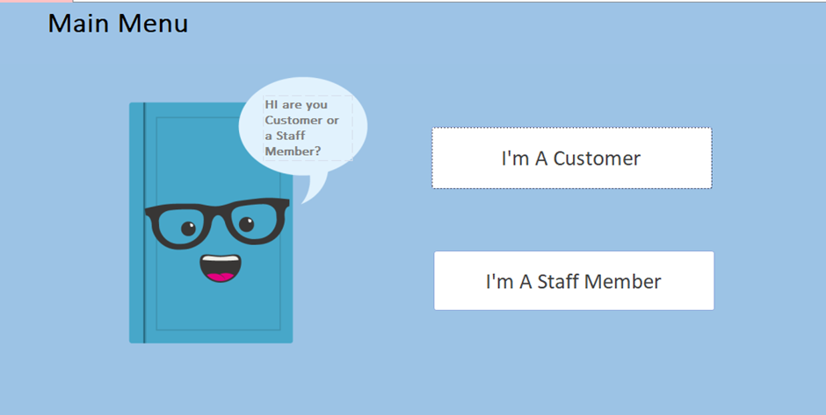
The Visual Design of the menu is much the same as the forms, they have a light blue background to give off the calming, trusting, tranquil feeling discussed before. The white buttons are used again to hopefully give the impression of a blue sky and clouds. The only addition is the blue book (property of FAVPNG) [8] used to add visualisation to the database and help the customer find their designated menu and inform them where to go to add orders. The talking book was not included in the staff menu as it makes the menu system to bulky and big. The whole aim of the menus is to convey the needed information as simply as possible.

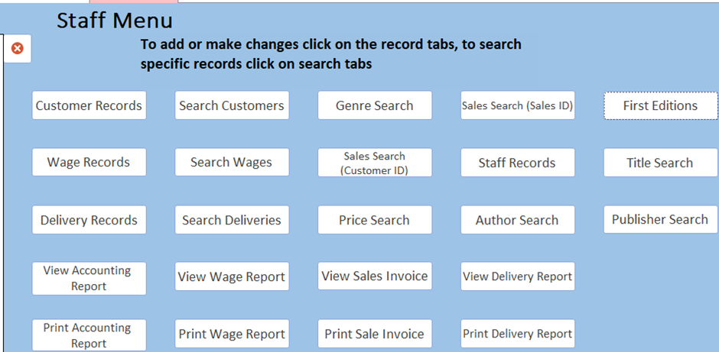

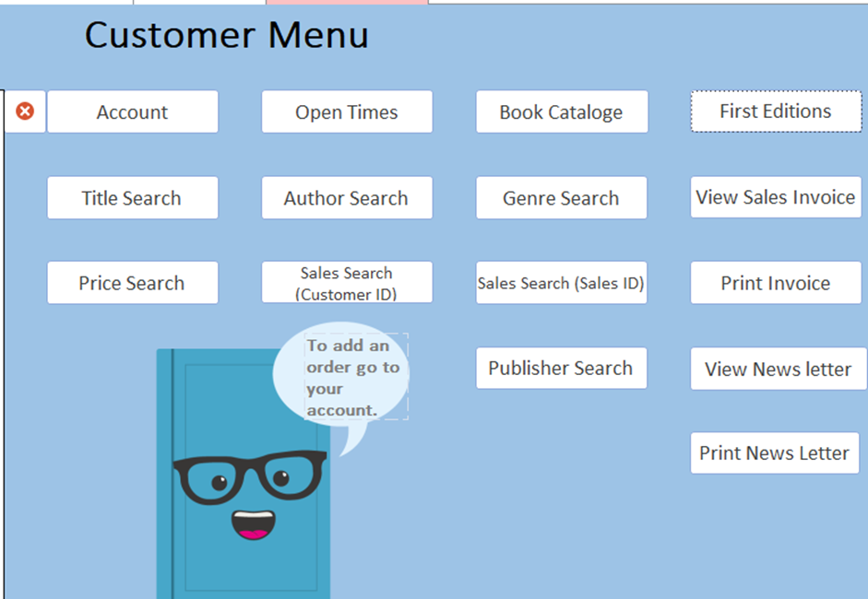
Conclusion
The author feels that the database he created is relatively good and fit for purpose the audience can search specific titles, genres, publishers, authors as well as a specific price range. The staff can view all the table records in form view, customer view an entire book catalogue and the collectors can view all the first edition books available. The forms have navigation controls to allow for easy navigation, they allow for specific search on entry or searching keyword via the magnifying glass button. The reports also can be queried to view a specific record in report view and print it out. The customers can view and print a newsletter with information on new additions to the store and a catalogue of every book available at the store. The menu system was easy for the authors family to navigate when they were given the user instructions, the user instructions can be seen in appendix one. The menu should also appear once the database opens thanks to instruction from support office [9] The author, however, feels he could have done much more with the macros and will aim to use them to much better effect in the future.

Appendix One -User Guide

Suitable Searches
Books ( a Few Examples)(All = entire collection)
- A.B.C Murders
- BFG
- Billionaire Boy
- Boy
- Ratburger
- Charlie & the Chocolate Factory
- Crooked Horse
- Clash of Kings
- Colour of Magic
- Death on the Nile
- Darker
- Dance with Dragons
- The hollow crown
- Good Omens
- Game of Thrones
- (ALL)Harry Potter (entire book title required)
- (ALL)Lord of the Rings (entire title required)
- Matilda

Authors
- Dan Jones
- Agatha Christie
- David Walliams
- EL James
- George RR Martin
- J.K.Rowling
- JRR Tolkien
- Roald Dahl
- Terry Pratchett
Publishers
- Allen & Unwin
- Bloomsbury
- Hardie Grant
- Harper Collins
- Penguin
- Vintage Books

Staff (Use when searching staff/wages)
- S1
- S2
- S3
- S4
- S5
- S6
- S7

Delivery
- D1
- D2
- D3
- D4
- D5
- D6
- D7
- D8
Prices
Lowest price- £3.99
Highest price- £220.99
Sales
- Sl1
- Sl2
- Sl3
- Sl4
- Sl5
- Sl6
- Sl7

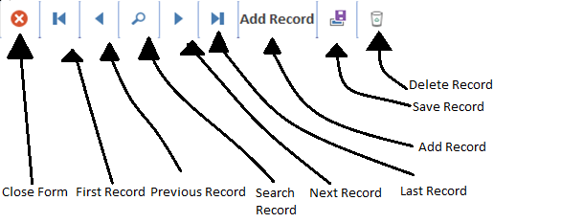


Print report



Click white boxes to perform action specified.


The search form will not allow the user to add records


Record forms will allow for records to be added

Appendix Two – ERD
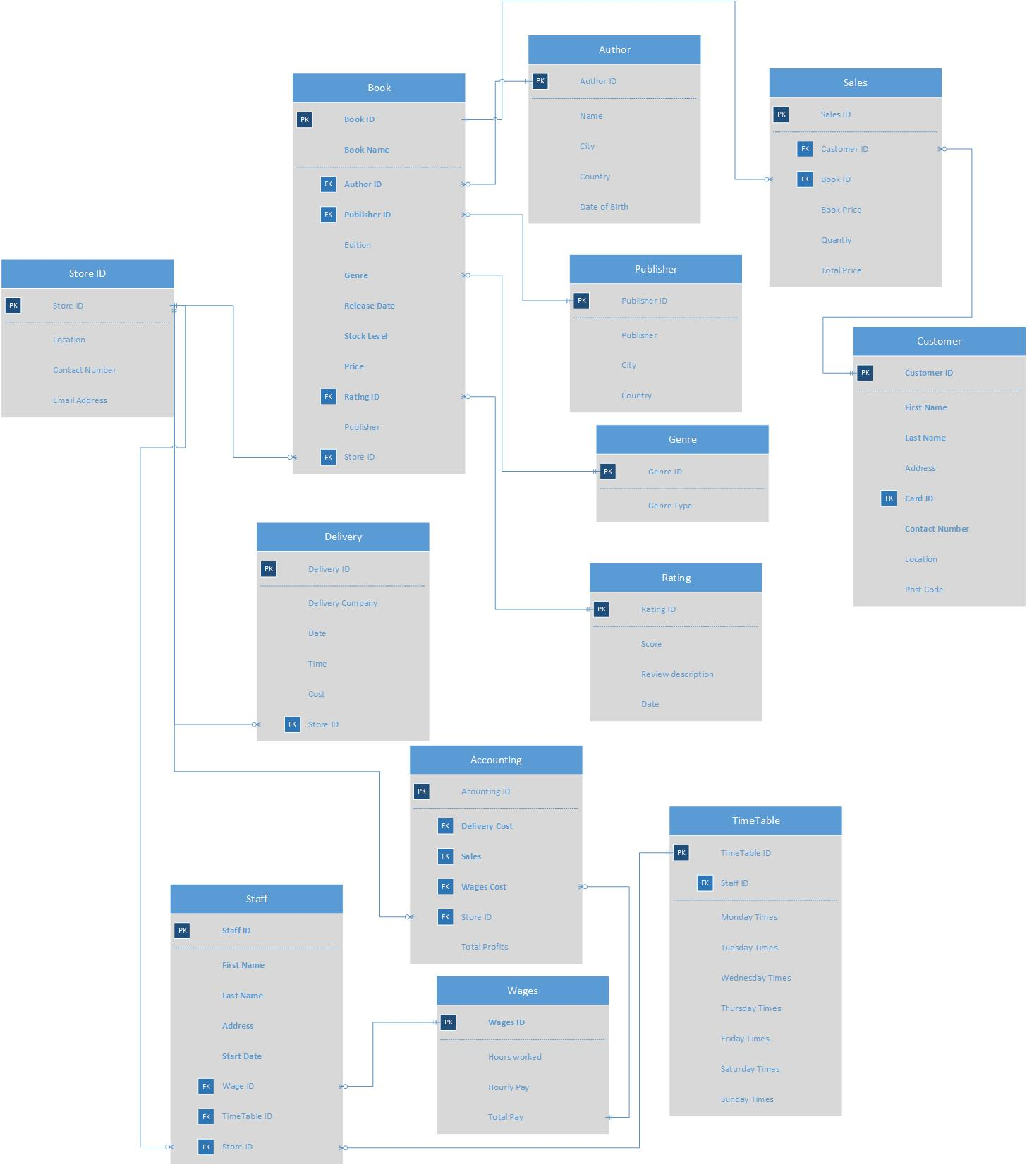

References

References

[1] | Computer Application Training, "Access Part 2 - Design," CAT, [Online]. Available: https://lib2.colostate.edu/images/cat/Access2_Design.pdf. [Accessed 19 04 2020].
[2] | University of Exeter, "Creating Databases- Fundamentals," University of Exeter, [Online]. Available: http://www.exeter.ac.uk/media/universityofexeter/humanresources/documents/learningdevelopment/ittrainingdocs/Access_Designing_Databases_Manual.pdf. [Accessed 20 04 2020].
[3] | Microsoft, "Create and delete tables and indexes using Access SQL," Microsoft, 18 07 2019. [Online]. Available: https://docs.microsoft.com/en-us/office/vba/access/concepts/structured-query-language/create-and-delete-tables-and-indexes-using-access-sql. [Accessed 20 04 2020].
[4] | Baskent, "SQL: CREATE," Baskent, [Online]. Available: http://www.baskent.edu.tr/~tkaracay/etudio/ders/dbase/sql/pdfSQL/CreateTable.pdf. [Accessed 21 04 2020].
[5] | "Structured Query," Moodle, [Online]. Available: https://moodle.uwtsd.ac.uk/pluginfile.php/349620/mod_resource/content/0/Structured%20Query%20Language%201.pdf. [Accessed 20 04 2020].
[6] | Six-degree, "INTERNATIONAL COLOR SYMBOLISM," Six-degree, [Online]. Available: https://www.six-degrees.com/pdf/International-Color-Symbolism-Chart.pdf. [Accessed 16 04 2020].
[7] | Rikard, "The Psychology of Color: A Designer’s Guide to Color Association & Meaning," Zevendesign, [Online]. Available: https://zevendesign.com/color-association/. [Accessed 16 04 2020].
[8] | FAVPNG, "Vector Talking Book - 600 Vector Download," [Online]. Available: https://favpng.com/png_view/vector-talking-book-600-vector-download-png/U2jg3URN. [Accessed 26 04 2020].
[9] | Microsoft, "Set the default form that appears when you open an Access database," Microsoft, [Online]. Available: https://support.office.com/en-gb/article/set-the-default-form-that-appears-when-you-open-an-access-database-94961011-392f-4c3b-8dbc-e5d5adbff1df. [Accessed 26 04 2020].

