Entrepreneurship

Assessment 1

by Anca Ghizela Hotca
(2021006/BABM Level5T2G1/25.08.2022)

Tutor’s name:John-Paul Okeke

Table of Contents
Introduction 4
1. Business description/ Market opportunity 5
Overview of the business plan: 5
Business description 5
Considerations of intellectual property in the business idea 5
Ownership structure 6
Legal considerations 6
2. Industry analysis 8
Size, Growth rate, Sales projections 8
Porter’s five forces model 8
3. Operations and Management Team Plan 10
Operations 10
How to generate revenue for business and prevent loss of revenue 10
Management team plan 10
Legal structure 11
4. Marketing plan 12
Marketing strategy 12
Positioning, and Points of differentiation 13
5. Financial plan 14
Source of funds 14
Uses of funds 14
Achieving financial sustainability 14
6. Market research 15
Research on the specific industry 15
Research on macro-environment 15
Conclusion 16
References 17

Introduction
This assessment requires the creation of a business plan for an English-styled restaurant in Romania. The assessment outlines six tasks for creating a viable business plan for the new restaurant. The business description will provide an overview of the business plan and business description. The industry analysis will outline size, growth rate, and sales projection and use porter's five forces model to analyse the industry. The operations and Management team plan will describe the business model and create a profile of team members. The marketing plan uses the 4P of the marketing mix, the financial plan will give a forecast of six-month sales and plans to achieve financial sustainability. The market research involves analysing the restaurant market and macro-environment.

1. Business description/ Market opportunity

Overview of the business plan:
The idea of the business plan is to open an English-styled restaurant in Romania. The restaurant will have a diversified menu and cuisine. The focus of the company will be on providing customers with a warm, friendly and cosy place where they can enjoy themselves. The restaurant will provide different menus and a party menu in Romania. The restaurant may also start a catering business later.

Business description
Description of the company
The restaurant company will be based in Romania. The products of the company include a diversified menu for breakfast, lunch and dinner. The focus of the English-styled restaurant will be on diversified cuisine and providing a place other than shopping centres where people can spend quality time, enjoy themselves, and consume healthy food, drinks, and beverages after the covid-19 crisis.

Mission statement
The mission statement of the company is to provide the people in Romania with the opportunity to go out with the family to celebrate or enjoy a cosy, welcoming and friendly place with healthy food and drinks.

Description of the product or service
The company will offer food and drink products with a diverse side menu for breakfast, lunch, and dinner. The student will also provide consumers with a party menu with healthy sandwiches and drinks. The company expects to have a social impact in its operating location.

Considerations of intellectual property in the business idea
The Romanian law has a functional approach to addressing the challenges of intellectual property (Dincă and Rizoiu, 2020). Buta et al. (2020) mention that the intellectual property laws in Romania protect inventions, services, and products. The restaurant owners should be aware of the intellectual property regulations in Romania to protect their products or services through trademarks, copyrights, design rights, and other methods.

Ownership structure
The business will be a Limited Liability Company and the professional chef is the owner of the business. This business structure will protect the owner against legal issues (Gerard, 2018). According to Scarlat and Şişu (2019), businesses undergo various strategic changes along the lifecycle. An ownership structure is critical for the restaurant business to manage the company and associated risks.
The following further demonstrates the organisational structure intended for the restaurant company. The owner of the business is a professional chef, who along with the assistant shape will be responsible for preparing food and drink products. The business will have a total of employees including two attendants, an assistantship, a cashier, a manager, and the owner.
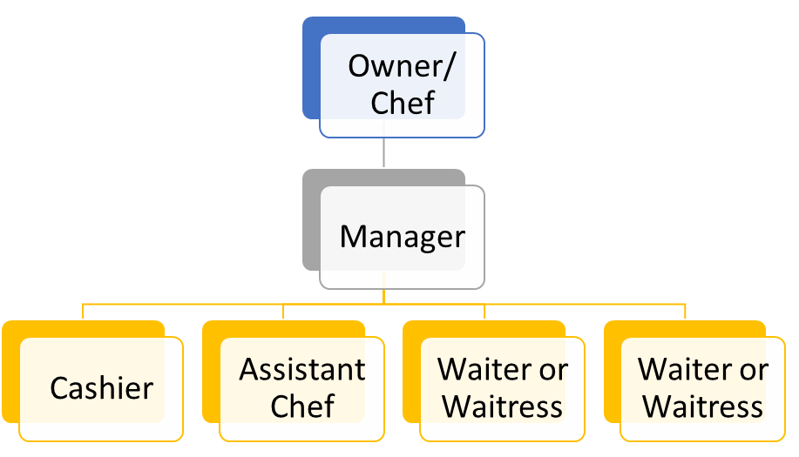
Figure 1: Organisational structure
(Created by the author)

Legal considerations
According to Gerard (2018) the restaurant has opted for a limited liability company structure for the business to eliminate the issues of liability on the business owner. Băltescu et al. (2022) state that as a result of the covid-19 crisis, restaurants have to focus on various legal considerations and laws related to food, energy, water, and sustainable practices.
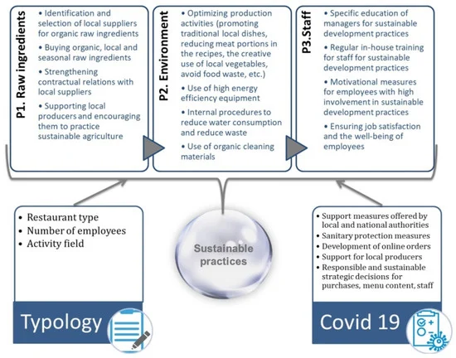
Figure 2: Sustainable practices
(Source: Băltescu et al., 2022)

2. Industry analysis

Size, Growth rate, Sales projections
Ibis World (2022) states that the restaurant industry is among the largest contributors to the Romanian economy. The restaurant and takeaway food Industry of Romania is among the 15th largest in Europe, and the growth rate of the industry is 0.2 % per year. There has been a 6.4% growth in business since 2017.

Porter’s five forces model
The application of Porter’s five forces on the restaurant industry of Romania is given below.

The threat of new entry
According to Ibis World (2022), the restaurant industry in Romania has a business growth of 3.3 % in 2022. Hence, there is a moderate threat due to the increased business growth rate.

The threat of substitutes
The products of restaurants can be substituted by other entities. Harba, Tigu, and Davidescu (2021) state that consumers are less satisfied with restaurants’ services and products. Thus, there is a high threat of substitution.

The Bargaining power of customers
The restaurant industry in Romania depends on the satisfaction, preferences and attitude of customers (Harba, Tigu, and Davidescu, 2021). When customers are not satisfied and their demands are not fulfiled they can explore other options indicating a moderate threat.

Bargaining power of suppliers
The covid-19 crisis deteriorated the growth of the Romanian restaurant industry impacting suppliers. The restaurants can change suppliers, indicating a low threat from them.

Competitive rivalry
The competitor restaurants are sources from Ghangas (2021). The competitive rivalry table of the new restaurant is as follows:
Name of competitor | Differentiation
Bistro Guxt | Different options for all customers with an impressive collection of drinks.
the ARTIST | A cosy, welcoming, and friendly atmosphere with amazing experience and food.
Maize | Diverse food and cuisine with a focus on health
Table 1: Competitive rivalry
(Source: Created by author)

3. Operations and Management Team Plan

Operations
The numerous components of a restaurant enable it to operate efficiently. The operation of a restaurant business includes purchasing, pricing, preparation, service, and cleanup (Indeed, 2021). Purchasing operations in a restaurant include buying products for the inventory and maintaining the availability of table cloth, cutlery, and other items. Restaurants generally develop a contract with suppliers such as local producers and wholesalers for purchasing needs. The pricing operations of students include maintaining the price of products and services depending on market fluctuations such as transportation cost, increase in product prices, and managing utilities to ensure profitable margins. Preparation operations involved the methods and Systems used by kitchen staff to prepare menu items. Service operations are crucial that involve direct interaction with customers. Service operations include hosting, serving and bartending. Cleanup operations include the procedures, specific rules and regulations to meet health and hygiene standards. Harba, Tigu, and Davidescu (2021) mention that there are various operations in a restaurant managed by managers to improve supply, operational activities, the well-being of staff and more.

How to generate revenue for business and prevent loss of revenue
Sjödin et al. (2020) acknowledge that it is crucial for businesses to align value creation and business model for development and growth. The garden is for the state that organisations are making changes in Business models to optimise performance outcomes. These changes focus on creating, delivering and capturing values. The researchers state that the profit formulas of business depend on the interdependence and interaction between users and the company. Hence, the company should focus on aligning with customers and managing risks. The generated profit is distributed among participants such as suppliers, employees and customers in the case of the intended new restaurant.

Management team plan
Profile of members and founders
The profile of employees and owners of the restaurant business are illustrated in the following table.
Name | Skills | What do they bring to the firm
Maria Smith | Professional chef and managing business | Prepare menu items for customers
Andreea Tuffin | Managing business | Ensure effective operations and manage issues
Oliver Muller | Accounting and finance | Managing payments and transactions
Alexandra Dascalu | Cooking and preparing drinks | Assists the head chef and prepares menu items
Elena Martin | Communication and sales skills | Encourage the customer to try products and increase sales
David Escu | Communication and sales skills | Encourage the customer to try products and increase sales
Table 2: Profile of members and founders
(Source: Created by the author)

Legal structure
There are different legal structures for businesses. The major four business structures are sole proprietorship, partnership, limited liability company (LLC), and operation (Gerard, 2018). The legal structure for the restaurant business is LLC, as this legal structure separates the owner from the business and reduces the risks of legal liabilities. In comparison with sole proprietorship, LLC has low risk. LLC enables the business owner to add partners. Also, LLC has more fluidity than cooperation and there is no necessity for shareholders (Gerard, 2018).

4. Marketing plan

Marketing strategy
For devising the marketing strategy of the restaurant business, the assessment uses the 4Ps of marketing.

Product
The product of the company will include a diversified menu of healthy breakfast, lunch and dinner. The restaurant will provide customers with diversified cuisine and a special party menu. Some of the products on the party menu will include healthy drinks, afternoon teas, and healthy sandwiches.

Price
The price strategy of the restaurant will have a direct influence on sales volume, demand and business profit. The price strategy of the company should initially focus on maintaining a moderate profit margin to attract customers. Gradually, the company can increase prices and offer discounts.

Promotional mix
The promotional activities include advertising, direct marketing, sales promotion and public relations. The use of these strategies includes inculcating awareness and persuading customers to buy products (CFI, 2022).

Place (distribution strategy)
The place or distribution strategy involves selecting a place where the company can provide available products and services to the customers (CFI, 2022). Play strategy will focus on channels, market coverage, location, inventory and transport. A strategic location will help the restaurant to attract more footfalls.
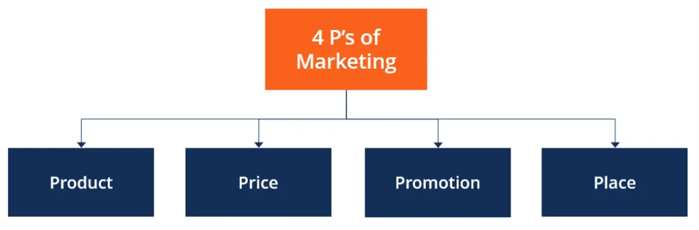
Figure 3: 4Ps of marketing
(Source: CFI, 2022)

Positioning, and Points of differentiation
According to CFI (2022) the use of marketing mix elements can help the company to influence customers and persuade them to buy products. This framework increases his understanding of the business on customer desires and needs. The other advantages of this marketing framework include increased competitive advantage and changing perception. The effective application of the 4P element empowers the company to strengthen its position and differentiate its products from that of the competitors.

5. Financial plan

Source of funds
The creation of a new business requires capital, and Mason and Botelho (2018) emphasise that new business owners can use their own money to support the company or source funding or investment in the business-to-business angels, venture capitalists and investors. In this case, the business owner will be self-funding the business.

Uses of funds
 | Month 1 | Month 2 | Month 3 | Month 4 | Month 5 | Month 6
Revenue from operations and market section | 25,000 | 25,000 | 28,000 | 28,000 | 32,000 | 33,000
Fixed costs | 3,000 | 3,000 | 3,000 | 3,000 | 3,000 | 3,000
Variable costs
Salary | 13,000 | 13,000 | 13,000 | 13,000 | 13,000 | 13,000
Materials | 3,000 | 3,000 | 3,500 | 3,500 | 3,800 | 3,900
Delivery | 1,500 | 1,500 | 1,500 | 1,500 | 1,500 | 1,500
Marketing and advertising | 1,000 | 1,000 | 1,200 | 1,200 | 1,400 | 1,400
Profit | 3,500 | 3,500 | 5,800 | 5,800 | 7,300 | 7,400
Table 3: Use of funds
(Source: Created by the author)

Achieving financial sustainability
It is essential for the business to maintain profitability and continued growth to achieve financial stability. The company should review the current capital needs and forecasted capital needs to determine anticipated growth. The evaluation of financial information will help to understand the purchasing behaviour of customers and primary prospects.

6. Market research

Research on the specific industry
Harba, Tigu, and Davidescu (2021) has analysed and examined the restaurant industry in Romania depending on customer perspective before the pandemic and during the pandemic. The academics suggest that there have been changes in customer behaviour and market trends. The analysis is dependent on the fine dining restaurant in Romania including the artist, Casa di David, L ‘Atelier and others (Harba, Tigu, and Davidescu, 2021). The states that the pandemic has posed unprecedented challenges to the companies operating in the Romanian restaurant industry. The study indicates that customers have an overall positive sentiment for the restaurants.

Research on macro-environment
According to Gabriela et al. (2021), the covid-19 pandemic has immobilized the world and the industries and sectors were severely affected. A similar pattern was observed in the Romanian economy. The academics have anodized the restaurant, hotel and travel industry of Romania and the influence of macro-environmental factors such as economic factors and social factors. The researchers state that organisations are optimising radical measures to reduce the impact of the pandemic and recover.

Conclusion
This assessment has analysed the different aspects necessary for developing a business plan. The different tasks of the assessment included a business description, industry analysis, operations and management team plan, marketing plan, financial plan, and market research.

References
Băltescu, C.A., Neacșu, N.A., Madar, A., Boșcor, D. and Zamfirache, A., (2022). ‘Sustainable Development Practices of Restaurants in Romania and Changes during the COVID-19 Pandemic.’ Sustainability, 14(7), p.3798.
Buta, P., Sfecla, J., Turcu, C., Laufer, Y., Musat and Asociatii S.P.A.R.L, (2020). ‘Intellectual Property Transactions in Romania: Overview’ | Practical Law. [online] Practical Law. Available at: <https://uk.practicallaw.thomsonreuters.com/7-634-6959?transitionType=Default&contextData=(sc.Default)&firstPage=true#:~:text=Romania%20protects%20authors'%20rights%20under,the%20author's%20own%20intellectual%20creation.> [Accessed 15 July 2022].
CFI, (2022). ‘4 P’s of Marketing.’ [online] Corporate Finance Institute. Available at: <https://corporatefinanceinstitute.com/resources/knowledge/other/4-ps-of-marketing/> [Accessed 15 July 2022].
Dincă, R. and Rizoiu, R., (2020). ‘Security rights in intellectual property in Romania.’ In Security rights in intellectual property (pp. 555-595). Springer, Cham.
Gabriela, T., Costin, C., Aureliana, P.M., Dan, B., Diana, C.O. and Bogdan, C.A., (2021). ‘Restart the Hotel, Restaurant, and Travel Industry in Romania After the COVID-19 Pandemic.’ In Economic Recovery After COVID-19 (pp. 87-107). Springer, Cham.
Gerard, J., (2018). ‘Four Types of Business Ownership’ | Bizfluent. [online] Bizfluent. Available at: <https://bizfluent.com/info-8162541-four-types-business-ownership.html> [Accessed 15 July 2022].
Ghangas, S., (2021). ‘12 Splendid Restaurants In Bucharest: To Have Delicious Meals.’ [online] Traveltriangle.com. Available at: <https://traveltriangle.com/blog/restaurants-in-bucharest/> [Accessed 15 July 2022].
Harba, J.N., Tigu, G. and Davidescu, A.A., (2021). ‘Exploring consumer emotions in pre-pandemic and pandemic times.’ A sentiment analysis of perceptions in the fine-dining restaurant industry in Bucharest, Romania. International Journal of Environmental Research and Public Health, 18(24), p.13300.
Ibis World, (2022). ‘IBISWorld - Industry Market Research, Reports, and Statistics.’ [online] Ibisworld.com. Available at: <https://www.ibisworld.com/romania/industry-statistics/restaurants-takeaway-food-operators/3420/#:~:text=How%20many%20businesses%20are%20there,increase%20of%206.4%25%20from%202021.> [Accessed 15 July 2022].
Indeed, (2021). ‘What Are Restaurant Operations?’ (With Components and Tips). [online] Indeed Career Guide. Available at: <https://www.indeed.com/career-advice/career-development/what-are-restaurant-operations> [Accessed 15 July 2022].
Mason, C. and Botelho, T., (2018). ‘Early sources of funding (2): business angels.’ In Entrepreneurial finance: The art and science of growing ventures (pp. 60-96). Cambridge University Press.
Scarlat, C. and Şişu, M., (2019). ‘Strategic Changes along the Lifecycle of Small International Organizations.’ A Case from Romania. In Conference Proceedings Chapters (pp. 157-169). Bulgarian Association for Management Development and Entrepreneurship.
Sjödin, D., Parida, V., Jovanovic, M. and Visnjic, I., (2020). ‘Value creation and value capture alignment in business model innovation: A process view on outcome‐based business models.’ Journal of Product Innovation Management, 37(2), pp.158-183.

