OLTEANU PATRICIA GEORGIANA

STUDENT ID:2411182
DIG: ASSIGNMENT 3
IMPACT OF LINKEDIN ON STAFF RECRUITMENT PROCESS
[Company name] | [Company address]
2024
Contents
- What is Linkedin? 2
Difference between Linkedin and other social media platforms 2
How Linkedin helps for Job Seekers? 3
How Linedin help Employers? 4
How to create an active Linkedin account? 4
Challenges of having a Linkedin account 5
Conclusion 5
Referencing 6

What is Linkedin?
LinkedIn is the biggest professional network . This network will help: companies, job seekers and entrepreneurs to find what they need. LinkedIn can help you to find the best workers for your company based on the work requirements you will need.( Louis-Etienne,2024)
Using this platform can help you to stay in touch with new jobs or business partners. On this platform you can upload what kind of experience you have, how many years you was working in another places, the type of work place you are qualified, etc.

Difference between LinkedIn and other social media platforms
The difference between LinkediIn and other social media platforms is the fact that in LinkedIn we will found a lot of useful different things than we can’t found in other social media platforms. For example:
You will found more people with a business mindset. That means all the people has a professional purpose and you will find what are you looking for. While another type of social media platforms like Facebook, Instagram, etc, didn’t have this purpose.
You have more opportunities to grew up your brand. The nature of this platform is to make everything be easier. For example you can start your own personal brand and in this platform you can resonate with the audience you will need and you can deal with people who’s going to achieve your goals. While another type of social media platforms are unprofessional because throughout them the people is sharing unintentionally ,personal and private information about themselves. That’s why Linkedin is an official site where everything is only professional information.( Graham Townley, 2023)

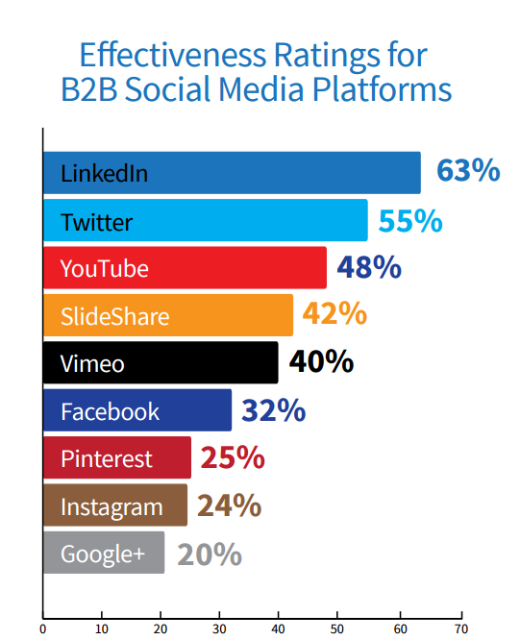
As we can see, LinkedIn is the most used website on social media platforms category.
Sproutsocial.com

How LinkedIn helps for Job Seekers?
LinkedIn will help Job Seekers to make a professional profile where they can write their details like: job titles, dates or places of employment, etc. Is important for Job Seekers to make an persuasive profile to convince recruiters to contact you and possibly offer you a work place. As more information you provide ,that will be better because this helps recruiters to understand with type of person you are and if you really need a work place in their company.
LinkedIn can help you to indicate different types of work places based on your personal data. You can choose which type of requests you want to accept and if you want honour your interview or not.
In this website, your colleagues, clients, supervisors can also give you feedbacks. That can help you more when recruiters check your profile because in that way they can try to trust you, based on the feedbacks that you have and maybe make bigger the chance to a work place.

How LinkedIn help Employers?
LinkedIn can help employers to find the perfect person for the work place they are looking for. Is important as a Employer to check all the details provided by the Job Seekers. Because the information they give in their profile will be helpful for the employers to choose between different people, and see witch one meets all the conditions for the respective work place.
When a employer is recruiting people for a work place he need to meet the criteria for the respective work place and understand the type of person the company needs. As a employer you cannot choose a person without knowing the basic information. Different employers have different criteria for employability for example:
- We can found companies where they want experience of minimum one year.
- We can found companies where they ask for any valid certificate for the work place.
- We can found companies where they don’t want people under 21 or above 65 years.

How to create an active LinkedIn account?
To create an active LinkedIn account :
- First we should need to access the website on google and click “ Join now”
- We need to fill the “sign in” section with our personal information (e-mail, phone number, a private password)
- In the screen you will found instructions to keep going to finish your LinkedIn profile.
- Once you did everything you can start to create your profile where you will upload all your personal information, what kind of workplace you need, what speciality you have, etc.
- Be ready to receive workplace requests from employers!

Challenges of having a LinkedIn account
As we know social media platforms are secure, but we can also have problems with them. Some bad points of having an LinkedIn account are:
- The premium record can be expensive. That means you can pay for an LinkedIn premium account but this will cost you 120$ per year.
- Spam: some people make fake account like a “recruiter” and they stole private information from job seekers .
- Time: not all the companies have n LinkedIn account, that means you can wait a lot of time to be contacted .

Conclusion
Finally, the conclusion of this report is , LinkedIn is a very helpful website for job seekers and for employers. It will help everyone to find what they are looking for without to much complexity. In this report we can find a lot of important information about this specifically website, and the most important information is “How to create an LinkedIn account” because if we don’t know how to make an account we cannot start to look for a work place or to recruit people for our company. The most important thing is to understand how we should start and what we need to write in our profile to make everything easier.

Referencing

Etienne, L. (2024). Microsoft - Search. [online] www.bing.com. Available at: https://www.bing.com/ck/a? [Accessed 8 Dec. 2024].

Townley, G. (2023). Connecting with others and sharing our lives has become second nature. But when it comes to reaching a professional audience, LinkedIn stands out as the platform of choice. [online] Linkedin.com. Available at: https://www.linkedin.com/pulse/linkedin-vs-other-social-media-why-its-ultimate-platform-townley-i5sic [Accessed 8 Dec. 2024].
‌

