University of Wales Trinity St. David

Student Name: Jane Nakitto

Student ID: 2008466

Managing Enterprises in 21st century

A Business Plan on Re-Usable Antiviral Mask

Executive Summary

This study has developed a business plan where numerous aspects to acquire a business plan effectively was scrutinized. Henceforth, the chosen business for this report was, Re-Usable anti-viral face mask under Better Health Company which is all set to introduce itself within the business environment of the UK as part of the medical supply. Therefore, researcher has illustrated various requirement of a prosperous business plan as a map to aid chosen business organization to ensure greater effectiveness and competiveness. Hitherto, this business plan incorporates wide range of aspects such as business idea, its operation, product types and description, industry analysis and so on with the support of existing literature. All the information gathered within the business plan are referenced as per university guideline to avoid collusion.

Table of Contents

1.0 Introduction 3
2.0 Business description and History 5
3.0 Business structure 5
4.0 Product and Service description 5
5.0 Market analysis and Trends 6
6.0 Operations 7
Porters five forces 7
7.0 Technology 9
8.0 Management and Organization 10
9.0 Social responsibility and sustainability 11
10.0 Development, Milestone and Exit plan 11
11.0 Financial Plan 12
12.0 References 15

1.00 Introduction

Due to globalization, vibrant changes have been encountered within the business environment where numerous businesses are adopting different change management strategy to stay ahead with prevailing business trends to ensure effective competitive edge (Venkata and Narayana., 2015). Therefore, as per the given instruction, this study had chosen a product called “Re-Usable” antiviral face mask which will be launch by Better health company. Choosing “Re-Usable” antiviral face mask this study will develop a business plan where financial design of the business will be expounded.

2.0 Business description and History

Better health is renowned company that offer tailored training, health programs and resources with the support of health professionals and government department. The company has focus on three major elements which are; community based services, developing health professionals, practical action. Through community based services, Better health ensure cost effective and funded services for all cultures, ages and communities. Via developing health professional, Better health ensure evidence based services through experts and finally through practical action Better health certify holistic approach to ensure advice are achievable as well as supports better lifestyle. The company is running its operation more than 10 years within the market and add its great value to natural health field (Betterhealthcompany, 2022).

3.0 Business structure

Better health company is medium sized business that offer medical supplies with range of health consultation. The company type is private limited with share capital. Health professional and carers can register themselves within the business to take part in program developed by Better Health such as “Adult better Health Program” Active8, Go4Fun etc. The business is also offer different training facilities such as child obesity, talking about weight, professional development events and so on. The business is successfully running its operation by its owner in exchange of shares of ownership and shareholders exercise certain power on how the business is run (Betterhealthcompany, 2022).

4.0 Product and Service description

Better health was always been prominent for its excellent health program and training facilities towards physicians and carers (Betterhealthcompany, 2022). Now, the company is looking forward to expanding its market and get into health and safety kit as part of medical supplies Hitherto, taking pandemic into consideration the business which is developing a distinctive product named “Re-Usable” anti`viral face mask with the goal of developing prodigious significance towards wellbeing which would be manufactured, examined and packaged with up-to-date tech and zero human touch. The product will also ensure 99.9% protection from Covid viruses. As far as feature of the product is concern Re-Usable mask has unique features with up-to-date design functionality that ensure effective reusability and breathability for upto 60 times which is also eco-friendly in nature. Three layer of the mark function on the other hand, can fight again Corona viruses and its different variants such as omicron where inner layer developed through absorbent materials, outer level with non-absorbent and middle layer is developed through non-woven materials.

As per service of the business is concern, to serve the product to end consumers Better Health will use USP - unique selling point that would in turn help business to ensure pre-determined value while distinguishing itself from different rivals as well as benefitting the consumer through distinctive featured (Ensign, 2011). As part of the promotional activities, the business will promote is developed product through social media advertising where various platform like, Facebook, YouTube, Instagram will be used to reach potential consumers.

5.0 Market analysis and Trends

Emergence of the recent pandemic consider as major aspect which push huge global demand for medical supplies since the pandemic began. Even though the impact of pandemic is not severe as before but still scientists are predicting it could get worse anytime soon if correct precaution is not taken seriously (Ahlstrom, 2021). Thus, by scrutinizing the scale of market, Better health will introduce its product in medium scale which will fulfill the need of the healthcare setting and meet the increasing demand of the customers. Market trends of the product will be justifying through effective marker segmentations which will be divided into two categories demographic and psychographic (Benjaminsson et al, 2019). Through psychographic trait consumer’s behavior, buying nature, personalities, interests, psychology will be identified. Second segmentation is consumer demography where consumer’s location, age, income, structure of the family, demands, needs will be identified through their income matrices.

6.0 Operations

Unexpected wave of covid-19 triggered huge demand for the medical supplies where overall demand of the mask specially was huge. Taking that as an example different stakeholders need to be ready to for any types of pandemic or variant to minimize the shortage of mask supply. Henceforth, in regard to that Emergo (2021) indicated, overall market supply for the medical will go up £130m by the year 2025. Out of all medical equipment’s hitherto, mask became basic needs for majority of population in the UK however the nation is still struggling in terms of supply chain of mask where nation like Germany and French ensured significant growth on their availability.
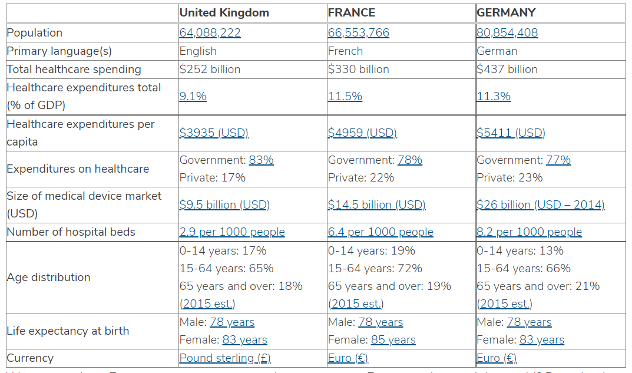 Medical supplies of France and Germany (Source: Emergo, 2021).

By taking that into account Better Health have chosen UK as hub to trade their product which will eventually close the gap within the market via supply-demand issues. In the production cycle, Better Health will develop their product through good quality materials where effective distribution through USP will be ensured aside competitive valuing plans. The developed creation would be open for the medical settings, consumers and manufacture (Kampaba, 2015).

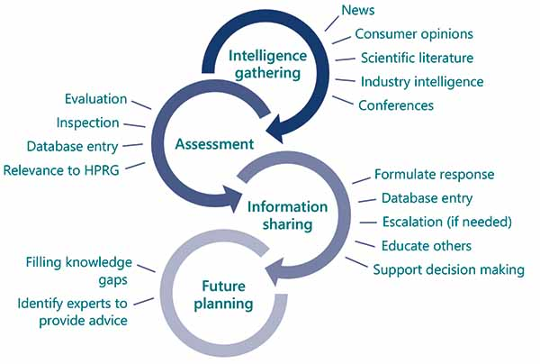
Current market position of Re-Useable face masks

Better Health is in good strategic market position however only rival that can harm business operation of Better health is SERA suppliers which has similar product and good channel of distribution however their product does not built through three layer which in turn putting Better Health one step ahead than them (Global forecast, 2025).

7.0 Technology

As far as technology is concern, Re-Usable mask ensured it tech through zero skin touch feature where the overall manufacturing process has adopted automation (Gov.co.uk, 2020). Due to its hi-tech feature, the mask will protect others to spread infection via its three-layer mask functionality which was ensured through effective technology. Moreover, as per of the technological plan, the business will summarize its vital financial objectives and operational goals, as well as details on how it will accomplish these goals with unique software where road map of the business and how it could be achieved will be projected in advance. Finally, technological grounding of the business will be cross checked through the use of on0site and elongating techniques (Lee and Han, 2009).

8.0 Management and Organization

Better health company is medium sized business which is private limited company with share capital where health professional and carers can register themselves within the business to take part in program developed by Better Health such as “Adult better Health Program” Active8, Go4Fun and so on. The business is also offer different training facilities such as child obesity, talking about weight, professional development events and so on. The business is successfully running its operation by its owner in exchange of shares of ownership and shareholders exercise certain power on how the business is run. The board of directors can take the ownership by becoming shareholders of the business (Betterhealthcompany, 2022).

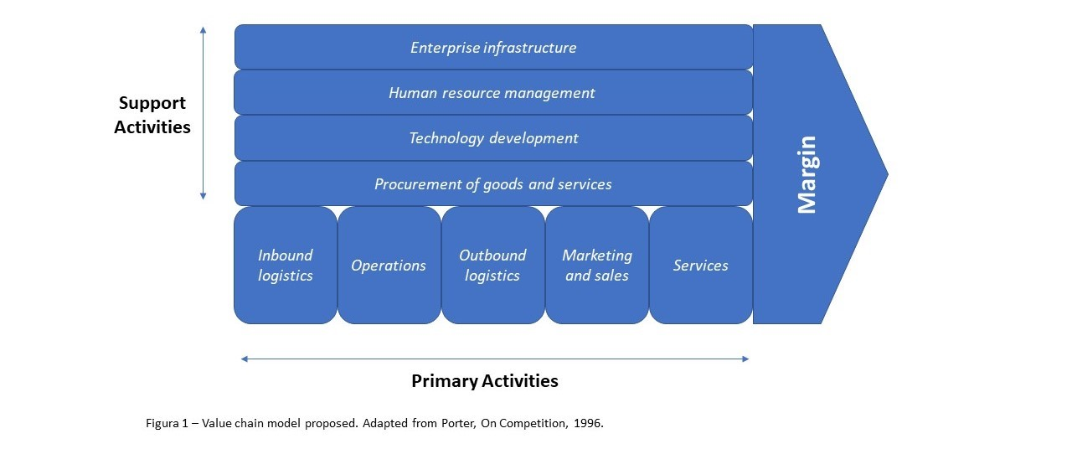
(Source: Kampaba, 2015).

The support activities and management of the business is flat in nature where different depart would initiate and each of them will have its own set of responsibilities to ensure trade runs smoothly.

9.0 Social responsibility and sustainability

Overall social impact of Better Health is relatively low in compare to its competitor’s reason being, the business has followed proper sanitation process as well as developed mask will be environment and skin friendly with zero waste to landfill. To ensure such eco-friendly product Better health will be using French flax grown with the mix of organic handkerchief linen which has zero chemical present. 20% of its profit will be donated to charity of its choices that would benefit healthcare workers, social justice and women’s empowerment.

10.0 Development, Milestone and Exit plan

The business will be developed through inbound and outbound logistic system. Through inbound logistic system Better Health will penetrate agile and lean operational tactics to reduce needless payments to the suppliers (Kampab, 2015) while on the other hand, through outbound logistics Better Health will concentrate over the channel of distribution via E-Commerce, SML stores, Pharmaceutical outlets to guarantee higher consumer exposure. Further, the business will also adopt effective online marketing promotional strategy by social media platform like Facebook, Insta and Youtuve to reach towards its potential consuemrs (Strakova et al, 2020).

Milestone

Better Health will ensure efficient implementation of the personalized ERP system and Unique selling point. On the other hand, as per procurements of business the end-item of the business will allocate through NHS, medical professionals, e-commerce platforms, convenience stores to develop good consumers base (Gov.co.uk, 2020). In terms of technology and development, it will be ensured by apparent requirement of the quality checks and standardizations by depending upon on-site and elongating testing (Lee and Han, 2009). The product quality will be sustainable and user friendly in nature with its three layer of distinctive features and overall recruitment process will be skill based where shortlisted and selected employee should have good knowledge on medical equipment (Lee and Han, 2009).

Expected Date to achieve Milestone:

Milestone | Expected date
HRM | December 2021-January 2022
Operations | January 2022
Sales and marketing | February 2022
Services | February 2022
Procurement | February 2022

Business Exit plan

It has been identified through the research, the overall demand of the masks will rise by 50% by 2050 (Emergo 2021) thus the exit plan of the business is long-term in nature and with market demand Better Health will experiment more onto research about the affectability of the mask. If in near future new variant of virus come up where the developed mask is not working anymore then the it will exit the market and replaced by another unique one which has better affectability.

11.0 Financial plan for chosen business

The chosen business this for business plan is private limited company with share capital. Where multiple individual can get involved by buying share capital and personal investment is the investment sources.

Particular’s | Amount’s
 | Year 1 (£) | Year 2 (£) | Year 3 (£)
Asset’s
Non-current Asset’s
Plant’s-and-Equipment’s | `2000’ | `4000’ | `8000’
Land’s-and-Building’s | `2100’ | `2000’ | `3500’
Furniture’s | `4000’ | `8000’ | `6000’
In-tangible-asset’s | `2000’ | `3000’ | `2800’
Non-Current Investment’s | `1000’ | `1000’ | `1000’
Other’s | `200’ | `200’ | `200’
Total Non-Current Asset’s | `11300’ | `18200’ | `21500’
Current-Asset’s
Inventories.’ | `800’ | `1000’ | `1200’
Receivable-Trade.’s | `300’ | `400’ | `4410’
Trade-Safety | `220’ | `240’ | `280’
Other-Current-Asset’s | `260’ | `240’ | `300’
Cash-Equivalent’ | `14000’ | `17000’ | `18000’
Total-Current-Assets | `15580’ | `18800’ | `24190’
Total Asset’s | `26880’ | `37080’ | `45690’
Liabilities’
Loan’s | `3000’ | - | `1000’
Non-Current-Liabilities | `100’ | - | `100’
Total-N-C-L’ | `3100’ | - | `1100’
Cu.rrent-liabilities’
Short-T-Loan | `2200’ | `1000’ | `5990’
Trade-Payable’s | `1176’ | `180’ | `1400’
Other-Occurred-liabilities’ | `400’ | `600’ | `200’
Deferred-liabilities’ | `300’ | `300’ | `300’
Total-Current-Liabilities’ | `3784’ | `2080’ | `7890’
Total-Liabilities’ | `6880’ | `2080’ | `8990’
Equity-of-Owners;
Paid-in-Capital | `10000’ | `20000’ | `30000’
Re-Tained Earnings' | `10000’ | `15000’ | `7100’
Total Equities’ and Liabilities’ | `26880’ | `37080’ | `45690’

Forecast-of-financial-position

Particular’s | Amount’s
 | Year 1 (£) | Year 2 (£) | Year 3 (£)
Revenues-and-Operation’s
Overall Sale’s | `20000’ | `30000’ | `40000’
- Return on sales (less) | `40’ | `34’ | `24’
- Discount’s and allowence’s (less) | `8’ | `6’ | `4’
Net Sales | `19952’ | `29960’ | `39972’
COGS | `3000’ | `4000’ | `6000’
Gross-profit’s | `16952’ | `25960’ | `33972’
Gross-Profit-Margin’s (%) | `170’ | `174’ | `170’
Operational-expense’s
Selling Expenses’ | `500’ | `600’ | `300’
Salaries’ | `1500’ | `1400’ | `1300’
Rents’ | `200’ | `100’ | `100’
Office Supplies’ | `20’ | `22’ | `20’
Depreciations’ | `800’ | `600’ | `800’
Interest’s | `50’ | `40’ | `40’
Expenses-on-Market-Research’ | `20’ | `20’ | `20’
Insurance’s-expenses-incurred | `20’ | `20’ | `20’
Payroll-Taxes’ | `18’ | - | `14’
Commissioned-Expenses’ | `10’ | - | -
Other-Expenses’ | `2’ | `4’ | `6’
Total-Operating-Expenses’ | `3140’ | `2806’ | `2610’
Operating-Profit’s | `13812’ | `23154’ | `31352’
ADD + other income’s | `240’ | `300’ | `340’
Income-on-Interest’s | `100’ | `100’ | `130’
Profit-before-Taxes’ | `14152’ | `23554’ | `31822’
Less-End-of-Year-Taxes’ | `200’ | `240’ | `300’
Profits-After-Taxes’ | `13953’ | `23314’ | `31522’

Forecast-on-profit-and-loss-account’s

Particular’s | Amount’s
 | Year 1 (£) | Year 2 (£) | Year 3 (£)
Footfall’s
Pass-Footfalls-Everyday | `6000’ | `8000’ | `10000’
% footfall-to-channel-of-distribution’s | `1%’ | `1.5%’ | `1.7%
Consumer’s-daily | `60’ | `120’ | `170’
Sales’
Est.-Consumer-Purchases (%) | `20%’ | `24%’ | `26%”
Regular-Sales | `6’ | `14’ | `22’
Revenues’
Avg.-Sales-Values | `6’ | `14’ | `16’
Daily-Revenues’ | `18’ | `100’ | `176’
Revenue-per-annum | `6480’ | `36288’ | `63648’
 | `720’ | `720’ | `720’

Forecasts-of-sales-projection

12.0 References

Ahlstrom-Munksjö partners with Finnish companies on face mask supply. (2020). Filtration Industry Analyst, 2020(5), p.2. [Accessed 7 Jan. 2020].

Benjaminsson, F., Kronholm, T. and Erlandsson, E. (2019). A framework for characterizing business models applied by forestry service contractors. Scandinavian Journal of Forest Research, 34(8), pp.779–788.

Better Health Company. (2022). Adult Health Programs by Better Health Company, Must Check. [online] Available at: https://betterhealthcompany.org/adult-better-health-program/ [Accessed 10 Jan. 2022].

Emergo. (2021`). UK -- Overview of medical device industry and healthcar`e statistic. [online] Available https://www.emergobyul.com/resources/market-united-kingdom [Accessed 8 Jan. 2020].

Ensign, P.C. (2011). Value Chain Analysis and Competitive Advantage. Journal of General Management, 27(1), pp.18–42.

G, A.S., K Venkata Subbaiah and K Narayana Rao (2015). Value Chain Model for Steel Manufacturing Sector: A Case Study. International Journal of Managing Value and Supply Chains, [online] 6(4), pp.45–53. Available at: http://aircconline.com/ijmvsc/V6N4/6415ijmvsc04.pdf [Accessed 7 Jan. 2020].

Hoffmann, C., Tripi, P. and Rubin, K. (2020). Potential Makeshift Solution to Coronavirus Disease 2019–Related N95 Mask Shortage. A&A Practice, 14(9), p.e01280.

Kampaba, J,z. (2015`). ResearchGate. (PDF) An Analysis of the Potential Target Market through the Application of the stp [online] Available at: https://www.researchgate.net/publication/281521878_An_Analysis_of_the_Potential_Target_Market_through_the_Application_of_the_STP_PrincipleModel. [Accessed 5 Jan. 2020].

Lee C and Han, M.-W. (2009). Knowledge Value Chain Model Implemented for Supply Chain Available at: https://www.researchgate.net/publication/221522192_Knowledge_Value_Chain_Model_Implemented_for_Supply_Chain_Management_Performance [Accessed 5 Jan. 2020].

Laskowski-Jones, L. (2020). Time for an about-face on face mask defiance. Nursing, 50(10), pp.6–6.

GOV.UK. (2020). Regulatory status of equipment being used to help prevent coronavirus (COVID-19). [online] Available at: https://www.gov.uk/guidance/regulatory-status-of-equipment-being-used-to-help-prevent-coronavirus-covid-19. [Accessed 5 Jan. 2020].

Strakova, J. Rajiani, I. and Dobrovic, J. (2020). `Use of the Value Chain Available at https://www.researchgate.net/publication/339422054_Use_of_the_Value_Chain_in_the_Process_of_Generating_a_Sustainable_Business_Strategy_on_the_Example_of_Manufacturing_and_Industrial_Enterprises_in_the_Czech_Republic` [Accessed 5 Jan. 2020].

Presentation slides

