Healthcare Assistant

Student Name: Dornequa Fleming
Student Number: 2440155
Module Name: Professional Development in Health & Social Care
Module Code: 4009
Lecturer: Dr. Besty Jose
Table of Contents
Job Role Within the National Health Service 2
Curriculum Vitae 3
Personal Statement for Health Care Assistance 5
Personal SWOT Analysis 7
Personal Development Plan Template 9
Reflection 10
References 13

Job Role Within the National Health Service

Job Advert

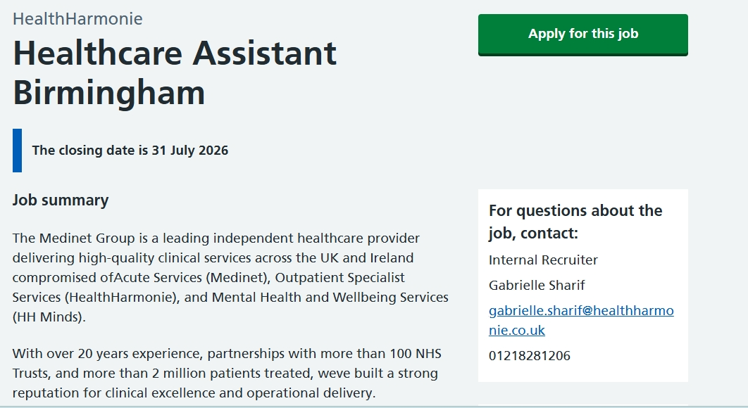

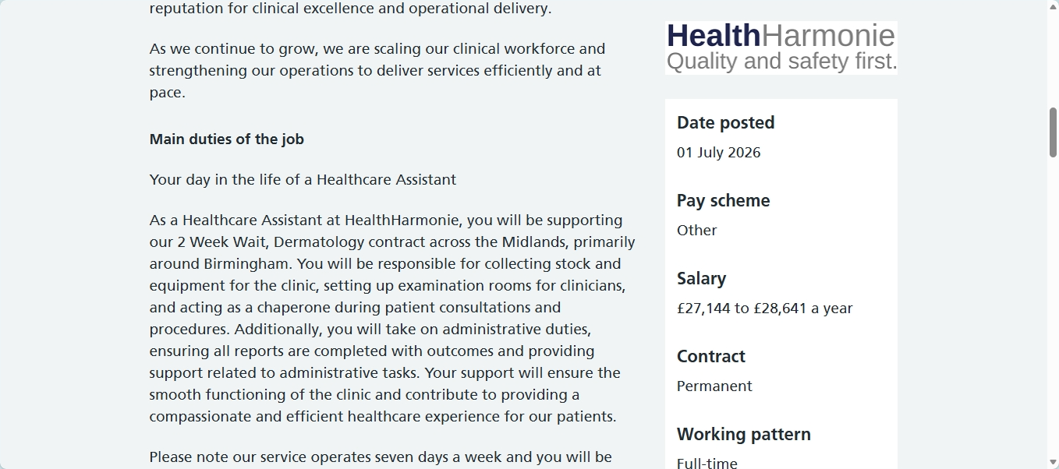

Curriculum Vitae

Dornequa Fleming

Mobile: 07960 428326 Email: dornequafleming@gmail.com

Personal Profile

A diligent individual with a strong dedication to providing service for others and a good working knowledge of customer service quality. Pay attention to details and is a good written and verbal communicator. Excellent team worker, punctual, hardworking and physically fit. Able to work at recommended locations according to varied shift patterns. Experienced in providing excellent service oriented to clients/service users as providing adequate information regarding a desired request.

Key Skills

- Excellent communication and listening skills
- Excellent time management and organizational skills
- Producing work of high quality within required timescales
- IT Competent

Employment History

Aurora Anguilla Resort & Golf Club Jan 2021- Jan 2024
Anguilla
Role & Responsibilities: Server
- Preparing the restaurant before opening
- Preparing the kitchen
- Serving the customers
- Greetings and welcoming customers
- Assisting the bartender

Education History

Alison
Special Education Needs and Disability (SEND) Inclusion in Schools
Introduction of Caregiving
Understanding Medication for Caregivers

Hodge Comprehensive School Sept 2011- June 2017
Albena Lake
Principal of Accounts
Electronic Document Preparation and Management
Agriculture Science
English

University of Wales Trinity Sanit David Sept 2025- Sept 2026
Certificate in Higher Education in Health & Social Care
Level 4

References available upon request

Personal Statement for Health Care Assistance

I am a compassionate, hardworking and reliable individual with a genuine passion for caring for others. My ambition is to build a successful career as a Healthcare Assistant, where I can make a positive difference to lives of patients by providing high quality, person – centred care. I enjoy helping people, supporting their wellbeing and promoting their independence while treating everyone with dignity, respect and kindness.

I have studied Health and Social Care, when I have developed a strong understanding of key principles such as safeguarding, duty of care, infection prevention and control, confidentiality, equality and diversity, and person-centered care. My education has given me the knowledge needed to understand patients’ physical, emotional and social needs. As well as the importance of working within professional standards and following health and safety procedures.

Throughout my learning, I have developed valuable communication and teamwork skills. I understand the importance of listening carefully to patients, showing empathy and providing reassurance during difficult situations. I can communicate effectively with patients, their families and members of the healthcare team, ensuring information is shared clearly and professionally. I also understand the importance of maintaining accurate records and respecting confidentiality at all times.

My personal strengths include being patient, caring, organized and dependable. I work well under pressure, remain calm in challenging situations and am always willing to support others. I am a quick learner who enjoys developing new skills and adapting to different working environments. I can work effectively as part of a team but am also confident in taking responsibility for completing tasks independently when required.

I have gained practical knowledge through my Health and Social Care studies. I have learned the importance of providing compassionate care while respecting everyone’s dignity and personal choices. My career goal is to continue developing within the healthcare sector by gaining experience, completing training and eventually progressing into more senior healthcare roles. I am committed to continuous learning and understand the importance of keeping my knowledge and skills up to date to provide the highest standard of care.

I believe I would be a valuable Healthcare Assistant because I am dedicated to delivering safe, compassionate and person-centered care. I have a positive attitude, a strong work ethic and a genuine desire to improve the lives of others. I understand the importance of treating every patient with respect, maintaining confidentiality and working collaboratively with colleagues to achieve the best possible outcomes.

I am excited about the opportunity to contribute to your organization and support patients with professionalism, empathy and kindness. I am confident that my caring nature, communication skills and commitment to high-quality care will enable me to make a positive contribution to your healthcare team while continuing to develop my career within the NHS or the wider healthcare sector.

Personal SWOT Analysis

SWOT analysis is a planning tool used to evaluate strengths, weaknesses, opportunities and threats. In corporate settings, it helps organizations assess their competitiveness and identify areas for improvement. At an individual level, a SWOT analysis can also be used to reflect on personal circumstances, compare skills and experiences with others, and recognize areas for development (Teoli, Sanvictores and An, 2023).

Strengths

- I am caring, compassionate, and empathetic, which will help me build positive relationships with patients.
- I have good communication and listening skills, allowing me to understand patients’ needs and work effectively with colleagues
- I am reliable, responsible and able to work independently and as part of a multidisciplinary team.
- I am willing to learn and committed to continuous development.

Weaknesses

- I have limited practical experience in a healthcare setting and need to develop my confidence through workplace learning.
- I need to continue developing my knowledge of some clinical procedures and healthcare equipment through training.
- I need to gain more confidence in handling challenging situations, such as dealing with distressed patients or relatives.

Opportunities

- Gaining work experience or volunteering in hospitals, care home or community settings.
- Completing additional healthcare training, such as First Aid, Manual Handling, Infection Prevention and Safeguarding.
- Learning from experience healthcare professionals to improve clinical and communication skills
- Progressing to senior Healthcare Assistant roles or studying to become a Registered Nurse in the future.
Threats
- High competition for Healthcare Assistant positions may make securing employment more challenging.
- Working in healthcare can be physically demanding, which may lead to stress or burnout if not manages effectively.
- Changes in healthcare policies, staffing, shortages, and increased workloads may affect work life balance.
- Exposure to infectious diseases requires strict adherence to health and safety procedures.

(Treanor, 2000)

Personal Development Plan Template

Goals | List the actions to complete to achieve the goal | Support/resources needed | Target date | Review date
Getting my License | Need to take the test and road test | - Using the driving app for test practice  - Start taking driving practice | January 2027 | May 2027
Associate Nursing Apprenticeship | Apply commencing September 2027 | - Fill out application  - Do Voluntary work  - Apply for a part time/full time Healthcare Assistance | September 2027 | September 2030
Graduate from UWTSD | Finish my assessments on time and pass | - Attend class so I don’t miss information  - Revise my work  - Use academic sources | September 2025 | September 2026

Reflection

Purpose of Reflection: Reflection is a structured process that helps you think critically about your professional practice, recognise what went well, and identify areas for improvement. It supports learning by helping you gain insight from your experiences and apply that understanding to improve your practice and service delivery (Health and Care Professions Council, 2024; University of Birmingham Academic Skills Centre, 2024).

A framework for reflection is Gibbs' Reflective Cycle (Gibbs, 1988). It comprises of six steps that will lead you through a methodical process of thinking back on your educational experiences (University of Derby Library, 2024).

Description
The purpose of the presentation was to demonstrate my understanding of the chosen topic while presenting information clearly and professionally. I research the topic, prepared presentation slides, and delivered my presentation to my lecturer. The presentation required effective communication, confidence, organization, and the ability to answer questions appropriately.

Feelings
Before the presentation, I felt nervous and lacked confidence because I was concerned about speaking in front of my lecturer and while it’s also being recorded for others. I worried that I might go under my given time to present or become anxious during presentation. However, once I began speaking, I gradually become more confident, after completing the presentation, I felt relieved and proud that I had successfully delivered my work despite my initial nervousness.

Evaluation
Several aspects of my presentation were successful. I had prepared thoroughly by researching the topic and the organising the information logically. My PowerPoint slides were clear, relevant, and easy to understand. I maintained a professional appearance and engaged with my lecturer by speaking clearly and maintaining eye contact where possible. However, I could have use more academic sources and creditable sources for my presentation and improve on my confidence.

Analysis
The presentation highlighted the importance of working in teams within healthcare education. Healthcare Assistants must be able to work in teams effectively with healthcare professionals especially where you work with a multidisciplinary team consisting of physiotherapist, pharmacist and others. Therefore, developing strong presentation and the ability to work in teams is directly relevant to my future career.
The verbal feedback from my lecturer recognised that my presentation was well organised demonstrate a good understanding of the topic. My lecturer also commented that my slides was appropriately structured. However, I was advised to improve my communication and build confidence by participating in class discussions and taking part more frequently. This constructive feedback helped me identify practical strategies to improve my future presentations.

Conclusion
Overall, I believe the presentation was a valuable learning experience. Although I experienced nervousness, I successfully communicated the main point of my topic and completed the presentation professionally. The feedback I received helped me recognise both my strengths and the area requiring further development. Reflecting on this experience has increased my awareness of the importance of effective teamwork and continuous professional improvement.

Action Plan
To improve future presentation, I will practice speaking regularly before presenting to increase my confidence. I will rehearse my presentation several times while timing myself to improve my pacing. I also intend to reduce my reliance on presentation slides by using brief prompts instead of reading directly from them. Additionally, I will seek feedback from my lecturers after future presentations so that I can continue developing my communication and engaging in class discussions.

References

Teoli, D., Sanvictores, T. and An, J., 2023. SWOT Analysis. In: StatPearls. Available at: https://www.ncbi.nlm.nih.gov/books/NBK537302/ (Accessed 22nd July 2026).
University of Derby Library, 2024. Gibbs Reflective Cycle. Available at: https://libguides.derby.ac.uk/develop-at-derby/resilience/gibbs-reflective-cycle (Accessed 22nd July 2026).
Health and Care Professions Council (HCPC), 2024. What is reflection? Available at: https://www.hcpc-uk.org/standards/meeting-our-standards/reflective-practice/what-is-reflection/ (Accessed 22nd July 2026).
NHS Jobs, 2024. Job Advertisement: U0024-26-0049. Available at: https://beta.jobs.nhs.uk/candidate/jobadvert/U0024-26-0049 (Accessed 22nd July 2026).
Treanor, H.L., 2000. Health risks and the health care professional. Medicine, Health Care and Philosophy, 3(3), pp.251–255. Available at: Health risks and the health care professional - PubMed (Accessed: 22nd July 2026).
University of Birmingham Academic Skills Centre, 2024. Reflective Writing. Available at: https://libguides.bham.ac.uk/asc/reflectivewriting (Accessed: 22nd July 2026).

