REFLECTIVE PORTFOLIO

MODULE NAME: PROFESSIONAL AND CAREER DEVELOPMENT
MODULE CODE: BMSW4005
STUDENT NAME: DENISE CHAMBERS
STUDENT NUMBER: 2020342

LECTURER NAME: KINGSLEY OMEIHE

ABSTRACT
This is a reflective report on the three learning styles learned in the module using the Gibbs reflective cycle I have assessed my skills creating a SWOT analysis, I have updated my cv and learned more about myself. I have created a personal development plan and an action plan which have already helped at lot with my career.

CONTENTS

Introduction 2
SWOT ANALYSIS 2
Table 1. SWOT Analysis 2
PERSONAL DEVELOPMENT PLAN 3
Figure 2. PDP Cycle 3
LEARNING STYLE THEORIES 4
Figure 3. Kolb Learning Styles 4
Figure 4. Neil Fleming Learning Style 5
Figure 5. Honey and Mumford Learning Styles. 6
LEARNING REFLECTION 6
Figure 6. Gibbs Reflective Cycle 7
Action Plan 8
Table 2. Action Plan 8
Conclusion 8
References 8

Introduction
In this report I will be reflecting on my experience in the module Professional Career Development, the aim of this report is to address the assignment questions, which are to assess my skills using the analytical tools SWOT analysis and create Personal Development Plan. Reflect on Learning Style Theories of Kolb, Honey and Mumford and Neil Fleming which we learned in this module indicating the theory you identify with. Explaining the impacts on my own career and personal life. I will be assessing the concepts learned during this module using the Gibbs Reflective Cycle.

SWOT ANALYSIS
I chose to apply for the role of Ward Administrator at Band 4 grade to provide an administrative support service to 2 Acute Mental Health Ward at Moseley Street Hospital. SWOT is a strategic planning tool, listing of the pros and cons for internal and external issues in the 4 sections of the table, planners can better understand how to use them to their advantage (Helms, 2010). It is useful for determining the strengths, weaknesses, opportunities and threats I face with my career development, the below table provides a snapshot of my SWOT analysis.

Table 1. SWOT Analysis
STRENGTHS | OPPORTUNITIES
Team Player  Presentation Skills  Flexibility  Adaptability  Organised  Keen to Learn | Education  New Roles  Good Salaries  Training  Networking
WEAKNESS | THREATS
Time poor  Location  Resources  Inpatient | Competition  Skills  Education  Distraction

The above SWOT analysis list my strengths, opportunities, weakness and threats. In terms of my strengths, I am a great team player and have excellent presentation skills, I currently have very little spare time as I work full time and study full time so have very little time for anything else therefore which also leads onto location as a single parent I cannot travel too far for work. One of my current threats are competition from other applicants as they may have better education, training or experience to equal the playing field I need to plan on how to develop my skills and competences to achieve my goals. Training and networking are opportunities for me as new training help to bring new skills and bring the opportunities for networking.

PERSONAL DEVELOPMENT PLAN
A Personal Development Plan is an assessment tool used to assess the cycle of development by gathering information about skills competencies an individual has previously gained and is planning to gain in the future to improve current skills and competencies (Beausaert, 2013; CMI Report, 2022). During the first lesson we created our own personal development plan following the steps (shown in the table below) of Establish Purpose/Direction – my purpose was to become an Operations Manager, Identify Development Needs – my needs are to develop my typing skills and source management training, Look at Development Opportunities – research training available for both typing and management skills, Formulate an Action Plan – attend training for both typing and managements skills, Undertake Development - complete training for typing and management, Record Outcomes – update cv and LinkedIn and Review and Evaluate – apply for Operation Manager position. Evaluation will provide valuable insight on the next stage of development in the ongoing cycle. Circumstances can change as well as goals, new need will be identified so it is important to check your plan with these changes (Chartered Management Institute, 2023).

Figure 2. PDP Cycle
ESTABLISH
PURPOSE / DIRECTION
Become Operations Manager

Review and Evaluate
Apply for Management positions
IDENTIFY DEVELOPMENT NEEDS
Improve Typing Skills /
Management Training

PERSONAL DEVELOPMENT PLANNING CYCLE
RECORD OUTCOMES
Update CV
Update Linkedin
LOOK AT DEVELOPMENT OPPORTUNITIES
Source/Research training both internal and external to my organisation

FORMULATE A PLAN
Join Training for both Typing and Management Skills
UNDERTAKE DEVELOPMENT
Complete Typing and Management Training

Source: Adapted from CMI Report (2022).

LEARNING STYLE THEORIES

During our second lecture we discussed the three learning styles theories which were: Honey and Mumford, Neil Flemming and Kolb. Learning styles are important as they measure the way individuals are inclined to approach learning (Cassidy 2004). Learning styles are a combination of cognitive, affective, and psychological factors that point out how students interact with and respond to learning environments (Duff 2002).

Kolb learning style theory developed by David Kolb in 1984 also known as ELM which shows 4 learning types matching how learners preserve and process information (Sharpe 1997). The four types are Divergers, Assimilators, Convergers and Accommodators as demonstrated in the below diagram.

Figure 3. Kolb Learning Styles

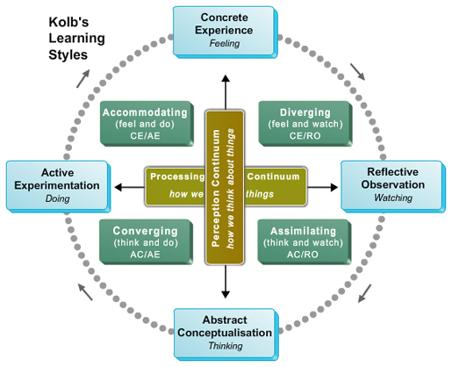
This Photo by Unknown Author is licensed under CC BY-SA
Source: University of Wales Trinity Saint David (2023)

VARK was created in 1992 by Neil Fleming as a tool to assess the learning preferences to inform both students and lecturers of their methods of learning. Visual, Arul, Read/Write and Kinesthetics are the four types of learners, these are based on real life situations making it more relatable to learners (Ganesh 2014).

Figure 4. Neil Fleming Learning Style

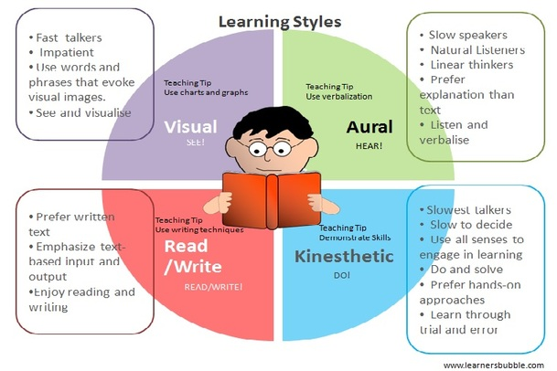

Source: University of Wales Trinity Saint David (2023).

Honey and Mumford learning style questionnaire measures the strength of the learner’s preferences for each style in the cycle which are Activist – an experience, Reflector – looking back at the experience, Theorist – conclude the experience and Pragmatist – plan what to do next (Swailes, Senior 1999).

Figure 5. Honey and Mumford Learning Styles.

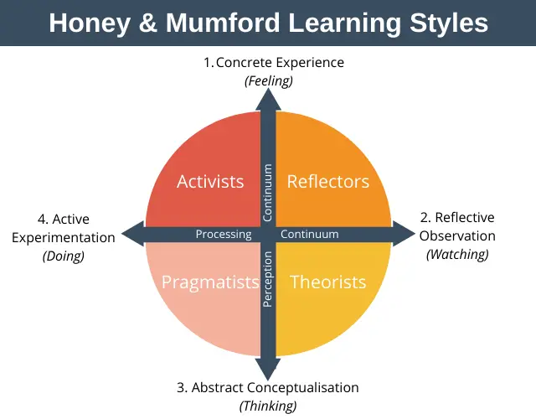
I have completed a few learning style quizzes, the personal test revealed that I am an Entertainer meaning I am energetic and enthusiastic, I enjoy social activities and value social interaction, I good at adapting to opportunities. The learning style quiz revealed that I am a visual learner scoring Auditory: 35%, Visual: 40%, Tactile: 25% overall I am a visual learner. This means I learn from reading and looking at pictures, I remember and understand things by seeing them. I need to see thing as well as hear them to absorb information (Pennsylvania Higher Education Assistance Agency, 2023).
My style of learning is more consistent with Honey and Mumford as I believe that I have been on this learning cycle many times throughout my life, I would receive information, process it by reflecting, assess to show understanding, create a plan. I am very comfortable learning visually, audibly, and physically doing things, but I do not enjoy reading and writing very much.
In my own career I was looking to make a move from my current position of employment, I felt like it was time for a change of experience. We began this moule with a personal development plan, which made it very clear to me what I needed to do the gain the necessary skills and experience to real my short and long term goals.
I updated my CV using techniques shown in lectures and with my personal development plan in mind I applied for some jobs in roles that would allow me to get some different experience. Fortunately for me learned some interview techniques, this is an area I struggle with. The mock interview was the day before a real interview, it felt so ideal for me as I could have a trial run. With some inspiring feedback I attended my interview and felt it went well on my way home and anxiously waiting to for the call back. I got the job, I never imagined how much this module would impact my career, I am over the moon.

LEARNING REFLECTION
In this section of the report, I will discuss concepts I have learned in class using the Gibbs Reflective Cycle, the cycle is a model of reflection looking into an experience it covers 6 stages: The description, the feeling, the evaluation, the analysis, the conclusion and the action plan allowing you the learn from the experience as to whether things went well or when they didn’t go so well, you can then use this to create a plan for the future (The University of Edinburgh, 2020).

Figure 6. Gibbs Reflective Cycle
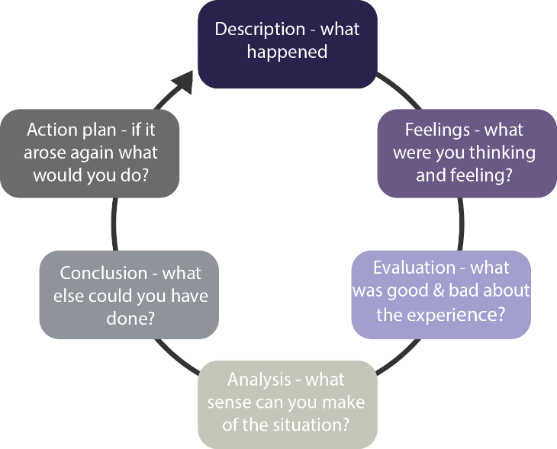
Source: Brokering (2023)
We created a Personal Development Plan to outline the skills we wanted to improve on to allow us to reach our individual goals, I felt very excited with this task as I am all about self-improvement and I found it very helpful as it was clear to see what I needed to do next. Training courses were necessary and the plan was to research, identify and attend the training courses available to me. In took quizzes on both Improving Self Awareness and Learning Styles, I found it very intriguing to learn more about myself, I found that I am a visual learner and that I relate to the Honey and Mumford style of learning.
In Open Book Assessment I was very nervous as I was completely unprepared for an examination as I had forgot it was happening, so I just threw myself into it and found that I produced some good work, but it needed more attention to detail, I now know how important it is the check my referencing.
I already had a CV that I was very happy with, which I updated with experience and qualifications gained over the last few years. During class we were tasked to look at 3 CVs relating to the job roles we planned to apply for. I realised that I failed to show some key skills I already have and failed to show them in a clear way, I should have used bullet points which highlight each skill. Functional CVs highlight skills and aptitudes. This will allow candidates to describe what they are able of rather than the work they have done in the past (Pearce 2007). This exercise was a very useful aid to producing a great CV document.
I also noticed that some others listed their core skills or education first whereas I have listed my work experience first, then my education history, then my core skills and Activities/Hobbies. You must be happy that your CV it should be a true reflection of you as a person also is written in language that you use yourself (Mortell 2006). It is important to be honest and reflect the truth about yourself when writing your CV.
The Interview Skills and Mock Interviews, I felt apprehensive about this process as I am terrible at interviews, I always fail to sell myself according to the feedback. This experience has shown me that I can do it, I applied technique shown to me and found the interview went well, the plan is to use these techniques in future interviews.

Action Plan

An action plan was created to easily identify the process necessary to reach my long term goal of becoming Operations Manager.

Table 2. Action Plan
OBJECTIVES | TIME | ACTIVITIES | SUCCESS CRITERIA | RESOURCES
SHORT TERM
Improve Typing | 6 Months | Typing course and time to practice | Speed and Accuracy | Online Training and Practice
Gain Band 4 Employment | 6 Months | Apply for band 4 positions | Successful band 4 position gained | Updated CV
Improve Time Keeping | 6 Months | Change routines slightly | More productive | Alarm / Planner
LONG TERM
Management Training | 3 years | Skills for the workplace certificate | Pass / Distinction | UWTSD
Operations Manager Position | 4 years | Apply for available positions | Successful Operations Manager Position gained | Personal Development Plan / CV

Conclusion

To conclude this module has been very insightful, I have created a personal development plan and updated my cv, I have learned more about myself though the personality and learning style quizzes. The Interview techniques we learned were helpful in my personal career. This module has allowed me to take a close look at how I was doing things when looking for employment and developing myself. I plan to use the techniques learned in this module achieve the goals I have listed in my personal development plan. The new job role I now have will give me the experience I need and I have already enrolled on an online typing course. I will continue to implement the following stages of my action.

References

Beausaert, S. et al. (2013) ‘Effect of using a personal development plan on learning and development’, The journal of workplace learning., 25(3), pp. 145–158. Available at: https://doi.org/10.1108/13665621311306538. (Accessed 19/03/2023)
Brokering, T.J. of P. (2023). The value of reflective practice for partnership brokers – The Partnership Brokers Association. [online] Partnershipbrokers.org. Available at: http://partnershipbrokers.org/w/journal/the-value-of-reflective-practice-for-partnership-brokers/. (Accessed 26/03/2023)
Cassidy *, S. (2004) ‘Learning Styles: An overview of theories, models, and measures’, Educational psychology., 24(4), pp. 419–444. Available at: https://doi.org/10.1080/0144341042000228834. (Accessed 26/03/2023)
Chartered Management Institute (2023). UWTSD Moodle 2022/23: Log in to the site. [online] moodle.uwtsd.ac.uk. Available at: https://moodle.uwtsd.ac.uk/pluginfile.php/365937/mod_resource/content/2/Personal_Development_Planning.pdf?redirect=1 [Accessed 19 Mar. 2023].
Duff, A. and Duffy, T. (2002) ‘Psychometric properties of Honey & Mumford’s Learning Styles Questionnaire (LSQ)’, Personality and individual differences, 33(1), pp. 147–163. Available at: https://doi.org/10.1016/S0191-8869(01)00141-6. (Accessed 26/03/2023)
Ganesh (2014) ‘Learning preferences of PG and UG students: Application of VARK’, SCMS Journal of Indian Management, 11(3). (Accessed 24/03/2023)
Helms, M.M. and Nixon, J. (2010) ‘Exploring SWOT analysis – where are we now?’, Journal of strategy and management., 3(3), pp. 215–251. Available at: https://doi.org/10.1108/17554251011064837. (Access 18/03/2023)
Mortell, N. (2006) ‘Letter writing and CV savvy’, Lab animal, 35(6), pp. 51–51. Available at: https://doi.org/10.1038/laban0606-51. (Accessed 26/02/2023)
Pearce (2007) ‘Ten steps to welting curricula vitae: Chris Pearce offers a guide to help nursing leaders write effective CVs’, Nursing management., 14(7). (Accessed 26/02/2023)
Pennsylvania Higher Education Assistance Agency (2023). What’s Your Learning Style? 20 Questions. [online] www.educationplanner.org. Available at: http://www.educationplanner.org/students/self-assessments/learning-styles-quiz.shtml?event=results&A=7&V=8&T=5. (Accessed 18/03/2023)
Rogers, K.M.A. (2009) ‘A preliminary investigation and analysis of student learning style preferences in further and higher education’, Journal of Further and Higher Education [Periodical], 33(1), pp. 13–21. Available at: https://doi.org/10.1080/03098770802638234. (Accessed 24/03/2023)
Sharp, J.E. (1997) ‘Applying Kolb Learning Style Theory in the Communication Classroom’, Business communication quarterly., 60(2), pp. 129–134. Available at: https://doi.org/10.1177/108056999706000214. (Accessed 24/03/2023)
Swailes, S. and Senior, B. (1999) ‘The Dimensionality of Honey and Mumford’s Learning Styles Questionnaire’, International journal of selection and assessment., 7(1), pp. 1–11. Available at: https://doi.org/10.1111/1468-2389.00099. (Accessed 24/03/2023)
The University of Edinburgh (2020). Gibbs’ reflective cycle. [online] The University of Edinburgh. Available at: https://www.ed.ac.uk/reflection/reflectors-toolkit/reflecting-on-experience/gibbs-reflective-cycle#:~:text=One%20of%20the%20most%20famous. (Accessed 20/03/2023)

