University of Wales Trinity Saint David
ACCB6000 – Computer Networks and Cyber Security
Analyzing, Ethically Hacking and Securing an Enterprise Network



Module: Advanced Cybersecurity
Module Code: ACCA-4023
Student: Gabriel Munteanu
Student Id: 2318069
Lecturer`s Name: Dr. Mohamed Ghanem

Contents
1. Scope and lab environment 3
2. Methodology 4
3. Evidence: baseline connectivity 4
4. Automated host discovery (Nmap -sn) 7
5. Results: attack surface discovery (full TCP scan) 8
6. Results: service/version detection and OS identification 9
7. Vulnerability scripting (NSE) results 10
8. SMB focused assessment (Windows targets) 11
9. Findings and simple risk discussion 12
10. Recommendations (what I would do first) 13
11. Limitations 13
12. Conclusion 14

1. Scope and lab environment
In this report I am trying to show and explain the steps that I have followed to complete an vulnerability assessment on the lab environment offered by the university . The main purpose of this report is to show that the network works properly, to identify what services were exposed on the machines and use nmap to check for common vulnerabilities and weak configurations.
All VM`s used for this assignment have been started successfully with network connectivity and behaving as they should in their environment. The Screenshots taken show that all were running and also have valid ip addresses . I have used screen shots also to show initial network configuration and connectivity, because scanning only makes sense if the machines can communicate properly.
The target machines included in scope are:
- S-DC (Windows Server / Domain Controller): 192.168.1.1
- ClientS1 (Windows 10 client): 192.168.1.10
- L-CD (Debian CLI server): 192.168.2.1
- ClientL1 (Debian GUI client): 192.168.2.10
A security testing machine was a KALI 2019 as it has all the tools necessary for scanning. In my screenshots, I included the network configuration output for each system so it is clear which IP address belongs to which host. All screenshots were captured using Windows 11 Snipping Tool and the Windows taskbar time is visible, which provides a timestamp for the evidence.
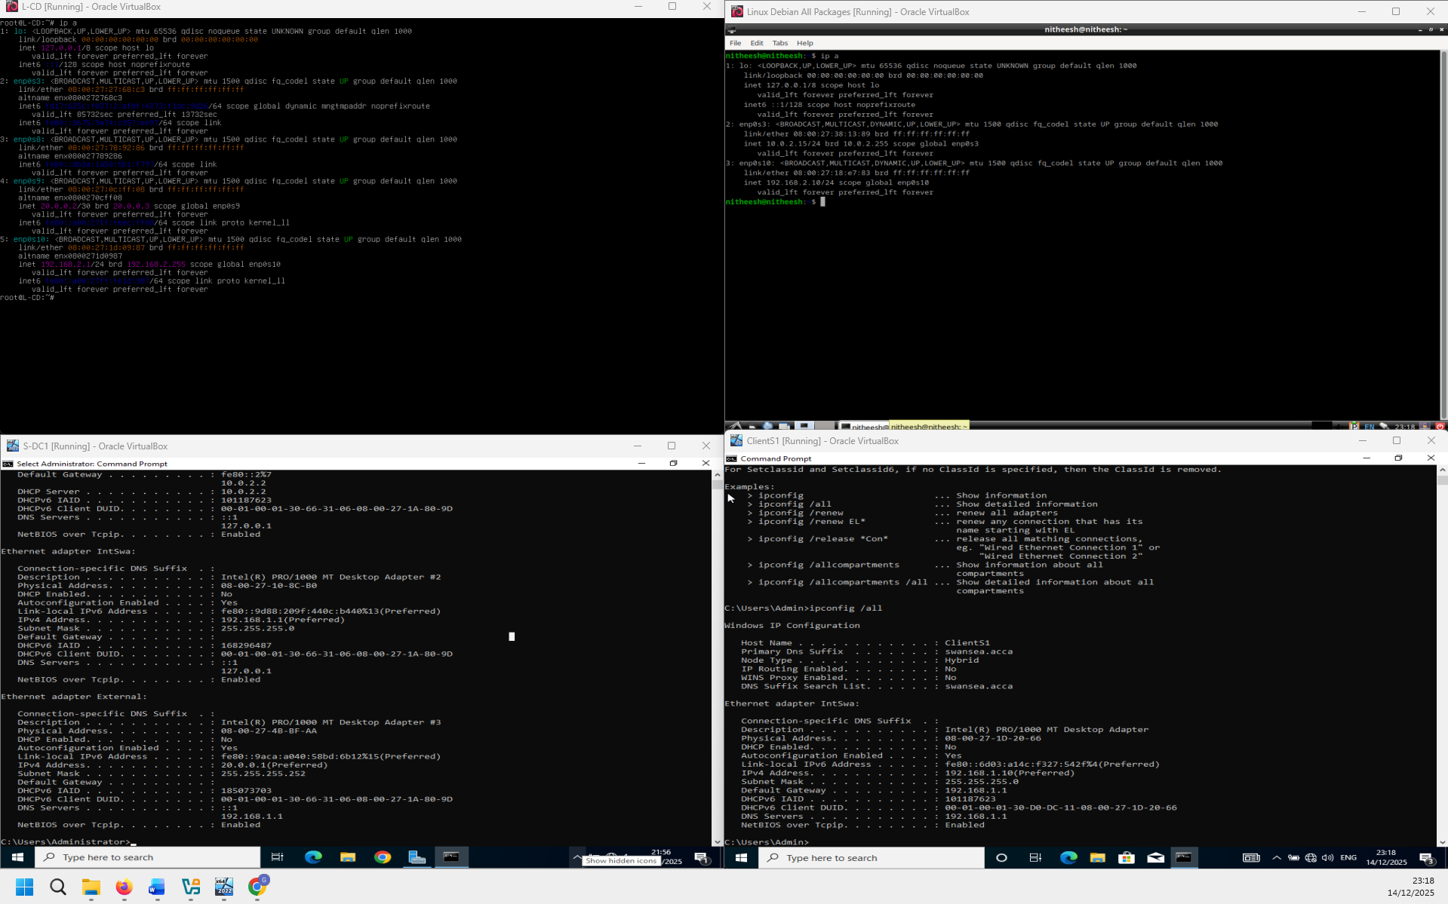
Figure 1 – Network configuration / IP addressing for all lab machines (ip a / ipconfig /all).
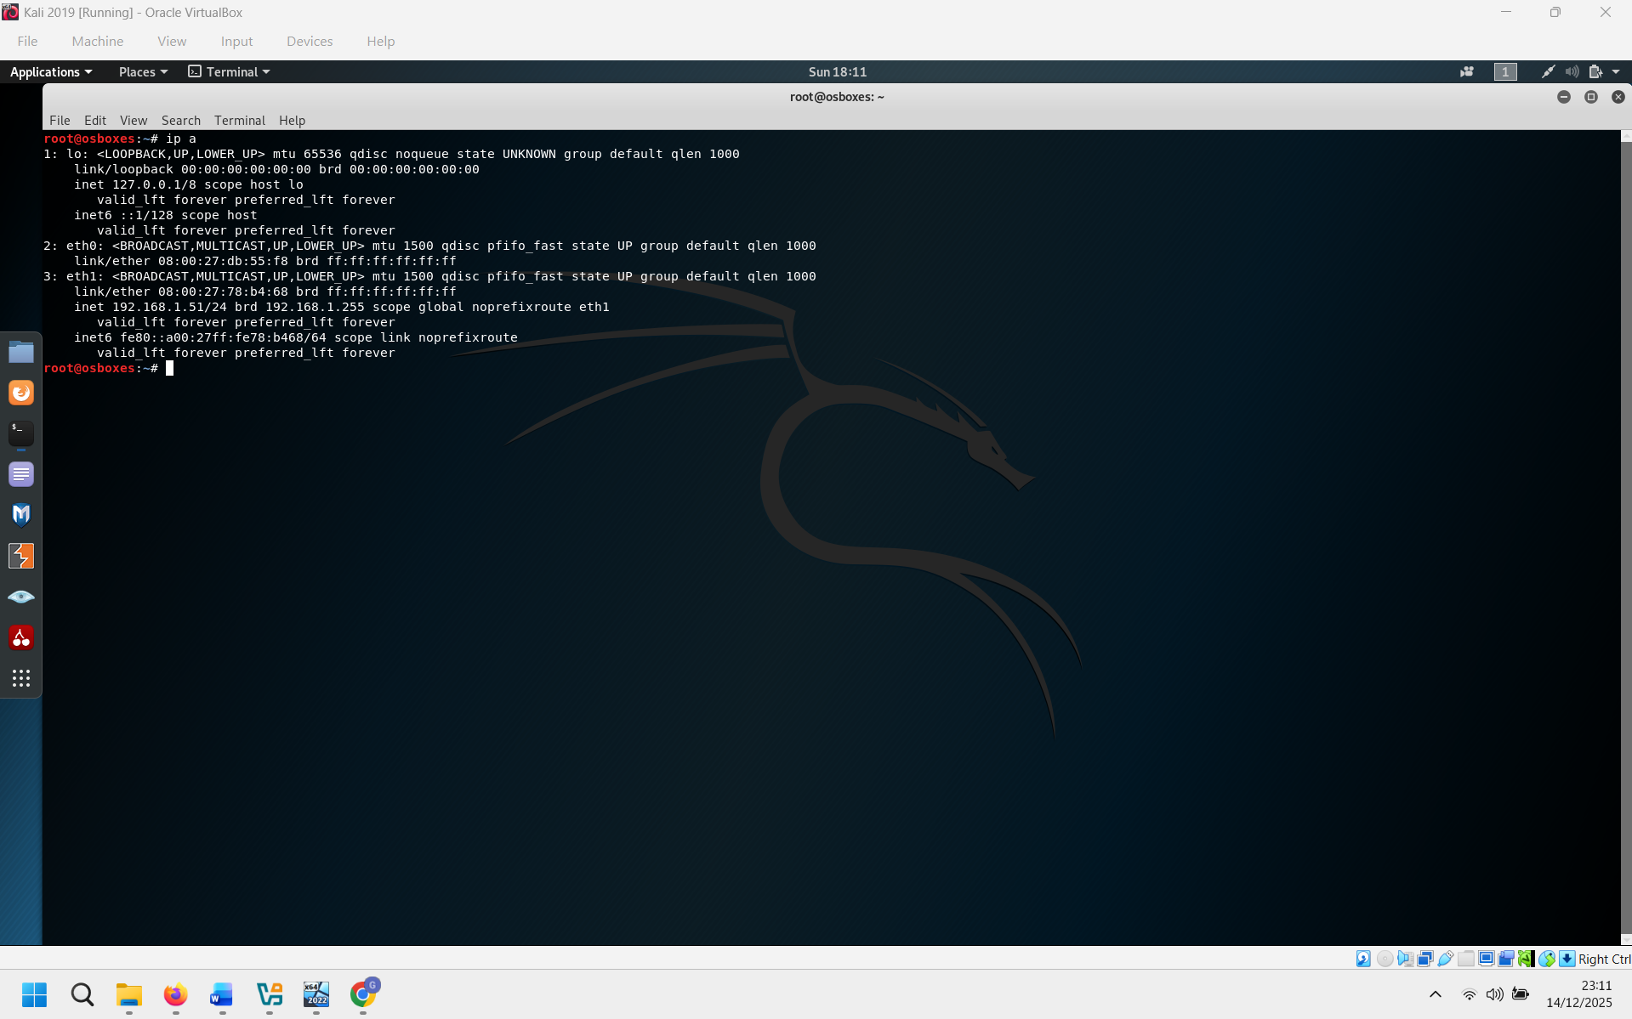
Figure 2 – Kali Linux network configuration showing the scanner IP address (ip a).

2. Methodology
I followed a simple step-by-step approach so that each stage built on the previous one. This helps avoid scanning problems caused by networking issues.
- Step 1 – I have confirmed that every machine has the right ip configuration (Windows: ipconfig /all, Linux: ip a).
- Step 2 – I have confirmed that all machins can communicate with eachother by using ping from London network to Swansea and the other way around.
- Step 3 – Create a targets file on Kali to avoid typing mistakes.
- Step 4 – I have used Nmap host discovery (-sn) to confirm targets are online.
- Step 5 –I have run a full TCP port scan (-p-) to identify exposed services.
- Step 6 – Run service/version detection (-sV) and OS guessing (-O) to understand what is running.
- Step 7 – Run vulnerability scripts (--script vuln) and SMB-specific scripts for Windows hosts.
- Step 8 – Save outputs and (optionally) convert XML results into HTML for easier reading.

3. Evidence: baseline connectivity
Before scanning, I confirmed that the two networks can communicate. This is important because Nmap results can be misleading if we cannot reach a host (for example, ports may appear closed just because the scanner cannot reach the target).
From S-DC1 (192.168.1.1), ping tests to ClientS1, L-CD and Linux Debian were positive, showing end-to-end connectivity across both networks.
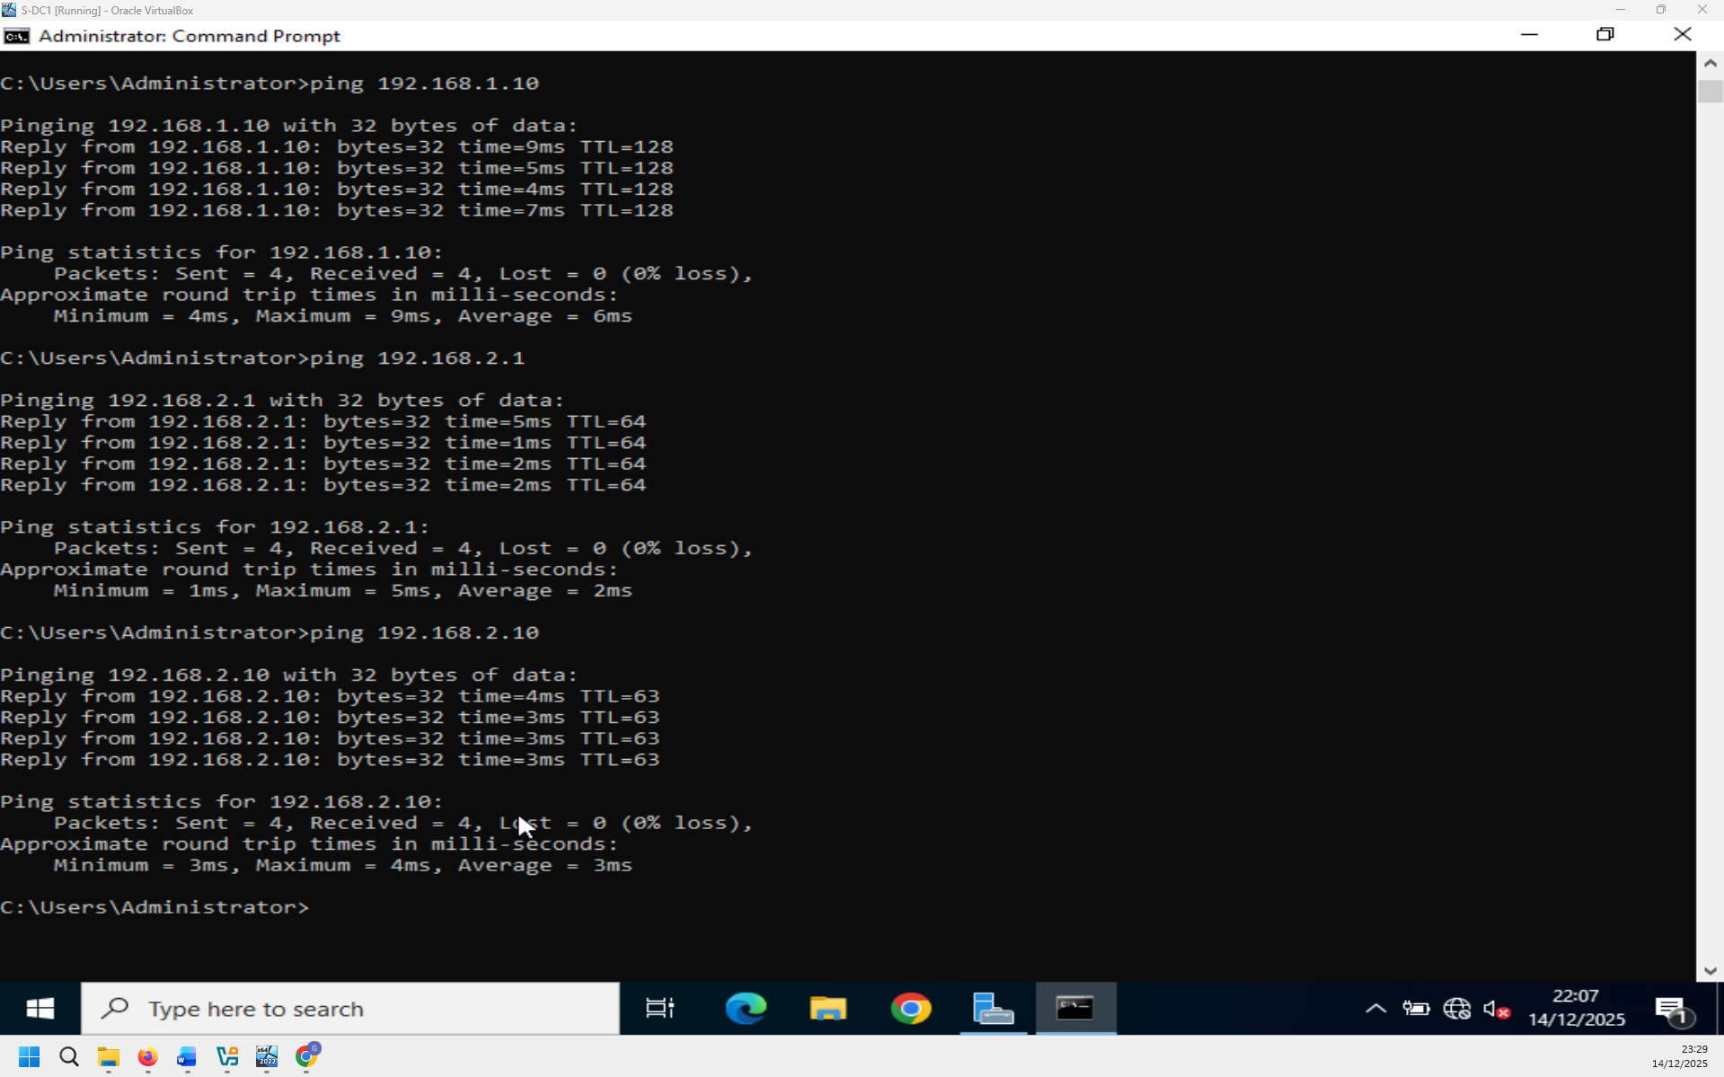
Figure 3 – Ping connectivity from S-DC to targets in Swansea and London (successful replies).
From L-CD (192.168.2.1), ping tests to Swansea hosts and the Kali scanner were successful. This supports that the London side can also reach the Swansea side and the scanning machine.
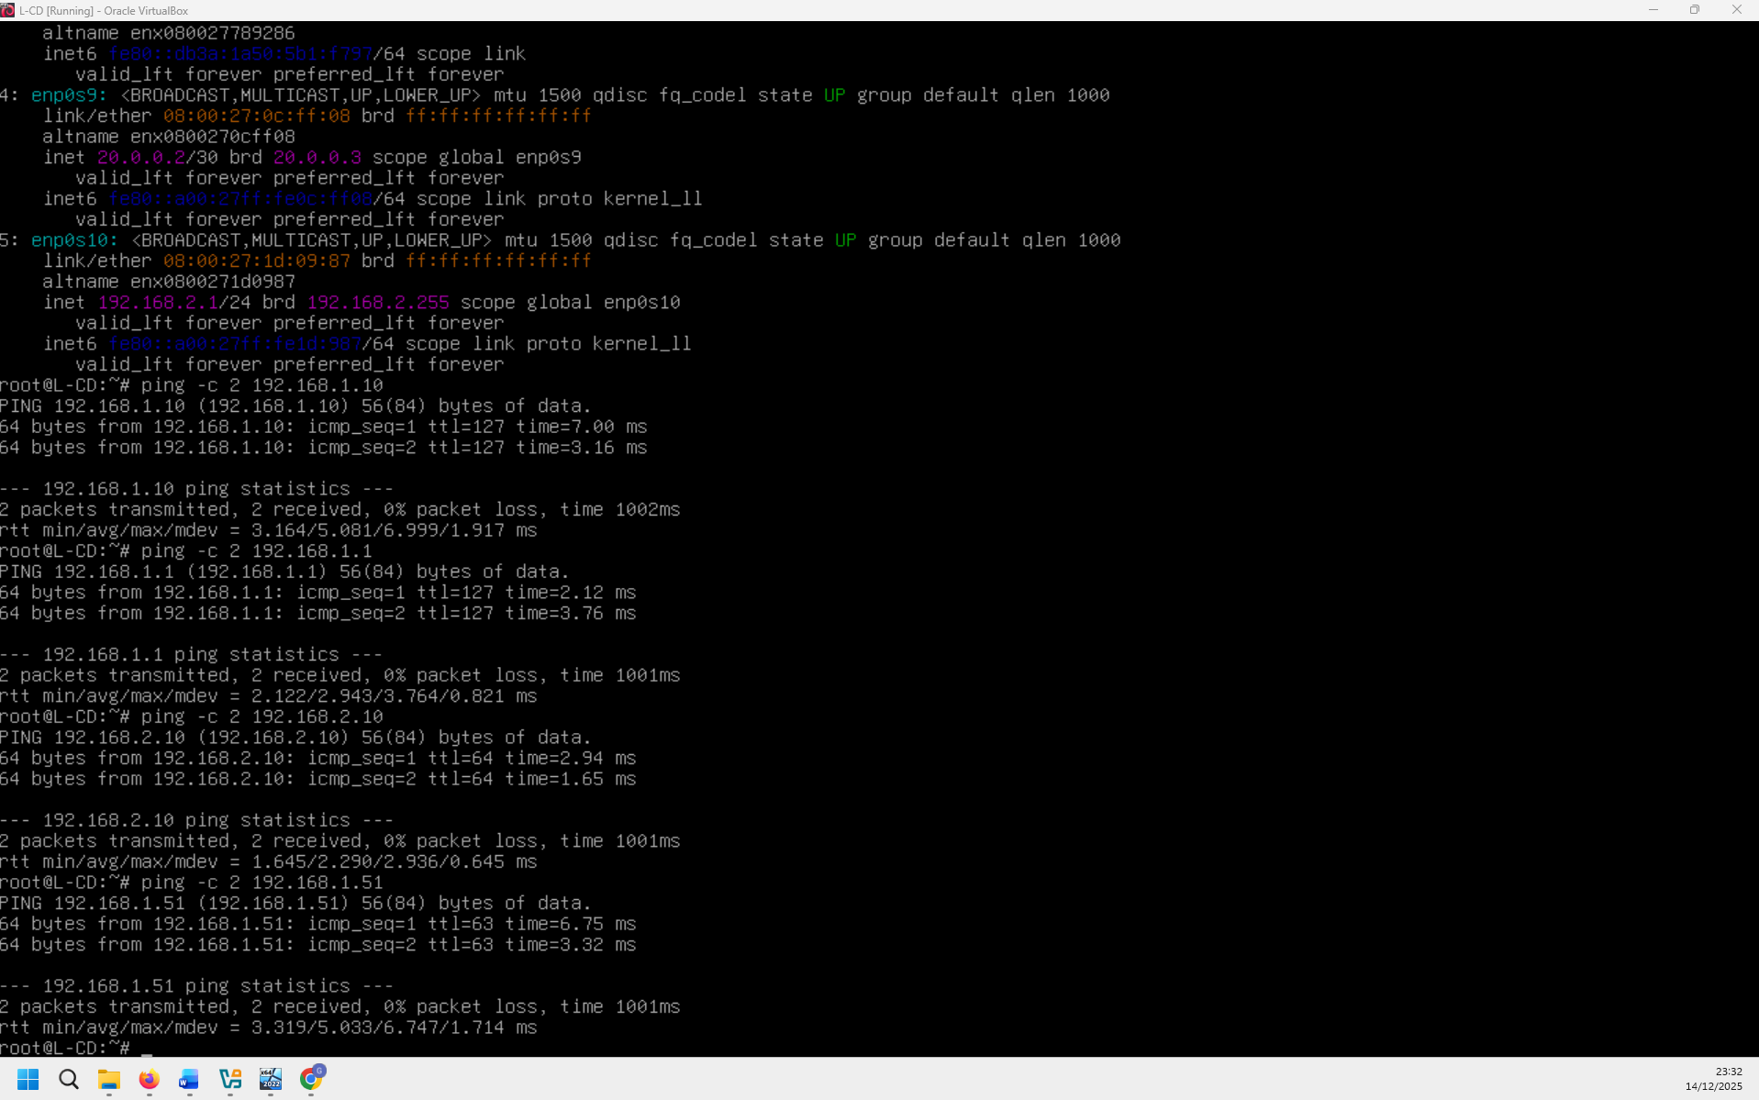
Figure 4 – Ping connectivity from L-CD (London) to Swansea targets and Kali (successful replies).
On Kali, I created the evidence folder and targets file, and then checked each target by using ping command. This ensures the scanner sees both networks and all targets.
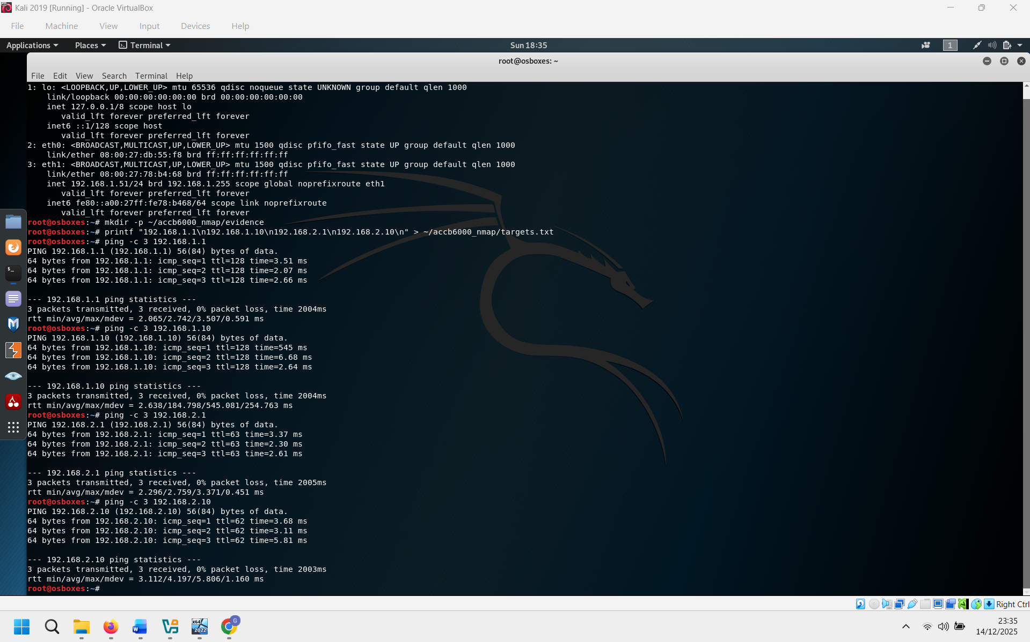
Figure 5 – Kali targets file creation and ping validation for all targets.

4. Automated host discovery (Nmap -sn)
After checking that all targets communicate through the network , I ran Nmap host discovery scans. First I checked each subnet (192.168.1.0/24 and 192.168.2.0/24) to see what machines we have alive. After that I ran host discovery using my saved targets list. This provides evidence that the targets were online before going further with the scans.
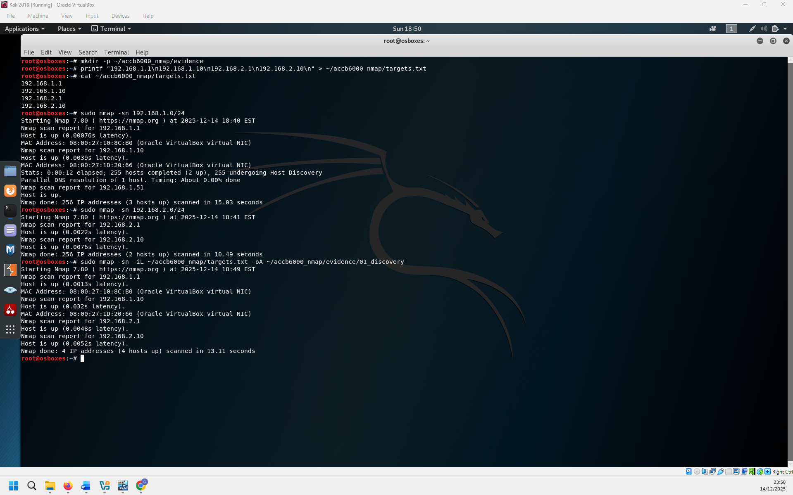
Figure 6 – Host discovery results on both subnets and using the targets file (hosts up).

5. Results: attack surface discovery (full TCP scan)
To discover exposed services, I ran a full TCP port scan across all targets using -p- (all ports) and --open (That only shows open ports). This shows us which network services can be attacked or misconfigured. In the captured output, S-DC shows a large number of open ports including legacy services , FTP, web services (HTTP/HTTPS), Active Directory related services (Kerberos, LDAP), SMB (139/445), and remote management ports such as WinRM.
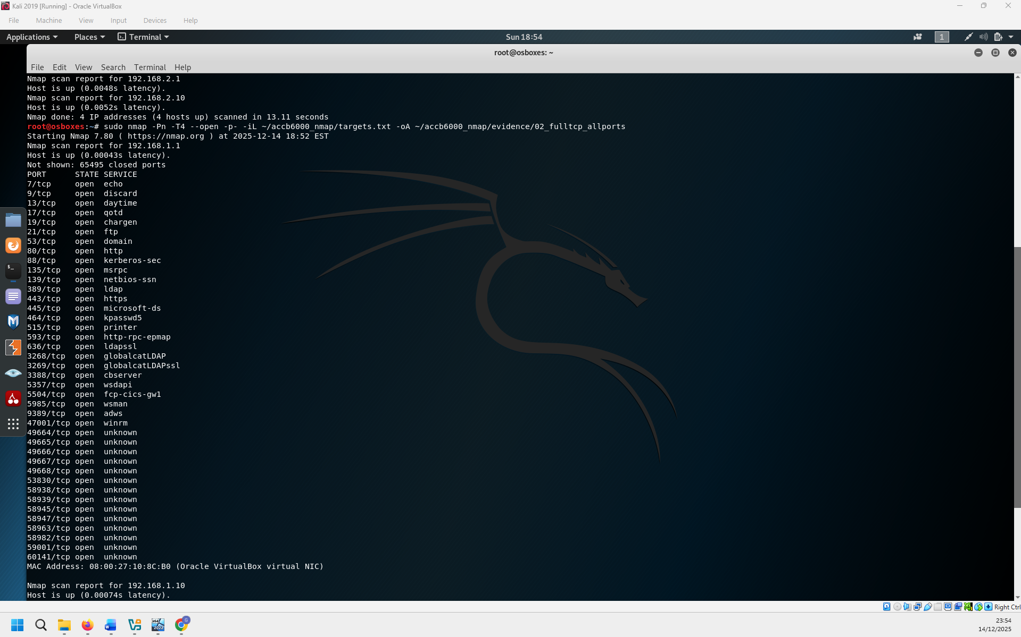
Figure 7 – Nmap full TCP scan output (open ports shown) for S-DC

6. Results: service/version detection and OS identification
After identifying open ports, I used Nmap service/version detection (-sV) and OS guessing (-O). This step helps us identify software version and is important because vulnerabilities often depend on the exact version of that software(for example, web server type or SMB ). In the evidence for S-DC, Nmap identifies Microsoft IIS 10.0 on HTTP/HTTPS and Active Directory services such as LDAP and Kerberos. Nmap also indicates the host is Windows .
During the first run, Nmap returned a ‘Segmentation fault’ message, so I re-ran the same command. The second run completed and produced the expected service output.
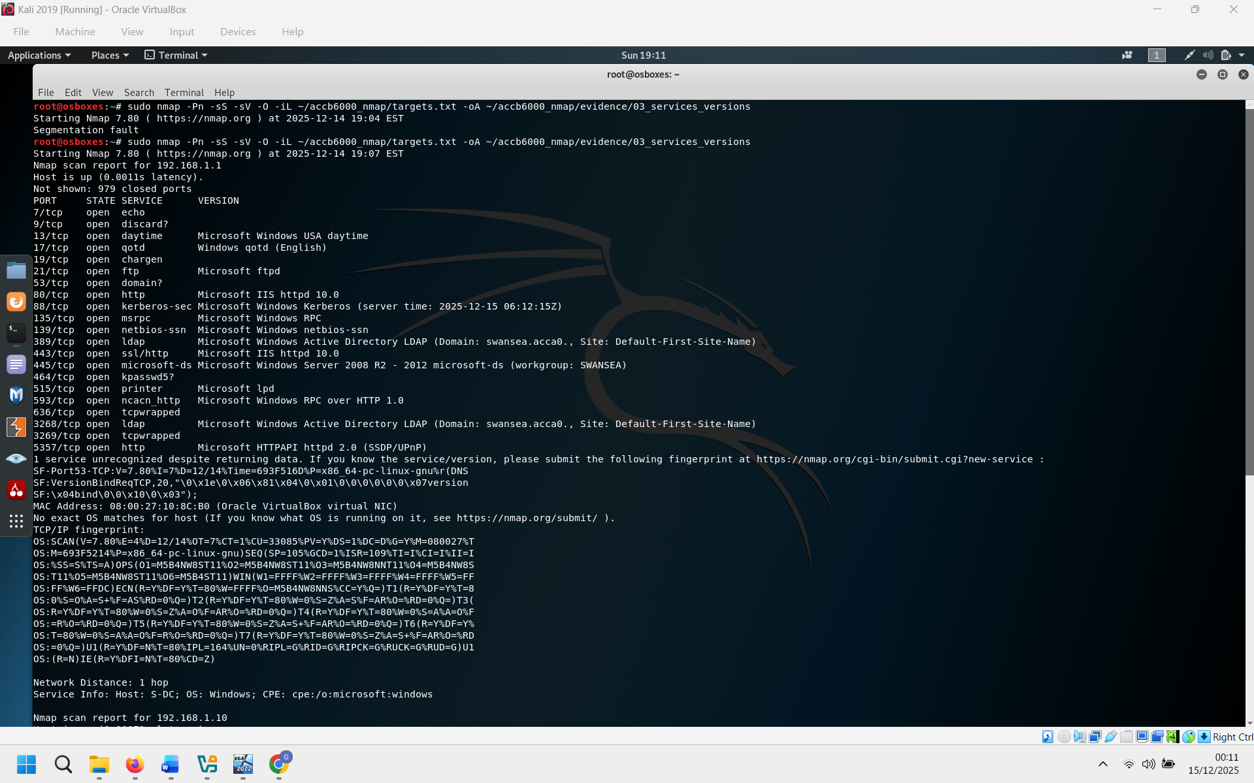
Figure 8 – Nmap service/version detection and OS guess output (including the re-run after an error).

7. Vulnerability scripting (NSE) results
Next, I used Nmap NSE scripts in the ‘vuln’ category to perform automated checks against the discovered services. The goal of this step was to find known vulnerabilities or risky configurations. In the evidence, the HTTP-related scripts did not report CSRF or XSS vulnerabilities on the web service, but this does not guarantee the site is secure; it only means those specific scripts did not detect issues. We have also seen that some scripts (for example, clamav-exec) failed to execute, which is a limitation of script-based scanning in a lab environment.
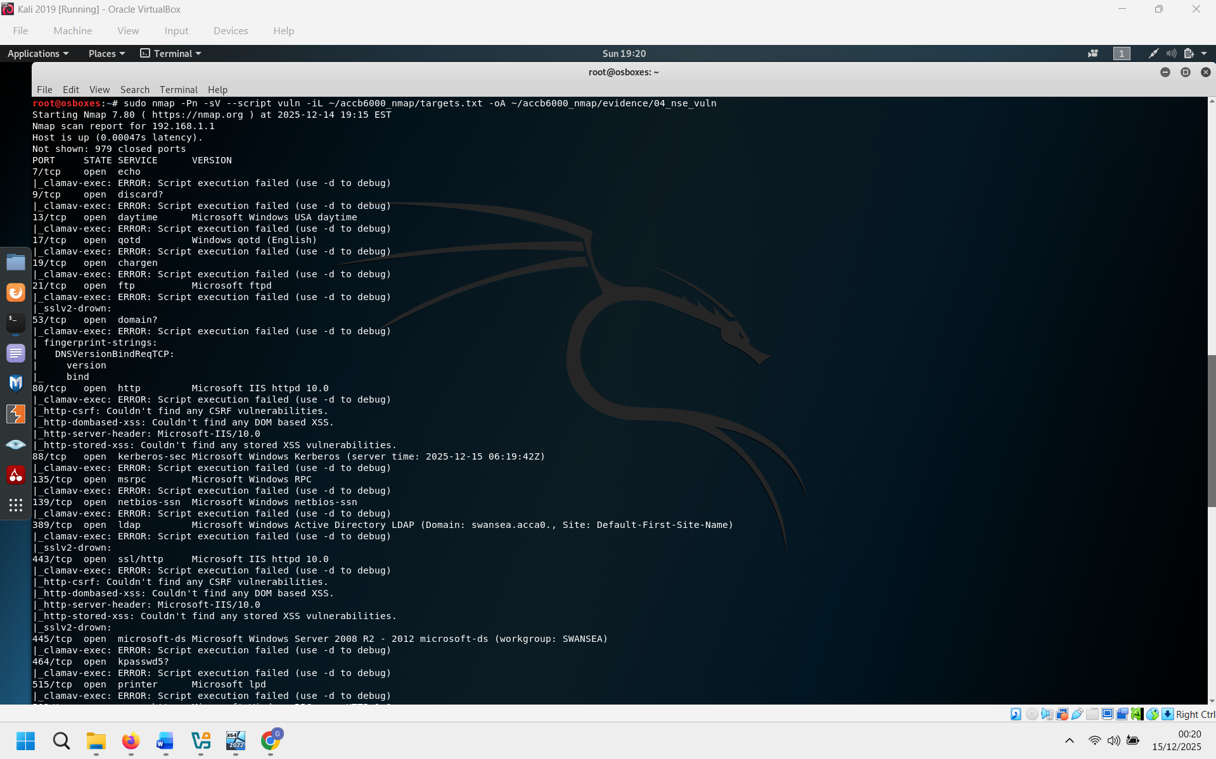
Figure 9 – Nmap ‘--script vuln’ output showing script checks and some script execution errors.

8. SMB focused assessment (Windows targets)
Because SMB is a common target in Windows networks, I ran SMB-focused scripts against the Windows hosts (S-DC and ClientS1) on ports 139 and 445. The most important result in the evidence is that S-DC is reported as ‘LIKELY VULNERABLE’ to MS08-067 (CVE-2008-4250). This is a serious finding because it is a remote code execution vulnerability. Even though the script says ‘likely’, it should be treated as high risk in a real environment until confirmed and mitigated.
The SMB2 security mode output also shows a policy difference: on S-DC, message signing is enabled and required; on ClientS1, message signing is enabled but not required. In simple terms, requiring signing is stronger because it reduces the risk of certain man-in-the-middle style attacks on SMB sessions.
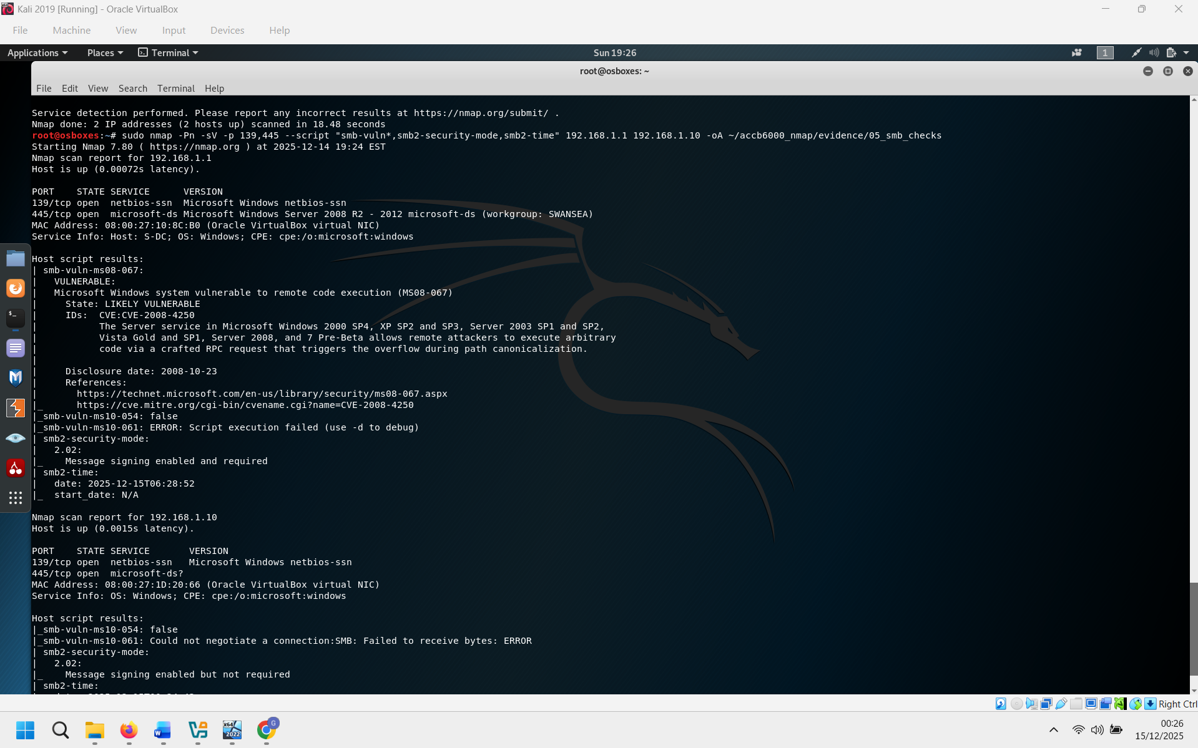
Figure 10 – SMB scan results including MS08-067 ‘LIKELY VULNERABLE’ on S-DC and SMB signing status.

9. Findings and simple risk discussion
- Finding 1 (High): MS08-067 (CVE-2008-4250) flagged as ‘LIKELY VULNERABLE’ on S-DC via SMB scripting.
Why it matters: This is associated with remote code execution. If exploited, an attacker could potentially run code on the server. Because S-DC is a domain controller, compromise would be very serious.
- Finding 2 (Medium): Large exposed service surface on S-DC, including several legacy services and FTP.
Why it matters: Each open service increases the attack surface. Legacy services like echo/daytime/qotd/chargen are normally not needed on a domain controller and may be abused for scanning, information gathering, or network abuse.
- Finding 3 (Medium): SMB signing policy difference (ClientS1 signing enabled but not required).
Why it matters: Not requiring signing can reduce security in some network situations, especially if an attacker can intercept traffic. Making security settings consistent is a basic hardening step.
- Finding 4 (Low): Web server information exposure (IIS 10.0 shown by Nmap scripts).
Why it matters: Server headers can give attackers clues about software type. This is not a direct vulnerability by itself, but it can help attackers plan which exploits to try.
- Finding 5 (Low): Some vulnerability scripts failed to run (e.g., clamav-exec errors).
Why it matters: This reduces coverage. It means the scan may miss issues that would be detected by a dedicated vulnerability scanner.

10. Recommendations (what I would do first)
- Priority 1: Address the SMB/MS08-067 risk on S-DC.
Apply relevant Microsoft security updates and verify SMB configuration. If this is a training lab, document that the host is intentionally vulnerable. In a real environment, treat this as urgent because it affects a domain controller.
- Priority 2: Reduce exposed services on the domain controller.
Disable or firewall services that are not required for the role of the server (for example, legacy services and FTP). Where possible, allow management services only from trusted admin IPs.
- Priority 3: Harden SMB client settings.
Make SMB signing consistent by requiring signing where appropriate (especially on systems handling sensitive authentication). This supports better defence against interception and downgrade risks.
- Priority 4: Improve web service hygiene.
Review IIS configuration, remove unnecessary modules, and consider reducing server header information. Also, use a dedicated web vulnerability tool if web services are in scope for deeper testing.

11. Limitations
This assessment is based on Nmap and Nmap NSE scripts. Nmap provides strong visibility into ports and services, but it is not the same as a full vulnerability scanner such as Nessus or OpenVAS. NSE results can produce false positives/negatives, and some scripts may fail, as shown in the evidence. For a professional report, findings would normally be validated with patch level checks and (if permitted) controlled exploitation or vendor confirmation.

12. Conclusion
Based on the evidence, the environment is reachable and scanning was successfully completed across both subnets. The most serious result is the SMB vulnerability indication (MS08-067) on S-DC, which should be prioritised. The scans also show that S-DC exposes many services, which increases the potential attack surface. The recommended next steps are to patch/harden SMB, reduce unnecessary services, and standardise SMB security settings.

