.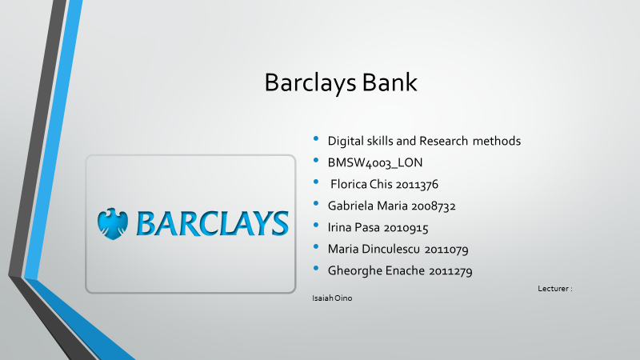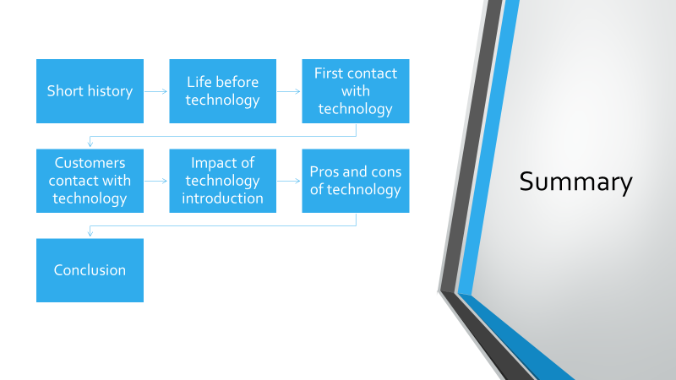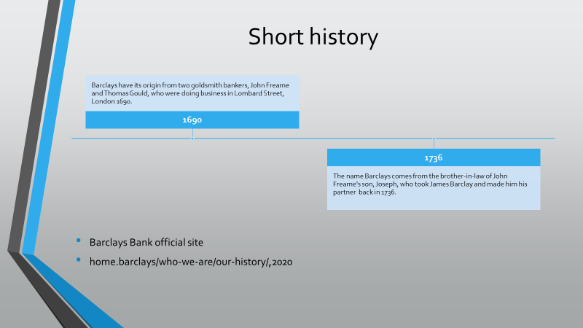
Barclays traces its ancestry back to two goldsmith bankers, John Freame and Thomas Gould, who were doing business in Lombard Street, London in 1690. In 1736, Freame’s son, Joseph took his brother-in-law, James Barclay on as a partner, and the name has remained a constant presence in the business ever since.
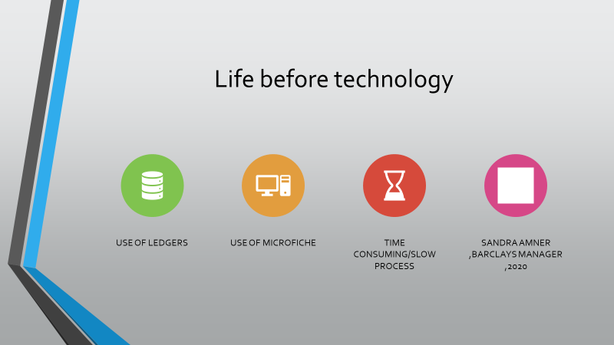
Before excel, word or power point, the workers had to use hand writing on ledgers and microfiche. They were updated every 24 hours and once again at the end of the week.
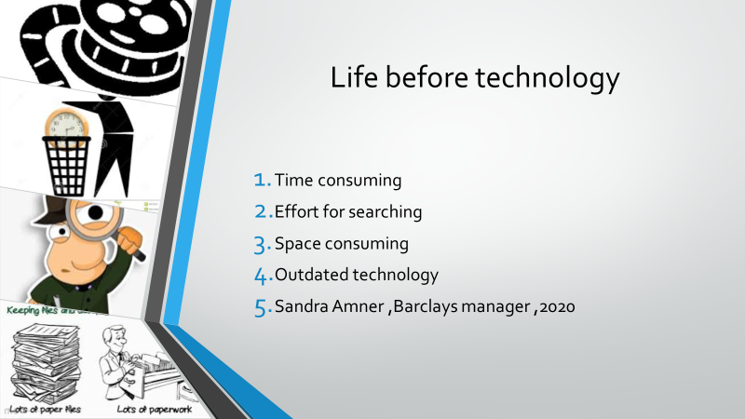
The bank workers said it was time consuming and really slow. The process of interrogating a bank account could take up to 25 minutes, and the first 10 minutes were used just to find the bank account microfiche and the record.
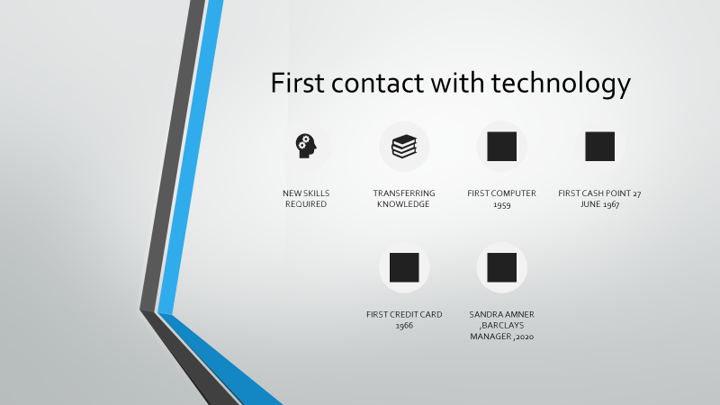
In a history moment, Barclays became the first British bank to introduce an electronic computer in 1959. Bookkeeping had been done by hand in large, leather-bound ledgers. Later accounting machines were slowly introduced and continually improved (www.barclays.co.uk).New skills and a lot of patience was needed when bank workers first faced the new technological era!
"Shock" was the word to describe the first contact with it.
But as good part for the bank workers, introduction of Cash points and cards was a relief and time saving for both workers and customers.
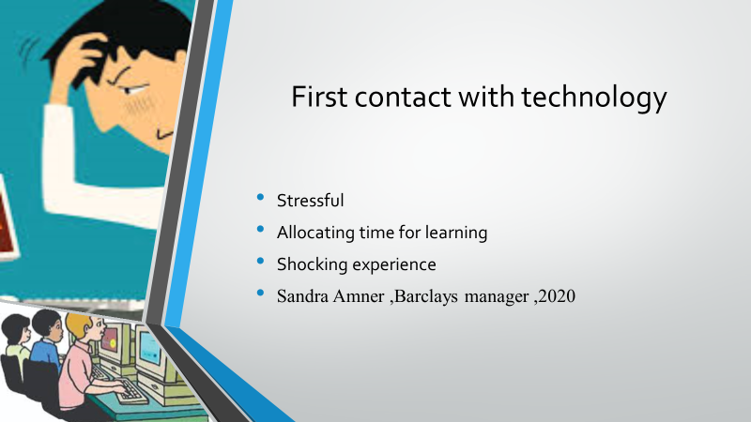
Eventually the bank workers got to love the introduction of technology. It made their life a lot easier. As we already said, looking back it was at first a massive shock. For a long time they had trained peoples coming in and explaining them how they will have to do the same job , which they pretty much did all their life , in a new and digital manner.
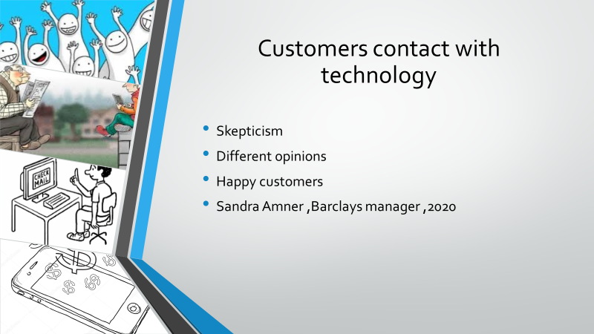
At this point we can all agree that we can not live without technology.
We can not find answers, locations and even gifts, without the help of technology.
When it was first introduced, technology had different feedbacks from different generations. Older generations didn’t approved it and they were a bit skeptic but the younger generation loved it and adopted it a second.
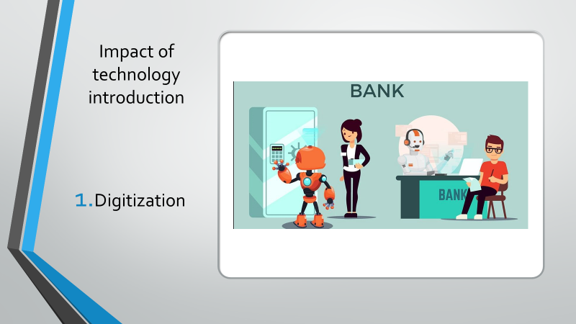
The biggest change that came in banks is Digitization. Banking process is faster than before and more reliable. Maintenance and retrieval of documents and records have become much faster and easier. Computerized banking also improves the core banking system
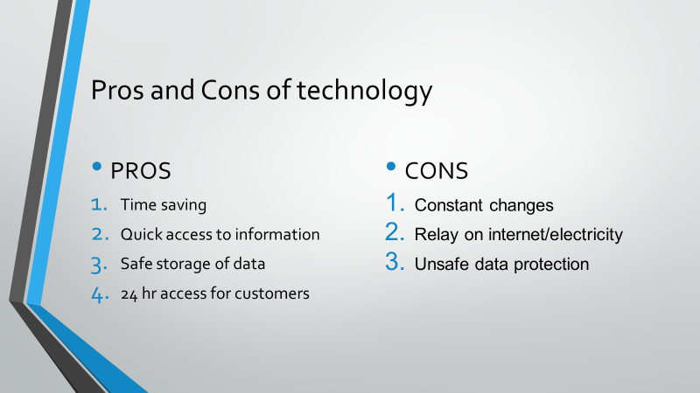
We will get to discuss them in the next slide.
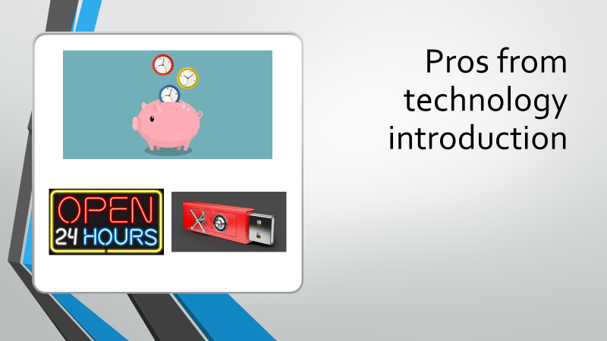
Time is something which we all value. By having any information one click away , we can say we saved a lot of time when in need of information. Speaking of information , we can find the answer the most of our questions in matter of seconds. In the field of bank jobs , the bank workers said they are a really happy they can provide almost every information the customers need in a few seconds, this also keeps the customer happy. Another thing that helps the bank workers is keeping data storage on cloud servers, easily accessible and safe. Customers can also say they are happy with cloud servers and data storage because they can also have 24hr access to bank accounts with their mobile banking apps.
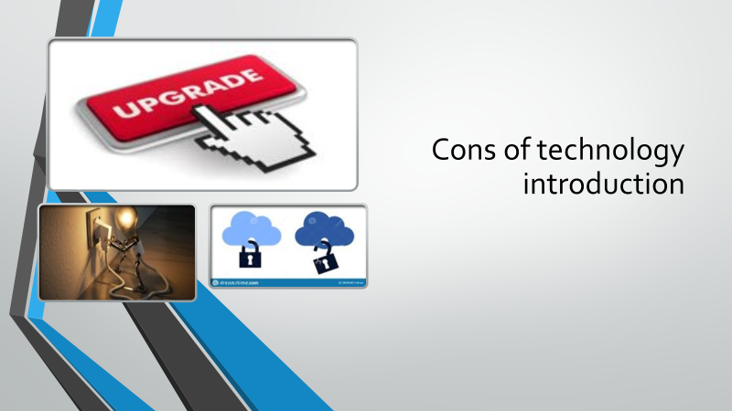
On the other hand, technology can be stressful because of constant changes and updates . This means keeping up your level of knowledge and also updating your tools(phones, laptops etc.)
It depends on many other factors like electricity, internet connection, good server maintenance and good training team.
These days pretty much everything happens remote. This means is a lot easier for criminals to pretend they are someone else and gain access to customers data and funds.

We can all agree on one thing. The introduction of technology in any working area had brought nothing but benefits.
It's true it took us a long and hard time but right now we are in a point in which we can only go higher and higher in matter of technological development.
We discussed about the impact of technology in banks, about how both ends faced the change that technology has brought and we say that it made our life's easier and happier.


