Student Name: Jessica Pritchard
P Number: 2109765
Programme of Study: Graphic Design
Module: ADAD4018 Ways of Thinking

Tasks in the order I received them:
Task One: Semiotic Analysis = 539
Task Two: Manifesto = 526
Task Three: Practice-based writing = 487

Task One: Semiotic Analysis

Early in life we learn what objects are and we do not all learn the same way. The way we interpret visual phenomena is based on our knowledge, culture, and personal experiences. This process happens so quickly and simply we do not realise this learning experience has happened (Berger 1998).

We only see what we choose to look at, and only then can we then reflect on the visual. (Berger 1972) However, simply looking at something is not enough; we need to learn how to see and what to see. It is impossible to give our full attention to everything around us (Berger 1998) which is why we never just look at one thing, we look at the relationship between us and the things we observe (Berger 1972). In this poster there are many different signs that can be decoded and meaning behind them discovered. But it is important to remember that signs are not isolated to mean one thing. We need to look at the context which they are being used and the meaning within the poster (Hall 2012).
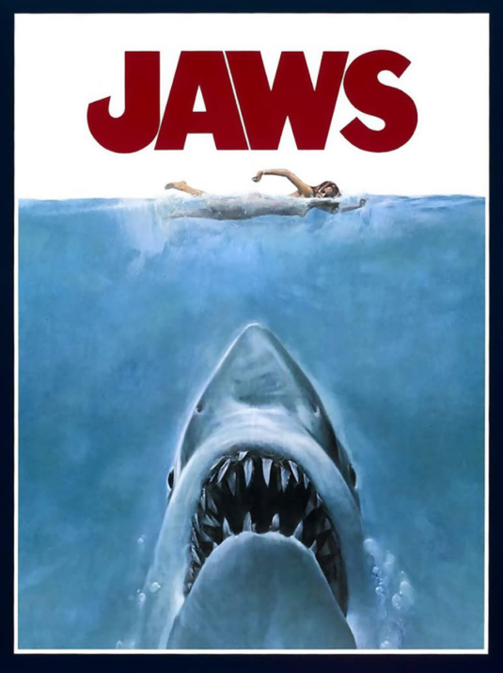
The title of this poster is a perfect example. As the largest piece of text it immediately draws your eye, therefore fulfilling the role of anchorage text which conveys important information about the film, which is done clearly by using the word Jaws (Cobley et al 2012). However, the text implies more than the title of the film. The choice of the colour red could signify danger due to it being the colour of blood, which is fitting considering the events of the film. Furthermore, the colour red paired with the image of the shark about to attack also denotes aggression (St Clair 2018).
Fig 1. “Jaws” Poster, 1975
The image of the shark is a clear icon of the aquatic animal, but this sign cannot be viewed as merely what it is, there is a deeper meaning behind it (Chandler, 2002). The image of the shark is powerful indexical sign, putting the unpleasant image of a shark attack into a person’s mind. Humans are fascinated by sharks and cannot seem to hear enough about them, no matter the fear this may drive into them as they regard them as killing machines (Leatherman 2003).

Colour is fundamental to our understanding of the world around us, which helps to explain why the colour white was used for the area above the water. Due to its link with light, it can give a sense of divinity and sublimeness, but also a sense of terror. (St Clair 2018) This use of colour fits well in the poster as the woman is swimming in what seems to be an area of safety but there is a danger lurking beneath that she cannot see. Mirroring the familiar imagery from nature of unsuspecting prey being stalked by a predator.

When looking at images captured by photographers there are an infinite number of possible sights they could have selected but the image captured was chosen for a reason (Berger 2008). Knowing this helps with the understanding of the poster as the reason the creator chose the signs becomes clearer, as we then understand how one thing put together with something creates a clear relationship (Hall 2012).

Bibliography:
Berger, A.A (1998). Seeing is believing : an introduction to visual communication. 2nd ed. Mountain View, Calif.: Mayfield Pub. Co.
Berger, J. (1972). Ways of seeing. London: British Broadcasting Corp. And Penguin Books.
Berger, J. (2008). Ways of seeing : based on the BBC television series with John Berger. London: British Broadcasting Corporation.
Chandler, D. (2002). Semiotics : the basics. Abingdon ; New York, Ny: Routledge.
Cobley, P., Litza Jansz and Appignanesi, R. (2012). Introducing semiotics. London: Icon Books Ltd.
Fiske, J. (1990). Introduction to Communication Studies. 2nd ed. Routledge.
Hall, S. (2012). This means this, this means that: a user’s guide to semiotics. 2nd ed. London: Laurence King Publishing.
Hébert, L. and Tabler, J. (2020). An introduction to applied semiotics : tools for text and image analysis. New York: Taylor And Francis.
Kassia St Clair (2018). The Secret Lives of Colour. Hodder.
Leatherman, S.P. (2003). Dr. Beach’s survival guide : what you need to know about sharks, rip currents, and more before going in the water. New Haven: Yale University Press.
Schirato, T. and Webb, J. (2004). Understanding the visual. London ; Thousand Oaks, Calif.: Sage.
Van Leeuwen, T. and Jewitt, C. (2013). Handbook of Visual Analysis. Los Angeles: Sage.

List of figures:
Figure 1: “Jaws” poster, 1975, https://www.imdb.com/title/tt0073195/mediaviewer/rm1449540864/ (Accessed 30th December, 2021)

Task 2: Manifesto

- Produce work that brings good into the world
- Try to avoid stress, it won’t help
- Think outside the box and try new things
- Ask questions and be curious
- Trust your instincts
- Don’t let mistakes get you down
- Make time to go outside, especially the beach
- Don’t neglect looking after yourself, you can’t pour from an empty cup

There is a science and an art to design resulting in meaningful outcomes. Requiring a balance between intellectual and rational thoughts while incorporating beliefs and controlling emotions (Millman, 2007). Designers will have a powerful message to convey, usually through their work, but a manifesto can be used in addition to state what a designer’s beliefs are (Goins, 2010).
- Produce work that brings good into the world

All designers want their work to be good, but what does good design mean? We cannot merely look at the function and artistic style of the design, we need to look at its contribution in a wider social context. When creating a piece of work there are many aspects that need to be considered. Is it helping to solve a problem? Is there a positive impact? Is it causing additional problems or harm? How, is the production of the design affecting the environment for example? are recyclable materials being used where appropriate? These are all ethical considerations which could determine if a piece of work is good (Roberts 2006). When creating a piece of design these should be considered to give the design purpose and make a difference in the world.

- Try to avoid stress, it won’t help

In the clinical world there is an awareness that stress and other mental health issues can make a person more likely to develop a physical illness (Drake et al, 2003). This has become a cause of concern during the covid pandemic which has brought additional stress into our daily lives. It has been important to combat illness during this time due to extra demands on health care services and resources (Vos 2021). Not only does stress increase the risk of an individual’s health deteriorating but also creates issues when working. Productivity of an unwell individual or workplace collective could be affected should they need to take time off to recover from an illness (Rossi et al 2020). Therefore, if stress is avoided it would not only have positive benefits to a person’s health but also within their working lives. Everyone should strive towards this goal.

7. Make time to go outside, especially the beach

Graphic design is a role that requires a large amount of screen time, which can have negative effects on health if coupled with low levels of physical fitness and activity (Celis-Morales et al, 2018). However, this cannot be taken for granted as the location in which we live influences our ability to spend time outdoors. Studies have suggested that those who live closer to green spaces are more likely to engage in outdoor physical activities resulting in better wellbeing and less mental health issues (Barton 2016). More specifically other than outdoor spaces, studies have been conducted to show that exposure to blue spaces, such as lakes, rivers, or the ses can also positively affect a person’s health (Gascon et al, 2017).

From the last two manifesto points there is a clear correlation regarding the importance of remaining healthy and looking after yourself when working. If you are unable to be sustainable in your work practices, then you will not be able to produce the quality of work you desire in the long term. This connection demonstrates that to continue to create positive good designs also requires good healthy working practices.
Bibliography:
Rossi A.M, Meurs, J.A. and Perrewé P.L. (2020). Stress and quality of working life : finding meaning in grief and suffering. Charlotte, Nc: Information Age Publishing, Inc.
Barton, J. (2016). Green exercise linking nature, health and well-being. London New York Routledge, Taylor & Francis Group, Earthscan From Routledge.
Celis-Morales, et al (2018). Associations of discretionary screen time with mortality, cardiovascular disease and cancer are attenuated by strength, fitness and physical activity: findings from the UK Biobank study. BMC Medicine, 16(1).
Drake, M., Deacon, M. and Collins, E. (2013). The Physical Care of People with Mental Health Problems : A Guide for Best Practice. London: Sage.
Gascon, M., et al (2017). Outdoor blue spaces, human health and well-being: A systematic review of quantitative studies. International Journal of Hygiene and Environmental Health, [online] 220(8), pp.1207–1221. Available at: https://www.sciencedirect.com/science/article/pii/S1438463917302699.
Goins, J. (2010). How to Spread Your Ideas: Write a Manifesto. [online] goinswriter. Available at: https://goinswriter.com/how-to-spread-your-ideas-write-a-manifesto/ [Accessed 3 Jan. 2022].
Millman, D. (2007). How to think like a great graphic designer. New York, Ny: Allworth Press.
Roberts, L. (2006). Good : an introduction to ethics in graphic design. Lausanne ; New York: Distributed In The] Usa And Canada [By] Watson Guptill.
Vos, J. (2021). The psychology of COVID-19 : building resilience for future pandemics. Los Angeles: Sage Publishing.

Task 3: Practice based writing
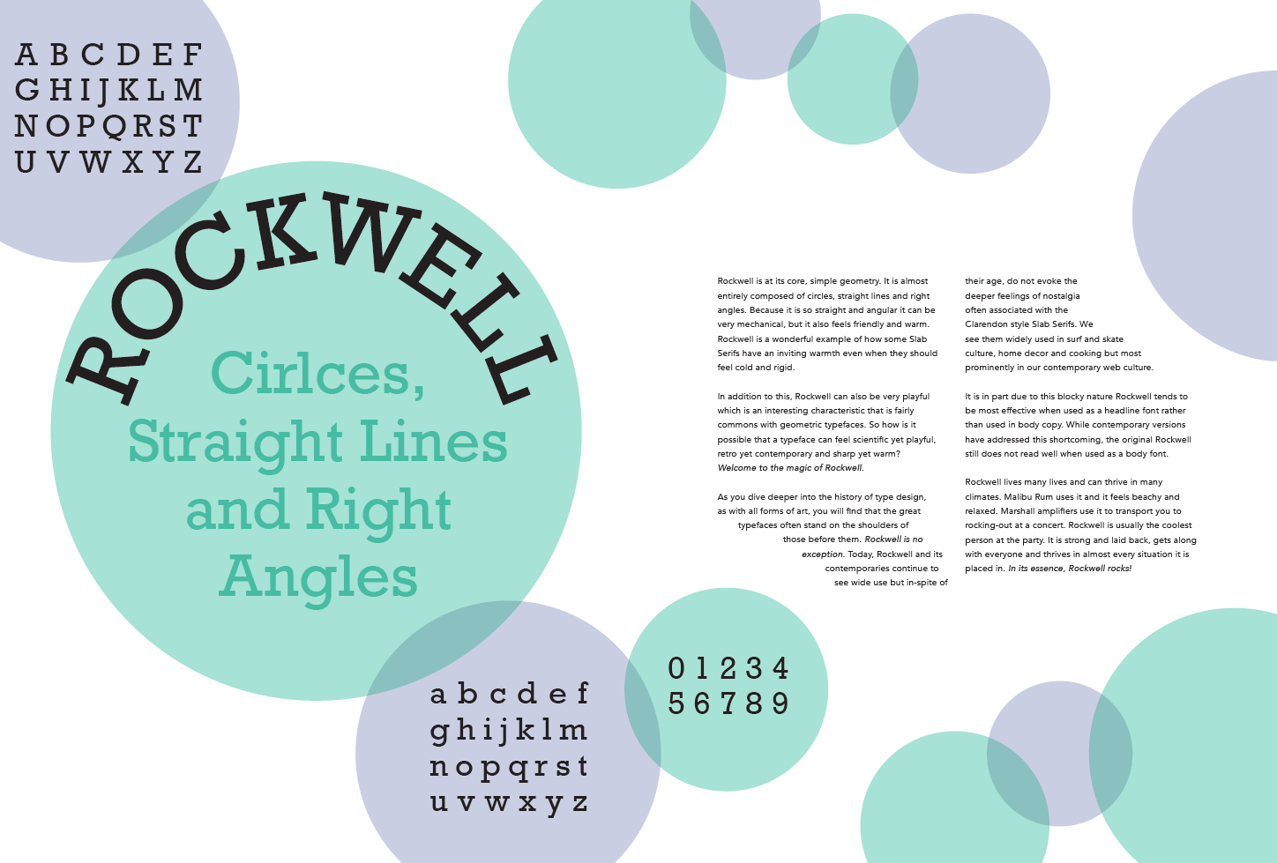
Fig 1. Two page magazine spread discussing the typeface Rockwell

The selected piece is a magazine spread discussing the typeface Rockwell. This task formed a portion of my portfolio for the typography module, it was one of the first projects undertaken during this course. I used InDesign to create this piece after researching different magazine spreads as inspiration and finding the information on the typeface. When researching the typeface, I came across an article which stated that Rockwell was a geometric font made from circles, right angles straight lines which inspired me to use circles as the focus.

Before achieving the final design there were many initial drafts improving on the design gradually with small edits. Initially I created designs using all three shapes mentioned in the title, however following discussion, and contemplation I concluded the design appeared cluttered. Therefore, I selected one shape then developed the design before creating the final piece.

This thought process of amending and building upon initial concepts is something I will take into future projects to ensure the work fulfils the role of graphic design which is to use visual communication to solve a problem. After reading about this process further graphic design, I am also looking to develop my understanding in how to work in a creative and expressive way without undermining the purpose of the design itself (Kim et al, 2018)

The beginning of this process was quite difficult as InDesign was a software I had not used before so I started by feeling nervous and apprehensive that I would not be able to produce anything to a high standard. However, one thing I learnt when going through the process is that by making mistakes, I was then able to learn what to correctly do the next time. Mistakes can be discouraging, but it is from mistakes that we learn, and this can be a significant aid to guide the creative process (Sawyer, 2018).
After this process and further reading I now believe that it is important to move out of your comfort zone, I cannot just avoid risk to avoid failure. In future I intend to try different methods or styles that I would not usually gravitate towards to avoid work becoming repetitive or predictable when I remain in my comfort zone (Shaughnessy 2010).

I feel this project was successful in that I created a magazine spread that was legible, it gave a basic overview of the typeface and was visually appealing but remained simple. However, if I were to complete this project again one aspect that I would think more about would be planning. After reading an interview with Paula Scher, (an extremely successful graphic designer), she responded to one question talking about how she saw design as the art of planning, this has impacted my way of thinking. If someone as successful as Scher needs to plan her work, how much more do I need to as someone in the beginning stages of design. (Millman 2007).

Bibliography:
Kim, H.H. and Geissbühler, S (2018). Graphic design discourse : evolving theories, ideologies and processes of visual communication. New York: Princeton Architectural Press.
Millman, D. (2007). How to think like a great graphic designer. New York, Ny: Allworth Press.
Sawyer, R.K. (2018). The role of failure in learning how to create in art and design. Thinking Skills and Creativity, 33(100527).
Shaughnessy, A. (2010). How to be a graphic designer, without losing your soul. New York: Princeton Architectural Press.

List of figures:
Figure 1. Two-page magazine spread discussing the typeface Rockwell. Created by myself

