Catherine Ford
Student ID 1650242
Course Illustration BA
Word Count 1589
Jonathan Pugh

Death and the stages of grief my experience
During the years of 2016, 2017 and 2018 I experienced four deaths in my
immediate family . It started with my father in 2016 and ended with my
grandmother in 2018 . For those three years there seemed like no escape
from death and grieving . My mum was taken into hospital in May 2016
having suffered a severe brain haemorrhage located in her brain stem . For
the ten months following her admission I was back and forth to the hospital
everyday whilst still trying to come to terms with my dad dying , my Mamgu
then passed away in November of 2016 . After 10 months we were advised
by the consultant that he felt there would be no value to my mum’s life and
it would have been a life in hospital getting treated for infections , that she
would soon build a tolerance to the antibiotics , that there was also a high
risk of possible further haemorrhages that they would be unable to treat due
to the previous untreatable haemorrhage that put her in hospital in the first
place . We made the collective decision to start palliative care , something we
had done with my dad no less than a year prior . A mere few hours after
that decision was made I was greeted by a grief counsellor for the first and
last time at the hospital . A leaflet and a booklet were handed to me that
showed the different stages of grief and how we would feel at each stage , a
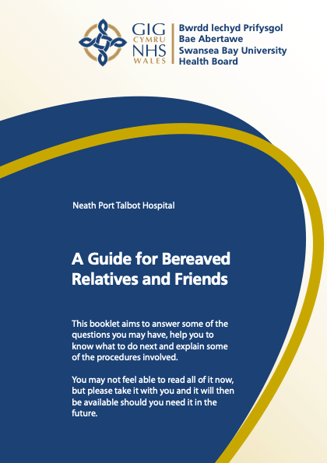
couple of phone numbers and a sympathetic smile.
Bereavement Support (2020)
This image is the cover of one of the guidebooks that were given to me
moments after agreeing for my mum to be placed in palliative care . The book
felt cold and hard . There was no comfort just words of impending doom of
how awful I was going to feel afterwards for an unconfirmed amount of time
before my mum had even passed away .
I’d never had any experience with family death before my dad passed away .
Having been thrown into the experience of death quite violently and being forced to deal with numerous deaths unexpectedly and in a proximity to each other I can’t say I experienced the stages of grief that were noted in the guidebook . It felt as though I was constantly falling down a cliff . On some days I would find a ledge , but in an unknown amount of time , the ledge would break , and I’d start falling . This process is continuous , and I presume will continue for the rest of my life . Over the years these symbolic ledges have stayed in place longer , and don’t break so often , but they do , and it comes as a surprise but soon enough the ledge comes back .
In my exhibition I want to display these ledges and how they have supported me but also how they have unexpectedly let me down . I will break down the idea of the stages of grief how they are blurred and without real foundation or structure.

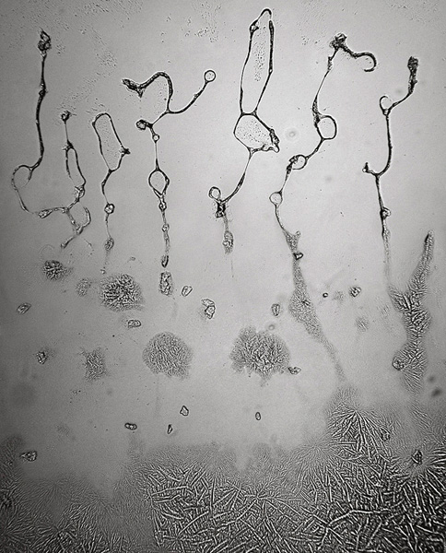
Overwhelm (Fisher 2015)
Rose Lynn Fishers work , Typography of Tears “Started in 2008 during a period of life changes and grief .” ( Fisher 2020 ). Fisher’s work shows tears underneath a microscope . “On a day of endless tears , I suddenly wondered , what are tears ? What do tears really look like ? Are tears of grief different to tears of happiness ? ” ( Frey , Lauterbach , Fisher 2017 p.7 ) Fisher’s work looks further into the tears that are easily and thoughtlessly wiped away .

In the same way that Fisher looks at the structure and meaning of these tears that are shed during difficult times . Showing how grief is not just set stages . In article it states “ We think we know what to expect of mourning , but the intensity or the duration or echo of previous losses is unexpected . ” Jurecic (2015).
Exhibition Space
To exhibit my work, I would use the Bristol museum and art gallery . When I initially started looking into the subject of art and death , this gallery caught my eye . My dad was from Bristol and only move to Swansea when he met my mum in 1992 . Bristol holds a very special place in my heart , whenever I visit it makes me feel closer to my dad . Another reason is because of the date of the last art exhibition about death was in February 2016 . I am quite a realist and don’t overly believe in fate and destiny , but any reminder of my parents always feels as if it was meant to be.
To shows the ledges I mentioned previously I would deconstruct a painting I have been working on of my father since September 2016 .

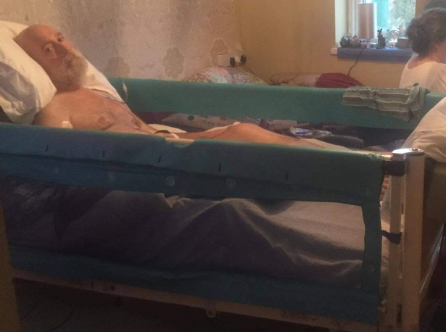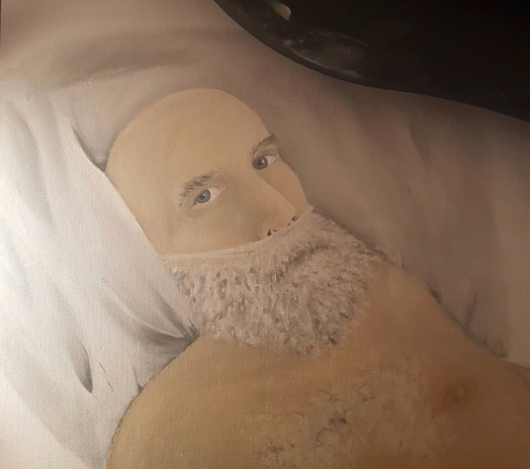
Dad January 2016. Painting using acrylic 2016
The above photo was taken during the last couple of weeks of my dad’s life. He asked me to take a photo of the room . Because of the effects of Motor Neuron Disease the only way to communicate with my dad was to go through each letter of the alphabet very slowly , one letter every 5 seconds was what worked best at this point , it took around 5 minutes for him to ask this . I took the picture of the room and showed him , he wanted the photo taken discreetly so that my mum wouldn’t notice . After showing him the photograph , I asked him why he wanted me to take it . I tried to understand him for 10 minutes what he was trying to say without any real success . He then tilted his head to the sky , I asked “Away with the fairies?” To which he responded with a slight nod and a sparkle in his eye . On reflection I think he was confused as to where he was and he didn’t want to worry my mum about it . I decided to start the painting which I placed next to the photograph in September . I felt an overwhelming sadness about the loss of my dad and the loss of my mum as she was before the brain haemorrhage. I’ve always found art as an escape and that is what the piece started as, an escape and essentially reflects the ledges of my grief . Every time I feel an overwhelming sadness and sense of loss I start the painting , using a different media to what I had previously used . In Malchiodi’s book The Art Therapy Handbook she states “Art is a powerful tool in communication . It is now widely acknowledged that art expression is a way to visually communicate thoughts and feelings that are too painful to put into words.” ( Malchiodi 2011 p.viii ) . I truly feel that to its core and that if it wasn’t for the powers of art therapy I’m not sure where I would be today .
I want the viewer of the exhibition to feel that . By deconstructing the artwork , each additional layer of paint becoming its own piece . To show how with the deconstruction you can essentially see these stages , or ledges , of grief that I have been experiencing since 2016 . The first layer of paint being displayed by itself , then slowly as we go through each layer of the deconstructed painting having layers cluster and overlay each other to show the frequency of these stages and the proximity of them . This would be a walk-through installation , starting at the beginning of an enclosed arch , with the arch becoming more claustrophobic the further into the layers you get . Building up a visual representation of how these episodes of overwhelming grief have lessened over the years, but how initially in the beginning they were all one and felt suffocating .

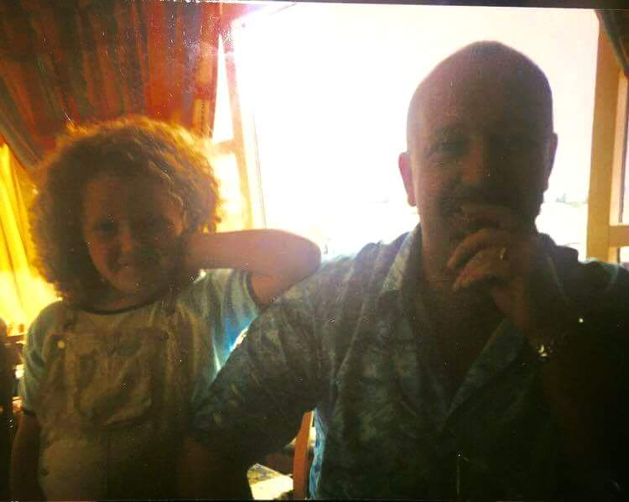
Dad and I, approx. 2003

The exhibition will finish in an empty room with just one photograph of me and my dad , a very long time ago when I was young . Showing the beginning , a happiness that was felt long ago . Being worry free , not counting down the days until the anniversary of the next death . To show the relief of a happy memory with no sadness attached to it . The viewer will experience the same relief as having come out of the claustrophobic space to a white empty room with a photo with no upset or hurt attached. Introducing a sound element into this installation at the end , simple early morning bird song . Almost immediately after my dad took his last breath , I left the hospice building being overcome with emotion and not sure what to do except to try and get away from it . As I stood in the Ty Olwen garden , I was surrounded by the most beautiful sound of birds , swirling around me , and taking away that gut wrenching pain to then feeling a momentary sense of release . It was as if my dad had been lifted up and away with the birds , floating in the sky , completely pain free .

Bibliography

Figure 1 Bereavement Support (2020) A Guide for Bereaved Family and Friends, Available at : https://www.rns.uk/wp-content/uploads/2020/06/Neath-Port-Talbot-Hospital-English-73214-.pdf (Accessed : 10th April 2021)
Figure 2 Fisher, R (2015) Overwhelm, Available at : https://www.rose-lynnfisher.com/tears.html (Accessed : 11th April 2021)
Rose Lynn Fisher (2020) Typography of Tears, Available at : https://www.rose-lynnfisher.com/tears.html (Accessed : 11th April 2021)
Frey, Lauter, Fisher (2017), Typography of Tears , Bellevue Literary Press
Jurecic, A (2015) The Art of Medicine, Available at : https://www-sciencedirect-com.ezproxy.uwtsd.ac.uk/science/article/pii/S0140673615000537?via%3Dihub (Accessed : 11th April 2021)

Malchiodi, C ,( 2011) ,The Art Therapy Handbook, 2nd edition, Guliford Press

