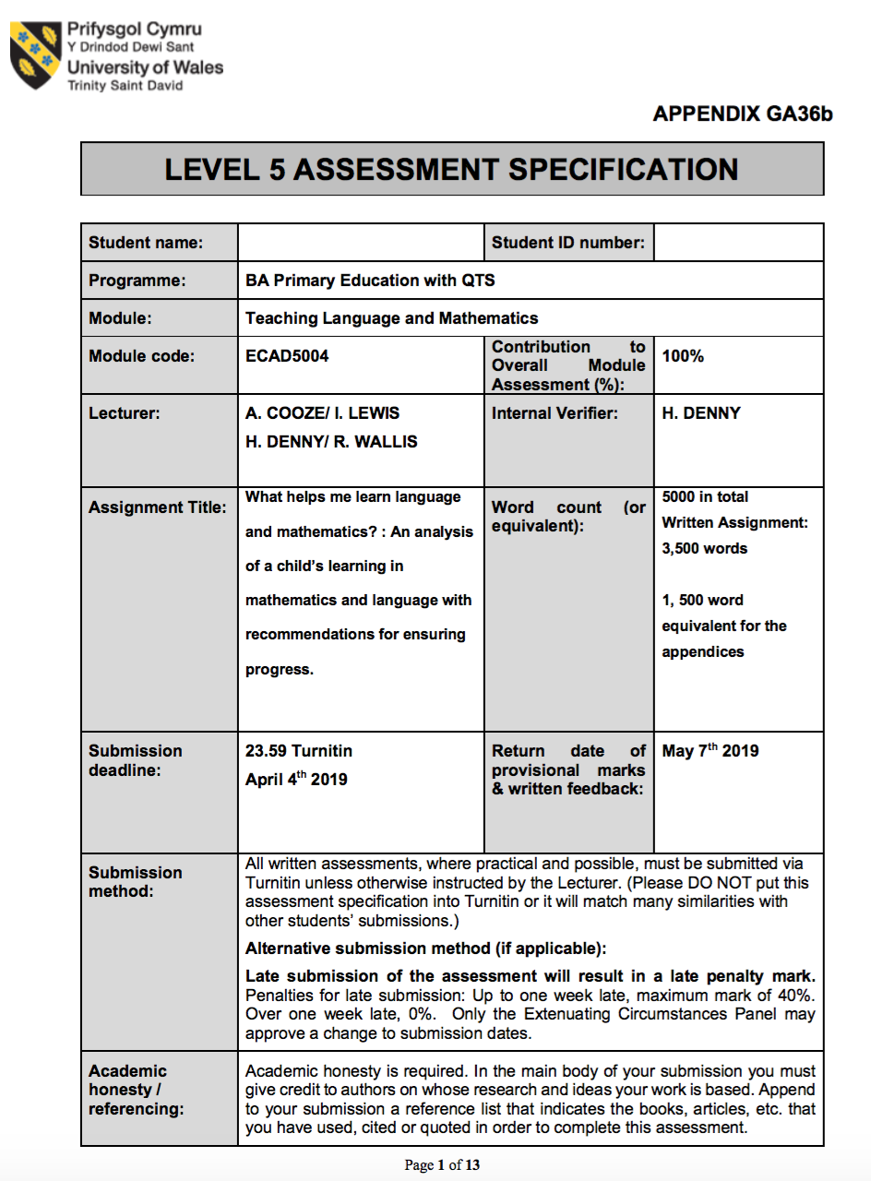
1700085
Emily Thomas
Title: What helps me learn language and mathematics? : An analysis of a child’s learning in mathematics and language with recommendations for ensuring progress.
Word count: 3844 (3500 10%+/-)
Within this assignment, the writer will identify how children learn language and mathematics, distinguishing key aspects of what aids them throughout the learning-process.
The analysis occurred within a small semi-rural primary school in South Wales with 301 full-time pupils. The profile child (child-A) is a five-year-old girl within a reception class of 45 pupils, who is of higher ability for both language and mathematics. It is evident she exceeds expectations within mathematics, repeatedly being challenged and completing extension tasks.
To further analyse child-A, the Mosaic-Approach(Clark&Moss,2011) was utilised including the child’s voice(Clark,2005) as children are not seen as passive objects, learning should be student-centered, practised through active-discovery-learning(Mcleod,2018). The Mosaic-Approach stresses the exploration of children’s perceptions of their lives and interests(Clark,2005) therefore seeing learning from a child’s perspective assisting the understanding of what aids child-A to retain information through informal conversations, work samples, interviews and personal reflections. Research was conducted ethically under University guidelines. Appendix-1 provides suitable signed documentation. Child-A was informed regarding the process prior to the collection of evidence as BERA(2018) stresses the importance of receiving full-consent from the child.

When analysing child-A, the Attitudes, Skills and Knowledge (ASK) model(Nottingham,2013) was used. This consisted of interviewing child-A understanding her attitude, likes, dislikes and resilience. Looking at samples of work and observations helped to recognise her strengths and weaknesses for her to become a successful learner, focusing on increasing motivation with the main aim being to learn, rather than focusing on a grading-system. This allowed time for independent-reflection, shifting responsibility for learning from practitioner to student, as the practitioner’s role is to elicit performance from students, making them available for shaping (Fitch&Semb,1993). Bakarman(2011) agrees, describing the ASK-model as the practitioner’s duty to identify ASK aspects aiming the curriculum towards them allowing for independent-learning to take place, once the ASK is taken into consideration.
Language and mathematics are important learning areas as both are essentially the foundations for life, recognised as the building blocks for young people to lead fulfilling and purposeful lives(WG,2016).This conveys the importance of understanding practitioners need as it is significant to the learning-process.
The analysis of child-A’s learning of mathematics will be discussed. Reflecting upon the teaching experience, it is important to make connections between the experiences of the child outside of the classroom and the present lesson as children’s learning will become deeply embedded enhancing understanding (Haylock&Cockburn,1989). Therefore, the connective model (1997) supports the pedagogy when teaching aspects of mathematics as it teaches children real-life numeracy skills simultaneously enhancing language by using concrete experiences(Murray,1997).
One of the aims of the Literacy and Numeracy Framework (LNF) is to assist “teachers, providing opportunities for learners to apply literacy and numeracy across the curriculum”(WG,2013). This implies the importance of integrating literacy and numeracy into all learning areas as truly “mathematics is not about number, but about life”(Pound and Lee,2015) suggesting both can be integrated giving children a wider range of skills to utilise within out-of-school contexts. Literacy and numeracy is split into strands with numeracy strands being to develop numerical reasoning, using number, measuring and data skills, which are split further into elements. The LNF stresses the opportunity for all foundation-phase learners to progress, regardless of their ability(WG,2013).Therefore, the year-by-year manner of the framework allows learners to work at a pace that suits their ability and understand what is expected.

Child-A was able to achieve numeracy skills allocated for reception children, therefore the LNF allowed for child-A and others to extend their mathematical skills working towards skills of a year 1 child, enhancing numeracy standards from a young age. It is argued, if the attitude of children is negative, improving numeracy and literacy skills will never happen (Preidt,2018).

Relating to the attitude element of the ASK model(Nottingham,2013), an interview with child-A was conducted to analyse her attitude towards mathematics. This allowed me to understand her thoughts and feelings towards maths thus could encourage her further. Dweck(2008) highlights our mind-set, not talent or abilities lead us to success. This implies if a child possesses a growth mind-set opposed to a fixed mind-set, the child will learn from mistakes simultaneously embracing challenges. Analysing the interview, clearly she possesses a growth mind-set as within question 8 she states “I try again when I make a mistake”(appendix-2) therefore conveying eagerness and a ‘can do’ attitude to completing maths. Although, Young(2018) contends this viewpoint highlighting children who are led to believe they succeed because they are intelligent may not seek difficult challenges, in case they fail. This conveys how some children fear failure, making limited progress.

Analysing child-A, it was clear she embraced new challenges and enjoyed completing mathematical tasks stating how she completes them at home (appendix-2-question-1.) It could be argued; the positive attitude towards mathematics is because of parent motivation as child-A receives regular support at home. It is suggested family should be encouraged to explore mathematics as children need regular support to recognise mathematics within the outside world and parents are the best people to provide this support (Jay,Rose&Simmons,2015). This relates to Vygotsky’s theory of the zone-of-proximal-development where learners obtain information with instruction from a capable other.(Simplypsychology.org,2018.) Additionally, Bruner(1996) agrees describing how adult-interaction helps solve problems and master tasks beyond their immediate capability. This suggests adult-interaction can increase attitude to both mathematics and language as it increases motivation and familiarises children to these skills within differing contexts.

Comparing child-A and B’s interview (appendix-2&3) it is clear their attitudes oppose regarding mathematics. Child B states he does not like learning mathematics at home (appendix-3-question-2.) Nevertheless, both children complete mathematics outside of school yet attitudes are opposing suggesting adult-interaction is not always successful at providing positive attitudes. It is argued, “negative attitudes towards maths are damaging, leading to disengagement, a lack of confidence, and reluctance to try to improve”(National-Numeracy,n.d) thus suggesting child B needs to gain motivation another way, Dweck(2008) suggesting a growth mind-set.
Interviews allow children to openly discuss their likes and dislikes regarding subject-related questions in an accepting environment(Esomar,2009). Although analysing the data, interviews where neither contributors use power nor agree to lead is an awkward situation. According to Kyronlampi and Maatta(2011) the quality of interviews is better when a child takes control developing the quality conversation. Clark and Moss(2011) indicate interviews may be too long and intense for children making it difficult to express themselves. Although reflecting upon the interviews, they were both truthful, eager to give opinions.
To further analyse child-A’s attitude, I asked her to take me to a place within school where she believes best promotes mathematics (appendix-4.) She chose one area, which was called ‘the maths table’ within the classroom as she thought this provided the best tools to learn mathematics. This suggests child-A believes maths only occurs when on the maths table; even though all other provision-areas were maths related. This conveys without the word ‘maths’ within a lesson, children like child-A do not realise they are completing math related tasks. This indicates children like child-A learn mathematical skills without knowing through unconventional means such as play. Pound, and Lee(2015) highlight maths is the most playful of all disciplines and numbers are toys as well as tools.
Child-A discussed when on the ‘maths table’ she learns using concrete materials including number lines, numicon, whiteboards and whiteboard pens including these on her map (appendix-5.) Mapmaking was helpful in identifying what helps child-A to learn. Mapmaking helps construct an understanding of children’s views and experiences of their present environment in order to inform future changes (Kyronlampi&Maatta,2011) giving an insight into which resources work best from a child’s perspective. Having multiple concrete resources on the table (appendix-4) allows for a variety of strategies to be used for example, working with a number line or numicon (appendix-8.) Pound&Lee(2015) argue it is essential children maintain flexible thinking when becoming effective problem-solvers, in order that they persist when one method does not work. Child-A used many concrete resources to complete maths challenges, one being an adding task showing resilience when she made mistakes. Detailed observation notes shown in appendix-6.
Relating to the skills and knowledge element of the ASK model(Nottingham, 2013), evaluating child-A took place through observations and samples of work. Within the first week on PTE, the maths topic was money and identifying coins. It is important for children to handle money from a young age as “playing with money helps children learn essential mathematical concepts”(Engel,2003). Nevertheless, using money enhances mathematical concepts yet simultaneously enhances a wider skillset such as social, communication, problem-solving, critical-thinking and financial skills (Dupaix,2018).

Estyn(2017) state very few schools teach financial-skills and it is the school’s responsibility to ensure pupils develop knowledge and skills to manage money confidently (Cox,2014) emphasising the importance of money. Concrete materials such as real-money and chocolate were used when teaching child-A as it is argued the “brain retains most when it is actively involved exploring concrete materials” (Jensen,2004) proposing in order for children to learn successfully they need to be physically engaged. Child-A showed enthusiasm and portrayed a desire to handle money to buy chocolate from the shop, she was engaged throughout and her concentration was excellent therefore proving using concrete-materials helped child-A to learn. Piaget(1970) reinforces this stating “children need to experiment actively with materials and experience things in the real-world to develop thought.”
Analysing child-A’s learning it was evident using concrete-materials such as real-money and chocolate allowed for play-based learning to occur. Child-A achieved the reception-skill of “using 1p, 2p, 5p,10p coins to pay for items” (WG,2015) (appendix-7.) However, child-A and others completed this effortlessly therefore achieved the year-one skill “using different combinations of money paying for items up to 20p”(WG,2015) (appendix-9.)This conveys child-A’s excellent knowledge surrounding money as she portrayed enthusiasm and was challenged still achieving higher-end skills. However, child-A rushed aspects as she was excited over the chocolate thus had to slow the pace down for her to grasp concepts. However, Pound and Lee(2015) stress “enthusiasm and interest is what makes us good learners” thus her excitement conveys a positive attitude when learning new concepts.
Child-A achieved wider-skills such as an enhancement of communication-skills. Rose(2009) advocates communication is essential for learning, thus suggesting the importance of integrating it within mathematics. Child-A proved her leadership within a group-measuring task(appendix-10.) This allowed for communication skills to thrive enhancing the language of length for example, long, longest and short and shortest. Child-A conveyed her excellent mathematical knowledge by sharing her ideas about what she thought the vocabulary meant, as the others did not understand portraying leadership-skills. Leadership allows for confidence to thrive helping children solve-problems, work in a team and work collaboratively with others, (Mincemoyer,2016) which is what child-A achieves, gaining wider skills simultaneously sharing her knowledge. Vygotsky believed when students are within the ZPD, giving child-to-child feedback will give the pupil a boost to prosper(Simplypsychology.org,2018) therefore increasing her confidence within mathematics and the vocabulary used regarding measurement concurrently achieving the year one skill “using non-standard units to measure: – length, height and distance”(WG,2015). However, Piaget(1970) advocates humans must construct their own knowledge thus Child A taking leadership does not allow her peers to learn independently. Although, it is believed all children should ‘have a voice’ by participating in decision-making, sharing opinion and be listened to(Laing,2015) therefore child-A’s knowledge regarding language of measurement allowed her to have a voice and gain the skill of sharing knowledge enhancing her learning.
Child-A is currently working towards outcome 3, conveying aspects of outcome 4, shown in appendix-11.

The analysis of child-A’s learning within language will be discussed. The literacy aspect of the LNF is split into three strands: reading, writing and oracy. Language, literacy and communication are crucial factors in development, as children need to communicate and express thoughts, feelings and emotions(WG,2008). Analysing attitude, skills and knowledge of child-A within these three strands enabled me to gain insight into a child’s perspective of learning.

Within the classroom, there were various opportunities for reading to occur. When asking child-A where she enjoys reading, she took me to the reading-corner and a fish and chip role-play area(appendix-12&13.) Child-A discussed how she liked playing in these areas and learning new vocabulary and sounds; this is constructed through a play-like environment where children learn independently without additional adults. Through play, children develop social and cognitive-skills; mature emotionally, gaining self-confidence by experiencing new concepts(Ali,Aziz&Majzu,2011).
Child-A’s attitude to reading is positive as she independently chooses to spend time within the reading-corner learning new words becoming self-supporting at five years-old. Piaget believes children are lone-scientists learning from becoming independent(Cremin&Arthur,2014). Clearly, child-A is able to read CVC words independently appendix-14 showing observation notes. Child-A’s attitude continues to be positive regarding reading as she revealed her favourite books(appendix-15.) Appendix-16 shows her positive attitude towards reading. Child-A achieves the skill of “blending combinations of known letters”(WG,2015) figuring out words independently yet simultaneously developing communication skills with peers in the reading corner, as she helps peers who cannot sound out words as well as her. It is evident child-A attempts to learn independently, enhancing her can-do attitude and learns by helping others. It enhances her communication and emotional development by leading a group and shows an understanding of others emotions as she helps those who struggle. This suggests learning will take place if the person delivering acts as a facilitator(Rogers,1983) which child-A undertakes, portraying her maturity to learning.
The phonics programme Read Write Inc (RWI) was used. Miskin(2013) states RWI gets children reading and writing quickly suggesting children engage within the programme. Analysing child-A, she has learnt from RWI as when she reads she uses the rhymes to identify and sound-out words. For example, within appendix-16 she states she likes to read words containing oo sounds because she can say “oo oo poo at the zoo.” Teaching phonics within early-years needs to be based on informal-activities in a play-context (Jolliffe,Waugh&Gill,2015:86).The use of humour when learning to read evidently grabs and sustains her attention evoking pleasant and positive feelings towards reading, enhancing her knowledge and skills. It is clear she can sound-out different words showing she learns from humour and RWI. Humour elicits a positive effect in learners, which creates a pleasant and enjoyable learning-environment(Malamed,2018). This conveys child-A learns within a comfortable learning-environment, which evokes humour and excitement. Reading also exposes children to the written language register(Mason& Allen,1986) therefore developing wider-skills other than solely reading.
Analysing appendix-16, child-A declares she learns reading best during RWI, which is with adult-interaction. Teachers who continually observe children using knowledge about language and cognition can ask appropriate questions, posing specific problems(Jaggar&Smith-Burke,1995).With adult interaction child-A is able to enhance her reading skills disagreeing with Piaget’s(1970) lone-scientist viewpoint.

When analysing child-A’s attitude to writing, it was clear it wasn’t her favourite aspect of English, as she stated she much prefers attempting to read. Although, observing her learning it was evident she achieved the skills expected.
When explained to child-A they would be participating within a writing task, she groaned slightly. See appendix-17 for observation notes. However, when explaining they were writing to Theresa May, her attitude became positive as this gave her a motive to complete the task. Writing is learned, improved and embraced through motivation and regular practice (Leister,2013) therefore allowing enthusiasm to thrive, suggesting she learns writing through motivational aspects.

Within the writing task, it was evident she was confused by full stops, capital letters and finger spaces; she kept forgetting to use them. Using actions instead of words helped child-A to remember what each one was, it was called Kung-Fu punctuation(appendix-18.) Looking at appendix-19, it is evident child-A is able to perform full stops, finger spaces and capital letters correctly using Kung-Fu punctuation therefore achieving the reception writing-skill of “distinguishing between upper and lower case letters showing an awareness of full stops” yet also the year-one skill “using capital letters and full stops with some degree of consistency”(WG,2015). This conveys child-A learns aspects of writing through physical-means, as appendix-20 shows she can use aspects of punctuation correctly. Child-A is achieving writing-skills yet simultaneously enhancing her physical development and gross motor skills by performing actions. In the foundation phase, learner’s benefit from being physical as this develops pupils’ resilience and determination towards challenges (Estyn,2018a). Child-A showed enthusiasm and enjoyment to writing when completing Kung-Fu punctuation.
Child-A’s letter formation was correct; appendix-20, 21 and 22 show this. She would verbalise the RWI rhymes when writing words, sounding them out as she goes along conveying her knowledge of this as excellent.
Learning oracy within the classroom has many benefits including cognitive, personal and social gains, civic engagement and empowerment(Millard,2018) suggesting using oracy within class allows for positive academic and additional social-outcomes.
Child-A’s attitudes using oracy were extremely positive; these are shown within both interviews conducted, showing an enthusiasm to share ideas and opinions. She was eager to discuss aspects important to her including her swimming lessons and especially her older brother in year three. She explained her achievements and activities during show and tell, proving she can speak to her peers and adults using appropriate language. This conveys she has knowledge of social-skills. Children’s identity and ability to make friends is connected to communication-skills, linked to their capacity to express feelings and thoughts(VSG,2016). Child-A possesses these traits, always talking to peers and adults openly and freely.
Child-A struggled to identify rhyming words through speaking orally, thus had to find another method to accommodate. According to Estyn(2018b), to improve oracy-skills a range of communication techniques should be used from singing, to speaking. Child-A understood rhyming words through the use of song, appendix-23. “Learning a piece of information attached to a tune implants that information more rapidly into a child’s mind”(Dalrymple,2015) therefore conveying child-A learnt rhyming words through the singing element of oracy, appendix-24 shows her work. Child-A sang the song simultaneously completing the activity portraying her enthusiasm to finish the task correctly. Therefore singing allowed for her to achieve a language-skill yet concurrently developing emotional-skills as children naturally foster important social and emotional skills from singing(Guilmartin,2012). However, some children feel embarrassed to learn through song therefore will not gain the extra skills singing offers(Morrison,2011). Although, child-A was not embarrassed, she portrayed confidence when singing whilst completing the task.
Child-A is currently working towards outcome 3 and aspects of outcome 4, shown in appendix-25.
Evidently the subject-child has made good progression within mathematics, however this can be developed further.
Reflecting, to develop child-A’s understanding of mathematics further she could be introduced to abstract mathematical symbols (+) regarding addition as she already has understanding of addition using mathematic manipulative materials. Children are “able to apply their knowledge better if they are taught using generic abstract examples” (Uttal,Scudder&Deloache,1997) including the use of symbols, therefore child-A can deposit her concrete, real-life experiences regarding maths into a symbolic-nature. However in all situations, symbols should be meaningfully linked to concrete materials(NCTM,1989:pp.38) therefore suggesting concrete materials should be used continuously throughout the teaching and learning process. Consequently, child-A could be introduced to a wider-range of manipulative-materials including base-ten equipment, multi-link cubes and Cuisenaire rods to progress their learning of number and sums. Using more manipulative materials, the learner can construct their own meanings relating concrete materials to abstract symbols in ways that make sense to them (Black,2013).

Child-A could be shown subtraction sums, moving forward from addition. Reflecting, she completed many tasks independently therefore adult-interaction could be used to assist in subtraction by asking her more probing-questions. This allows the child to work with an adult yet encourages them to produce an answer independently. Using the scaffolding approach, the teacher can construct a bridge from the learners' current knowledge to information being taught(Peters,2019). Scaffolding is also tailored to students needs, shifting the responsibility when necessary(Pol et al,2015) therefore a good model to use when teaching child-A.
For the subject-child to enhance her understanding of mathematics, the development of number is needed. Child-A can count up to fifty with her group independently therefore a provision-area is needed in order to recite numbers from different starting points within a relaxed environment. Mathematic play encourages children to improve logical thinking-skills and work on procedural knowledge(Burton,2010) therefore enhancing a wider range of skills rather than just social and communication. Child-A can develop her knowledge and skills regarding money, and begin to give change from a small amount however; this can only be achieved after progressing within subtraction.
Through assessment, it is evident the subject-child has made good progression within language, however this can be developed further.
When reading, child-A can blend phonemes successfully reading CVC words attempting to spell understanding the grapheme-phoneme correspondence. In order to move her forward, child-A could learn adjacent consonant words, including ‘frog,’ ‘test,’ ‘come’ and ‘jump.’ This will allow child A to extend her vocabulary and familiarise herself with words she will see in books, therefore extending her knowledge of adjacent consonant words through the learning of phonics. This can be performed in a scaffolding approach being taught systematically and discretely. Goodman(1996) concludes language is learned with ease when the focus isn’t on the language but on what we’re doing with it. Therefore as child-A gets frustrated when reading words incorrectly, performing phonics in an inclusive environment will create a positive attitude to language(BBC,2012).
As child-A enjoys the company of others, perhaps a ‘reading buddy’ programme would benefit her in reading trickier words, as when children instruct each other, both improve their social and communication skills. Child-A would benefit from hearing stories read aloud; hearing expression in the form of modelling which simultaneously would develop her vocabulary and oral language abilities.
Within writing, it is evident child-A is confident using capital-letters, full-stops and finger-spaces through a physical-manner. To develop her writing skills, child-A can begin to use question-marks and exclamation-marks to enhance her understanding of writing. Child A- could look for this punctuation throughout story-books identifying where the punctuation is and what makes it different using a visual-approach.
The teacher could model what this punctuation looks like and continue to teach this through kinaesthetic learning, which worked excellently for child A. Students prefer kinaesthetic learning styles above others, whereas teaching methods mostly suit auditory learners(Gilakjani,2011).
Child-A is used to completing letter formation with a pencil. Therefore, to enhance her gross motor skills she could practise with paintbrushes and chalk within a mark-making provision area to explore with writing little and large letters.

Child-A has excellent oral skills proving this through discussing with both adults and peers appropriately within show and tell. To further develop child-A’s oral skills, she could “answer ‘Who?’, ’What?’, ‘Where?’ and open-ended questions relating to own experiences”(WG,2015). This allows child-A to reflect upon what she is discussing, helping to broaden her thinking processes. Open-ended questions develop speech and language skills building confidence to express themselves using words(Arnerich,2019).
The teacher should continue to promote learning through play within the provision-areas as it develops communication, social and oral skills. During play, children are more likely to use an abundance of complex language as they are within a non-judgemental learning-environment(Bergen&Mauer,2000) thus implying the importance of children developing various skills through play.

Concluding, the teacher should continue to promote various aspects of teaching strategies such as modelling, open-ended questions, learning through play and manipulative materials in order to assist children like child-A within their learning.

Reference List

Ali, A. Aziz, Z. Majzub, R. (2011). World Applied Sciences Journal 14 (Learning Innovation and Intervention for Diverse Learners). Teaching and Learning Reading Through Play, (1818-4952), pp.15–20. [online] Available at: https://pdfs.semanticscholar.org/429f/54be9be455ebe48e7050f7ba70b9b529c2e3.pdf [Accessed April 2, 2019].

Arnerich, M., 2019. How to Use Open-Ended Questions In The Early Years. Famly. Available at: https://famly.co/blog/management/open-ended-questions-early-years/ [Accessed April 3, 2019].

Bakarman, A. (2011). ATTITUDE, SKILL, AND KNOWLEDGE: (ASK) A NEW MODEL FOR DESIGN EDUCATION. Proceedings of the Canadian Engineering Education Association.

BBC, 2012. Creating an inclusive learning experience for English language learners with specific needs. TeachingEnglish. Available at: https://www.teachingenglish.org.uk/article/creating-inclusive-learning-experience-english-language-learners-specific-needs [Accessed April 3, 2019].

BERA (2018). SUMMER 2018 | BERA. [online] Bera.ac.uk. Available at: https://www.bera.ac.uk/researchers-resources/publications/summer-2018 [Accessed 2 Apr. 2019].

Black, J. 2013. Manipulatives in the Primary Classroom. NRICH. Available at: https://nrich.maths.org/10461 [Accessed April 3, 2019].

Bruner, J. S. (1996). The Culture of Education. Cambridge, MA: Harvard University Press.
Burton, M. (2010, November). Five Strategies For Creating Meaningful Mathematics Experiences In The Primary Years. Young Children , 65 (6), pp. 92-96.
Burton, M. (2010). Five Strategies For Creating Meaningful Mathematics Experiences In The Primary Years. Young Children , 65 (6), pp. 92-96.
Clark, A. (2005). Ways of seeing: using the Mosaic Approach to listen to young children’s perspectives in Beyond Listening: Children’s Perspectives on Early Childhood Services. Bristol: Policy Press.
Clark, A. and Moss, P. (2011) Listening to Young Children: The Mosaic Approach (2nd ed.) National Children’s Bureau
Cox, J., 2014. Classroom Activities that Teach Money Skills. TeachHUB. Available at: https://www.teachhub.com/classroom-activities-teach-money-skills [Accessed April 2, 2019].

Cremin, T. and Arthur, J. (2014). Learning to Teach in the Primary School 3rd Ed. Routledge: Oxon.
Bergen, D. Mauer, D. (2000). Symbolic Play, Phonological Awareness, and Lit- eracy Skills at Three Age Levels. In Play and Literacy in Early Childhood: Research from Multiple Perspectives. pp.45–62.
Dalrymple, E. (2015.) How singing can support children's learning. TheSchoolRun. Available at: https://www.theschoolrun.com/how-singing-can-support-learning [Accessed April 2, 2019].

Dupaix, M. (2018). Try a Few of These Fun Coin Games to Teach Kids About Money. [online] The Balance. Available at: https://www.thebalance.com/use-coin-based-games-to-teach-money-skills-2085683 [Accessed 2 Apr. 2019].
Dweck, C. 2008. Mindsets and Math/Science Achievement. Stanford University: New York. [online]. Available at: https://www.growthmindsetmaths.com/uploads/2/3/7/7/23776169/mindset_and_math_science_achievement_-_nov_2013.pdf (Accessed 2nd April 2019).
Engel, L. (2003). Money money money | Nursery World. [online] Nurseryworld.co.uk. Available at: https://www.nurseryworld.co.uk/nursery-world/news/1079809/money-money-money [Accessed 2 Apr. 2019].

Esomar (2009). ESOMAR WORLD RESEARCH CODES & GUIDELINES INTERVIEWING CHILDREN AND YOUNG PEOPLE. [online] Esomar.org. Available at: https://www.esomar.org/uploads/public/knowledge-and-standards/codes-and-guidelines/ESOMAR_Codes-and-Guidelines_Interviewing-Children-and-Young-People.pdf [Accessed 2 Apr. 2019].

Estyn (2018). Rapid development of pupils' oracy skills. Estyn. Available at: https://www.estyn.gov.wales/effective-practice/rapid-development-pupils’-oracy-skills [Accessed April 2, 2019]. (b)

ESTYN, 2018. Creating strategies to develop pupils' independence. Creating strategies to develop pupils’ independence. Available at: https://www.estyn.gov.wales/effective-practice/creating-strategies-develop-pupils-independence [Accessed April 2, 2019]. (a)

Estyn. (2017). Schools need to improve money lessons, says Estyn. BBC News. Available at: https://www.bbc.co.uk/news/uk-wales-politics-40559765 [Accessed April 3, 2019].
Fitch, M. Semb, G. (1993). The ASK Model of Peer Tutoring: Theory and Research. Navy Personnel Research and Development Center: San Diego. [online]. Available at: https://pdfs.semanticscholar.org/6978/9e861f1c9fa75ce64615375de5278dd315f4.pdf (Accessed April 2nd 2019.)
Gilakjani, A.P., 2011. Visual, Auditory, Kinaesthetic Learning Styles and Their Impacts on English Language Teaching. Journal of Studies in Education, 2(1), p.104.

Goodman, S. 1996. On Reading. Portsmouth, NH: Heinemann. pp. 118-125.

Guilmartin, L. (2012). Creating Harmony: How Music Can Support Social Emotional Development. Parent Toolkit. Available at: https://www.parenttoolkit.com/social-and-emotional-development/news/general-parenting/creating-harmony-how-music-can-support-social-emotional-development [Accessed April 2, 2019].

Haylock, D. and Cockburn, A. (1989). Understanding early years mathematics. London: Paul Chapman Publishing.

Jaggar, A. Smith-Burke, M.T. (1995). Observing the language learner, Ann Arbor, Mich: UMI Out-of-Print Books on Demand.

Jay, T. Rose, J. Simmons, B. (2015). Empowering parents to support their children's maths understanding | Nuffield Foundation. [online] Nuffieldfoundation.org. Available at: http://www.nuffieldfoundation.org/empowering-parents-support-their-childrens-maths-understanding [Accessed 2 Apr. 2019].

Jensen, E. (2004). Arts with the brain in mind. Moorabbin, Vic: Hawker Brownlow Education.

Jolliffe, W. Waugh, D. Gill, A. (2015). Teaching systematic synthetic phonics in primary schools2nd ed., London: SAGE Publications.

Kyronlampi-Kylmanen, T. and Maatta, K. (2011). Using children as research subjects: How to interview a child aged 5 to 7 years. Educational Research and Reviews, [online] 6(1990-3839), pp.87-93. Available at: https://academicjournals.org/article/article1379666282_Taina%20and%20Määttä.pdf [Accessed 2 Apr. 2019].
Laing, S. (2015). ‘Championing the Child’s Voice: Research, Practice and Theory.’ SSSC National Conference: Improving Lives with Childhood Practice Heriot-Watt University Conference Centre, Edingburgh. [online] Available at: http://ssscnews.uk.com/wpcontent/uploads/SarahLaing.pdf (Accessed 2nd April 2019).
Leister, M. (2013). Fostering the Motivation to Write in Children. Study.com. Available at: https://study.com/academy/lesson/fostering-the-motivation-to-write-in-children.html [Accessed April 2, 2019].

Malamed, C. (2018). Does Humor Enhance Learning? The eLearning Coach. Available at: http://theelearningcoach.com/elearning_design/isd/humor-and-learning/ [Accessed April 2, 2019].

Mason, J. Allen, J. (1986). Review of Research in Education . A Review of Emergent Literacy with Implications for Research and Practice in Reading, pp.76–98.

Mcleod, S. (2018). Jean Piaget's Theory of Cognitive Development | Simply Psychology. [online] Simplypsychology.org. Available at: https://www.simplypsychology.org/piaget.html [Accessed 2 Apr. 2019].

Millard, W. (2018). Speaking up: The importance of oracy in teaching and learning. Chartered College of Teaching. Available at: https://impact.chartered.college/article/millard-importance-of-oracy-in-teaching-learning/ [Accessed April 2, 2019].

Mincemoyer, C. (2016). Leadership and children (Better Kid Care). Better Kid Care (Penn State Extension). Available at: https://extension.psu.edu/programs/betterkidcare/early-care/tip-pages/all/leadership-and-children [Accessed April 2, 2019].

Miskin, R. (2013). An overview of Read Write Inc. Phonics by Ruth Miskin: Oxford Education [video]. Available at: https://www.youtube.com/watch?v=-6dSsXkD1wM (Accessed: 2nd April 2019).

Morrison, J. (2011). Musical youth: How can we get boys singing? The Independent. Available at: https://www.independent.co.uk/news/education/schools/musical-youth-how-can-we-get-boys-singing-917732.html [Accessed April 2, 2019].

Murray, J. D. (1997). Connectives and narrative text: The role of continuity. Memory & Cognition, 25(2), 227-236.

National Council of Teachers of Mathematics (NCTM). (1989). Curriculum and evaluation standards for school mathematics. Reston, VA: Author.
National Numeracy (n.d.). [online] Nationalnumeracy.org.uk. Available at: https://www.nationalnumeracy.org.uk/sites/default/files/attitudes_towards_maths_-_updated_branding.pdf [Accessed 2 Apr. 2019].
Nottingham, J. (2013) Encouraging Learning. Oxon: Routledge
Peters, G. (2019). Advantages & Disadvantages of Scaffolding in the Classroom. The Classroom | Empowering Students in Their College Journey. Available at: https://www.theclassroom.com/advantages-disadvantages-scaffolding-classroom-8008434.html [Accessed April 3, 2019].

Piaget, J. (1970). The Science Of Education and the Psychology of the Child. New York: Crossman.

Pol, J.V.D. et al., 2015. The effects of scaffolding in the classroom: support contingency and student independent working time in relation to student achievement, task effort and appreciation of support. Instructional Science, 43(5), pp.615–641.

Pound, L. and Lee, T. (2015). Teaching Mathematics Creatively. 2nd ed. Oxon: Routledge.

Preidt, R. (2018). Positive Attitude Adds Up to Better Math Grades. [online] Consumer HealthDay. Available at: https://consumer.healthday.com/cognitive-health-information-26/brain-health-news-80/positive-attitude-adds-up-to-better-math-grades-730422.html [Accessed 2 Apr. 2019].

Rogers, CR. (1983). Freedom to Learn for the 80s. Columbus, OH: Charles Merrill

Rose, J. (2009). Independent Review of the Primary Curriculum: Final report. London: DCSF.

Simplypsychology.org. (2018). Zone of Proximal Development and Scaffolding | Simply Psychology. [online] Available at: https://www.simplypsychology.org/Zone-of-Proximal-Development.html [Accessed: 10th March 2019].

Uttal, D.H. Scudder, K.V. Deloache, J.S., 1997. Manipulatives as symbols: A new perspective on the use of concrete objects to teach mathematics. Journal of Applied Developmental Psychology, 18(1), pp.37–54.

Victoria State Government. (2016). Conversation and social skills. Department of Education and Training Victoria. Available at: https://www.education.vic.gov.au/childhood/professionals/learning/ecliteracy/interactingwithothers/Pages/conversationandsocialskills.aspx [Accessed April 2, 2019]. (VSG)

Welsh Government. (2008). Language, Literacy and Communication Skills. Cardiff: Welsh Assembly Government. [online] Available at:
https://learning.gov.wales/docs/learningwales/publications/130612-language-literacy-and-comunication-skills-en.pdf (Accessed April 3rd 2019). (WG)

Welsh Government. (2013). National Literacy and Numeracy Framework. Cardiff: Welsh Government. [online] Available at: https://learning.gov.wales/docs/learningwales/publications/130415-lnf-guidance-en.pdf (Accessed 3rd April 2019) (WG)

Welsh Government. (2015).Foundation Phase Framework (revised 2015). Curriculum for Wales. [online] Available at: https://gov.wales/sites/default/files/publications/2018-02/foundation-phase-framework-revised-2015.pdf (Accessed: 3rd April 2019) (WG)

Welsh Government. (2016). National Numeracy and Literacy Programme: A Strategic Plan. Cardiff: Welsh Government. [online] Available at: https://learning.gov.wales/docs/learningwales/publications/160316-national-literacy-and-numeracy-programmes-en.pdf (Accessed: April 3rd 2019) (WG)

Young, E. (2018). “Growth mindset” theory doesn’t translate directly from kids to adults – telling an adult they are a “hard worker” can backfire. [online] Research Digest. Available at: https://digest.bps.org.uk/2018/05/24/growth-mindset-theory-doesnt-translate-directly-from-kids-to-adults-telling-an-adult-they-are-a-hard-worker-can-backfire/ [Accessed 2 Apr. 2019].

Appendices
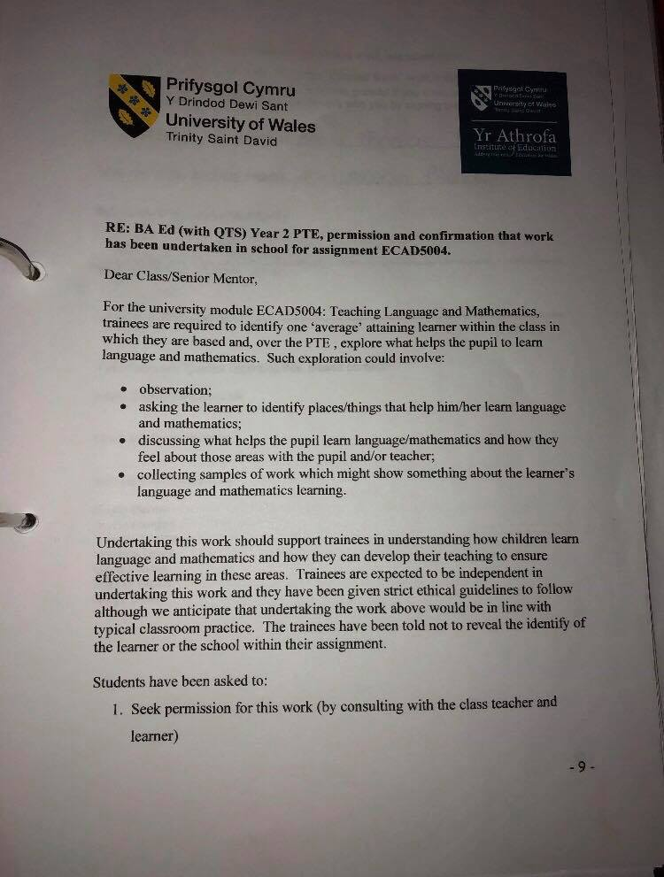
Appendix-1 Documentation

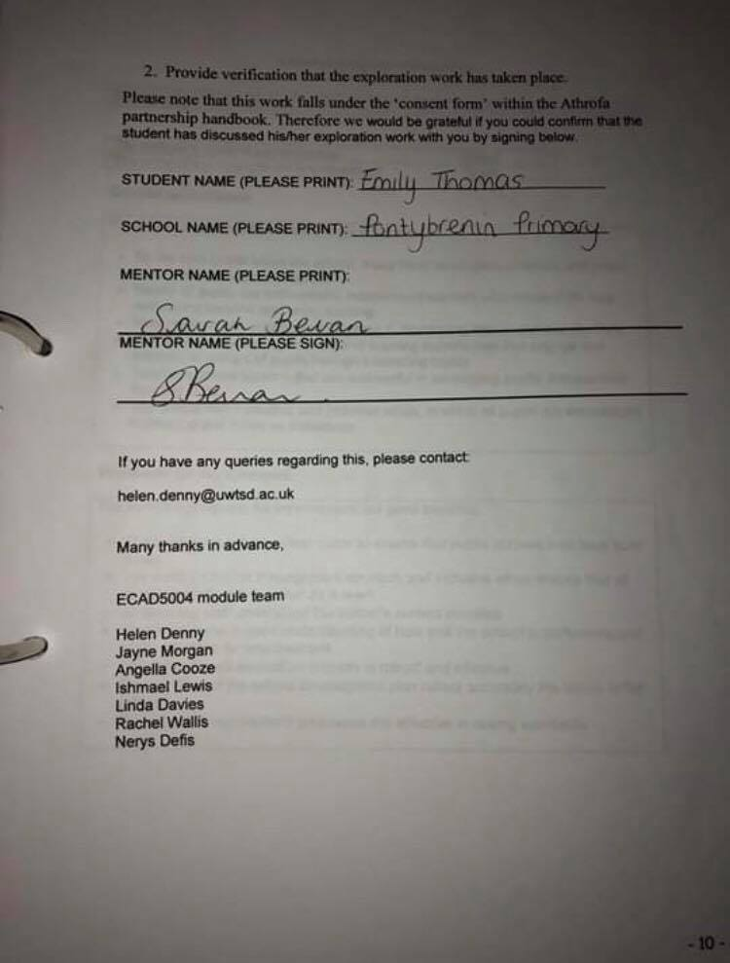

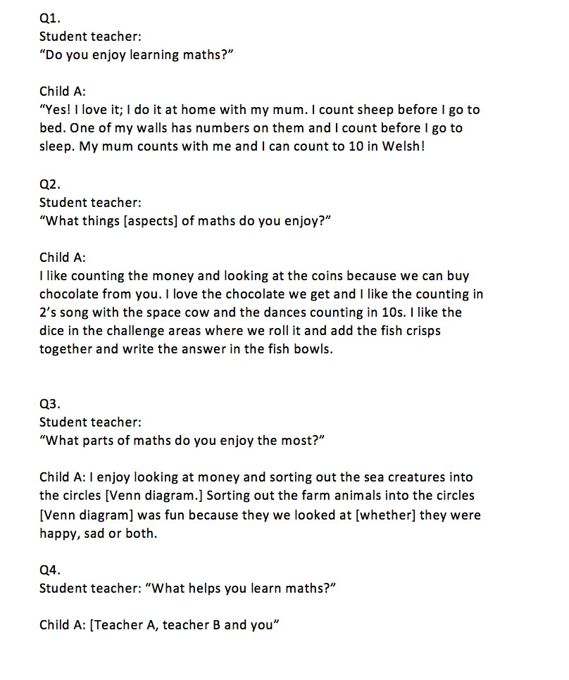
Appendix-2- Interview with child-A Maths

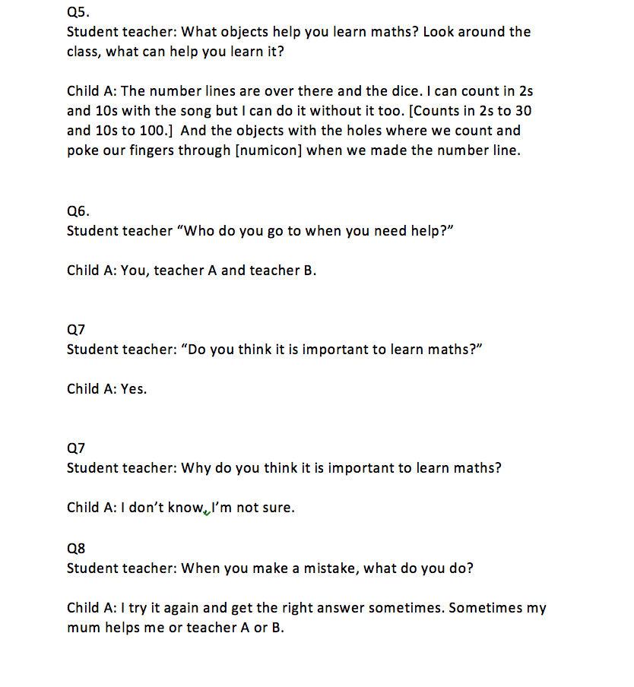

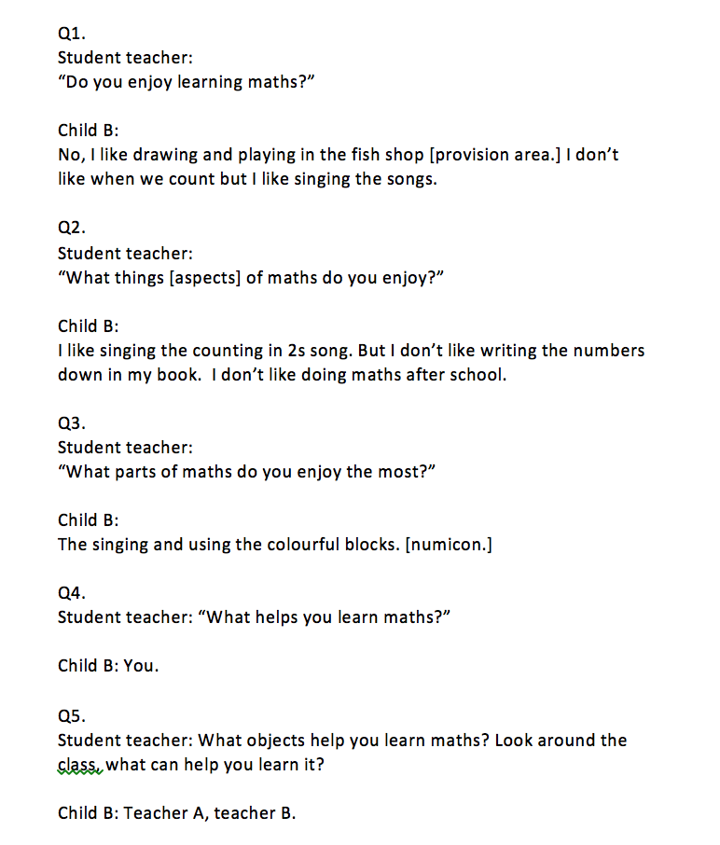
Appendix-3- Interview with child B- Maths

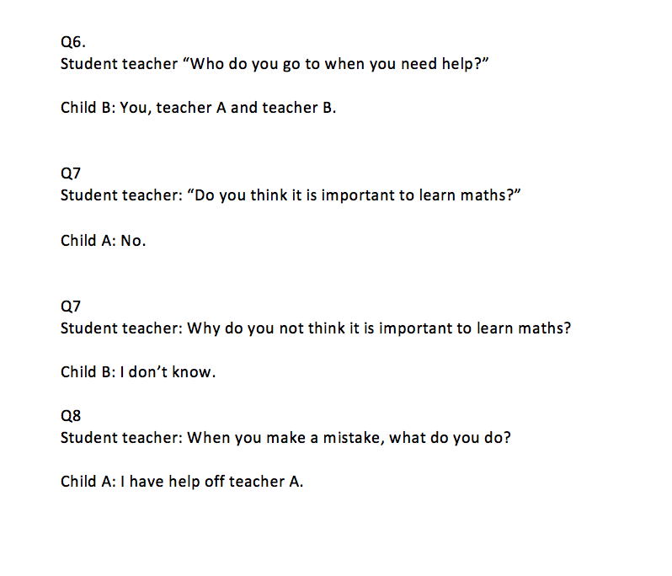

Appendix-4
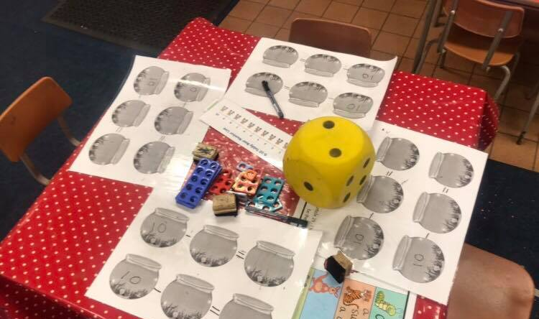

Appendix-5

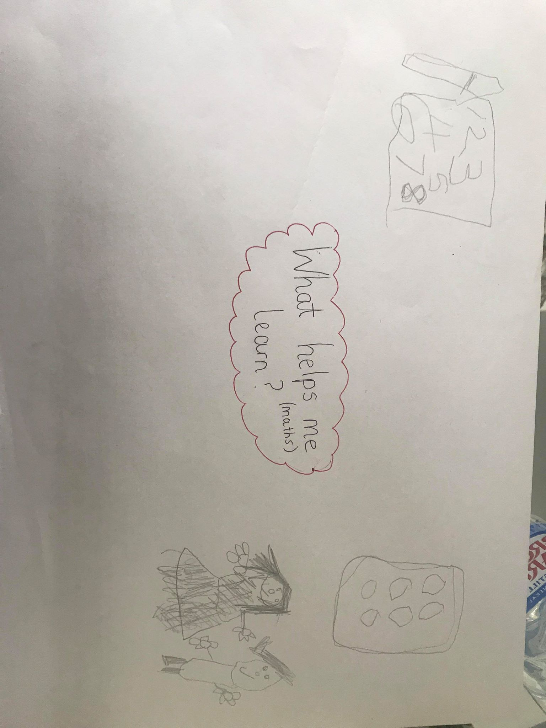

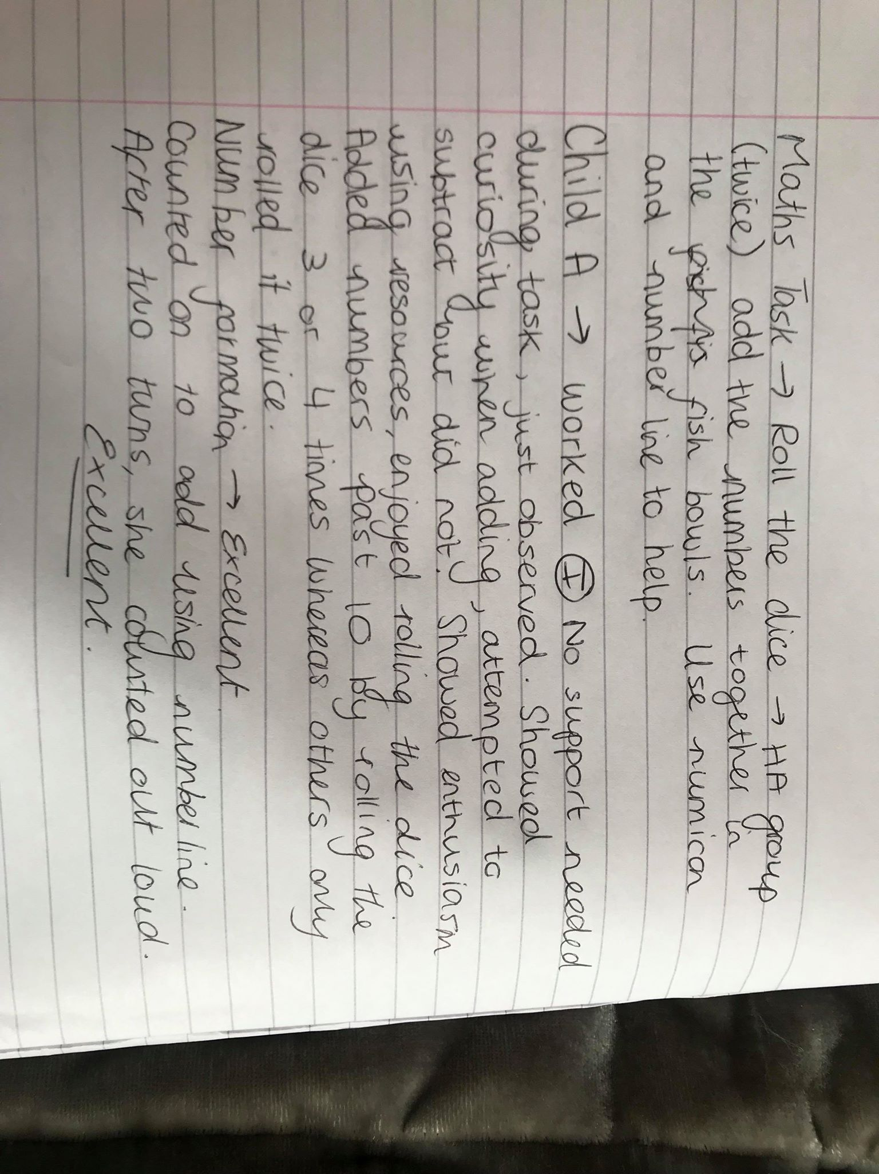
Appendix-6

Appendix-7

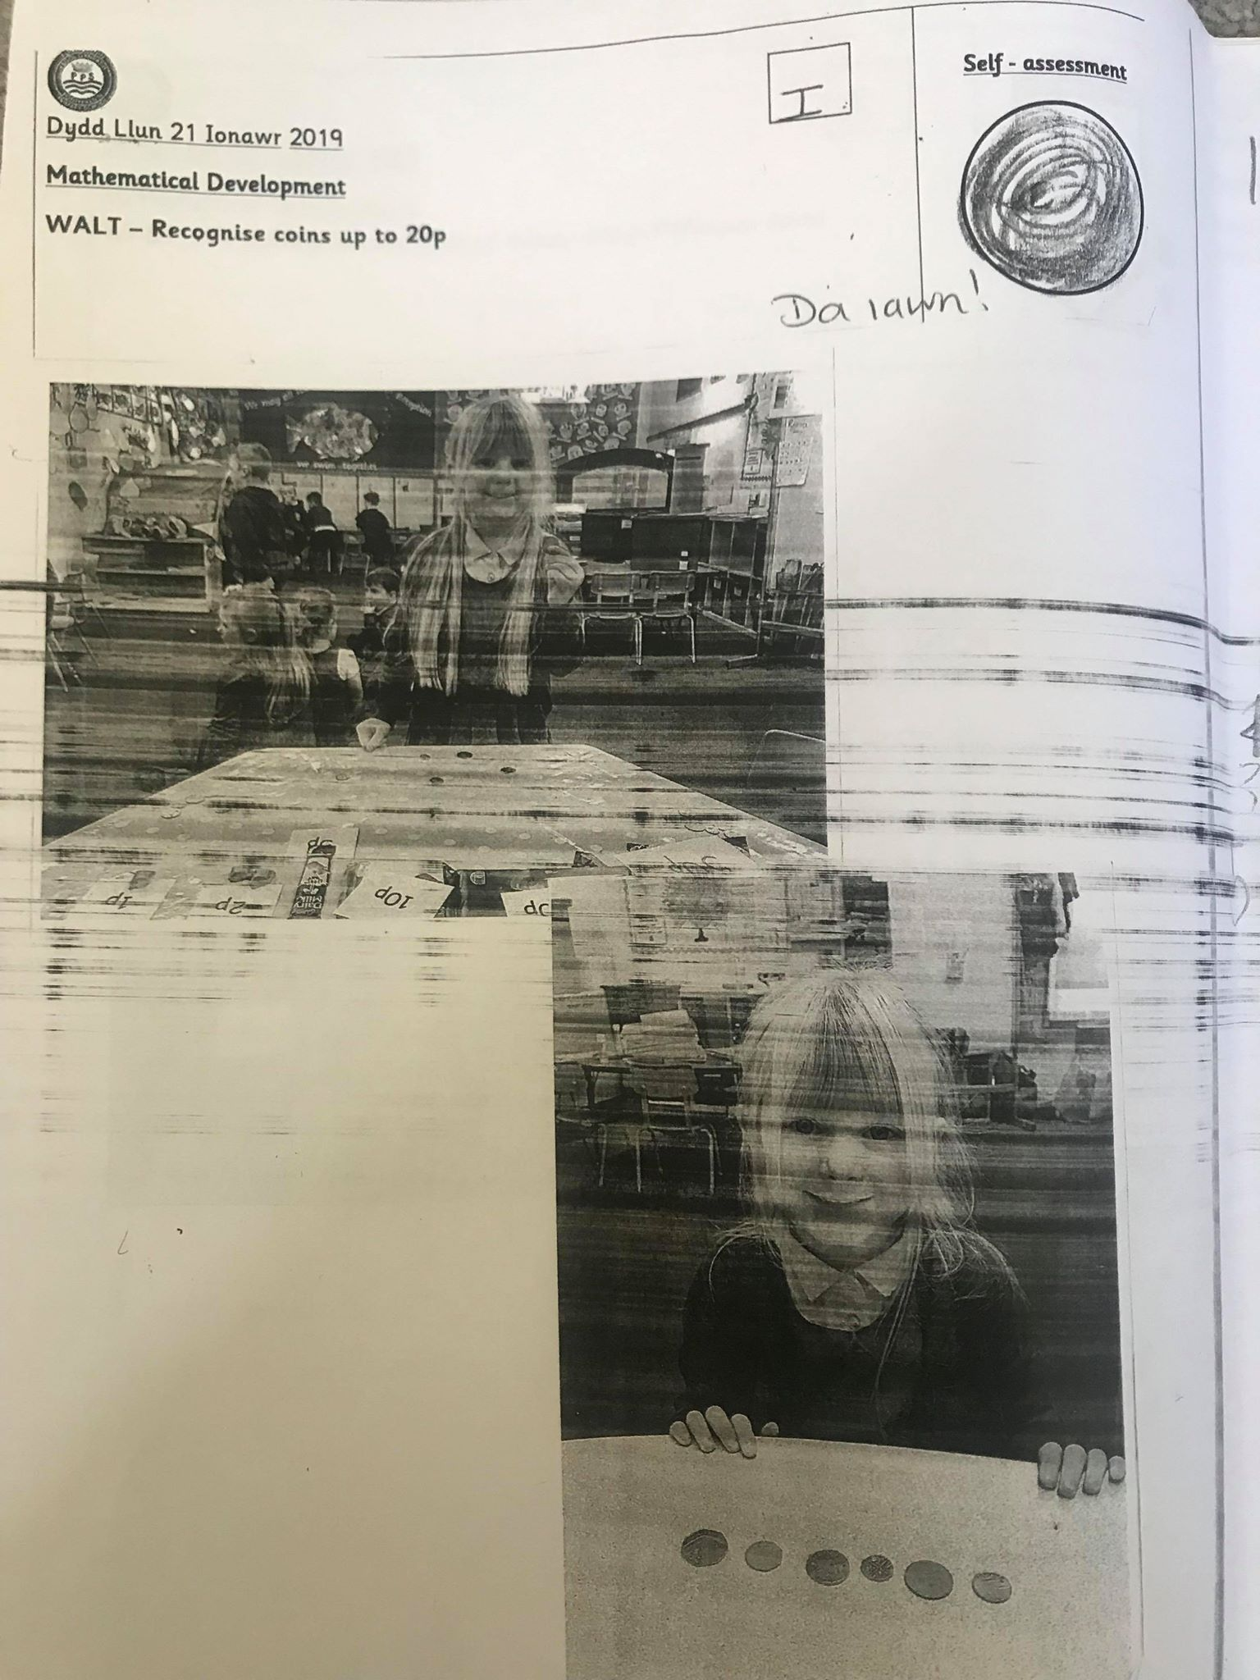

Appendix-8
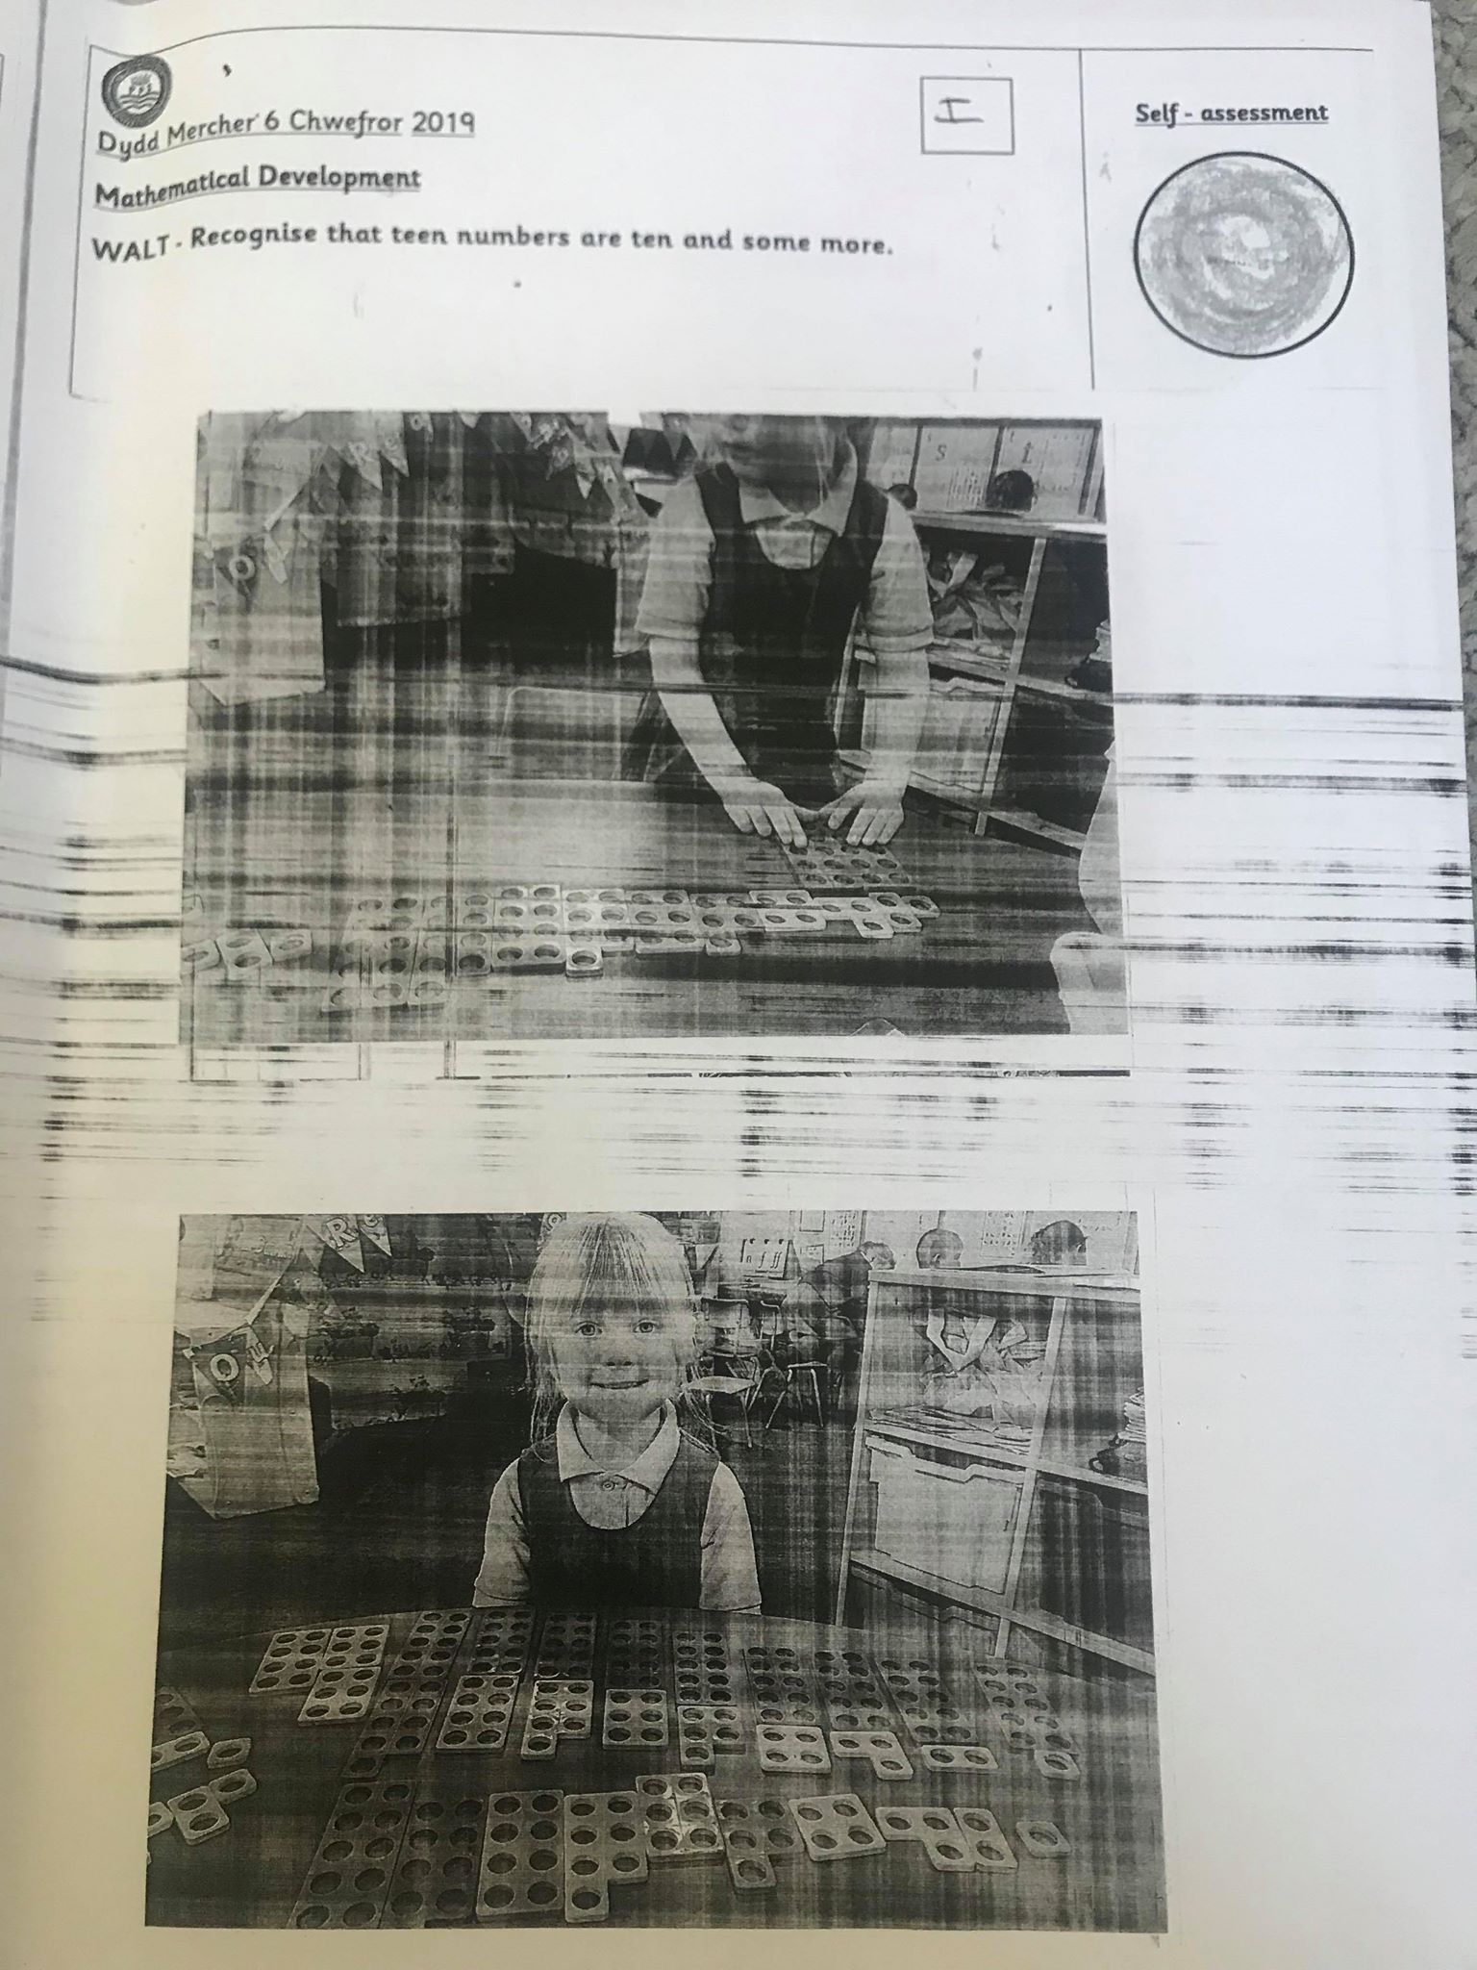

Appendix-9

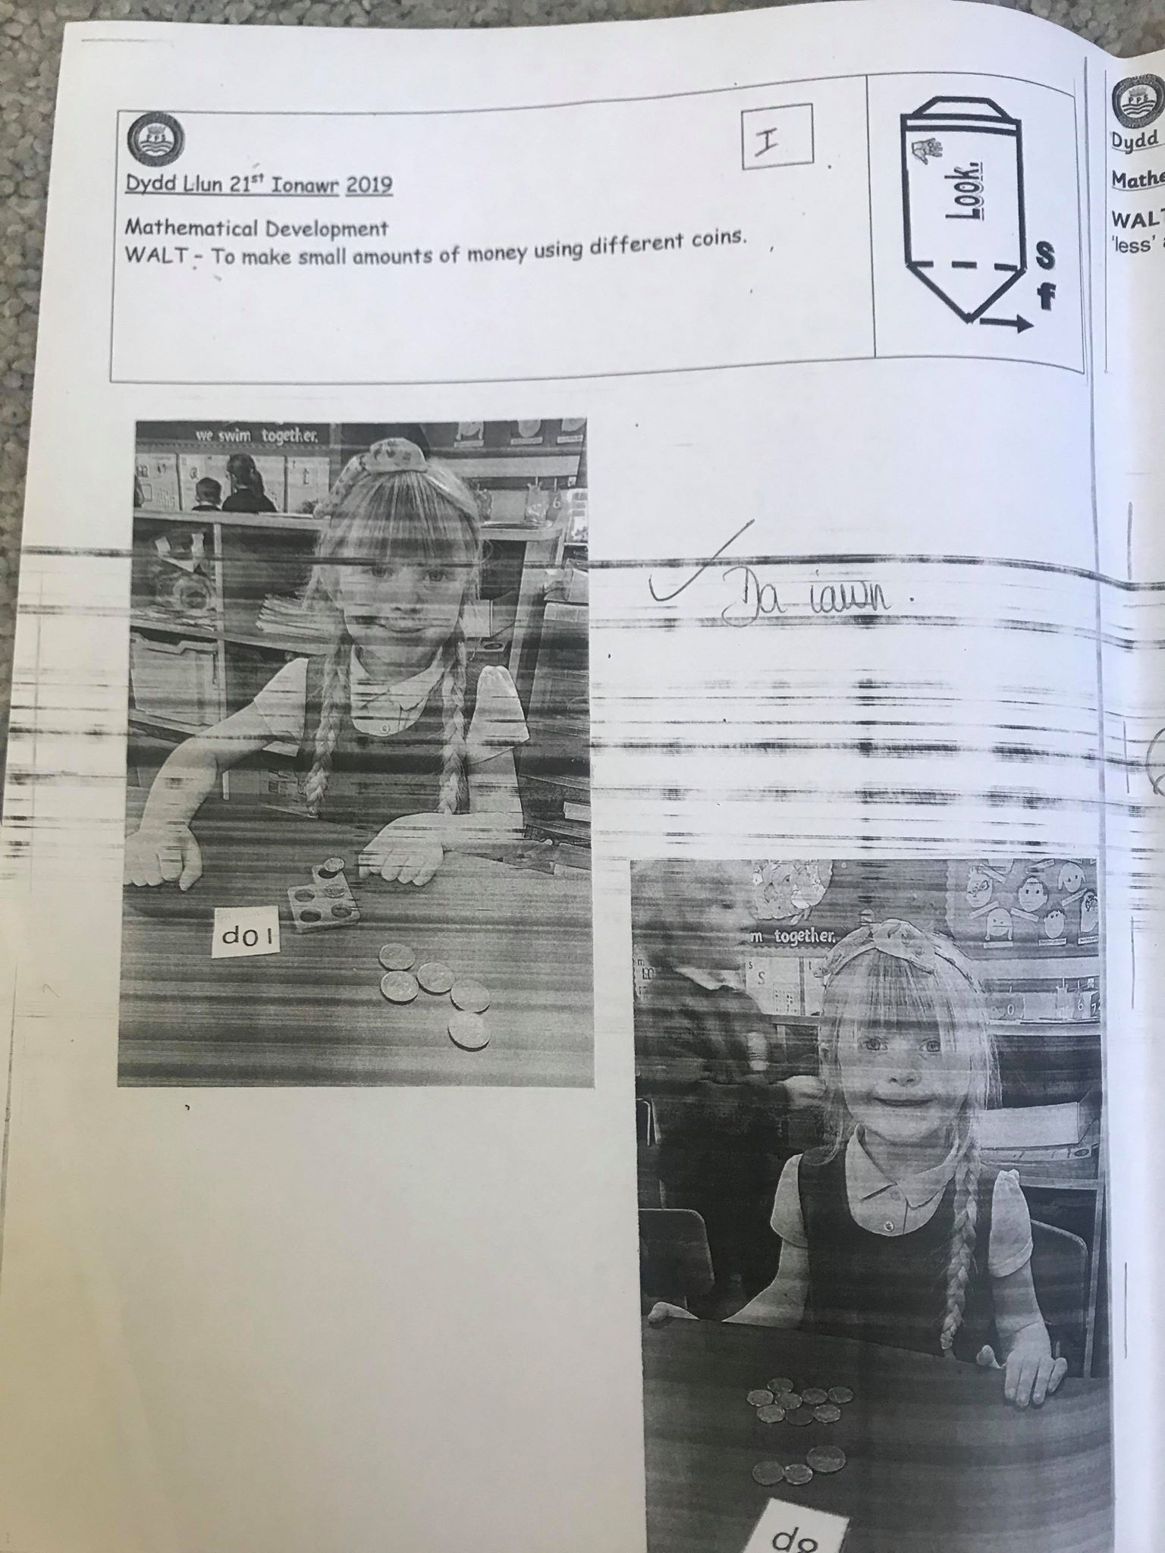

Appendix-10

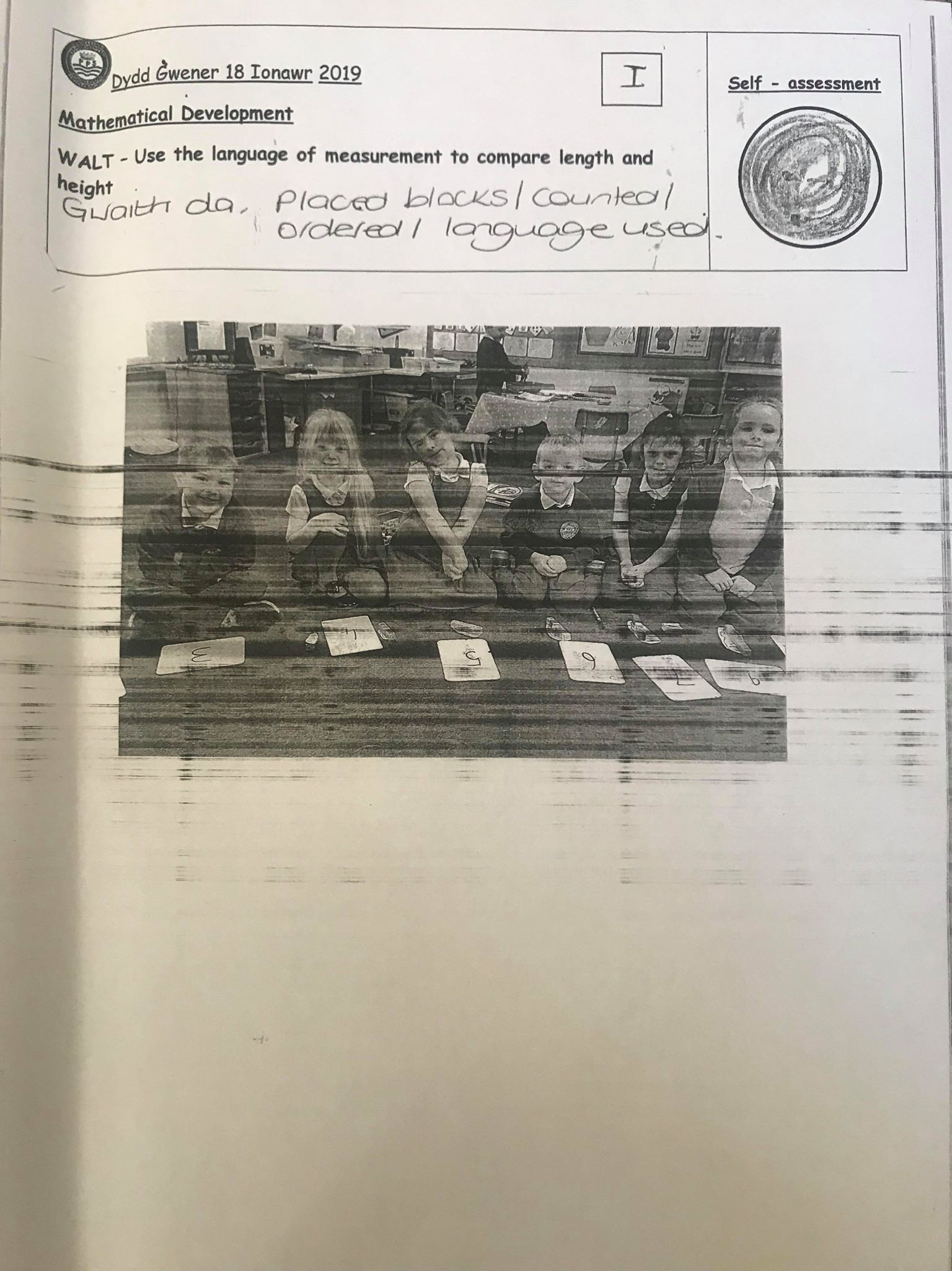

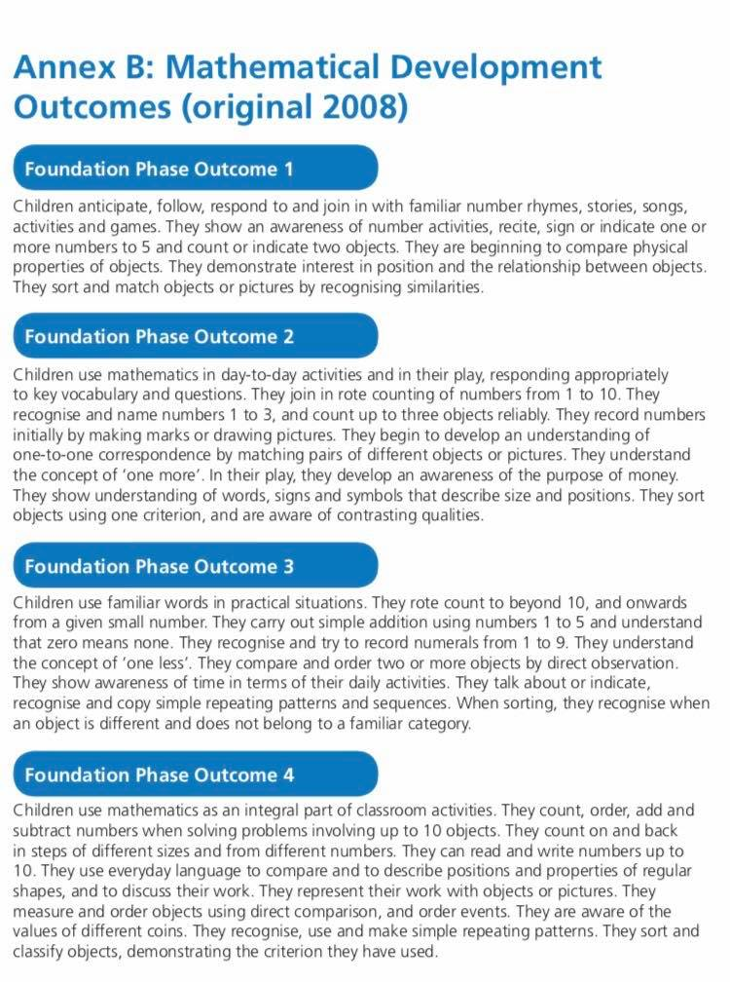
Appendix-11

Appendix-12
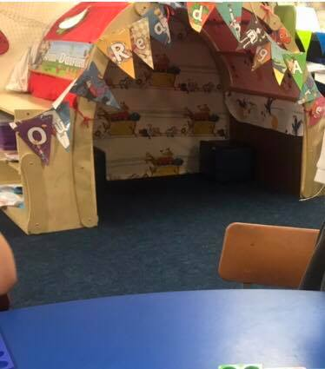

Appendix-13
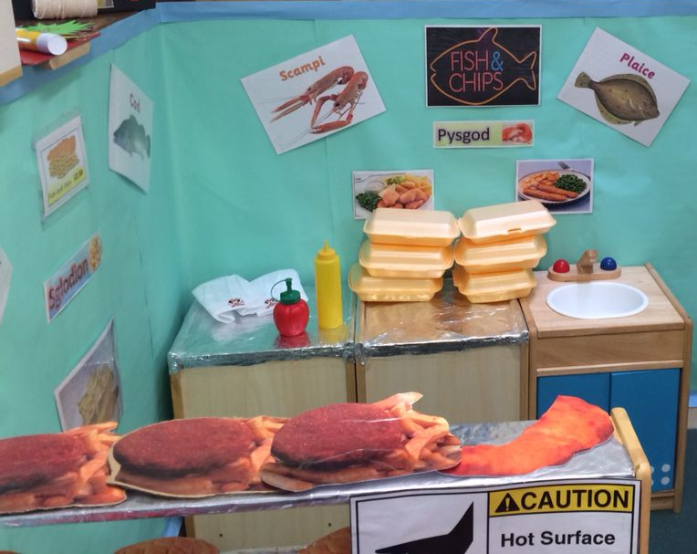

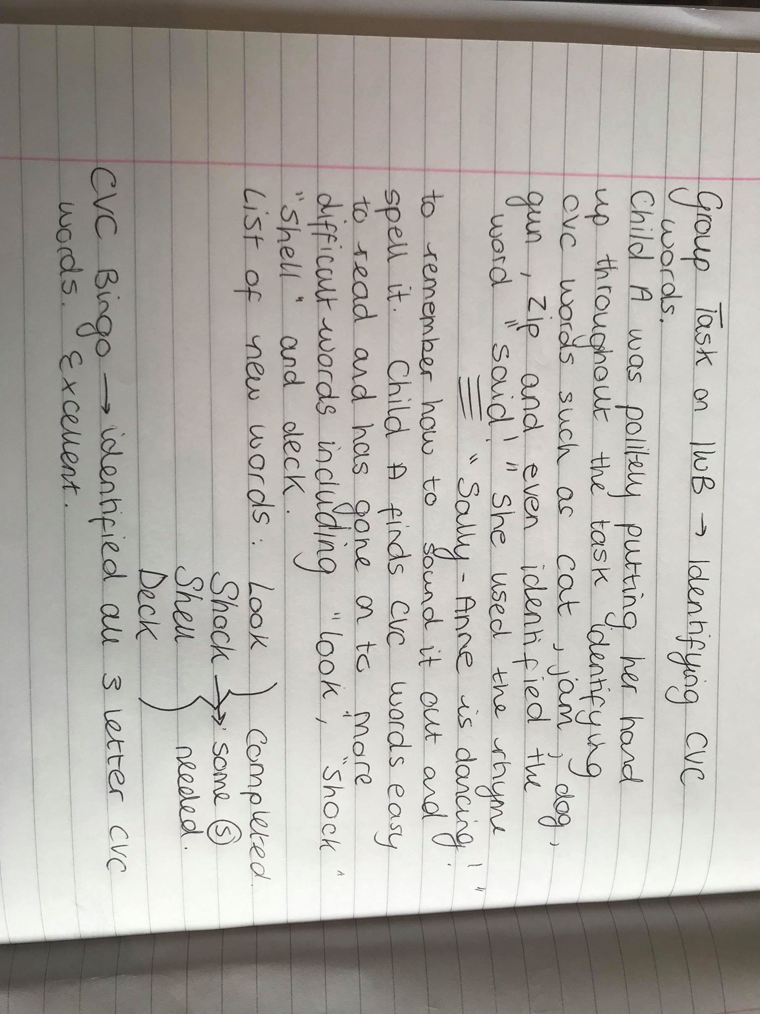
Appendix-14

Appendix-15
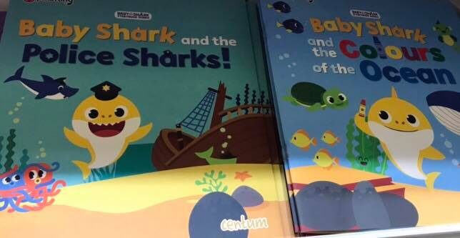

Appendix-16: Interview regarding reading
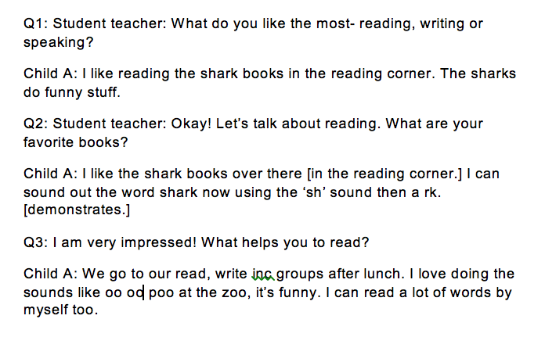

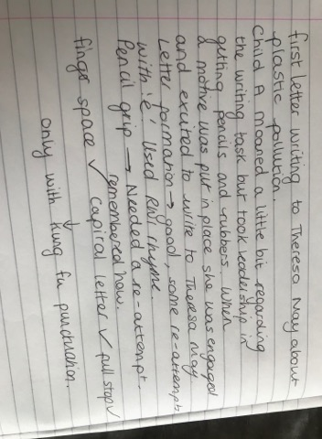
Appendix-17

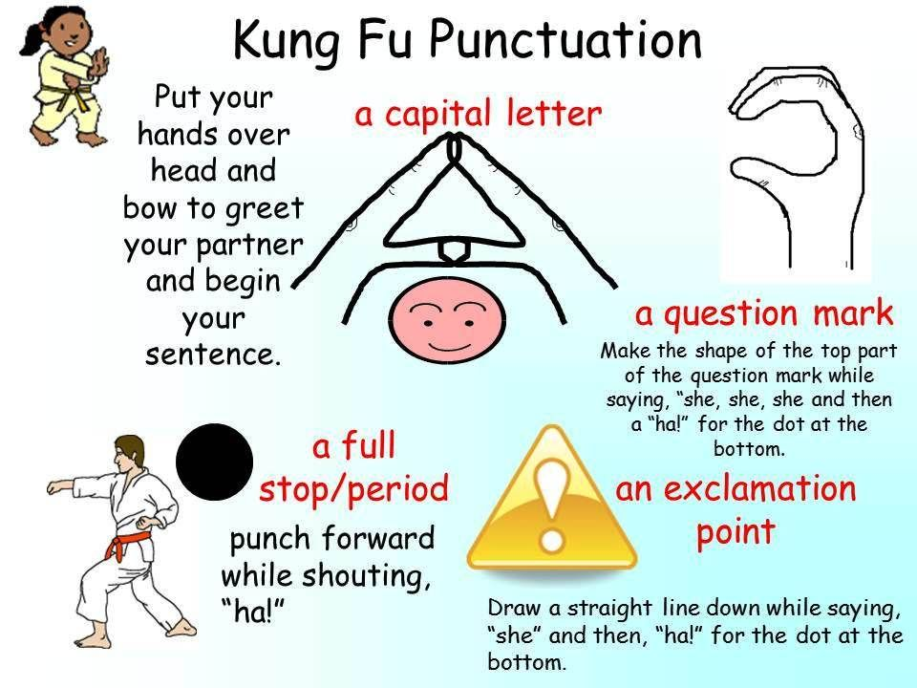
Appendix-18

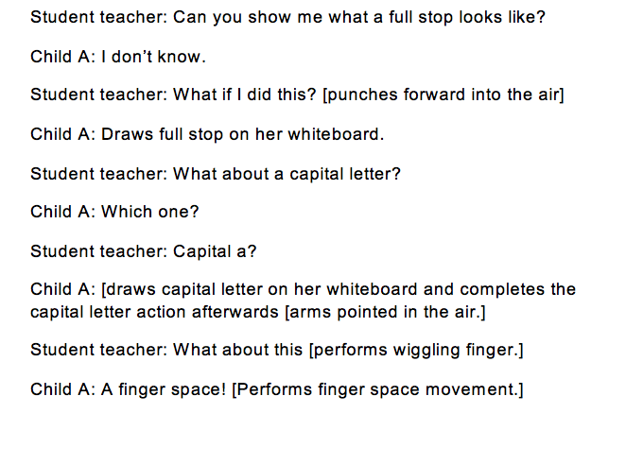
Appendix-19

Appendix-20

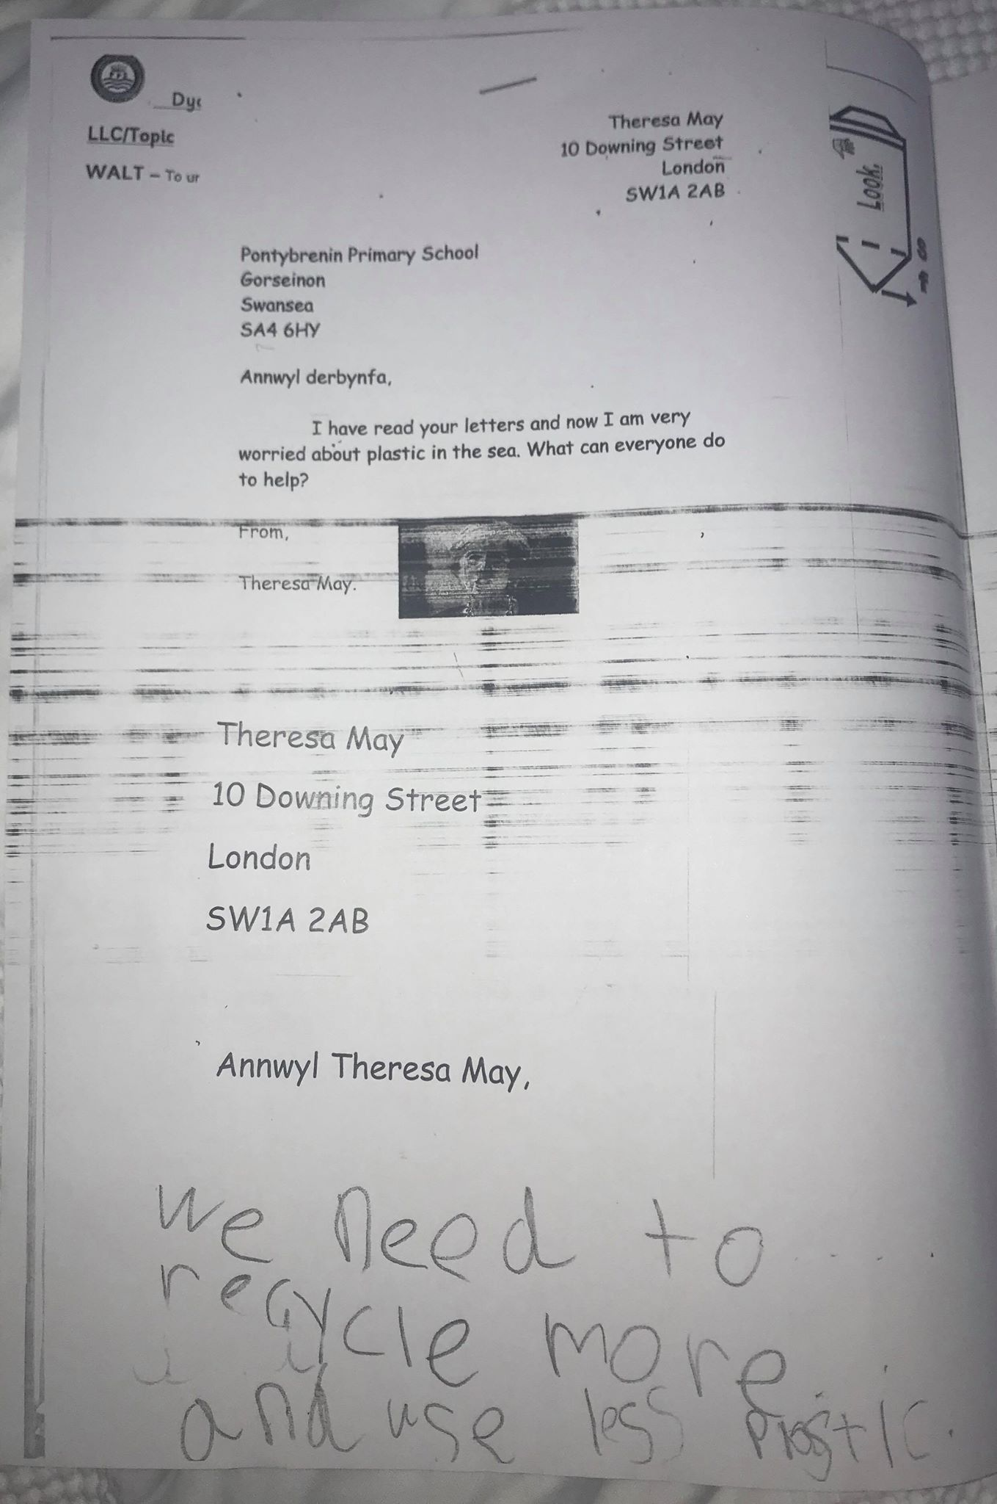

Appendix-21

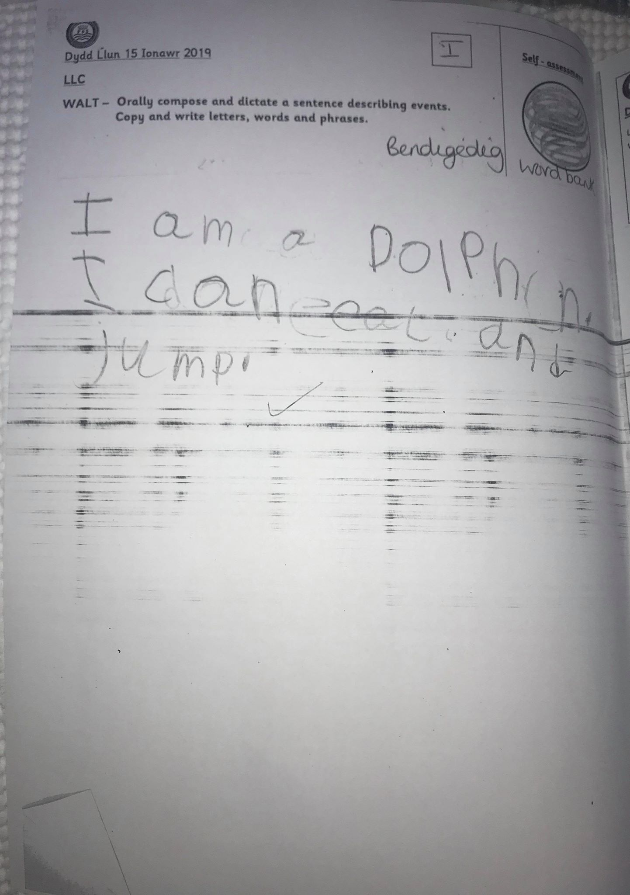

Appendix-22
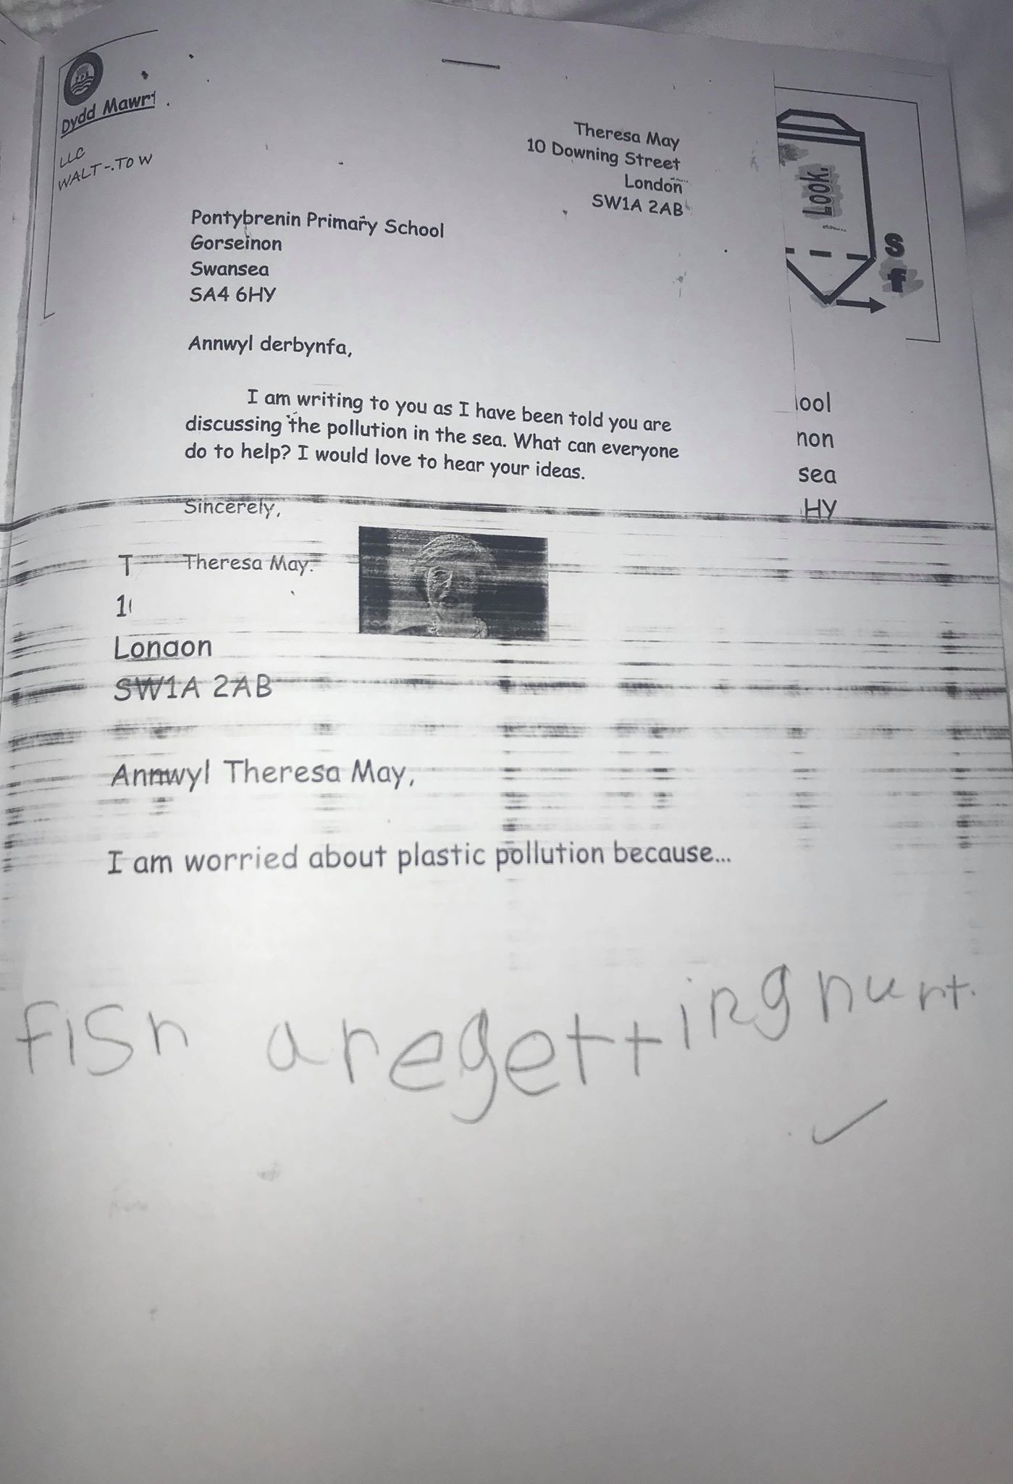

Appendix-23
Rhyming Song: https://www.youtube.com/watch?v=aP3UHE0duCU

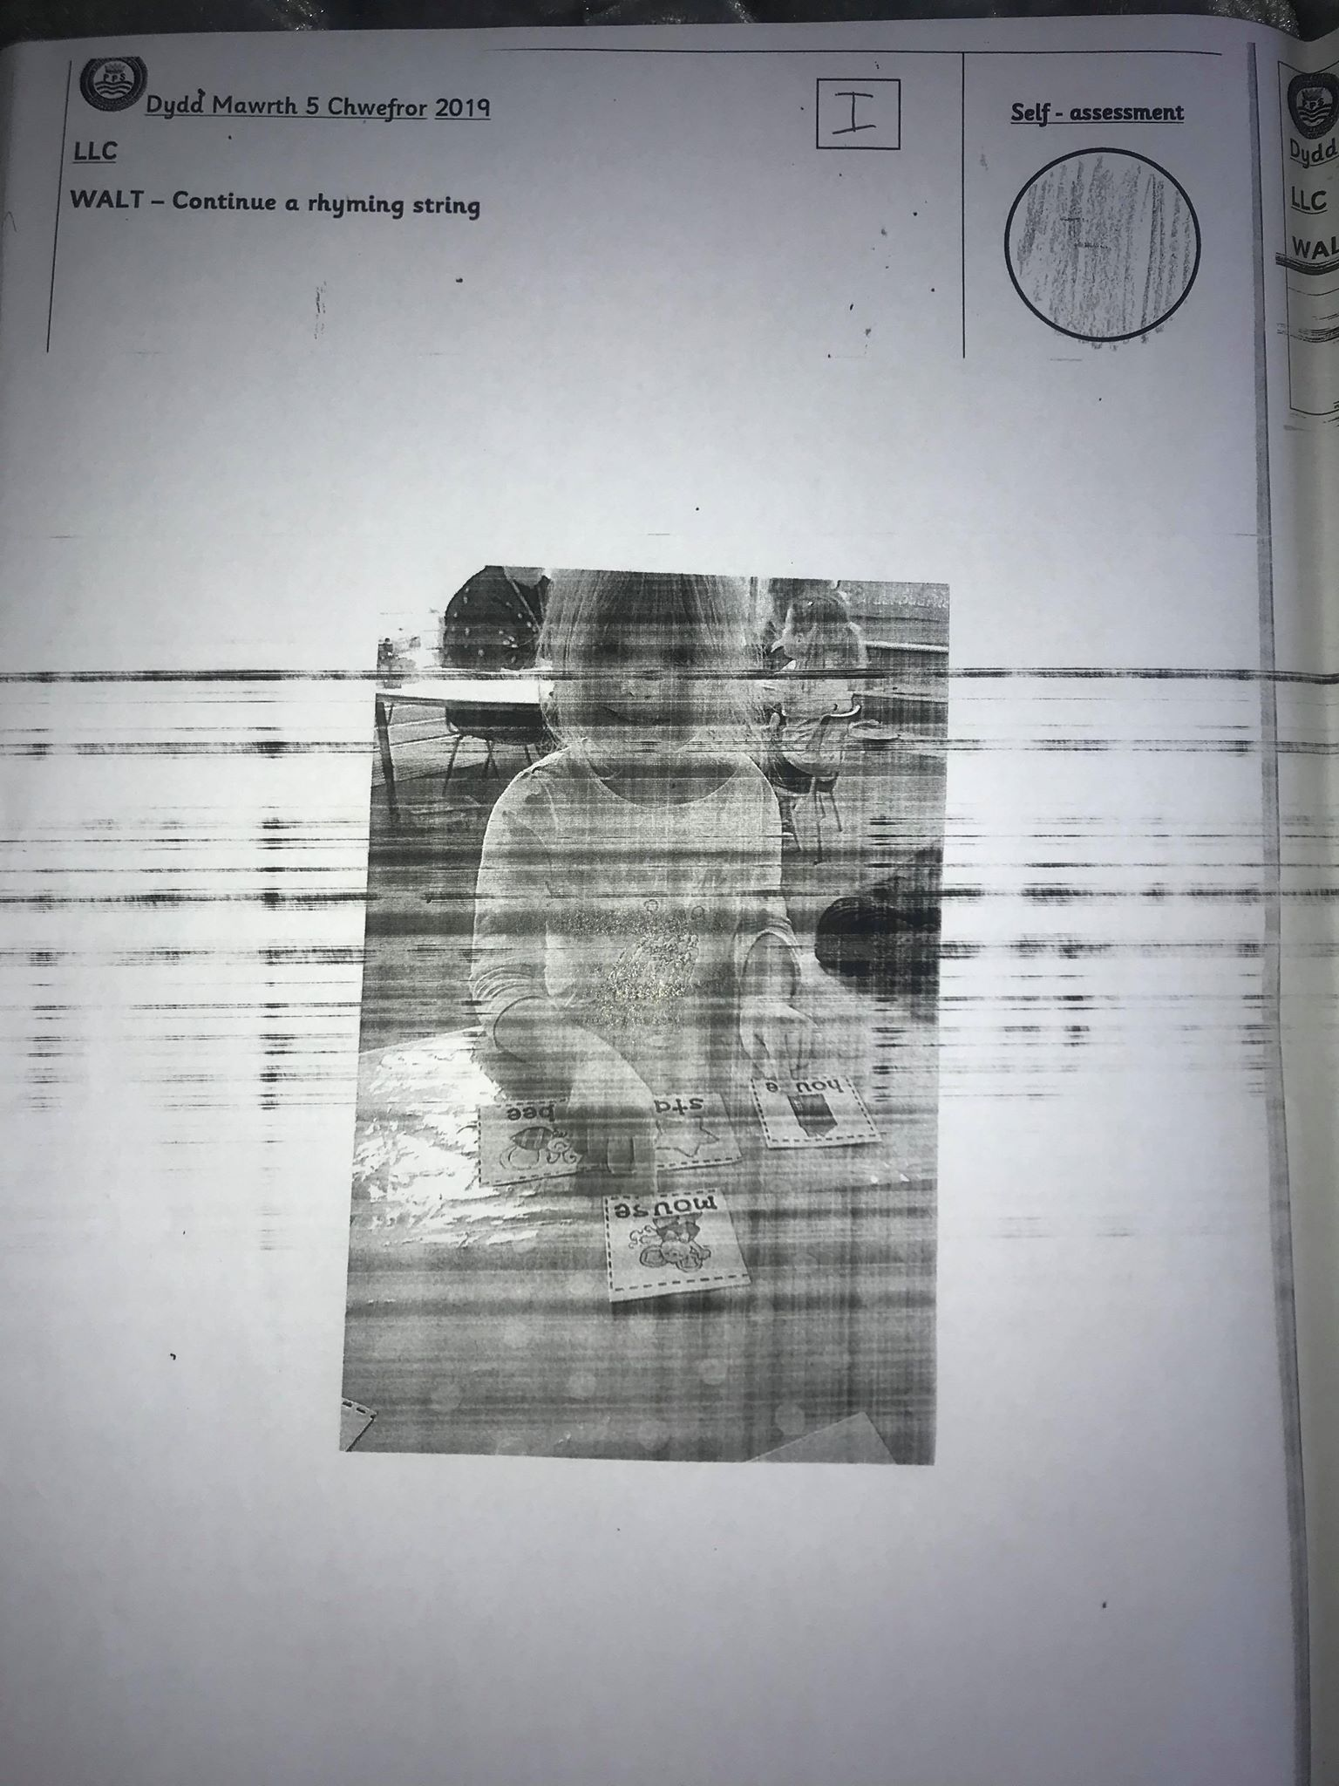
Appendix-24

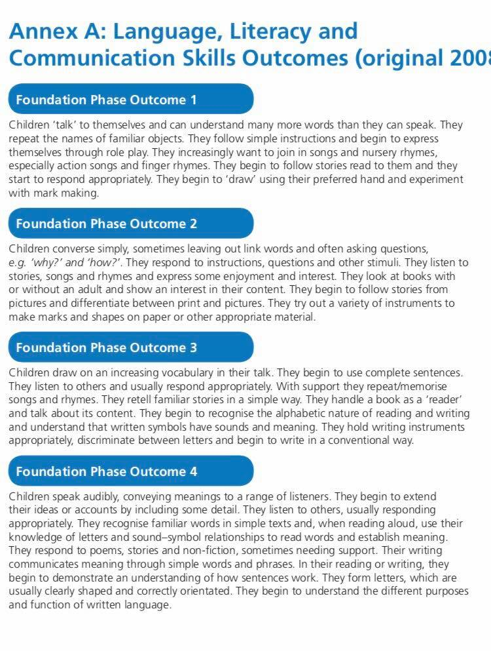
Appendix 25

