COMPARISON OF TWO ORGANISATIONS HILTON HOTEL AND MARRIOTT
INTERNATIONAL
SHAHEDA AHMED

2109892

BMIH5007 / BMIH5002

FINANCIAL MANAGEMENT FOR THE HOTEL INDUSTRY

LECTURER DALE CLARKE

CONTENTS
EXECUTIVE SUMMARY PAGE 1

INTRODUCTION PAGE 2

TOTAL REVENUE FOR HILTON AND MARRIOTT PAGE 2 - 4

MARKET POSITION FOR HILTON AND MARRIOTT PAGE 4 – 5

GROWTH POSITION FOR HILTON AND MARRIOTT PAGE 5 – 6

FINNANCIAL COMMITMENT TO CSR FOR HILTON AND MARRIOTT PAGE 6 –7

RECOMMENDATIONS AND CONCLUSION PAGE 7

BIBLIOGRAPHY PAGE 8

EXECUTIVE SUMMARY

This report will compare two hotel chains Hilton hotel and Marriott International, with a view to compare their approach to financial management when considering a few areas such as, total revenue, market position, and financial commitment to CSR.

A REPORT COMPARING HILTON HOTEL AND MARRIOT HOTEL AND THEIR APPROACH TO FINANCIAL MANAGEMENT.

This report will compare Hilton hotel and Marriott hotels approach to financial management when considering these areas.
Total Revenue
Market Position
Growth Potential
Financial commitment to CSR

INTRODUCTION
Hilton hotel founded by Conrad Hilton on May 31,1919 now owned by Hilton Worldwide, with more than 570 Hilton hotels and resorts in 85 different countries it is one of the largest hotel brands in the world (Bhasin, 2018).
Marriot hotels then owner John Willard Marriot started off with a root beer stand in 1927 they then moved into hotels in1957 where they opened the first motor home in the world. Today Marriott owns over 7,000 hotels in over 131 countries. Bill Marriott is still the executive chairman (Forbes, 2020).
TOTAL REVENUE
Here we will look at both Hiltons and Marriotts total revenue.
Hilton worldwide financial reports show the company’s current revenue is $8.16B in 2022, in 2021 it made a total revenue of $5.78B an increase from the year before which had a total revenue of $4.30B (Macrotrends, 2022). We can see that this low annual revenue for 2020 was due to the covid pandemic as all industries were hit hard. Preventing many from travelling. But Hilton seemed to have picked up once the travel surge was back, and restrictions lifted (Hawkins, 2022).
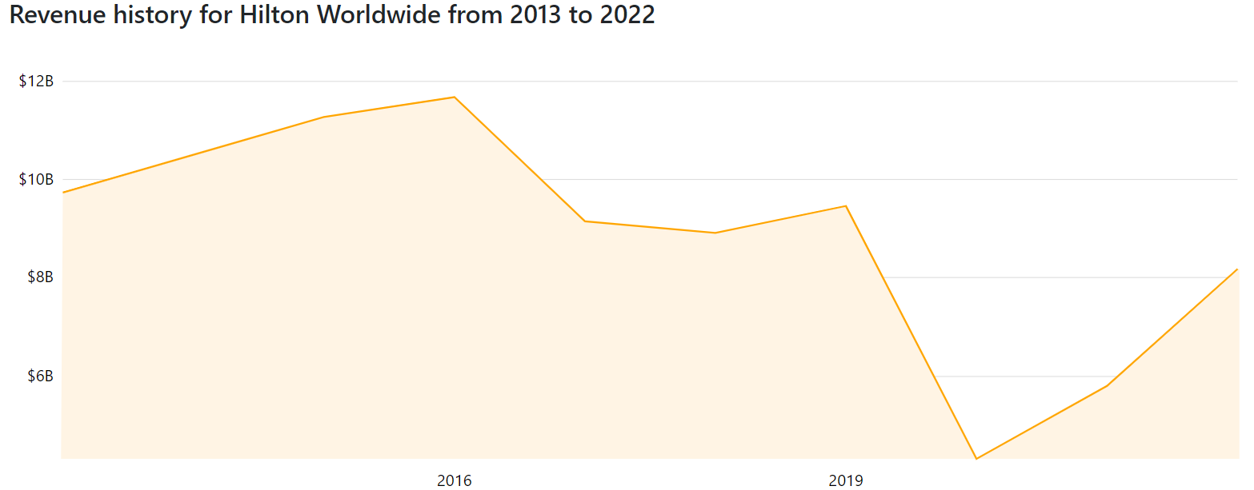
(Companiesmarket.com, 2022)
Marriott’s annual revenue for 2022 was $19.297B, in 2021 it made a total revenue of $13.857B an increase from the year before which had a total $10.571B but this was a decline from 2019 when the company made $20.972B a better total revenue than 2022, (Macrotrends, 2023)
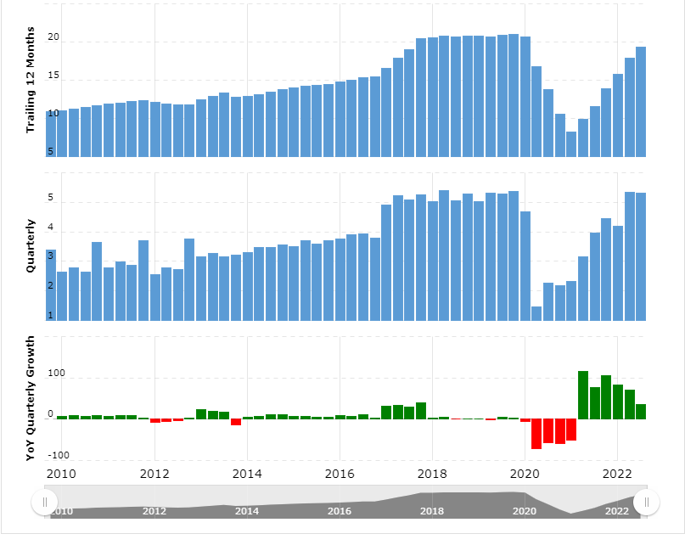
(Macrotrends, 2023)
Despite the success of Hilton, it still ranked second to its rival Marriott which generated double the revenue of Hilton. With a slight dip in the market during the covid pandemic (Statista Research Department, 2022).
MARKET POSITION
The process of market positioning involves targeting consumers according to their needs and wants.
Hilton divides it in to four different groups so their product can be targeted effectively geographically this focuses on building hotels in popular locations for example in London Hilton hotels are found in popular business places like Canary Wharf, Tower Bridge and Trafalgar Square (Dudovskiy, 2016)
Demographic position targets gender, age, social class, and lifestyle, so the middle-aged professionals, and belonging to upper social classes. With high level of income, and a want to pursue a luxury lifestyle, this reflects on the premium prices Hilton charge for their product and services (Dudovskiy, 2016)
Psychographic position looks at how a person thinks, feels, and behaves. Hilton targets ambitious people who would like to stay in a 5-star hotel and feel a sense of achievement, at a premium price (Dudovskiy, 2016)
Benefits position is where customers benefit from using products and their services either through being an existing customer or a potential one (Dudovskiy, 2016)
Hilton worldwide targets multi segment type of positioning, targeting more than one segment of customers at the same time, with a portfolio of 13 different brands, each brand is positioned accordingly. Luxury, lifestyle, full service, focused service, all suites, and vacation (Dudovskiy, 2016).
Marriott on the other hand with 30 different brands represents quality, reliability, and trust. From a clean comfortable, affordable room not far from home to upscale accommodation in major cities, to luxurious resorts in exotic locations around the world. Customers also know what ever their travel needs Marriott brands offer the right price at the right time (Brand Value, 2000)
We can see here that both Hilton and Marriott have the same values and mission and a similar mix of how and which customers they are targeting. From the luxury upmarket customers to the business travellers.to the customers looking for a family holiday. They are doing this by having good products, services and giving existing customers offers, benefits and perks like Hilton honours which every time you stay you can get points and redeem them, for breakfast, points towards another night’s stay or room upgrade (McHugh, 2023).
Marriott also have membership rewards program the easiest way to get points is to stay in a Marriott hotel, but there are also different ways to earn points stays in cruises, rental cars, you can even earn points when you order an uber ride, just by linking your Marriott account to the uber app. All this can be redeemed and used towards your stay at a Marriott hotel. (Arghandewal, 2023)
This keeps both hotels in a good position with customers and has a variety to suit everyone’s needs, and target different types of customers, therefore generate more revenue.
GROWTH POTENTIAL
Hilton is leading the industry with un precedented growth and have ambitions to capture opportunities in APAC as travel recovers, with a target to exceed 1,000 trading hotels by 2025. Hilton is in prime position to work with established owners to get the best brands and to capture travel demands to pre pandemic levels. Despite some macroeconomic headwinds, Hilton is seeing a fast return to normality (Clare, 2022).
The core of Hiltons growth strategy has been changed from a property management company to a focus on hospitality. Hilton will continue to grow as it adds new hotels (Sanchez, 2019).
Marriott International is on track for growth and remains on track to add 70,000 rooms Marriotts strategy of managing than owning hotels results in a strong balance sheet and healthy cash flow, this allows them to expand the brands without, being overly in debt. (Marriott, no date)
Marriott found that the ability to scale hotel growth for its brand was its biggest assets on offer. With the aim of achieving growth opportunities Marriott sees major growth in star woods luxury collection, with their distribution and marketing program. The international segment is seen as Marriott’s biggest growth opportunity in 2010 there were 243 hotels opened internationally across 56 countries now there are 912 properties 476 open and 436 in its pipeline across 91 countries. (Mest, 2017)
Marriott’s approach to growth potential is on a much bigger scale than there rival Hilton. But both hotels are seizing the opportunity for growth.to keep their hotels afloat.
FINANCIAL COMMITMENT TO CSR
Corporate social responsibility is an important factor for hotels all over the world. CSR is how hotels and companies recognise their social and environmental impact and try and develop initiatives that benefit the society (Impact partners, 2016)
Hilton world wides commitment to continuously improve CSR are in the following areas
1 Employees
2 Impact on the local community
3 Environment
4 Responsible sourcing (Dudovskiy, 2016)

Hilton’s efficiency and sustainability are a significant part of their business model. Hilton identified a need for room upgrades for example things like energy efficiency LED lights, and a plan to phase out in efficient room appliances in the hotel rooms as energy is one of the second largest cost for Hilton. In making these simple changes, Hilton maximises, environmental and financial efficiency. (Impact partners, 2016)
Focusing on sustainability, Hilton hotel plans to cut its environmental footprint in half and double its social impact by 2030.Hilton has been making efforts in these areas from 2008, by reducing carbon emissions and waste by 30% and energy and water consumption by 20%. Hilton has saved $1 billion dollars through these initiatives. (Tolentino, 2018).
Mattress recycling, donating soap and surplus food have contributed to these results. Hilton has recycled 8,100 mattresses and box spring pieces. Up to 95 percent of the mattress and its component can be recycled. Hilton has partnered with clean the world too and recycled over 1 million pounds of soap in to 5 million new bars to reduce hygiene related illnesses, within communities in need. Making them the largest soap recycling program in the industry (Lozanova, 2017).
Marriot International launched a CSR strategy called serve 360 and is the latest group to align their commitment and goals to CSR
Serve 360: Doing good in every direction their platform outlines commitments for 2025.
Nurture our world.
Sustain Responsible Operations.
Empower through opportunity.
Welcome all and advance human rights. (Guest User, 2018)
2025 goals consist of by 2022 80% of hotels should participate in community activities. By 2025 100% of employees have completed human rights training. Sustainably source 95% of their priority categories. And have 100% of their hotels with a sustainability certificate (McConnell Marketing, 2017).
Marriotts sustainability strategy is driven by many initiatives, the reduction of plastic bottles, shampoo, shower gel, conditioner all replaced by larger pump bottles in hotels, fully implementing this will prevent 500 bottles going to landfills (Fox, 2021).
To cut carbon footprint Marriot is using energy demand. This is an energy demand programme, anything from air conditioning in the rooms to fridges in the kitchen, can be turned down straight away if required. It is all triggered by a set top box, installed by Kiwi power. This means Marriott is on standby to help cut power, and are the first hotel to embrace demand response, and reduce its own bill by using less power (Macalister, 2015)
Both Marriott and Hilton are very concerned about their hotels being environmentally friendly. Sustainability has been a hot topic for the hospitality industry and will continue. According to Deloitte 95% of traveller’s surveyed said the hotel industry should go green or take steps towards a greener approach. Not embracing these initiatives could impact the hotel negatively as consumer trends matter (Hannah, 2022).
Comparing both these hotels, they are focused on similar commitments to CSR with one thing in mind reducing bills, being energy efficient, looking after the environment and listening to their customer’s needs. All this helps them bring in the revenue and keep each hotel top of its game and a place where people and employees are happy to be.
CONCLUSION / RECOMMENDATION
Recommendations for Hilton hotel would be the potential for outsourcing the hotels IT services which can reduce overhead and keep systems up to date and well maintained (Staron, 2021). Marriotts recommendation found in this report for potential growth would be to complete the 436 hotels they have in the pipeline over the 91 countries to start generating a revenue as soon as possible without going overly in to debt (Mest, 2017).
In conclusion this report has shown us that both Hilton and Marriott are following the mission, vision, and values they are so well known for. Marriotts is to enhance the lives of their customers and to be the world’s favourite travel company. Whilst Hiltons is to be the most hospitable company in the world by creating great experiences for their guests and opportunities for team members (Pratap, 2017). As well as keeping the hotel generating revenue, always trying to improve the hotel, and keeping it green, competing with each hotel and striving to give their customers the best experience, with an end goal of customer satisfaction, being profitable, and we can see in this report how they are keeping on top their financial commitments to total revenue, market position, growth potential and financial commitment to CSR.

Bibliography

Argandewal, A. (2023) ‘Everything you need to know about the Marriott Bonvoy rewards program’, CNN Underscored, 9th February. Available at: https://edition.cnn.com/cnn-underscored/travel/marriott-bonvoy-guide (Accessed: 13 February 2023).

Bhasin, H. (2018) ‘Marketing Strategy of Hilton Hotels’, Marketing91, 18th September. Available at: https://www.marketing91.com/marketing-strategy-of-hilton-hotels/ (Accessed: 12 February 2023).

Brand Value (2000) Marriott International, Inc. Available at: https://marriott.gcs-web.com/static-files/6c691ae7-0c1e-44ff-85c0-4a790721428b (Accessed: 13 February 2023).

Clare, N. (2022) ‘Hilton heading for ‘unprecedented growth’ in APAC’, Top Hotel Projects News, 8th November. Available at: https://tophotel.news/hilton-heading-for-unprecedented-growth-in-apac/ (Accessed: 13 February 2023).

Dudovskiy, J. (2016) ‘Hilton Hotels Segmentation, Targeting and Positioning’, Business Research Methodology, 24th August. Available at: https://research-methodology.net/hilton-hotels-segmentation/ (Accessed: 13 February 2023).

Forbes (2020) Marriott family. Available at: https://www.forbes.com/profile/marriott/?sh=670ce07031c0 (Accessed: 12 February 2023).

Fox, J.T. (2021) ‘Marriott announces new environmental initiatives’, Hotel Management, 23rd September. Available at: https://www.hotelmanagement.net/operate/marriott-announces-new-environmental-initiatives (Accessed: 14 February 2023).

Guest User. (2018) ‘Marriott latest hotel group to align CSR with the Global Goals’, Green Key, 3rd January. Available at: https://www.greenkey.global/stories-news-1/2017/12/13/marriott-latest-hotel-group-to-align-csr-with-the-global-goals (Accessed: 14 February 2023).

Hannah. (2022) ‘7 Hotel Sustainability Trends You Should Consider’, Gourmet Marketing, 24th June. Available at: https://www.gourmetmarketing.net/blog/7-hotel-sustainability-trends-consider (Accessed: 14 February 2023).

Hawkins, E. (2022) ‘Hilton marks ‘better than expected’ performance as travel demand returns’, CITYA.G., 3rd May. Available at: https://www.cityam.com/hilton-marks-better-than-expected-performance-as-travel-demand-returns/ (Accessed: 13 February 2023).

Impact Partners. (2016) ‘Hilton Sets the Bar for CSR in the Hospitality Industry’, Clean the World [blog]. 9th March. Available at: https://cleantheworld.org/blog/hilton-worldwide-sets-bar-csr-hospitality-industry/ (Accessed: 14 February 2023).

Lozanova, S. (2017) ‘For Hilton, Corporate Responsibility Means Customer Trust’, Triple Pundit, 22nd March. Available at: https://www.triplepundit.com/story/2017/hilton-corporate-responsibility-means-customer-trust/19116 (Accessed: 14 February 2023).

Macalister, T. (2015) ‘Marriott hotels using energy demand reduction to cut carbon footprint’, The Guardian, 6th May. Available at: https://www.theguardian.com/environment/2015/may/06/marriott-hotels-using-energy-demand-reduction-to-cut-carbon-footprint (Accessed: 14 February 2023).
Macrotrends (2022) Hilton Worldwide Holdings Revenue 2011-2022. Available at: https://www.macrotrends.net/stocks/charts/HLT/hilton-worldwide-holdings/revenue (Accessed: 13 February 2023).

Macrotrends (2023) Marriott Revenue 2010-2022. Available at: https://www.macrotrends.net/stocks/charts/MAR/marriott/revenue (Accessed: 13 February 2023).
Marriott International, Inc. (no date) Marriott on Track for Growth; Poised to Expand. Available at: https://marriott.gcs-web.com/news-releases/news-release-details/marriott-track-growth-poised-expand-leadership (Accessed: 15 February 2023).

McConnell Marketing. (2017) Marriott’s New CSR Initiative. Available at: https://mcconnellmarketing.com/2017/11/10/marriott-unveils-new-corporate-social-responsibility-initiative/ (Accessed: 14 February 2023).

McHugh, M. (2023) ‘The Benefits and Perks of Hilton Honors Elite Status [Silver, Gold, and Diamond]’, Upgraded Points, 17th January. Available at: https://upgradedpoints.com/travel/hotels/hilton-honors-elite-status-benefits/ (Accessed: 13 February 2023).

Mest, E. (2017) ‘5 growth opportunities for Marriott’, Hotel Management, 21st March. Available at: https://www.hotelmanagement.net/development/5-ways-marriott-planning-for-development-domination (Accessed: 12 February 2023).

Pratap, A. (2017) ‘Mission And Vision Of Hilton Worldwide: An Analysis’, Notesmatic, 9th March. Available at: https://www.notesmatic.com/mission-and-vision-of-hilton-worldwide-an-analysis/ (Accessed: 14 February 2023).

Sanchez, L. (2019) ‘How Hilton's Growth Strategy Is Delivering Strong Results’, The Motley Fool, 29th November. Available at: https://www.fool.com/investing/2019/11/29/how-hiltons-growth-strategy-deliver-strong-results.aspx (Accessed: 13 February 2023).

Staron, L. (2015) ‘4 services hotels should outsource’, Typsy [blog]. 15th November. Available at: https://blog.typsy.com/4-services-hotels-should-outsource (Accessed: 14 February 2023).

Statista Research Department. (2022) ‘Revenue of Hilton Worldwide Holdings 2009-2021’, Statista, 21st April. Available at: https://www.statista.com/statistics/297760/revenue-of-hilton-worldwide-holdings-inc/ (Accessed: 13 February 2023).

Tolentino, C. (2018) ‘Hilton commits to saving the world – one hotel at a time’, Travel Daily, 24th May. Available at: https://www.traveldailymedia.com/hilton-travel-with-purpose/ (Accessed: 14 February 2023).

