Introduction to Web and Database Concepts
Applied Computing
Lewis Allen
2320070
Contents
Introduction 1
Requirements 1
Implementation 2
Validation: 4
Evaluation 4
Search Engine Optimisation: 4
Usability: 5
Accessibility: 5
Bibliography 6
Appendices 7
HTML: 7
Home Page: 7
History Page: 8
Types Page: 10
Cocktails Page: 14
Contact Page: 18
CSS: 19

Introduction
In this report I will be covering the website I have created, its requirements and the implementation of the website, including validation. I will also be evaluating the website, covering the usability and utility, search engine optimisation and accessibility.

Requirements
The website that I have created is based on rum. The purpose of the website is to provide information about different rums, providing detail about the history of the spirit. The website also includes a page dedicated to the types of rum; however, this does not include every single type but the 5 most common. The intended purpose for this page is to provide the users with information on the type of rum, describing flavour profiles how it is made, and how it is commonly drunk. It is intended for people aged 18 and above, more specifically for people who enjoy rum. It is to show these people the interesting facts behind their favourite drink.

Implementation
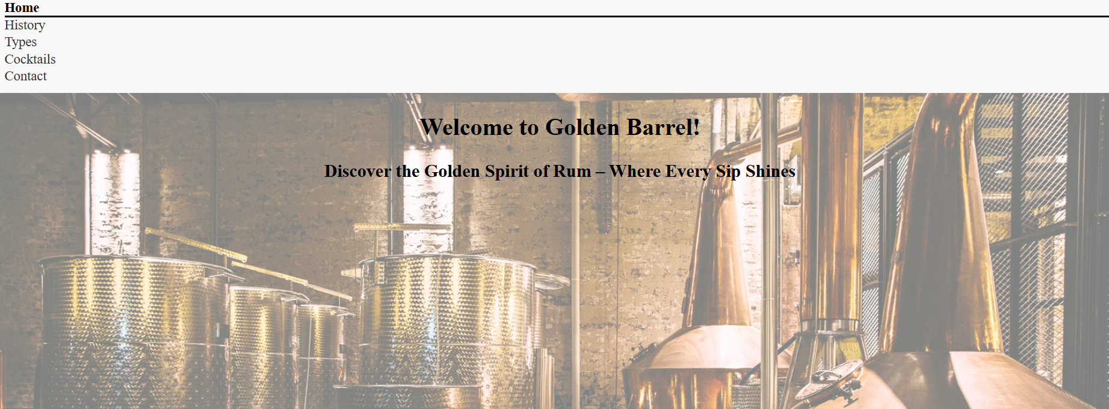
This is the home page for my website. I decided that I just wanted this page to be a simple welcoming page for the users to see when they first load onto the website. For this page I added a background image of a distillery, which felt fitting considering it is a rum website. For the text I thought I needed a catch to entice the customers; so, I decided to come up with a company name and a slogan, tying in a part of the company name into the slogan. I also added a navigation bar to the top of the page, I added additional styling to the navigation bar, I added an underline and bold text to identify the active page. This navigation bar appears on all the pages.
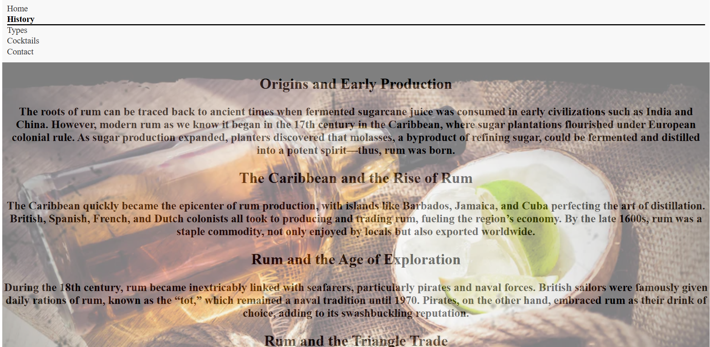
This is the history page of my website. I had some issues with the CSS on this page; the image opacity had also affected the text. The purpose for this page was to separate the stages of rums long history. I wanted to explain each section with sufficient detail to inform the website user of the history, however, I did not want each section to appear too long and in depth. I did not feel that the user of this website would want to read an overly large piece of text. The chosen background image for this page was to try and show the history of rum, I could have chosen a distillery, however because I had already used this on the home page, I needed something different.
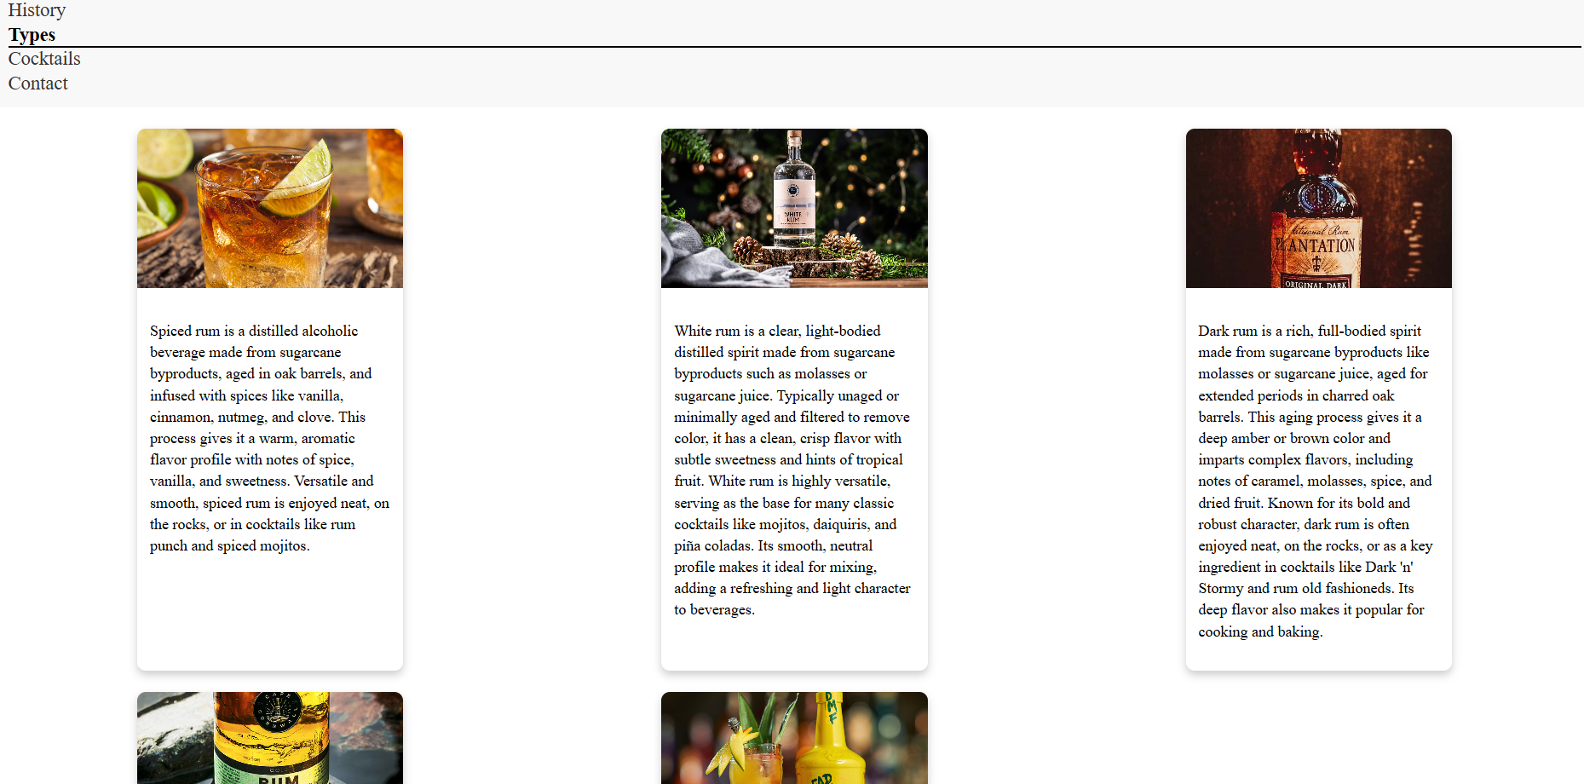
For the ‘Types’ page I decided to use CSS cards to list the types of rum I had chosen, I had only chosen 5 types of rum because there are many different types which I felt would be too many to put onto the website; I could have chosen 6 types to even out the number of cards on the page.
I used CSS cards as it felt almost menu esque which I felt would give the page a unique feeling. I added an image for each type of rum that I had, also providing a description of each type of rum, detailing how it is made and what type of cocktails it would be typically used in.

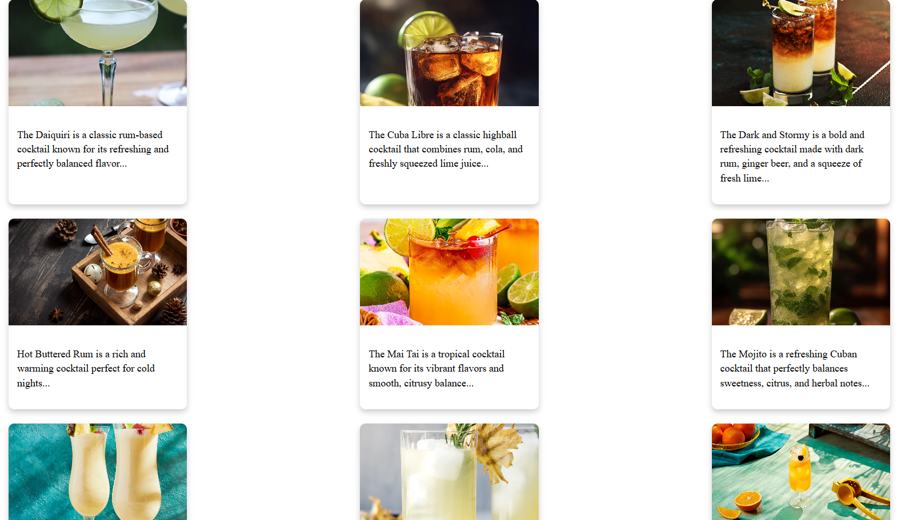
For the ‘Cocktails’ page I decided to style it the same as the ‘Types’ page. Using the CSS cards gave the page the menu esque feel that I was looking for. For the cocktail’s description underneath the images, I decided using a short amount of text would be better. I added 9 cocktails to this page, each type of rum has at least one cocktail on this page.

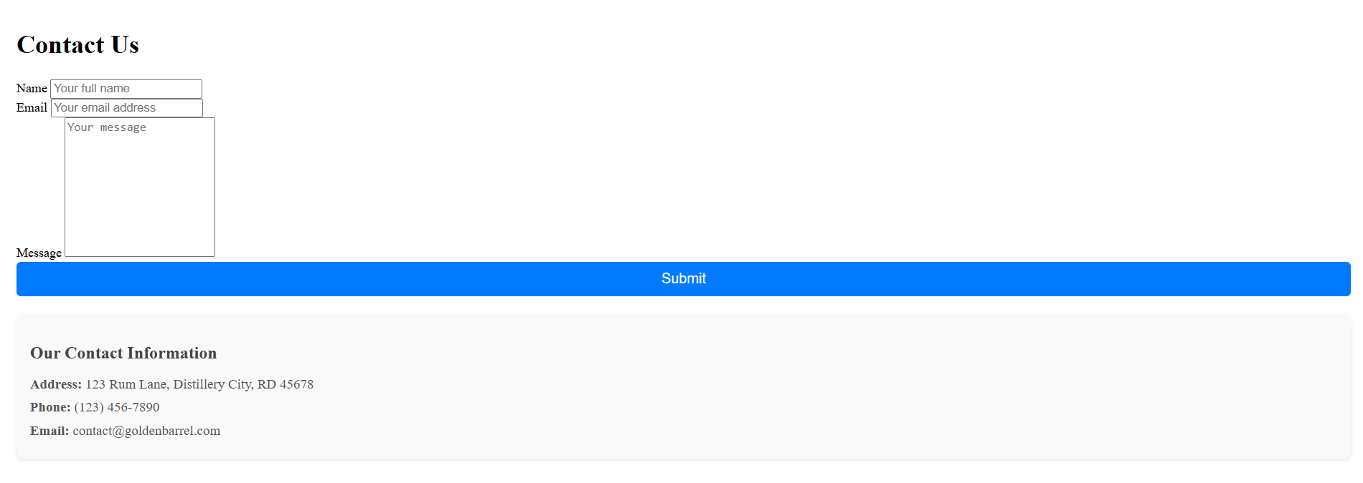
For the ‘Contact’ page I thought it would be good idea to present more like a form for the user to fill in. I used text boxes for the name and email fields, a text area for the message field that does expand if the user enters a lot into it. For the submit button I added CSS to change the colour of the button when the user is hovering over it. At the bottom of the page, I added some additional information in a separate div tag. I added CSS to change the background colour and text colour slightly, to differentiate from the form element.

Validation:
Originally, I had an issue with the active tab on my navigation bar. No matter what page the user is on it would constantly show the home page as the active page. I had initially thought that maybe I had entered something wrong into my CSS, but upon inspection the CSS was correct. I then looked into the HTML pages; comparing the home page to the others. Upon doing this I had notice something in the navigation bar classes, I had set all pages to have the active class for the home page, I then amended this so the page would show the correct active page. However, these were not direct issues with the coding.
From using the online tools provided to us, my HTML file for my home page had an error within it:
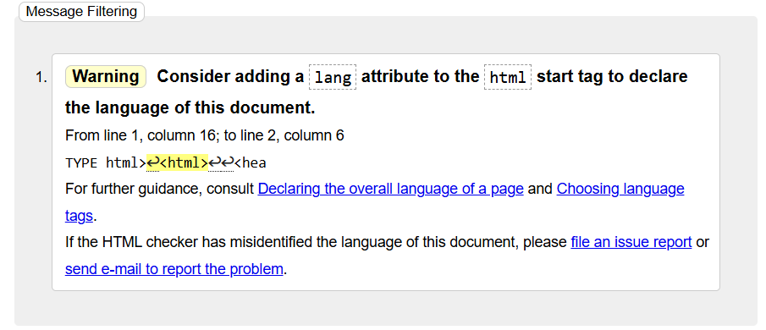
This is an easy error to fix though, as it does not actually affect the functionality of my website and only requires a quick fix.

I had also had an issue with the background opacity on the home page. I wanted the background image to be more transparent so that the text would be more readable. I had to add extra CSS to the banner using a banner::before CSS to amend the opacity. For some reason though this has not fixed the issue on the history page, I duplicated all the banners and renamed them to history banners as I needed a different image. I feel as though this issue lies within the CSS. However, these were not direct issues with the coding.
From using the online tools provided to us, my CSS file had zero errors within it:
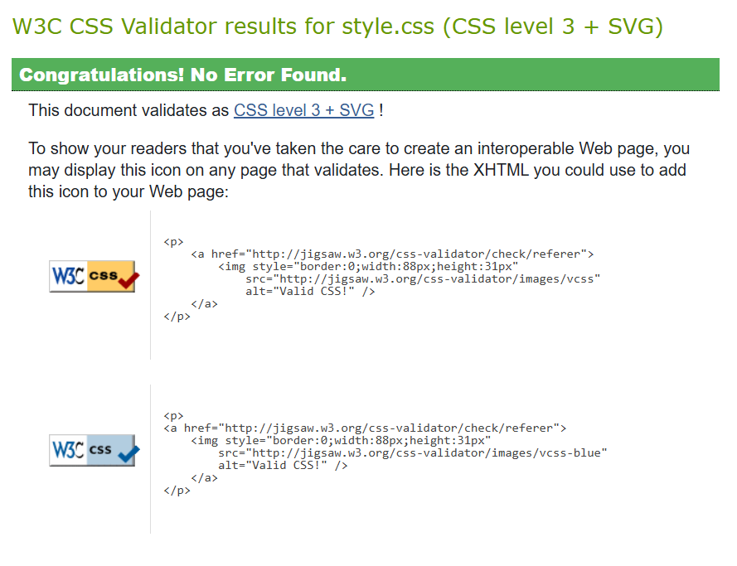

Evaluation

Search Engine Optimisation:
Search engine optimisation is a ‘discipline’ that is used to boost a website’s visibility in a search engines results page, also known as SERPs. This is a tactic used by websites as it means that they do not need to pay for advertisement (as much) boosting their traffic.
There are many different components of SEO:
One of which being keyword optimisation. This is the act of researching and selecting the most optimal keywords to target traffic from a search engine to your website [1]. Keyword optimisation is very important, this is because so many websites are published every day, so your website has to stand out amongst the rest so that it reaches your intended audience; there are several benefits to keyword optimisation such as improved search engine rankings, improved brand awareness and SERP visibility, as well as higher topical authority [2].
Another component of SEO is link building. Link building is an important aspect of SEO this is because if a search engine is not capable of following at least one link to your website it is unlikely to rank highly on a SERP [3]. This would mean that the more links there are to access your website the better, however, the quality of a link matters with some links potentially harming your website [3]. Link building has its benefits, similar to keyword optimisation and any other components of SEO, link building boosts the rankings of your website on a SERP. It can also provide increased referral traffic; this depends on whether your link can promise the user value as they will not just click on any link they see [4].
From this we can see that integrating SEO into your website can provide huge benefits. Imbedding SEO into the development of your website, it will position your website better on a SERP [5].
In terms of how I implemented SEO into the development process of my website I feel as though I could have done better. My use of keyword optimisation was ok, I used words, phrases, and even drink types to boost my keyword optimisation; however, because these words would be commonly used in most rum websites it would not benefit me greatly. Using keyword optimisation still provides benefits, but they are not as great in this scenario. When it comes to link building, my website does not utilise this in any way. My website can only be accessed via the links to the pages, totalling 5 links. These links are only accessible via a SERP. In total I feel as though given the theme of my website my search engine optimisation was ok at best, utilising some key components and disregarding others.

Usability:
Usability is a measure of how easy or hard a website is to use for the average user, regarding how easy it is for them to find what they want [6].
Similar to search engine optimisation, web usability has many different principles. One of which being efficiency. The efficiency of a website is also reliant on the learnability of the website, once a user has learnt how to use the website, the efficiency of the website can be tested. Efficiency is determined on how quickly the user can then perform tasks on the website.
Website usability is an important aspect of the development process of the website. Web usability is key, this is because most people will only have basic level IT skills, so if a website is difficult to use most of the users will immediately leave the website and not return [7].
Ensuring that your website has good usability will provide many benefits, one of those benefits being a competitive advantage. Having good usability will give users more of an incentive to choose to view your website over a competitor. Another benefit would be user satisfaction, good usability ensures that a user can get to what they need with ease, preventing any user frustration [8].
From this, we know that having good website usability is important as it can keep users on a website and away from a competitor [9].
In terms of how I implemented usability into my website, I decided to use basic navigation functions allowing for a user to easily find and access the pages that they need to. My pages themselves were not overly detailed and allowed for easy reading. I feel as though the usability of my website is strong.

Accessibility:
Website accessibility means that the website has been designed so that users with disabilities are able to use the website [10]. Web accessibility covers every disability that could affect a user’s access to the website, including auditory, cognitive, neurological, physical, speech and visual [10]. However, web accessibility also covers for those who may not have disabilities but instead have poor access to the internet.
Web accessibility also follows many principles, whether the site is perceivable, operable, understandable and robust [11]. The perceivability of a website depends on how the components of your website are presented, such as providing a text alternative to non-text content. The understandability of a website depends on different factors, one of which would be the text contents of the website. Making text readable is key, ensuring that there is a stark contrast between the background colour and the font colour.
Having good web accessibility has many benefits, web accessibility ties in directly to SEO. Having proper heading structures and alt text for your images, can boost the performance of your website on a SERP [12]. Having an accessible website can appeal to younger and more modern users. As the world is beginning to consider the ethical stance of the companies they choose to visit and support, so by ensuring that you have good web accessibility can put you into favour of those users [12].
In terms of my website, I like to think that my website has good accessibility. During development I added alt text to all of my images used on the website. There are some instances where I feel like the accessibility of my website could be improved on, the home page text can be a little difficult to read due to the background image, the same can be said for the history page; however, the history page has more of an issue, where the home page background was more opaque than the text, the opacity code applied to both the text and background image on the history page.
Again, from this we can see that accessibility is key for a developer to consider when developing a website. Accessibility plays a huge role in the world today due to the ever-evolving ethical standards [13].

Bibliography

[1] | K. Lyons, “Keyword Optimization: Why Optimizing for the Right Keywords is ‘Do or Die’,” WordStream, 6 November 2022. [Online]. Available: https://www.wordstream.com/blog/ws/2010/04/14/keyword-optimization. [Accessed 4 February 2025].
[2] | S. D, “Keyword Optimization Explained: 7 Effective Tips to Rank Higher,” Surfer blog, 4 November 2022. [Online]. Available: https://surferseo.com/blog/keyword-optimization/. [Accessed 4 February 2025].
[3] | “SEO Basics: What is link building?,” Yoast, 22 December 2022. [Online]. Available: https://yoast.com/what-is-link-building/. [Accessed 4 February 2025].
[4] | D. Sokach, “10 Main Benefits of Link Building,” editorial.link, 24 January 2025. [Online]. Available: https://editorial.link/benefits-of-link-building/#:~:text=10%20Benefits%20of%20Link%20Building%20for%20SEO%201,...%208%208.%20Faster%20indexing%20...%20More%20items. [Accessed 4 February 2025].
[5] | F. Zhang, “Research on Google’s Latest Algorithm Rules and Application Strategies,” Academic Journal of Science and Technology, vol. 9, no. 2, pp. 185-192, 2024.
[6] | S. Bose, “Website Usability Testing: A Beginner's Guide,” BrowserStack, 25 November 2024. [Online]. Available: https://www.browserstack.com/guide/website-usability-testing. [Accessed 9 February 2025].
[7] | J. Nielsen, “Usability 101: Introduction to Usability,” nngroup, 3 January 2012. [Online]. Available: https://www.nngroup.com/articles/usability-101-introduction-to-usability/. [Accessed 9 February 2025].
[8] | “Website Usability 101: Definition, Principles and Methods,” Ramotion, 4 October 2024. [Online]. Available: https://www.ramotion.com/blog/website-usability/#section-importance-of-website-usability. [Accessed 9 February 2025].
[9] | I. I. Tuba Ugras, “Research Trends in Web Site Usability: A Systemic Review,” July 2016. [Online]. Available: https://www.researchgate.net/publication/304370784_Research_Trends_in_Web_Site_Usability_A_Systematic_Review. [Accessed 9 February 2025].
[10] | S. L. Henry, “Introduction to Web Accessibility,” W3C, 7 March 2024. [Online]. Available: https://www.w3.org/WAI/fundamentals/accessibility-intro/. [Accessed 9 February 2025].
[11] | “Understanding WCAG 2.2,” GOV.UK, 29 October 2024. [Online]. Available: https://www.gov.uk/service-manual/helping-people-to-use-your-service/understanding-wcag. [Accessed 9 February 2025].
[12] | Y. Yampolsky, “The Benefits of Web Accessibility,” accessiBe, 1 October 2024. [Online]. Available: https://accessibe.com/blog/knowledgebase/benefits-of-web-accessibility#:~:text=The%20Benefits%20of%20Web%20Accessibility%201%20Web%20accessibility,...%205%20Start%20your%20accessibility%20journey%20now%20. [Accessed 9 February 2025].
[13] | C. S.-L. J Ara, “Accessibility engineering in web evaluation process: a systematic litrature review,” Universal Access in the Information Society, vol. 23, no. 2, pp. 653-686, 2024.

Appendices

HTML:

Home Page:
<!DOCTYPE html>
<html>

<head>
<meta charset="utf-8">
<link rel="stylesheet" href="style.css"> <!-- Link to external CSS file for styling -->
<title>Golden Barrel</title> <!-- Page title displayed in the browser tab -->
</head>

<body>

<header>
<h1>Golden Barrel</h1> <!-- Main heading of the website -->
<nav> <!-- Navigation menu for different sections of the website -->
<a href="Assignment.html" class="active">Home</a> <!-- Active link for the homepage -->
<a href="History.html">History</a> <!-- Link to the history page -->
<a href="Types.html">Types</a> <!-- Link to the types of rum page -->
<a href="Cocktails.html">Cocktails</a> <!-- Link to the cocktails page -->
<a href="Contact.html">Contact</a> <!-- Link to the contact page -->
</nav>
</header>

<div class="banner"> <!-- Banner section for welcome message -->
<div class="content"> <!-- Content inside the banner -->
<h2>Welcome to Golden Barrel!</h2>
<p>Discover the Golden Spirit of Rum – Where Every Sip Shines</p>
</div>
</div>

</body>
</html>

History Page:
<!DOCTYPE html>
<html lang="en">
<head>
<meta charset="UTF-8">
<link rel="stylesheet" href="style.css"> <!-- Link to external CSS file for styling -->
<meta name="viewport" content="width=device-width, initial-scale=1.0"> <!-- Ensures proper scaling on different devices -->
<title>History</title> <!-- Page title displayed in the browser tab -->
</head>
<header>
<nav> <!-- Navigation menu for site pages -->
<a href="Assignment.html">Home</a> <!-- Link to the homepage -->
<a href="History.html" class="active">History</a> <!-- Active link for the history page -->
<a href="Types.html">Types</a> <!-- Link to the types of rum page -->
<a href="Cocktails.html">Cocktails</a> <!-- Link to the cocktails page -->
<a href="Contact.html">Contact</a> <!-- Link to the contact page -->
</nav>
</header>
<body>

<div class="historybanner"> <!-- Banner section for the history page -->
<div class="historycontent"> <!-- Section for history introduction -->
<h2>Origins and Early Production</h2>
<p>The roots of rum can be traced back to ancient times when fermented sugarcane juice was consumed in early civilizations such as India and China. However,
modern rum as we know it began in the 17th century in the Caribbean, where sugar plantations flourished under European colonial rule. As sugar production expanded, planters discovered that molasses, a byproduct of refining sugar, could be fermented and distilled into a potent spirit—thus, rum was born.</p>
</div>

<div class="historycontent"> <!-- Section about Caribbean rum production -->
<h2>The Caribbean and the Rise of Rum</h2>
<p>The Caribbean quickly became the epicenter of rum production, with islands like Barbados, Jamaica, and Cuba perfecting the art of distillation.
British, Spanish, French, and Dutch colonists all took to producing and trading rum, fueling the region’s economy. By the late 1600s, rum was a staple commodity, not only enjoyed by locals but also exported worldwide.</p>
</div>

<div class="historycontent"> <!-- Section on rum's connection to sailors and pirates -->
<h2>Rum and the Age of Exploration</h2>
<p>During the 18th century, rum became inextricably linked with seafarers, particularly pirates and naval forces.
British sailors were famously given daily rations of rum, known as the “tot,” which remained a naval tradition until 1970. Pirates, on the other hand, embraced rum as their drink of choice, adding to its swashbuckling reputation.</p>
</div>

<div class="historycontent"> <!-- Section about rum's role in the Triangle Trade -->
<h2>Rum and the Triangle Trade</h2>
<p>Rum played a significant role in the transatlantic trade, often referred to as the Triangle Trade. Sugar plantations in the Caribbean produced molasses, which was shipped to New England to be distilled into rum. The rum was then traded for enslaved people in Africa, who were forced to work on Caribbean plantations.
This dark chapter in rum’s history is a sobering reminder of the economic forces that shaped its rise in global commerce.</p>
</div>

<div class="historycontent"> <!-- Section about modern rum production -->
<h2>Rum in the Modern Era</h2>
<p>By the 19th and 20th centuries, advancements in distillation technology and the abolition of slavery led to refined rum production methods. Countries like Cuba and Puerto Rico became known for their smooth and sophisticated rums, while aged varieties gained popularity worldwide.
Today, rum is enjoyed in an array of styles, from light and crisp to dark and complex, used in classic cocktails like the Daiquiri, Mojito, and Piña Colada.</p>
</div>
</div>

</body>
</html>

Types Page:
<!DOCTYPE html>
<html lang="en">
<head>
<meta charset="UTF-8">
<link rel="stylesheet" href="style.css"> <!-- Link to external CSS file for styling -->
<meta name="viewport" content="width=device-width, initial-scale=1.0"> <!-- Ensures proper scaling on different devices -->
<title>Types of Rum</title> <!-- Page title displayed in the browser tab -->
</head>
<header>
<nav> <!-- Navigation menu for site pages -->
<a href="Assignment.html">Home</a> <!-- Link to the homepage -->
<a href="History.html">History</a> <!-- Link to the history page -->
<a href="Types.html" class="active">Types</a> <!-- Active link for the types of rum page -->
<a href="Cocktails.html">Cocktails</a> <!-- Link to the cocktails page -->
<a href="Contact.html">Contact</a> <!-- Link to the contact page -->
</nav>
</header>
<body>

<div class="cards-container"> <!-- Container for rum type cards -->
<div class="card spicedcard"> <!-- Spiced rum card -->
<img src="../Assignment/images/Spiced_rum.png" alt="spicedrum" style="width:100%"> <!-- Spiced rum image -->
<div class="container spicedcontainer">
<p>
Spiced rum is a distilled alcoholic beverage made from sugarcane byproducts, aged in oak barrels, and infused with spices like vanilla, cinnamon, nutmeg, and clove. This process gives it a warm, aromatic flavor profile with notes of spice, vanilla, and sweetness. Versatile and smooth, spiced rum is enjoyed neat, on the rocks, or in cocktails like rum punch and spiced mojitos.
</p>
</div>
</div>

<div class="card whitecard"> <!-- White rum card -->
<img src="../Assignment/images/White_rum.png" alt="whiterum" style="width:100%"> <!-- White rum image -->
<div class="container whitecontainer">
<p>
White rum is a clear, light-bodied distilled spirit made from sugarcane byproducts such as molasses or sugarcane juice. Typically unaged or minimally aged and filtered to remove color, it has a clean, crisp flavor with subtle sweetness and hints of tropical fruit.

White rum is highly versatile, serving as the base for many classic cocktails like mojitos, daiquiris, and piña coladas. Its smooth, neutral profile makes it ideal for mixing, adding a refreshing and light character to beverages.
</p>
</div>
</div>

<div class="card darkcard"> <!-- Dark rum card -->
<img src="../Assignment/images/Dark_rum.png" alt="darkrum" style="width:100%"> <!-- Dark rum image -->
<div class="container darkcontainer">
<p>
Dark rum is a rich, full-bodied spirit made from sugarcane byproducts like molasses or sugarcane juice, aged for extended periods in charred oak barrels. This aging process gives it a deep amber or brown color and imparts complex flavors, including notes of caramel, molasses, spice, and dried fruit.

Known for its bold and robust character, dark rum is often enjoyed neat, on the rocks, or as a key ingredient in cocktails like Dark 'n' Stormy and rum old fashioneds. Its deep flavor also makes it popular for cooking and baking.
</p>
</div>
</div>

<div class="card goldcard"> <!-- Gold rum card -->
<img src="../Assignment/images/Gold_rum.png" alt="goldrum" style="width:100%"> <!-- Gold rum image -->
<div class="container goldcontainer">
<p>
Gold rum, also known as amber rum, is a medium-bodied spirit made from sugarcane byproducts, aged in oak barrels to develop its rich golden color and balanced flavor. It bridges the gap between the lightness of white rum and the depth of dark rum, offering subtle notes of caramel, vanilla, and mild spice.

Versatile and smooth, gold rum is enjoyed neat, on the rocks, or in cocktails like Mai Tais and Rum Sours. Its balanced profile also makes it a popular choice for cooking and blending.
</p>
</div>
</div>

<div class="card flavouredcard"> <!-- Flavored rum card -->
<img src="../Assignment/images/Flavoured_rum.png" alt="flavouredrum" style="width:100%"> <!-- Flavored rum image -->
<div class="container flavouredcontainer">
<p>
Flavored rum is a versatile spirit made from traditional rum infused with additional flavors such as coconut, pineapple, mango, or spices. These flavors are often added after distillation, resulting in a sweeter and more aromatic profile tailored to specific tastes.

Light and fun, flavored rum is commonly used in tropical cocktails like piña coladas, rum punches, or simply mixed with soda or juice. Its diverse range of flavors makes it a favorite for creative drinks and casual sipping.
</p>
</div>
</div>
</div>

</body>
</html>

Cocktails Page:
<!DOCTYPE html>
<html lang="en">
<head>
<meta charset="UTF-8">
<link rel="stylesheet" href="style.css"> <!-- Link to external CSS file -->
<meta name="viewport" content="width=device-width, initial-scale=1.0">
<title>Cocktails</title> <!-- Page title -->
</head>

<header>
<nav> <!-- Navigation menu -->
<a href="Assignment.html">Home</a>
<a href="History.html">History</a>
<a href="Types.html">Types</a>
<a href="Cocktails.html" class="active">Cocktails</a> <!-- Active page -->
<a href="Contact.html">Contact</a>
</nav>
</header>

<body>
<div class="cards-container"> <!-- Container for cocktail cards -->

<!-- Daiquiri Card -->
<div class="card daquiricard">
<img src="../Assignment/images/Daquiri.png" alt="Daquiri" style="width:100%"> <!-- Cocktail image -->
<div class="container daquiricontainer">
<p>
The Daiquiri is a classic rum-based cocktail known for its refreshing and perfectly balanced flavor...
</p>
</div>
</div>

<!-- Cuba Libre Card -->
<div class="card cubalibrecard">
<img src="../Assignment/images/CubLibre.png" alt="Cuba Libre" style="width:100%">
<div class="container cubalibrecontainer">
<p>
The Cuba Libre is a classic highball cocktail that combines rum, cola, and freshly squeezed lime juice...
</p>
</div>
</div>

<!-- Dark and Stormy Card -->
<div class="card darkandstormycard">
<img src="../Assignment/images/darkandstormy.png" alt="dark and stormy" style="width:100%">
<div class="container darkandstormycontainer">
<p>
The Dark and Stormy is a bold and refreshing cocktail made with dark rum, ginger beer, and a squeeze of fresh lime...
</p>
</div>
</div>

<!-- Hot Buttered Rum Card -->
<div class="card hotbutteredrumcard">
<img src="../Assignment/images/hotbutteredrum.png" alt="Hot buttered rum" style="width:100%">
<div class="container hotbutteredrumcontainer">
<p>
Hot Buttered Rum is a rich and warming cocktail perfect for cold nights...
</p>
</div>
</div>

<!-- Mai Tai Card -->
<div class="card maitaicard">
<img src="../Assignment/images/MaiTai.png" alt="Mai Tai" style="width:100%">
<div class="container maitaicontainer">
<p>
The Mai Tai is a tropical cocktail known for its vibrant flavors and smooth, citrusy balance...
</p>
</div>
</div>

<!-- Mojito Card -->
<div class="card mojitocard">
<img src="../Assignment/images/mojito.png" alt="Mojito" style="width:100%">
<div class="container mojitocontainer">
<p>
The Mojito is a refreshing Cuban cocktail that perfectly balances sweetness, citrus, and herbal notes...
</p>
</div>
</div>

<!-- Piña Colada Card -->
<div class="card pinacoladacard">
<img src="../Assignment/images/Pina_colada.png" alt="Pina Colada" style="width:100%">
<div class="container pinacoladacontainer">
<p>
The Piña Colada is a creamy and tropical cocktail that blends the rich flavors of coconut, pineapple, and rum...
</p>
</div>
</div>

<!-- Pineapple Rum Fizz Card -->
<div class="card pineapplerumfizzcard">
<img src="../Assignment/images/Pineapplerumfizz.png" alt="Pineapple rum fizz" style="width:100%">
<div class="container pineapplerumfizzcontainer">
<p>
The Pineapple Rum Fizz is a light, tropical cocktail that combines the smoothness of rum with the bright, refreshing taste of pineapple...
</p>
</div>
</div>

<!-- Tropical Storm Card -->
<div class="card tropicalstormcard">
<img src="../Assignment/images/TropicalStorm.png" alt="Tropical Storm" style="width:100%">
<div class="container tropicalstormcontainer">
<p>
The Tropical Storm is a bold and refreshing cocktail that combines the tropical flavors of rum and fruit juices...
</p>
</div>
</div>
</div>
</body>
</html>

Contact Page:
<!DOCTYPE html>
<html lang="en">
<head>
<meta charset="UTF-8">
<link rel="stylesheet" href="style.css"> <!-- Link to external CSS file -->
<meta name="viewport" content="width=device-width, initial-scale=1.0">
<title>Contact Us</title> <!-- Page title -->
</head>

<header>
<nav> <!-- Navigation menu -->
<a href="Assignment.html">Home</a>
<a href="History.html">History</a>
<a href="Types.html">Types</a>
<a href="Cocktails.html">Cocktails</a>
<a href="Contact.html" class="active">Contact</a> <!-- Active page -->
</nav>
</header>

<body>
<div class="container"> <!-- Main container -->
<h1>Contact Us</h1>

<form> <!-- Contact form -->
<div class="form-group"> <!-- Name input field -->
<label for="name">Name</label>
<input type="text" id="name" name="name" placeholder="Your full name" required>
</div>

<div class="form-group"> <!-- Email input field -->
<label for="email">Email</label>
<input type="email" id="email" name="email" placeholder="Your email address" required>
</div>

<div class="form-group"> <!-- Message text area -->
<label for="message">Message</label>
<textarea id="message" name="message" placeholder="Your message" required></textarea>
</div>

<button type="submit">Submit</button> <!-- Submit button -->
</form>

<div class="contact-info"> <!-- Contact details section -->
<h2>Our Contact Information</h2>
<p><strong>Address:</strong> 123 Rum Lane, Distillery City, RD 45678</p>
<p><strong>Phone:</strong> (123) 456-7890</p>
<p><strong>Email:</strong> contact@goldenbarrel.com</p>
</div>
</div>
</body>
</html>

CSS:
/* styling for the body text */
.body{
font-family: Georgia, serif;
font-size: 100%;
line-height: 175%;
margin: 0 15% 0;
background-color: #f4f4f4;
}

/* styling for the header text */
.header {
margin-top: 0;
padding: 3em 1em 2em 1em;
text-align: center;
}

/* styling for the h1 text */
.h1 {
font: bold 1.5em Georgia, serif;
color: black;
text-align: center;
}

/* Navigation styling */
nav {
position: relative; /* Ensures it is placed relative to the normal flow */
z-index: 3; /* Places it above the ::before pseudo-element in .banner */
background-color: #f8f8f8;
padding: 10px;
}

/* Navigation styling */
nav a {
color: #333;
text-decoration: none;
font-size: 18px;
position: relative;
}

/* Navigation styling */
nav a::after {
content: '';
display: block;
width: 0;
height: 2px;
background: #333;
transition: width 0.3s;
}

/* styling for the nav bar when hovering over */
nav a:hover::after {
width: 100%;
}

/* styling for the nav bar on an active page */
nav a.active {
font-weight: bold;
color: #000;
}

nav a.active::after {
width: 100%;
background: #000;
}

/* Banner styling */
.banner {
position: relative;
min-height: 100vh;
overflow: hidden;
}

/* Banner styling */
.banner::before {
content: "";
position: absolute;
top: 0;
left: 0;
width: 100%;
height: 100%;
background-image: url(../Assignment/images/rumdist.png);
background-size: cover;
background-position: center;
opacity: 0.5; /* Applies opacity only to the background */
z-index: 1;
}

/* styling for the content */
.content {
position: relative;
z-index: 2; /* Ensures content appears above the background */
}

/* styling for the content h2 */
.content h2 {
text-align: center;
font-weight: bold;
font-size: xx-large;
color: black;
}

/* styling for the content */
.content p {
text-align: center;
font-weight: bold;
font-size: x-large;
color: black;
}

/* styling for the card container */
.cards-container {
display: grid;
grid-template-columns: repeat(3, 1fr); /* Three cards per row */
gap: 20px; /* Space between cards */
justify-items: center; /* Center the cards */
margin: 20px;
}

/* styling for the card */
.card {
width: 250px; /* Fixed width for cards */
box-shadow: 0 4px 8px rgba(0, 0, 0, 0.2);
transition: 0.3s;
border-radius: 8px;
overflow: hidden;
}

/* styling for the vard image */
.card img {
width: 100%;
height: 150px;
object-fit: cover;
}

/* styling for the card hover */
.card:hover {
box-shadow: 0 8px 16px rgba(0, 0, 0, 0.2);
}

.container {
padding: 12px;
font-size: 0.9rem;
line-height: 1.4;
}

/* styling for the form */
textarea {
resize: none;
height: 150px;
}

/* styling for the form button */
button {
display: block;
width: 100%;
padding: 10px;
font-size: 1rem;
color: #fff;
background-color: #007BFF;
border: none;
border-radius: 5px;
cursor: pointer;
transition: background-color 0.3s;
}

/* styling for the form button */
button:hover {
background-color: #0056b3;
}

/* styling for the form */
.contact-info {
margin-top: 20px;
padding: 15px;
background: #f9f9f9;
border-radius: 8px;
box-shadow: 0 2px 4px rgba(0, 0, 0, 0.1);
}

/* styling for the form */
.contact-info h2 {
font-size: 1.2rem;
margin-bottom: 10px;
color: #444;
}

/* styling for the form */
.contact-info p {
margin: 5px 0;
font-size: 0.95rem;
color: #555;
}

/* styling for the form */
@media (max-width: 480px) {
.container {
padding: 15px;
}
}

/* styling for the history page banner */
.historybanner {
position: relative;
min-height: 100vh;
overflow: hidden;
}

/* styling for the history page background */
.historybanner::before {
content: "";
position: absolute;
top: 0;
left: 0;
width: 100%;
height: 100%;
background-image: url(../Assignment/images/rumhistory.png);
background-size: cover;
background-position: center;
opacity: 0.5; /* Applies opacity only to the background */
z-index: 1;
}

/* styling for the history */
.historycontent h2 {
text-align: center;
font-weight: bold;
font-size: xx-large;
color: black;
}

/* styling for the history */
.historycontent p {
text-align: center;
font-weight: bold;
font-size: x-large;
color: black;
}

