Learning in the digital era
E- Portfolio Assessment
Richard Geci
2239132
Submission date : 7th October 2023

Academic writing

Academic writing is a form of writing that is mainly used by students in reports, papers and essays. It is a formal way of writing in mainly the third person and doesn’t include any anecdotes, however it includes many references to books, articles and journals made by others to back up any claims and conclusions made by the student. L Lennie Irvin. (2010). What is Academic writing. Writing spaces. 1(1), pp.3-17.

The importance of academic writing is quite simple. Many workplaces require a formal type of writing so learning how to properly write in a academic way will not only help students in their university careers but also their working careers. Jobs such as teaching, soliciting and medical require a formal way of writing. This is the main reason why academic writing is so important. As it not only helps with academic but also with work careers.
L Lennie Irvin. (2010). What is Academic writing. Writing spaces. 1(1), pp.3-17.

Academic writing not only helps students learn how to write more formally but professionally too. The language that they learn to use will be used in their future more than they realise as in any important job role they may be asked to write a report or a document using academic writing as they must be formal and professional in their writing. Academic writing is a very complex way of writing for most people however those who can are usually more successful in their line of work.
Joseph Malia. (2017). Strategies for developing English academic writing skills. Arab world English journal. 8(.), p...

Similarly checker

With my academic writing section I have checked my similarity with other students, papers and journals. My overall similarity was 5%. I believe that there isn’t really a way for me to improve as this percentage is very low and I am very happy with such a small percentage. The only way I believe I could have gotten better would be to not use the same language as my references have used to make sure that there is no similarity at all. With that being said I am happy with my current similarity percentage.
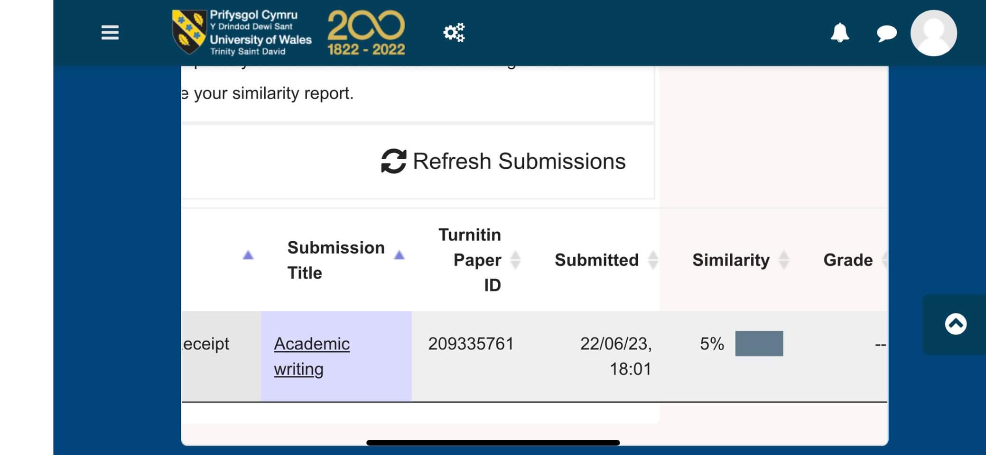

Sense of place and identity presentation video.

https://uowtsd-my.sharepoint.com/:v:/g/personal/2239132_student_uwtsd_ac_uk/ERGhxATucXhPgSWR38anV_UBqejfllrtYOgD3WXjj2mxdA?e=bOaD4t

Critical analysis

Critical analysis or critical thinking is combining all sorts of evidence, facts arguments and observations from different sources and making up one’s mind about a topic or paraphrasing a certain subject in writing, speaking and sharing of information. Peter A Facione. (2011). Critical thinking what is it and why it counts. Insight assessment. 1(1), pp.1-23.

Critical thinking includes all kinds of evidence and information. From a persons own experience and perspective to old and new books with a broad amount of information and research available in those books. A student would need to think about the information they include in their own writing and research. They should think about if the information is relevant to the topic they are discussing and if there are other sources that may explain the topic better than the current one they are using. This may be different depending on the topic of discussion for example if a student was writing a recipe they may refer to a chef’s book rather than a journal as with the chefs book they would know that the information is genuine from a credible source. However if they were writing about the nutritional values of food a chefs book may not be the best source of information from this topic. A scientific journal exploring nutrition or a nutrition expert may be the better choice for the source they choose.
Matthew Lipman. (1987). Critical thinking what can it be?. Analytic teaching. 8(1), p...

