

Student name: Ana-Maria Melinda Avram
Student ID: 2415593
Module name: Changemakers: Creativity and Value Creation
Module code: BMHP5014
Lecturer name: Laila Surani

Component 2: Written Assignment (Poster and Pitch)

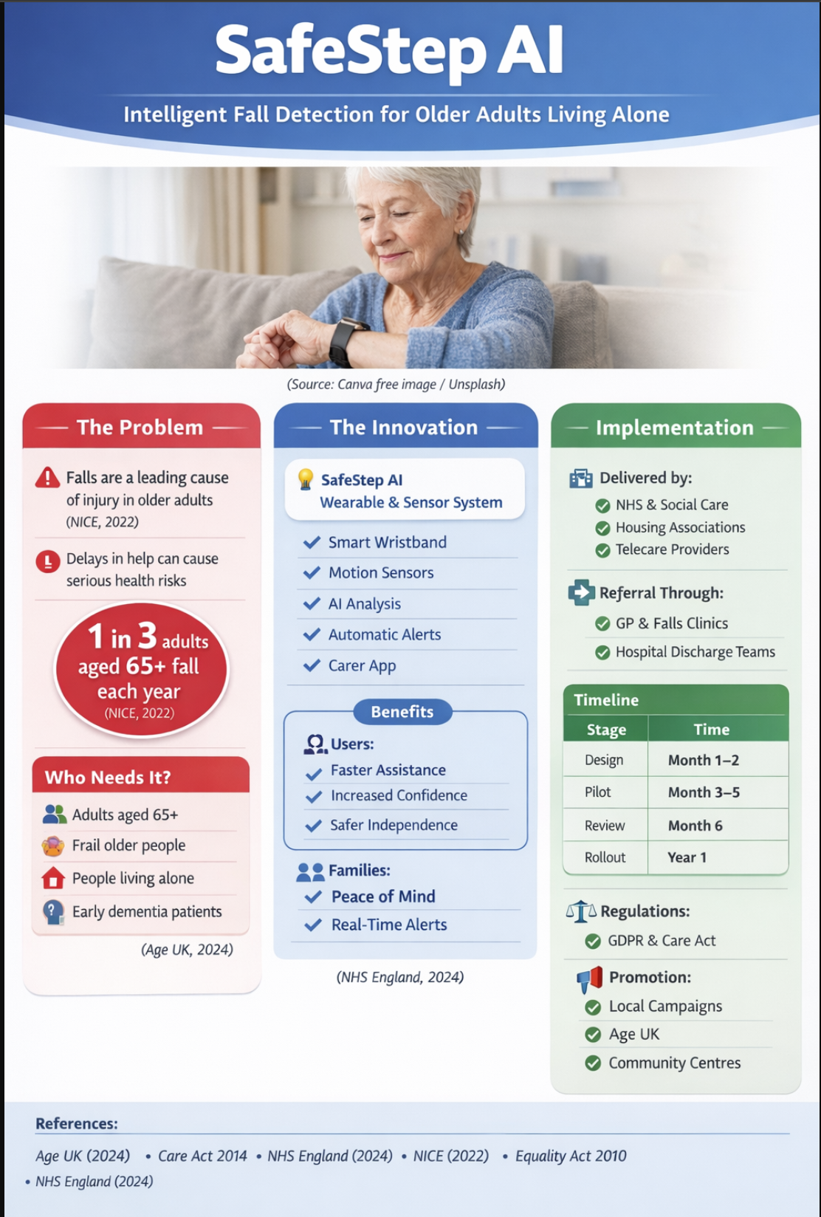
(Made in Canva)
Pitch for SafeStep AI

Introduction

The number of older persons living independently is rising as the UK's population ages quickly. Falls continue to be one of the biggest health concerns, often leading to fractures, hospital admission, and loss of confidence, even though independence may enhance wellness. People who live alone may have to wait a long time to get assistance. Many alarm systems now in use depend on manual activation, which may not be effective after an accident or unconsciousness. SafeStep AI is an intelligent fall detection system that uses home sensors and wearable technologies to automatically detect falls and notify the carers or emergency personnel. Enhancing safety, maintaining freedom, and easing the burden on health and social care services are the goals of this invention.

Background
The population of the United Kingdom is ageing, with a rising proportion of persons aged 65 and older, resulting in increased demand for health and social care services. As individuals live longer lives, an increasing number of elderly folks choose to stay in their own homes, sometimes living alone and managing several chronic medical conditions. While independent living might boost well-being and autonomy, it also increases susceptibility to accidents. According to NHS statistics, falls are the leading cause of emergency hospital admission among older persons. Falls are most prevalent among those over the age of 65, with around one in every three older adults falling at least once each year (NICE, 2022). Hip fractures, brain trauma, and soft tissue injury are common injuries that result in extended hospital stays, limited mobility, and long-term loss of independence. Many people never fully recover from a major fall. Furthermore, older persons who stay on the floor for a longer amount of time following a fall, sometimes known as a "long lie," are more likely to have dehydration, hypothermia, pressure ulcers, and death. Long lying may also induce psychological discomfort, worry, and apprehension about future collapses, resulting in decreased confidence and social isolation. Falls impose a significant financial strain on the NHS, requiring emergency calls, surgery, rehabilitation, and long-term care demands. Existing services, such as pendant alarms, give some assistance, but they depend on the individual's awareness, mobility, and ability to activate the device. This identifies an obvious gap in existing offering and shows the need for an innovative automated solution like SafeStep AI.

Innovation Description

SafeStep AI is an advanced fall detection system that uses wearable technology and ambient monitoring to enhance the safety of older individuals who live independently. The system incorporates a lightweight wrist-worn gadget that is intended for everyday comfort and convenience of usage. This wearable has sensors that record acceleration, impact force, body position, and movement patterns throughout the day. In addition, room-based sensors may be put in important parts of the house, such as bedrooms, bathrooms, and corridors, to detect unexpected changes in posture, atypical inactivity, or abrupt movement (NICE, 2022).
Artificial intelligence is fundamental to innovation. The AI program evaluates data in real time to differentiate between true falls and routine activity such as sitting rapidly, dropping the gadget, or making abrupt arm motions. This helps to prevent false alerts, which are a prevalent vulnerability in many conventional alarm systems. The technology may grow more precise and responsive as it learns the user's regular behaviour over time. When a fall is detected, SafeStep AI automatically sends notifications to specified contacts via a secure mobile platform, such as family members, caretakers, or emergency personnel. The alert might contain geographical information and reaction choices. If no response is obtained within a certain time limit, the system will immediately escalate the alarm to the next contact or emergency support (Care Quality Commission, 2023). This invention is more effective than standard telecare systems since it does not need the user to physically click a button after a fall. It is also preventive, since movement trend data may reveal decreased mobility, increasing instability, or changes in habit, allowing healthcare professionals to intervene earlier and reduce future risk. This promotes proactive and client-centered treatment in community health and social care settings (Department of Health and Social treatment, 2022).

Impact on Health & Social Care:
For older adults
SafeStep AI has the ability to greatly enhance the quality of life for elderly people living alone. Many elderly persons are afraid of falling, which may lead to decreased mobility, lack of confidence, and social isolation. By providing continuous monitoring and timely emergency notifications, the system may boost confidence and encourage people to be active in their homes and communities. This promotes prolonged independent living and may postpone the need for residential care or intensive support services (Age UK, 2024).
For families
SafeStep AI also helps family members and informal caretakers who are concerned about the safety of an elderly relative living alone. Instant alerts after a detected fall enable families to react promptly and make educated judgements regarding whether emergency help is needed. Remote monitoring features may provide reassurance, alleviate stress, and increase communication between family members and carers. This might be particularly useful for relatives who live far away or have caring obligations in addition to work or childcare (Carers UK, 2023).
For Health and Social Care Services
For health and social care services, early identification and reaction to falls may minimise injury severity, avoid consequences like dehydration or pressure ulcers, and shorten hospital stays. A timely response may help minimise ambulance demand and prevent needless emergency hospitalisations. In the long run, assisting individuals to stay securely at home may relieve demand on residential care places and community care resources (NHS England, 2024).
SafeStep AI fosters dignity, equality, and communal well-being by safeguarding vulnerable persons while respecting their autonomy. It highlights how innovation may benefit people, families, and public services all at once (Department of Health and Social Care, 2022).

Stakeholder Involvement
SafeStep AI adoption demands a collaborative strategy that includes both service users and professionals. Older persons should take an important part in influencing device design, including comfort, simplicity of use, accessibility, and privacy settings, to ensure that the technology is person-centred and acceptable to users. Family members and informal caretakers may provide essential feedback on alert choices, communication methods, and emergency contact information. Nurses, occupational therapists, physiotherapists, and social workers may assist in identifying appropriate users, assessing fall risk, and integrating the system into current care plans. In addition, organisations like Age UK and community groups might help with awareness campaigns and user education. Co-production is expected to boost trust, relevance, engagement, and long-term adoption of innovation (NICE, 2022; Age UK, 2024; NHS England, 2024).

Policy / Professional Links
The suggestion is consistent with the Care Act's 2014 mandate to promote wellbeing and avoid growing care demands. It advances the NHS Long Term Plan's goal of providing digitally enabled community care. NICE's (2022) falls prevention advice promotes proactive techniques for reducing risk and maintaining independence. The Equality Act of 2010 ensures justice and inclusion in the provision of assistive technology to handicapped and elderly individuals. Professional engagement by nurses, occupational therapists, physiotherapists, and safeguarding teams assures ethical, person-centred implementation and adherence to care standards. This integrated strategy improves cooperation between the health, social care, and technology sectors, resulting in safer ageing and fewer hospital admissions. (Care Act 2014; NHS England 2024; NICE 2022; Equality Act 2010)

Critical Evaluation
Despite its advantages, some obstacles remain. Local governments and service providers may find it difficult to cover the initial purchase and maintenance expenditures. Some elderly persons may be resistant to wearable technology or have low digital trust, limiting adoption. Continuous home monitoring may raise privacy issues, and false alerts may diminish confidence in the system (NICE, 2022). However, these concerns are manageable. Means-tested financing or NHS pilot initiatives may increase affordability and fairness of access. Training programs and streamlined design would help elderly people accept new technologies. Transparent permission methods and GDPR-compliant technology would alleviate privacy worries. Continuous AI learning and human supervision may improve accuracy and dependability over time. The constraints of SafeStep AI do not exceed its potential advantages, since it coincides with NHS England's (2024) digital transformation objectives and the Care Act's 2014 focus on prevention and welfare. (NICE, 2022; NHS England, 2024; Care Act, 2014).
Conclusion
SafeStep AI provides an innovative and practical solution to a significant public health concern. Integrating technological technology with person-centred care concepts may prevent damage, increase independence, and provide long-term benefit to health and social care systems. The strategy promotes prevention, early intervention, and safer ageing, which aligns with national digital transformation agendas. With careful implementation, clear administration, and active participation from professionals, carers, and service users, the innovation has the potential to significantly enhance outcomes for older individuals in the UK. (NHS England, 2024; Care Act of 2014; NICE, 2022).

References

Age UK (2024) Later life in the United Kingdom. London: Age UK. Available at: https://www.ageuk.org.uk (Accessed: 12 March 2026).
British Geriatrics Society (2023) Fit for frailty: Falls and frailty guidance. London: BGS. Available at: https://www.bgs.org.uk (Accessed: 18 April 2026).
Care Act 2014. London: The Stationery Office. Available at: https://www.legislation.gov.uk/ukpga/2014/23/contents (Accessed: 05 April 2026).
Care Quality Commission (2023) The state of health care and adult social care in England. London: CQC. Available at: https://www.cqc.org.uk (Accessed: 22 March 2026).
Department of Health and Social Care (2023) People at the heart of care: Adult social care reform. London: DHSC. Available at: https://www.gov.uk/government/publications/people-at-the-heart-of-care-adult-social-care-reform (Accessed: 09 April 2026).
Equality Act 2010. London: The Stationery Office. Available at: https://www.legislation.gov.uk/ukpga/2010/15/contents (Accessed: 14 April 2026).
Health Foundation (2023) The future of digital health in the UK. London: The Health Foundation. Available at: https://www.health.org.uk (Accessed: 27 April 2026).
King’s Fund (2024) Prevention and community based care: Policy analysis. London: The King’s Fund. Available at: https://www.kingsfund.org.uk (Accessed: 03 April 2026).
Local Government Association (2023) Using technology to support adult social care. London: LGA. Available at: https://www.local.gov.uk (Accessed: 16 March 2026).
National Institute for Health and Care Excellence (NICE) (2022) Falls in older people: Quality standard QS86. London: NICE. Available at: https://www.nice.org.uk/guidance/qs86 (Accessed: 25 April 2026).
NHS Confederation (2024) Digital transformation in integrated care systems. London: NHS Confederation. Available at: https://www.nhsconfed.org (Accessed: 11 April 2026).
NHS Digital (2023) Adult social care activity and finance report. Leeds: NHS Digital. Available at: https://digital.nhs.uk (Accessed: 08 April 2026).
NHS England (2019) The NHS Long Term Plan. London: NHS England. Available at: https://www.longtermplan.nhs.uk (Accessed: 20 March 2026).
NHS England (2024) Urgent and emergency care data. London: NHS England. Available at: https://www.england.nhs.uk/statistics (Accessed: 30 April 2026).
NHSX (2022) Digital technology for community health services. London: NHSX. Available at: https://www.nhsx.nhs.uk (Accessed: 02 April 2026).
Office for National Statistics (ONS) (2024) Living longer: The UK’s ageing population. London: ONS. Available at: https://www.ons.gov.uk (Accessed: 19 April 2026).
Public Health England (2021) Falls: Applying All Our Health. London: PHE. Available at: https://www.gov.uk/government/publications/falls-applying-all-our-health (Accessed: 07 March 2026).
Royal College of Occupational Therapists (2022) Occupational therapy and falls prevention. London: RCOT. Available at: https://www.rcot.co.uk (Accessed: 24 April 2026).
Telecare Services Association (2023) Technology enabled care standards. London: TSA. Available at: https://www.tsa-voice.org.uk (Accessed: 06 April 2026).
World Health Organization (2021) Falls fact sheet. Geneva: WHO. Available at: https://www.who.int/news-room/fact-sheets/detail/falls (Accessed: 28 April 2026).

